**AAROHI SEWING ENTERPRISES**

**One Stop Store for All Sewing Needs**

**RICOMA SWD SERIES: 1201-8S/ 1501-8S Single Head Commercial Embroidery Machine**

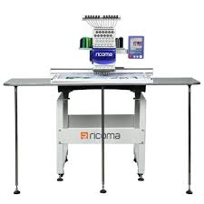

***USA brand. It is with extra wide SWD embroidery machine. With the largest embroidery area in the industry, this 12 or 15-needle commercial embroidery machine is perfect for embroidery on large items like blouses, sarees, bags, jackets and tablecloths as well as regular items like polos and caps, etc.*** ***Optional device has : Sequins, Cording, rhinestone, beads, laser cutting, Robot frame device etc.***

***Perfect for small and established businesses alike***

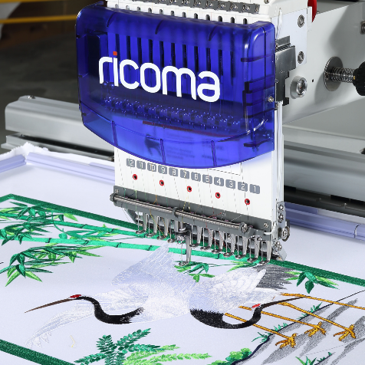

**Major Features**

* Max Speed: 1000 SPM
* Memory Capacity: 20 Million Stitches / 200 designs
* High definition color 8” LCD screen
* Around 10 Hoops
* Design format: DST and DSB
* Automatic Thread Trimmer & Auto Color Change
* Built-In Universal Power Supply, 110v/60hz and 220v/50hz Self-Adaptable Worldwide
* 1 Auto winding machine
* 1 Toolbox

**Price and Delivery Time**

|  |  |  |
| --- | --- | --- |
| No. Of Needles | Frame/Hoop size | Price (In lacks) |
| 12 | 500x800 mm | 5.9 |
| 12 | 500X1200 mm | 6.7 |
| 15 | 500X800 mm | 6.1 |
| 15 | 500X1200 mm | 6.9 |

Difference is 20000 Rs between 12 and 15 needles.

Extra charges applicable for optional devices like cap, shoe, cording, Sequins, and Beads devices, etc.,

**Delivery time:** 1 to 2 days incase stock is available, else 1 to 2 months’ time for delivery since advance

**Our Services**

* 1 Year Free Service
* Welcome Kit
* 500+ Blouse Designs, 3000+ Butties, Extra Dress and Kid designs
* Home Delivery (Customer to pay transport charges)
* Home Installation
* Home Demo
* Home Service
* Training is available at our store (Charges applicable)