Easyrec
Refer: http://easyrec.org/ for installation guide, API details and downloading source code, and war files

Requirements
To install easyrec you need the following prerequisites installed:
- Java 7 SE or later
- Application Server Tomcat 6.0 or later recommended or see Application Servers
- Database Server MySQL 5.1 or later (5.5 or later recommended)

Installation:
easyrec comes with an interactive, web-based installer that is run automatically when you start easyrec for the first time.
Before you can run easyrec, make sure your deployment environment meets the prerequisites outlined above (Tomcat6 , MySQL 5.1 or later and JAVA 7 SE or later.
Once you have established an environment with Tomcat 6 running and a MySQL server reachable, acquire the latest easyrec_X_xx.war from the download section of the easyrec website.

Creating the database
Make sure you downloaded and installed MySQL server in your machine

Open my sql db.
Next, create a database and a user that has all privileges for that database:
create database easyrec;

- Create a user and grant all privileges to it for the database you just created.
For environments where the MySQL server and the web server (i. e. Tomcat) are hosted on the same machine this is done by issuing the following command (Please replace 'easyrecuser' and 'password' with appropriate values of your choice):

grant index, create, select, insert, update, drop, delete, alter, lock tables on

easyrec.* to 'easyrecuser'@'localhost' identified by 'password';

Note: Here user is created and password is assigned directly with grant command.

Deploying the Web Application

Download source code and import it into Eclipse IDE.
Link to download source code of the project: https://sourceforge.net/p/easyrec/code/ci/master/tree/
It’s a maven project, download and import it into Eclipse as a maven project
Generate a war file in Eclipse (or) download a war file whatever the version you want from the website

Link to Download latest war file: https://sourceforge.net/projects/easyrec/files/latest/download
Deploy the war file in Tomcat server webapps folder

Configuration
First startup/Initial configuration
Once all of the above steps are completed, you can continue with the installation and configuration of easyrec using a web browser.
When accessing the URL where easyrec was deployed e.g.http://myserver.com/easyrec-web for the first time after you deployed the web application, you will be guided through the final steps of the easyrec setup and configuration.
Ex: localhost:<portno>/easyrec-web

Database connection setup
As a first step you will be welcomed by a page that allows you to set up the database connection as pictured below.
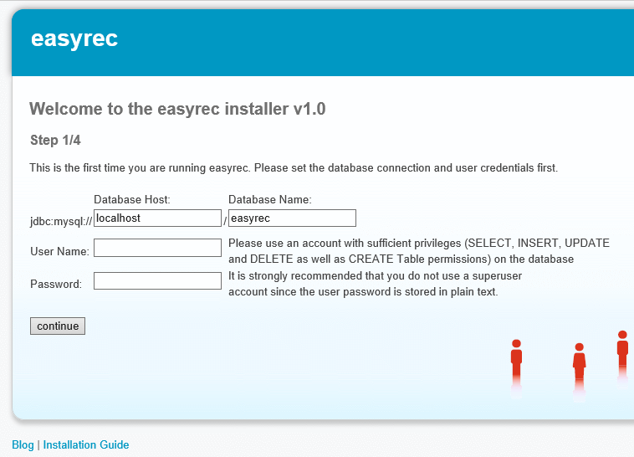
Simply enter the details about your database connection and the username/password created in the previous section of this installation guide.
Field | Explanation
Database Host | The host the database is located on. If the database is located on the same host as the web server use "localhost".
Database Name | The name of the MySQL database you created.Note: If the MySQL server is configured to listen an a port other than the MySQL default port (3306), add the port to the hostname, separated by a colon (e.g. 'myserver:4711').
Username | The username used to access the easyrec database.Ensure that the user has SELECT, INSERT, UPDATE, DROP and DELETE permissions on the easyrec database. For security reasons it is strongly suggested that you do not use a database superuser account.
Password | The user password for accessing the easyrec database.

Once you have entered appropriate values in each field click the 'continue' button. easyrec will try to establish a connection to the database server using the information you provided in the form. If any problems should arise, an error message hinting at the cause of the problem will be displayed. If the connection attempt was successful you will progress to the next step.

Database initialization

Once you have made sure that your MySQL configuration is correct, click away the alert message box and continue.

Hint: You can edit your database settings and restart MySQL right at this moment. There is no need to stop the easyrec installer. Just configure your database and when you are done return to the browser window and continue with easyrec setup.

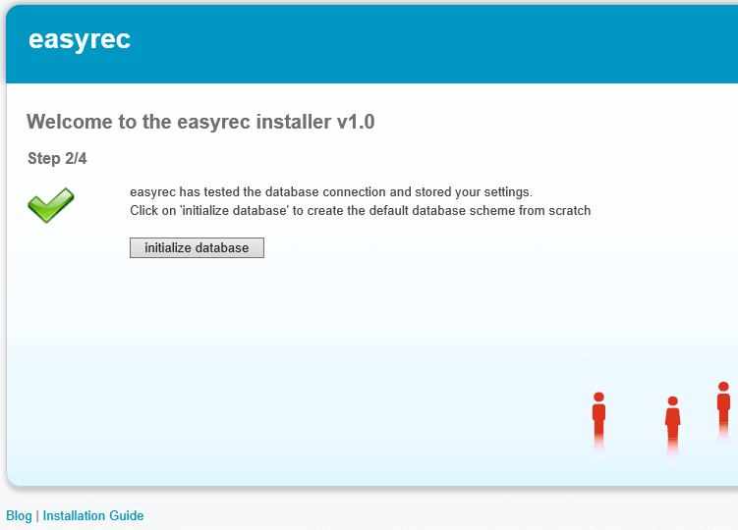

Click the 'initialize database' button to continue.
In case you are redeploying the easyrec-web.war file and the database has already been created, you are presented with a slightly different screen:

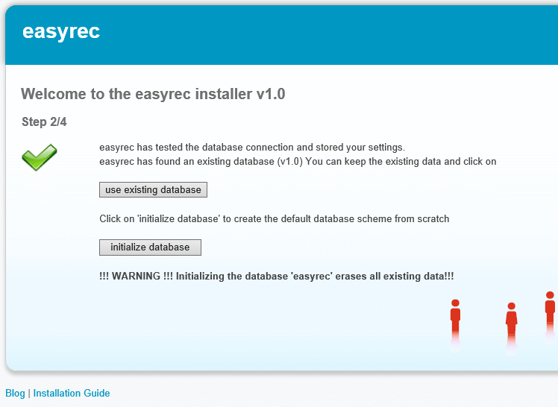
You can either choose between 'initialize database' or 'use existing database'.
When using the second option, no tables will be created or altered and all existing data is kept in the database.
WARNING: Be aware that all easyrec tables will be deleted from the database specified in case you click on 'initialize database'

easyrec feature selection

If database initialization was successful you will be directed to the easyrec feature selection page.

If database initialization was successful you will be directed to the easyrec feature selection page.
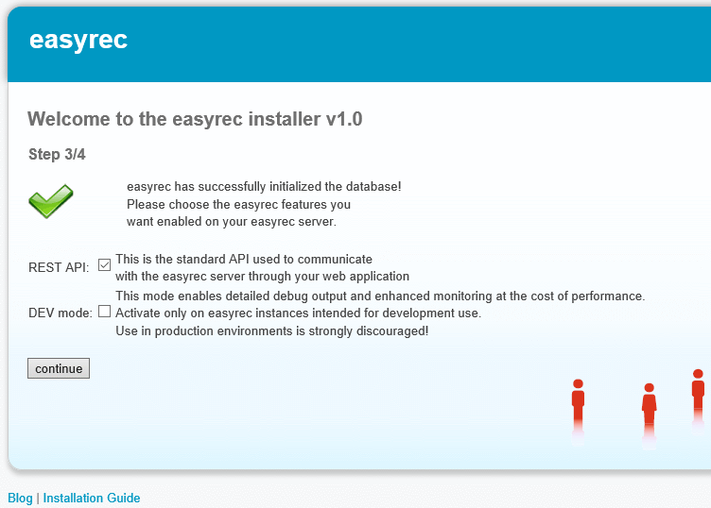

Field | Explanation
Use REST | enable easyrec REST API. This is the default way to communicate with easyrec.
Developer Mode | This mode enables detailed debug output and enhanced monitoring at the cost of performance. Activate this option only on easyrec instances intended for development use. The use of this feature in production environments is strongly discouraged!
Developer mode just enables detailed log output about internal method calls and response values as well as more detailed performance profiling information. Unless you are a developer without direct debug access to the machine running easyrec you will want to leave this feature OFF.
By clicking the 'continue' button, easyrec will proceed to load and initialize all the services necessary for providing the selected features. This operation may take some time (usually several seconds up to 1 minute) to complete. If everything loaded according to plan you will be forwarded to the final step of the easyrec installation process.

User account creation
The final step before you can start using easyrec is to create user account, which is required to log in to the easyrec admin tool. The tool provides you with a basic overview about the easyrec status, allows you to perform some administrative operations. Most importantly it is the place to obtain your API key that needs to be passed along with every request to the easyrec API.

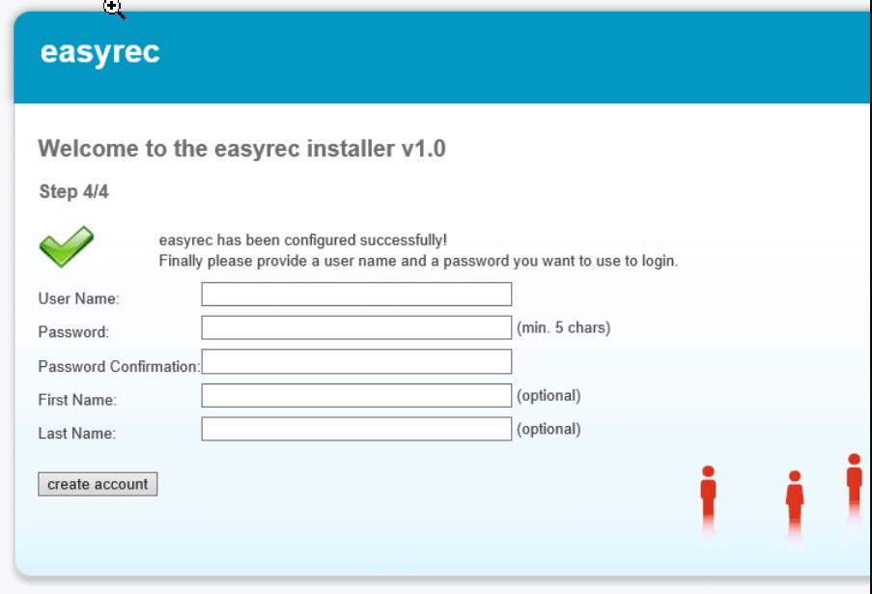
The user registration form should be self-explanatory. Simply provide a username and a password you want to use to log in to the easyrec admin tool. If you want you can supply some personal information as well. The personal information can be altered later on from within the admin tool. However, for the time being be aware that there is no easy way to change the username and password afterwards.

Ready to go
Congratulations! You have installed and configured easyrec successfully. You are now ready to start using easyrec and integrate it into your web applications.

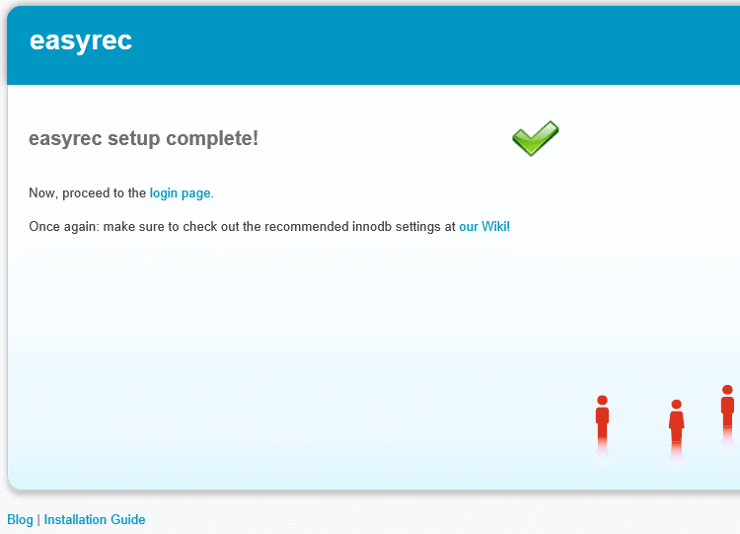

The final screen informs you of the successful completion of the easyrec setup process. By clicking the 'management section' link you will be forwarded to the easyrec admin tool and logged in with the credentials provided in the previous step.

Testing
Test the application with REST API from postman plugin
- Open REST API link on your local application, take URIs, paste it in postman URL and hit the service
Note: Make sure you replace API key with your local API key in the request

Once the request is successful, then check requested details are inserted in DB table.

Ex: select * from actions;

- See analytics graphs from the applications.

Hitting Buy webservice from Postman
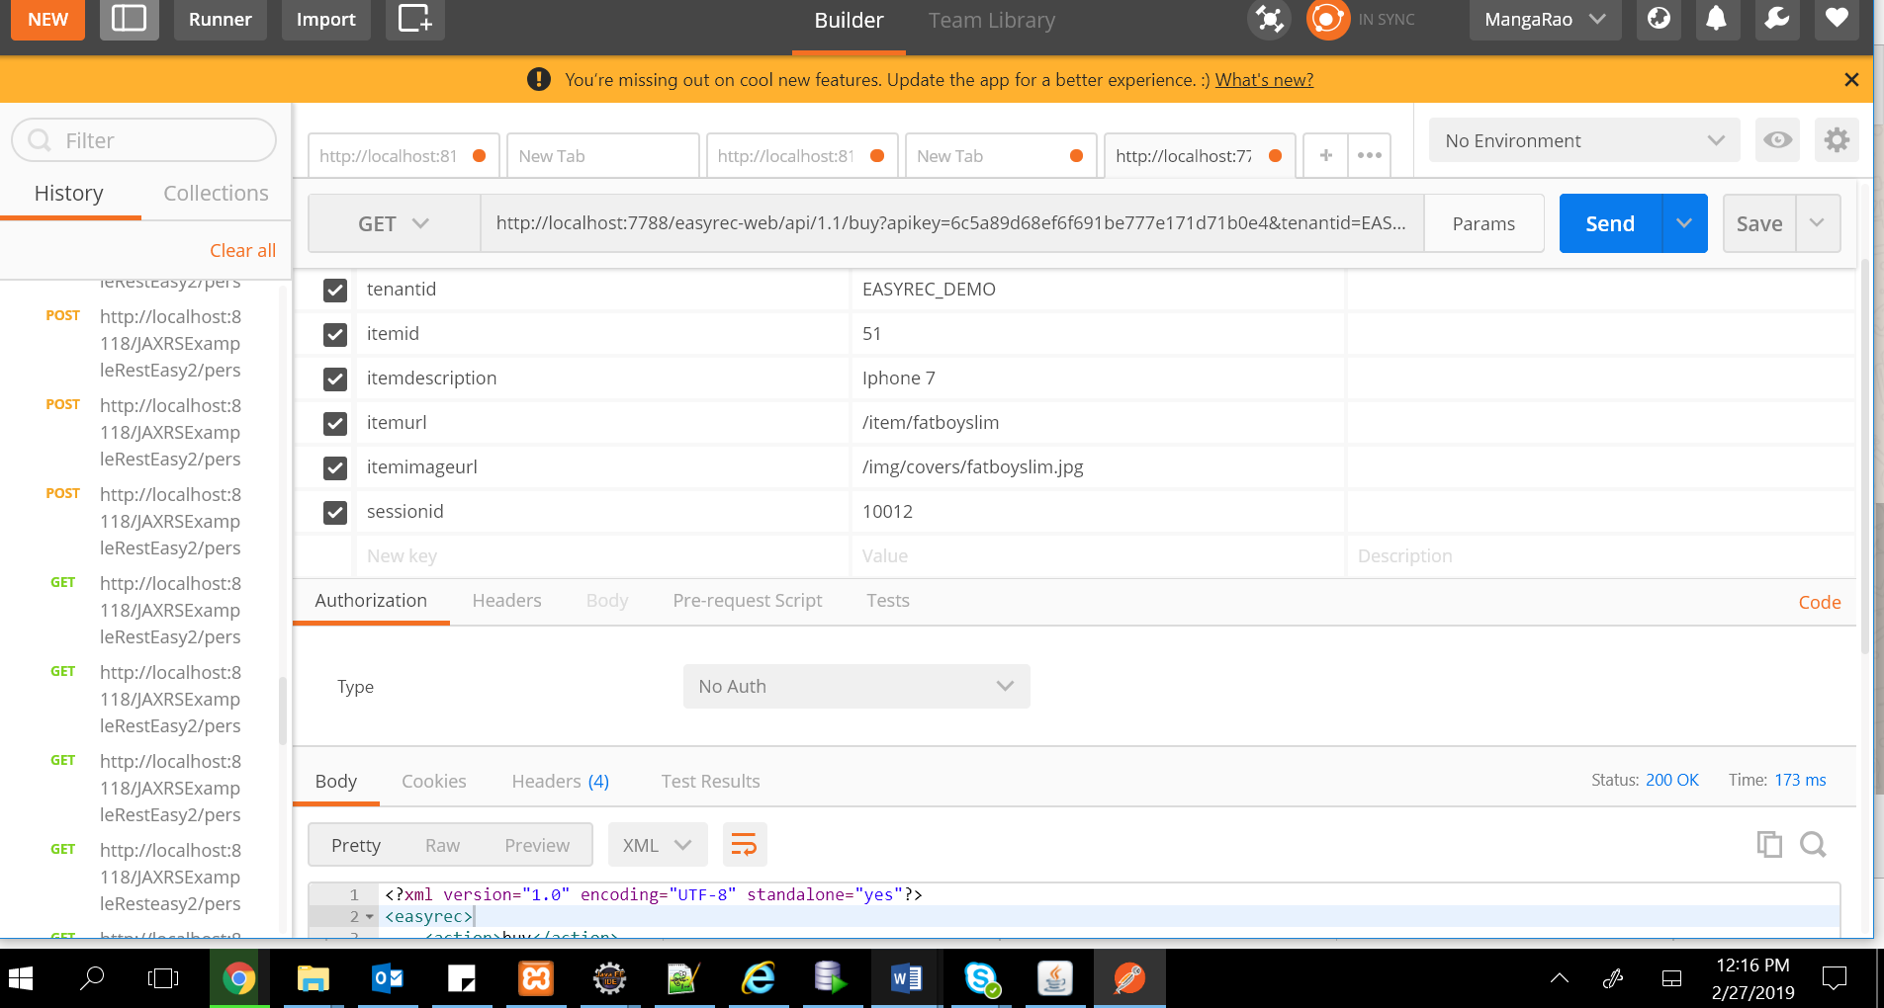

Check DB
