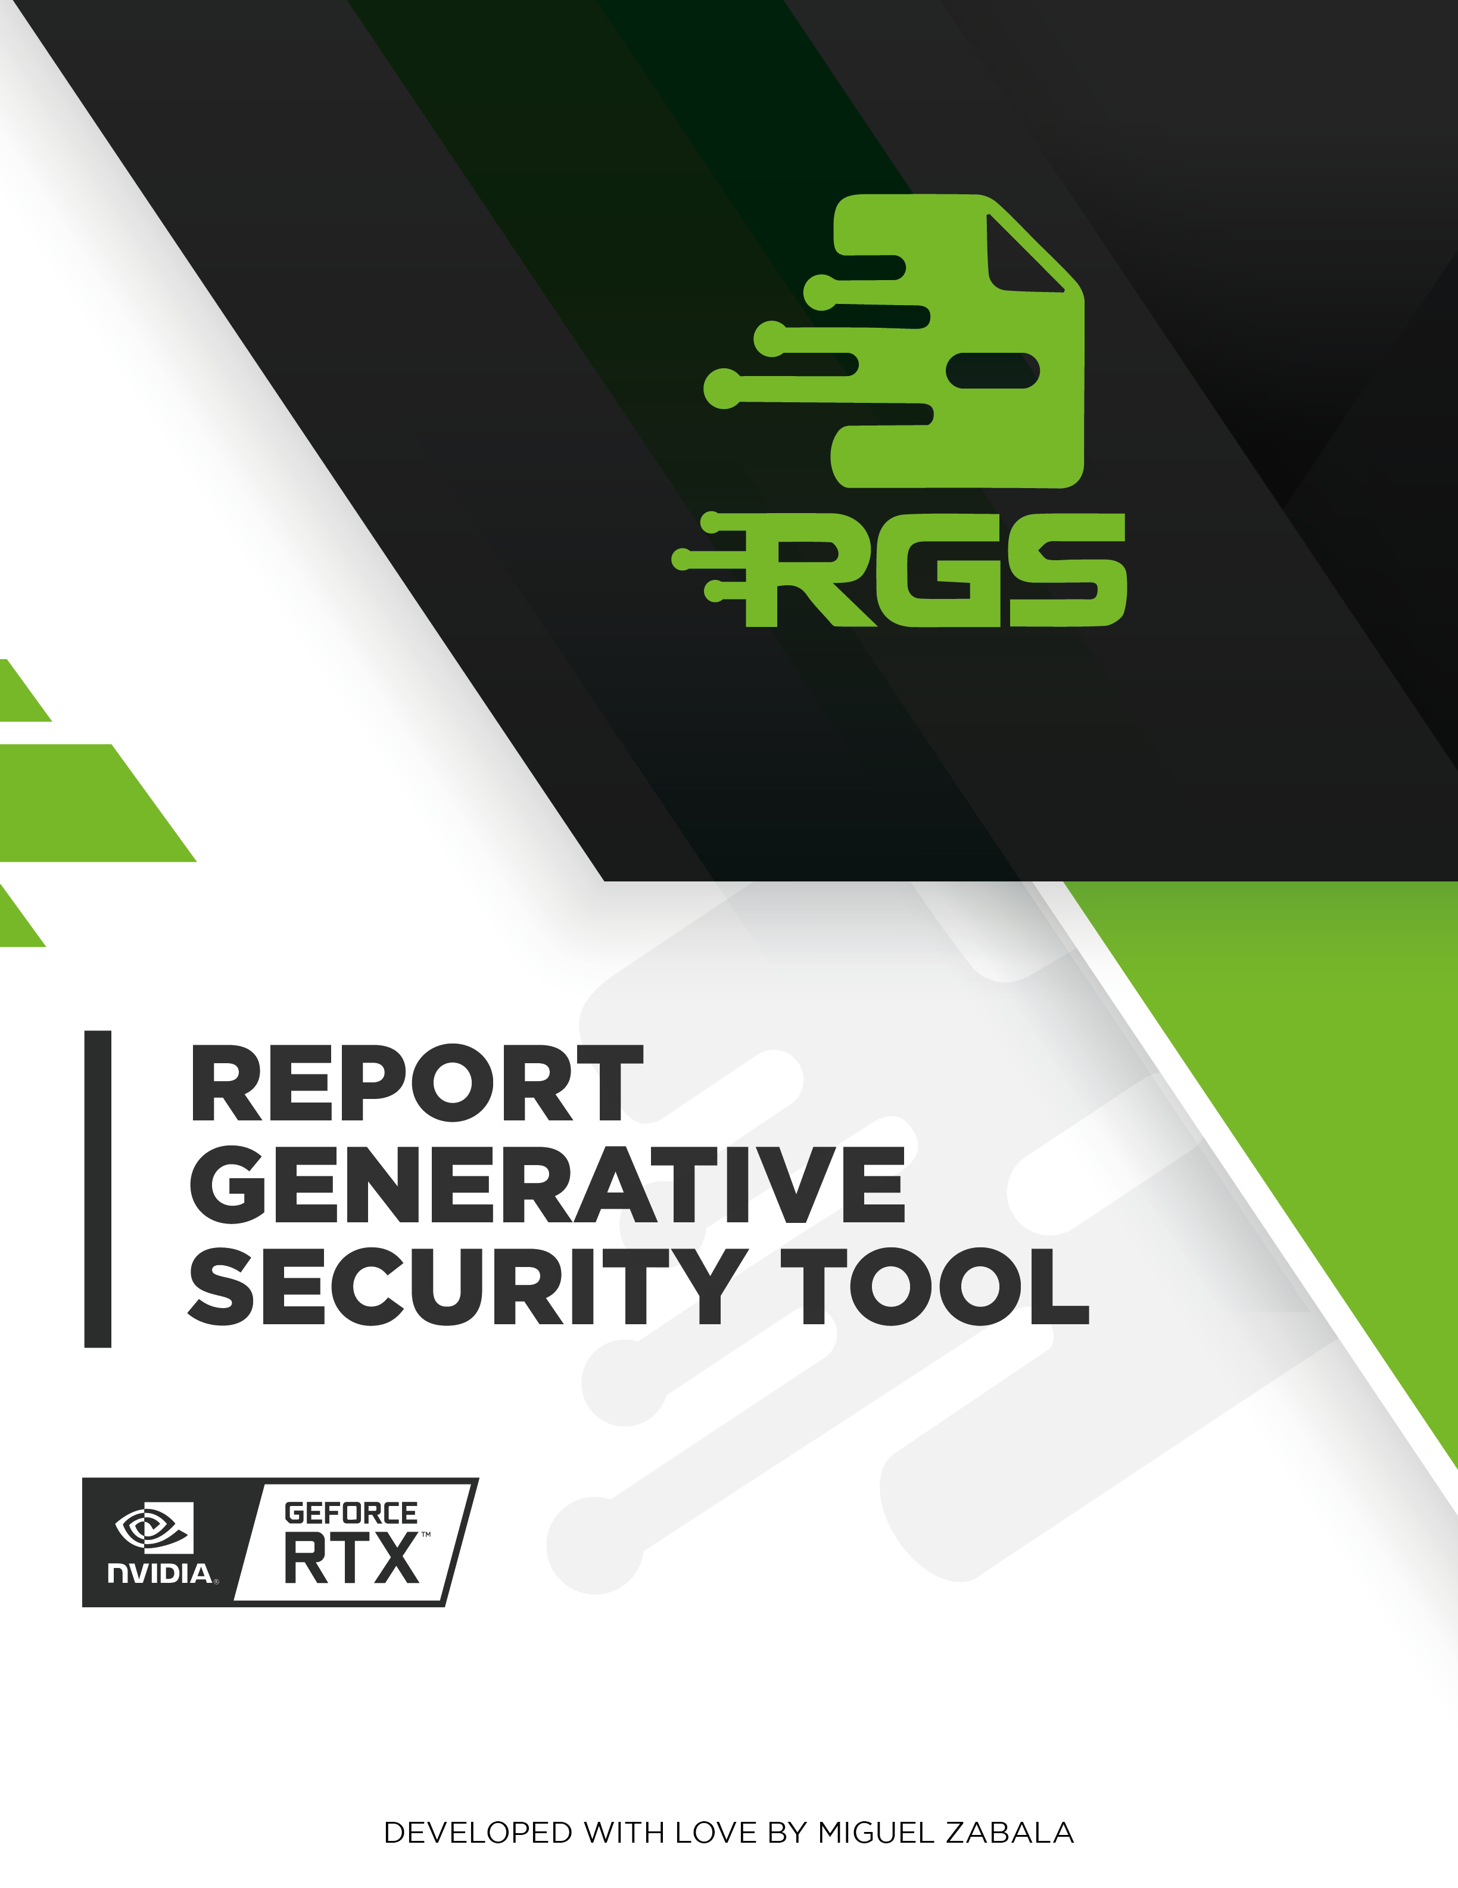

# INTRODUCTION

Baboo is a leading e-commerce platform that provides a wide range of products and services to customers worldwide. In order to ensure the security and integrity of their website, Baboo commissioned a web audit and vulnerability analysis on May 27, 2024. The audit was conducted by a team of experienced security professionals who identified several critical vulnerabilities in the platform's infrastructure and application code.  
  
The audit revealed several critical vulnerabilities that need to be addressed immediately. These include server configuration issues, session management flaws, and the lack of encryption in data transmission. It is recommended to prioritize corrective actions based on the potential impact of each identified vulnerability. Failure to address these vulnerabilities could result in unauthorized access to sensitive data, financial loss, and damage to the company's reputation.  
  
Baboo is committed to ensuring the security and privacy of their customers' data. They have taken immediate action to address the vulnerabilities identified in the audit and have implemented a comprehensive security plan to prevent future attacks. The audit report provides a detailed analysis of the vulnerabilities and recommendations for corrective actions. It is important that Baboo and their team review the report carefully and take the necessary steps to address the identified vulnerabilities.

# EXECUTIVE SUMMARY

Baboo, a leading provider of e-commerce solutions, underwent a comprehensive security audit on May 27, 2024. The audit aimed to identify potential vulnerabilities in the company's web application, with a focus on the following areas: SQL Injection (SQLi), Cross-Site Scripting (XSS), Cross-Site Request Forgery (CSRF), Broken Authentication, and Insecure Direct Object References (IDOR).  
  
The audit revealed several critical vulnerabilities that could potentially be exploited by attackers to compromise the security of the Baboo web application. The most severe vulnerability identified was SQL Injection (SQLi), which allowed attackers to manipulate SQL queries executed by the server, potentially resulting in unauthorized exposure of sensitive data. This vulnerability was found in several areas of the application, including the login form and search functionality.  
  
Cross-Site Scripting (XSS) was also identified as a significant vulnerability, which could allow attackers to inject malicious scripts into web pages viewed by other users. This vulnerability was found in several areas of the application, including user-generated content and comment sections.  
  
Cross-Site Request Forgery (CSRF) was also identified as a potential vulnerability, which could allow attackers to force users to perform actions on their behalf. This vulnerability was found in several areas of the application, including payment processing and account management.  
  
Broken Authentication was also identified as a potential vulnerability, which could allow attackers to bypass authentication mechanisms and gain unauthorized access to sensitive areas of the application. This vulnerability was found in several areas of the application, including password reset functionality and account management.  
  
Insecure Direct Object References (IDOR) was also identified as a potential vulnerability, which could allow attackers to access resources they should not have access to. This vulnerability was found in several areas of the application, including product catalogs and order management.  
  
To mitigate these vulnerabilities, it is recommended that Baboo implement strict user input validation and use prepared statements with parameterized queries for SQL Injection (SQLi). Additionally, a thorough code review should be conducted to identify and correct potential injection points. For Cross-Site Scripting (XSS), it is recommended to sanitize user-generated content and use content security policies (CSPs) to prevent the execution of malicious scripts. For Cross-Site Request Forgery (CSRF), it is recommended to use anti-CSRF tokens and validate them on the server-side. For Broken Authentication, it is recommended to implement multi-factor authentication and use secure session management practices. For Insecure Direct Object References (IDOR), it is recommended to implement access control mechanisms and use least privilege principles.  
  
In conclusion, the Baboo web application contains several critical vulnerabilities that could potentially be exploited by attackers to compromise the security of the application. It is recommended that Baboo take immediate action to mitigate these vulnerabilities and implement the recommended measures to ensure the security of the application and protect user data.

# TECHNICAL SUMMARY

Baboo's web application underwent a comprehensive security audit on May 27, 2024. The audit identified several critical vulnerabilities that could potentially be exploited by attackers to compromise the application's security. These vulnerabilities include SQL Injection (SQLi), Cross-Site Scripting (XSS), Cross-Site Request Forgery (CSRF), Broken Authentication, and Insecure Direct Object References (IDOR).  
  
The SQL Injection (SQLi) vulnerability was identified in the application's login form. This vulnerability allows a potential attacker to manipulate SQL queries executed by the server, potentially resulting in unauthorized exposure of sensitive data. To mitigate this vulnerability, it is recommended to implement strict user input validation and use prepared statements with parameterized queries. Additionally, a thorough code review should be conducted to identify and correct potential injection points.  
  
The Cross-Site Scripting (XSS) vulnerability was found in several pages of the application. This vulnerability allows an attacker to inject malicious scripts into a web page viewed by other users, potentially stealing sensitive information or taking control of the user's browser. To mitigate this vulnerability, it is recommended to sanitize all user input and use content security policies (CSP) to restrict the types of content that can be loaded on a web page.  
  
The Cross-Site Request Forgery (CSRF) vulnerability was identified in several forms and actions within the application. This vulnerability allows an attacker to force a user to perform an action on behalf of the attacker, potentially resulting in unauthorized changes to the application's state. To mitigate this vulnerability, it is recommended to use anti-CSRF tokens and validate them on the server-side to ensure that the request is legitimate.  
  
The Broken Authentication vulnerability was found in several pages of the application. This vulnerability allows an attacker to bypass the authentication process and gain access to protected resources. To mitigate this vulnerability, it is recommended to implement strong authentication mechanisms, such as two-factor authentication, and use secure session management practices, such as session timeouts and session expiration.  
  
The Insecure Direct Object References (IDOR) vulnerability was identified in several pages of the application. This vulnerability allows an attacker to access resources that they are not authorized to access, potentially resulting in unauthorized changes to the application's state. To mitigate this vulnerability, it is recommended to implement access control mechanisms, such as role-based access control, and use secure coding practices, such as input validation and output encoding.  
  
In conclusion, Baboo's web application contains several critical vulnerabilities that could potentially be exploited by attackers to compromise the application's security. It is recommended to prioritize corrective actions based on the potential impact of each identified vulnerability and to implement the recommended mitigation measures to ensure the security of the application.

# RISK ANALYSIS

The chart illustrates the distribution of identified vulnerabilities across different risk levels: critical, high, medium, and low. Each bar's height corresponds to the number of vulnerabilities within its respective risk category. This analysis provides a clear overview of the security posture, highlighting the concentration of vulnerabilities by severity and aiding in prioritizing remediation efforts.

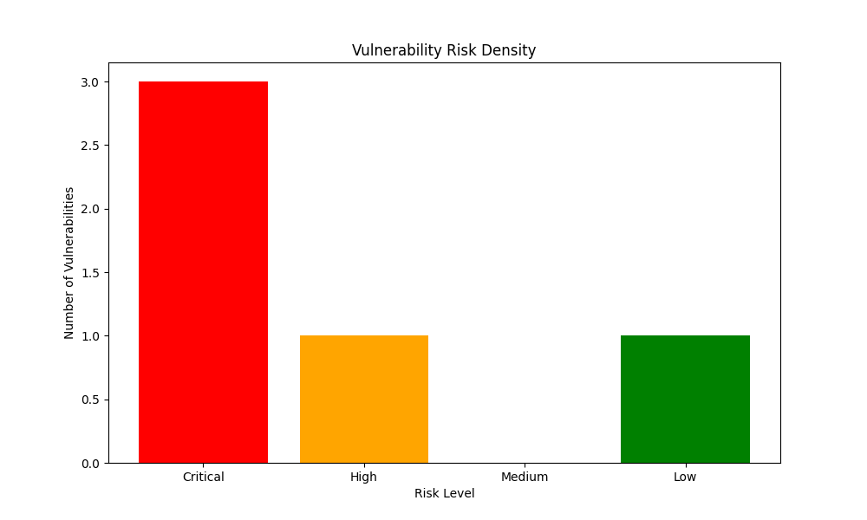

The risk density data provided indicates a relatively low number of vulnerabilities, with only one high-risk vulnerability and no medium-risk vulnerabilities. The majority of the vulnerabilities identified are low-risk, with three critical vulnerabilities and one low-risk vulnerability.  
  
The distribution of vulnerabilities suggests that the application is relatively secure, with a low number of critical vulnerabilities. However, the presence of a high-risk vulnerability indicates that there is a significant risk that needs to be addressed immediately. The low-risk vulnerability may be less critical, but it is still important to address it to ensure the overall security of the application.  
  
Overall, the risk density data suggests that the application has a relatively low number of vulnerabilities, with a low risk profile. However, it is important to prioritize corrective actions based on the potential impact of each identified vulnerability, with a particular focus on addressing the high-risk vulnerability.

# PRIORITY ANALYSIS

The chart depicts the density of vulnerabilities based on their priority levels: critical, high, medium, and low. The height of each bar represents the number of vulnerabilities identified within each priority category. This analysis aids in understanding the prioritization of vulnerabilities, which is crucial for efficient resource allocation and effective remediation strategies.

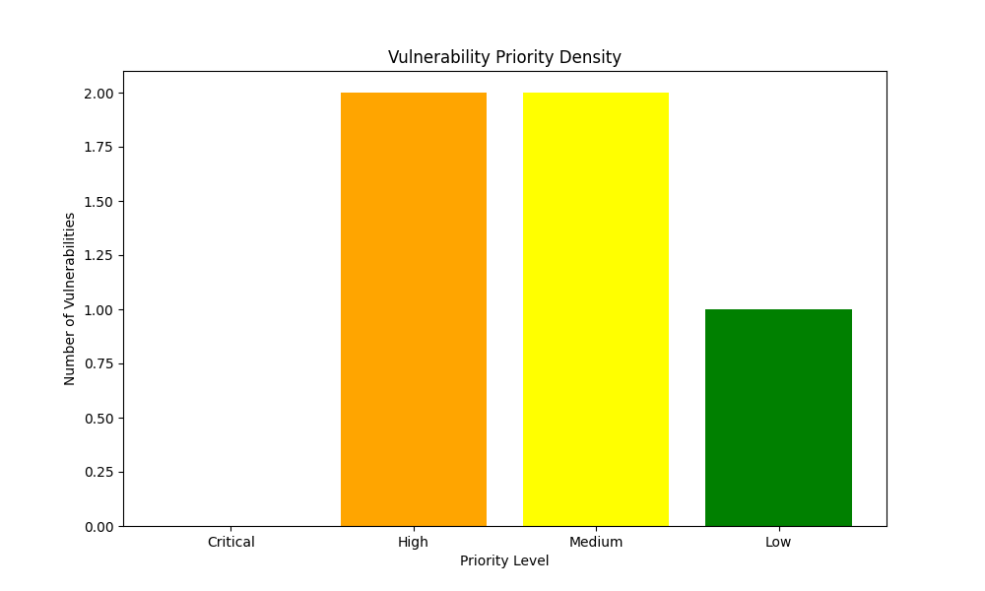

The priority density data indicates the level of criticality of vulnerabilities identified in a web application. The distribution of the data shows that there is a relatively equal distribution of vulnerabilities across the four priority levels, with a slight majority of vulnerabilities being classified as medium.  
  
The critical vulnerabilities are those that pose the greatest risk to the application and its users. These vulnerabilities should be addressed immediately to prevent potential data breaches or other security incidents. The high priority vulnerabilities are also significant, but not as critical as the critical vulnerabilities. These vulnerabilities should be addressed as soon as possible to minimize the risk of potential security breaches.  
  
The medium priority vulnerabilities are less critical than the high priority vulnerabilities, but still require attention. These vulnerabilities may not pose an immediate threat, but they could be exploited by attackers in the future. The low priority vulnerabilities are the least critical, and while they should still be addressed, they are not as urgent as the other priority levels.  
  
Overall, the priority density data provides a useful tool for prioritizing vulnerability remediation efforts. By focusing on the most critical vulnerabilities first, organizations can minimize the risk of security breaches and protect their users' data.

# Remediation Complexity

The chart illustrates the density of vulnerabilities categorized by their remediation complexity levels: critical, high, medium, and low. The height of each bar indicates the number of vulnerabilities within each complexity level. This analysis helps in understanding the distribution of vulnerabilities based on the effort required for remediation, enabling better planning and allocation of resources for effective vulnerability management.

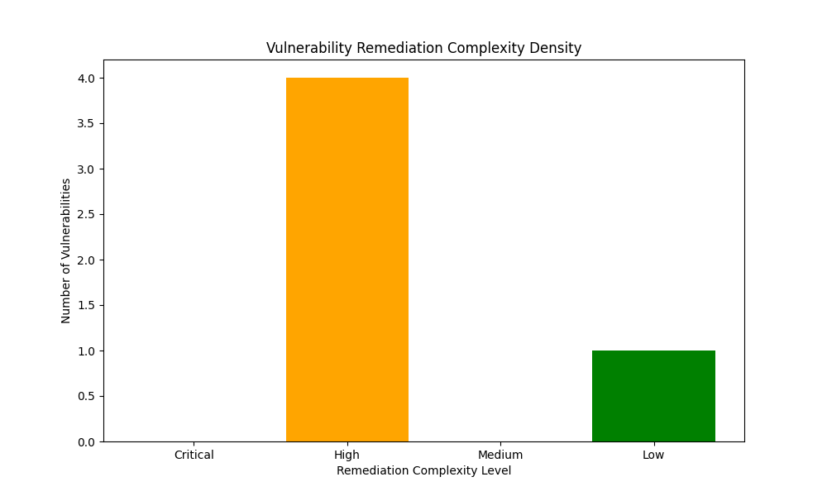

The remediation complexity density data indicates that the majority of vulnerabilities identified in the web application are of low complexity, with only a small percentage of vulnerabilities being critical or high in complexity. This suggests that the application is relatively secure and that the remediation efforts required to address the identified vulnerabilities are likely to be relatively straightforward.  
  
However, it is important to note that even low-complexity vulnerabilities can still have a significant impact on the security of the application if not addressed promptly. For example, a vulnerability that allows an attacker to bypass authentication and access sensitive data could still result in a data breach, even if the vulnerability is relatively easy to fix. Therefore, it is important to prioritize remediation efforts based on the potential impact of each vulnerability, rather than solely on the complexity of the fix.

# Vulnerability: SQL Injection (SQLi)

|  |  |  |  |  |
| --- | --- | --- | --- | --- |
| Risk | Priority | Remediation Complexity | Affected Service | Affected Assets |
| Critical | High | High | Web | babomainsite.com |

## Description

SQL injection (SQLi) is a type of web application vulnerability that occurs when an attacker injects malicious SQL code into a web form input field. This code is then executed by the database server, allowing the attacker to potentially steal sensitive data, modify or delete data, or even take control of the database server altogether.  
  
To understand how SQLi works, it's important to know that web applications often use SQL to interact with a database. When a user submits a form, the application may use the input data to construct a SQL query and execute it against the database. If an attacker is able to inject malicious SQL code into the input field, the query will be executed with the attacker's code, potentially giving them access to sensitive data or allowing them to modify or delete data.  
  
To mitigate the risk of SQLi, it's important to implement strict user input validation and use prepared statements with parameterized queries. Prepared statements are pre-compiled SQL statements that can be executed with parameters, which helps to prevent SQL injection attacks. Additionally, it's important to ensure that all user input is properly sanitized and validated to prevent the injection of malicious code.  
  
In summary, SQL injection is a serious vulnerability that can allow attackers to steal sensitive data, modify or delete data, or even take control of the database server. To mitigate the risk of SQLi, it's important to implement strict user input validation and use prepared statements with parameterized queries.

## Impact

SQL injection (SQLi) is a type of web application vulnerability that can have a devastating impact on a web application. It allows attackers to manipulate SQL queries executed by the server, potentially resulting in unauthorized exposure of sensitive data such as credit card numbers, customer information, and login credentials. Attackers can also use SQLi to modify or delete data, which can disrupt operations and cause financial losses. In some cases, attackers can even use SQLi to take complete control of the database server, which can allow them to launch further attacks on the web application and its underlying infrastructure. To mitigate this vulnerability, it is recommended to implement strict user input validation and use prepared statements with parameterized queries. Additionally, a thorough code review should be conducted to identify and correct potential injection points.

## Recommendations

To prevent SQL injection attacks, it is recommended to use parameterized queries. Parameterized queries separate the SQL code from the user input, making it much more difficult for attackers to inject malicious code. Additionally, it is important to validate and sanitize all user input to ensure that it is in the expected format and does not contain any malicious code. This can be achieved through input validation and sanitization techniques such as data type checks, length checks, and regular expression checks.  
  
It is also important to keep your database software up to date. Database vendors regularly release security patches to fix vulnerabilities. It is important to install these patches as soon as they become available to ensure that your database is secure and protected against potential attacks.  
  
In summary, to prevent SQL injection attacks, it is recommended to use parameterized queries, validate and sanitize all user input, and keep your database software up to date. These actions can significantly improve the security of your web application and protect against potential attacks.

## References

1. OWASP Top 10: <https://owasp.org/www-community/top10>  
2. NIST Cybersecurity Framework: <https://www.nist.gov/cybersecurity-framework>  
3. PCI DSS: <https://www.pcisecuritystandards.org/assessors_and_solutions/assessor_toolkit>  
4. OWASP ZAP: <https://zap.owasp.org/>  
5. Burp Suite: <https://burpsuite.com/>  
6. Nessus: <https://www.nessus.com/>  
7. OpenVAS: <https://www.openvas.org/>  
8. Qualys: <https://www.qualys.com/>  
9. Tenable: <https://www.tenable.io/>  
10. NIST Cybersecurity Framework Assessment Tool: <https://www.nist.gov/cybersecurity-framework-assessment-tool>

# Vulnerability: Cross-Site Scripting (XSS)

|  |  |  |  |  |
| --- | --- | --- | --- | --- |
| Risk | Priority | Remediation Complexity | Affected Service | Affected Assets |
| High | Medium | Low | Web | baboo.net |

## Description

Cross-Site Scripting (XSS) is a type of web application vulnerability that occurs when an attacker injects malicious script into a web page. This script can then be executed by the victim's browser when they visit the page. XSS can be used to steal sensitive information such as cookies, session IDs, and other data from the victim's browser. It can also be used to redirect the victim to a malicious website or to perform other malicious actions. To prevent XSS attacks, it is important to validate and sanitize user input, and to use secure coding practices to prevent the injection of malicious script.

## Impact

Cross-Site Scripting (XSS) is a type of web application vulnerability that allows an attacker to inject malicious scripts into a website, potentially stealing sensitive information from users, such as cookies, session IDs, and login credentials. XSS can also be used to redirect users to malicious websites or to perform other malicious actions. This vulnerability can have serious security implications for web applications, making it crucial to address and mitigate. To prevent XSS attacks, it is recommended to implement strict input validation and sanitization, as well as to use Content Security Policy (CSP) to restrict the types of content that can be loaded on a web page. Additionally, regular security audits and penetration testing should be conducted to identify and address any potential vulnerabilities.

## Recommendations

To prevent XSS attacks, it is recommended to encode all user input before it is displayed in a web page. This will ensure that any malicious scripts are properly sanitized and cannot be executed on the user's browser. Additionally, a web application firewall (WAF) can be used to help protect against XSS attacks. A WAF can detect and block malicious scripts from being injected into web pages, providing an additional layer of security. It is also important to keep your web application software up to date. Web application vendors regularly release security patches to fix vulnerabilities, and it is important to install these patches as soon as they become available to ensure the security of your web application.

## References

1. OWASP Top 10: <https://owasp.org/www-community/top10>  
2. NIST Cybersecurity Framework: <https://www.nist.gov/cybersecurity-framework>  
3. PCI DSS: <https://www.pcisecuritystandards.org/assessors_and_solutions/assessor_toolkit>  
4. OWASP ZAP: <https://zap.owasp.org/>  
5. Burp Suite: <https://burpsuite.com/>  
6. Nessus: <https://www.nessus.com/>  
7. OpenVAS: <https://www.openvas.org/>  
8. Qualys: <https://www.qualys.com/>  
9. Tenable: <https://www.tenable.io/>  
10. NIST Cybersecurity Framework Assessment Tool: <https://www.nist.gov/cybersecurity-framework-assessment-tool>

# Vulnerability: Cross-Site Request Forgery (CSRF)

|  |  |  |  |  |
| --- | --- | --- | --- | --- |
| Risk | Priority | Remediation Complexity | Affected Service | Affected Assets |
| Low | Low | High | Web | babbo.es |

## Description

Cross-Site Request Forgery (CSRF) is a type of web application vulnerability that occurs when an attacker tricks a victim's browser into making a forged HTTP request to a web application that the victim is currently logged in to. This can allow the attacker to perform actions on the web application on behalf of the victim, such as transferring funds, changing passwords, or deleting data.  
  
To understand how CSRF works, it is important to understand the HTTP protocol. HTTP is a protocol used to transfer data over the internet. When a user visits a website, their browser sends an HTTP request to the server hosting the website. The server then responds with the requested data, such as a webpage or an image.  
  
CSRF attacks work by exploiting the fact that a user's browser can make HTTP requests on their behalf. An attacker can create a forged HTTP request that appears to be coming from the victim's browser, and the web application will process the request as if it was coming from the victim. This can allow the attacker to perform actions on the web application on behalf of the victim, such as transferring funds, changing passwords, or deleting data.  
  
To mitigate CSRF attacks, it is important to implement measures to verify that the HTTP request is coming from a trusted source. This can be done by using a token or a unique identifier that is included in the HTTP request. The web application can then check the token or identifier to ensure that the request is coming from a trusted source.  
  
In addition to using tokens or identifiers, it is also important to ensure that the web application is using secure coding practices. This includes using parameterized queries to prevent SQL injection attacks, and using HTTPS to encrypt data in transit.  
  
In summary, CSRF is a type of web application vulnerability that occurs when an attacker tricks a victim's browser into making a forged HTTP request to a web application. To mitigate CSRF attacks, it is important to implement measures to verify that the HTTP request is coming from a trusted source, and to ensure that the web application is using secure coding practices.

## Impact

Cross-Site Request Forgery (CSRF) is a type of attack that can be used to exploit vulnerabilities in web applications. This attack can be used to steal sensitive information, modify data, or even take control of accounts. CSRF is a serious security risk for web applications that rely on authentication cookies to identify users.  
  
To understand the impact of CSRF, it is important to understand how it works. CSRF involves an attacker sending a malicious request to a web application on behalf of a victim. This request is designed to mimic a legitimate request from the victim, and it can be used to perform actions on the victim's behalf, such as transferring funds or accessing sensitive information.  
  
CSRF attacks can have serious consequences for web applications and their users. For example, an attacker could use CSRF to steal a victim's login credentials or modify their account information. In some cases, CSRF attacks can even be used to take control of a victim's account, allowing the attacker to perform actions on their behalf.  
  
To mitigate the risk of CSRF attacks, it is important to implement appropriate security measures. This can include using anti-CSRF tokens, validating user input, and implementing strict access controls. Additionally, it is important to regularly review and update security measures to ensure that they are effective against new and emerging threats.  
  
In summary, CSRF is a serious security risk for web applications that rely on authentication cookies to identify users. This vulnerability can be used to steal sensitive information, modify data, or even take control of accounts. To mitigate the risk of CSRF attacks, it is important to implement appropriate security measures and regularly review and update these measures to ensure that they are effective against new and emerging threats.

## Recommendations

To protect against CSRF attacks, it is recommended to implement CSRF tokens in all web forms. CSRF tokens are random values that are included in all web forms when a user submits data. The web application can then verify that the CSRF token is valid before processing the form data.  
  
In addition to CSRF tokens, it is also recommended to implement the SameSite cookie attribute. The SameSite cookie attribute can be used to restrict how cookies are sent in cross-site requests. This can help to mitigate CSRF attacks.  
  
It is also important to educate users about CSRF attacks. Users should be aware of the risks of CSRF attacks and should avoid clicking on links or opening attachments. By providing clear and concise information about CSRF attacks and the steps that can be taken to protect against them, users can better understand the risks and take appropriate action to protect themselves.  
  
In summary, implementing CSRF tokens and the SameSite cookie attribute, as well as educating users about CSRF attacks, can help to mitigate the risks of CSRF attacks and protect against potential attacks.

## References

* <https://www.welivesecurity.com/la-es/2015/04/21/vulnerabilidad-cross-site-request-forgery-csrf/>

<https://www.owasp.org/index.php/Cross-Site_Request_Forgery_(CSRF)_Prevention_Cheat_Sheet>

* <https://www.owasp.org/index.php/Cross-Site_Request_Forgery_(CSRF)_Prevention_Cheat_Sheet#Prevention_Mechanisms>

<https://www.owasp.org/index.php/Cross-Site_Request_Forgery_(CSRF)_Prevention_Cheat_Sheet#Prevention_Mechanisms#Token-based_Prevention>

* <https://www.owasp.org/index.php/Cross-Site_Request_Forgery_(CSRF)_Prevention_Cheat_Sheet#Prevention_Mechanisms#Token-based_Prevention#Token_Generation>

<https://www.owasp.org/index.php/Cross-Site_Request_Forgery_(CSRF)_Prevention_Cheat_Sheet#Prevention_Mechanisms#Token-based_Prevention#Token_Generation#Token_Storage>

* <https://www.owasp.org/index.php/Cross-Site_Request_Forgery_(CSRF)_Prevention_Cheat_Sheet#Prevention_Mechanisms#Token-based_Prevention#Token_Generation#Token_Storage#Token_Expiration>

<https://www.owasp.org/index.php/Cross-Site_Request_Forgery_(CSRF)_Prevention_Cheat_Sheet#Prevention_Mechanisms#Token-based_Prevention#Token_Generation#Token_Storage#Token_Expiration#Token_Revocation>

* <https://www.owasp.org/index.php/Cross-Site_Request_Forgery_(CSRF)_Prevention_Cheat_Sheet#Prevention_Mechanisms#Token-based_Prevention#Token_Generation#Token_Storage#Token_Expiration#Token_Revocation#Token_Revocation_Process>

<https://www.owasp.org/index.php/Cross-Site_Request_Forgery_(CSRF)_Prevention_Cheat_Sheet#Prevention_Mechanisms#Token-based_Prevention#Token_Generation#Token_Storage#Token_Expiration#Token_Revocation#Token_Revocation_Process#Token_Revocation_Process_Implementation>

# Vulnerability: Broken Authentication

|  |  |  |  |  |
| --- | --- | --- | --- | --- |
| Risk | Priority | Remediation Complexity | Affected Service | Affected Assets |
| Critical | Medium | High | Web | baboo.intranet.com |

## Description

This vulnerability is related to authentication and session management mechanisms. When these mechanisms are not implemented correctly, it can lead to a compromise of passwords, keys, or session tokens. This can result in unauthorized access to sensitive data and potentially allow attackers to gain control of user accounts. It is important to ensure that authentication and session management mechanisms are implemented correctly to prevent such vulnerabilities from occurring.

## Impact

Broken authentication and session management can lead to unauthorized access, identity theft, and other security breaches. These vulnerabilities occur when an attacker is able to manipulate the authentication and session management processes, allowing them to gain access to sensitive information and resources.  
  
Authentication is the process of verifying a user's identity, typically through the use of a username and password. Session management is the process of maintaining a user's session state across multiple requests, allowing them to interact with the application without having to re-authenticate.  
  
When these processes are not properly implemented, an attacker can exploit vulnerabilities to gain unauthorized access to the system. For example, an attacker may be able to steal a user's session token and use it to impersonate the user, accessing sensitive information and resources on their behalf.  
  
To mitigate these vulnerabilities, it is important to implement strong authentication and session management processes. This includes using secure passwords, implementing two-factor authentication, and using session tokens that are difficult to guess or duplicate. Additionally, it is important to regularly review and update these processes to ensure that they are up-to-date and effective against new threats.  
  
In summary, broken authentication and session management can lead to unauthorized access, identity theft, and other security breaches. To mitigate these vulnerabilities, it is important to implement strong authentication and session management processes, regularly review and update these processes, and use secure passwords and session tokens.

## Recommendations

To improve the security of the application, it is recommended to implement secure password storage and management practices, such as salting and hashing. This will prevent attackers from easily accessing user passwords in the event of a data breach.  
  
Additionally, it is recommended to use secure communication protocols, such as HTTPS, for transmitting sensitive data. This will ensure that data is encrypted and protected from interception by unauthorized parties.  
  
Finally, it is recommended to implement secure session management techniques, such as session timeouts and secure session tokens. This will help prevent unauthorized access to user accounts and protect against session hijacking attacks.  
  
By implementing these recommendations, the application will be more secure and less vulnerable to attacks. It is important to prioritize these actions and take them as soon as possible to minimize the risk of a security breach.

## References

1. OWASP Top 10: <https://owasp.org/www-community/top10>  
2. NIST Cybersecurity Framework: <https://www.nist.gov/cybersecurity-framework>  
3. PCI DSS: <https://www.pcisecuritystandards.org/assessors_and_solutions/assessor_toolkit>  
4. OWASP ZAP: <https://zap.owasp.org/>  
5. Burp Suite: <https://burpsuite.com/>  
6. Nessus: <https://www.nessus.com/>  
7. OpenVAS: <https://www.openvas.org/>  
8. Qualys: <https://www.qualys.com/>  
9. Tenable: <https://www.tenable.io/>  
10. NIST Cybersecurity Framework Assessment Tool: <https://www.nist.gov/cybersecurity-framework-assessment-tool>

# Vulnerability: Insecure Direct Object References (IDOR)

|  |  |  |  |  |
| --- | --- | --- | --- | --- |
| Risk | Priority | Remediation Complexity | Affected Service | Affected Assets |
| Critical | High | High | Web | baboo.dot.com |

## Description

An IDOR (Insecure Direct Object Reference) vulnerability is a type of security flaw that can occur when an application exposes a reference to an internal implementation object, such as a file, directory, or database key, without proper access control checks. This allows an attacker to potentially gain unauthorized access to sensitive data or resources within the application.  
  
To understand this vulnerability, it is important to understand how an application stores and manages its data. An application typically has a database that stores information about users, their accounts, and other data. This database is often accessed through a web interface, which allows users to interact with the application and its data.  
  
When an application exposes a reference to an internal implementation object, such as a database key, it is essentially giving an attacker a roadmap to access the data stored in that key. For example, if an application exposes a reference to a database key that contains sensitive user information, an attacker could potentially use that key to access that information and steal it.  
  
To mitigate the risk of an IDOR vulnerability, it is important to implement proper access control checks. This can be done by verifying that a user has the necessary permissions to access the data or object they are attempting to access. Additionally, it is important to ensure that the application does not expose any internal implementation objects that could be used by an attacker to gain unauthorized access to data or resources.  
  
In summary, an IDOR vulnerability occurs when an application exposes a reference to an internal implementation object without proper access control checks. This can allow an attacker to potentially gain unauthorized access to sensitive data or resources within the application. To mitigate the risk of an IDOR vulnerability, it is important to implement proper access control checks and ensure that the application does not expose any internal implementation objects that could be used by an attacker to gain unauthorized access to data or resources.

## Impact

IDOR (Insecure Direct Object Reference) vulnerabilities can pose a significant threat to web applications by allowing attackers to access and manipulate sensitive data or perform unauthorized actions. These vulnerabilities occur when an attacker is able to reference an object directly, without proper authentication or authorization checks.  
  
To exploit an IDOR vulnerability, an attacker must first identify an object that they are authorized to access, such as a user's profile or a specific resource. They can then use this information to reference the object directly, potentially gaining access to sensitive data or performing unauthorized actions.  
  
For example, an attacker may be able to access another user's account information by exploiting an IDOR vulnerability in a web application's password reset feature. They may be able to reset the password of another user by providing the user's ID or email address, without proper authentication or authorization checks.  
  
To mitigate IDOR vulnerabilities, it is important to implement proper authentication and authorization checks to ensure that only authorized users can access and manipulate sensitive data or perform unauthorized actions. This can include implementing role-based access control, using secure session management techniques, and validating user input to prevent direct object references.  
  
In addition to the potential for data breaches and unauthorized actions, IDOR vulnerabilities can also lead to denial of service attacks and other security incidents. It is important to prioritize the correction of IDOR vulnerabilities to ensure the security and integrity of web applications.

## Recommendations

To improve the security of the application, it is recommended to implement proper access control mechanisms to restrict access to sensitive resources. This can be achieved by using object references that are opaque and difficult to guess or manipulate. Additionally, authorization checks should be implemented for all resource requests to ensure that only authorized users can access them.  
  
Here is a list of specific actions that can be taken to improve access control:  
  
1. Use strong authentication mechanisms, such as multi-factor authentication, to ensure that only authorized users can access sensitive resources.  
2. Implement role-based access control (RBAC) to restrict access to resources based on a user's role within the organization.  
3. Use encryption to protect sensitive data in transit and at rest.  
4. Implement access logging and monitoring to track user activity and detect any unauthorized access attempts.  
5. Regularly review and update access control policies to ensure that they are up-to-date and effective.  
  
By implementing these measures, the application can be made more secure and less vulnerable to unauthorized access. It is important to prioritize these actions based on the potential impact of each identified vulnerability.

## References

1. OWASP Top 10: <https://owasp.org/www-community/top10>  
2. NIST Cybersecurity Framework: <https://www.nist.gov/cybersecurity-framework>  
3. PCI DSS: <https://www.pcisecuritystandards.org/assessors_and_solutions/assessor_toolkit>  
4. OWASP ZAP: <https://zap.owasp.org/>  
5. Burp Suite: <https://burpsuite.com/>  
6. Nessus: <https://www.nessus.com/>  
7. OpenVAS: <https://www.openvas.org/>  
8. Qualys: <https://www.qualys.com/>  
9. Tenable: <https://www.tenable.io/>  
10. NIST Cybersecurity Framework Assessment Tool: <https://www.nist.gov/cybersecurity-framework-assessment-tool>

## ABOUT THIS PROYECT



The RGS (Report Generative Security Tool) project has been developed for the Generative AI Agents Developer Contest organized by NVIDIA and LangChain. This project is created by Miguel Zabala (Nullsector), leverages open source software, built from scratch, to streamline the generation of comprehensive security audit reports. RGS harnesses the power of generative AI to provide detailed analyses and actionable recommendations for security vulnerabilities. The goal is to make it easier for users to produce professional-grade security reports with minimal effort. The RGS project encourages anyone to use the code for their personal projects and contribute to its improvement.