**Domino's Ingredient Forecasting and Purchase Order System**

## Problem Statement

Domino's aims to optimize its ingredient ordering process by predicting future sales and creating a purchase order system. Accurate sales forecasting will ensure optimal stock levels, minimize waste, and prevent stockouts.

### Business Use Cases

* **Inventory Management**: Maintain optimal stock levels to meet future demand.
* **Cost Reduction**: Reduce waste and minimize costs associated with excess inventory.
* **Sales Forecasting**: Predict sales trends to inform business strategies and promotions.
* **Supply Chain Optimization**: Align ingredient ordering with predicted sales to avoid disruptions.

**CODE IMPLENTATION**

DATA LOADING AND PREPROCESSING

1. Import the libraries needed and load the data from csv to dataframe: 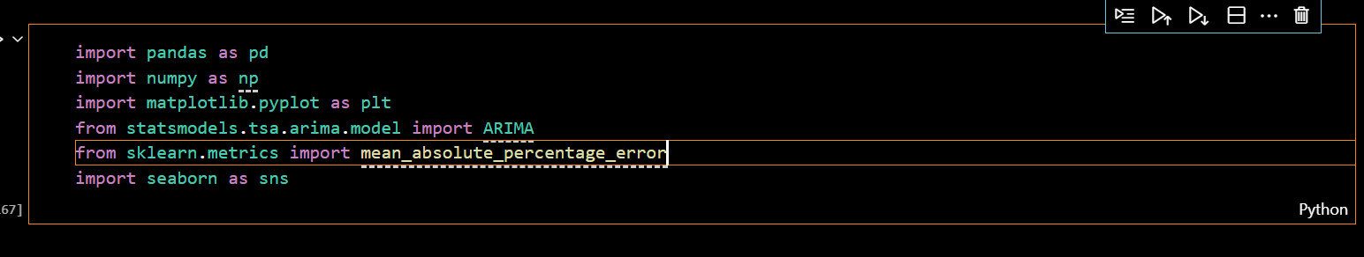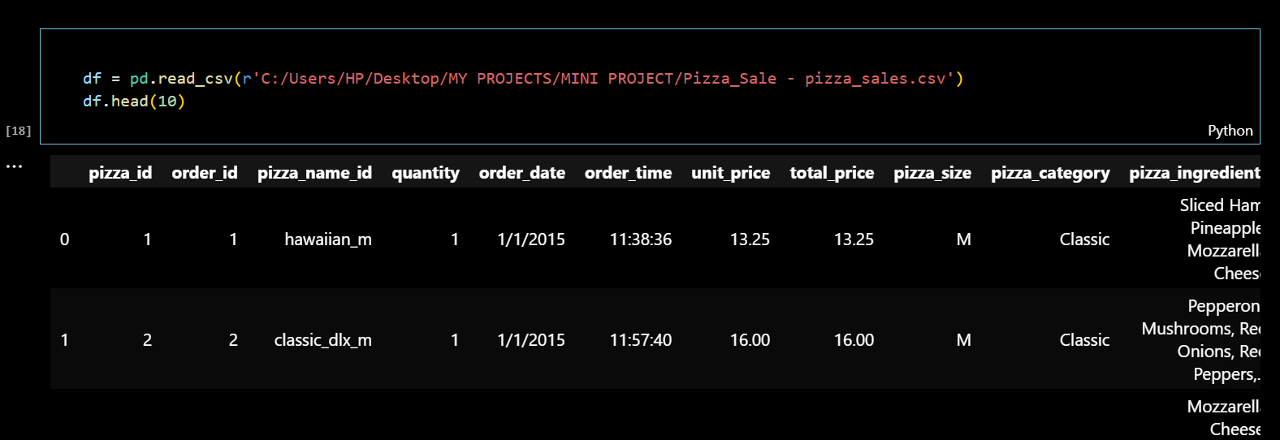
2. To check the datatype and if needed in any column which affects the result,will have change its dtype ,unneccessary will be removed shown in below figures.

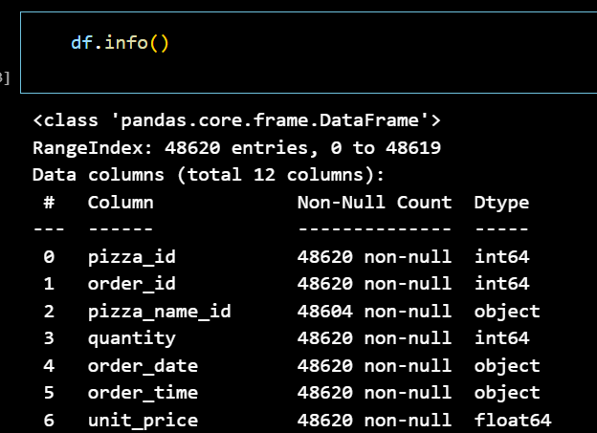  
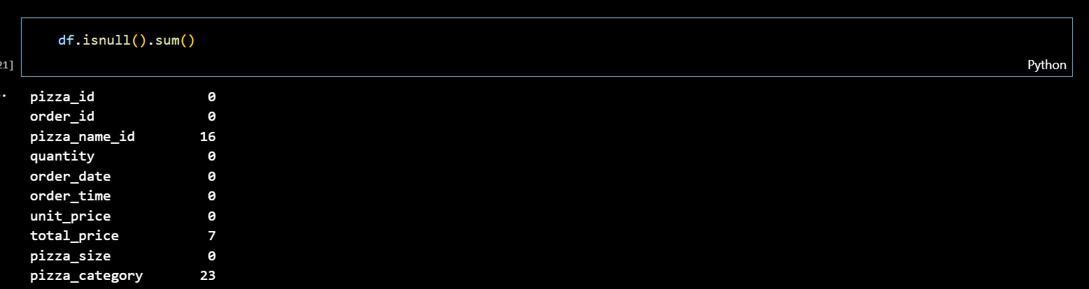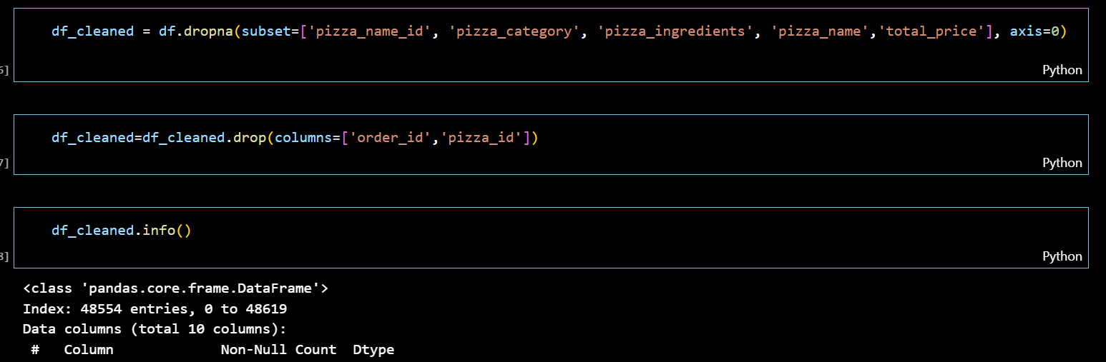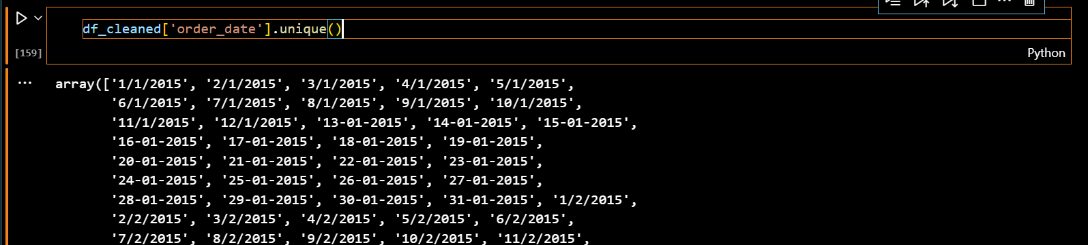

1. Dtype of order date has to change because bases on dates we have to predict next week selling pizzas and its ingradients and group by date and quantities
2. It shows how many quantities is sold in each day.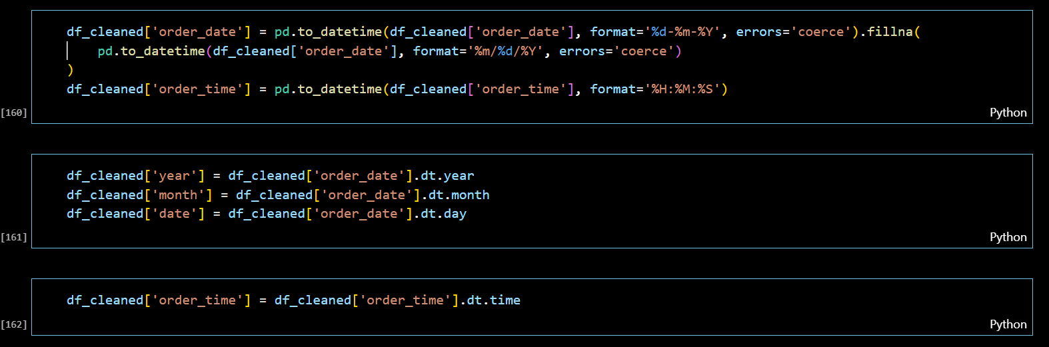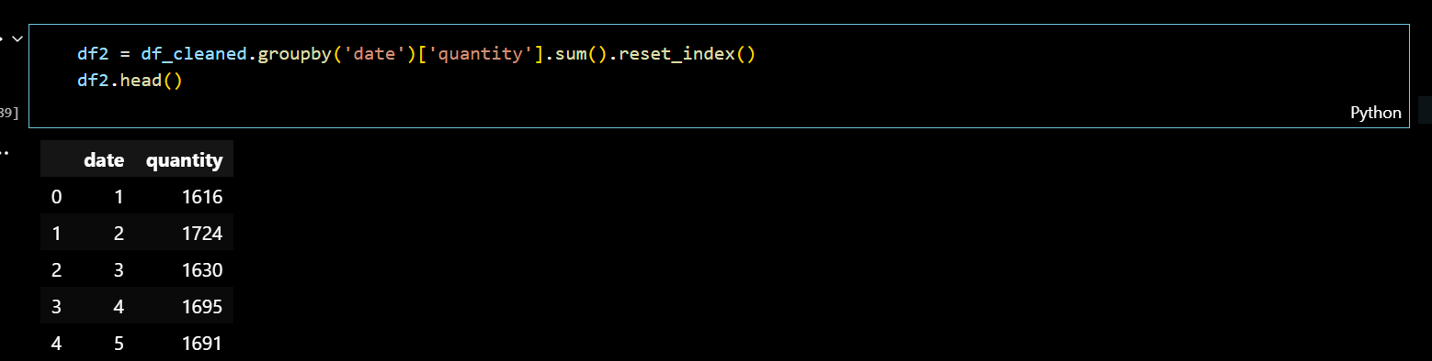
3. EDA

Represents on which day highest or lowest sales has done

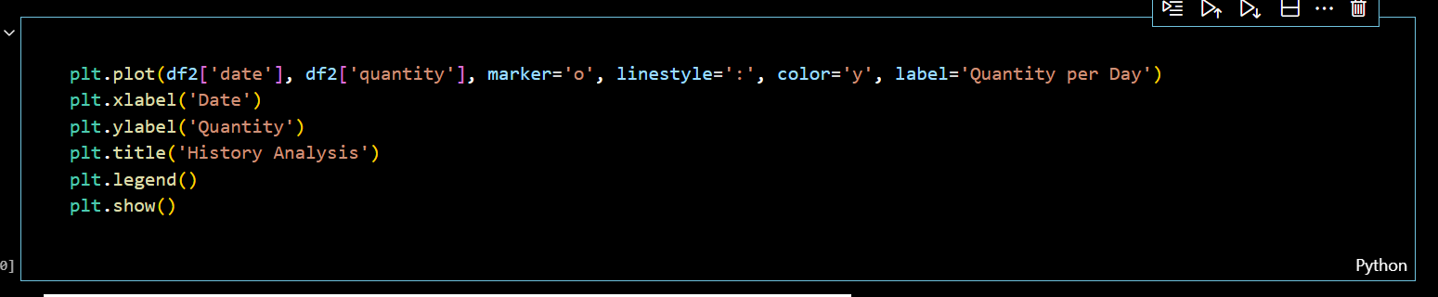

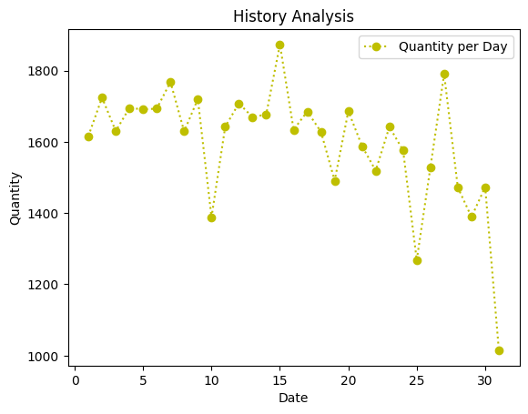

Similarly date by quantity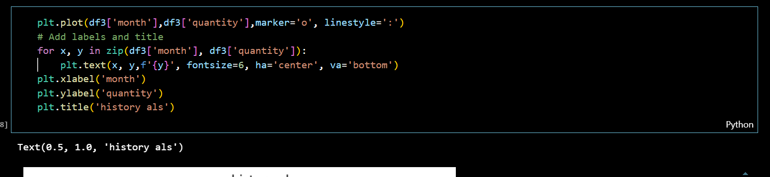

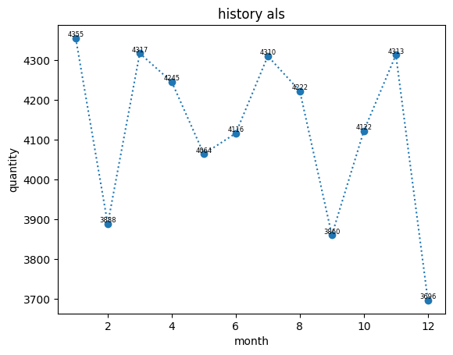

1. Now load the ingradient data and preprocess and clean the data,we have to do similar type of data cleaning as we did earlier,can be understandable by below figures.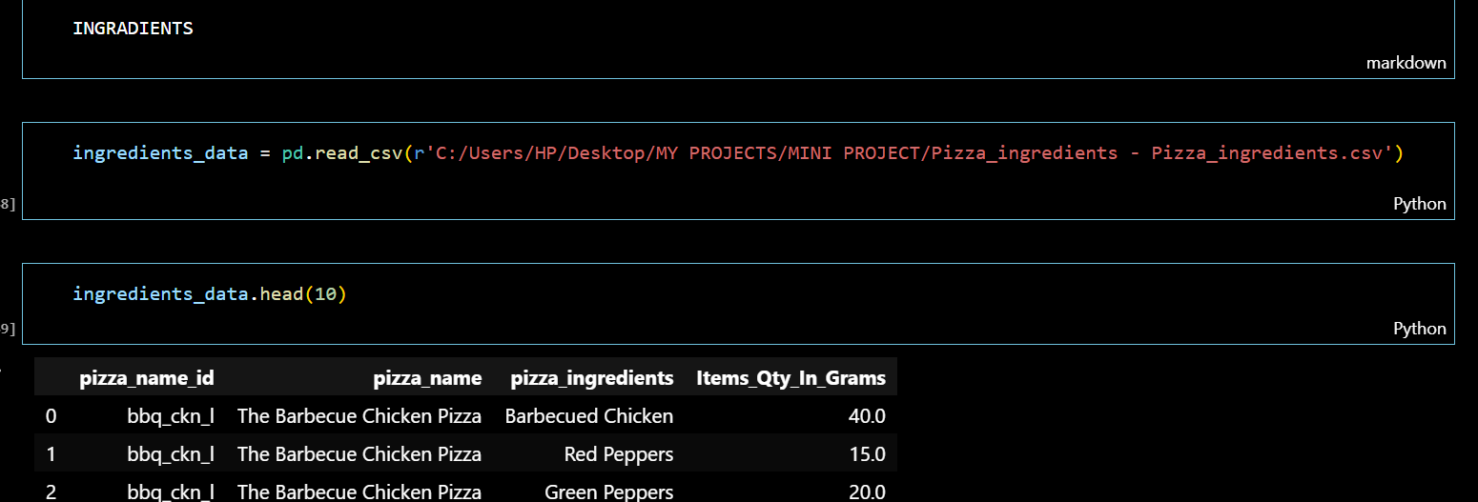

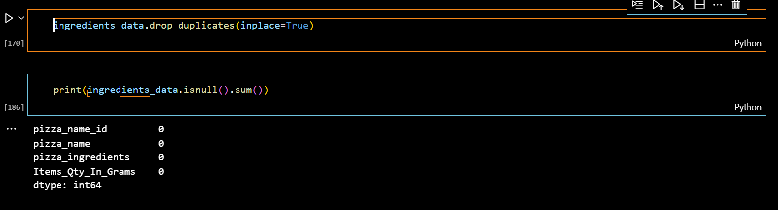

Here we have to remember the missing data has to be filled if its affects the result here I used interpolate to fill missing quantities .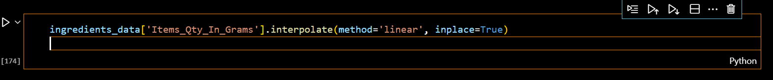

1. Now it’s a model training for forcasting by Arima model to forecast upcoming week sales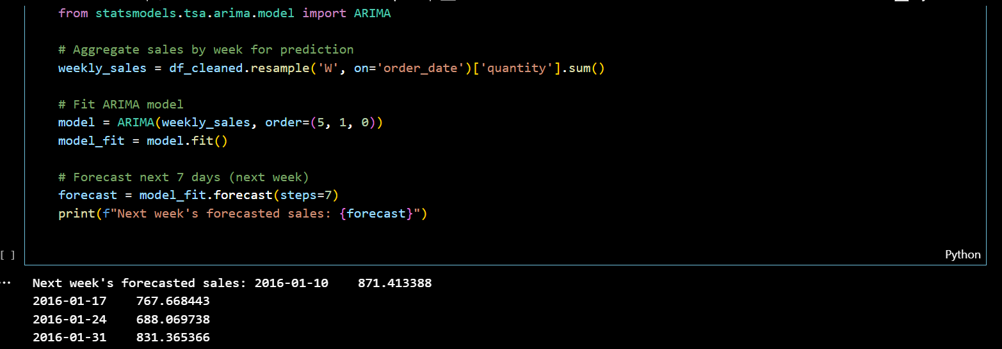
2. Merged the two dataframes based on unique column in both like in these it is ‘pizza name id’ and drop the duplicate unnecessary columns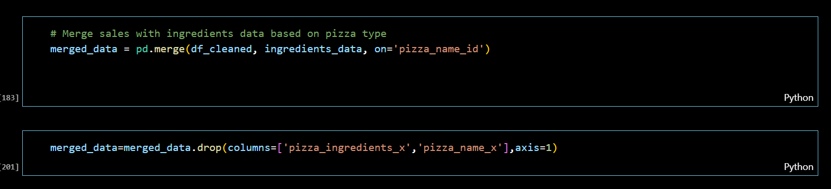
3. Bases on quantities and ingradients in historic pattern we forecast the required ingradients for upcoming week.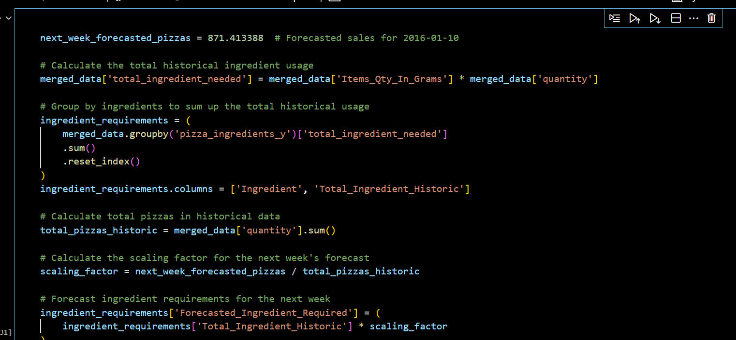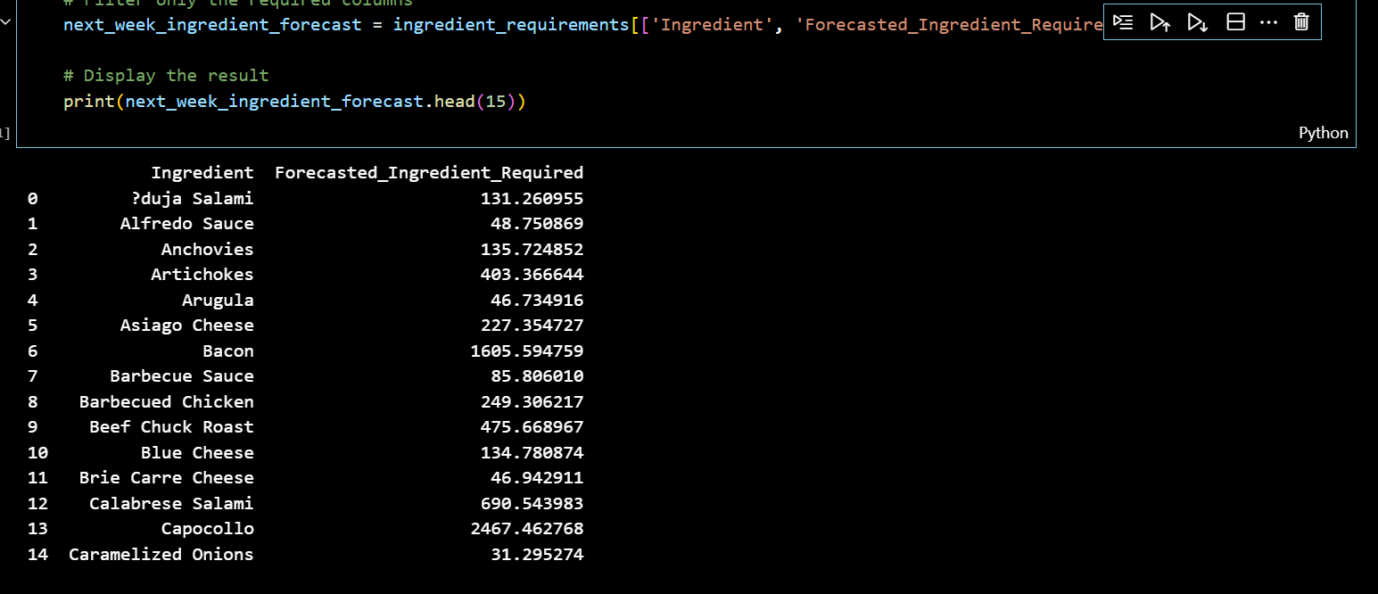

## Results

* **Accurate Sales Predictions**: Forecasted pizza sales for the next week.
* **Optimized Purchase Order**: Detailed ingredient requirements for the forecasted sales period.