**DataSpark: Illuminating Insights for Global Electronics**

**Problem Statement:**

As part of Global Electronics' data analytics team, you are tasked with conducting a comprehensive Exploratory Data Analysis (EDA) to uncover valuable insights from the company’s data. Your goal is to provide actionable recommendations that can enhance customer satisfaction, optimize operations, and drive overall business growth.

Global Electronics, a leading retailer of consumer electronics, has provided you with several datasets containing information about their customers, products, sales, stores, and currency exchange rates. The company seeks to leverage this data to better understand their business and identify areas for improvement.

CODE IMPLENTATION

1. Import required libraries and csv files.
2. Read all csv files such as customer, data dictionary,exchange rate,product ,sales,stores
3. Preprocess and clean the data

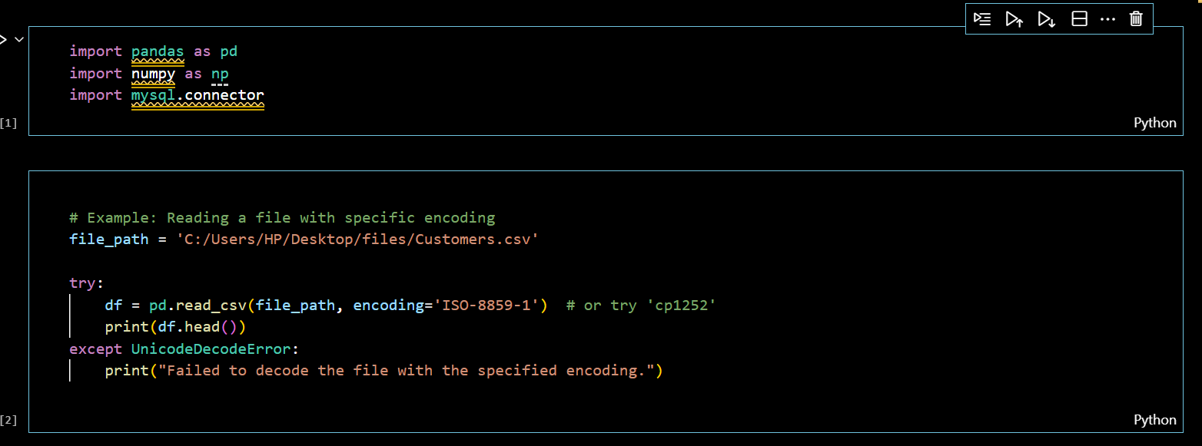

1. Changed the birthday column from object to datetime dtype
2. Similary changed other required dtypes from object to (int,float,datetime etc.)

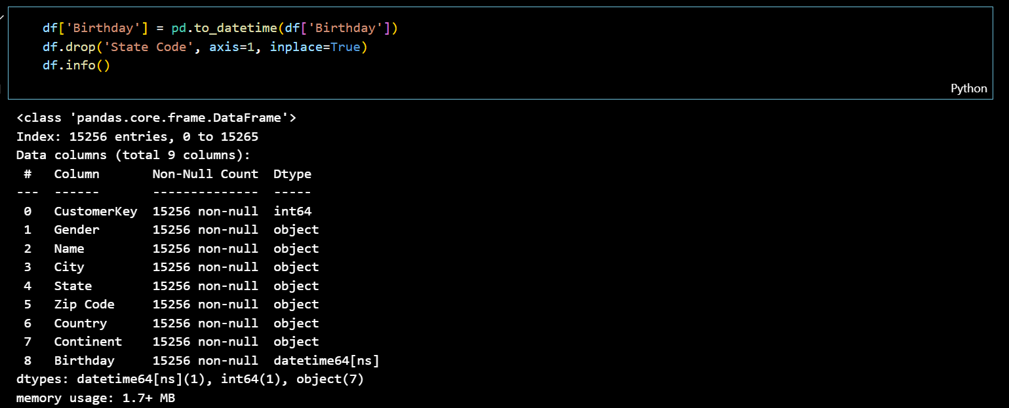

1. Read the sales csv file

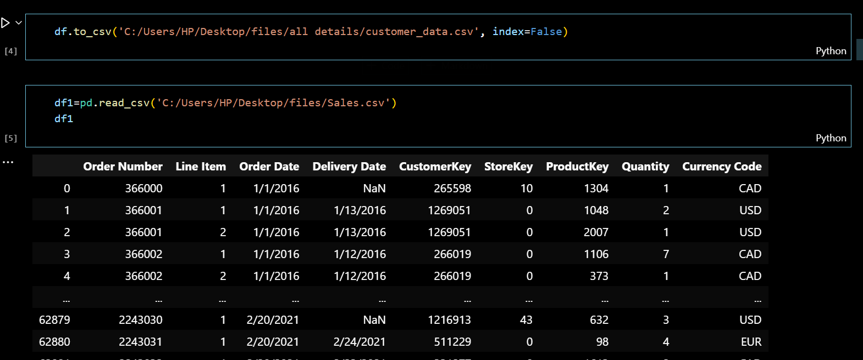

1. Here I used average gap between order & deliver date for missing data in delivery date & based on mean we have added to the order date i.e.(orderdate()+ mean()=delivery date)
2. For the price removed all the signs,space etc.., to convert as float futher future calculations

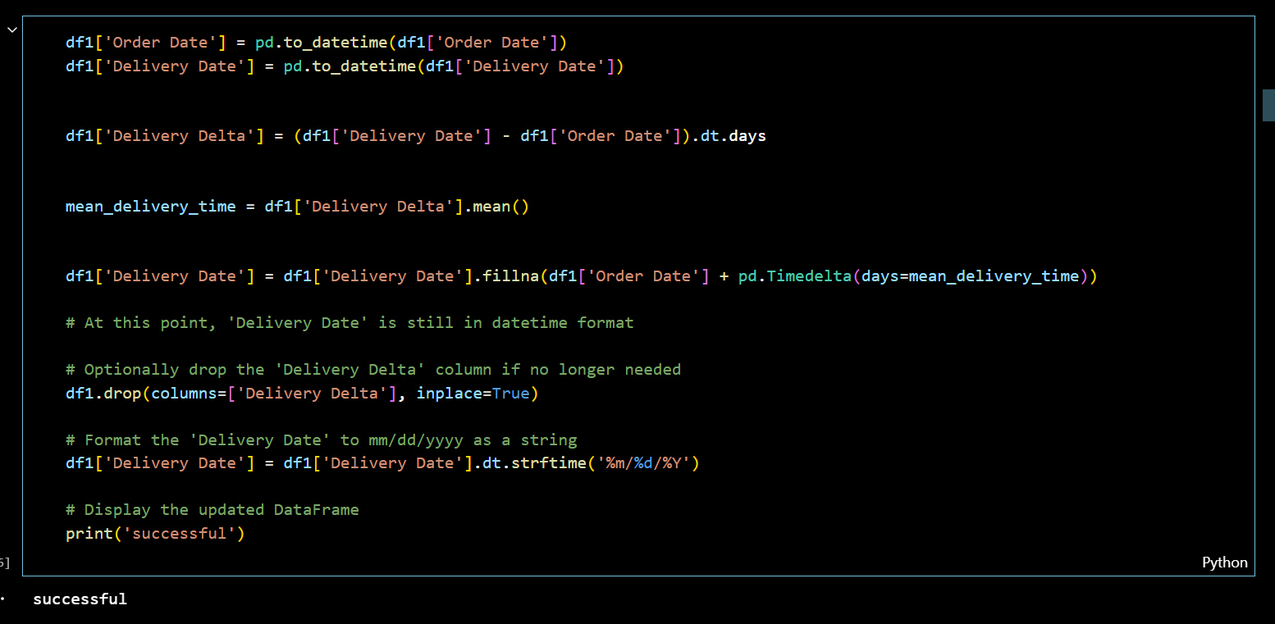

1. Drop the row where the country name assign as online because it doesn’t represent any region
2. Change date as datetime dtype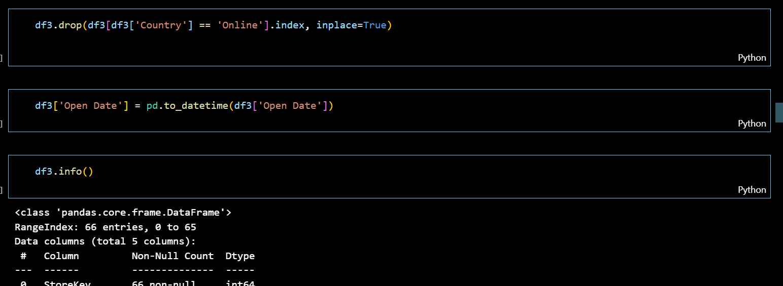
3. If data is ready ,export data into database (my sql)(remember username and password for access it into data visualizing tools(Power BI,Tableau))
4. Execute each and every table in database(do not merge the tables ,its easy if connct it from schema in Power BI)
5. Insert the values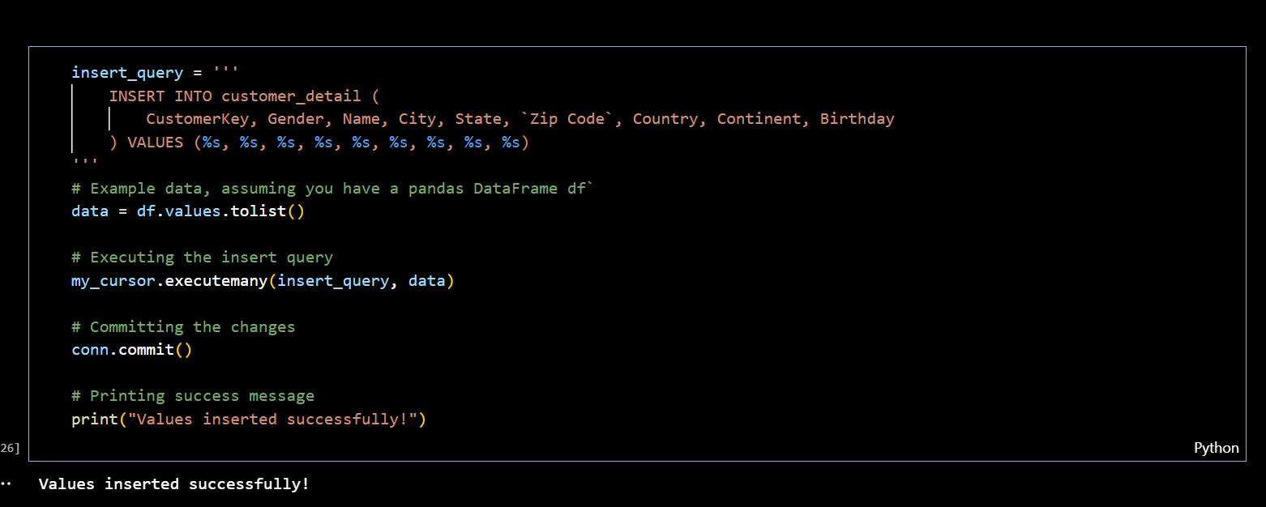
6. Open the Power bi
7. Connect the schema based on common columns in tables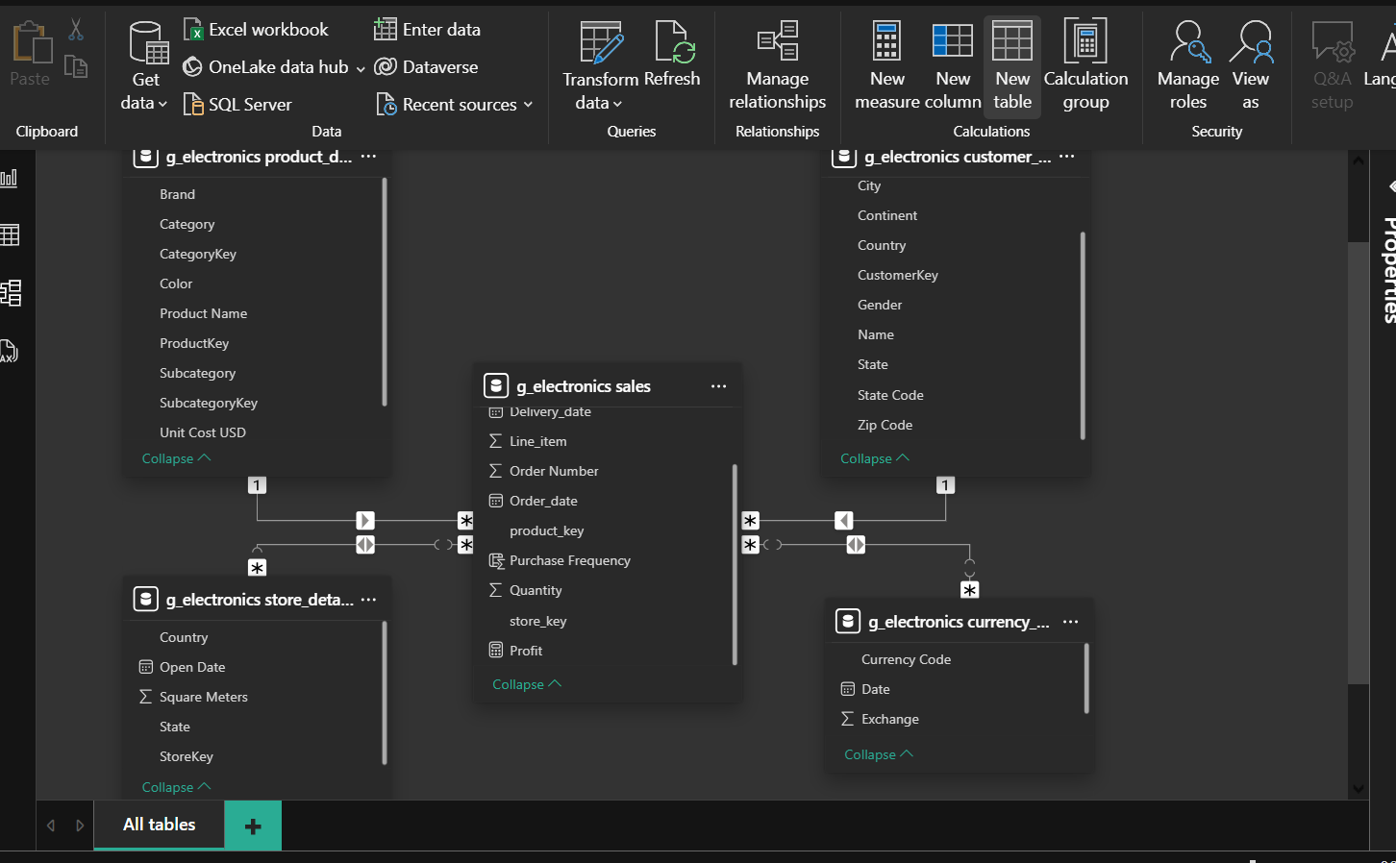
8. Here the first page of my dashboard based on customer data.

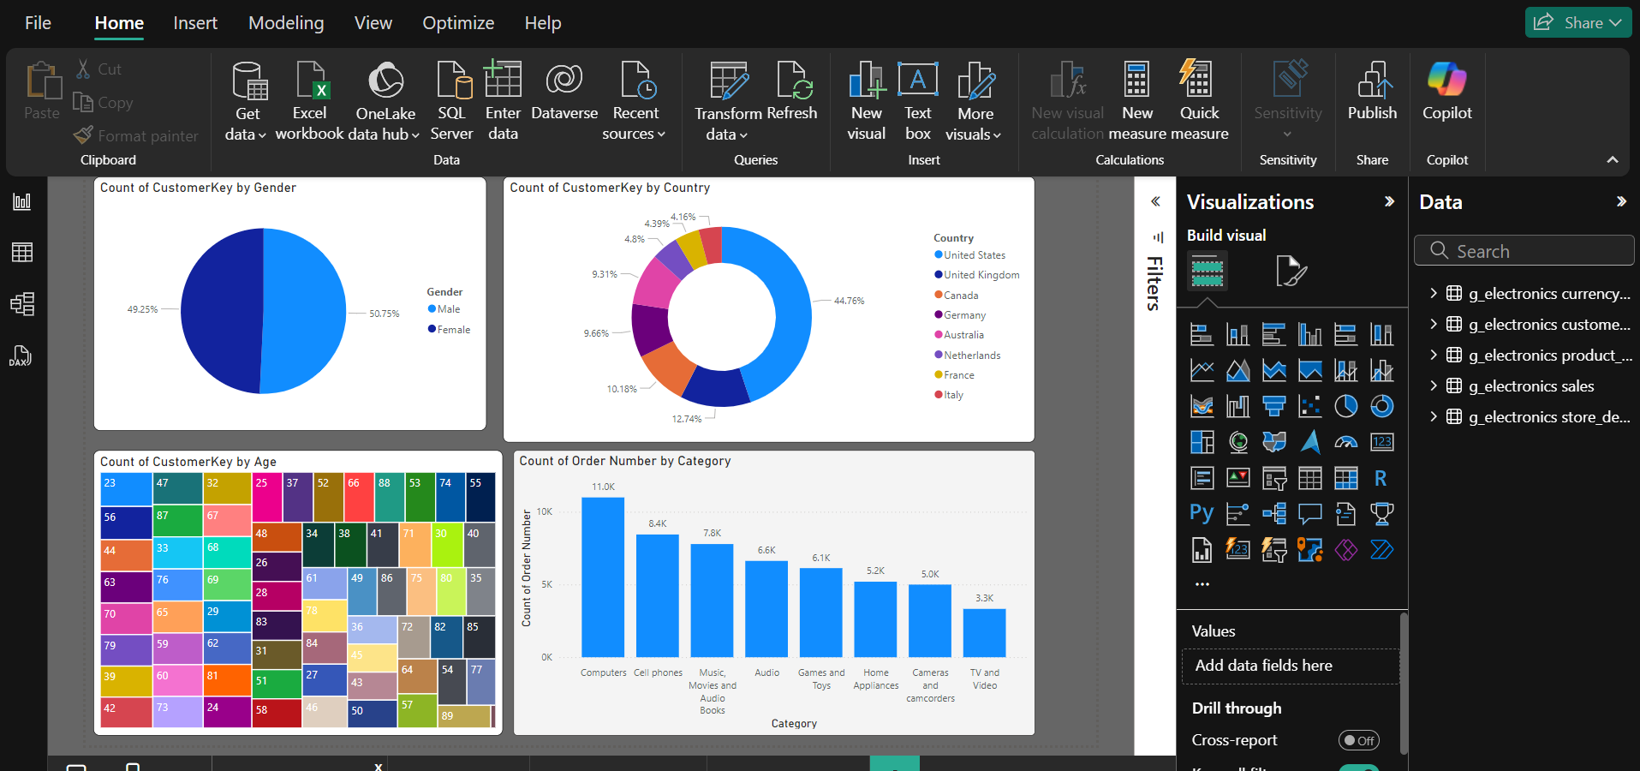

OBSERVATION :

1. The contribution of both gender is approx equal.
2. Most of the customers from USA particularly in the age of{23}and mostly they buy computer and follow on as shown above figure
3. Similarly the lowest is Italy
4. 2nd page of dashboard with respect to dashboard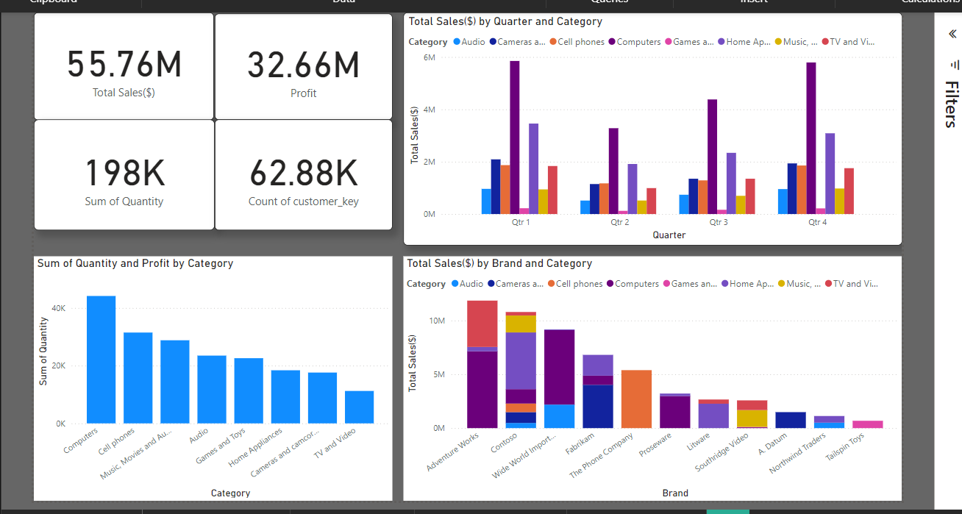

OBSERVATIONS :

1. Total no. of sales, profit, count of customers & sum of the quantity sold.
2. Total sales in every quarter lead by computer category, but we can observe the decline from 1st to 2nd quarter is huge and slowly it recovers(the pattern is almost similar to every catogary.)
3. So,there is no external factor that affects business it may be seasonal effect.
4. Not only in sales but also computers lead as profitable and customers are less interest on T.V and videos.
5. We can infer that as above we saw customers are youngers, most likely they are in carier zone & followed by [cell phones]
6. Even the most selling and the less selling product majority sells from the brand Adventure works.
7. We even get more data like (profit/sales )ratio, we can observe from Power BI dektop
8. 3rd page of dashboard

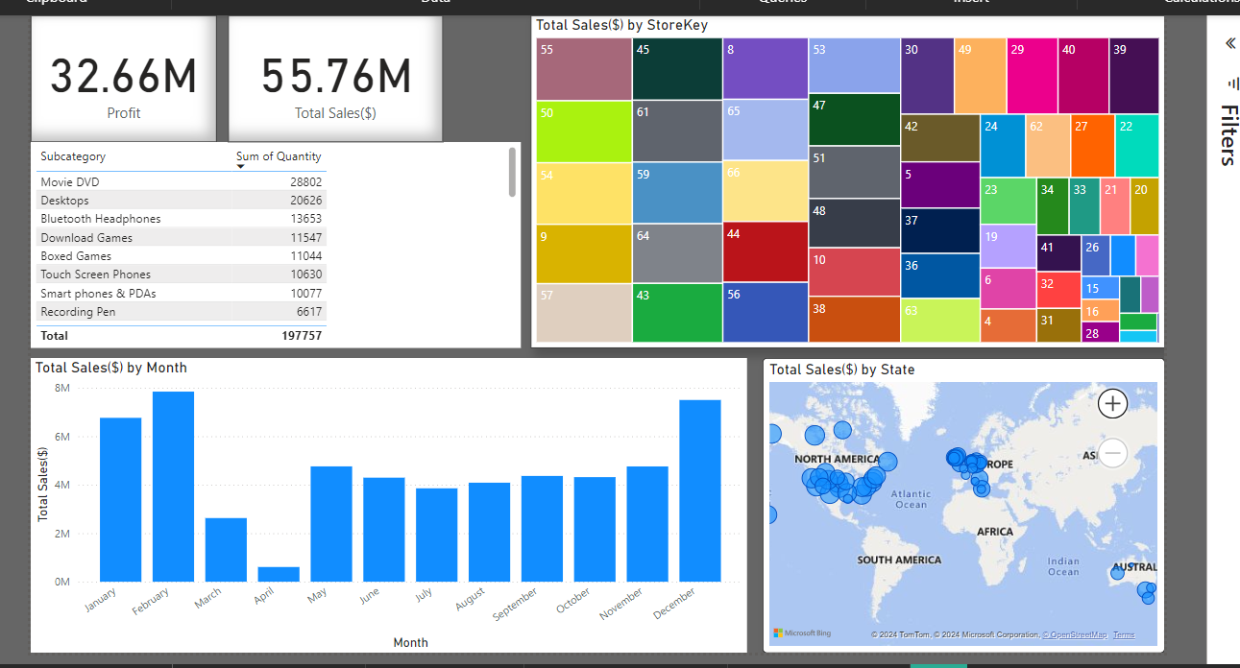

OBSERVATIONS :

1. Sales by store ,month& stores in which state.
2. High sale in February, December months, and the lowest in April&March
3. Mostly sales by store key no.55(state:NEVADA) & we can see in particular store which items are mostly sold & with respect to its sales and profit
4. Last page in Dashboard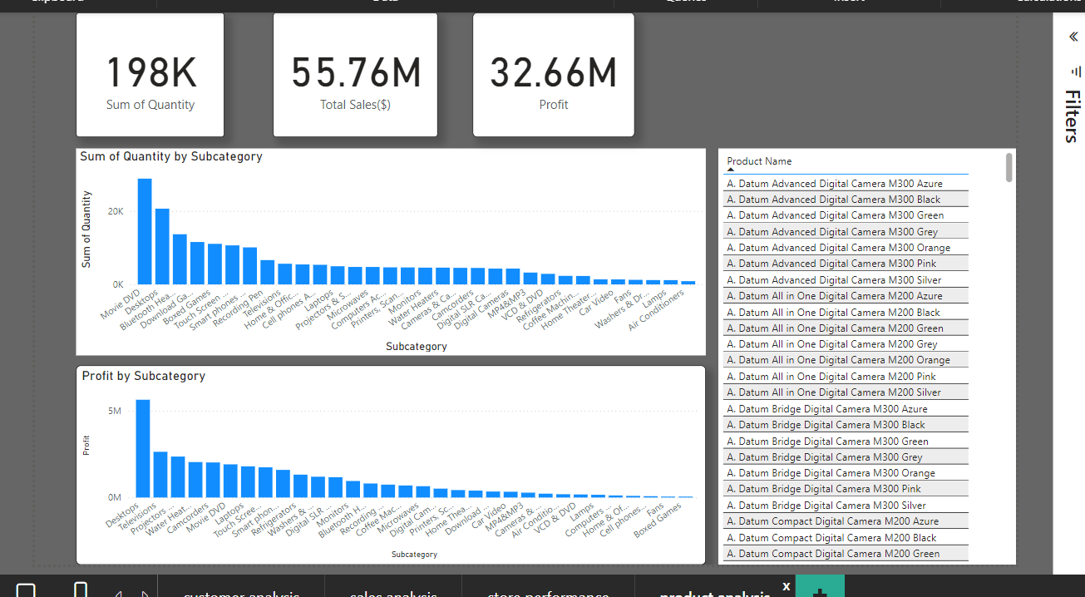

OBSERVATIONS:

1. Its simply based on quantity in subcategory how much profit we have earned.
2. Even the quantity is more in Movies and DVD the margin is in 5th place and the profit leads by Desktops, 2nd in sum of quantity.
3. In the side table each subcategory has products, based on each category & profits its shows the product name in Desc order(not explored earlier).