**Assignment 3**

**Name :** Hole Mangesh Vijay

**Roll No. :** N20111033

**Subject:** DevOps (write a docker-compose.yaml file to create a selenium cluster which is also called as Selenium Grid or Hub.

=======================================================

1. **Understanding of Selenium Hub or Grid ?**

**Selenium Grid** is a part of the Selenium Suite that specializes in running multiple tests across **different browsers, operating systems, and machines in parallel**. It is achieved by routing the commands of remote browser instances where a server acts as a **hub**. A user needs to configure the remote server in order to execute the tests.

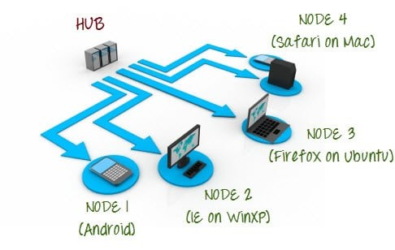

**Selenium Grid** uses a hub-node concept where you only run the test on a single machine called a **hub**, but the execution will be done by different machines called **nodes**.

**Selenium Grid Architecture**

Selenium Grid has a Hub and Node Architecture.

**The Hub**

* The hub is the central point where you load your tests into.
* There should only be one hub in a grid.
* The hub is launched only on a single machine, say, a computer whose O.S is Windows 7 and whose browser is IE.
* The machine containing the hub is where the tests will be run, but you will see the browser being automated on the node.

**The Nodes**

* Nodes are the Selenium instances that will execute the tests that you loaded on the hub.
* There can be one or more nodes in a grid.
* Nodes can be launched on multiple machines with different platforms and browsers.
* The machines running the nodes need not be the same platform as that of the hub.

—---------------------------------------------------------------------------------------------

**2 . Github profile Link to access the docker-compose.yaml file.**

<https://github.com/Mangesh-hole/Selenium-Hub-Grid-on-Docker-Compose.git>

—-------------------------------------------------------------------------------------------------

**3 :Is it good practice to use the Selenium Hub/Grid in software testing?**

**Testers should use Selenium Grid in the following circumstances:**

1. To run tests on multiple browsers and their versions, different devices, and operating systems.
2. To reduce the time that a test suite takes to complete execution.

**Disadvantages of Selenium**

* No reliable Technical Support from anybody. ...
* It supports Web-based applications only. ...
* Difficult to use, takes more time to create Test cases. ...
* Difficult to Setup Test Environment when it compares to Vendor Tools like UFT, RFT, SilkTest etc... ...
* Limited support for Image Testing.

**So according to situation we can use Selenium Hu/Grid in software testing.**