Project Report

On

**WEBSITE ON SCHOOL - AKAL ACADEMY KAJRI**

Submitted to:

DEPARTMENT OF COMPUTER SCIENCE

AKAL UNIVERSITY, TALWANDI SABO

In the partial fulfillment of the requirement for the degree of

**BACHELOR OF COMPUTER APPLICATIONS**

**(Session-2022-2023)**



**Under the Supervision of: Submitted by:**

Mr. Harpal Singh Mangesh Khode

Assistant Professor B.Tech CSE(H) 3rd Sem.

Department of Computer Science A.U.ID :

**Table of Content**

| **Sr. No** | **Title** | **Page No.** |
| --- | --- | --- |
| **1** | **Introduction of the Project** |  |
| **2** | **Purpose of the Project** |  |
| **3** | **YouTube Clone Breakdown** |  |
| **4** | ***YouTube Clone Layout*** |  |
| **5** |  |  |

***1.Introduction :***

*In this project we create a YouTube Clone using HTML ,CSS and JS. We use HTML for creating the basic structure of YouTube Clone . Then styling YouTube clone using CSS and add JavaScript for responsive YouTube Clone . First, for this project we have files YouTube_Clone.html, YouTube_clone.css and YouTube_Clone.js.*

***2.Purpose of the Project:***

*The objective of creating a YouTube clone is to have a website that functions similarly to YouTube.* *To create a platform for video categories and user-generated content that is similar to YouTube .*

***3.YouTube Clone Breakdown:***

*In the YouTube clone we'll be building, the website has about 6 units:*

*The****Header****contains three sections (left, center and right). The left section contains the logo and menu, the center contains the search box and an icon, and the right contains navigation icons.*

*The****Main****body contains two sections (sidebar and content). The navigation links in the sidebar are also similar, so they are just one thing. The same thing happens to the videos in the content section.*

*So, our YouTube clone has a header, main, sidebar, content, video-card, navigation link and navigation icon as the major units. That is the breakdown of the units of the web page we want to create.*

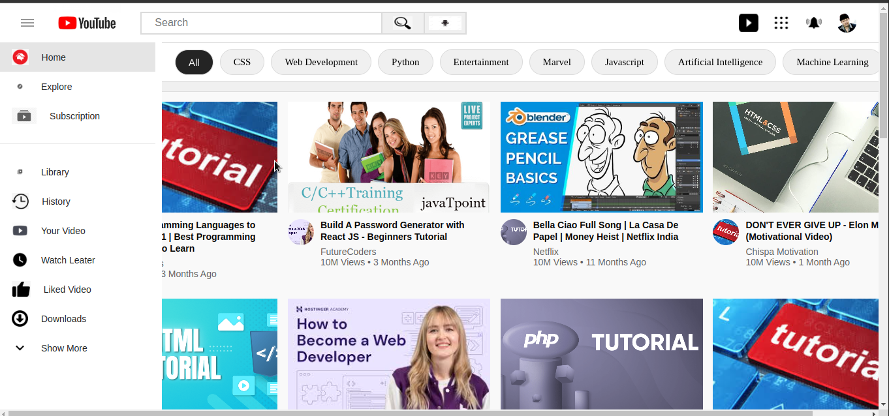

## *4.YouTube Clone Layout:*

### ***HTML for the YouTube Clone:***

*The first thing we have to do is create the layout structure of the YouTube clone with HTML. We'll do that with the below code:*

<html lang="en">

<head>

<meta charset="UTF-8" />

<meta http-equiv="X-UA-Compatible" content="IE=edge" />

<meta name="viewport" content="width=device-width, initial-scale=1.0" />

<!-- CSS File -->

<link rel="stylesheet" href="YouTube_Clone.css" />

<title>Document</title>

</head>

<body>

<div class="navbar">.</div>

<div class="side-bar">.</div>

<div class="videos">.</div>

<script src=”YouTube_Clone.js”></script>

</body>

</html>

### ***CSS for the YouTube Clone:***

#### **Step 1: Reset HTML default styles:**

* {

margin: 0;

padding: 0;

box-sizing: border-box;

}

#### ; The asterisk * is a CSS selector that selects all HTML tags on our page. We set their margin and padding to 0.

#### **Step 2: Set the font-family:**

body {

font-family: 'Roboto', sans-serif;

}

*We select the body tag and set its font-family to Roboto and use sans-serif as a fall-back in case Roboto is not available.*

#### **Step 4: Style the Header:**

/* header section*/

.navbar {

display: flex;

position:fixed;

justify-content: space-between;

align-items: center;

height: 60px;

padding: 15px;

z-index:3;

} (also same other properties)

*The .navbar class name is used to select (or connect to) the header section of our website so that we can add some styles to it.*

*We set its display property to flex to create a layout out of it, and then we can easily divide it into sections. We will divide it into sections later.*

*Align-items: centre is used to move all the contents of the navbar to the centre-left of your screen. We finally set the height of the navbar to 60px and its padding to 0 2.5vw.*

*z-index:3 is used to fixed the images.*

**

#### **Step 6: Hide the scrollbar**

/* Sidebar */

.side-bar {

Position:fixed;

height: calc(100vh-60px);

width: 250px;

background-color: white;

z-index:3;

}(also some other properties)

#### In short, 100vh means the total height that is visible in a browser without scrolling. And we use calc ( 100vh - 60px) to run a calculation that subtract 70px from 100vh.

*Finally, we set its background colour to #fff which is a kind of white.*

#### **Step 5: Set the height of the main section:**

.videos {

height: 100%;

width: 100%;

overflow-y: scroll;

background-color: #f9f9f9;

margin-left: 7%;

margin-top:10%;

}(also some other properties)

*The height and width of the .videos is set to 100% .  overflow-y :scroll is used to scroll the bar.*

#### **Step 7: Add media queries for responsiveness**

@media (max-width: 100px) {

.side-bar {

display: none;

}

.search{

display: none;

}

}

*We use this media query to make a website responsive on mobile, tablets, and desktop. When the YouTube clone is on a device whose screen is less than or equal to 100px (like mobile & tablet), the sidebar will disappear. Also, max-width: 100px means that a device’s screen can be less or equal to 100px.*

@media (max-width: 100px) {

.search input {

Width: 25rem; }

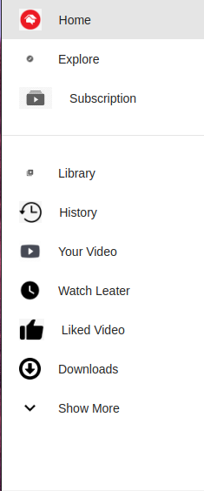

*Finally, we make the the search input a bit smaller whenever the* ***screen size of the device in use is less or equal to 100px.***

## *How to Add Content to the Header Section:*

*In this part, we are dividing the header section of the YouTube clone into three sections: left, center, and right. And each of the sections contains some tags. Let's get started!*

**

### *Step 1: Add children and grandchildren to the header*

*Here, we will simply add HTML tags to the header section of the YouTube Clone.*

*After dividing the header into three sections by adding three separate blocks of code, it is time to use CSS to make it more beautiful.*

### *Step 2: Style the left section*

.toggle-btn{

width: 20px;

height: 10px;

position: relative;

cursor: pointer;

}

.toggle-btn span{

position: absolute;

width: 100%;

height: 2px;

top: 50%;

transform: translateY(-50%);

background: #979797;

}

.toggle-btn span:nth-child(1){

top: 0;

}

.toggle-btn span:nth-child(2){

top: 100%;

}

.logo{

height: 30px;

margin: -10px 30px 0;

}

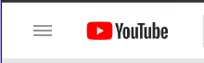

### *Step 3: Style the center section and its form*

.search-box{

position: relative;

max-width: 500px;

width: 50%;

height: 35px;

display: flex;

}

|  |
| --- |
| Search…… |

### *Step 4: Style the input in the search form*

.search-bar{

width: 85%;

height: 100%;

border: 2px solid #dbdbdb;

padding: 0 20px;

font-size: 16px;

text-transform: capitalize;

}

.search-btn{

width: 15%;

height: 100%;

background: #f0f0f0;

border: 2px solid #dbdbdb;

padding: 5px 0;

border-left: none;

}

.search-btn img{

height: 100%;

}



### ***Step 5: Style the right section:***

.user-options{

height: 35px;

display: flex;

margin-left: auto;

align-items: center;

}

.user-options img:hover{

transform: scale(1.5);}

.user-options .icon{

height: 80%;

margin-right: 20px;

cursor: pointer;

}

.user-dp{

cursor: pointer;

height: 30px;

width: 30px;

border-radius: 50%;

overflow: hidden;

}

.user-dp img{

width: 100%;

height: 100%;

object-fit: cover;

}



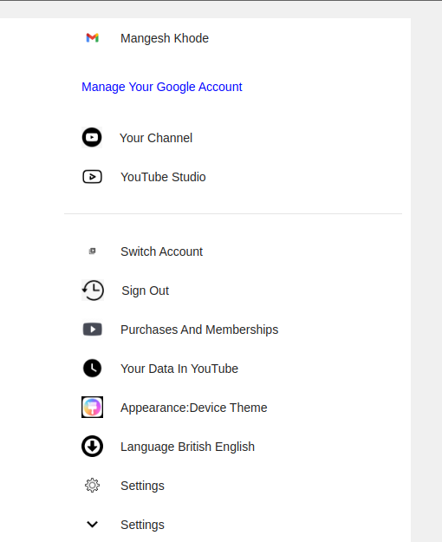

## *How to Add Content to the Sidebar*

*In this part, we are going to discuss how to add navigation links to the YouTube clone. In short, we will add a bunch of links to the existing sidebar.*

***We will add below HTML code to the sidebar:***

<div class="side-bar">

<a href="#" class="links active"><img src="img/home.png" alt="">home</a>

<a href="#" class="links"><img src="img/explore.png" alt="">explore</a>

<a href="#" class="links"><img src="img/subscription.png" alt="">subscription</a>

<hr class="seperator">

<a href="#" class="links"><img src="img/library.png" alt="">library</a>

<a href="#" class="links"><img src="img/history.png" alt="">history</a>

<a href="#" class="links"><img src="img/your-video.png" alt="">your video</a>

<a href="#" class="links"><img src="img/watch-later.png" alt="">watch leater</a>

<a href="#" class="links"><img src="img/liked video.png" alt="">like video</a>

<a href="#" class="links"><img src="img/show more.png" alt="">show more</a>

</div>

***Then, let's style the side-bar with CSS as shown below:***

.side-bar{

position: fixed;

top: 60px;

left: 0;

min-width: 250px;

width: 250px;

height: calc(100vh - 60px);

background: #fff;

padding-right: 10px;

}

.links{

display: block;

width: 100%;

padding: 10px 20px;

display: flex;

align-items: center;

text-transform: capitalize;

color: #242424;

font-size: 14px;

font-weight: 500;

text-decoration: none;

}

.links img{

height: 25px;

margin-right: 20px;

}

.links:hover,

.links.active{

background: rgba(0, 0, 0, 0.1);

}

.seperator{

border: none;

border-bottom: 1px solid rgba(0, 0, 0, 0.1);

margin: 20px 0;

}



***Now,html of Filters options:***

<div class="filters">

<button class="filter-options active">all</button>

<button class="filter-options">CSS</button>

<button class="filter-options">web development</button>

<button class="filter-options">python</button>

<button class="filter-options">entertainment</button>

<button class="filter-options">marvel</button>

<button class="filter-options">javascript</button>

<button class="filter-options">artificial intelligence</button>

<button class="filter-options">machine learning</button>

<button class="filter-options">trending</button>

</div>

***Now, CSS of Filters options:***

.filters{

position: fixed;

left: 250px;

top: 60px;

width: calc(100% - 250px);

height: 60px;

background: #fff;

border-top: 1px solid #dbdbdb;

border-bottom: 1px solid #dbdbdb;

padding: 0 20px;

display: flex;

align-items: center;

overflow-x: auto;

overflow-y: hidden;

}

.filters::-webkit-scrollbar{

display: none;

}

.filter-options{

flex: 0 0 auto;

padding: 10px 20px;

border-radius: 50px;

background: #f0f0f0;

border: 1px solid #dbdbdb;

text-transform: capitalize;

margin-right: 10px;

color: #242424;

font-size: 15px;

cursor: pointer;

}

.filter-options.active{

color: #fff;

background: #242424;

}



***How to Add Videos to the Content Section:***

## *Now the last and the main thing. Make video cards for just styling purpose we are creating a cards in HTML.*

<!-- Videos Section -->

<div class="videos">

<div class="videos__container">

<!-- Single Video starts -->

<div class="video">

<div class="video__thumbnail">

<img src="youtube1.jpeg" alt="" />

</div>

<div class="video__details">

<div class="author">

<img src="youtube2.png" alt="" />

</div>

<div class="title">

<h3>

Top 5 Programming Languages to Learn in 2021 | Best Programming Languages to Learn

</h3>

<a href="">FutureCoders</a>

<span>10M Views • 3 Months Ago</span>

</div>

</div>

</div>

<!-- Single Video Ends -->

/* videos */

.videos {

background-color: #f9f9f9;

width: 100%;

height: 100%;

padding: 15px 15px;

border-top: 1px solid #ddd;

overflow-y: scroll; }

.videos__container {

display: flex;

flex-direction: row;

justify-content: space-around;

flex-wrap: wrap;

}

.video {

width: 310px;

margin-bottom: 30px;

}

.video__thumbnail {

width: 100%;

height: 170px;

}

.video__thumbnail img {

object-fit: cover;

height: 100%;

width: 100%;

}

.author img {

object-fit: cover;

border-radius: 50%;

height: 40px;

width: 40px;

margin-right: 10px;

}

.video__details {

display: flex;

margin-top: 10px;

}

.title {

display: flex;

flex-direction: column;

}

.title h3 {

color: rgb(3, 3, 3);

line-height: 18px;

font-size: 14px;

margin-bottom: 6px;

}

.title a,

span {

text-decoration: none;

color: rgb(96, 96, 96);

font-size: 14px; }

h1 {

font-size: 20px;

margin-bottom: 10px;

color: rgb(3, 3, 3);

}

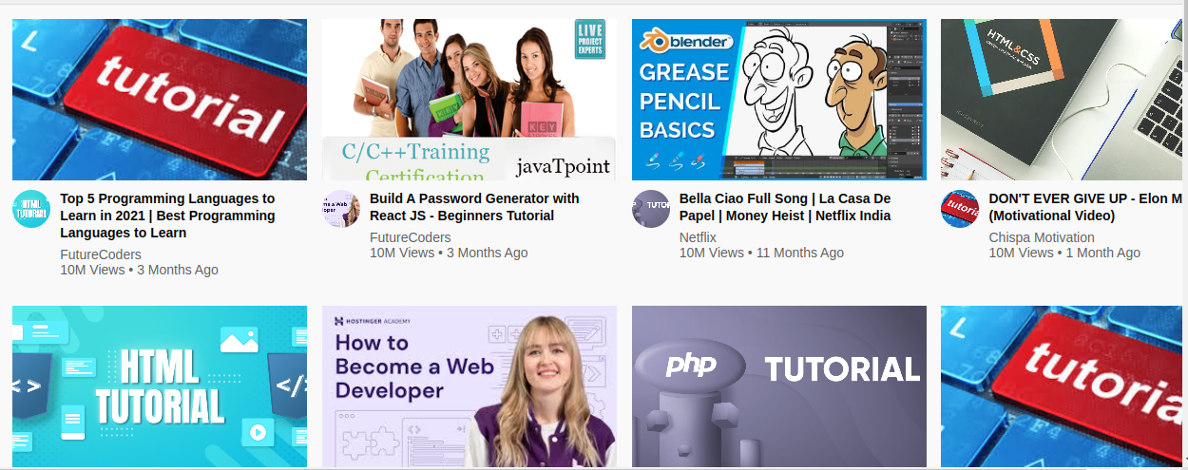

## *****JavaScript Code For YouTube Clone:*****

## *To make search box functional first select search box, and search button.*

const searchInput = document.querySelector('.search-bar');

const searchBtn = document.querySelector('.search-btn');

## 

***And also create a variable to store search route****.*

let searchLink = "https://www.youtube.com/results?search_query=";

***Now once we got our link. add click event to button and validate search box. Like this.***

searchBtn.addEventListener('click', () => {

if(searchInput.value.length){

location.href = searchLink + searchInput.value;

}

})

*And inside that condition use location.href to redirect user.*

