A PROJECT REPORT

ON

### SMART INSTITUTE ASSISTANT

*Submitted By*

###### ABHIJEET AWAGHADE (B150958502) MEGHARAJ DESHMUKH(B150958512) SAURABH PATIL(B150958542) MANGESH ZOKE (B150958560)

*Under the guidance of*

**PROF. KESHAV TAMBRE**



###### DEPARTMENT OF INFORMATION TECHNOLOGY

HOPE FOUNDATION’S

INTERNATIONAL INSTITUTE OF INFORMATION TECHNOLOGY PUNE - 411057

SAVITRIBAI PHULE PUNE UNIVERSITY - 411007 Θ 2018 - 2019 Θ

A Project Report On

### SMART INSTITUTE ASSISTANT

*submitted in partial fulfillment of the requirements for the award of the degree of*

#### Bachelor of Engineering

###### in INFORMATION TECHNOLOGY

*Submitted By*

###### ABHIJEET AWAGHADE (B150958502) MEGHARAJ DESHMUKH (B150958512) SAURABH PATIL (B150958542) MANGESH ZOKE (B150958560)

*Under the guidance of*

#### PROF. KESHAV TAMBRE



**DEPARTMENT OF INFORMATION TECHNOLOGY**

##### HOPE FOUNDATION’S

INTERNATIONAL INSTITUTE OF INFORMATION TECHNOLOGY

Hinjewadi, Pune-57

**2018-19**

##### HOPE FOUNDATION’S

INTERNATIONAL INSTITUTE OF INFORMATION TECHNOLOGY

Hinjawadi, Pune-57



**DEPARTMENT OF INFORMATION TECHNOLOGY**

## *Certificate*

##### This is to certify that the project report entitled

**SMART INSTITUTE ASSISTANT**

which is being submitted by

**ABHIJEET AWAGHADE (B150958502) MEGHARAJ DESHMUKH (B150958512) SAURABH PATIL (B150958542) MANGESH ZOKE (B150958560)**

is in partial fulfillment for the award of Degree of Bachelor of Engineering in Information Technology

###### [PROF. K. TAMBRE]

Guide **[External Examiner]**

###### [PROF. M AMRITKAR] [Dr. V. Patil]

Head of the Department Principal

##### HOPE FOUNDATION’S

INTERNATIONAL INSTITUTE OF INFORMATION TECHNOLOGY

Hinjawadi, Pune-57



**DEPARTMENT OF INFORMATION TECHNOLOGY**

## *Certificate*

##### This is to certify that the project report entitled

**SMART INSTITUTE ASSISTANT**

which is being submitted by

**ABHIJEET AWAGHADE (B150958502)**

is in partial fulfillment for the award of Degree of Bachelor of Engineering in Information Technology

###### [PROF. K. TAMBRE]

Guide **[External Examiner]**

##### HOPE FOUNDATION’S

INTERNATIONAL INSTITUTE OF INFORMATION TECHNOLOGY

Hinjawadi, Pune-57



**DEPARTMENT OF INFORMATION TECHNOLOGY**

## *Certificate*

##### This is to certify that the project report entitled

**SMART INSTITUTE ASSISTANT**

which is being submitted by

**MEGHARAJ DESHMUKH (B150958512)**

is in partial fulfillment for the award of Degree of Bachelor of Engineering in Information Technology

###### [PROF. K. TAMBRE]

Guide **[External Examiner]**

##### HOPE FOUNDATION’S

INTERNATIONAL INSTITUTE OF INFORMATION TECHNOLOGY

Hinjawadi, Pune-57



**DEPARTMENT OF INFORMATION TECHNOLOGY**

## *Certificate*

##### This is to certify that the project report entitled

**SMART INSTITUTE ASSISTANT**

which is being submitted by

**SAURABH PATIL (B150958542)**

is in partial fulfillment for the award of Degree of Bachelor of Engineering in Information Technology

###### [PROF. K. TAMBRE]

Guide **[External Examiner]**

##### HOPE FOUNDATION’S

INTERNATIONAL INSTITUTE OF INFORMATION TECHNOLOGY

Hinjawadi, Pune-57



**DEPARTMENT OF INFORMATION TECHNOLOGY**

## *Certificate*

##### This is to certify that the project report entitled

**SMART INSTITUTE ASSISTANT**

which is being submitted by

**MANGESH ZOKE (B150958560)**

is in partial fulfillment for the award of Degree of Bachelor of Engineering in Information Technology

###### [PROF. K. TAMBRE]

Guide **[External Examiner]**

***Acknowledgement***

*With deep sense of gratitude we would like to thank all the people who have lift our path with their kind guidance. We are very grateful to these intellectual who did their best to help during out project work. It is our proud privilege to express deep sense of gratitude to, Dr.Vaishali Patil, Principal of International Institute of Information Technology, Pune for her support and kind permissions to complete this project*

*I would like to show my greatest appreciation to our Guide Prof.Keshav Tambre thank you enough for tremendous support and help. I feel motivated and encouraged every time. With their encouragement and guidance this project would not have ma- terialized*

*We also take this opportunity to express a deep sense of gratitude to the Head of Department Prof. Manjusha Amritkar for her cordial support, valuable information and guidance, which helped us in completing this project through various stages.*

*The Special gratitude goes to our project in charge Prof. Vishal Chaudhary for his expensive, excellent and precious guidance in completion of this work. The guidance and support received from all the members who contributed and who are contributing to this project was vital for the success of the project. I am grateful for their constant support.*

*.*

###### ABHIJEET AWAGHADE MEGHARAJ DESHMUKH SAURABH PATIL MANGESH ZOKE

**Contents**

Abstract iii

1. Introduction 2

1.0.1 Project overview 3

* 1. Project Scope 3
  2. Problem Definition 4
  3. Applying Software Engineering Approach 4

1. Literature Survey 5
2. Software Requirements Speciftcation 7
   1. Introduction 7
      1. Purpose 7
      2. Intended Audience and Reading Suggestion 8
      3. Project Scope 8
      4. Design and Implementation Constraints 9
      5. System Features 9
   2. External Interface Requirements 10
      1. User Interfaces 10
      2. Hardware Interfaces 10
      3. Software Interfaces 11
      4. Communication Interfaces 11
   3. Non Functional Requirements (Compulsory) 11
      1. Performance Requirements 11
      2. Safety Requirements 11
      3. Security Requirements 12
      4. Software Quality Attributes 12
   4. Analysis Model 13
      1. Data Flow Diagram 13
3. System Design 15
   1. System Architecture 15
   2. UML Diagrams 16
4. Technical Speciftcation 20
   1. Advantage 20
   2. Application 20
5. Software Implementation 21
   1. Introduction 21
      1. Python 21
      2. Flask 22
      3. mongoDB 22
      4. Front End:- 23
   2. All Imported Packages 23
6. Software Testing 25
   1. Introduction 25
   2. Objectives of testing: 25
      1. Unit Testing: 26
      2. System Testing: 26
      3. Validation Testing: 26
      4. Integration Testing: 27
   3. TEST CASE DOCUMENT 27
   4. Training Dataset Table:- 28
   5. Snap Shots of the Cases and Test Plan 29
7. Deployment and Maintenance 36
8. Conclusion and Future Scope 37
   1. Conclusion 37
   2. Future Scope 37
9. References 38

**List of Figures**

* 1. DFD level 0 13
  2. DFD level 1 13
  3. DFD level 2 14
  4. Entity Relationship Diagram for System 14
  5. System Architecture 15
  6. Use Case Diagram 16
  7. Class Diagram 17
  8. Activity Diagram 17
  9. Component Diagram 18
  10. Sequence Diagram 18
  11. Deployment Diagram 19
  12. Login and Sign up page 29
  13. Sign up information 29
  14. Welcome Admin page showing Bar Chart 30
  15. User and list of issued book 30
  16. User profile information 31
  17. Search box and books list 31
  18. Add new book 32
  19. Show graph for each domain 32
  20. Enter query related to time table 33
  21. Graph for particular domain 33
  22. Issued books 34
  23. Best books and reviews 34
  24. Contact Details 35

# List Of Abbreviations

|  |  |
| --- | --- |
| NLP | Natural Language Processing |
| DAC | Discretionary Access Control |
| KWS | Keyword Spotting |
| RS | Recommender System |
| FA | False Accepts |
| FR | False Rejects |
| ASR | Automatic Speech Recognition |
| IDE | Integrated Development Environment |
| HTML | Hypertext Markup Language |
| CSS | Cascading Style Sheets |
| QA | Quality Assurance |

# Abstract

The Assistant in any field is gaining more importance as the number of its users are increasing rapidly. As the number is rising there is a need of effective suggestion within library, institute one such effective system is our Smart Institute Assistant. The transactions like login, register, add search, delete, issue are already provided the extra thing we are providing is for smart suggestion and answers to the questions of students The Library Management System stores the details like name, address, ID number, Date of Birth of members working in the library and users who come to library. The details of books like reviews of user, book name, book number, subject to which it belongs , author, edition, year of publication the total number of books that are present in the library ete are also stored.

Smart Institute Assistant is a project which aimed in developing a web based sys- tem so that user can view the updates of new books available, check their attendance, view the notice of college events or other and to maintain all the daily work of aca- demics and library. This project has many features like facility of user login and a facility of teachers or login It also has a facility of admin login through which the admin can monitor the whole system. It has also a facility where student after logging in their accounts can ask to our assistant about list of books issued and its issue date and return date and also the students can request the librarian to add new books by asking request for adding. The librarian after logging into his account i.e. admin ac- count can generate various reports such as student report, issue report, teacher report and book report Overall this project of ours is being developed to help the students as well as staff of library to increase in the way of learning subjects, getting information and maintain the academics and library in the best way possible and also reduce the human efforts.

**Chapter 1**

**Introduction**

In modern world of technology, education and anything related to it has been shifted to computer- ize through internet. In most undeveloped countries, high education suffers severely from the lack of modern information systems and technologies. The biggest characteristics of the department library and academics may be a highly skilled that gives a convenient conditions for lecturers and students to access data. But with for the most part increasing range of the library’s books and ac- tivities within institute, the traditional manual operation management is extremely low efficiency. Therefore, it’s necessary for lecturers and students of the university to use the modern Assistant application and is also an important part of the college of data construction. The development of technology not only give reliable basis for the books management automation, however also greatly improve the standard of the service for readers so the reader will able to get their required books conveniently.

The Smart Institute Assistant is assistant for suggesting, monitoring and controlling the transnational activities within academic and library. The Smart Institute Assistant is an Web ap- plication, which mainly focuses on recommending exact book require by student and get answers to his questions. Basic operations of library will be a small part of our project. We can enter the record of new books and retrieve the details of books available in the library. We can issue the books to the students and maintain their records and can also check how many books are issued and stock available in the library. We are adding the module of assistant of our system which will play the role same as google assistant or siri which is used for searching any data on google or opening any applications or games. Our systems assistant will also be used for recognition and which entity to enter

#### 1.0.1 Project overview

Smart Institute Assistant is project which aim in developing web based system for suggesting , monitoring and controlling the activities related to academic and library, which mainly focuses on recommending exact book require by student and get answer to his query. Basic oprations of library will be a part of our project. Admin can maintain the record of books and credentials of user .

* 1. **Project Scope**

The Smart Institute Assistant is developed to make task easy at library and academic level. Smart Institute Assistant will be helpful to complete transactions like issuing books, searching of book according to itˆas domain name or topic name. Assistant also helps in checking upcoming events and other notices . To make more easier way of interaction , Assistant is provided with voice commands.

Assistant will provide better understanding of books rating with the help of Bar Chart . So apolitical visualization will help more to understand the system in better way. User can search book by entering domain name in search field provided on system. Thus, user will get better ideas by reading the reviews provided by the user who already read the same book. Also user will come to know the difference in reviews and ratings between all the available books of same domain by analyzing count of negative and positive rating. User can issue better book by visualizing the graph and analyzing the rating and reviews. After issuing and reading the book, user can provide rating in the form of text so that new user searching for same book can get better idea about book that the book is better to read or not.

Rating provided by user will be in text form and it can be classified as either positive or negative rating. In this case text is processed under sentimental analysis. User can search book by voice commands. Also voice commands will be used in event tracking. Assistant is maintained and controlled by admin. Admin will simply maintain register usersˆa credential. Admin can add new books, modify the counting of the book, delete books of outdated technologies. Admin is having access of all information which contain number of issued books, who issued the book, all the ratings provided by the users.

### Problem Definition

Students are facing the problems while choosing the best book among the books of same domain. This issue results in wrong selection of book and wasting lots of time by reading wrong book as well as students are having difficulties to be up to date regarding notice board, time table and upcoming events. So, it is difficult to manage all the events. Hence to develop a Smart Institute Assistant which will be provide simplicity in process of academics and library related tasks. Institute assistant will assist the user by enhanced way of visualization of data and analysis of sentiments. User will experience completely new way of transactions through Voice Institute Assistant.

### Applying Software Engineering Approach

Iterative software engineering approach we are following for this project because Iterative pro- cess starts with a simple implementation of a subset of the software requirements and iteratively enhances the evolving versions until the full system is implemented. At each iteration, design modifications are made and new functional capabilities are added. The basic idea behind this method is to develop a system through repeated cycles (iterative) and in smaller portions at a time (incremental). Iterative and Incremental development is a combination of both iterative design or iterative method and incremental build model for development. ”During software development, more than one iteration of the software development cycle may be in progress at the same time.” This process may be described as an ”evolutionary acquisition” or ”incremental build” approach.”

In this incremental model, the whole requirement is divided into various builds. During each iteration, the development module goes through the requirements, design, implementation and testing phases. Each subsequent release of the module adds function to the previous release. The process continues till the complete system is ready as per the requirement. The key to a success- ful use of an iterative software development life cycle is rigorous validation of requirements, and verification and testing of each version of the software against those requirements within each cycle of the model. As the software evolves through successive cycles, tests must be repeated and extended to verify each version of the software.

**Chapter 2**

**Literature Survey**

In this paper a novel keyword spotting (KWS) system that uses contextual automatic speech recognition (ASR). For voice activated devices, it is common that a KWS system is run on the device in order to quickly detect a trigger phrase (e.g.”Ok Google”). After the trigger phrase is detected, the audio corresponding to the voice command that follows is streamed to the server. The audio is transcribed by the server-side ASR system and semantically processed to generate a response which is sent back to the device. Due to limited resources on the device, the device KWS system might introduce false accepts (FA) and false rejects (FR) that can cause an unsatisfactory user experience.[1]

In this paper after combining different the fields of sentiment analysis and recommendation using collaborative filtering to produce a unique and functioning recommender system. The goal of a Recommender System (RS) is to generate meaningful recommendations to users about items or products that might be of interest to them. This paper proposes to integrate a semi-supervised classification-based opinions analysis system into a multilingual recommendation system. To prove the proposed combination efficiency, we have tested and evaluated our system using three datasets (Arabic, Dialect, French and English,). The results were very promising, which encouraged us to continue working along this line.[2]

In this paper explained that system is divided into two types on basis of domains closed-domain question answering and open-domain question answering. Question answering system using NLP techniques is more complex compared to other type of Information Retrieval system. QA Systems can be developed for resources like web, semi-structured and structured knowledge- base domain. The Closed domain QA Systems give more accurate answer than that of open domain.[3]

In this paper, the machine learning methods of sentiment analysis are described in detail.

This paper introduces the popular sentiment analysis techniques from the perspective of machine learning technologies, including Support Vector Machine method, Naive Bayes method, Maxi- mum Entropy method and Artificial Neural Network method. Finally, the evaluation methods and challenges are given. This paper explained how dictionary matching leads to error and how machine earning technique overcome. The scenes of machine learning methods are more diverse, they can complete both subjective and objective classification or negative emotion classification and don’t need to go into the words, sentences or grammar level as well as the dictionary match- ing. Here the affective methods and challenges of emotion analysis are given.[4]

In this paper it been told how to understand usersˆa feelings, the vast amount of information collected from social networks must be analysed properly. The sentences posted in the Internet need to be analysed considering their grammatical structure, then adverbs, adjectives, nouns have to be considered. Additionally, the userˆas sentiment intensity has to be classified and quantified to be useful in different applications. The proposed study analysed different adverbs from a list of sentences used in the subjective tests and the adverbs were scored with different values to be added in a lexicon-based dictionary. The sentences are extracted from social networks and the study perceives, by the subjective tests, that the adverbs are very important in the senti- ment analysis and it is necessary to build adverbs dictionary of positive and negative polarity of sentiments. The solution through paper shows the importance to study the sentiment value of adverbs in a sentence. The study used a Portuguese dictionary but the solution can be developed in any language. Furthermore, the recommendation system has low complexity and presents low perceived impacts on the analysis.[5]

**Chapter 3**

**Software Requirements Specification**

### Introduction

#### Purpose

When any student go to the library he/she will be directed that how to issue a library card, issue a library book. Also, it will be let him know that how many books of desired domain are available in library and whether the copies of these books are currently available or not. But the faculty in the library cannot help him to select particular book among all the book of desire domain. So, now the problem is how to choose the book. Choosing book includes certain conditions and fac- tors. While choosing book, these factors which matter the choice of book vary domain to domain of book. Letˆas say, someone is looking for book which includes best explanation of numerical. In this case it is difficult to choose book just by overlooking the structure of book. Again if someone is looking for detail theory explanation of a particular topic then in this case one has to read the complete book and has to decide whether it is good or bad book for that particular topic. So, this is time wasting to read each and every book to understand the concepts. Also, it is impossible to read too many books just to clear few concepts. Hence implementation of an assistant will help to solve this issue where experience and learning is important. Assistant is already trained by reviews given by experienced readers. So, this is how processing of natural language will help to user where human experience is needed in terms of sentiment analysis. Here data visualization by graph will help user to analyze the information and decide about choosing book.

In day to day busy schedule, it is difficult to handle many events at a time. In these kinds of events, specially students faces issues to managing simultaneous events. For students, these events includes lecture schedules, technical events, other than technical events, sports events, etc. Students are facing the problem regarding notice board which are in colleges. These notice boards

are updated and it is really difficult to go and check notice board frequently. As well, when notice board get updated there is not any kind of notification for students. So, students have to manually check notice board regularly. Also, students having no access of notice board at anytime and from anywhere. So, it is extreme need to develop a system which will overcome on this. Here assistant can help to access the notices from anywhere and anytime. User can check daily schedule, lecture time table by voice assistant. Voice assistant will make task easier.

This System:-

* + - 1. To help the user to opt the book from various books by learning previous review.
      2. Voice Assistant will help to use system easily.
      3. To keep user up to date regarding events and various schedules, notices.

#### Intended Audience and Reading Suggestion

The project mainly focus on college students and faculty for suggesting , monitoring and control- ling the activities related to academic and library, which primely focuses on recommending exact book require by student or by faculty and to give answer to users query related to library and academic . Basic oprations of library will be a part of our project. clearly the intended audience for the project is students, faculty and or any other staff from institute.

#### Project Scope

Smart Institute Assistant will be helpful to complete transactions like issuing books, searching of book according to itˆas domain name or topic name. Assistant also helps in checking upcoming events and other notices . To make more easier way of interactions , Assistant is provided with voice commands. Assistant will provide better understanding of books rating with the help of Bar Chart . So analytical visualization will help more to understand the system in better way. User can search book by entering domain name in search field provided on system. After issuing and reading the book, user can provide rating in the form of text so that new user searching for same book can get better idea about book that the book is better to read or not.

Assistant is maintained and controlled by admin. Admin will simply maintain register usersˆa credential. Admin can add new books, modify the counting of the book, delete books of outdated technologies. Admin is having access of all information which contain number of issued books, who issued the book, all the ratings provided by the users. In essence, the Smart Institute Assis- tant is developed to make task easy at library and academic level.

###### The input to the system:

1. Select Domain name to see the graph.
2. Enter domain name to search books.
3. Enter review for issued book.
4. Provide Voice input to search books.
5. Click button to issue a book.
6. Provide voice input to deal with Events.

###### Output:

1. Show graph of books for each domain.
2. Show reviews and count of positive or negative ratings for each book.
3. Shows all information a user with booksˆa list issued by him.
4. Show next event from schedule .

#### Design and Implementation Constraints

* The Project ”Smart Institute Assistant” is designed using Python on sublime text editor IDE (Integrated Development Environment).
* The system uses MongoDB database to store the data.
* The system is developed on Ubuntu (Linux OS).

#### System Features

###### System Feature 1 (Functional Requirement)

1. Web application:
   1. Home :

It just is the homepage so that user know what all functionalities are available to him through this web application.

* 1. Book recommender system:

1. Search the book.
2. Get recommendation of books (list of book in descending order of positive rating).

(ii) Issue the book.

(iv) Provide the review for a book which is issued

* 1. Voice:

1. Give the voice command to search books.
2. The voice command one can get event information.
   1. Events:
3. It will show the various schedules of different events.
4. Next lecture and previous lecture from Time table will be shown

### External Interface Requirements

#### User Interfaces

A graphical user interface is available providing following functionalities:

1. The user interface shown is having search box to enter query to get list of books.
2. The user interface should be properly validated to accept only the alphabet.
3. When all the input given by the user are appropriate only then they should get submitted.
4. The recommended books with review and rating should be properly situated in the pages.
5. An alert message should be displayed on the screen in case wrong input is entered.
6. The user should not be required to scroll to submit input or see the result as that can be irritating.
7. In case of wrong input, pop up window will be generated to warn the user.
8. A maximum of 3 fonts should be used in the user interface. These shall be defined in the interface design.
9. A maximum of 4 font size should be used in the user interface.

#### Hardware Interfaces

For development of the system following hardware will be required: CPU type : Intel core i3/i5

Clock speed : 1.8 GHz RAM size : 2 GB

Hard disk capacity : 40 GB

Monitor type : 15 inch color monitor

#### Software Interfaces

Operating system : Windows/Linux Language: Python

Front end : HTML, CSS, JavaScript, Ajax, bootstrap Backend : Flask Framework

Database : mongo DB

#### Communication Interfaces

Communication Interface : Internet connectivity is required

### Non Functional Requirements (Compulsory)

#### Performance Requirements

Response time:

Response time of the system should be as low as possible while performing per user calcula- tions.Userˆas actions should be fast. Minimum time should be the target response time that has to be achieved to carry out any activity

Accuracy:

Accuracy of prediction model must be as high as possible. Scalability:

The database should be scalable to include more values or even attributes in case they need to be added in future.

Platform:

A platform is defined as the underlying hardware and software (operating system and software utilities) which will house the system.

#### Safety Requirements

* Run Applications with Least Privileges.
* Guard Against Malicious User Input.
* Access Databases Securely.
* Create Safe Error Messages.
* Keep Information Safely.

#### Security Requirements

* Data protection ensures that the data would be secure and would not be misused by anyone and would remain confidential.
* Non repudiation guarantees that the message sender is the same as the creator of the message

#### Software Quality Attributes

###### Python Attributes:

Python modules and Python packages, two mechanisms that facilitate modular programming. Modular programming refers to the process of breaking a large, unwieldy programming task into separate, smaller, more manageable subtasks or modules. Individual modules can then be cobbled together like building blocks to create a larger application.

There are several advantages to modularizing code in a large application:

###### Simplicity :-

Rather than focusing on the entire problem at hand, a module typically focuses on one relatively small portion of the problem. If youˆare working on a single module, youˆall have a smaller problem domain to wrap your head around. This makes development easier and less error-prone.

###### Maintainability :-

Modules are typically designed so that they enforce logical boundaries between different prob- lem domains. If modules are written in a way that minimizes interdependency, there is decreased likelihood that modifications to a single module will have an impact on other parts of the program.

###### Reusability :-

Functionality defined in a single module can be easily reused (through an appropriately defined interface) by other parts of the application. This eliminates the need to recreate duplicate code.

###### Data handling Capabilities :-

Python has good data handling capabilities and options for parallel computation.

###### Availability / Cost

Python is an open source and we can use it anywhere.

### Analysis Model

#### Data Flow Diagram

1. Data Flow Diagram Level 0
2. Data Flow Diagram Level 1
3. Data Flow Diagram Level 2

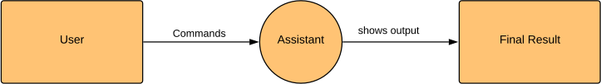

Figure 3.1: DFD level 0

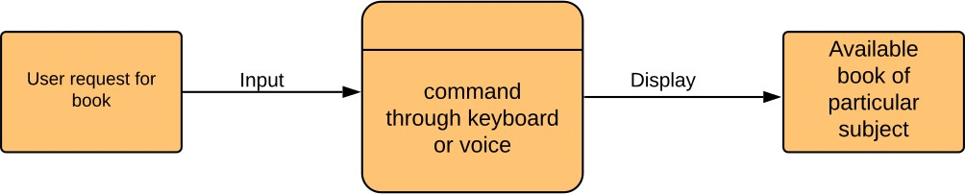

Figure 3.2: DFD level 1

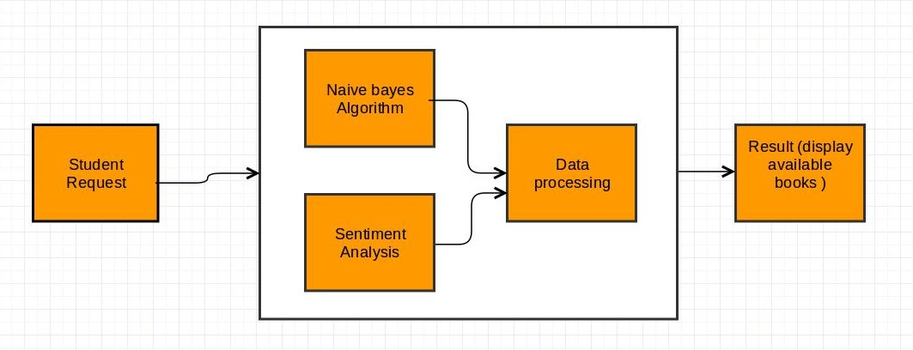

Figure 3.3: DFD level 2

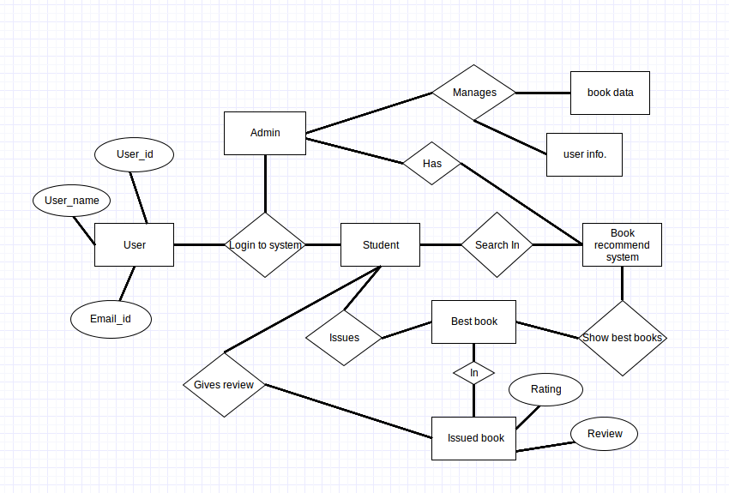

Figure 3.4: Entity Relationship Diagram for System

**Chapter 4**

**System Design**

The goal of system design is to produce a model or representation that exhibit, commodity and delight. It provides information about the application domain for the software to be built. It describes the internal details of software.

### System Architecture

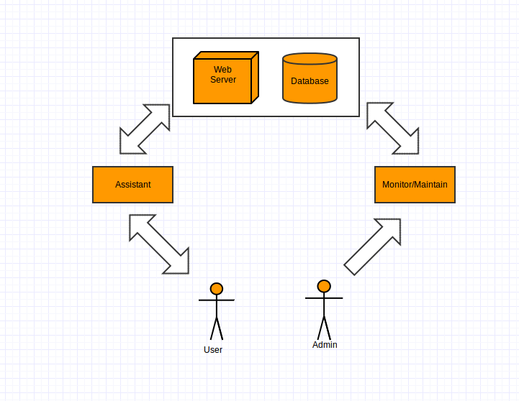

Figure 4.1: System Architecture

### UML Diagrams

Unified Modeling Language (UML) is a standardized general-purpose modeling language in the field of software engineering.UML includes a set of graphical notation techniques to create visual models of software-intensive systems.

The Unified Modeling Language (UML) is used to specify, visualize, modify, construct and docu- ment the artifacts of object-oriented software intensive system under development.UML offers a standard way to visualize a system’s architectural blueprints, including diagrams such as:

1 Use Case diagram 2 Class diagram

1. Activity diagram
2. Component diagram
3. Sequence Diagram
4. Deployment diagram

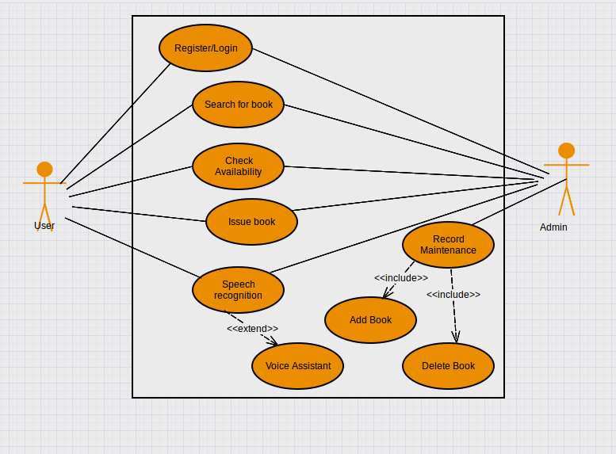

Figure 4.2: Use Case Diagram

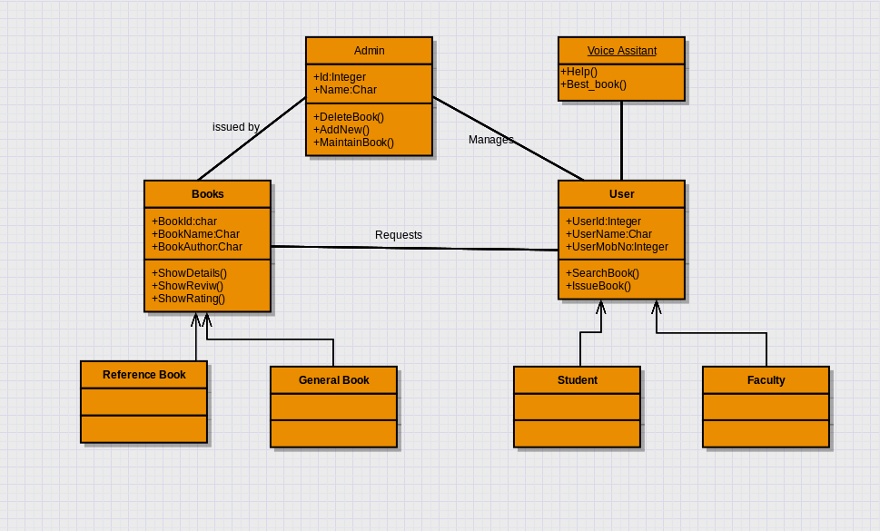

Figure 4.3: Class Diagram

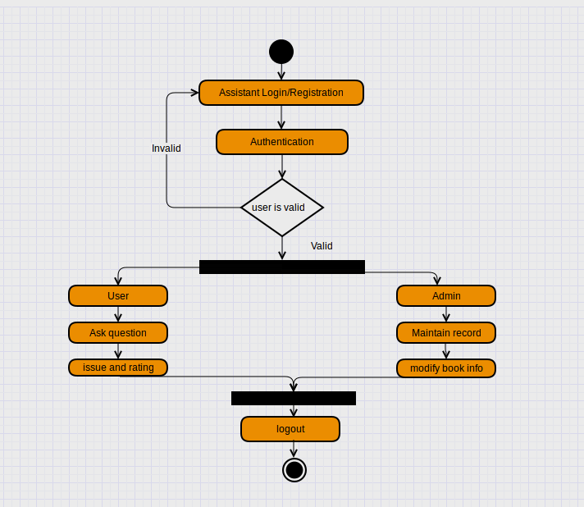

Figure 4.4: Activity Diagram

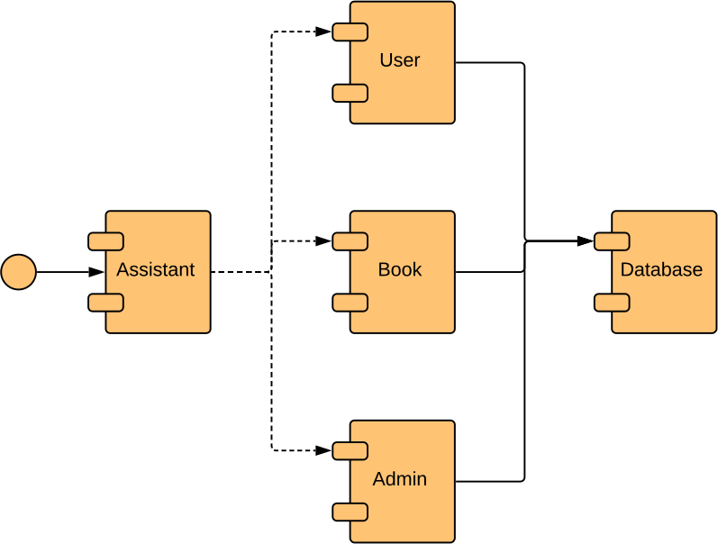

Figure 4.5: Component Diagram

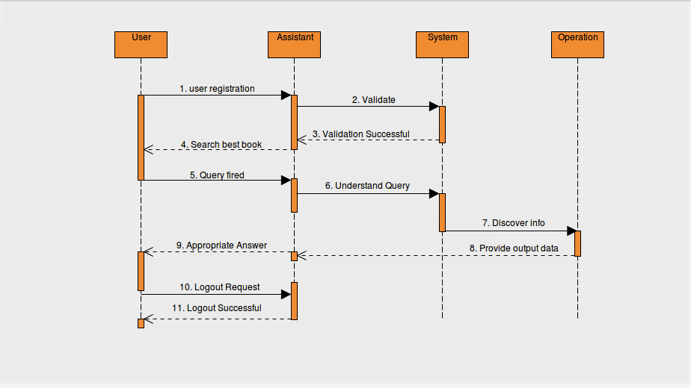

Figure 4.6: Sequence Diagram

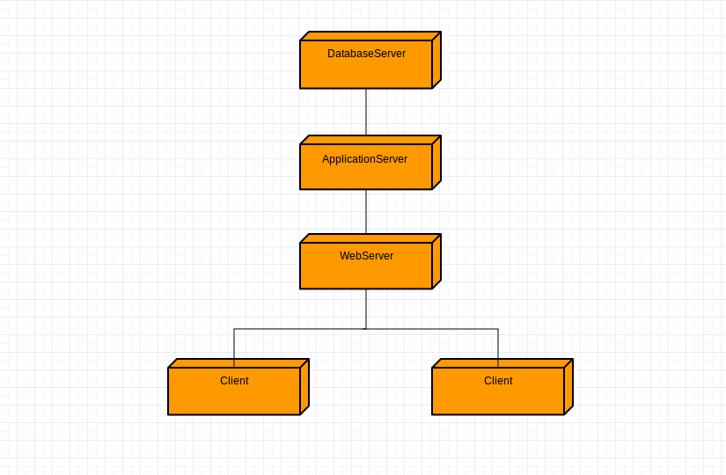

Figure 4.7: Deployment Diagram

**Chapter 5**

**Technical Specification**

### Advantage

* + 1. System will help students to easily search books. Also, system will show booksˆa review and rating, so that students can easily choose better book among books of same domain.
    2. Voice command will be helpful feature of system.
    3. Graph will help to visualize the analyzed data.
    4. Some other features like issue a book and provide feedback for issued book will make system robust.
    5. In event section, student are able to ask assistant about next or previous lecture, notice boards and other static data.

### Application

* + 1. Smart library can integrate this system for advancement of library with anytime and any- where access of information.
    2. Institute or any organization can have this system for enhancement.

**Chapter 6**

**Software Implementation**

### Introduction

#### Python

Python was designed for readability, and has some similarities to the English language with influ- ence from mathematics.Python is a general purpose and high level programming language. You can use Python for developing desktop GUI applications, websites and web applications. Also, Python, as a high level programming language, allows you to focus on core functionality of the application by taking care of common programming tasks. As we were planning to have web application so it was easy for us to use it in our project.It is used for web development (server- side),software development, mathematics, system scripting.

Python uses new lines to complete a command, as opposed to other programming languages which often use semicolons or parentheses. Python relies on indentation, using white space, to define scope; such as the scope of loops, functions and classes. Other programming languages often use curly-brackets for this purpose.

###### Features of Python :

1. Easy to Learn and Use :Python is easy to learn and use. It is developer-friendly and high level programming language.
2. Expressive Language: Python language is more expressive means that it is more understand- able and readable.
3. Interpreted Language: Python is an interpreted language i.e. interpreter executes the code line by line at a time. This makes debugging easy and thus suitable for beginners.
4. Cross-platform Language: Python can run equally on different platforms such as Windows, Linux, Unix and Macintosh etc. So, we can say that Python is a portable language.
5. Free and Open Source: Python language is freely available at official web address.The source- code is also available. Therefore i it is open source.
6. Object-Oriented Language: Python supports object oriented language and concepts of classes and objects come into existence.
7. Extensible: It implies that other languages such as C/C++ can be used to compile the code and thus it can be used further in our python code.
8. Large Standard Library: Python has a large and broad library and provides rich set of module and functions for rapid application development.
9. GUI Programming Support : Graphical user interfaces can be developed using Python.
10. Integrated: It can be easily integrated with languages like C, C++, JAVA etc.

#### Flask

Flask is a micro-framework for Python based on Werkzeug, Jinja 2 and good intentions.”Micro” does not mean that your whole web application has to fit into a single Python file (although it certainly can), nor does it mean that Flask is lacking in functionality. The ˆamicroˆa in micro- framework means Flask aims to keep the core simple but extensible. Flask wonˆat make many decisions for you, such as what database to use. Those decisions that it does make, such as what templating engine to use, are easy to change. Everything else is up to you, so that Flask can be everything you need and nothing you donˆat.Flask supports extensions to add such database abstraction layer, form validation or anything else to your application as if it was implemented in Flask itself. By convention, templates and static files are stored in sub-directories within the applicationˆas Python source tree, with the names templates and static respectively. As your code-base grows, you are free to make the design decisions appropriate for your project. Flask will continue to provide a very simple glue layer to the best that Python has to offer.

Installation of Flask: pip install flask

#### mongoDB

mongoDB is a document-oriented, open-source database program that is platform-independent. mongoDB, like some other NoSQL databases (but not all!), stores its data in documents using a JSON structure. This is what allows the data to be so flexible and not require a schema. Some of the more important features are:

You have support for many of the standard query types, like matching (==), comparison (¡,

¿), or even regex You can store virtually any kind of data - be it structured, partially structured, or even polymorphic To scale up and handle more queries, just add more machines It is highly flexible and agile, allowing you to quickly develop your applications Being a document-based database means you can store all the information regarding your model in a single document You can change the schema of your database on the fly Many relational database functionalities are also available in mongoDB (e.g. indexing)

As for the operations side of things, there are quite a few tools and features for mongoDB that you just canˆat find with any other database system:

Whether you need a standalone server or complete clusters of independent servers, mongoDB is as scalable as you need it to be mongoDB also provides load balancing support by automatically moving data across the various shards It has automatic failover support - in case your primary server goes down, a new primary will be up and running automatically The mongoDB Management Service or MMS is a very nice web tool that provides you with the ability to track your machines Thanks to the memory mapped files, youˆall save quite a bit of RAM, unlike relational databases

.

#### Front End:-

The frontend of a website is what you see and interact with on your browser. Also referred to as

ˆaclient-sideˆa, it includes everything the user experiences directly: from text and colors to buttons, images, and navigation menus. These three languages will do the trick:

1. HTML: HTML is the fundamental coding language that creates and organizes web content so it can be displayed by a browser. You can learn more about HTML here.
2. CSS: CSS is a language that accompanies HTML, and defines the style of a websiteˆas content, such as layout, colors, fonts, etc.
3. JavaScript: JavaScript is a programming language used for more interactive elements like drop down menus, modal windows, and contact forms.

### All Imported Packages

from f l a s k import Flask , request ,

render template , u r l f o r , s e s s i o n , re di re c t , j s o n i f y from f lask pymongo import PyMongo

import csv

import r e v i e w r a t i n g c a l as rc import search domain as sd

import b a s i c c l e a n as fd

import s p e e c h to te x t as sp import datetime

from f l a s k c o r s import CORS import pymongo

from f l a s k r e s t f u l import Resource , Api

**Chapter 7**

**Software Testing**

### Introduction

Software testing is a critical element of SQA and represents the ultimate review of specification, design and code generation. It is set of activities that attempt to find errors. Once source code has been generated, the s/w must be tested to uncover ( corrected) as many errors as possible before delivery to the customer. Our goal of testing is to design a series of test cases that have a likelihood of finding errors. The s/w testing techniques provide systematic guidance for designing tests that exercise the internal logic of software components. Exercise the inputs output domains of programs to uncover errors in program performance.

Project/system review and other SQA activates can uncover errors but they are not sufficient. Every time the program is executed, the customer tests it. Therefore, we have to execute the program before the customer with the intend of finding and removing all errors. In order to find the highest possible number of errors , tests must be conducted systematically and test cases must be designed using disciplined techniques.

### Objectives of testing:

1.Testing is a process of executing a program with the intent of finding errors.

2.A good test case is one that has a high probability of finding yet-undiscovered errors.

###### Levels of testing:

1. Unit Testing
2. System Testing
3. Validation Testing
4. Integration Testing

Each module is tested individually (Unit Testing). Testing is to be done to ensure that the module

meets its required specification and performs up to the desired level. Then modules are to be integrated. After integration regression testing is to be performed to ensure that integration does not introduce new bugs.

Finally, when all modules put in place alpha testing is to be carried out on entire system. Beta testing is to be carried out in which the third party records all the problem that are encountered during the testing and reports this to the developers at regular intervals as a result of which modifications are done. Stress testing is also required to be done to ensure that the system lives upon its desired performance and confirms to the requirement.

#### Unit Testing:

It is used to check the execution part of the module, function procedure of the system. Test is conducted with the help of normal data abnormal data. This testing includes different factors like statement coverage, branch coverage, look processing, abnormality circulations. With the help of this unit testing we check that all the statements in the code is executed or not so it avoids the dead code statements. It checks all the branches and execution path of the code. It ensures that all internal methods of program are executed properly integrated with program.

#### System Testing:

This is the important type in the testing phase. System testing is used to check whether the application is consistent with the userˆas requirement. System testing covers different types of testing views like application test view is to check whether the system is running normally or not. We check over the performance of the system by considering response time, process execution time. We also check the reliability of the system.

#### Validation Testing:

The system is tested to ensure the expected data in the various text boxes is accepted well pro- cessed by the system according to the flow defined in flow modules. The software is completely assembled as a package and interfacing errors are uncovered and corrected.e.g.:

1. Check if the text field accepts only numbers or not.
2. Check if the default value is present.
3. Check the maximum length of the text field.

#### Integration Testing:

The entire system interface such as database connectivity, the interface between the forms is check and testes to ensure the integrity of the system. All components integrated on the measure control paths are to be tested using depth first integration each module is to be tested by using the top-down integration strategy.

### TEST CASE DOCUMENT

###### 1 Black Box Testing:

Black Box Testing involves looking at the specifications and does not require examining the code of the program. Black box testing is done from the customers view point. The test engineer engaged in black box testing only knows the set of inputs and is unaware of how those inputs are transformed into outputs by the software.

Different techniques of Black Box Testing:

1. Requirement based testing
2. Positive and negative testing
3. Boundary value analysis
4. Decision tables
5. Equivalence partitioning
6. State based testing
7. Compatibility testing
8. User documentation testing
9. Domain testing

###### 2 White Box Testing:

White box testing is a way of testing the external functionality of the code by examining and testing the program code that realizes the external functionality. It is also known as clear box or glass box or open box testing. White box testing takes into account the program code, code structure and internal design flow. White box testing is classified into Static and Structural test- ing.

### Training Dataset Table:-

|  |  |
| --- | --- |
| Training | Dataset |
| Review | Rating Pos/Neg |
| good book | pos |
| better book | pos |
| not good book | neg |
| not love book | neg |
| not issue | neg |
| better book | pos |
| amazing book | pos |
| not love book | neg |
| explained well | pos |
| not go for it | neg |
| not bad book | pos |
| not well | neg |
| bright | pos |
| not beneficial | neg |
| not well | neg |
| bright | pos |
| not beneficial | neg |
| not well | neg |
| bright | pos |
| not beneficial | neg |

### Snap Shots of the Cases and Test Plan

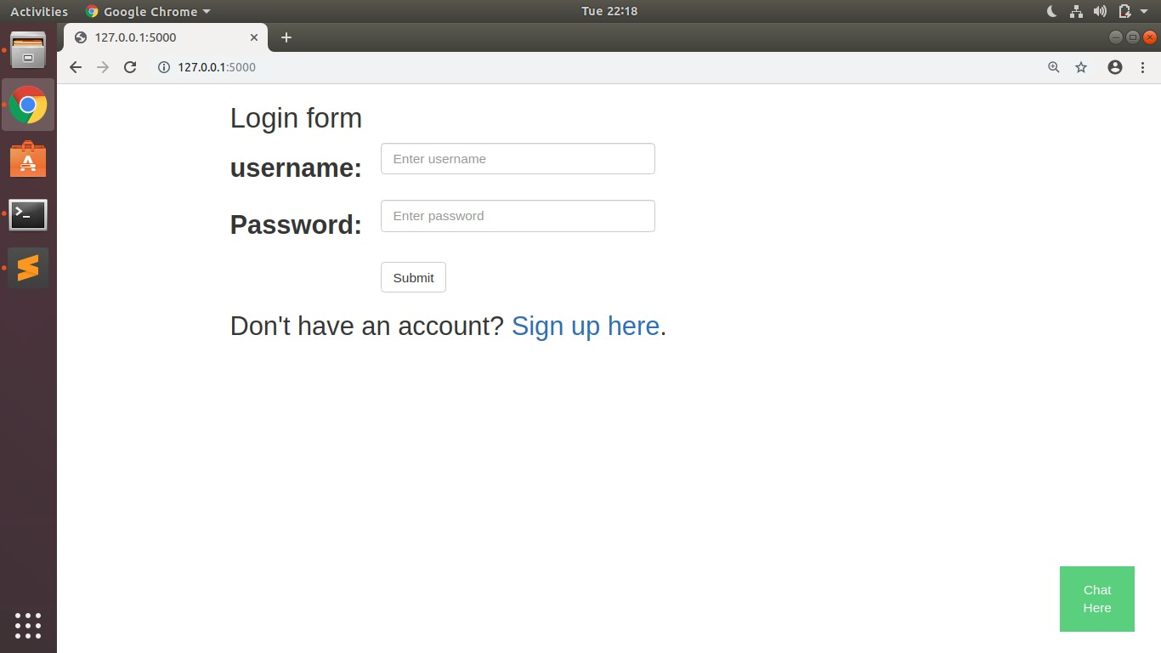

Figure 7.1: Login and Sign up page

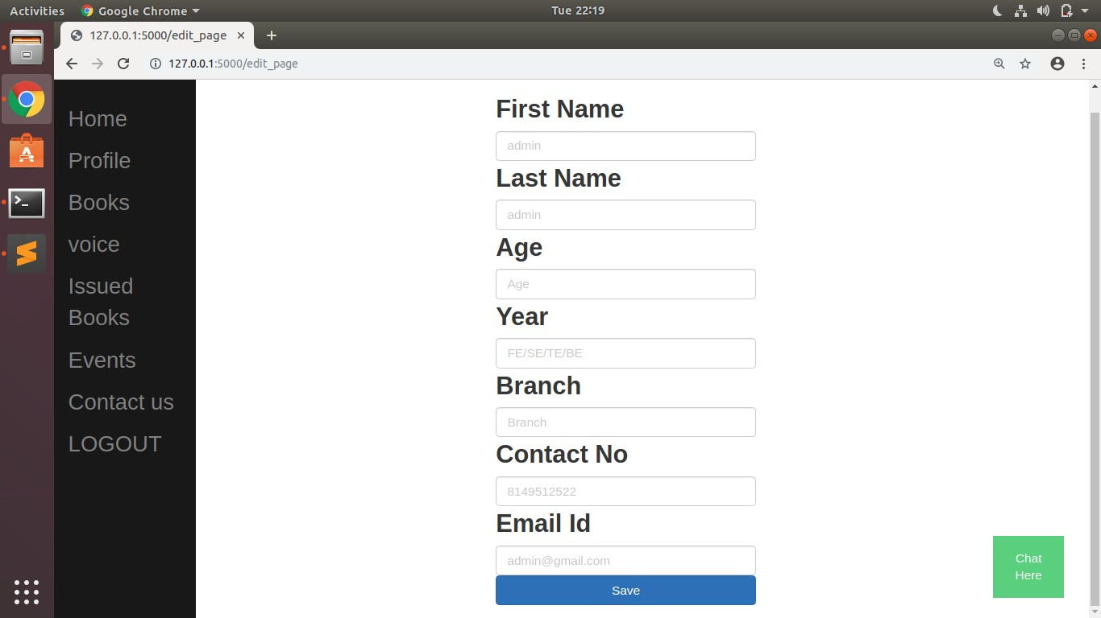

Figure 7.2: Sign up information

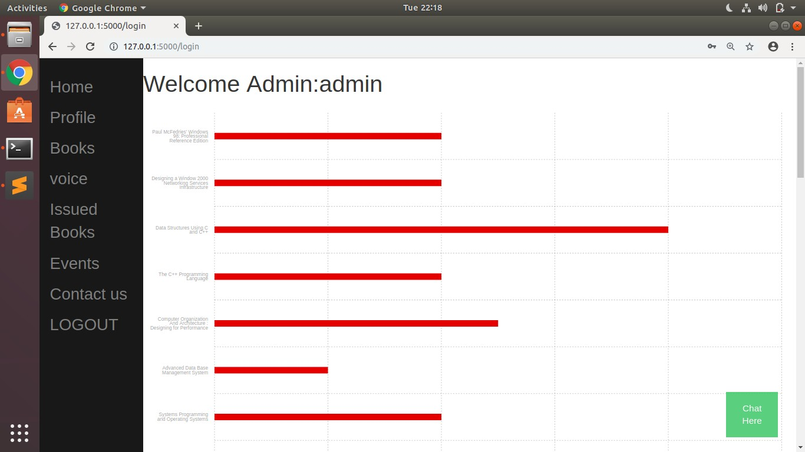

Figure 7.3: Welcome Admin page showing Bar Chart

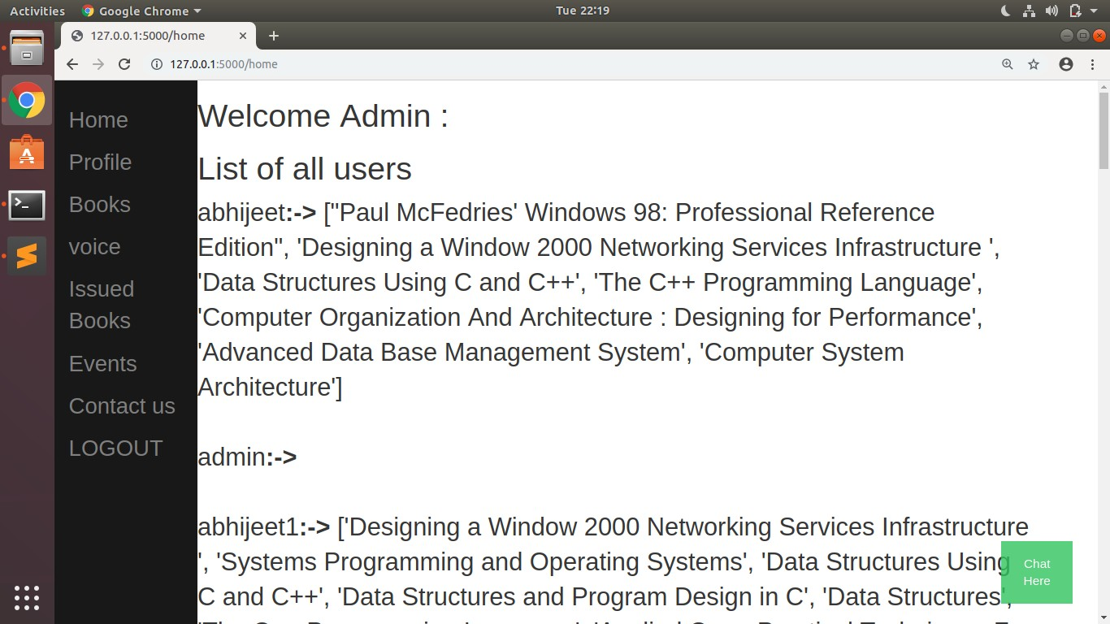

Figure 7.4: User and list of issued book

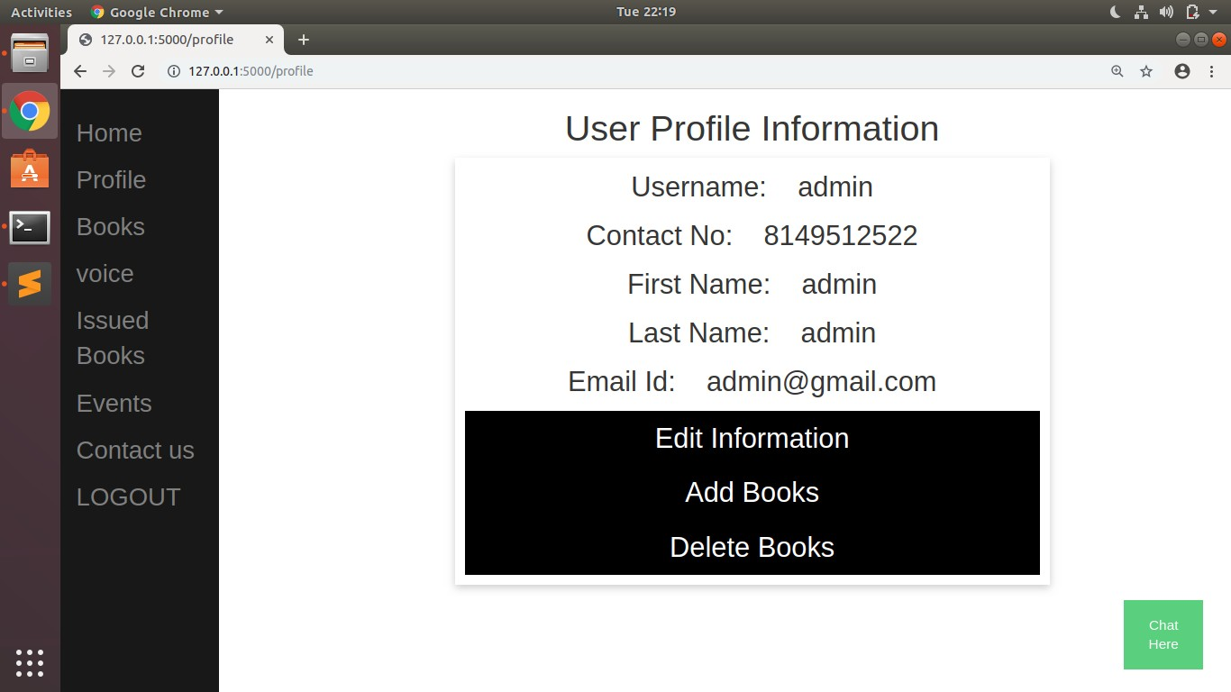

Figure 7.5: User profile information

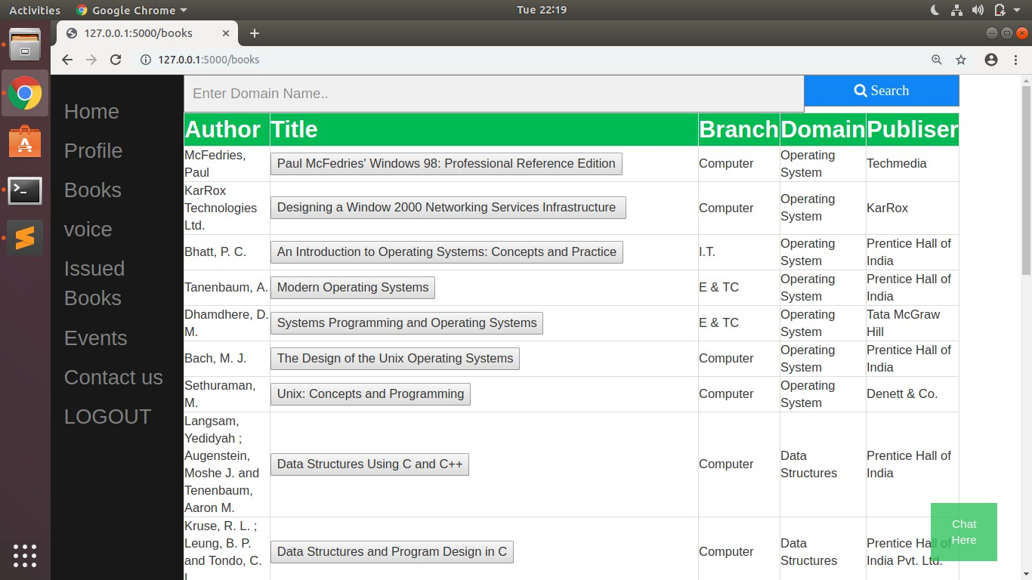

Figure 7.6: Search box and books list

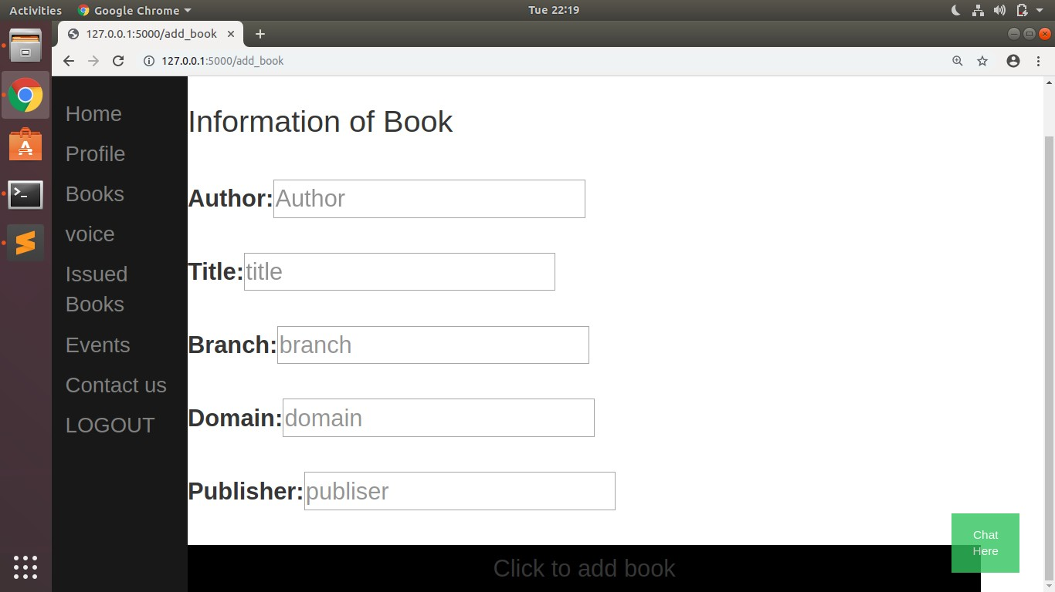

Figure 7.7: Add new book

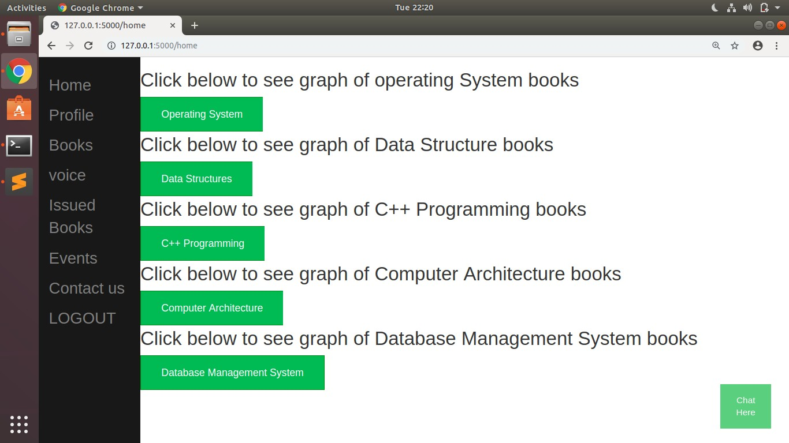

Figure 7.8: Show graph for each domain

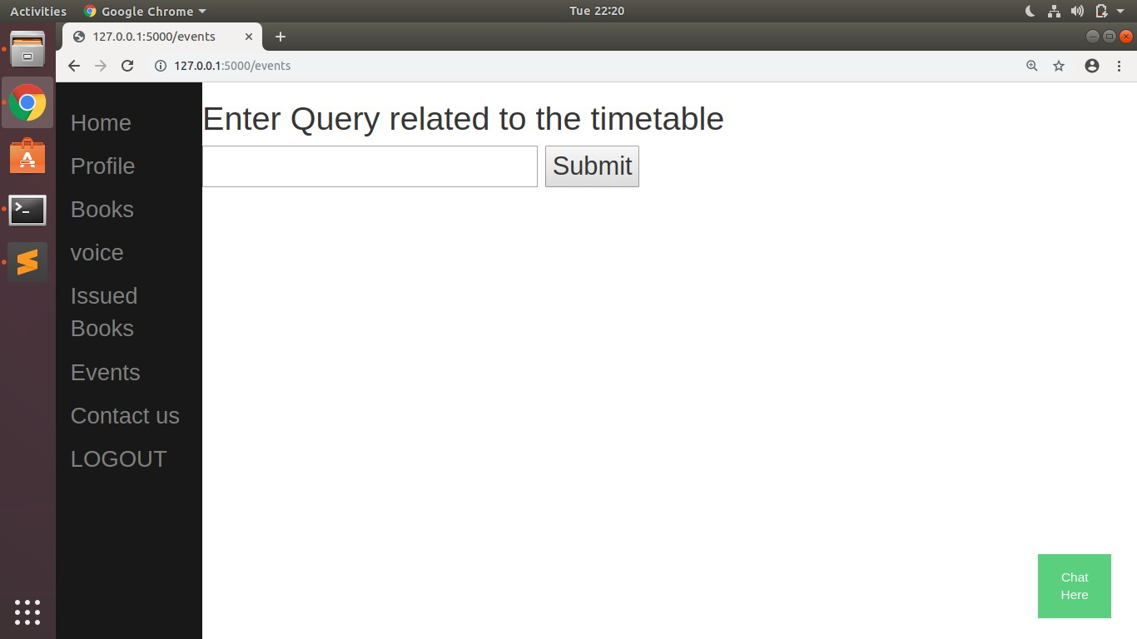

Figure 7.9: Enter query related to time table

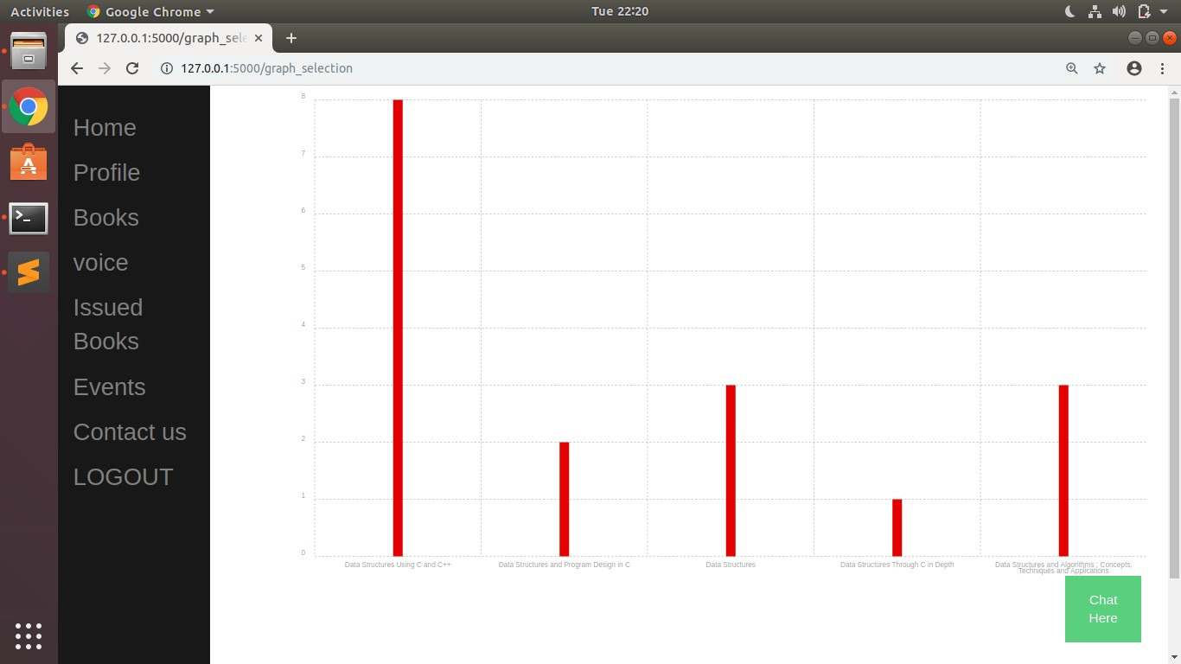

Figure 7.10: Graph for particular domain

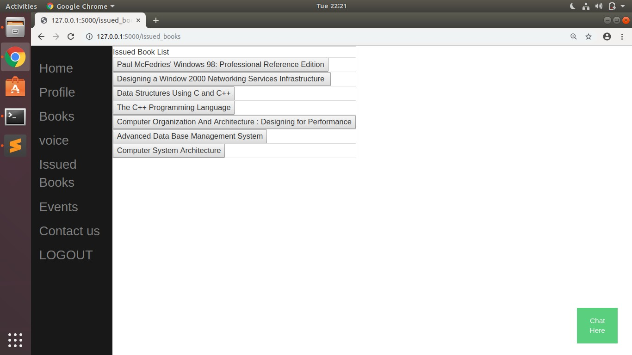

Figure 7.11: Issued books

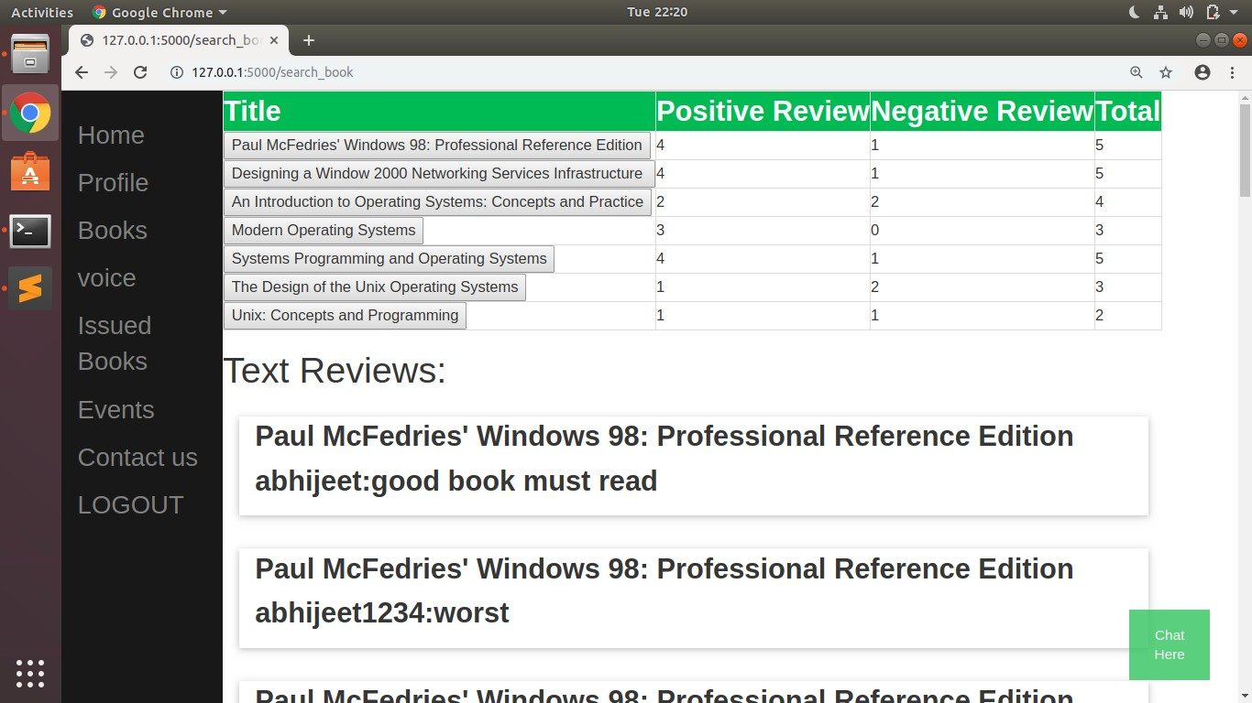

Figure 7.12: Best books and reviews

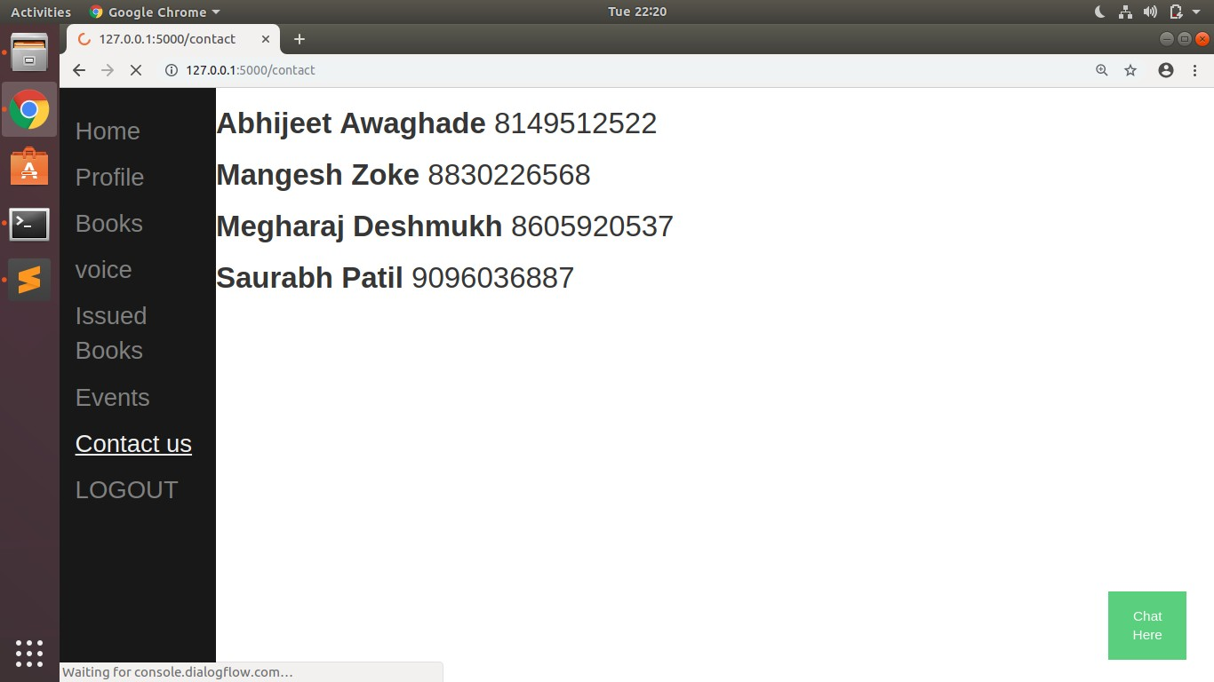

Figure 7.13: Contact Details

**Chapter 8**

**Deployment and Maintenance**

These are the steps to get started with the Smart Institute Assistant. It should wok on any operating system, but we have used Ubuntu (Linux OS).

1. Download and install python3.
2. Install pip 9.0.1 (if not install with python). 3.Set environment variable for python.
3. Install mongoDB server.
4. Download and install Sublime Text Editor IDE. 6.Import all packages of flask.

7.Python modules imported. 8.Python built in package imported.

1. Source code written with mongoDB connection.
2. Open the terminal and go to directory containing project. 11.Run main python file to start flask server.

12.Open browser and enter link http://127.0.0.1:5000/.

**Chapter 9**

**Conclusion and Future Scope**

### Conclusion

Proposed system will show books review and rating, so that students can easily choose better book among books of same domain.Voice command will be helpful feature of system. Visualiza- tion using graph will help in analyzing the data. Services like issue a book and provide feedback for issued book will make system robust. In event section, users are able to ask assistant about next or previous lecture, notice boards and other static data.

### Future Scope

All the transactions including search book, show the rating and review of books, issue a book will be done by voice assistant. No need to press any button and no need to write anything on web page, simply give input by voice commands to voice assistant.

**Chapter 10**

**References**

* + 1. Assaf Hurwitz Michaely, Xuedong Zhang, Gabor Simko,Carolina Parada, Petar Aleksic. ”Keyword Spotting for Google Assistant Using Contextual Speech Recognition”.
    2. Amel Ziani, Nabiha Aziz, Didier Schwab, Monther Aldwairi, Nassira Chekkai, Djamel Zenakhra, Soraya Cheriguene Dec 2017. ”Recommender System Through Sentiment Anal- ysis”.
    3. Sweta P. Lende, Dr.M.M. Raghuwanshi. ”Question Answering System on Education Acts Using NLP Techniques”.
    4. Peng Yang, Yunfang Chen.”A survey on Sentiment Analysis by using ML Methods”.
    5. Rita Guimaraes, Demostenes Z Rodriguez, Renata L Rosa, Grace Bressan. Recommenda- tion System using Sentient Analysis considering the polarity of adverb.
    6. Shally Garg, Suresh Kumar AIACTR, New Delhi, INDIA. ”JOSN, JAVA Oriented Question Answering System Combining Semantic Web and Natural language Processing techniques”.
    7. Haiyi Zhang, Di Li, ”Naive Bayes Text Classifier”.
    8. Patrick Vogel, Thijs Klooster, Vasilios Andrikopoulos, Mircea Lungu, ˆaA Low-Effort Ana- lytics Platform for Visualizing Evolving Flask-Based Python Web Servicesˆa.
    9. Vikas K Vijayan, Bindu K.R, Latha Parameswaran. ”A Comprehensive Study of Text Classification Algorithms”.
    10. Yu ong Zhong, ”The Analysis of Cases Based on Decision Tree”.
    11. Cornelia Gyorodi, Robert Gyorodi, George Pecherle, Andrada Olah, ”A Comparative Study: MongoDB vs. MySQL”.
    12. Bhagyashri Wagh, Prof. J. V. Shinde, Prof. P. A. Kale, ”A Twitter Sentiment Analysis Using NLTK and Machine Learning Techniques”.
    13. Ankur Goyal, Jyoti Gautam, Sitesh Kumar, ”Real Time Sentiment Analysis of Tweets Using Naive Bayes”.
    14. Nurulhuda Zainuddin, Ali Selamat , ”Sentiment Analysis Using Support Vector Machine”.