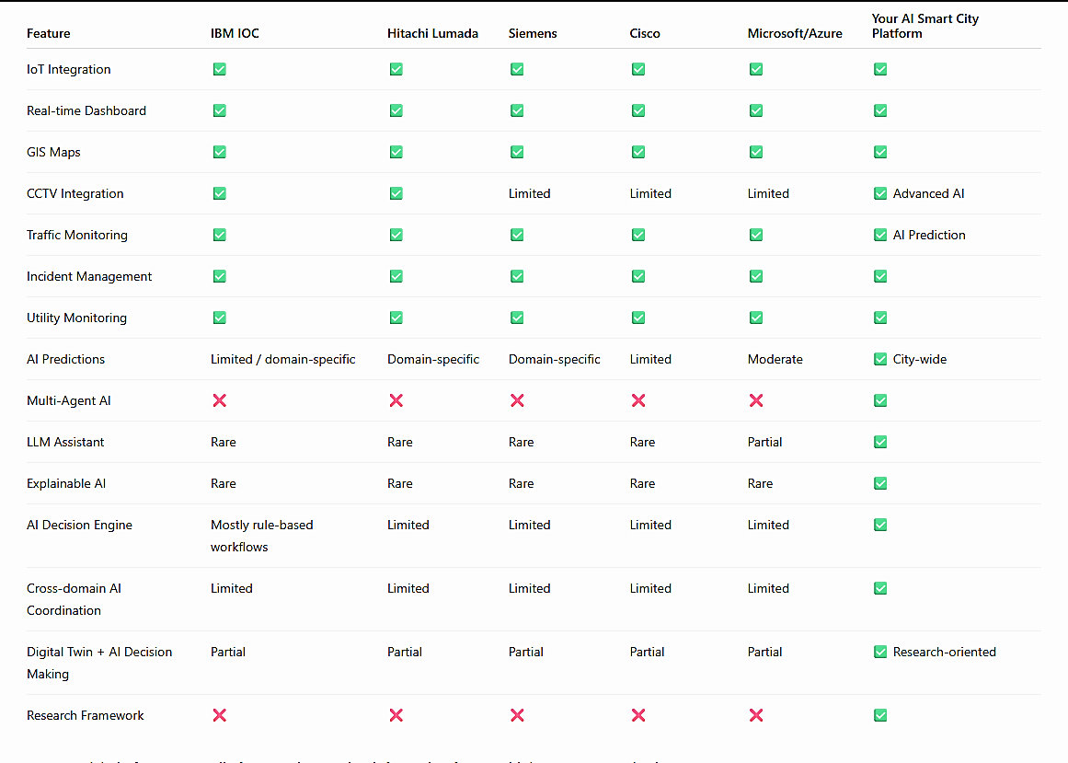

Multi-Agent AI
Traditional Smart City Platform  Current platforms mostly work like this  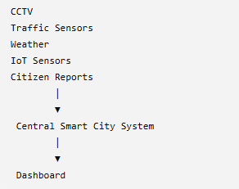  The system collects data and displays alerts. | Multi-Agent AI Platform  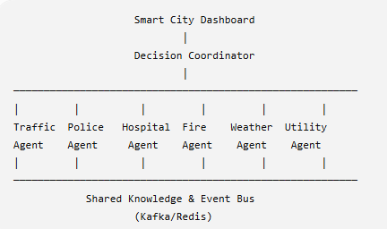  Each agent has its own expertise.

1. Traffic Agent 🚦  Responsibility  Monitors:  - CCTV  - GPS  - Traffic sensors  - Vehicle speed  - Signal timing  AI predicts:  - Congestion  - Accidents  - Traffic density  - Best routes | 2. Fire Agent 🔥  Monitors  - Smoke sensors  - CCTV  - Weather  - Building alarms  Detects  - Fire  - Smoke  - Explosion  AI estimates  - Fire severity  - Spread direction  - Risk level | 3. Hospital Agent 🏥  Knows  - ICU beds  - Doctors  - Ambulances  - Equipment  - Emergency room load
4. Police Agent 👮  Monitors  - Crime reports  - CCTV  - Emergency calls  Handles  - Crowd control  - Road closures  - Crime response | 5. Weather Agent 🌧  Collects  - Weather forecasts  - Rainfall  - Wind  - Temperature  Predicts  - Floods  - Storms  - Heat waves | 6. Utility Agent ⚡  Monitors  - Water  - Electricity  - Street lights  - Gas pipelines  Detects  - Water leakage  - Power failure  - Transformer overload
7. Citizen Agent 📱
Handles
- Complaints
- Mobile app reports
- Emergency SOS
- Social media alerts (if included)
AI categorizes reports and forwards them to the right department.

Instead, users can ask:
"Which roads are heavily congested right now?"
The assistant responds:
"MG Road, Highway 7, and Airport Road are experiencing heavy congestion. Estimated clearing time is 25 minutes. Suggested alternate routes are Ring Road and Central Avenue."

How It Works  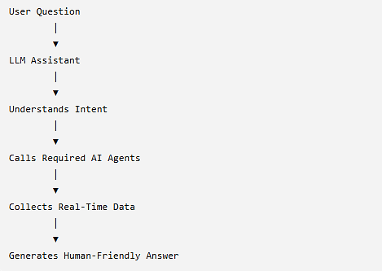 | Architecture  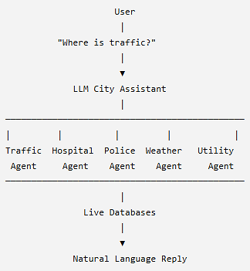

Explainable AI
Measure
- Decision time
- Decision accuracy
- User trust (through questionnaires)
- User satisfaction
- Number of incorrect decisions
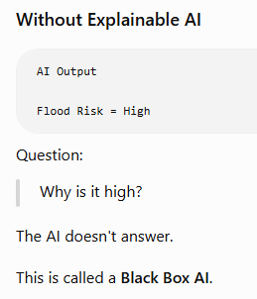 | 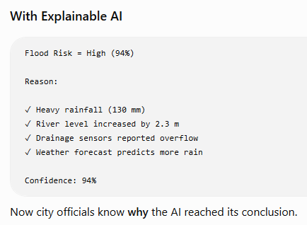

AI Decision Intelligence
1. Event Prioritization
Many incidents happen at the same time.
Example
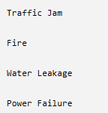
Decision Intelligence ranks them.
Example:
Event | Priority
Hospital Fire | Critical
Flood | High
Major Accident | High
Traffic Jam | Medium
Street Light Failure | Low

2. Resource Allocation
AI chooses:
Which ambulance?
Which hospital?
Which police station?
Which fire truck?
Instead of nearest,
AI selects best available resource.
3. Action Recommendation
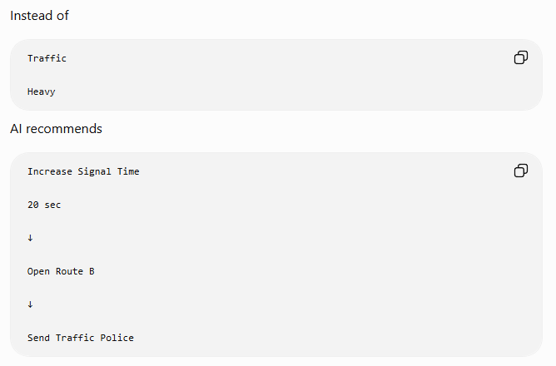

4. Scenario Simulation
Suppose the Mayor asks
"What happens if we close this road?"
Decision Intelligence simulates
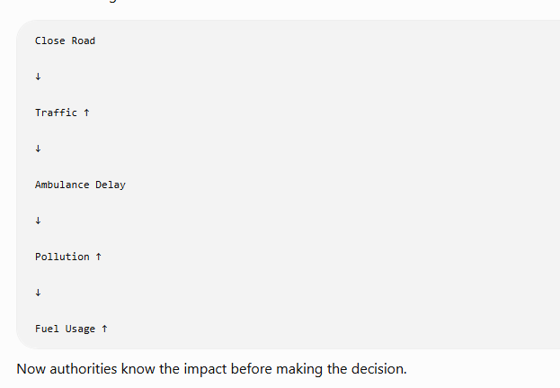

Cross-Domain Coordination
Cross-Domain Coordination means multiple city departments (domains) automatically work together through AI to solve one incident.
Normally, every department works independently:
- 🚦 Traffic Department
- 🚔 Police Department
- 🚑 Hospital Department
- 🔥 Fire Department
- ⚡ Electricity Department
- 💧 Water Department
- 🌦 Weather Department
Each has its own software and operators.
Your project connects all departments into one AI ecosystem.

Domain | Responsibility
Traffic | Roads, signals, congestion
Hospital | Ambulances, ICU, doctors
Fire | Fire incidents
Police | Security and law enforcement
Weather | Rain, storms, floods
Utility | Electricity, water, gas
Citizen | Public complaints and alerts
Public Transport | Buses, metro, trains

Digital Twin
A Digital Twin is a virtual (digital) copy of a real-world object, system, or city that updates continuously using real-time data.
Think of it as a Google Maps + City Simulation + AI Prediction System.
Instead of looking at static maps, city officials can see a live virtual city that behaves like the real city.

Learning System
What Can Learn?
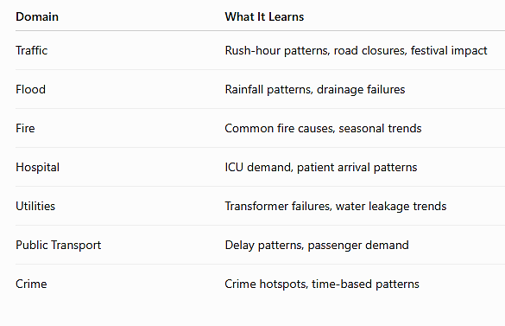

How Does It Learn?
1. Supervised Learning
2. Reinforcement Learning
3. Human Feedback

Research Framework for Your Project
Project Title
AI-Native Smart City Operating Platform with Multi-Agent Decision Intelligence, Explainable AI, Digital Twin, and LLM-Based Decision Support

Step 1: Problem Statement
Current smart city platforms:
- Monitor city infrastructure
- Display dashboards
- Generate alerts
However, they have several limitations:
- Departments often operate independently.
- AI models work in isolation.
- Decision-making still depends heavily on human operators.
- AI recommendations are often difficult to explain.
- Most systems do not continuously learn from outcomes.

Step 2: Research Gap
Your thesis identifies the following gaps:
Existing Systems | Research Gap
Independent AI models | No collaborative Multi-Agent AI
Dashboard-based monitoring | Limited autonomous decision support
Black-box predictions | Lack of Explainable AI
Manual coordination | Limited cross-domain AI coordination
Static models | Limited continuous learning
Multiple dashboards | No unified LLM assistant

Step 3: Research Objectives
Your objectives could be:
- Design a Multi-Agent AI architecture for smart city management.
- Develop an AI Decision Intelligence engine for coordinated decision-making.
- Implement Explainable AI for transparent recommendations.
- Build a 2D Digital Twin for city simulation.
- Develop an LLM-powered City Assistant.
- Evaluate system performance against traditional approaches.

Step 4: Research Questions
RQ1
Can Multi-Agent AI improve city-wide emergency response?

RQ2
Can AI Decision Intelligence make better recommendations than rule-based systems?

RQ3
Does Explainable AI improve operator trust?

RQ4
Can a Digital Twin improve planning accuracy?

RQ5
Does continuous learning improve prediction accuracy?

Step 5: Proposed Architecture
Smart City Data

CCTV
IoT
GPS
Weather
Citizen Reports

│
▼

Real-Time Data Collection Layer

│
▼

AI Detection & Prediction Layer

│
▼

Multi-Agent AI Collaboration

│
▼

AI Decision Intelligence

│
┌───────┴─────────┐
│ │
Explainable AI Digital Twin

│ │
└───────┬─────────┘
▼

LLM City Assistant

│
▼

Smart City Dashboard

Step 6: Research Contribution
This is the most important section of your thesis.
Your contribution is not:
"I built a dashboard."
Your contribution is:
A novel AI architecture that combines Multi-Agent AI, Explainable AI, AI Decision Intelligence, a 2D Digital Twin, and an LLM-powered assistant into a unified smart city operating platform.

Step 7: Research Methodology
Data Collection
Collect or simulate:
- Traffic
- Weather
- GPS
- Hospitals
- Utilities
- CCTV
- Citizen reports

AI Training
Train:
- Traffic Prediction
- Flood Prediction
- Hospital Occupancy
- Fire Detection

Multi-Agent Coordination
Create:
- Traffic Agent
- Hospital Agent
- Fire Agent
- Police Agent
- Weather Agent
- Utility Agent

Decision Intelligence
Develop algorithms to:
- Prioritize incidents
- Allocate resources
- Recommend actions

Explainable AI
Explain every recommendation.

Digital Twin
Simulate:
- Road closures
- Floods
- Fires
- Festivals

LLM
Natural-language interaction.

Step 8: Experimental Setup
Compare:
Existing Method
Rule-Based System
↓
Human Decision

Proposed Method
AI Platform
↓
Multi-Agent AI
↓
Decision Intelligence
↓
LLM

Step 9: Evaluation Metrics
Traffic
- Average travel time
- Congestion level
- Throughput

Emergency
- Response time
- Ambulance arrival time

AI
- Prediction accuracy
- Precision
- Recall
- F1-score

Decision Intelligence
- Decision quality
- Resource utilization
- Decision latency

Explainable AI
Use user studies or simulated operators to evaluate:
- User trust
- Decision confidence
- Satisfaction

Digital Twin
Measure:
- Simulation accuracy
- Planning effectiveness

LLM
Evaluate:
- Response correctness
- Response time
- User satisfaction

Step 10: Research Comparison
Compare your system against:
Feature | Traditional Platform | Your Platform
Monitoring | ✅ | ✅
AI Prediction | ✅ | ✅
Multi-Agent AI | ❌ | ✅
Explainable AI | ❌ | ✅
Decision Intelligence | ❌ | ✅
Digital Twin | Partial | ✅
LLM Assistant | ❌ | ✅
Continuous Learning | ❌ | ✅

Step 11: Expected Results
You expect:
- Faster emergency response
- Better traffic management
- Improved prediction accuracy
- Reduced human workload
- Better resource allocation
- Higher operator trust
- Improved planning using simulation

Step 12: Future Scope
Future work could include:
- Real IoT devices
- Drone integration
- 3D Digital Twin
- Federated Learning
- Edge AI
- Autonomous emergency dispatch
- Integration with hospital and police systems
- Smart energy optimization

Thesis Chapters
Chapter 1
Introduction

Chapter 2
Literature Review

Chapter 3
Existing Systems

Chapter 4
Research Gap

Chapter 5
Proposed Architecture

Chapter 6
System Design

Chapter 7
AI Models

Chapter 8
Implementation

Chapter 9
Experimental Results

Chapter 10
Conclusion

Chapter 11
Future Scope

Novelty Statement (Very Important)
Your project should be presented like this:
This research proposes an AI-native Smart City Operating Platform that integrates Multi-Agent AI, AI Decision Intelligence, Explainable AI, a 2D Digital Twin, and an LLM-powered assistant to support coordinated, transparent, and data-driven city operations.
Notice that you are not claiming to invent smart cities. Your contribution is the combination of these AI techniques into one coordinated architecture and then evaluating whether that combination improves measurable outcomes.
Strong Research Questions for Publication
If your goal is not only an M.Sc. thesis but also a conference or journal paper, these questions are stronger because they are specific and measurable:
- Does a Multi-Agent AI architecture reduce emergency response time compared to centralized rule-based coordination?
- How does Explainable AI affect operator trust and decision quality in smart city operations?
- Can AI Decision Intelligence improve resource allocation during multi-incident emergencies?
- Does a 2D Digital Twin improve planning accuracy for traffic and disaster scenarios?
- Can an LLM combined with Retrieval-Augmented Generation (RAG) provide accurate natural-language decision support using real-time smart city data?

