BANKING CREDIT RISK ANALYSIS
Who defaults, and why? An end-to-end analysis of 32,409 loans
Tools: Python (pandas, matplotlib, seaborn) · Power BI (DAX, 3-page interactive dashboard)
Dataset: Credit Risk Dataset (Kaggle), 32,581 raw loan records, 12 columns

Executive Summary
This project analyses a portfolio of personal loans to answer one question a bank risk manager asks every day: which borrowers are most likely to default, and what drives that
risk? The data was cleaned and explored in Python and presented in a three-page Power BI dashboard.
Overall, 21.9% of loans defaulted, roughly one in five. The risk is not spread evenly. It is concentrated in a few clearly identifiable groups, shown below.

32,409  Loans analysed | 311M  Total exposure | 21.9%  Overall default rate | 70.4%  Default rate, very high burden

- Debt burden is the strongest driver. Loans above 30% of the borrower's income default at 70.4%, against 11.8% for loans under 10% of income.
- Grades D to G default at 59% to 98%, versus 10% to 21% for grades A to C. The jump happens between C and D.
- Income and burden combine. A borrower earning under 30K with a very high burden defaults 82.4% of the time. Even above 100K, a very high burden defaults at 40.0%.
- Interest rates rise gently while risk jumps sharply, which suggests grades D to G may be under-priced for their risk (a hypothesis, see Limitations).
- Age is not a meaningful risk factor (20.2% to 23.1% across all age groups).

1. Business Understanding

Problem statement
Banks lose money when borrowers stop repaying. This project identifies where default risk is concentrated in a loan portfolio and which borrower and loan characteristics explain it, so that lending, pricing and monitoring decisions can be targeted.

Business questions
- What is the overall default rate and the total money at risk?
- Which loan grades, purposes and income groups are the riskiest?
- How do debt burden, interest rate and past default history relate to default?
- Which combinations of customer characteristics form the highest-risk segments?
- Is the bank pricing risk appropriately?

Audience
The dashboard is designed for a bank Risk Manager: the first page gives a portfolio summary, and the second explains the causes of default.

Key terms
Term | Meaning in this project
Default | Borrower stopped repaying (loan_status = 1)
Default rate | Share of loans that defaulted
Exposure | Total money lent (sum of loan amounts)
Debt burden | Loan amount as a share of yearly income (loan_percent_income)
Credit grade | Bank's rating of the borrower, A (safest) to G (riskiest)

2. Data Description
The dataset is the public Credit Risk Dataset from Kaggle. It has 32,581 rows and 12 columns. The target variable is loan_status (0 = repaid, 1 = defaulted). In the raw data 21.8% of loans were defaults, an imbalance of about 4 repaid loans to every 1 default, which is typical for lending.
Column | Description | Type
person_age | Borrower age | Numeric
person_income | Yearly income | Numeric
person_home_ownership | Rent / Mortgage / Own / Other | Category
person_emp_length | Years employed | Numeric
loan_intent | Loan purpose | Category
loan_grade | Credit grade A to G | Category
loan_amnt | Loan amount | Numeric
loan_int_rate | Interest rate (%) | Numeric
loan_status | Target: 0 = repaid, 1 = default | Binary
loan_percent_income | Loan as a share of income | Numeric
cb_person_default_on_file | Past default on record (Y/N) | Category
cb_person_cred_hist_length | Years of credit history | Numeric

Initial inspection with info() and describe() revealed two columns with missing values and several impossible or extreme values, described in the next section.

3. Data Cleaning
Cleaning was done in Python on a working copy so the raw file stayed untouched. Every step was logged with row counts.
Step | Action | Rows before | Removed | Rows after
1 | Load raw data | 32,581 | 0 | 32,581
2 | Remove exact duplicate rows | 32,581 | 165 | 32,416
3 | Remove impossible values (age > 100, employment > 60 years) | 32,416 | 7 | 32,409
4 | Fill missing employment length (895 raw) and interest rate (3,116 raw) with the median | 32,409 | 0 | 32,409
5 | Cap extreme incomes at the 99th percentile (225,000) in a new column | 32,409 | 0 | 32,409
6 | Standardise text labels and create banded columns | 32,409 | 0 | 32,409

In total only 172 rows (0.5%) were removed. The key decisions and the reasons behind them:
- Median, not mean, for missing values. A few extreme values pull the mean, while the median stays stable. The median interest rate and employment length keep the distributions realistic.
- Impossible values were deleted, unusual values were kept. An age of 144 or 123 years of employment is a data error. An income of 1.2 million is rare but believable (51 borrowers earned over 500K), so those rows were kept.
- Income was capped in a separate column (income_capped) instead of overwritten, so the original income stays available and charts are not distorted by a handful of very high earners.
- Text columns needed no repair (no spelling variants or odd categories). Labels were only made dashboard-friendly, for example DEBTCONSOLIDATION became Debt Consolidation.

4. Feature Engineering
Raw numbers such as age 27 are too detailed for a dashboard, so borrowers were grouped into bands. Sort-order helper columns were also added so that Power BI shows bands in a logical order instead of alphabetically.
New column | How it is built
age_group | Up to 25, 26-30, 31-35, 36-45, 46+
income_band | Under 30K, 30-50K, 50-75K, 75-100K, Above 100K
loan_amount_band | Up to 5K, 5-10K, 10-15K, 15-20K, 20K+
burden_band | Low (under 10%), Moderate (10-20%), High (20-30%), Very High (30%+) of income
risk_bucket | Grades A-B = Low, C-D = Medium, E-G = High (also fixes the tiny sample sizes of grades F and G)
loan_outcome | Readable label: Repaid or Defaulted
income_capped | Income limited to the 99th percentile (225,000)

5. Exploratory Data Analysis
EDA moved from single columns to relationships with default, and finally to combinations of factors.

5.1 Loan grade and pricing
Default rises with grade, but not smoothly. There is a cliff between grades C and D, where the default rate nearly triples. The average interest rate over the same step increases by less than two percentage points.
Grade | A | B | C | D | E | F | G
Default rate | 10.0% | 16.3% | 20.8% | 59.0% | 64.5% | 70.5% | 98.4%
Avg interest rate | 7.7% | 11.0% | 13.2% | 15.0% | 16.5% | 17.8% | 19.5%
Grade G is based on only 64 raw loans, so its 98.4% should be read as 'almost all defaulted, from a small sample'.

5.2 Borrower and loan characteristics
Segment | Group | Default rate
Income band | Under 30K / 30-50K / 50-75K / 75-100K / Above 100K | 45.6% / 25.7% / 17.6% / 11.0% / 9.6%
Debt burden | Low / Moderate / High / Very High | 11.8% / 15.1% / 22.0% / 70.4%
Past default on file | Yes / No | 37.9% / 18.4%
Home ownership | Rent / Other / Mortgage / Own | 31.6% / 31.1% / 12.6% / 7.5%
Loan purpose | Debt consolidation / Medical / Home improvement | 28.7% / 26.8% / 26.2%
 | Personal / Education / Venture | 19.9% / 17.3% / 14.9%
Age group | Up to 25 / 26-30 / 31-35 / 36-45 / 46+ | 23.1% / 20.9% / 20.2% / 20.7% / 22.3%

Borrowers who are already under financial pressure (consolidating debt, paying medical bills) default more often than those borrowing for ventures or education. Renters default about four times as often as owners. Age shows no meaningful pattern.

5.3 Correlation with default
The correlation heatmap confirmed the two strongest numeric drivers. All correlations are modest, which shows that default depends on several factors acting together rather than on any single one.
Variable | Correlation with default | Reading
loan_percent_income | +0.38 | Strongest driver: bigger loan relative to income
loan_int_rate | +0.32 | Higher rate goes with higher default
person_income | -0.17 | Higher income goes with lower default
loan_amnt | +0.11 | Weak
person_emp_length | -0.09 | Weak
person_age | -0.02 | No relationship
Age and credit history length are strongly correlated with each other (0.88), so they carry nearly the same information.

5.4 Income and debt burden together
The most useful view for finding the highest-risk customer profile combines income and burden. Default rate by segment:
Income band | Low burden | Moderate | High | Very High | Total
Under 30K | 24.6% | 32.8% | 37.2% | 82.4% | 45.6%
30-50K | 16.3% | 16.2% | 18.6% | 68.4% | 25.7%
50-75K | 11.9% | 12.4% | 17.8% | 62.0% | 17.6%
75-100K | 7.2% | 8.6% | 18.1% | 52.2% | 11.0%
Above 100K | 7.2% | 11.0% | 19.7% | 40.0% | 9.6%
Total | 11.8% | 15.1% | 22.0% | 70.4% | 21.9%

A very high burden is risky at every income level, and low income makes it worse. The profile of the highest-risk customer is a low-income borrower, renting, with a loan above 30% of income and a grade of D or worse.

6. Power BI Dashboard
The dashboard has three pages with a consistent palette: navy for headers, teal for normal values, and red reserved for risk and default. Slicers for loan purpose, risk bucket and home ownership are synchronised across pages. The main measures are written in DAX, for example Default Rate % = DIVIDE([Defaults], [Total Loans]).

Home page
A landing page with navigation buttons to the two analysis pages.
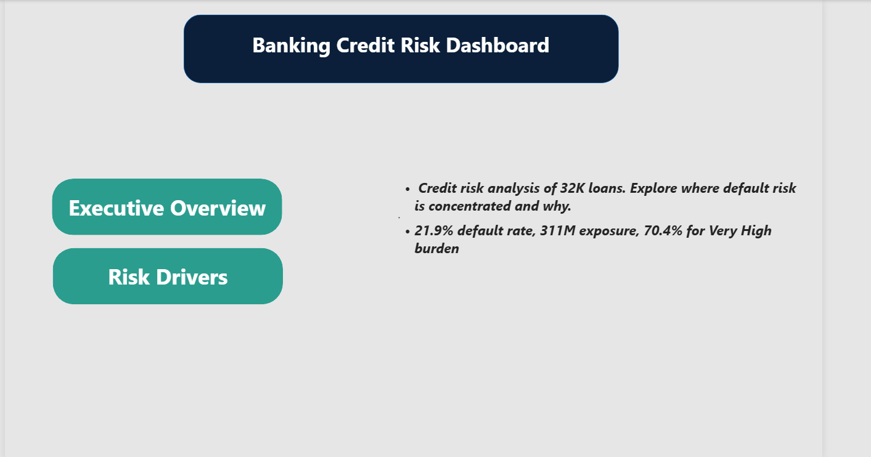
Figure 1: Home page

Executive Overview
Headline KPIs (loans, exposure, default rate, average interest rate) with default rate by grade, income band and loan purpose, and the portfolio mix by risk bucket. Grades D to G are coloured red so the cliff stands out.
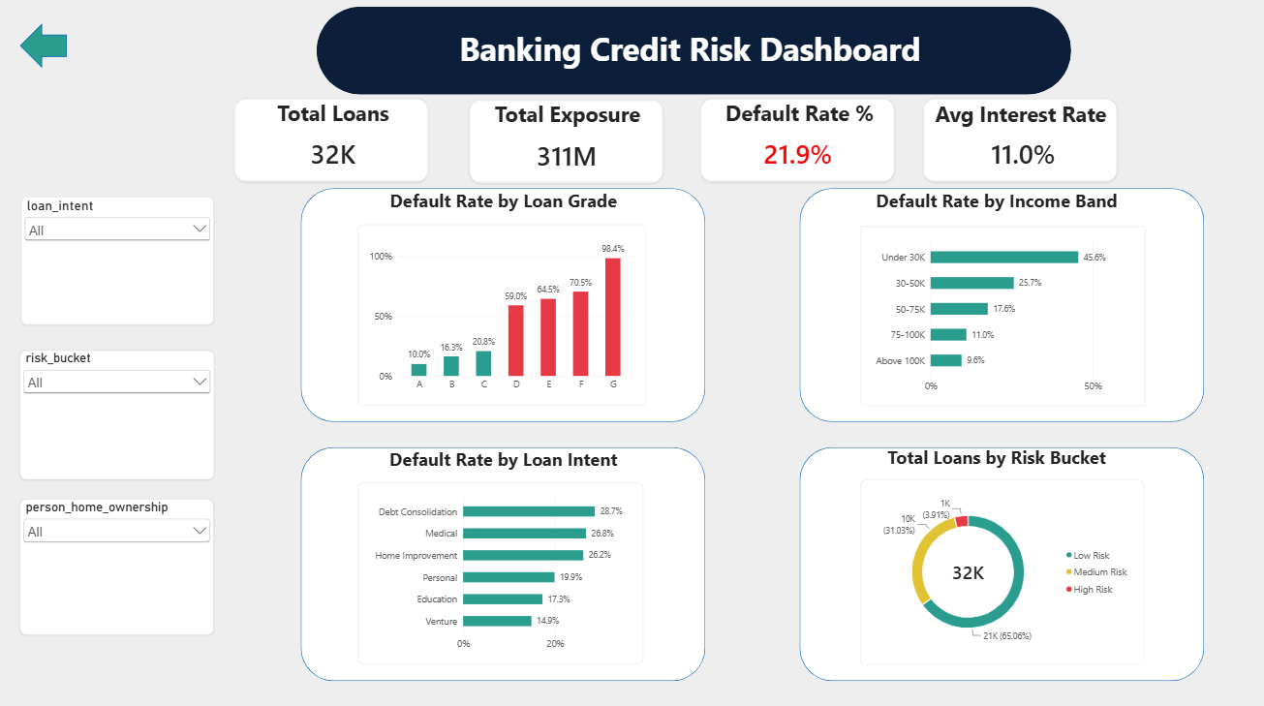
Figure 2: Executive Overview page

Risk Drivers
Explains why default happens: debt burden, past default history, home ownership, interest rate by grade, and a heat-map matrix of income against debt burden. Dotted reference lines show the portfolio average.
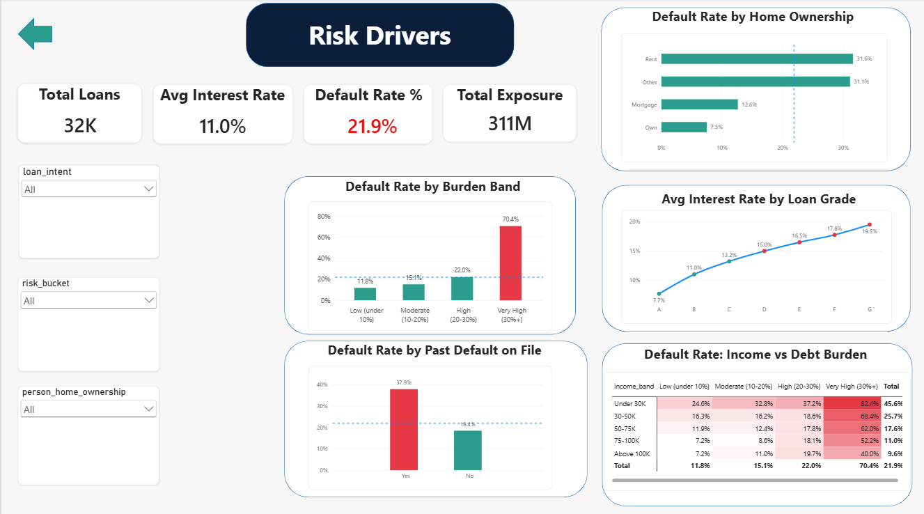
Figure 3: Risk Drivers page

7. Recommendations
- Cap or review high-burden loans. Add a stricter approval step for loans above 30% of income, the single largest source of default.
- Re-examine pricing and limits for grades D to G. Default rates of 59% to 98% are not matched by the interest rate increase, so either price these loans higher or limit exposure.
- Tighten checks for borrowers with a past default, who default at roughly twice the rate of others (37.9% vs 18.4%).
- Use smaller limits for borrowers under 30K income, particularly when combined with debt consolidation or medical purposes.
- Do not use age as a risk criterion. It shows no relationship with default in this data, and relying on it would add unfairness without adding accuracy.

8. Limitations
- No dates. The data has no time column, so trends and seasonality could not be analysed.
- No recovery or loss amounts. Default rate is not the same as financial loss, so the pricing conclusion is a hypothesis, not proof.
- Grade is assigned by the bank, so it labels risk rather than causing it. Income and burden are closer to causal drivers.
- Correlation is not causation, and all correlations here are modest.
- Small groups give unstable percentages (grade G, and 'Other' home ownership with about 100 loans).
- Public dataset. It may not represent any specific bank's portfolio.

9. Conclusion and Next Steps
The analysis shows that default risk in this portfolio is highly concentrated and largely explained by three things: how large the loan is relative to income, the credit grade, and the borrower's income level. The dashboard lets a risk manager see this at a glance and drill into any segment.
Possible extensions:
- Build a probability of default model (logistic regression, then gradient boosting) and evaluate it with ROC-AUC, using class-weighting for the 4:1 imbalance.
- Add Expected Loss = PD x LGD x EAD if recovery data becomes available.
- Test a dataset with dates to add trend analysis and early-warning indicators.

