BANKING CREDIT RISK ANALYSIS
A look at which borrowers default on loans, and why
Tools: Python (pandas, matplotlib, seaborn), Power BI (DAX)
Data: Credit Risk Dataset from Kaggle, 32,581 loan records, 12 columns

Summary
For this project I analysed a set of personal loans to answer a question every bank risk team cares about: which borrowers are most likely to default, and what is behind it? I cleaned and explored the data in Python, then built a three-page Power BI dashboard to show the results.
About 21.9% of the loans in the data defaulted, roughly one in five. The more useful result is that the defaults are not spread evenly. A few groups account for most of the problem.

32,409  Loans analysed | 311M  Total exposure | 21.9%  Overall default rate | 70.4%  Default rate, very high burden

- Loans that were more than 30% of the borrower's income defaulted 70.4% of the time. Loans under 10% of income defaulted 11.8% of the time.
- Grades A to C had default rates between 10% and 21%. For grades D to G the range was 59% to 98%.
- Low income and a heavy debt burden made things worse together: borrowers earning under 30K with a very high burden defaulted 82.4% of the time.
- Age made almost no difference (20.2% to 23.1% across age groups).

1. The Business Problem
When a borrower stops repaying, the bank loses money. I wanted to find out where that risk sits in a loan portfolio and which borrower or loan details explain it, so a bank could decide who to lend to, how to price loans and which accounts to watch.
I wrote down five questions to guide the work:
- What is the overall default rate, and how much money is at risk?
- Which grades, loan purposes and income groups are riskiest?
- How do debt burden, interest rate and past defaults relate to default?
- Which combinations of borrower traits make up the highest-risk group?
- Do interest rates reflect the risk?
I treated a bank risk manager as the reader of the dashboard. Page one gives the overall picture and page two explains the causes.
A few terms used throughout:
Term | Meaning here
Default | The borrower stopped repaying (loan_status = 1)
Default rate | Share of loans that defaulted
Exposure | Total money lent, the sum of loan amounts
Debt burden | Loan amount as a share of yearly income (loan_percent_income)
Credit grade | The bank's rating of the borrower, A (safest) to G (riskiest)

2. The Data
I first looked at the Lending Club data, but it has around 2 million rows and over 100 columns, which was too much for a first dashboard. I switched to the Credit Risk Dataset on Kaggle. It has 32,581 rows and 12 columns, and it already includes a default column, so I could spend my time on cleaning and analysis.
In the raw data 21.8% of loans were defaults. That is about four repaid loans for every default, which is normal for lending, but it means percentages are more useful than raw counts when comparing groups.
Column | Description | Type
person_age | Borrower age | Numeric
person_income | Yearly income | Numeric
person_home_ownership | Rent / Mortgage / Own / Other | Category
person_emp_length | Years employed | Numeric
loan_intent | Loan purpose | Category
loan_grade | Credit grade A to G | Category
loan_amnt | Loan amount | Numeric
loan_int_rate | Interest rate (%) | Numeric
loan_status | Target: 0 = repaid, 1 = default | Binary
loan_percent_income | Loan as a share of income | Numeric
cb_person_default_on_file | Past default on record (Y/N) | Category
cb_person_cred_hist_length | Years of credit history | Numeric

3. Cleaning the Data
I worked on a copy of the data so the original stayed untouched, and I wrote down the row count after every step.
Step | Action | Rows before | Removed | Rows after
1 | Load raw data | 32,581 | 0 | 32,581
2 | Remove exact duplicate rows | 32,581 | 165 | 32,416
3 | Remove impossible values (age over 100, employment over 60 years) | 32,416 | 7 | 32,409
4 | Fill missing employment length (895 in the raw data) and interest rate (3,116) with the median | 32,409 | 0 | 32,409
5 | Cap very high incomes at the 99th percentile (225,000) in a new column | 32,409 | 0 | 32,409
6 | Tidy text labels and create banded columns | 32,409 | 0 | 32,409

Altogether I removed 172 rows, about 0.5% of the data.
Running describe() showed the problems quickly: a maximum age of 144, a maximum employment length of 123 years, and a maximum income of 6 million. The first two are clearly errors, so I deleted those rows. The income was different. Fifty-one borrowers earned more than 500K, and while that is unusual, it is possible. Deleting real customers would throw away real information, so I kept them and added a second column with income capped at 225,000. That way the original numbers are still there, and the charts are not stretched by a handful of very high earners.
For the missing values I used the median instead of the mean, because extreme values pull the mean up or down while the median stays steady. The text columns had no spelling problems, so I only changed labels to make them readable in charts (for example DEBTCONSOLIDATION became Debt Consolidation).

4. New Columns
Exact values like age 27 are too detailed for a dashboard, so I grouped borrowers into bands. I also added number columns that tell Power BI what order the bands go in, because otherwise it sorts them alphabetically.
New column | How it is built
age_group | Up to 25, 26-30, 31-35, 36-45, 46+
income_band | Under 30K, 30-50K, 50-75K, 75-100K, Above 100K
loan_amount_band | Up to 5K, 5-10K, 10-15K, 15-20K, 20K+
burden_band | Low (under 10%), Moderate (10-20%), High (20-30%), Very High (30%+) of income
risk_bucket | Grades A-B = Low, C-D = Medium, E-G = High (this also fixes the tiny sample sizes of grades F and G)
loan_outcome | Repaid or Defaulted, as a readable label
income_capped | Income limited to 225,000

5. What the Data Shows

5.1 Loan grade and interest rates
Default rises with grade, but not in a smooth line. Between grades C and D the default rate nearly triples, from 20.8% to 59.0%. Over the same step, the average interest rate goes up by less than two points.
Grade | A | B | C | D | E | F | G
Default rate | 10.0% | 16.3% | 20.8% | 59.0% | 64.5% | 70.5% | 98.4%
Avg interest rate | 7.7% | 11.0% | 13.2% | 15.0% | 16.5% | 17.8% | 19.5%
Grade G is based on only 64 loans in the raw data, so I read the 98.4% as 'almost all of a small group defaulted'.

5.2 Borrower and loan details
Segment | Group | Default rate
Income band | Under 30K / 30-50K / 50-75K / 75-100K / Above 100K | 45.6% / 25.7% / 17.6% / 11.0% / 9.6%
Debt burden | Low / Moderate / High / Very High | 11.8% / 15.1% / 22.0% / 70.4%
Past default on file | Yes / No | 37.9% / 18.4%
Home ownership | Rent / Other / Mortgage / Own | 31.6% / 31.1% / 12.6% / 7.5%
Loan purpose | Debt consolidation / Medical / Home improvement | 28.7% / 26.8% / 26.2%
 | Personal / Education / Venture | 19.9% / 17.3% / 14.9%
Age group | Up to 25 / 26-30 / 31-35 / 36-45 / 46+ | 23.1% / 20.9% / 20.2% / 20.7% / 22.3%

People borrowing to consolidate debt or pay medical bills defaulted more than people borrowing for a venture or education, which fits the idea that financial pressure leads to missed payments. Renters defaulted about four times as often as owners. Age showed no real pattern.

5.3 Correlation with default
I used a correlation heatmap to check the numeric columns. Debt burden and interest rate came out on top, but none of the correlations are strong, so default seems to depend on several things together rather than any one.
Variable | Correlation with default | Comment
loan_percent_income | +0.38 | Strongest: bigger loan relative to income
loan_int_rate | +0.32 | Higher rate goes with higher default
person_income | -0.17 | Higher income goes with lower default
loan_amnt | +0.11 | Weak
person_emp_length | -0.09 | Weak
person_age | -0.02 | None
Age and credit history length are closely related to each other (0.88), so they tell almost the same story.

5.4 Income and debt burden together
The most useful view was income and debt burden side by side. Each cell is the default rate for that group.
Income band | Low burden | Moderate | High | Very High | Total
Under 30K | 24.6% | 32.8% | 37.2% | 82.4% | 45.6%
30-50K | 16.3% | 16.2% | 18.6% | 68.4% | 25.7%
50-75K | 11.9% | 12.4% | 17.8% | 62.0% | 17.6%
75-100K | 7.2% | 8.6% | 18.1% | 52.2% | 11.0%
Above 100K | 7.2% | 11.0% | 19.7% | 40.0% | 9.6%
Total | 11.8% | 15.1% | 22.0% | 70.4% | 21.9%

A very high burden is risky at every income level, even above 100K, where it still defaults at 40.0%. Low income makes it worse. Putting it together, the typical high-risk borrower in this data earns little, rents, has a loan above 30% of income and holds a grade of D or lower.

6. The Power BI Dashboard
The dashboard has three pages. I used navy for headers, teal for normal values and red only for risk and default, so red draws the eye to the problem areas. The slicers (loan purpose, risk bucket, home ownership) are synced across pages. The main measure is Default Rate % = DIVIDE([Defaults], [Total Loans]).

Home page
A simple landing page with buttons to the other two pages.
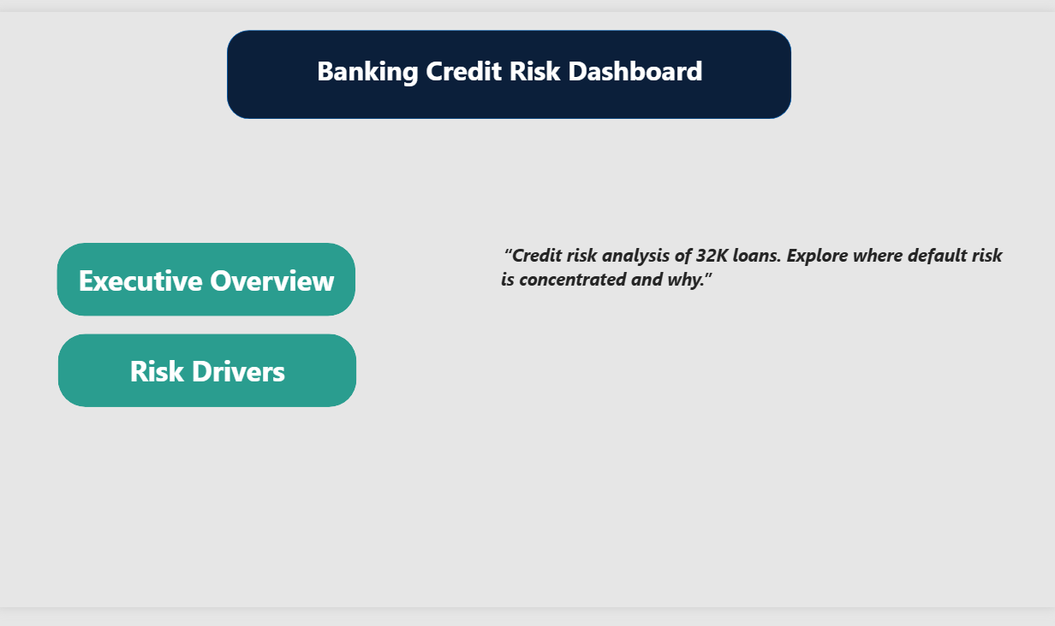
Figure 1: Home page

Executive Overview
The top row shows total loans, total exposure, default rate and average interest rate. Below that are default rate by grade, income band and loan purpose, and the portfolio split by risk bucket. Grades D to G are red so the jump after grade C is easy to see.
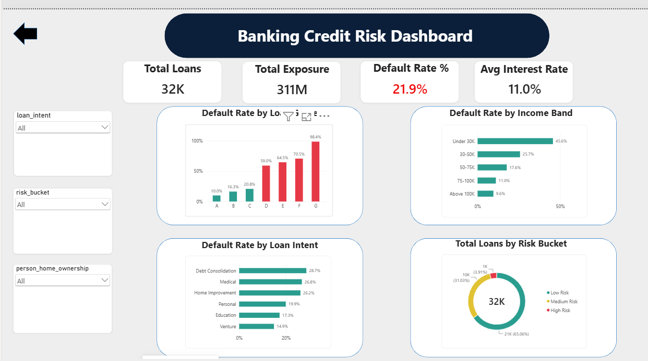
Figure 2: Executive Overview page

Risk Drivers
This page looks at why default happens: debt burden, past default, home ownership, interest rate by grade, and a heat map of income against debt burden. The dotted lines mark the portfolio average of 21.9%.
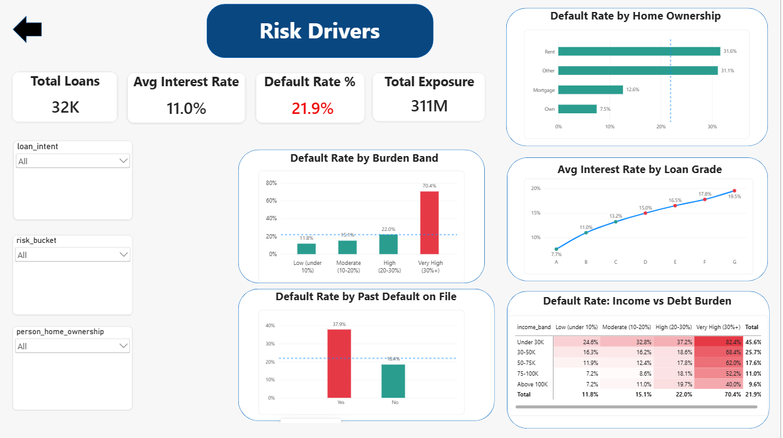
Figure 3: Risk Drivers page

7. Problems I Ran Into
Not everything worked the first time, and fixing these taught me more than the parts that went smoothly.
- Dataset too large. My first choice, Lending Club, was too big and had too many columns. Moving to a smaller dataset let me finish the full process properly.
- A column that did not exist. I tried to check credit_score and got an error, because that column is not in this version of the data. I now run df.columns before using a column name.
- Bands sorted alphabetically in Power BI. Income bands showed as 30-50K, 50-75K, 75-100K, Above 100K, Under 30K. I fixed it with a sort-order column and the Sort by column option. At first I set the order column to sort by the band column as well, which caused a circular dependency error. The order column has to sort by itself.
- Numbers that looked wrong. At one point the donut chart showed 106 loans in total. A slicer was still set to the 'Other' home ownership group. Since then I reset all slicers to All before saving.
- Busy background. My first version had a bank photo behind the charts, which made them harder to read. A plain light background worked much better.

8. Recommendations
Based on what the data shows, a bank could consider:
- Adding an extra approval step for loans above 30% of the borrower's income, since this group defaults most.
- Reviewing the pricing and limits for grades D to G. Their default rates are far higher, but the interest rate only rises a little.
- Checking borrowers with a past default more carefully. They default at about twice the rate of others (37.9% against 18.4%).
- Offering smaller limits to borrowers earning under 30K, especially for debt consolidation and medical loans.
- Not using age as a risk factor. It had no relationship with default here.

9. Limitations
The results should be read with these limits in mind. The data has no dates, so I could not look at trends over time. It also has no recovery or loss amounts, which means default rate is not the same as money lost, and my point about under-priced grades is a guess that would need that data to confirm. The grade is set by the bank, so it reflects risk rather than causing it. All correlations are modest, and correlation does not prove cause. A few groups are small (grade G and the 'Other' home ownership group, about 100 loans), so their percentages can swing a lot. Finally, this is a public dataset and may not look like any real bank's portfolio.

10. What I Would Do Next
- Build a model that predicts probability of default, starting with logistic regression and then trying gradient boosting, and check it with ROC-AUC.
- Add expected loss (probability of default x loss given default x exposure at default) if recovery data can be found.
- Try a dataset with dates so the dashboard can show trends.

