**Help**

**Ecommerce Shopping Site**

This is the help page to describe how to use Ecommerce Shopping Site.

While opening the website, the home page with various options is displayed as follow:

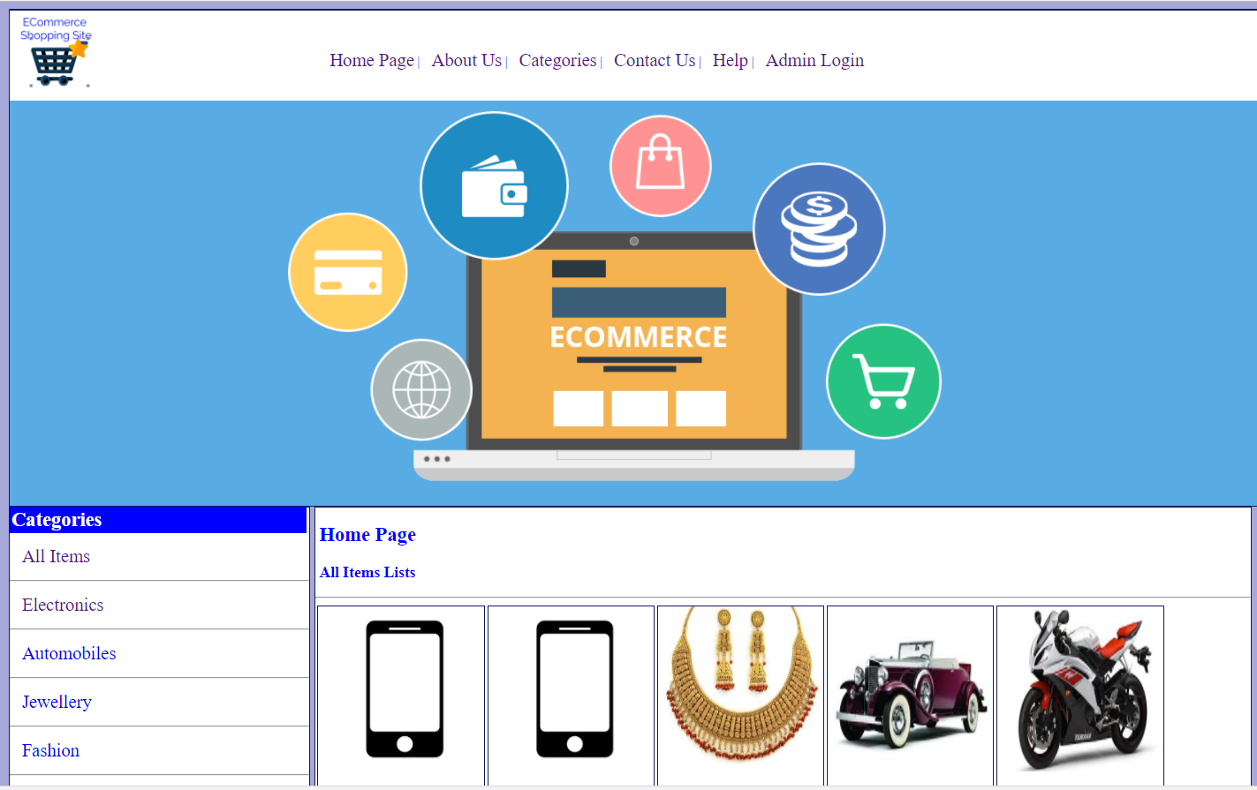

For the admin there is admin login, where admin can enter username and password and enter inside the system:

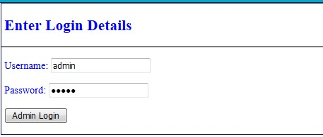

Inside admin panel, admin can perform various activities like:

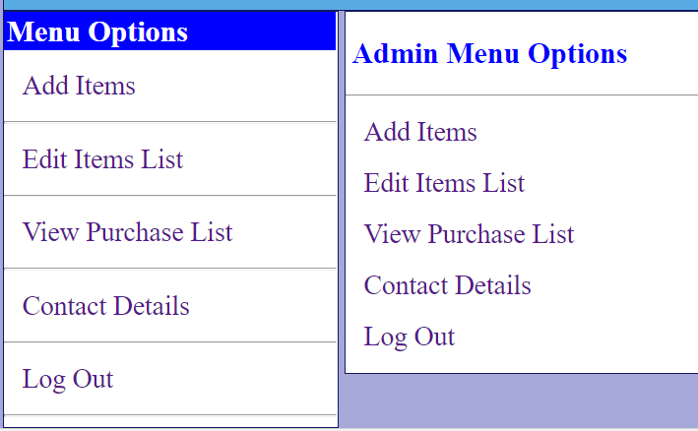

For normal user, Login is not required, and they can simply access the menu to perform various activities. In the header there are various options, which can be accessed.

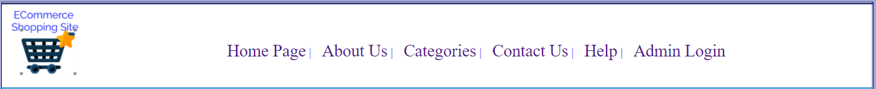

The Home Page Option will direct to index page.

The About Us page is used to view the details of the website/company as follows:

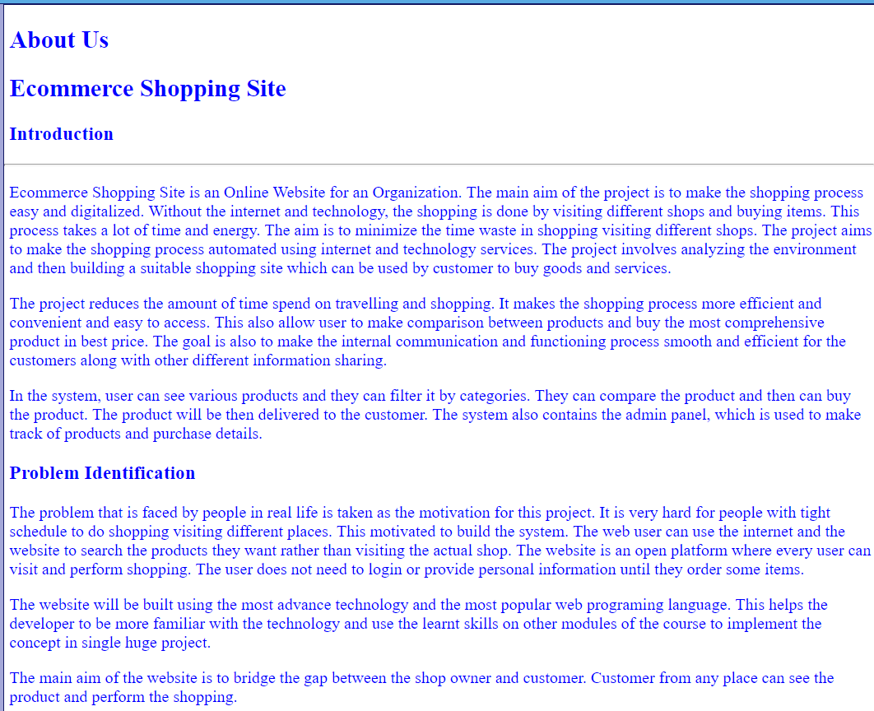

The Category page is used to view items according to different categories as follows whereas different categories are also shown in left side in every page:

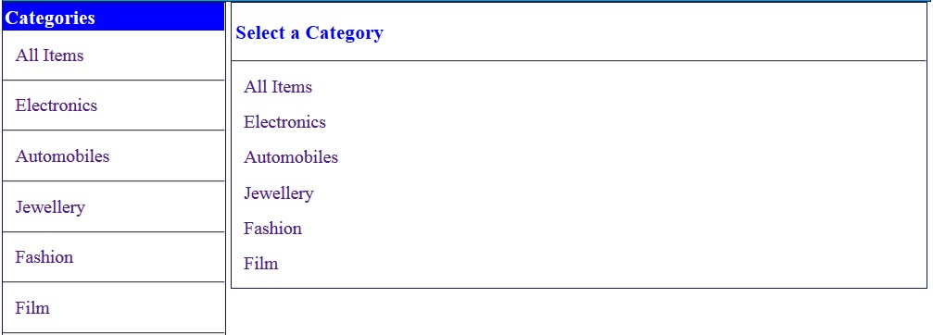

The Contact Us page is used to get the contact details of the company and also to send query to company:

