Bansilal Ramnath Agarwal Charitable Trust’s

VISHWAKARMA INSTITUTE OF TECHNOLOGY – PUNE

DATA STRUCTURES

Division | SY CS-A
Batch | 3
GR Number (PRN) | 12413247
Roll No. | 72
Name | ATHARVA DHAMDHERE

ASSIGNMENT 4

PROBLEMS:

Implement basic string operations such as length calculation, copy, reverse, and concatenation using character single dimensional arrays without using built-in string library functions.
- Write a program to construct and verify a magic square of order 'n' (for both even & odd) such that all rows, columns, and diagonals sum to the same value.
- Implement matrix multiplication and analyse its performance using row-major.
- Develop a program to identify and efficiently store a sparse matrix using compact representation and perform basic operations like display and simple transpose.
- Develop a program to compute the fast transpose of a sparse matrix using its compact (triplet) representation efficiently.

OBJECTIVES:
- To understand and implement basic data structures such as one-dimensional and two-dimensional arrays for representing strings and matrices.
- To explore the concept of sparse matrices, recognize the need for efficient storage, and implement compact (triplet) representations.
- To study and compare transpose operations by implementing both simple and fast transpose methods, and to analyze their efficiency in terms of time and space.
- To implement matrix multiplication using appropriate algorithms and measure the computational time taken for execution.
- To analyze algorithmic efficiency, focusing on the trade-off between simplicity and performance in different approaches.
- To gain hands-on experience in applying theoretical concepts of data structures to practical coding problems.
- To develop problem-solving and logical thinking skills by handling real-time data structure operations.

THEORY:

In this assignment, we engaged with some of the most fundamental concepts of data structures and examined their real-world applications through practical coding exercises. Among these, arrays serve as the foundation for many advanced data structures and algorithms. Arrays store multiple elements of the same type in contiguous memory locations, allowing efficient access through indexing. A one-dimensional array, for instance, can be effectively used to represent strings, where each character is stored sequentially and the string is terminated by a null character ('\0'). By implementing string operations such as calculating length, copying, reversing, and concatenation manually—without relying on predefined library functions—we gained a deeper understanding of memory-level operations and developed essential problem-solving skills. This exercise reinforced how low-level manipulations provide the backbone for higher-level abstractions in programming.

The concept of arrays naturally extends to two-dimensional arrays, which are particularly useful in representing matrices. Matrices play a vital role in numerous fields, from mathematics and physics to computer graphics and machine learning. Through this assignment, we implemented basic matrix operations like input, display, and multiplication using nested loops. Matrix multiplication was particularly important as it demonstrated how the efficiency of nested iterations and traversal patterns directly impacts computational performance. This experience laid the groundwork for analyzing time complexity in large datasets, emphasizing how the organization of data and the chosen algorithm can affect execution speed significantly.

Additionally, we explored the concept of magic squares, which are special matrices where the sums of rows, columns, and diagonals are equal. Constructing magic squares encouraged us to engage in algorithmic thinking and logical design strategies, since odd-order and even-order magic squares require different construction methods. Odd-order squares are typically generated using the diagonal wrap-around algorithm, while even-order cases demand more sophisticated approaches. Working on this problem improved our ability to recognize patterns, devise algorithms, and iteratively refine solutions. Such exercises bridge the gap between theoretical mathematics and practical computer science applications.
Another critical area studied was sparse matrices. A sparse matrix is defined as one where the majority of elements are zero. Storing such matrices in their original form leads to significant memory wastage. To address this inefficiency, we implemented the compact (triplet) representation, which stores only the non-zero elements along with their row and column indices. This approach results in substantial memory savings while making computations faster and more focused, as operations only involve meaningful data. Sparse matrices are not just an academic concept—they have extensive applications in graph theory, network modeling, scientific simulations, optimization problems, and database systems. By understanding sparse representations, we became familiar with how space complexity can be optimized in large-scale real-world systems.
We also examined the transpose operation on matrices, with a focus on compact representations. The transpose involves interchanging rows and columns, and in sparse form, this can be performed using two approaches: simple transpose and fast transpose. The simple method involves traversing through every non-zero element and repositioning it, which, while straightforward, can become inefficient for very large datasets, with a time complexity of O(n²). The fast transpose algorithm, however, introduced us to the concept of auxiliary arrays for counting the distribution of elements across columns. This allowed us to directly determine where each element should be placed in the transposed matrix, drastically improving efficiency. The result is a time complexity of O(n), which represents a significant performance improvement over the naïve approach. This exercise highlighted the importance of algorithmic optimization and how clever use of auxiliary structures can reduce execution time and computational overhead.
Furthermore, the assignment exposed us to the concepts of time complexity and space complexity, which are critical for evaluating algorithmic performance. Time complexity measures how the computational effort grows with input size, while space complexity measures the memory required to store input, auxiliary data structures, and intermediate results. Analyzing these complexities helped us appreciate the balance between correctness, efficiency, and resource utilization. In real-world computing environments, where datasets are massive and resources are finite, such analysis becomes indispensable.
Overall, this assignment not only deepened our technical knowledge of arrays, matrices, sparse representations, and transpose algorithms but also nurtured an appreciation for the practical relevance of data structures in solving computational problems efficiently. By combining theoretical understanding with hands-on coding practice, we gained the ability to critically evaluate different approaches, identify trade-offs, and make informed decisions when designing algorithms for real-world applications.

ALGORITHMS

Program 1

Step 1: Start the program.
Step 2: Declare required variables
- str_1[100] → to store the main string
- str_2[100] → to store copied string
- choice → for user menu selection
Step 3: Display a menu with the following options:
- Enter String
- Calculate String Length
- Copy String
- Reverse String
- Concatenate Strings
- Find Substring
- Exit
Step 4: Input user’s choice.
Step 5: Perform actions based on choice using switch-case:
Case 1: Enter String
Ask user to input a string.
Store it in str_1.
Print confirmation.
Case 2: Calculate String Length
Initialize length = 0.
Traverse str_1 character by character until '\0' is reached.
Increment length for each character.
Display original string and its length.
Case 3: Copy String
Traverse str_1 and copy each character into str_2.
Append '\0' at the end of str_2.
Display both original and copied string.
Case 4: Reverse String
Find length of str_1.
Traverse string from end to start, copying characters into a new string rev_str.
Append '\0'.
Display reversed string.
Case 5: Concatenate Strings
Ask user to input a second string str_2.
Copy all characters of str_1 into str_3.
Append all characters of str_2 after it.
Add '\0' at the end.
Display concatenated string.
Case 6: Find Substring
Input substring into substr.
For each position i in str_1, compare characters with substr.
If all characters match, mark substring as found.
Display result (found / not found).
Case 7: Exit
Display exit message.
Terminate program.
Step 6: Repeat steps 3–5 until user selects Exit.
Step 7: Stop the program.

Program 2

1. Start.
2. Input the size n of the magic square.
3. Dynamically allocate a 2D array magicSquare[n][n] and initialize all elements to 0.
4. Check if n is odd or even:
Case A: If n is odd → Use Siamese method
Set starting position: i = n/2, j = n-1.
For each number num from 1 to n*n:
If (i == -1 && j == n) → move to i = 0, j = n-2.
If j == n, wrap around → j = 0.
If i < 0, wrap around → i = n-1.
If the current cell square[i][j] is already filled → move to i = i+1, j = j-2.
Else, place num at square[i][j].
Move to next position → i--, j++.
Case B: If n is even → Use even-order construction
Fill the matrix sequentially with numbers from 1 to n².
Replace numbers at specific positions with (n*n + 1 – value) based on rules:
Top-left n/4 × n/4 block.
Top-right n/4 × n/4 block.
Bottom-left n/4 × n/4 block.
Bottom-right n/4 × n/4 block.
Center (n/2 × n/2) block.

5. Print the final magic square.
6. Free the dynamically allocated memory.
7. Stop.

Program 3
- Start the program.
- Read the size of the first matrix (rows1, cols1).
- Read the size of the second matrix (rows2, cols2).
- Check if multiplication is possible (cols1 == rows2).
  - If not possible → print message and stop.
- Create memory for both matrices and result matrix.
- Input elements of the first matrix.
- Input elements of the second matrix.
- Display both matrices.
- Start timer.
- Multiply the matrices using triple nested loops.
- Stop timer and display time taken.
- Print the resultant matrix.
- Free the allocated memory.
- End program.

Program 4
1. Start.
2. Input number of rows m and columns n.
3. Declare a matrix matrix[m][n].
4. Input all elements of the matrix.
- Keep a count of zeroCount (number of zeros).
5. Calculate total elements = m * n.
6. Check if matrix is sparse:
- If zeroCount <= total/2 → print "Matrix is NOT Sparse" and stop.
- Else → proceed to compact representation.
7. Construct Compact Representation (Triplet form).
- Initialize k = 0.
- For each element matrix[i][j]:
  - If value ≠ 0 → store row = i, col = j, value = matrix[i][j] in compact[k].
  - Increment k.
- Print the compact representation in tabular form: Row, Col, Value.
8. Perform Simple Transpose.
- For each entry in compact array:
  - Swap row and column → (row, col, value) becomes (col, row, value).
- Print transposed compact representation.
9. Stop.

Program 5

Step 1: Input Matrix
- Read number of rows m and columns n.
- Read all elements of the matrix.
Step 2: Check Sparsity
- Count number of zeros in the matrix.
- If zeros ≤ 50% of total elements → print “Matrix is NOT Sparse” and stop.
- Else → continue.
Step 3: Create Compact Representation
- For each non-zero element:
  - Store its (row, col, value) in a list/array.
- Display the compact representation.
Step 4: Prepare for Fast Transpose
- Count number of non-zero elements in each column → colCount.
- Compute starting positions for each column → startPos.
Step 5: Fast Transpose
- For each element in compact list:
  - Place it in transposed array at position startPos[column].
  - Swap row and column values.
  - Increment startPos[column].
- Display the transposed compact representation.
Step 6: End

PROGRAMS

Program 1
#include <iostream>
using namespace std;

int main() {
char str_1[100], str_2[100];
int choice;

do {
cout << "\n=== String Operations Menu ===\n";
cout << "1. Enter String\n";
cout << "2. Calculate String Length\n";
cout << "3. Copy String\n";
cout << "4. Reverse String\n";
cout << "5. Concatenate Strings\n";
cout << "6. Find Substring\n";
cout << "7. Exit\n";
cout << "Enter your choice: ";
cin >> choice;
cin.ignore();

switch (choice) {
case 1: {
cout << "Enter string: ";
cin.getline(str_1, 100);
cout << "String entered successfully: " << str_1 << endl;
break;
}
case 2: {
int i = 0, length = 0;
while (str_1[i] != '\0') {
length++;
i++;
}
cout << "Original string: " << str_1 << endl;
cout << "Length of the string: " << length << endl;
break;
}
case 3: {
// Copy string without using strcpy()
int i = 0;
while (str_1[i] != '\0') {
str_2[i] = str_1[i];
i++;
}
str_2[i] = '\0';
cout << "Original string: " << str_1 << endl;
cout << "Copied string: " << str_2 << endl;
break;
}
case 4: {
int i = 0, len = 0;
while (str_1[i] != '\0') {
len++;
i++;
}

char rev_str[100];
for (i = 0; i < len; i++) {
rev_str[i] = str_1[len - 1 - i];
}
rev_str[len] = '\0';

cout << "Original string: " << str_1 << endl;
cout << "Reversed string: " << rev_str << endl;
break;
}
case 5: {
char str_3[200];
cout << "Enter second string: ";
cin.getline(str_2, 100);

int i = 0, j = 0;
while (str_1[i] != '\0') {
str_3[i] = str_1[i];
i++;
}
while (str_2[j] != '\0') {
str_3[i] = str_2[j];
i++;
j++;
}
str_3[i] = '\0';

cout << "First string: " << str_1 << endl;
cout << "Second string: " << str_2 << endl;
cout << "Concatenated string: " << str_3 << endl;
break;
}
case 6: {
char substr[100];
cout << "Enter substring to search: ";
cin.getline(substr, 100);
int i = 0, found = 0;
while (str_1[i] != '\0') {
int j = 0, k = i;
while (str_1[k] == substr[j] && substr[j] != '\0' && str_1[k] != '\0') {
k++;
j++;
}
if (substr[j] == '\0') {
found = 1;
break;
}
i++;
}

cout << "Original string: " << str_1 << endl;
cout << "Substring to find: " << substr << endl;
if (found)
cout << "Substring found in the string.\n";
else
cout << "Substring not found in the string.\n";
break;
}
case 7:
cout << "Exiting program...\n";
break;
default:
cout << "Invalid choice! Please try again.\n";
}
} while (choice != 7);
return 0;
}

Program 2

#include <iostream>
using namespace std;

void generateOddMagicSquare(int** square, int n) {
int i = n/2, j = n-1;
for (int num = 1; num <= n*n;) {
if (i == -1 && j == n) {
j = n-2;
i = 0;
}
else {
if (j == n)
j = 0;

if (i < 0)
i = n-1;
}
if (square[i][j])
{
j -= 2;
i++;
continue;
}
else
square[i][j] = num++;
j++;
i--;
}
}

void generateEvenMagicSquare(int** square, int n) {
for(int i = 0; i < n; i++)
for(int j = 0; j < n; j++)
square[i][j] = ((i+1)*(j+1));

for(int i = 0; i < n/4; i++)
for(int j = 0; j < n/4; j++)
square[i][j] = (n*n + 1) - square[i][j];

for(int i = 0; i < n/4; i++)
for(int j = 3*(n/4); j < n; j++)
square[i][j] = (n*n + 1) - square[i][j];

for(int i = 3*(n/4); i < n; i++)
for(int j = 0; j < n/4; j++)
square[i][j] = (n*n + 1) - square[i][j];

for(int i = 3*(n/4); i < n; i++)
for(int j = 3*(n/4); j < n; j++)
square[i][j] = (n*n + 1) - square[i][j];

for(int i = n/4; i < 3*(n/4); i++)
for(int j = n/4; j < 3*(n/4); j++)
square[i][j] = (n*n + 1) - square[i][j];
}

void printMagicSquare(int** square, int n) {
for(int i = 0; i < n; i++) {
for(int j = 0; j < n; j++)
cout << square[i][j] << "\t";
cout << endl;
}
}

int main() {
int n;
cout << "Enter the size of magic square: ";
cin >> n;

int** magicSquare = new int*[n];
for(int i = 0; i < n; i++)
magicSquare[i] = new int[n]();

if(n % 2 == 0)
generateEvenMagicSquare(magicSquare, n);
else
generateOddMagicSquare(magicSquare, n);

cout << "\nThe Magic Square is:\n";
printMagicSquare(magicSquare, n);

for(int i = 0; i < n; i++)
delete[] magicSquare[i];
delete[] magicSquare;

return 0;
}

Program 3
#include <iostream>
#include <chrono>
using namespace std;

void inputMatrix(int** matrix, int rows, int cols) {
for(int i = 0; i < rows; i++) {
for(int j = 0; j < cols; j++) {
cout << "Enter element [" << i << "][" << j << "]: ";
cin >> matrix[i][j];
}
}
}

void displayMatrix(int** matrix, int rows, int cols) {
for(int i = 0; i < rows; i++) {
for(int j = 0; j < cols; j++) {
cout << matrix[i][j] << "\t";
}
cout << endl;
}
}

void multiplyMatrices(int** matrix1, int** matrix2, int** result,
int rows1, int cols1, int cols2) {
auto start = chrono::high_resolution_clock::now();

for(int i = 0; i < rows1; i++) {
for(int j = 0; j < cols2; j++) {
result[i][j] = 0;
for(int k = 0; k < cols1; k++) {
result[i][j] += matrix1[i][k] * matrix2[k][j];
}
}
}

auto end = chrono::high_resolution_clock::now();
auto duration = chrono::duration_cast<chrono::microseconds>(end - start);

cout << "\nTime taken by multiplication: " << duration.count() << " microseconds" << endl;
}

int main() {
int rows1, cols1, rows2, cols2;

cout << "Enter dimensions of first matrix (rows cols): ";
cin >> rows1 >> cols1;

cout << "Enter dimensions of second matrix (rows cols): ";
cin >> rows2 >> cols2;

if(cols1 != rows2) {
cout << "Matrix multiplication not possible!" << endl;
return 1;
}

int** matrix1 = new int*[rows1];
int** matrix2 = new int*[rows2];
int** result = new int*[rows1];

for(int i = 0; i < rows1; i++) matrix1[i] = new int[cols1];
for(int i = 0; i < rows2; i++) matrix2[i] = new int[cols2];
for(int i = 0; i < rows1; i++) result[i] = new int[cols2];

cout << "\nEnter elements of first matrix:\n";
inputMatrix(matrix1, rows1, cols1);

cout << "\nEnter elements of second matrix:\n";
inputMatrix(matrix2, rows2, cols2);
cout << "\nFirst Matrix:\n";
displayMatrix(matrix1, rows1, cols1);
cout << "\nSecond Matrix:\n";
displayMatrix(matrix2, rows2, cols2);
multiplyMatrices(matrix1, matrix2, result, rows1, cols1, cols2);

cout << "\nResultant Matrix:\n";
displayMatrix(result, rows1, cols2);
for(int i = 0; i < rows1; i++) delete[] matrix1[i];
for(int i = 0; i < rows2; i++) delete[] matrix2[i];
for(int i = 0; i < rows1; i++) delete[] result[i];
delete[] matrix1;
delete[] matrix2;
delete[] result;

return 0;
}

Program 4
#include <iostream>
using namespace std;

struct Element {
int row;
int col;
int value;
};

int main() {
int m, n;
cout << "Enter number of rows and columns: ";
cin >> m >> n;

int matrix[20][20];
cout << "Enter matrix elements:\n";
int zeroCount = 0;

for (int i = 0; i < m; i++) {
for (int j = 0; j < n; j++) {
cin >> matrix[i][j];
if (matrix[i][j] == 0)
zeroCount++;
}
}

int total = m * n;
if (zeroCount <= total / 2) {
cout << "\nMatrix is NOT Sparse (less than 50% zeros)." << endl;
return 0;
}

cout << "\nMatrix is Sparse. Compact Representation:\n";
Element compact[100];
int k = 0;

for (int i = 0; i < m; i++) {
for (int j = 0; j < n; j++) {
if (matrix[i][j] != 0) {
compact[k].row = i;
compact[k].col = j;
compact[k].value = matrix[i][j];
k++;
}
}
}

cout << "Row\tCol\tValue\n";
for (int i = 0; i < k; i++) {
cout << compact[i].row << "\t" << compact[i].col
<< "\t" << compact[i].value << endl;
}

// Simple Transpose
cout << "\nSimple Transpose (Row <-> Col):\n";
cout << "Row\tCol\tValue\n";
for (int i = 0; i < k; i++) {
cout << compact[i].col << "\t" << compact[i].row
<< "\t" << compact[i].value << endl;
}

return 0;
}

Program 5
#include <iostream>
using namespace std;

struct Element {
int row, col, value;
};

int main() {
int m, n;
cout << "Enter number of rows and columns: ";
cin >> m >> n;

int matrix[20][20];
cout << "Enter matrix elements:\n";
int zeroCount = 0;

// Read matrix & count zeros
for (int i = 0; i < m; i++) {
for (int j = 0; j < n; j++) {
cin >> matrix[i][j];
if (matrix[i][j] == 0) zeroCount++;
}
}

int total = m * n;
if (zeroCount <= total / 2) {
cout << "\nMatrix is NOT Sparse (less than 50% zeros)." << endl;
return 0;
}

// Step 1: Build Compact Representation
Element compact[100];
int k = 0;
for (int i = 0; i < m; i++) {
for (int j = 0; j < n; j++) {
if (matrix[i][j] != 0) {
compact[k].row = i;
compact[k].col = j;
compact[k].value = matrix[i][j];
k++;
}
}
}

cout << "\nCompact Representation:\nRow\tCol\tValue\n";
for (int i = 0; i < k; i++)
cout << compact[i].row << "\t" << compact[i].col << "\t" << compact[i].value << endl;

// Step 2: Fast Transpose
Element transpose[100];
int colCount[20] = {0};
int startPos[20] = {0};

// Count number of entries in each column
for (int i = 0; i < k; i++)
colCount[compact[i].col]++;

// Compute starting positions
startPos[0] = 0;
for (int i = 1; i < n; i++)
startPos[i] = startPos[i - 1] + colCount[i - 1];

// Place elements in transposed array
for (int i = 0; i < k; i++) {
int pos = startPos[compact[i].col]++;
transpose[pos].row = compact[i].col;
transpose[pos].col = compact[i].row;
transpose[pos].value = compact[i].value;
}

// Display fast transpose
cout << "\nFast Transpose (Row <-> Col):\nRow\tCol\tValue\n";
for (int i = 0; i < k; i++)
cout << transpose[i].row << "\t" << transpose[i].col << "\t" << transpose[i].value << endl;

return 0;
}

OUTPUT

Program 1
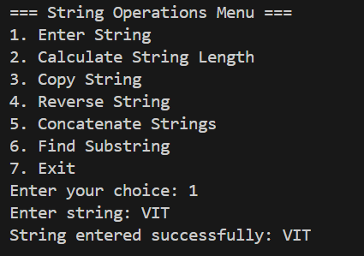
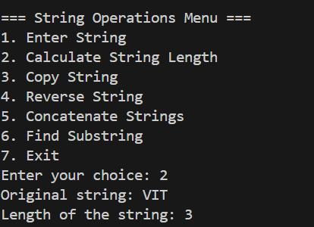

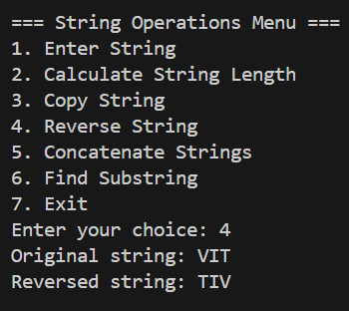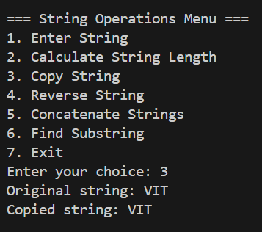

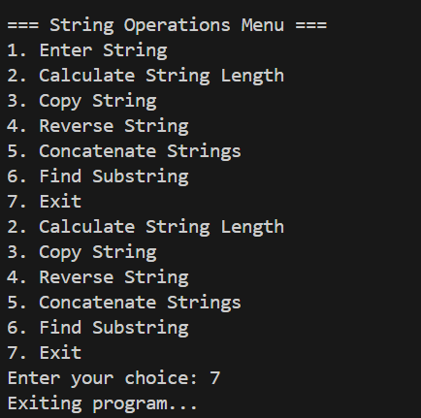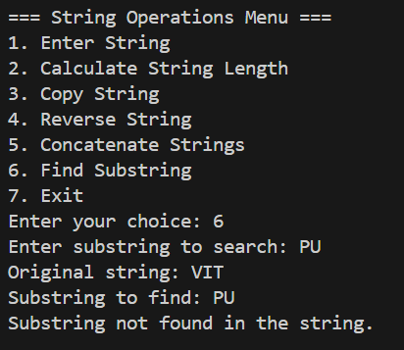

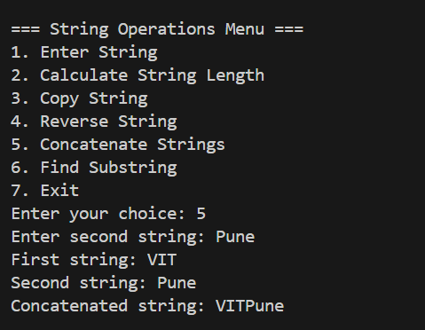

Program 2

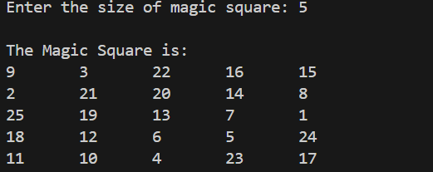

Program 3

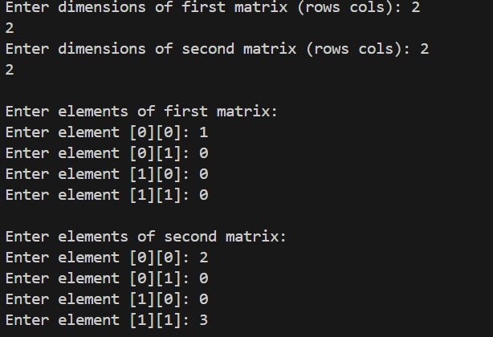
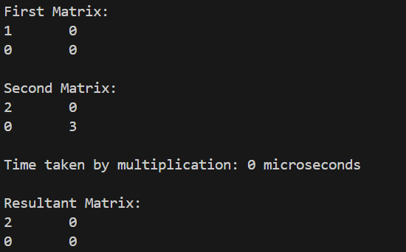

Program 4

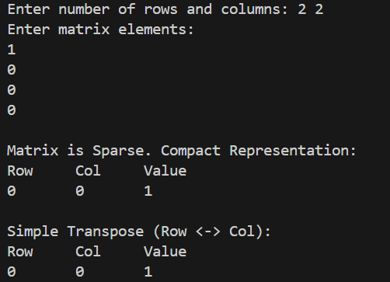

Program 5

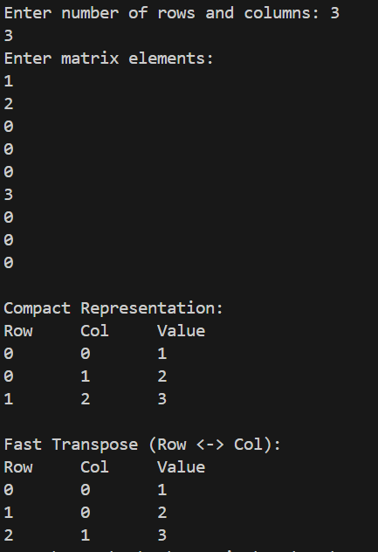

CONCLUSION

The assignment offered a thorough understanding of linear data structures, including arrays and matrices, while introducing memory-efficient techniques such as sparse matrix representation and performance-optimized methods like fast transpose. These implementations reinforced fundamental programming skills and highlighted the significance of memory management, algorithm design, and efficiency in tackling practical computational problems.

