Bansilal Ramnath Agarwal Charitable Trust’s

VISHWAKARMA INSTITUTE OF TECHNOLOGY – PUNE

DATA STRUCTURES

Division | SY CS-A
Batch | 3
GR Number (PRN) | 12413247
Roll No. | 72
Name | Atharva Dhamdhere

ASSIGNMENT 2

AIM:

- In Computer Engg. Dept. of VIT there are S.Y., T.Y., and B.Tech. students. Assume that all these students are on ground for a function. We need to identify a student of S.Y. div. (X) whose name is "XYZ" and roll no. is "17". Apply appropriate Searching method to identify the required student.

- WAP to implement Bubble sort and Quick Sort on a 1D array of Student structure (contains student_name, student_roll_no, total_marks), with key as student_roll_no. And count the number of swap performed by each method.
- Write a program to input marks of n students Sort the marks in ascending order using the Quick Sort algorithm without using built-in library functions and analyse the sorting algorithm pass by pass. Find the minimum and maximum marks using Divide and Conquer (recursively).

- Write a program using Bubble sort algorithm, assign the roll nos. to the students of your class as per their previous years result. i.e. topper will be roll no. 1 and analyse the sorting algorithm pass by pass.

- Write a program to arrange the list of employees as per the average of their height and weight by using Merge and Selection sorting method. Analyse their time complexities and conclude which algorithm will take less time to sort the list.

OBJECTIVE:
This assignment is designed to enhance understanding of fundamental data structure algorithms by applying searching, sorting, and divide-and-conquer techniques to practical computational problems. The objectives are achieved through the following approaches:

- Searching Techniques – efficiently locating specific records within a dataset, such as identifying a student by name or roll number.
- Bubble Sort – performing simple comparison-based sorting with step-by-step analysis to understand iterative sorting behavior.
- Quick Sort – implementing an efficient divide-and-conquer sorting method, with tracking of swaps and performance evaluation.
- Selection Sort – iterative sorting by repeatedly selecting minimum or maximum values, reinforcing basic algorithmic logic.
- Merge Sort – recursive divide-and-conquer sorting with merging of sublists, emphasizing recursion and memory utilization.
- Divide and Conquer Applications – applying recursion to solve problems such as finding minimum and maximum marks in a dataset.
- Performance Analysis – studying the time and space complexities, counting swaps or comparisons, and comparing efficiency across different algorithms.
- Algorithmic Thinking and Optimization – understanding how choice of algorithm affects computational efficiency and resource management, preparing for real-world programming challenges.

This structured approach not only strengthens programming skills but also develops analytical thinking, problem-solving strategies, and a deeper appreciation for algorithmic efficiency in practical scenarios.

THEORY:

Searching and sorting are two core operations in computer science that are essential for efficient data management and retrieval. Searching involves locating a specific element within a dataset using a key, such as a roll number, name, or employee ID. Various searching techniques exist, with linear search and binary search being the most widely used. Linear search sequentially scans the dataset and is simple to implement but has a time complexity of O(n). Binary search, on the other hand, requires the data to be pre-sorted and achieves O(log n) efficiency, making it highly suitable for large datasets. In this assignment, searching was applied to retrieve a student’s record from a division using a given roll number and name, highlighting the importance of selecting the appropriate search technique based on dataset properties.
Sorting is the process of arranging data in a particular order (ascending or descending) to enhance readability and improve the efficiency of subsequent operations like searching and merging. Several sorting algorithms were explored in this assignment to understand their mechanics, performance, and practical applications:
- Bubble Sort is a simple, comparison-based algorithm that repeatedly swaps adjacent elements if they are in the wrong order. While intuitive and easy to implement, its O(n²) time complexity makes it inefficient for large datasets. However, it is useful for understanding step-by-step sorting and analyzing pass-by-pass operations. In the assignment, Bubble Sort was applied to assign roll numbers to students based on academic performance, with the topper receiving Roll No. 1.
- Quick Sort is an efficient divide-and-conquer algorithm that partitions the array around a pivot and recursively sorts the subarrays. With an average-case complexity of O(n log n), Quick Sort generally outperforms Bubble Sort, although its worst-case complexity can reach O(n²) if poor pivots are chosen. It was used in the assignment to sort student records by roll numbers and marks, while also tracking swaps and evaluating the sorting process step by step.
- Selection Sort iteratively selects the minimum or maximum element from the unsorted portion and places it at the correct position. While also having O(n²) time complexity, it performs fewer swaps than Bubble Sort, making it more efficient when swaps are costly. This method was applied to organize employee records based on average height and weight.
- Merge Sort is a recursive divide-and-conquer algorithm that splits the array into halves, sorts each half, and merges them into a fully sorted list. It guarantees a time complexity of O(n log n) and is stable, though it requires additional memory for merging (O(n) space complexity). The assignment used Merge Sort to efficiently sort employee records while examining the tradeoff between speed and memory usage.
- Divide and Conquer Applications were also applied to identify the minimum and maximum marks among students. By recursively dividing the dataset into smaller segments and combining results, this approach reduces the number of comparisons and demonstrates the power of recursive problem-solving for efficiency and logical clarity.
Performance Analysis is critical for understanding the practical implications of algorithm choices. Time complexity evaluates the computational effort relative to input size, while space complexity measures memory usage. Algorithms like Bubble Sort and Selection Sort have quadratic time complexity, making them impractical for large datasets. Quick Sort and Merge Sort provide significant speed improvements on average, although Merge Sort consumes more memory.
Additionally, this assignment highlighted the importance of algorithm stability, swap optimization, and memory management. Stability ensures that equal elements retain their original relative order, which is important in datasets like student marks or employee records. Swap optimization reduces unnecessary operations, improving overall efficiency. Memory management is critical, especially in recursive algorithms like Merge Sort, where additional space is required.
Overall, the assignment reinforced a deep understanding of searching and sorting techniques, algorithmic efficiency, and practical applications, while developing skills in problem-solving, logical reasoning, and computational analysis. It provided hands-on experience in selecting appropriate algorithms based on dataset characteristics, balancing time and space requirements, and applying advanced strategies like divide-and-conquer to real-world problems.

ALGORITHMS:

Program 1

Step 1: Input Number of Students
- Read the total number of students n.
Step 2: Input Student Details
- Create a dynamic array of Student objects of size n.
- For each student, input:
  - year
  - division
  - name
  - rollNo
Step 3: Input Search Criteria
- Ask the user to enter the details of the student to search:
  - year
  - division
  - name
  - rollNo
Step 4: Search for the Student
- Loop through the array of students:
  - If a student matches all the search criteria, return its index.
  - If no match is found after checking all students, return -1.
Step 5: Display Result
- If the student is found, display their details.
- Otherwise, print “Student not found.”
Step 6: Free Memory
- Delete the dynamically allocated student array.
Step 7: End

Program 2

Step 1: Define Student Structure
- Create a Student struct with attributes: name, roll_no, total_marks.
Step 2: Input Student Data
- Read the number of students n.
- Loop through n students and input their roll number, name, and total marks.
Step 3: Copy Data for Sorting
- Make separate copies of the original student array for Bubble Sort and Quick Sort to keep the original data intact.
Step 4: Display Original List
- Display all student details using a display() function.
Step 5: Bubble Sort (by Roll No)
- Loop through the array repeatedly:
  - Compare adjacent elements’ roll_no.
  - Swap if they are in the wrong order.
  - Count total swaps.
- Display the sorted list and the total number of swaps.
Step 6: Quick Sort (by Roll No)
- Apply recursive Quick Sort using divide-and-conquer:
  - Choose the last element as pivot.
  - Partition the array around the pivot.
  - Recursively sort subarrays.
  - Count total swaps during the process.
- Display the sorted list and the total number of swaps.
Step 7: End

Program 3
Step 1: Input Number of Students
- Read the total number of students n.
Step 2: Input Student Details
- For each student, input:
  - rollNo
  - name
  - marks
- Store each student in an array of Student structs.
Step 3: Display Original List
- Print all students with their roll numbers, names, and marks.
Step 4: Quick Sort by Marks
- Initialize pass = 0.
- Recursively sort students based on marks using Quick Sort:
  - Choose the last element as the pivot.
  - Partition the array so that students with marks less than pivot are on the left, greater on the right.
  - Swap students accordingly, maintaining roll number and name association.
  - After each partition, increment pass and display the current array.
  - Recursively sort left and right subarrays.
Step 5: Display Sorted List
- Print students after sorting (with roll number, name, and marks).
Step 6: Find Minimum and Maximum Marks (Divide and Conquer)
- Recursively divide the array into smaller segments:
  - If one student, return it as both min and max.
  - If two students, compare marks and return min and max.
  - Otherwise, split into two halves, find min and max for each half, and combine results.
Step 7: Display Minimum and Maximum Students
- Print the roll number, name, and marks of the students with minimum and maximum marks.
Step 8: End

Program 4

Step 1: Input Student Data
- Read the number of students n.
- For each student, input their name and marks.
Step 2: Bubble Sort by Marks (Descending)
- Initialize swapCount = 0.
- Repeat for n-1 passes:
  - Compare adjacent students’ marks.
  - If the left student has fewer marks than the right, swap them and increment swapCount.
  - After each pass, display the current order of students with their marks.
Step 3: Display Total Swaps
- Print the total number of swaps performed during Bubble Sort.
Step 4: Assign Roll Numbers
- Assign Roll No. 1 to the student with highest marks, Roll No. 2 to the next highest, and so on.
Step 5: Display Final List
- Print each student’s roll number, name, and marks.
Step 6: End

Program 5

Step 1: Input Employee Data
- Read the number of employees n.
- For each employee, input name, height, and weight.
Step 2: Calculate Average
- For each employee, compute avg = (height + weight) / 2.
Step 3: Copy Data for Sorting
- Make two copies of the employee array: one for Selection Sort, one for Merge Sort, to keep original data intact.
Step 4: Selection Sort by Average
- For each position i in the array:
  - Find the employee with the minimum average in the unsorted portion.
  - Swap with the employee at position i.
- Display the sorted list after Selection Sort.
Step 5: Merge Sort by Average
- Recursively divide the array into halves until single-element arrays remain.
- Merge sorted halves back together by comparing averages.
- Display the sorted list after Merge Sort.
Step 6: Time Complexity Analysis
- Selection Sort: O(n²)
- Merge Sort: O(n log n)
- Conclude that Merge Sort is more efficient for larger datasets.
Step 7: End

PROGRAMS:

Program 1
#include <iostream>
#include <string>
using namespace std;

class Student {
public:
string year;
string division;
string name;
int rollNo;

Student() {
year = "";
division = "";
name = "";
rollNo = 0;
}

Student(string y, string d, string n, int r) {
year = y;
division = d;
name = n;
rollNo = r;
}

void display() const {
cout << "Details: " << year << " "
<< division << " "
<< name << " (Roll No: "
<< rollNo << ")" << endl;
}
};

int searchStudent(Student students[], int n,
string year, string div, string name, int rollNo) {
for (int i = 0; i < n; i++) {
if (students[i].year == year &&
students[i].division == div &&
students[i].name == name &&
students[i].rollNo == rollNo) {
return i;
}
}
return -1;
}

int main() {
int n;
cout << "Enter number of students: ";
cin >> n;

Student* students = new Student[n];
for (int i = 0; i < n; i++) {
cout << "\nEnter details of student " << i + 1 << ":\n";
cout << "Year: ";
cin >> students[i].year;
cout << "Division: ";
cin >> students[i].division;
cout << "Name: ";
cin >> students[i].name;
cout << "Roll No: ";
cin >> students[i].rollNo;
}
string searchYear, searchDiv, searchName;
int searchRoll;
cout << "\nEnter student details to search:\n";
cout << "Year: ";
cin >> searchYear;
cout << "Division: ";
cin >> searchDiv;
cout << "Name: ";
cin >> searchName;
cout << "Roll No: ";
cin >> searchRoll;
int index = searchStudent(students, n, searchYear, searchDiv, searchName, searchRoll);

if (index != -1) {
cout << "\nStudent found!\n";
students[index].display();
} else {
cout << "\nStudent not found.\n";
}

delete[] students;
return 0;
}

Program 2
#include <iostream>
#include <string>
using namespace std;

struct Student {
string name;
int roll_no;
int total_marks;
};

void display(Student arr[], int n) {
cout << "\nRoll No\tName\tMarks\n";
for (int i = 0; i < n; i++) {
cout << arr[i].roll_no << "\t" << arr[i].name << "\t" << arr[i].total_marks << endl;
}
}

int bubbleSort(Student arr[], int n) {
int swaps = 0;
for (int i = 0; i < n - 1; i++) {
for (int j = 0; j < n - i - 1; j++) {
if (arr[j].roll_no > arr[j + 1].roll_no) {
swap(arr[j], arr[j + 1]);
swaps++;
}
}
}
return swaps;
}

int quickSortSwaps = 0;

int partition(Student arr[], int low, int high) {
int pivot = arr[high].roll_no;
int i = low - 1;

for (int j = low; j < high; j++) {
if (arr[j].roll_no < pivot) {
i++;
swap(arr[i], arr[j]);
quickSortSwaps++;
}
}
swap(arr[i + 1], arr[high]);
quickSortSwaps++;
return (i + 1);
}

void quickSort(Student arr[], int low, int high) {
if (low < high) {
int pi = partition(arr, low, high);
quickSort(arr, low, pi - 1);
quickSort(arr, pi + 1, high);
}
}

int main() {
int n;
cout << "Enter number of students: ";
cin >> n;

Student students[n];

for (int i = 0; i < n; i++) {
cout << "\nEnter details of student " << i + 1 << ":\n";
cout << "Roll No: ";
cin >> students[i].roll_no;
cout << "Name: ";
cin >> students[i].name;
cout << "Total Marks: ";
cin >> students[i].total_marks;
}

Student bubbleArr[n], quickArr[n];
for (int i = 0; i < n; i++) {
bubbleArr[i] = students[i];
quickArr[i] = students[i];
}

cout << "\nOriginal List:";
display(students, n);

int bubbleSwaps = bubbleSort(bubbleArr, n);
cout << "\nAfter Bubble Sort (by Roll No):";
display(bubbleArr, n);
cout << "Total swaps in Bubble Sort = " << bubbleSwaps << endl;

quickSortSwaps = 0;
quickSort(quickArr, 0, n - 1);
cout << "\nAfter Quick Sort (by Roll No):";
display(quickArr, n);
cout << "Total swaps in Quick Sort = " << quickSortSwaps << endl;

return 0;
}

Program 3
#include <iostream>
#include <string>
using namespace std;

struct Student {
string name;
int rollNo;
int marks;
};

void display(Student arr[], int n) {
cout << "\nRoll No\tName\tMarks\n";
for (int i = 0; i < n; i++) {
cout << arr[i].rollNo << "\t" << arr[i].name << "\t" << arr[i].marks << endl;
}
}

int partition(Student arr[], int low, int high, int n, int &pass) {
int pivot = arr[high].marks;
int i = low - 1;

for (int j = low; j < high; j++) {
if (arr[j].marks < pivot) {
i++;
swap(arr[i], arr[j]);
}
}
swap(arr[i + 1], arr[high]);

pass++;
cout << "Pass " << pass << ": ";
display(arr, n);

return i + 1;
}

void quickSort(Student arr[], int low, int high, int n, int &pass) {
if (low < high) {
int pi = partition(arr, low, high, n, pass);
quickSort(arr, low, pi - 1, n, pass);
quickSort(arr, pi + 1, high, n, pass);
}
}

pair<Student, Student> findMinMax(Student arr[], int low, int high) {
if (low == high) {
return {arr[low], arr[low]};
}
if (high == low + 1) {
if (arr[low].marks < arr[high].marks)
return {arr[low], arr[high]};
else
return {arr[high], arr[low]};
}
int mid = (low + high) / 2;
pair<Student, Student> left = findMinMax(arr, low, mid);
pair<Student, Student> right = findMinMax(arr, mid + 1, high);

Student finalMin = (left.first.marks < right.first.marks) ? left.first : right.first;
Student finalMax = (left.second.marks > right.second.marks) ? left.second : right.second;

return {finalMin, finalMax};
}

int main() {
int n;
cout << "Enter number of students: ";
cin >> n;

Student arr[100];

for (int i = 0; i < n; i++) {
cout << "\nEnter details of student " << i + 1 << ":\n";
cout << "Roll No: ";
cin >> arr[i].rollNo;
cout << "Name: ";
cin >> arr[i].name;
cout << "Marks: ";
cin >> arr[i].marks;
}

cout << "\nOriginal List:";
display(arr, n);

int pass = 0;
quickSort(arr, 0, n - 1, n, pass);

cout << "\nSorted List:";
display(arr, n);

pair<Student, Student> ans = findMinMax(arr, 0, n - 1);
cout << "\nMinimum Marks: " << ans.first.marks
<< " (Roll No: " << ans.first.rollNo << ", Name: " << ans.first.name << ")" << endl;
cout << "Maximum Marks: " << ans.second.marks
<< " (Roll No: " << ans.second.rollNo << ", Name: " << ans.second.name << ")" << endl;

return 0;
}

Program 4
#include <iostream>
#include <string>
using namespace std;

struct Student {
string name;
int marks;
int roll_no;
};

// Bubble Sort function
void bubbleSort(Student arr[], int n) {
int swapCount = 0;
for (int i = 0; i < n - 1; i++) {
cout << "\nPass " << i + 1 << ": ";
for (int j = 0; j < n - i - 1; j++) {
if (arr[j].marks < arr[j + 1].marks) {
swap(arr[j], arr[j + 1]);
swapCount++;
}
}

for (int k = 0; k < n; k++) {
cout << arr[k].name << "(" << arr[k].marks << ") ";
}
cout << endl;
}
cout << "\nTotal swaps performed: " << swapCount << endl;
}

int main() {
int n;
cout << "Enter number of students: ";
cin >> n;

Student arr[50];
for (int i = 0; i < n; i++) {
cout << "\nEnter name of student " << i + 1 << ": ";
cin >> arr[i].name;
cout << "Enter marks: ";
cin >> arr[i].marks;
}

bubbleSort(arr, n);

cout << "\nFinal Roll Number Assignment (Topper = Roll No. 1):\n";
for (int i = 0; i < n; i++) {
arr[i].roll_no = i + 1;
cout << "Roll No. " << arr[i].roll_no << " -> " << arr[i].name
<< " (Marks: " << arr[i].marks << ")" << endl;
}

return 0;
}

Program 5

#include <iostream>
#include <string>
using namespace std;

struct Employee {
string name;
float height;
float weight;
float avg;
};

class Sorting {
public:

static void calculateAvg(Employee arr[], int n) {
for (int i = 0; i < n; i++) {
arr[i].avg = (arr[i].height + arr[i].weight) / 2.0;
}
}

static void selectionSort(Employee arr[], int n) {
for (int i = 0; i < n - 1; i++) {
int minIndex = i;
for (int j = i + 1; j < n; j++) {
if (arr[j].avg < arr[minIndex].avg) {
minIndex = j;
}
}
swap(arr[i], arr[minIndex]);
}
}

static void merge(Employee arr[], int left, int mid, int right) {
int n1 = mid - left + 1;
int n2 = right - mid;

Employee L[50], R[50];
for (int i = 0; i < n1; i++) L[i] = arr[left + i];
for (int j = 0; j < n2; j++) R[j] = arr[mid + 1 + j];

int i = 0, j = 0, k = left;
while (i < n1 && j < n2) {
if (L[i].avg <= R[j].avg) {
arr[k] = L[i];
i++;
} else {
arr[k] = R[j];
j++;
}
k++;
}
while (i < n1) arr[k++] = L[i++];
while (j < n2) arr[k++] = R[j++];
}

static void mergeSort(Employee arr[], int left, int right) {
if (left < right) {
int mid = (left + right) / 2;
mergeSort(arr, left, mid);
mergeSort(arr, mid + 1, right);
merge(arr, left, mid, right);
}
}

static void display(Employee arr[], int n) {
for (int i = 0; i < n; i++) {
cout << arr[i].name << " (H=" << arr[i].height
<< ", W=" << arr[i].weight
<< ", Avg=" << arr[i].avg << ")\n";
}
}
};

int main() {
int n;
cout << "Enter number of employees: ";
cin >> n;

Employee arr1[50], arr2[50];
for (int i = 0; i < n; i++) {
cout << "\nEnter name of employee " << i + 1 << ": ";
cin >> arr1[i].name;
cout << "Enter height(in cm): ";
cin >> arr1[i].height;
cout << "Enter weight(in Kg): ";
cin >> arr1[i].weight;
}

for (int i = 0; i < n; i++) arr2[i] = arr1[i];

Sorting::calculateAvg(arr1, n);
Sorting::calculateAvg(arr2, n);

cout << "\nSorting using Selection Sort:\n";
Sorting::selectionSort(arr1, n);
Sorting::display(arr1, n);

cout << "\nSorting using Merge Sort:\n";
Sorting::mergeSort(arr2, 0, n - 1);
Sorting::display(arr2, n);

cout << "\n--- Time Complexity Analysis ---\n";
cout << "Selection Sort: O(n^2)\n";
cout << "Merge Sort: O(n log n)\n";
cout << "Conclusion: Merge Sort is more efficient for larger datasets.\n";

return 0;
}

OUTPUT:

Program 1
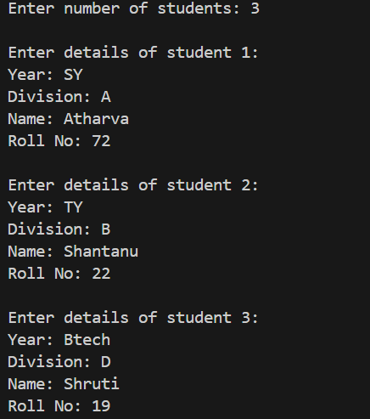

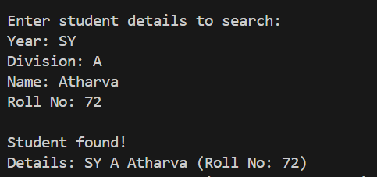

Program 2
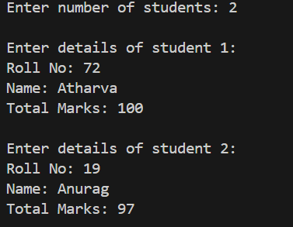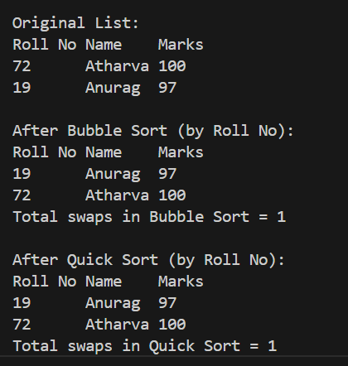
Program 3
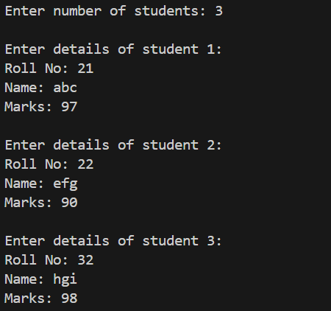
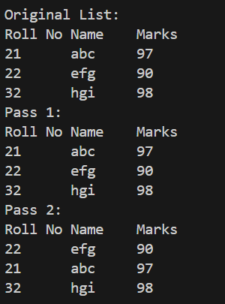

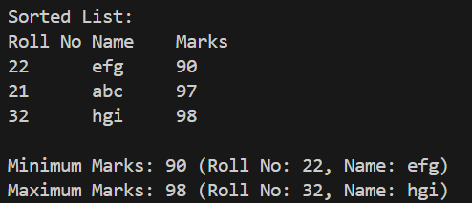

Program 4

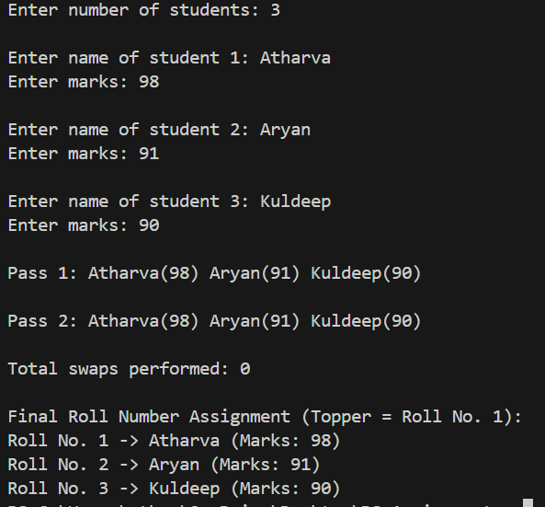

Program 5

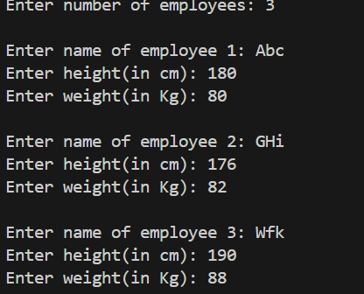

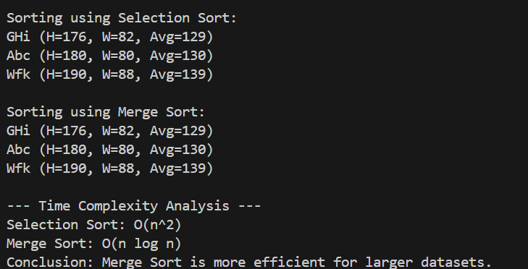

CONCLUSION
This assignment provided an in-depth exploration of fundamental searching and sorting algorithms and their practical applications in diverse scenarios. Through hands-on implementation, we observed how different algorithms balance trade-offs between simplicity, computational efficiency, and memory usage. Basic algorithms such as Bubble Sort and Selection Sort offered insight into the mechanics of iterative comparison-based sorting, while more advanced techniques like Quick Sort and Merge Sort showcased the efficiency gains achievable through divide-and-conquer strategies.
The exercises on searching emphasized the importance of systematic and structured data access, highlighting how appropriate selection of search methods can significantly improve performance, especially in larger datasets. Additionally, analyzing time and space complexities for each algorithm offered a clear understanding of their strengths, weaknesses, and suitability for different types of problems.
Beyond technical execution, the assignment reinforced critical algorithmic thinking, including the evaluation of trade-offs, optimization of operations like swaps and comparisons, and effective handling of real-world data. It also emphasized the value of designing solutions that are not only correct but also efficient and scalable.
Overall, this exercise strengthened both theoretical knowledge and practical skills in algorithm design, preparing us to make informed decisions when applying these techniques to real-world computational challenges. It highlighted how foundational concepts in searching and sorting form the backbone of efficient data handling in software development and computational problem-solving.

