Bansilal Ramnath Agarwal Charitable Trust’s

VISHWAKARMA INSTITUTE OF TECHNOLOGY – PUNE

DATA STRUCTURES

Division | SY CS-A
Batch | 3
GR Number (PRN) | 12413247
Roll No. | 72
Name | Atharva Dhamdhere

ASSIGNMENT 3

AIM
1. Implementation of Singly Linked List to Manage ‘Vertex Club’ Membership Records. The Department of Computer Engineering has a student club named ‘Vertex Club’ for second, third, and final year students. The first member is the President and the last member is the Secretary. Write a C++ program to: Add/delete members (including President/Secretary) Count members Display members Concatenate two division lists. Also implement: reverse, search by PRN, and sort by PRN operations.
2. The ticket reservation system for Galaxy Multiplex is to be implemented using a C++ program. The multiplex has 8 rows, with 8 seats in each row. A doubly circular linked list will be used to track the availability of seats in each row. Initially, assume that some seats are randomly booked. An array will store head pointers for each row’s linked list. The system should support the following operations: a) Display the current list of available seats. b) Book one or more seats as per customer request. c) Cancel an existing booking when requested.
3. Develop a C++ program to store and manage an appointment schedule for a single day. Appointments should be scheduled randomly using a linked list. The system must define the start time, end time, and specify the minimum and maximum duration allowed for each appointment slot. The program should include the following operations: a) Display the list of currently available time slots. b) Book a new appointment within the defined time limits. c) Cancel an existing appointment after validating its time, availability, and correctness. d) Sort the appointment list in order of appointment times. e) Sort the list based on appointment times using pointer manipulation (without swapping data values).
4. In the Second Year Computer Engineering class, there are two groups of students based on their favourite sports: Set A includes students who like Cricket. Set B includes students who like Football. Write a C++ program to represent these two sets using linked lists and perform the following operations: a) Find and display the set of students who like both Cricket and Football. b) Find and display the set of students who like either Cricket or Football, but not both. c) Display the number of students who like neither Cricket nor Football.
5. Write a C++ program to store a binary number using a doubly linked list. Implement the following functions: a) Calculate and display the 1’s complement and 2’s complement of the stored binary number. b) Perform addition of two binary numbers represented using doubly linked lists and display the result.

OBJECTIVE:

This assignment is designed to strengthen understanding and practical skills in linked data structures by implementing various list types and applying them to solve algorithmic problems. The key objectives include:
- Singly Linked List (SLL): Implementing fundamental operations—such as insertion, deletion, traversal, search, reversal, concatenation, and sorting—to manage a student club roster. This helps demonstrate sequential data organization and real-world applications like maintaining hierarchical records (e.g., president, secretary, members).
- Doubly Circular Linked List (DCLL): Using a two-way circular structure combined with arrays of head pointers to model a multiplex seating chart. This approach enables bidirectional traversal, efficient management of dynamic seat states (available/booked), and handling complex 2D data effectively.
- Linked Lists as an ADT: Representing sets with linked lists to perform operations such as intersection, symmetric difference, and complement. This illustrates the use of linked structures for abstract concepts, highlighting dynamic memory management and algorithmic problem solving.
- Doubly Linked List (DLL) Algorithms: Applying two-way traversal from head and tail to perform binary arithmetic operations, including 1’s complement, 2’s complement, and addition with carry. This showcases DLLs’ ability to handle both forward and backward computations efficiently.
- Linked List Sorting: Implementing and comparing two sorting methods—swapping data versus manipulating node pointers—demonstrating different algorithmic strategies and trade-offs in time and space efficiency.

THEORY:

A linked list is a fundamental, dynamic data structure consisting of a sequence of nodes, where each node contains data and a pointer to the next node. Unlike arrays, linked lists do not require contiguous memory allocation, allowing them to grow or shrink dynamically at runtime. The list is accessed via a head pointer, which points to the first node, and optionally a tail pointer for quick access to the last node.
The simplest type, a Singly Linked List (SLL), is unidirectional, meaning each node points only to its successor, and the last node points to NULL to indicate the end. SLLs support efficient insertion and deletion at the head, requiring O(1) time. However, accessing nodes in the middle or at the end requires linear traversal, giving O(n) time complexity. Maintaining a tail pointer allows O(1) insertion at the end, which is particularly useful in practical applications like managing a club roster. Reversing an SLL is an O(n) operation that requires careful pointer manipulation, typically using three pointers: prev, current, and next, to reverse the next references iteratively.

A Doubly Linked List (DLL) improves on the SLL by adding a prev pointer to each node, allowing bidirectional traversal. This facilitates faster insertion and deletion operations, as both the previous and next nodes are immediately accessible. For instance, deleting a node in a DLL is an O(1) operation if a pointer to the node is available, unlike SLLs, which may require O(n) traversal to locate the preceding node. Edge cases, such as empty lists or lists with a single node, must be handled carefully to maintain the integrity of the pointers.
The Doubly Circular Linked List (DCLL) further extends DLLs by connecting the head and tail nodes: head->prev points to the tail and tail->next points to the head, forming a closed loop without NULL pointers. This structure is ideal for modeling continuous, cyclic data, such as a row of seats in a theater. When combined with an array of head pointers, it can represent a 2D grid of independent linked lists, effectively creating a hybrid data structure for more complex, real-world scenarios.
Linked lists are also highly effective for implementing Abstract Data Types (ADTs), which define operations without prescribing the underlying implementation. For example, the Sports Club problem uses linked lists to model a Set ADT, where membership checking is implemented as a linear search. High-level set operations such as Intersection (A ∩ B), Union (A ∪ B), and Symmetric Difference (A Δ B) rely on these basic searches. This demonstrates the trade-off between abstract mathematical concepts and their concrete, sometimes less-efficient, implementations.

Binary arithmetic operations illustrate the power of DLLs in algorithmic problem-solving. Representing a binary number as a DLL allows operations like 1’s complement, 2’s complement, and addition to be performed efficiently. The Least Significant Bit (LSB) can be stored at the tail, enabling O(1) access and backward traversal using prev pointers. Binary addition involves iterating from the tails of two lists while maintaining a carry variable. Each step calculates (bit1 + bit2 + carry) and prepends the resulting bit (sum % 2) to a new result list. This approach naturally handles operands of unequal lengths and ensures correct carry propagation.

Sorting linked lists requires careful handling due to the absence of random access. The Appointment Scheduler problem demonstrates two approaches. Sorting by data swapping, such as with Bubble Sort, swaps the contents of nodes rather than altering pointers. While simple, it becomes inefficient when node data is large. Sorting by pointer manipulation, often using Insertion Sort, rearranges the nodes themselves by rewiring their next (and prev in DLLs) pointers. This method avoids moving data, reduces memory overhead, and ensures optimal efficiency, though it demands careful pointer management to avoid breaking the list.
In addition to these operations, linked lists support advanced functionalities such as list concatenation, reversal, and multi-list traversal, making them versatile for solving a wide range of computational problems. Their dynamic nature and pointer-based structure make them particularly suitable for applications where the size of data is unknown at compile-time, memory fragmentation is a concern, or frequent insertions and deletions occur.
Overall, linked lists provide a rich framework for exploring fundamental data structures, algorithmic efficiency, and real-world applications. Their variants—SLL, DLL, and DCLL—demonstrate a balance between simplicity, flexibility, and performance, allowing developers to choose the most suitable structure based on the problem requirements.

ALGORITHMS

Program 1

1. Start

2. Define Node Structure
• Data fields:
o PRN (unique ID)
o Name (string)
o next (pointer to next node)

3. Define SinglyLinkedList Class
• Data members:
o head → pointer to first node (President)
o tail → pointer to last node (Secretary)
• Member functions:
(a) insertMember()
1. Create a new node with PRN and Name
2. If list is empty:
o Set head = tail = newNode (President = Secretary)
3. Else:
o Insert new node before tail to maintain President at head and Secretary at end
o Adjust links accordingly
(b) deleteMemberByPRN()
1. If list empty → display "List empty"
2. If PRN matches President (head):
o Delete head node → update head
3. If PRN matches Secretary (tail):
o Traverse to second-last node
o Delete tail node → update tail
4. Otherwise:
o Traverse to find matching PRN
o Adjust links and delete node
(c) displayList()
1. Traverse from head to tail
2. Print PRN and Name of each member
(d) countMembers()
1. Initialize counter = 0
2. Traverse list → increment counter
3. Return total count
(e) searchMember()
1. Input PRN
2. Traverse list → compare each node’s PRN
3. If found → display Name and PRN
4. Else → display "Not found"
(f) sortList()
1. Apply Bubble Sort using nested traversal
2. Compare PRN values
3. Swap data (not nodes)
(g) reverseList()
1. Initialize three pointers: prev = NULL, curr = head, next = NULL
2. While curr != NULL:
o Store next = curr->next
o Update curr->next = prev
o Move prev = curr, curr = next
3. Update head = prev
(h) concatenate(SinglyLinkedList B)
1. If A is empty → set head = B.head
2. Else → set tail->next = B.head
3. Update tail = B.tail

4. Menu-Driven Program
1. Create two objects: Division A and Division B
2. Display menu:
o Insert member
o Delete member
o Display list
o Count members
o Search member
o Sort list
o Reverse list
o Concatenate divisions
o Exit
3. Perform operations until user chooses Exit

5. End
Program 2

1. Start

2. Define Seat Node:
- seat_number (int)
- status ('A' = Available, 'B' = Booked)
- next (pointer to next seat)
- prev (pointer to previous seat)

3. Define Theater Class:
- rows[NUM_ROWS] → array of head pointers for each row
- Constructor:
a) For each row:
i. Create circular doubly linked list of NUM_SEATS_PER_ROW seats
ii. Randomly mark some seats as booked ('B')
- Destructor:
a) Delete all nodes in each row to free memory

4. displaySeats():
- For each row:
a) Traverse the circular list
b) Display seat number and status
- Show screen orientation and legend

5. bookSeats():
- Input row number and number of seats to book
- Input seat numbers
- For each requested seat:
a) Check if it exists and is available
b) If any seat is invalid or already booked → abort booking
- If all seats are available → mark them as booked ('B')

6. cancelBooking():
- Input row number and seat number
- Traverse row list to find the seat
- If seat is booked → change status to 'A'
- Else → display "Seat not booked" message

7. Main Menu:
- Repeat until user chooses exit:
1. Display Seat Availability → call displaySeats()
2. Book Seats → call bookSeats()
3. Cancel Booking → call cancelBooking()
0. Exit

8. End

Program 3
1. Initialize Schedule
1.1 Create a Slot node representing the whole day from DAY_START_TIME to DAY_END_TIME.
1.2 Set this node as the head of the doubly linked list.

2. Display All Slots
2.1 Start from head.
2.2 While current node is not NULL:
2.2.1 Print start_time, end_time, and is_booked status.
2.2.2 Move to the next node.

3. Display Free Slots
3.1 Start from head.
3.2 While current node is not NULL:
3.2.1 If is_booked is false, print the slot details.
3.2.2 Move to the next node.

4. Book an Appointment
4.1 Read start_time and end_time from the user and convert to minutes.
4.2 Validate:
4.2.1 Start and end times within working hours.
4.2.2 Duration between MIN_DURATION and MAX_DURATION.
4.3 Traverse the list to find a free slot where start_time >= slot.start_time and end_time <= slot.end_time.
4.4 Depending on overlap:
4.4.1 Exact match: mark slot as booked.
4.4.2 Start matches: split slot into booked + remaining free slot.
4.4.3 End matches: split slot into free + booked slot.
4.4.4 Middle: split slot into free + booked + free.
4.5 Update next and prev pointers accordingly.

5. Cancel an Appointment
5.1 Read start_time of the appointment to cancel.
5.2 Traverse the list to find a booked slot with the given start time.
5.3 Mark the slot as free.
5.4 Merge with adjacent free slots if they exist:
5.4.1 If next slot is free, merge with current.
5.4.2 If previous slot is free, merge with previous.

6. Sort by Swapping Data
6.1 If list has 0 or 1 node, return.
6.2 Repeat until no swaps:
6.2.1 Traverse from head.
6.2.2 Compare current node with next node:
6.2.2.1 If current.start_time > next.start_time, swap data fields (start, end, is_booked).

7. Sort by Manipulating Pointers
7.1 If list has 0 or 1 node, return.
7.2 Repeat until no swaps:
7.2.1 Traverse from head.
7.2.2 Compare current node with next node:
7.2.2.1 If current.start_time > next.start_time, rewire prev and next pointers to swap nodes.

8. Utility Functions
8.1 Convert time string to minutes: "HH:MM" → hours*60 + minutes.
8.2 Convert minutes to time string: minutes/60 : minutes%60 (formatted with 2 digits).

9. Main Menu Loop
9.1 Repeat until user chooses exit:
9.1.1 Display menu:
1. Display Free Slots
2. Book an Appointment
3. Cancel an Appointment
4. Sort Appointments (data swap)
5. Sort Appointments (pointer manipulation)
6. Display Full Schedule
0. Exit
9.1.2 Read user choice.
9.1.3 Call corresponding function.

Program 4

1. Start

2. Define Node Structure (StudentNode)
• Data fields:
o roll_number (unique ID)
o name (string)
o next (pointer to next node)

3. Define StudentSet Class
• Data members:
o head → pointer to first node
• Member functions:
(a) contains(roll_number)
1. Traverse list from head
2. If roll_number matches any node → return true
3. Else → return false
(b) addStudent(roll_number, name)
1. If roll_number already exists (contains) → do nothing
2. Else → create new node
3. If head is null → set head = new node
4. Else → traverse to last node and insert at end
(c) display()
1. Traverse from head
2. Print roll_number and name
(d) getHead()
1. Return head pointer

4. Define Set Operations
(a) findIntersection(setA, setB)
1. Initialize empty result set
2. Traverse setA
3. If setB contains current roll_number → add to result
(b) findSymmetricDifference(setA, setB)
1. Initialize empty result set
2. Traverse setA → if setB does not contain roll_number → add to result
3. Traverse setB → if setA does not contain roll_number → add to result
(c) findUnion(setA, setB)
1. Initialize empty result set
2. Traverse setA → add all nodes to result
3. Traverse setB → add all nodes to result (skip duplicates using contains)

5. Main Program
1. Create three sets:
o totalStudents
o cricketFans (Set A)
o footballFans (Set B)
2. Add students to each set
3. Display initial sets
4. Perform set operations:
(a) Intersection (A n B) → students who like BOTH sports
(b) Symmetric Difference (A ^ B) → students who like EITHER sport but not both
(c) Neither → traverse totalStudents and exclude union of sets A and B
5. Display results of each operation with counts

6. End

Program 5

1. Start

2. Define Node Structure (BitNode)
• Data fields:
o bit → 0 or 1
o next → pointer to next node
o prev → pointer to previous node

3. Define BinaryNumber Class
• Data members:
o head → points to first bit (MSB)
o tail → points to last bit (LSB)
• Member functions:
(a) create(binStr)
1. Traverse each character of input string
2. Convert '0'/'1' to integer bit
3. Append new node to the end of the list
(b) display()
1. Traverse from head to tail
2. Print each bit
(c) prependBit(bit)
1. Create a new node
2. Insert at head
3. Adjust head and prev pointers
(d) onesComplement()
1. Traverse the list
2. Invert each bit (0→1, 1→0)
3. Store in a new BinaryNumber
4. Return new BinaryNumber
(e) twosComplement()
1. Get onesComplement
2. Add 1 to the LSB
3. Handle carry propagation to MSB
4. If carry remains, prepend new node
5. Return new BinaryNumber
(f) add(BinaryNumber other)
1. Initialize carry = 0
2. Traverse both lists from tail to head
3. sum = bit1 + bit2 + carry
4. resultBit = sum % 2
5. carry = sum / 2
6. Prepend resultBit to new BinaryNumber
7. Continue until both lists and carry are processed
8. Return result

4. Main Program
1. Input two binary numbers from user
2. Create BinaryNumber objects for each input
3. Display menu:
o Calculate 1's and 2's Complement
o Add the two binary numbers
o Enter new numbers
o Exit
4. Perform selected operation:
(a) Complement:
i. Select number (1 or 2)
ii. Display original, 1's complement, 2's complement
(b) Addition:
i. Add two BinaryNumber objects
ii. Display the sum
(c) Enter new numbers:
i. Input new binary numbers
ii. Update objects
5. Repeat until user chooses Exit

5. End

PROGRAMS:

Program 1

#include <iostream>
#include <string>
#include <limits>

class Member {
public:
int prn;
std::string name;
Member* next;

Member(int p, const std::string& n) : prn(p), name(n), next(nullptr) {}
};

class VertexClub {
private:
Member* head;

public:
VertexClub() : head(nullptr) {}

~VertexClub() {
Member* current = head;
while (current != nullptr) {
Member* nextNode = current->next;
delete current;
current = nextNode;
}
}

void addMember() {
int prn;
std::string name;
std::cout << "Enter PRN: ";
std::cin >> prn;
std::cout << "Enter Name: ";
std::cin.ignore(std::numeric_limits<std::streamsize>::max(), '\n');
std::getline(std::cin, name);

Member* newMember = new Member(prn, name);

if (!head) {
head = newMember;
} else {
Member* temp = head;
while (temp->next != nullptr) {
temp = temp->next;
}
temp->next = newMember;
}
std::cout << "Member added successfully!\n";
}

void deleteMemberByPRN(int prn) {
if (!head) {
std::cout << "Club is empty. Nothing to delete.\n";
return;
}

if (head->prn == prn) {
Member* temp = head;
head = head->next;
delete temp;
std::cout << "President with PRN " << prn << " deleted.\n";
return;
}

Member* current = head->next;
Member* prev = head;
while (current != nullptr) {
if (current->prn == prn) {
prev->next = current->next;
delete current;
std::cout << "Member with PRN " << prn << " deleted.\n";
return;
}
prev = current;
current = current->next;
}
std::cout << "Member with PRN " << prn << " not found.\n";
}

int countMembers() {
int count = 0;
Member* temp = head;
while (temp != nullptr) {
count++;
temp = temp->next;
}
return count;
}

void displayMembers() {
if (!head) {
std::cout << "The club has no members.\n";
return;
}

Member* temp = head;
std::cout << "\n--- Vertex Club Members ---\n";
while (temp != nullptr) {
std::cout << "PRN: " << temp->prn << ", Name: " << temp->name;
if (temp == head) {
std::cout << " (President)";
}
if (temp->next == nullptr && temp != head) {
std::cout << " (Secretary)";
}
std::cout << std::endl;
temp = temp->next;
}
std::cout << "-------------------------\n";
}

void concatenate(VertexClub& otherList) {
if (!otherList.head) {
std::cout << "The other list is empty, nothing to concatenate.\n";
return;
}
if (!this->head) {
this->head = otherList.head;
} else {
Member* temp = this->head;
while (temp->next != nullptr) {
temp = temp->next;
}
temp->next = otherList.head;
}
otherList.head = nullptr;
std::cout << "Lists concatenated successfully.\n";
}

void reverse() {
if (!head || !head->next) {
return;
}
Member* prev = nullptr;
Member* current = head;
Member* nextNode = nullptr;
while (current != nullptr) {
nextNode = current->next;
current->next = prev;
prev = current;
current = nextNode;
}
head = prev;
std::cout << "List reversed successfully.\n";
}

void searchByPRN(int prn) {
if (!head) {
std::cout << "Club is empty.\n";
return;
}
Member* temp = head;
while (temp != nullptr) {
if (temp->prn == prn) {
std::cout << "Member Found -> PRN: " << temp->prn << ", Name: " << temp->name << std::endl;
return;
}
temp = temp->next;
}
std::cout << "Member with PRN " << prn << " not found.\n";
}

void sortByPRN() {
if (!head || !head->next) {
return;
}

bool swapped;
Member* ptr1;
Member* lptr = nullptr;

do {
swapped = false;
ptr1 = head;

while (ptr1->next != lptr) {
if (ptr1->prn > ptr1->next->prn) {
std::swap(ptr1->prn, ptr1->next->prn);
std::swap(ptr1->name, ptr1->next->name);
swapped = true;
}
ptr1 = ptr1->next;
}
lptr = ptr1;
} while (swapped);

std::cout << "List sorted successfully by PRN.\n";
}
};

void manageClub(VertexClub& club, const std::string& divisionName) {
int choice, prn;
do {
std::cout << "\n--- Managing Division " << divisionName << " ---\n";
std::cout << "1. Add Member\n";
std::cout << "2. Delete Member by PRN\n";
std::cout << "3. Display Members\n";
std::cout << "4. Count Members\n";
std::cout << "5. Search by PRN\n";
std::cout << "6. Sort by PRN\n";
std::cout << "7. Reverse List\n";
std::cout << "8. Return to Main Menu\n";
std::cout << "Enter your choice: ";
std::cin >> choice;

switch (choice) {
case 1: club.addMember(); break;
case 2:
std::cout << "Enter PRN to delete: ";
std::cin >> prn;
club.deleteMemberByPRN(prn);
break;
case 3: club.displayMembers(); break;
case 4:
std::cout << "Total members: " << club.countMembers() << std::endl;
break;
case 5:
std::cout << "Enter PRN to search: ";
std::cin >> prn;
club.searchByPRN(prn);
break;
case 6: club.sortByPRN(); break;
case 7: club.reverse(); break;
case 8: std::cout << "Returning to Main Menu...\n"; break;
default: std::cout << "Invalid choice. Please try again.\n";
}
} while (choice != 8);
}

int main() {
VertexClub divisionA, divisionB;
int choice;

do {
std::cout << "\n========= Main Menu =========\n";
std::cout << "1. Manage Division A Club\n";
std::cout << "2. Manage Division B Club\n";
std::cout << "3. Concatenate Division B list to Division A list\n";
std::cout << "4. Exit\n";
std::cout << "Enter your choice: ";
std::cin >> choice;

switch (choice) {
case 1:
manageClub(divisionA, "A");
break;
case 2:
manageClub(divisionB, "B");
break;
case 3:
std::cout << "Concatenating B into A...\n";
divisionA.concatenate(divisionB);
std::cout << "Division A now contains all members.\n";
divisionA.displayMembers();
break;
case 4:
std::cout << "Exiting program. Goodbye! \n";
break;
default:
std::cout << "Invalid choice. Please try again.\n";
}
} while (choice != 4);

return 0;
}

Program 2

#include <iostream>
#include <vector>
#include <iomanip>
#include <cstdlib>
#include <ctime>

const int NUM_ROWS = 8;
const int NUM_SEATS_PER_ROW = 8;

class Seat {
public:
int seat_number;
char status;
Seat* next;
Seat* prev;

Seat(int num) : seat_number(num), status('A'), next(nullptr), prev(nullptr) {}
};

class Theater {
private:
Seat* rows[NUM_ROWS];

public:
Theater() {
srand(time(0));

for (int i = 0; i < NUM_ROWS; ++i) {
rows[i] = new Seat(1);
Seat* head = rows[i];
Seat* current = head;

if (rand() % 3 == 0) {
head->status = 'B';
}

for (int j = 2; j <= NUM_SEATS_PER_ROW; ++j) {
Seat* newSeat = new Seat(j);
if (rand() % 3 == 0) {
newSeat->status = 'B';
}
current->next = newSeat;
newSeat->prev = current;
current = newSeat;
}

current->next = head;
head->prev = current;
}
}

~Theater() {
for (int i = 0; i < NUM_ROWS; ++i) {
Seat* head = rows[i];
if (!head) continue;

Seat* current = head;
do {
Seat* temp = current;
current = current->next;
delete temp;
} while (current != head);
}
}

void displaySeats() {
std::cout << "\n==================== SCREEN THIS WAY ====================\n";
for (int i = 0; i < NUM_ROWS; ++i) {
std::cout << "Row " << (i + 1) << ": ";
Seat* head = rows[i];
Seat* current = head;
do {
std::cout << "[S" << std::setw(2) << current->seat_number << ":" << current->status << "] ";
current = current->next;
} while (current != head);
std::cout << std::endl;
}
std::cout << "=========================================================\n";
std::cout << "Legend: [S#: A] = Available, [S#: B] = Booked\n";
}

void bookSeats() {
int row, num_seats;
std::cout << "Enter Row number (1-" << NUM_ROWS << "): ";
std::cin >> row;
if (row < 1 || row > NUM_ROWS) {
std::cout << "Invalid row number.\n";
return;
}

std::cout << "How many seats to book? ";
std::cin >> num_seats;
if (num_seats <= 0) {
std::cout << "Invalid number of seats.\n";
return;
}

std::vector<int> seats_to_book(num_seats);
std::cout << "Enter seat numbers separated by spaces: ";
for (int i = 0; i < num_seats; ++i) {
std::cin >> seats_to_book[i];
}

Seat* head = rows[row - 1];
bool all_available = true;

for (int seat_num : seats_to_book) {
Seat* current = head;
bool found = false;
do {
if (current->seat_number == seat_num) {
found = true;
if (current->status == 'B') {
std::cout << "Error: Seat " << seat_num << " in Row " << row << " is already booked.\n";
all_available = false;
}
break;
}
current = current->next;
} while (current != head);
if (!found) {
std::cout << "Error: Seat " << seat_num << " does not exist in Row " << row << ".\n";
all_available = false;
}
}

if (all_available) {
for (int seat_num : seats_to_book) {
Seat* current = head;
do {
if (current->seat_number == seat_num) {
current->status = 'B';
break;
}
current = current->next;
} while (current != head);
}
std::cout << "Booking successful for all requested seats in Row " << row << "!\n";
} else {
std::cout << "Booking failed. Please try again with different seats.\n";
}
}

void cancelBooking() {
int row, seat_num;
std::cout << "Enter Row number for cancellation (1-" << NUM_ROWS << "): ";
std::cin >> row;
std::cout << "Enter Seat number for cancellation: ";
std::cin >> seat_num;

if (row < 1 || row > NUM_ROWS) {
std::cout << "Invalid row number.\n";
return;
}

Seat* head = rows[row - 1];
Seat* current = head;
bool found = false;

do {
if (current->seat_number == seat_num) {
found = true;
if (current->status == 'B') {
current->status = 'A';
std::cout << "Cancellation successful for Seat " << seat_num << " in Row " << row << ".\n";
} else {
std::cout << "Seat " << seat_num << " in Row " << row << " was not booked.\n";
}
break;
}
current = current->next;
} while (current != head);

if (!found) {
std::cout << "Invalid seat number for Row " << row << ".\n";
}
}
};

int main() {
Theater multiplex;
int choice;

do {
std::cout << "\n--- Galaxy Multiplex Ticket System ---\n";
std::cout << "1. Display Seat Availability\n";
std::cout << "2. Book Seats\n";
std::cout << "3. Cancel Booking\n";
std::cout << "0. Exit\n";
std::cout << "Enter your choice: ";
std::cin >> choice;

switch (choice) {
case 1:
multiplex.displaySeats();
break;
case 2:
multiplex.bookSeats();
break;
case 3:
multiplex.cancelBooking();
break;
case 0:
std::cout << "Thank you for using the system. Goodbye! \n";
break;
default:
std::cout << "Invalid choice. Please try again.\n";
}
} while (choice != 0);

return 0;
}

Program 3

#include <iostream>
#include <string>
#include <vector>
#include <iomanip>
#include <sstream>

const int DAY_START_TIME = 540;
const int DAY_END_TIME = 1020;
const int MIN_DURATION = 15;
const int MAX_DURATION = 60;

class Slot {
public:
int start_time;
int end_time;
bool is_booked;
Slot* next;
Slot* prev;

Slot(int start, int end, bool booked = false)
: start_time(start), end_time(end), is_booked(booked), next(nullptr), prev(nullptr) {}
};

class Scheduler {
private:
Slot* head;

std::string minutesToString(int minutes) const {
std::ostringstream oss;
oss << std::setw(2) << std::setfill('0') << minutes / 60 << ":"
<< std::setw(2) << std::setfill('0') << minutes % 60;
return oss.str();
}

int stringToMinutes(const std::string& time_str) const {
int hours, minutes;
if (sscanf(time_str.c_str(), "%d:%d", &hours, &minutes) == 2) {
return hours * 60 + minutes;
}
return -1;
}

public:
Scheduler() {
head = new Slot(DAY_START_TIME, DAY_END_TIME, false);
}

~Scheduler() {
Slot* current = head;
while (current != nullptr) {
Slot* nextNode = current->next;
delete current;
current = nextNode;
}
}

void displayAllSlots() const {
if (!head) {
std::cout << "Schedule is empty.\n";
return;
}
std::cout << "\n--- Full Day Schedule ---\n";
Slot* temp = head;
while (temp != nullptr) {
std::cout << "Time: " << minutesToString(temp->start_time)
<< " - " << minutesToString(temp->end_time)
<< " | Status: " << (temp->is_booked ? "Booked" : "Free") << std::endl;
temp = temp->next;
}
std::cout << "-------------------------\n";
}

void displayFreeSlots() const {
if (!head) {
std::cout << "Schedule is empty.\n";
return;
}
std::cout << "\n--- Available Time Slots ---\n";
Slot* temp = head;
bool found = false;
while (temp != nullptr) {
if (!temp->is_booked) {
std::cout << "Free from " << minutesToString(temp->start_time)
<< " to " << minutesToString(temp->end_time) << " ("
<< (temp->end_time - temp->start_time) << " mins)\n";
found = true;
}
temp = temp->next;
}
if (!found) {
std::cout << "No available slots found.\n";
}
std::cout << "---------------------------\n";
}

void bookAppointment() {
std::string start_str, end_str;
std::cout << "Enter start time (HH:MM): ";
std::cin >> start_str;
std::cout << "Enter end time (HH:MM): ";
std::cin >> end_str;

int start = stringToMinutes(start_str);
int end = stringToMinutes(end_str);
int duration = end - start;

if (start < DAY_START_TIME || end > DAY_END_TIME || start >= end) {
std::cout << "Error: Time is outside of working hours (09:00 - 17:00).\n";
return;
}
if (duration < MIN_DURATION || duration > MAX_DURATION) {
std::cout << "Error: Duration must be between " << MIN_DURATION << " and " << MAX_DURATION << " minutes.\n";
return;
}

Slot* current = head;
while (current != nullptr) {
if (!current->is_booked && start >= current->start_time && end <= current->end_time) {
int original_end_time = current->end_time;

if (start == current->start_time && end == original_end_time) {
current->is_booked = true;
}
else if (start == current->start_time) {
current->end_time = end;
current->is_booked = true;
Slot* newFreeSlot = new Slot(end, original_end_time, false);
newFreeSlot->next = current->next;
if (current->next) {
current->next->prev = newFreeSlot;
}
current->next = newFreeSlot;
newFreeSlot->prev = current;
}
else if (end == original_end_time) {
current->end_time = start;
Slot* newBookedSlot = new Slot(start, end, true);
newBookedSlot->next = current->next;
if (current->next) {
current->next->prev = newBookedSlot;
}
current->next = newBookedSlot;
newBookedSlot->prev = current;
}
else {
current->end_time = start;
Slot* newBookedSlot = new Slot(start, end, true);
Slot* newFreeSlot = new Slot(end, original_end_time, false);

newFreeSlot->next = current->next;
if (current->next) {
current->next->prev = newFreeSlot;
}
newBookedSlot->next = newFreeSlot;
newFreeSlot->prev = newBookedSlot;
current->next = newBookedSlot;
newBookedSlot->prev = current;
}

std::cout << "Appointment from " << start_str << " to " << end_str << " booked successfully!\n";
return;
}
current = current->next;
}
std::cout << "Booking failed. The requested time slot is not available or invalid.\n";
}

void cancelAppointment() {
std::string start_str;
std::cout << "Enter the start time of the appointment to cancel (HH:MM): ";
std::cin >> start_str;
int start = stringToMinutes(start_str);

Slot* current = head;
while (current != nullptr) {
if (current->is_booked && current->start_time == start) {
current->is_booked = false;
std::cout << "Appointment at " << start_str << " cancelled.\n";

if (current->next && !current->next->is_booked) {
Slot* to_merge = current->next;
current->end_time = to_merge->end_time;
current->next = to_merge->next;
if (to_merge->next) to_merge->next->prev = current;
delete to_merge;
}

if (current->prev && !current->prev->is_booked) {
Slot* to_merge_with = current->prev;
to_merge_with->end_time = current->end_time;
to_merge_with->next = current->next;
if (current->next) current->next->prev = to_merge_with;
if (current == head) head = to_merge_with;
delete current;
}
return;
}
current = current->next;
}
std::cout << "No booked appointment found at the specified time.\n";
}

void sortData() {
if (!head || !head->next) return;
bool swapped;
do {
swapped = false;
Slot* current = head;
while (current->next != nullptr) {
if (current->start_time > current->next->start_time) {
std::swap(current->start_time, current->next->start_time);
std::swap(current->end_time, current->next->end_time);
std::swap(current->is_booked, current->next->is_booked);
swapped = true;
}
current = current->next;
}
} while (swapped);
std::cout << "Schedule sorted by time (data swap).\n";
}

void sortPointers() {
if (!head || !head->next) return;
bool swapped;
do {
swapped = false;
Slot* current = head;
while (current->next != nullptr) {
if (current->start_time > current->next->start_time) {
Slot* node1 = current;
Slot* node2 = current->next;

if (node1->prev) node1->prev->next = node2;
else head = node2;

if (node2->next) node2->next->prev = node1;

node2->prev = node1->prev;
node1->prev = node2;
node1->next = node2->next;
node2->next = node1;

swapped = true;
} else {
current = current->next;
}
}
} while (swapped);
std::cout << "Schedule sorted by time (pointer manipulation).\n";
}
};

int main() {
Scheduler schedule;
int choice;

do {
std::cout << "\n--- Appointment Scheduler Menu ---\n";
std::cout << "1. Display Free Slots\n";
std::cout << "2. Book an Appointment\n";
std::cout << "3. Cancel an Appointment\n";
std::cout << "4. Sort Appointments (by swapping data)\n";
std::cout << "5. Sort Appointments (by manipulating pointers)\n";
std::cout << "6. Display Full Schedule\n";
std::cout << "0. Exit\n";
std::cout << "Enter your choice: ";
std::cin >> choice;

switch (choice) {
case 1: schedule.displayFreeSlots(); break;
case 2: schedule.bookAppointment(); break;
case 3: schedule.cancelAppointment(); break;
case 4: schedule.sortData(); break;
case 5: schedule.sortPointers(); break;
case 6: schedule.displayAllSlots(); break;
case 0: std::cout << "Exiting program. Goodbye!\n"; break;
default: std::cout << "Invalid choice. Please try again.\n";
}
} while (choice != 0);

return 0;
}

Program 4

#include <iostream>
#include <string>

class StudentNode {
public:
int roll_number;
std::string name;
StudentNode* next;

StudentNode(int roll, const std::string& studentName)
: roll_number(roll), name(studentName), next(nullptr) {}
};

class StudentSet {
private:
StudentNode* head;

public:
StudentSet();
~StudentSet();
StudentNode* getHead() const;
bool contains(int roll) const;
void addStudent(int roll, const std::string& name);
void display() const;
};

StudentSet::StudentSet() : head(nullptr) {}

StudentSet::~StudentSet() {
StudentNode* current = head;
while (current != nullptr) {
StudentNode* nextNode = current->next;
delete current;
current = nextNode;
}
}

StudentNode* StudentSet::getHead() const {
return head;
}

bool StudentSet::contains(int roll) const {
StudentNode* temp = head;
while (temp != nullptr) {
if (temp->roll_number == roll) {
return true;
}
temp = temp->next;
}
return false;
}

void StudentSet::addStudent(int roll, const std::string& name) {
if (contains(roll)) {
return;
}
StudentNode* newStudent = new StudentNode(roll, name);
if (!head) {
head = newStudent;
} else {
StudentNode* temp = head;
while (temp->next != nullptr) {
temp = temp->next;
}
temp->next = newStudent;
}
}

void StudentSet::display() const {
if (!head) {
std::cout << " (empty set)" << std::endl;
return;
}
StudentNode* temp = head;
while (temp != nullptr) {
std::cout << " [" << temp->roll_number << ": " << temp->name << "]";
temp = temp->next;
if (temp) std::cout << ",";
}
std::cout << std::endl;
}

StudentSet findIntersection(const StudentSet& setA, const StudentSet& setB) {
StudentSet result;
StudentNode* current = setA.getHead();
while (current != nullptr) {
if (setB.contains(current->roll_number)) {
result.addStudent(current->roll_number, current->name);
}
current = current->next;
}
return result;
}

StudentSet findSymmetricDifference(const StudentSet& setA, const StudentSet& setB) {
StudentSet result;
StudentNode* currentA = setA.getHead();
while (currentA != nullptr) {
if (!setB.contains(currentA->roll_number)) {
result.addStudent(currentA->roll_number, currentA->name);
}
currentA = currentA->next;
}

StudentNode* currentB = setB.getHead();
while (currentB != nullptr) {
if (!setA.contains(currentB->roll_number)) {
result.addStudent(currentB->roll_number, currentB->name);
}
currentB = currentB->next;
}
return result;
}

StudentSet findUnion(const StudentSet& setA, const StudentSet& setB) {
StudentSet result;
StudentNode* currentA = setA.getHead();
while (currentA != nullptr) {
result.addStudent(currentA->roll_number, currentA->name);
currentA = currentA->next;
}

StudentNode* currentB = setB.getHead();
while (currentB != nullptr) {
result.addStudent(currentB->roll_number, currentB->name);
currentB = currentB->next;
}
return result;
}

int main() {
StudentSet totalStudents, cricketFans, footballFans;

totalStudents.addStudent(1, "Rahul");
totalStudents.addStudent(2, "Amit");
totalStudents.addStudent(3, "Priya");
totalStudents.addStudent(4, "Sneha");
totalStudents.addStudent(5, "Vikas");
totalStudents.addStudent(6, "Nidhi");
totalStudents.addStudent(7, "Ravi");
totalStudents.addStudent(8, "Kavita");

cricketFans.addStudent(1, "Rahul");
cricketFans.addStudent(3, "Priya");
cricketFans.addStudent(5, "Vikas");
cricketFans.addStudent(7, "Ravi");

footballFans.addStudent(3, "Priya");
footballFans.addStudent(4, "Sneha");
footballFans.addStudent(5, "Vikas");
footballFans.addStudent(8, "Kavita");

std::cout << "--- Initial Student Groups ---\n";
std::cout << "Total Students in Class:";
totalStudents.display();
std::cout << "Cricket Fans (Set A):";
cricketFans.display();
std::cout << "Football Fans (Set B):";
footballFans.display();
std::cout << "\n--- Set Operations ---\n";

std::cout << "a) Students who like BOTH Cricket and Football (A n B):\n";
StudentSet bothSports = findIntersection(cricketFans, footballFans);
bothSports.display();

std::cout << "\n" << "b) Students who like EITHER Cricket OR Football, but NOT BOTH (A ^ B):\n";
StudentSet oneSportOnly = findSymmetricDifference(cricketFans, footballFans);
oneSportOnly.display();

std::cout << "\n" << "c) Students who like NEITHER Cricket NOR Football:\n";
StudentSet sportsFans = findUnion(cricketFans, footballFans);
int neitherCount = 0;
StudentNode* current = totalStudents.getHead();
while (current != nullptr) {
if (!sportsFans.contains(current->roll_number)) {
neitherCount++;
std::cout << " [" << current->roll_number << ": " << current->name << "]";
}
current = current->next;
}
if (neitherCount == 0) {
std::cout << " (none)";
}
std::cout << "\nTotal number of students who like neither sport: " << neitherCount << std::endl;

return 0;
}

Program 5

#include <iostream>
#include <string>
#include <algorithm>

class BitNode {
public:
int bit;
BitNode* next;
BitNode* prev;

BitNode(int b) : bit(b), next(nullptr), prev(nullptr) {}
};

class BinaryNumber {
private:
BitNode* head;
BitNode* tail;

void prependBit(int bit) {
BitNode* newNode = new BitNode(bit);
if (!head) {
head = tail = newNode;
} else {
newNode->next = head;
head->prev = newNode;
head = newNode;
}
}

public:
BinaryNumber() : head(nullptr), tail(nullptr) {}

~BinaryNumber() {
BitNode* current = head;
while (current != nullptr) {
BitNode* nextNode = current->next;
delete current;
current = nextNode;
}
}

BinaryNumber(const BinaryNumber& other) : head(nullptr), tail(nullptr) {
BitNode* temp = other.head;
while (temp != nullptr) {
int bit = temp->bit;
BitNode* newNode = new BitNode(bit);
if (!head) {
head = tail = newNode;
} else {
tail->next = newNode;
newNode->prev = tail;
tail = newNode;
}
temp = temp->next;
}
}

BinaryNumber& operator=(const BinaryNumber& other) {
if (this == &other) {
return *this;
}

BitNode* current = head;
while (current != nullptr) {
BitNode* nextNode = current->next;
delete current;
current = nextNode;
}
head = tail = nullptr;

BitNode* temp = other.head;
while (temp != nullptr) {
int bit = temp->bit;
BitNode* newNode = new BitNode(bit);
if (!head) {
head = tail = newNode;
} else {
tail->next = newNode;
newNode->prev = tail;
tail = newNode;
}
temp = temp->next;
}
return *this;
}

void create(const std::string& binStr) {
if (!binStr.empty()) {
for (char bitChar : binStr) {
if (bitChar == '0' || bitChar == '1') {
int bit = bitChar - '0';
BitNode* newNode = new BitNode(bit);
if (!head) {
head = tail = newNode;
} else {
tail->next = newNode;
newNode->prev = tail;
tail = newNode;
}
}
}
}
}

void display() const {
if (!head) {
std::cout << " (empty)";
return;
}
BitNode* temp = head;
while (temp != nullptr) {
std::cout << temp->bit;
temp = temp->next;
}
}

BinaryNumber onesComplement() const {
BinaryNumber result;
BitNode* temp = head;
while (temp != nullptr) {
std::string bit_str = std::to_string(1 - temp->bit);
result.create(bit_str);
temp = temp->next;
}
return result;
}

BinaryNumber twosComplement() const {
BinaryNumber onesComp = this->onesComplement();
if (!onesComp.head) {
return onesComp;
}

int carry = 1;
BitNode* temp = onesComp.tail;
while (temp != nullptr && carry > 0) {
int sum = temp->bit + carry;
temp->bit = sum % 2;
carry = sum / 2;
temp = temp->prev;
}

if (carry > 0) {
onesComp.prependBit(carry);
}

return onesComp;
}

BinaryNumber add(const BinaryNumber& other) const {
BinaryNumber result;
BitNode* p1 = this->tail;
BitNode* p2 = other.tail;
int carry = 0;

while (p1 != nullptr || p2 != nullptr || carry != 0) {
int bit1 = (p1) ? p1->bit : 0;
int bit2 = (p2) ? p2->bit : 0;

int sum = bit1 + bit2 + carry;
int resultBit = sum % 2;
carry = sum / 2;

result.prependBit(resultBit);

if (p1) p1 = p1->prev;
if (p2) p2 = p2->prev;
}
return result;
}
};

int main() {
BinaryNumber num1, num2;
int choice;
std::string binStr1, binStr2;

std::cout << "Enter the first binary number: ";
std::cin >> binStr1;
num1.create(binStr1);

std::cout << "Enter the second binary number: ";
std::cin >> binStr2;
num2.create(binStr2);

do {
std::cout << "\n--- Binary Number Operations Menu ---\n";
std::cout << "Current Numbers -> 1: "; num1.display(); std::cout << " | 2: "; num2.display(); std::cout << "\n";
std::cout << "1. Calculate 1's and 2's Complement\n";
std::cout << "2. Add the two binary numbers\n";
std::cout << "3. Enter new numbers\n";
std::cout << "0. Exit\n";
std::cout << "Enter your choice: ";
std::cin >> choice;

switch (choice) {
case 1: {
int numChoice;
std::cout << "Calculate complement for which number (1 or 2)? ";
std::cin >> numChoice;
BinaryNumber selectedNum = (numChoice == 1) ? num1 : num2;

std::cout << "Original Number: "; selectedNum.display(); std::cout << "\n";

BinaryNumber ones = selectedNum.onesComplement();
std::cout << "1's Complement: "; ones.display(); std::cout << "\n";

BinaryNumber twos = selectedNum.twosComplement();
std::cout << "2's Complement: "; twos.display(); std::cout << "\n";
break;
}
case 2: {
std::cout << " "; num1.display(); std::cout << "\n";
std::cout << "+ "; num2.display(); std::cout << "\n";
std::cout << "--------------------\n";
BinaryNumber sum = num1.add(num2);
std::cout << "= "; sum.display(); std::cout << "\n";
break;
}
case 3:
std::cout << "Enter the first binary number: ";
std::cin >> binStr1;
num1 = BinaryNumber();
num1.create(binStr1);

std::cout << "Enter the second binary number: ";
std::cin >> binStr2;
num2 = BinaryNumber();
num2.create(binStr2);
break;
case 0:
std::cout << "Exiting program. Goodbye! \n";
break;
default:
std::cout << "Invalid choice. Please try again.\n";
}
} while (choice != 0);

return 0;
}

OUTPUT

Program 1

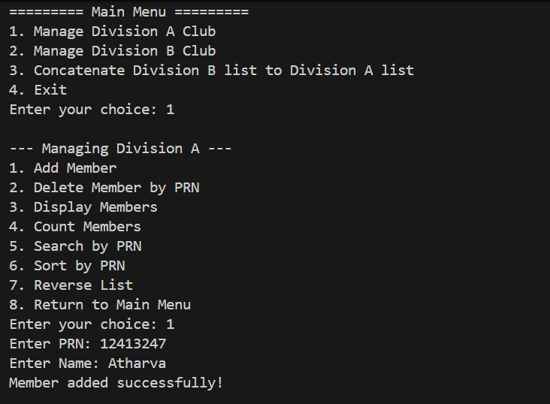
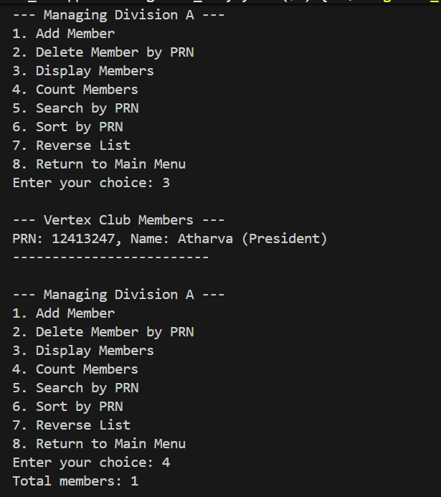
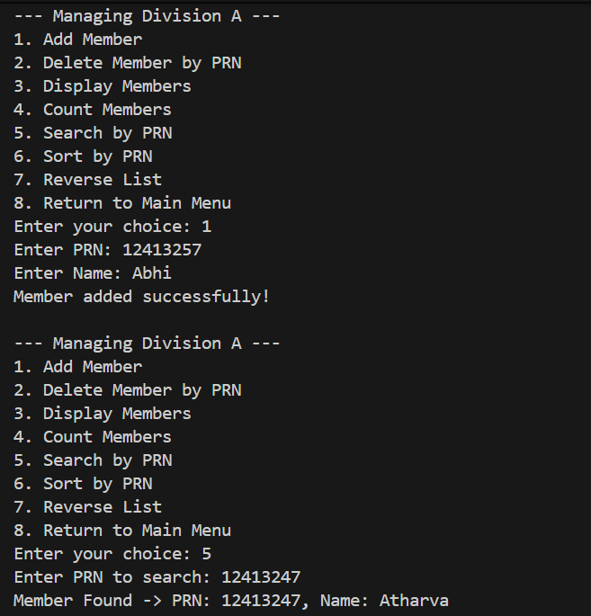
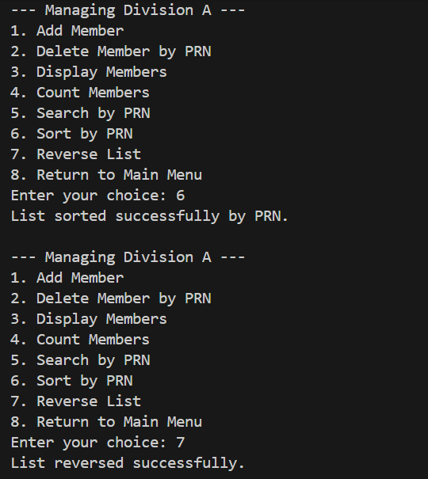
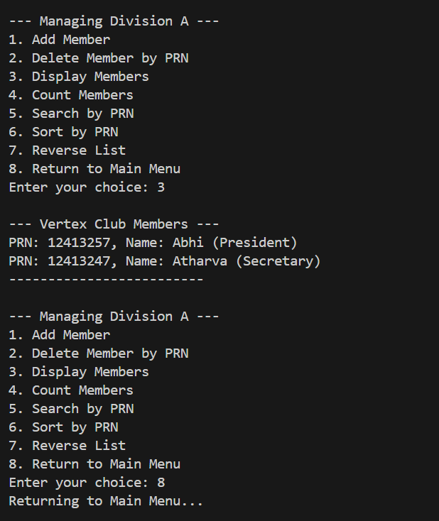
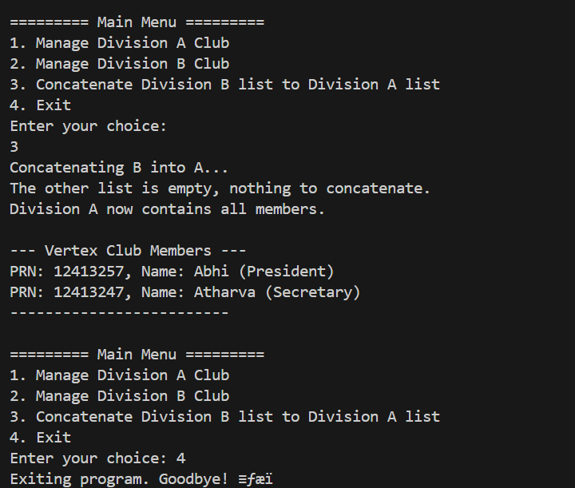

Program 2

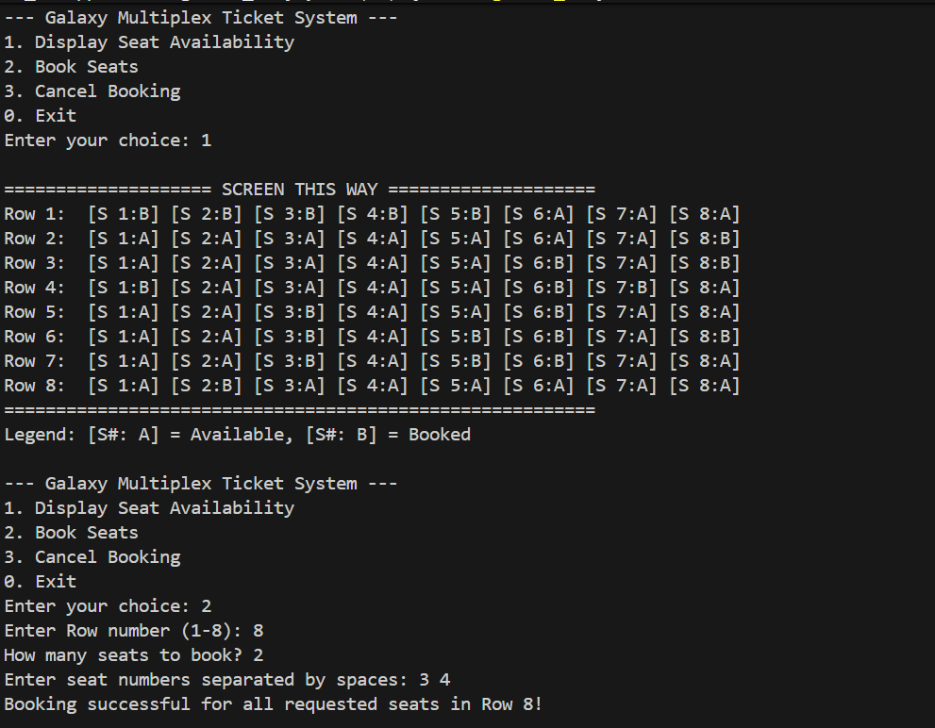

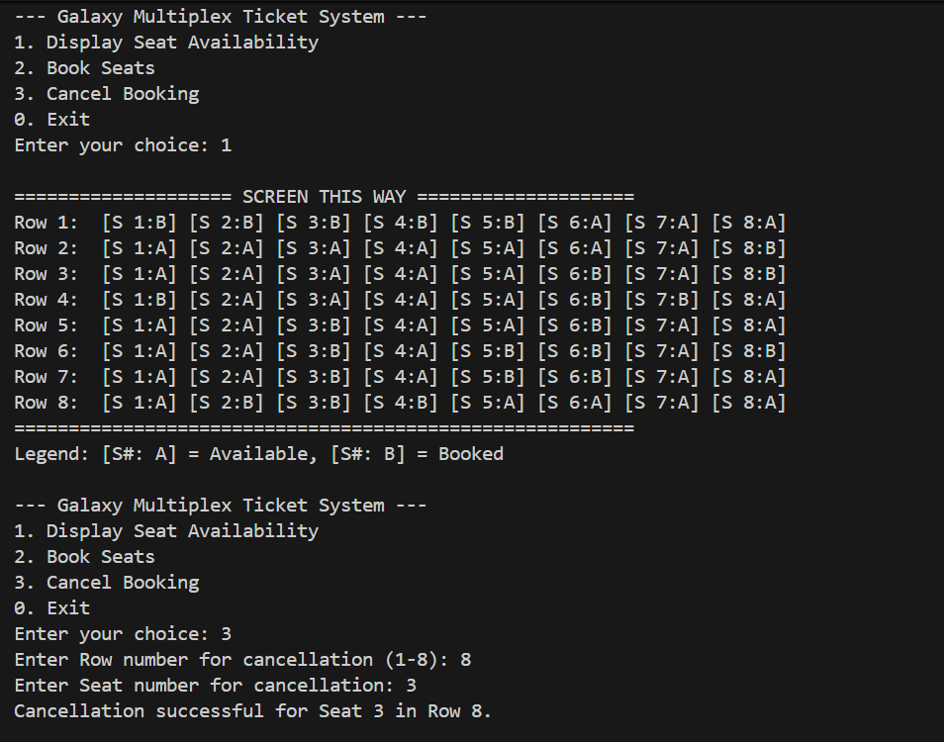
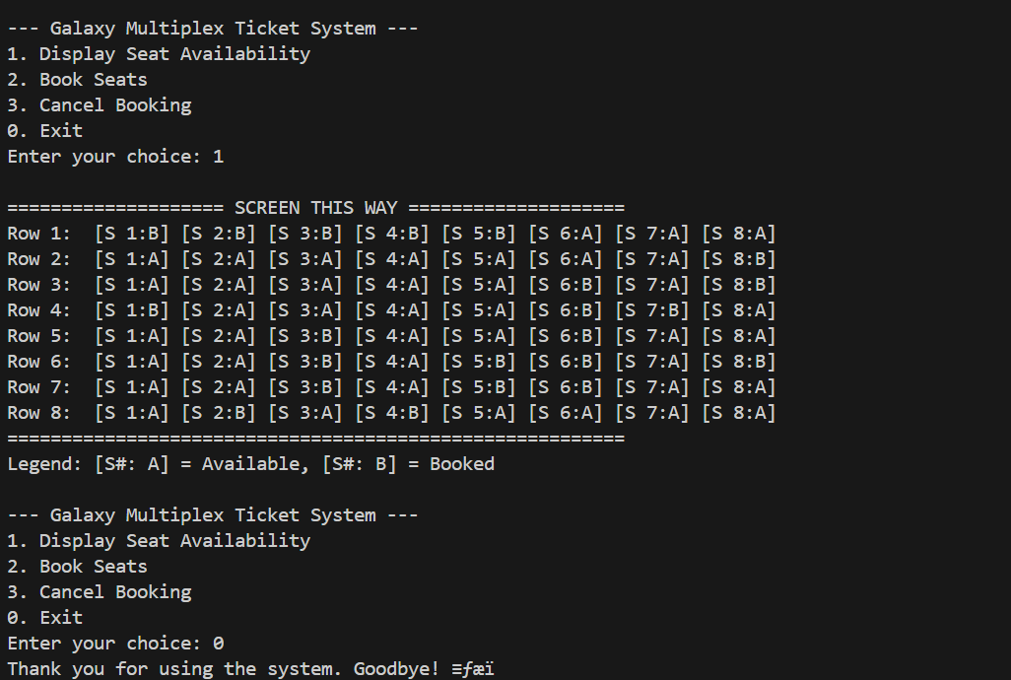

Program 3
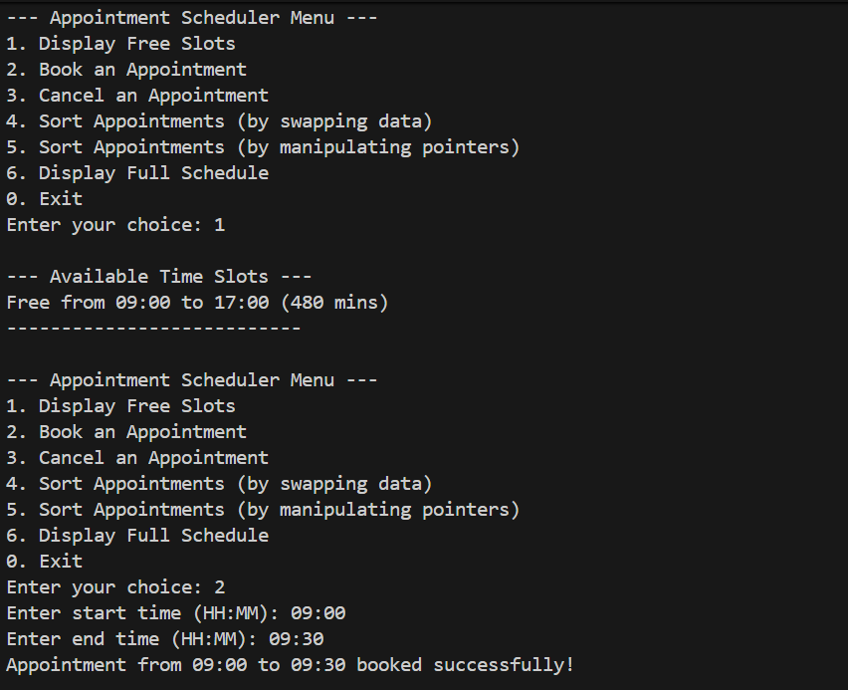
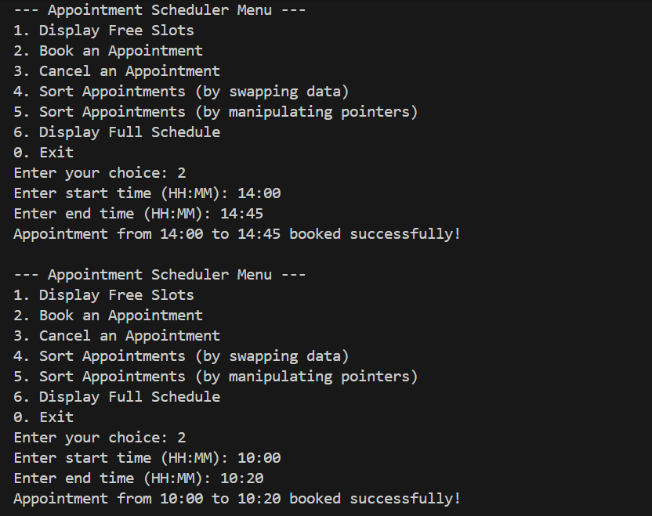
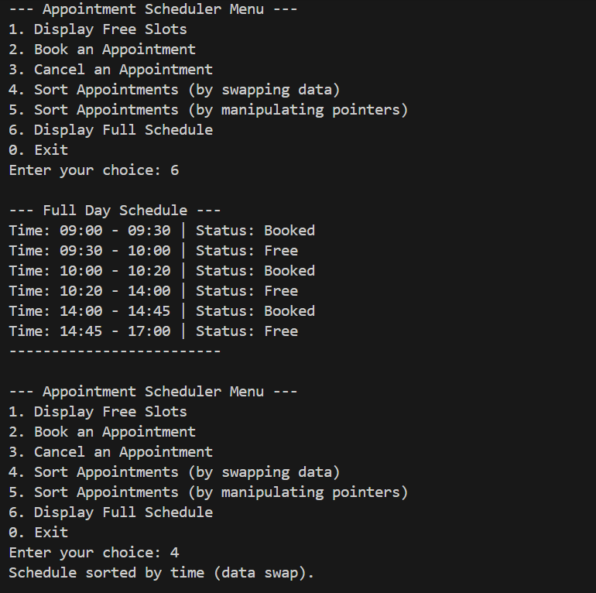
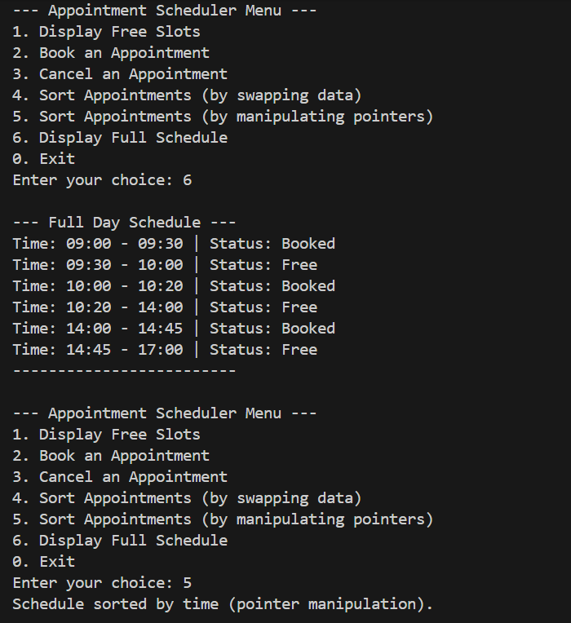
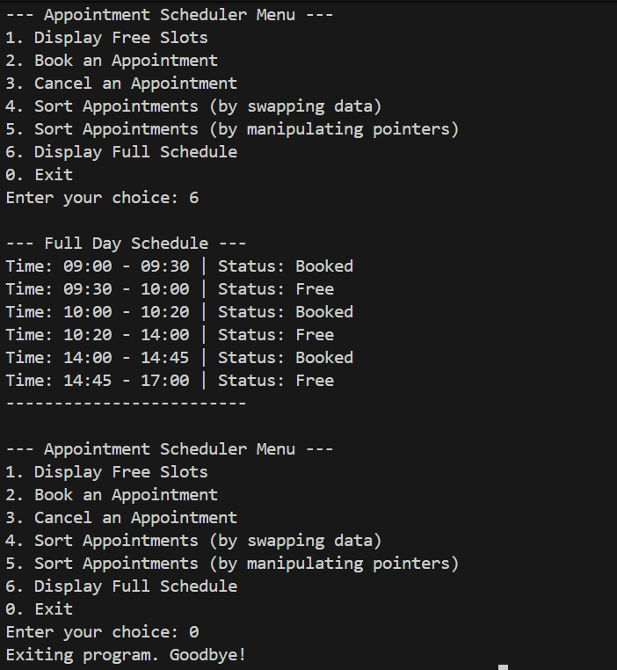

Program 4
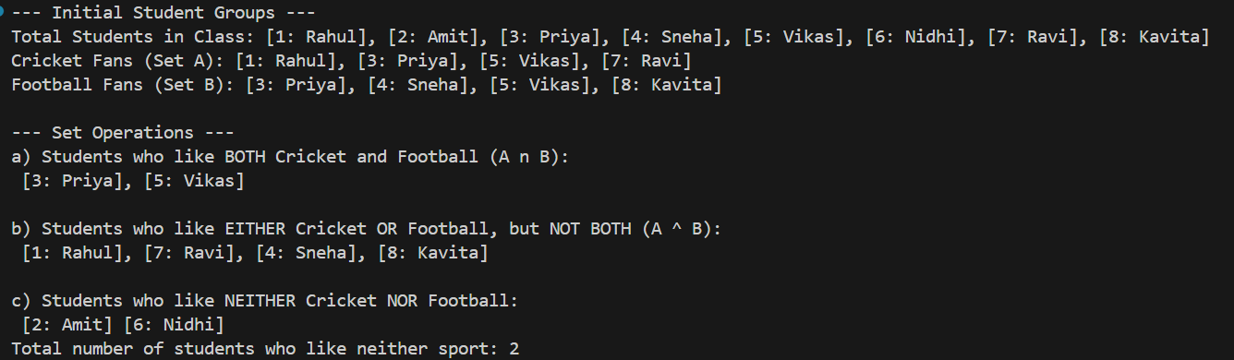

Program 5
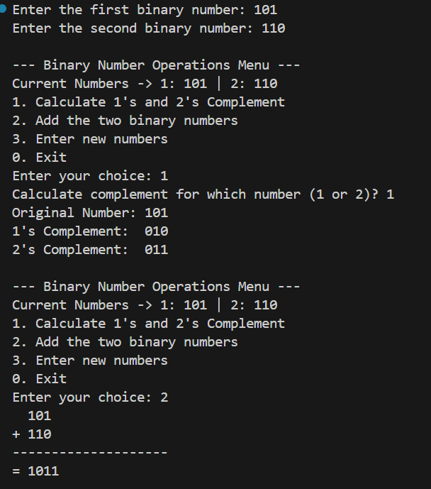

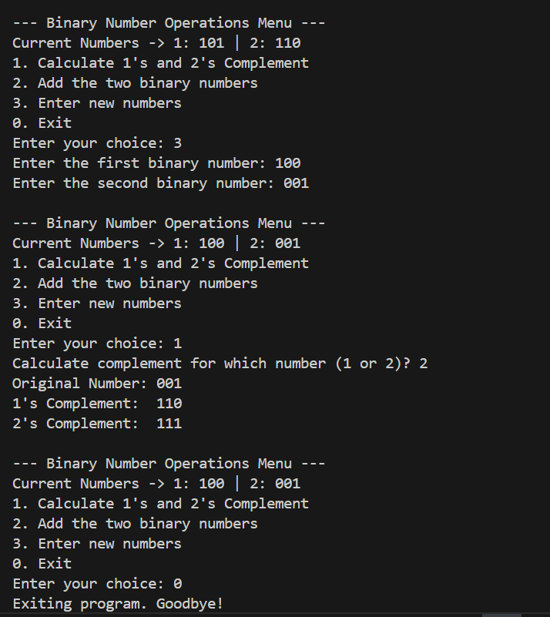

CONCLUSION:

This assignment provided a comprehensive, hands-on exploration of dynamic data structures, with a particular focus on the implementation and application of linked lists. By developing five distinct programs, we progressed from foundational concepts to the solution of complex, algorithmic problems.

We began with the Singly Linked List (SLL), using it to manage student rosters, perform Set operations (intersection and symmetric difference), and organize daily schedules. This exercise reinforced the fundamentals of node creation, traversal, insertion, and deletion, while also introducing important sorting techniques, comparing the simpler data-swapping approach with the more efficient pointer-manipulation method.
The assignment then advanced to more complex structures. Using a Doubly Circular Linked List (DCLL), managed via an array of head pointers, we effectively modeled and solved a 2D reservation problem, illustrating how to handle continuous, looping data in practical scenarios.

Finally, we leveraged a Doubly Linked List (DLL) to implement binary arithmetic operations, including 1’s complement, 2’s complement, and multi-bit addition with carry. By utilizing bidirectional traversal via prev pointers and starting operations from the tail (representing the Least Significant Bit), we were able to execute these computations efficiently and correctly.

Overall, this assignment highlighted the versatility and power of linked lists. Each variant—SLL, DLL, and DCLL—proved to be a specialized tool, suited to specific tasks ranging from simple data management to complex mathematical computation and real-world simulations. It reinforced both the theoretical understanding and practical implementation skills necessary for mastering dynamic data structures.

