Bansilal Ramnath Agarwal Charitable Trust’s

VISHWAKARMA INSTITUTE OF TECHNOLOGY – PUNE

DATA STRUCTURES

Division | SY CS-A
Batch | 3
GR Number (PRN) | 12413247
Roll No. | 72
Name | Atharva Dhamdhere

ASSIGNMENT 4

AIM

- Write a program to perform addition of two polynomials using singly linked list

- Implement Bubble sort using Doubly Linked List

- Write a program to create a doubly linked list and perform following operations on it:

  - Insert (all cases)
  - Delete (all cases)

OBJECTIVE:

The primary objective of this assignment is to develop a comprehensive, hands-on understanding of singly and doubly linked list data structures. This will be achieved by progressing from fundamental pointer mechanics to the application of these structures in solving complex algorithmic problems.
- Master the Foundational Mechanics of a Doubly Linked List (DLL):
  - Implement a complete set of insertion operations: at the head, at the tail, and at a specific position or by key.
  - Implement a complete set of deletion operations: from the head, from the tail, and by key.
  - Demonstrate proficient management of both next and prev pointers, with special attention to correctly handling all edge cases, including operations on empty lists and single-node lists.
- Implement Sorting Algorithms on a Non-Contiguous Data Structure:
  - Apply a classic, comparison-based sorting algorithm (e.g., Bubble Sort) to a doubly linked list.
  - Successfully sort the list by traversing its nodes and swapping the data values contained within them, demonstrating an understanding of in-place sorting on a dynamic structure.
- Apply Singly Linked Lists (SLL) for Algorithmic Problem-Solving:
  - Utilize a singly linked list to model and represent an abstract mathematical object—a polynomial—where each node represents a term with a coefficient and an exponent.
  - Design and implement a "merge-style" two-list traversal algorithm to perform polynomial addition, creating a third linked list to store the result.
  - Demonstrate the ability to use linked lists not just as data containers but as a core component of a computational algorithm.

THEORY

Singly Linked Lists (SLL):
A Singly Linked List (SLL) offers an elegant and highly efficient method for implementing the abstract data type (ADT) of a polynomial. A polynomial, like 5x4+2x2−7 , is fundamentally a collection of terms. Each term is defined by two key pieces of information: a coefficient (the number, e.g., 5) and an exponent (the power, e.g., 4). This structure maps perfectly to a linked list, where each node in the list represents a single term.
The node structure would look like this:
- An integer to store the coefficient.
- An integer to store the exponent.
- A pointer, next, to the following term in the polynomial.
To maximize the efficiency of this representation, the linked list is always kept sorted in descending order of exponents. This convention is the secret to making mathematical operations incredibly fast.
The Power of Sorted Addition
Adding two polynomials becomes a streamlined, single-pass operation analogous to a classic merge algorithm. Imagine you have two polynomial lists, p1 and p2, and you want to compute their sum to create a new result list. Using two pointers, t1 and t2, you traverse both lists simultaneously, comparing the exponents at each step:
- If t1->exponent > t2->exponent: The term from p1 is of a higher degree. You append this term to the result list and advance only the t1 pointer.
- If t2->exponent > t1->exponent: The term from p2 is of a higher degree. You append this term to the result list and advance only the t2 pointer.
- If the exponents are equal: The terms are of the same degree. You add their coefficients, create a new node with this sum and the common exponent, append it to the result list, and advance both t1 and t2. (If the sum of coefficients is zero, you simply skip adding the term).
This process continues until one list is fully traversed. At that point, all remaining terms from the other list are simply linked to the end of the result list, as there are no more terms to combine them with. This single-pass approach avoids nested loops, giving the addition algorithm a highly efficient time complexity of O(n+m), where n and m are the number of terms in the two polynomials, respectively.

The Doubly Linked List (DLL) ⛓️
A Doubly Linked List (DLL) enhances the basic linked list by providing the ability to traverse in both directions. Think of it like a train where each car is linked not only to the car in front of it but also to the one behind it. Each node in a DLL contains three fields:
- A next pointer, pointing to the subsequent node.
- A prev pointer, pointing to the preceding node.
- The data itself.
The list is managed by a head pointer (pointing to the first node) and a tail pointer (pointing to the last). The head's prev pointer and the tail's next pointer are both NULL, signifying the boundaries of the list.

Operational Advantages
The primary advantage of the prev pointer is the dramatic boost in operational efficiency for certain tasks.
- End-of-List Operations: Insertion and deletion at either the head or the tail become O(1) (constant time) operations. To remove the last element, you simply set tail = tail->prev and update the new tail's next pointer to NULL. This is a massive improvement over an SLL, which would require an O(n) traversal to find the second-to-last node.
- Middle-of-List Operations: While finding a node in the middle of the list still takes O(n) time, the subsequent insertion or deletion is an O(1) operation.
  - To insert a new node N after a node P: Four pointer assignments must be carefully re-wired. N must point forward to P->next and backward to P. Then, P and its original successor must be updated to point to N.
  - To delete a node N: The process is even more intuitive. You "bypass" the node by linking its neighbors directly to each other: N->prev->next = N->next and N->next->prev = N->prev. This effectively unlinks N from the chain.
The main challenge in implementing a DLL is the meticulous management of these pointers. Forgetting to update even one prev or next pointer can corrupt the list. Careful handling of edge cases—such as an empty list (head and tail are NULL), a single-node list (head == tail), or operations at the head/tail—is crucial for robust code. The trade-off is clear: a DLL consumes slightly more memory per node for the prev pointer but provides significant flexibility and performance gains in return.

Bubble Sort on a Linked List
Bubble Sort is a simple, comparison-based sorting algorithm often used in introductory computer science for its straightforward logic. It is, however, known for its simplicity rather than its efficiency. The algorithm works by repeatedly stepping through the list, comparing each adjacent pair of elements, and swapping them if they are not in the correct order. With each full pass, the next largest unsorted element "bubbles up" to its correct position at the end of the list. This continues until a complete pass is made with no swaps, indicating the list is sorted.
Due to its nested-loop nature (an outer loop for each pass and an inner loop for comparisons), the time complexity of Bubble Sort is a sluggish O(n2) in the average and worst cases, making it impractical for large datasets.
When applying Bubble Sort to a linked list, the "swap" can be implemented in two distinct ways:
1. Data Swap (Simple but Potentially Inefficient)
This is the most straightforward method. When two adjacent nodes, current and current->next, need to be swapped, you only exchange the data they hold, leaving the pointer structure of the list completely untouched.
While easy to implement, this approach can be very inefficient if the data within each node is large (e.g., a complex object or a large string). Copying large blocks of data repeatedly is computationally expensive.

2. Pointer Swap (Complex but Efficient)
A more sophisticated and performant method is to physically change the position of the nodes by re-wiring their next (and prev in a DLL) pointers. This "pointer swap" is an O(1) operation for each swap, regardless of the size of the data stored in the nodes.
However, it is significantly more complex to implement correctly. Swapping two adjacent nodes A and B requires carefully managing the pointers of A's predecessor, A itself, B, and B's successor. Special care must be taken for edge cases, such as when the swap involves the head of the list. Despite its complexity, this is the preferred method in any performance-critical scenario.

ALGORITHMS

Program 1

1. Start
2. Define a Term node with:
- coefficient
- exponent
- pointer to next term
3. Define a Polynomial class with:
- head pointer
- appendTerm(coeff, exp) → to insert new term
- create() → to build polynomial from user input
- operator+ → to add two polynomials
- display() → to print polynomial
4. Create First Polynomial (p1)
- Input number of terms
- For each term, input coefficient and exponent
- Insert term into linked list
5. Create Second Polynomial (p2)
- Repeat same steps as p1
6. Add Polynomials (p3 = p1 + p2)
- Initialize result polynomial
- Set pointers p1 and p2 to first terms
- While both p1 and p2 are not NULL:
a) If p1.exponent > p2.exponent
→ append p1 term to result, move p1
b) Else if p2.exponent > p1.exponent
→ append p2 term to result, move p2
c) Else (exponents equal)
→ sum = p1.coeff + p2.coeff
→ if sum ≠ 0, append(sum, exponent) to result
→ move both p1 and p2
- Append remaining terms of p1 (if any)
- Append remaining terms of p2 (if any)

7. Display:
- Print first polynomial
- Print second polynomial
- Print sum polynomial
8. End
Program 2

1. Start

2. Define a Node with:
- data
- pointer to next
- pointer to prev

3. Define a DoublyLinkedList class with:
- head pointer
- push(data) → insert node at end
- printList() → display list
- bubbleSort() → sort using bubble sort

4. Insert elements into the list using push()

5. Display the original list using printList()

6. Perform bubble sort:
- If list is empty or has only one node → return
- Repeat until no swaps occur:
a) Initialize swapped = false
b) Start from head, compare current node with next node
c) If current.data > next.data:
→ Swap the two nodes by adjusting pointers
→ Set swapped = true
Else:
→ Move current to next
d) After each pass, mark the last node as sorted (lastSorted)

7. Display the sorted list

8. End

Program 3
1. Start
2. Define Node with:
- data
- pointer next
- pointer prev

3. Define DoublyLinkedList class with:
- head, tail pointers
- insertAtBeginning(data)
- insertAtEnd(data)
- insertAtPosition(data, pos)
- deleteFromBeginning()
- deleteFromEnd()
- deleteByValue(value)
- display() → forward and backward traversal

4. In main program:
- Create an empty list
- Repeat until user chooses Exit:
a) Display menu:
1. Insert at Beginning
2. Insert at End
3. Insert at Position
4. Delete from Beginning
5. Delete from End
6. Delete by Value
7. Display List
0. Exit
b) Take user choice

5. Perform operations based on choice:
- Case 1: Input data → call insertAtBeginning()
- Case 2: Input data → call insertAtEnd()
- Case 3: Input data & position → call insertAtPosition()
- Case 4: Call deleteFromBeginning()
- Case 5: Call deleteFromEnd()
- Case 6: Input value → call deleteByValue()
- Case 7: Call display()
- Case 0: Exit program
- Default: Print invalid choice
6. End

PROGRAMS

Program 1

#include <iostream>

class Term {
public:
int coefficient;
int exponent;
Term* next;

Term(int coeff, int exp) : coefficient(coeff), exponent(exp), next(nullptr) {}
};

class Polynomial {
private:
Term* head;

void appendTerm(int coeff, int exp) {
Term* newTerm = new Term(coeff, exp);
if (!head) {
head = newTerm;
} else {
Term* current = head;
while (current->next) {
current = current->next;
}
current->next = newTerm;
}
}

public:
Polynomial() : head(nullptr) {}

~Polynomial() {
Term* current = head;
while (current != nullptr) {
Term* nextTerm = current->next;
delete current;
current = nextTerm;
}
}

void create() {
int n;
std::cout << "Enter the number of terms: ";
std::cin >> n;
if (n <= 0) return;

std::cout << "Enter each term (coefficient and exponent), ensuring exponents are in DESCENDING order.\n";
for (int i = 0; i < n; ++i) {
int coeff, exp;
std::cout << "Term " << i + 1 << " (coeff exp): ";
std::cin >> coeff >> exp;
if (coeff != 0) {
appendTerm(coeff, exp);
}
}
}

Polynomial operator+(const Polynomial& other) const {
Polynomial result;
Term* p1 = this->head;
Term* p2 = other.head;

while (p1 && p2) {
if (p1->exponent > p2->exponent) {
result.appendTerm(p1->coefficient, p1->exponent);
p1 = p1->next;
} else if (p2->exponent > p1->exponent) {
result.appendTerm(p2->coefficient, p2->exponent);
p2 = p2->next;
} else {
int sum_coeff = p1->coefficient + p2->coefficient;
if (sum_coeff != 0) {
result.appendTerm(sum_coeff, p1->exponent);
}
p1 = p1->next;
p2 = p2->next;
}
}

while (p1) {
result.appendTerm(p1->coefficient, p1->exponent);
p1 = p1->next;
}

while (p2) {
result.appendTerm(p2->coefficient, p2->exponent);
p2 = p2->next;
}

return result;
}

void display() const {
if (!head) {
std::cout << "0\n";
return;
}

Term* current = head;
bool isFirst = true;

while (current) {
if (current->coefficient == 0) {
current = current->next;
continue;
}

if (!isFirst) {
if (current->coefficient > 0) std::cout << " + ";
else std::cout << " - ";
} else if (current->coefficient < 0) {
std::cout << "-";
}

int absCoeff = (current->coefficient > 0) ? current->coefficient : -current->coefficient;

if (absCoeff != 1 || current->exponent == 0) {
std::cout << absCoeff;
}

if (current->exponent != 0) {
std::cout << "x";
if (current->exponent != 1) {
std::cout << "^" << current->exponent;
}
}

isFirst = false;
current = current->next;
}

if (isFirst) {
std::cout << "0";
}

std::cout << std::endl;
}
};

int main() {
Polynomial p1, p2;

std::cout << "--- Create First Polynomial ---\n";
p1.create();

std::cout << "\n--- Create Second Polynomial ---\n";
p2.create();

Polynomial p3 = p1 + p2;

std::cout << "\n----------------------------------\n";
std::cout << "First Polynomial: ";
p1.display();
std::cout << "Second Polynomial: ";
p2.display();
std::cout << "Sum of Polynomials: ";
p3.display();
std::cout << "----------------------------------\n";

return 0;
}

Program 2

#include <iostream>

class Node {
public:
int data;
Node* next;
Node* prev;

Node(int val) : data(val), next(nullptr), prev(nullptr) {}
};

class DoublyLinkedList {
private:
Node* head;

public:
DoublyLinkedList() : head(nullptr) {}

~DoublyLinkedList() {
Node* current = head;
while (current != nullptr) {
Node* nextNode = current->next;
delete current;
current = nextNode;
}
}

void push(int data) {
Node* newNode = new Node(data);
if (!head) {
head = newNode;
return;
}
Node* last = head;
while (last->next != nullptr) {
last = last->next;
}
last->next = newNode;
newNode->prev = last;
}

void printList() const {
if (!head) {
std::cout << "List is empty." << std::endl;
return;
}
Node* current = head;
while (current != nullptr) {
std::cout << current->data << " <-> ";
current = current->next;
}
std::cout << "NULL" << std::endl;
}

void bubbleSort() {
if (!head || !head->next) {
return;
}

bool swapped;
Node* current;
Node* lastSorted = nullptr;

do {
swapped = false;
current = head;

while (current->next != lastSorted) {
if (current->data > current->next->data) {
Node* node1 = current;
Node* node2 = current->next;

if (node1->prev) {
node1->prev->next = node2;
} else {
head = node2;
}

if (node2->next) {
node2->next->prev = node1;
}

node2->prev = node1->prev;
node1->prev = node2;
node1->next = node2->next;
node2->next = node1;

swapped = true;
} else {
current = current->next;
}
}
lastSorted = current;
} while (swapped);
}
};

int main() {
DoublyLinkedList dll;

dll.push(65);
dll.push(52);
dll.push(90);
dll.push(13);
dll.push(5);
dll.push(74);

std::cout << "Original List:" << std::endl;
dll.printList();

std::cout << "\nSorting the list using Bubble Sort..." << std::endl;
dll.bubbleSort();

std::cout << "\nSorted List:" << std::endl;
dll.printList();

return 0;
}

Program 3

#include <iostream>

class Node {
public:
int data;
Node* next;
Node* prev;

Node(int val) : data(val), next(nullptr), prev(nullptr) {}
};

class DoublyLinkedList {
private:
Node* head;
Node* tail;

public:
DoublyLinkedList() : head(nullptr), tail(nullptr) {}

~DoublyLinkedList() {
Node* current = head;
while (current != nullptr) {
Node* nextNode = current->next;
delete current;
current = nextNode;
}
}

void insertAtBeginning(int data) {
Node* newNode = new Node(data);
if (!head) {
head = tail = newNode;
} else {
newNode->next = head;
head->prev = newNode;
head = newNode;
}
std::cout << data << " inserted at the beginning.\n";
}

void insertAtEnd(int data) {
Node* newNode = new Node(data);
if (!tail) {
head = tail = newNode;
} else {
tail->next = newNode;
newNode->prev = tail;
tail = newNode;
}
std::cout << data << " inserted at the end.\n";
}

void insertAtPosition(int data, int pos) {
if (pos < 1) {
std::cout << "Invalid position!\n";
return;
}
if (pos == 1) {
insertAtBeginning(data);
return;
}

Node* current = head;
for (int i = 1; i < pos - 1 && current != nullptr; ++i) {
current = current->next;
}

if (current == nullptr) {
std::cout << "Position out of bounds.\n";
return;
}

if (current == tail) {
insertAtEnd(data);
return;
}

Node* newNode = new Node(data);
newNode->next = current->next;
newNode->prev = current;
if (current->next != nullptr) {
current->next->prev = newNode;
}
current->next = newNode;
std::cout << data << " inserted at position " << pos << ".\n";
}

void deleteFromBeginning() {
if (!head) {
std::cout << "List is empty. Nothing to delete.\n";
return;
}
Node* temp = head;
int deletedValue = temp->data;
if (head == tail) {
head = tail = nullptr;
} else {
head = head->next;
head->prev = nullptr;
}
delete temp;
std::cout << deletedValue << " deleted from the beginning.\n";
}

void deleteFromEnd() {
if (!tail) {
std::cout << "List is empty. Nothing to delete.\n";
return;
}
Node* temp = tail;
int deletedValue = temp->data;
if (head == tail) {
head = tail = nullptr;
} else {
tail = tail->prev;
tail->next = nullptr;
}
delete temp;
std::cout << deletedValue << " deleted from the end.\n";
}

void deleteByValue(int value) {
if (!head) {
std::cout << "List is empty.\n";
return;
}

Node* current = head;
while (current != nullptr && current->data != value) {
current = current->next;
}

if (current == nullptr) {
std::cout << "Value " << value << " not found in the list.\n";
return;
}

if (current == head) {
deleteFromBeginning();
} else if (current == tail) {
deleteFromEnd();
} else {
current->prev->next = current->next;
current->next->prev = current->prev;
delete current;
std::cout << value << " has been deleted from the list.\n";
}
}

void display() const {
if (!head) {
std::cout << "List is empty.\n";
return;
}
Node* current = head;
std::cout << "List (Forward): NULL <-> ";
while (current != nullptr) {
std::cout << current->data << " <-> ";
current = current->next;
}
std::cout << "NULL\n";

current = tail;
std::cout << "List (Backward): NULL <-> ";
while (current != nullptr) {
std::cout << current->data << " <-> ";
current = current->prev;
}
std::cout << "NULL\n";
}
};

int main() {
DoublyLinkedList dll;
int choice, data, position;

do {
std::cout << "\n--- Doubly Linked List Menu ---\n";
std::cout << "1. Insert at Beginning\n";
std::cout << "2. Insert at End\n";
std::cout << "3. Insert at Position\n";
std::cout << "4. Delete from Beginning\n";
std::cout << "5. Delete from End\n";
std::cout << "6. Delete by Value\n";
std::cout << "7. Display List\n";
std::cout << "0. Exit\n";
std::cout << "Enter your choice: ";
std::cin >> choice;

switch (choice) {
case 1:
std::cout << "Enter data to insert: ";
std::cin >> data;
dll.insertAtBeginning(data);
break;
case 2:
std::cout << "Enter data to insert: ";
std::cin >> data;
dll.insertAtEnd(data);
break;
case 3:
std::cout << "Enter data: ";
std::cin >> data;
std::cout << "Enter position: ";
std::cin >> position;
dll.insertAtPosition(data, position);
break;
case 4:
dll.deleteFromBeginning();
break;
case 5:
dll.deleteFromEnd();
break;
case 6:
std::cout << "Enter value to delete: ";
std::cin >> data;
dll.deleteByValue(data);
break;
case 7:
dll.display();
break;
case 0:
std::cout << "Exiting program. Goodbye! \n";
break;
default:
std::cout << "Invalid choice. Please try again.\n";
}
} while (choice != 0);

return 0;
}

OUTPUT:

Program 1

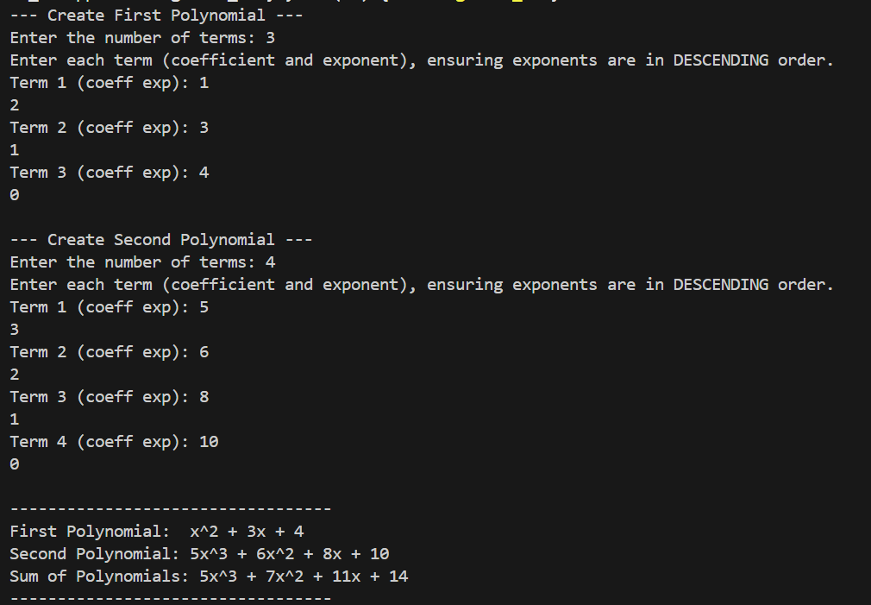

Program 2

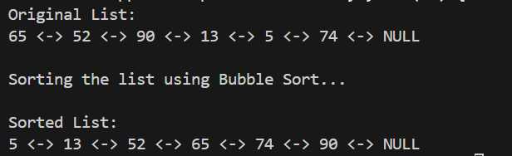

Program 3

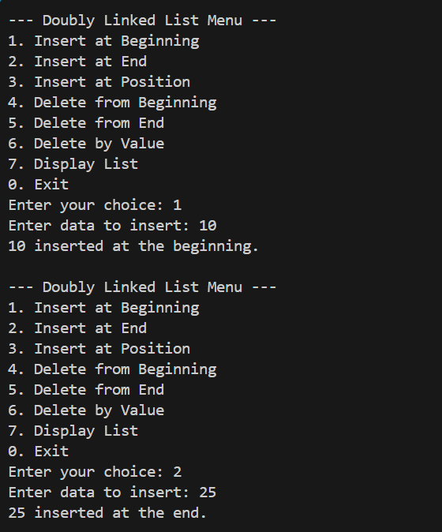

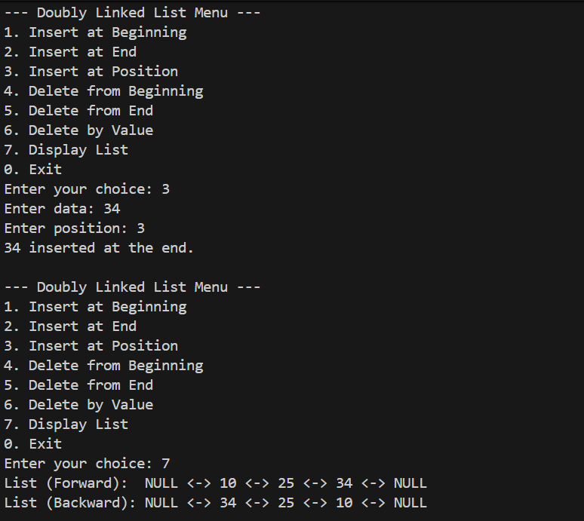

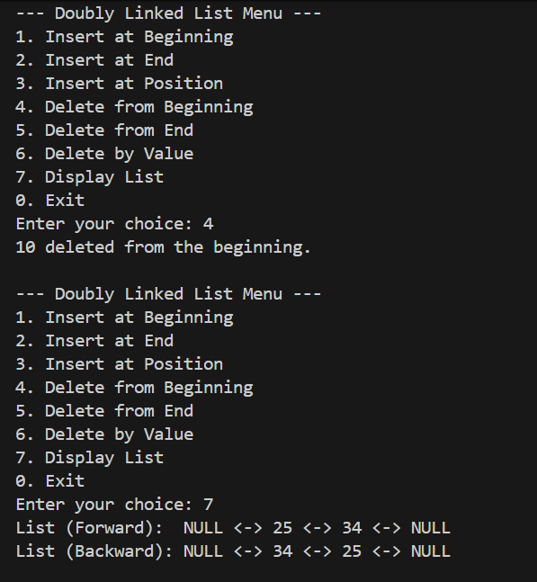

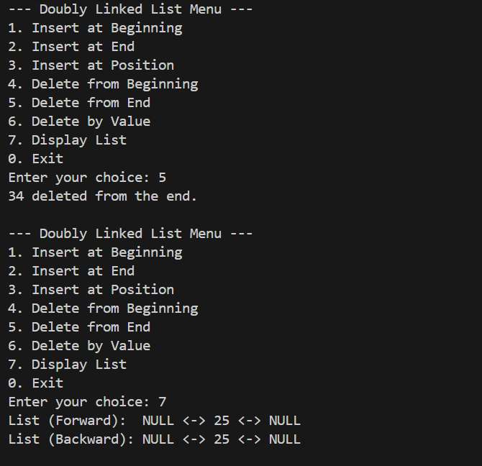

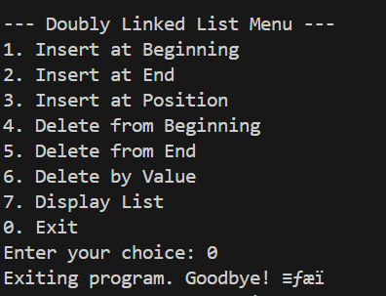

CONCLUSION:

This assignment provided an in-depth, practical exploration of singly and doubly linked lists and their algorithmic applications. Using an SLL, we modeled polynomials and implemented an efficient O(n+m) polynomial addition algorithm, demonstrating how linked lists simplify dynamic data representation. With a DLL, we applied Bubble Sort (O(n²)), carefully adapting the algorithm to a node-based structure through pointer manipulation. In addition, we developed the full set of DLL operations—insertions at the beginning, end, and specific positions, along with deletions by position and value—requiring accurate management of head, tail, next, and prev pointers. These implementations not only reinforced the theoretical aspects of linked lists but also enhanced problem-solving skills by handling edge cases and ensuring data integrity. Overall, the assignment built a solid foundation for understanding and working with advanced data structures such as circular lists, skip lists, and graph representations.

