Bansilal Ramnath Agarwal Charitable Trust’s

VISHWAKARMA INSTITUTE OF TECHNOLOGY – PUNE

DATA STRUCTURES

Division | SY CS-A
Batch | 3
GR Number (PRN) | 12413247
Roll No. | 72
Name | Atharva Dhamdhere

ASSIGNMENT 5

AIM

- WAP to build a simple stock price tracker that keeps a history of daily stock prices entered by the user. To allow users to go back and view or remove the most recent price, implement a stack using a linked list to store these integer prices. Implement the following operations:
- record(price) – Add a new stock price (an integer) to the stack.
- remove () – Remove and return the most recent price (top of the stack).
- latest () – Return the most recent stock price without removing it.
- isEmpty() – Check if there are no prices recorded.
- Convert given infix expression Eg. a-b*c-d/e+f into postfix form using stack and show the operations step by step.
- Write a program to implement multiple stack i.e more than two stack using array and perform following operations on it. A. Push B. Pop C. Stack Overflow D. Stack Underflow E. Display

- You are given a string containing only parentheses characters: '(', ')', '{', '}', '[', and ']'. Your task is to check whether the parentheses are balanced or not. A string is considered balanced if:
- Every opening bracket has a corresponding closing bracket of the same type
- Brackets are closed in the correct order.
- You are given a postfix expression (also known as Reverse Polish Notation) consisting of single-digit operands and binary operators (+, -, *, /). Your task is to evaluate the expression using stack and return its result.

OBJECTIVE:

The primary objective of this assignment is to foster a comprehensive, hands-on mastery of stack data structures, both through implementation and algorithmic application. This will be achieved by leveraging stacks built from linked lists and arrays, and by employing stack operations to solve classic computer science problems spanning expression parsing, evaluation, and correctness verification.
· Master Stack Implementation Using Linked Lists:
- Develop a fully functional stack using a singly linked list to dynamically manage a history of daily stock prices, where each node represents a price entry.
- Implement and demonstrate the complete suite of stack operations—push (record), pop (remove), peek (latest), and isEmpty—highlighting the flexibility of linked lists for dynamic storage beyond static arrays.
- Showcase real-world utilization of stacks by modeling a stock price tracker, focusing on how linked list nodes can be efficiently added and removed to maintain the latest state.
· Apply Stack-Based Algorithms for Expression Conversion:
- Utilize a stack to systematically convert infix expressions, such as "a-b*c-d/e+f", into their postfix (Reverse Polish Notation) equivalents, accounting for correct operator precedence and associativity.
- Provide a detailed, step-by-step illustration of the stack’s state during each conversion phase, emphasizing the core mechanics that make stacks indispensable in parsing and compiling expressions.
· Design and Implement Multiple Stacks within a Single Array:
- Construct a solution using arrays to manage more than two stacks simultaneously, optimizing the use of contiguous memory and preventing data collision.
- Implement robust control for push and pop operations, stack overflow, and stack underflow conditions, ensuring error-free boundary management.
- Demonstrate the ability to correctly display contents of all stacks, exploring techniques to partition a single array into distinct logical stack regions.
· Evaluate Balanced Parentheses Using Stacks:
- Develop an algorithm using a stack to validate whether a string of parentheses, braces, and brackets is properly balanced, as per syntax rules.
- Implement logic to push opening characters and match them with correct closing characters, leveraging stacks to ensure correct nesting and ordering—critical skills in compiler construction and syntax validation.
· Implement Stack Evaluation for Postfix Expressions:
- Employ stack operations to interpret and evaluate postfix expressions consisting of single-digit operands and binary operators.
- Demonstrate the sequential process of pushing operands and applying operators by popping from the stack, reflecting the stack’s LIFO property in arithmetic computation.
- Illustrate how postfix evaluation bypasses the need for parentheses by enacting operations in strict left-to-right order, simplifying expression handling.

THEORY

Stack Using Linked List:
A stack implemented with a singly linked list provides a dynamic and flexible way to record a sequence of daily stock prices, supporting efficient addition and removal operations from the top (latest entry).
Each node in such a linked list typically contains:
- An integer representing the stock price.
- A pointer to the next node, which represents the previous price in the history.
The stack structure is governed by the Last-In-First-Out (LIFO) principle. This means the most recent price added is always at the top of the stack.
Common stack operations include:
- record(price): Pushes a new node onto the linked list, storing the newly entered price as the top of the stack.
- remove(): Pops the top node, which removes and returns the latest price.
- latest(): Returns (without removing) the value stored in the top node.
- isEmpty(): Checks whether the stack has any nodes remaining.
Stacks using linked lists do not face any predetermined size restrictions and can efficiently handle dynamic price sequences. The flexibility of node management allows for rapid addition and removal, a critical feature for scenarios like financial price tracking where updates are frequent.

Stack-Based Expression Conversion: Infix to Postfix
Stacks are fundamental in parsing and converting mathematical expressions, particularly infix to postfix transformations.
The conversion requires systematically scanning the infix expression (e.g., a−b∗c−d/e+fa−b∗c−d/e+f) and handling operators according to their precedence using stack operations.
Key mechanics:
- Operands (variables/numbers) are directly appended to the output.
- Operators are pushed onto the stack. Before pushing, operators with lower or equal precedence already on the stack are popped off and added to the output.
- Parentheses act as explicit precedence boundaries supplied to and removed from the stack in correct order.
The step-by-step conversion process reveals how stacks exploit LIFO order to ensure operators are handled before those with lower precedence, mirroring how compilers parse mathematical expressions for evaluation.

Multiple Stacks Using Arrays
Managing multiple stacks within a single array requires thoughtful partitioning of array space, typically through careful index management and boundary checks.
Such a design divides the array logically so each stack operates independently, minimizing wasted space and eliminating the need for multiple separate arrays.
Operational highlights:
- Push and Pop: Operations must maintain independent top pointers for each stack and adjust array boundaries accordingly.
- Stack Overflow/Underflow: Checks ensure that one stack does not overwrite another or exceed the array’s total capacity.
- Display: Each stack’s contents can be displayed by traversing only the elements assigned to its respective section.
This approach primarily demonstrates memory-efficient stack implementation, a key concept when resources are constrained or multiple stacks—such as undo/redo histories—are needed in a single application.

Balanced Parentheses with Stack
The problem of verifying balanced parentheses in a string is elegantly solved using stacks.
The algorithm traverses the string, pushing opening brackets ('(', '{', '[') onto the stack, and pops when a corresponding closing bracket is found.
Essential details:
- Matching is only valid if a closing bracket matches the type and order of the opening bracket at the stack’s top.
- Any mismatch or leftover brackets after traversal indicates imbalance.
Stack’s LIFO nature ensures the most recent opening symbol is always checked first for closure, enforcing correct nesting and order—core concepts in syntax parsing and compiler frontends.

Evaluating Postfix Expressions with Stack
Stack structures support efficient computation of expressions written in postfix, or Reverse Polish Notation (RPN).
The algorithm reads the input from left to right, pushing operands onto the stack and applying operators to the top-most operands as they appear.
Operational steps:
- When an operator is encountered, pop the top two operands, perform the computation, and push the result back onto the stack.
- The process continues until the end of the expression, where the last value on the stack is the result.
Postfix notation eliminates the need for parentheses and operator precedence management, making evaluation straightforward via stack operations. This concept is widely leveraged in calculators and expression evaluators for its simplicity and efficiency.

ALGORITHMS

Program 1

BEGIN
- Initialize top ← NULL.
- REPEAT
  - Display menu:
    - Record a new price
    - Remove the most recent price
    - View the latest price
    - Display price history
    - Exit
  - Read choice.
CASE 1: Record a new price
  - Input price.
  - Create a new node with price.
  - Set newNode.next ← top.
  - Set top ← newNode.
  - Print "Recorded price".
CASE 2: Remove most recent price
  - IF top = NULL THEN
    - Print "History empty".
  - ELSE
    - Set removedPrice ← top.price.
    - Move top ← top.next.
    - Delete old node.
    - Print removedPrice.
CASE 3: View latest price
  - IF top = NULL THEN
    - Print "No prices recorded".
  - ELSE
    - Print top.price.
CASE 4: Display price history
  - IF top = NULL THEN
    - Print "History empty".
  - ELSE
    - Set current ← top.
    - WHILE current ≠ NULL DO
      - Print current.price.
      - Move current ← current.next.
CASE 5: Exit
  - Print "Goodbye".
  - Terminate loop.
DEFAULT
  - Print "Invalid choice".
- UNTIL choice = 5
END

Program 2
1. Initialize:
- Create an empty stack for operators.
- Create an empty string for the postfix expression.

2. Scan the infix expression from left to right.

3. For each symbol in the expression:
a. If the symbol is an operand (letter/number):
- Append it to the postfix expression.
b. If the symbol is '(':
- Push it onto the stack.
c. If the symbol is ')':
- Pop from the stack and append to postfix until '(' is encountered.
- Discard the '('.
d. If the symbol is an operator (+, -, *, /, ^):
- While the stack is not empty AND top of stack is not '(' AND
precedence of current operator ≤ precedence of top of stack:
- Pop from stack and append to postfix.
- Push the current operator onto the stack.

4. After scanning the entire expression:
- Pop all remaining operators from the stack and append them to postfix.

5. Output the postfix expression..

Program 3

1. Initialize:
- Input total array size (n) and number of stacks (k).
- Compute stack capacity = n / k.
- Create an array 'arr' of size n.
- Create arrays 'top' and 'base' of size k.
- For each stack i (0 to k-1):
- base[i] = i * stack_capacity
- top[i] = base[i] - 1

2. Push(stack_num, value):
- If top[stack_num] >= base[stack_num] + stack_capacity - 1:
- Stack Overflow, return.
- Else:
- Increment top[stack_num]
- arr[top[stack_num]] = value

3. Pop(stack_num):
- If top[stack_num] < base[stack_num]:
- Stack Underflow, return error.
- Else:
- value = arr[top[stack_num]]
- Decrement top[stack_num]
- Return value

4. isFull(stack_num):
- Return true if top[stack_num] >= base[stack_num] + stack_capacity - 1

5. isEmpty(stack_num):
- Return true if top[stack_num] < base[stack_num]

6. Display(stack_num):
- If isEmpty(stack_num), print "Stack empty"
- Else, print all elements from base[stack_num] to top[stack_num]

7. User Menu:
- Show options: Push, Pop, Display, Exit
- Take user choice and stack number
- Call corresponding function
- Repeat until user exits

Program 4

1. Initialize an empty stack.

2. Scan the expression from left to right.

3. For each character in the expression:
a. If the character is an opening bracket '(', '{', or '[':
- Push it onto the stack.
b. If the character is a closing bracket ')', '}', or ']':
- If the stack is empty:
- Expression is not balanced, return false.
- Else:
- Pop the top element from the stack.
- If the popped element does not match the corresponding opening bracket:
- Expression is not balanced, return false.

4. After scanning the entire expression:
- If the stack is empty:
- Expression is balanced, return true.
- Else:
- Expression is not balanced, return false.

5. Output the result.

Program 5

1. Initialize an empty stack.

2. Scan the postfix expression from left to right.

3. For each character in the expression:
a. If it is an operand (digit):
- Convert it to an integer and push onto the stack.
b. If it is an operator (+, -, *, /):
- Pop the top two elements from the stack (val2 = top, val1 = next top).
- Perform the operation: val1 <operator> val2.
- Push the result back onto the stack.
c. If the stack has fewer than two operands when an operator is encountered:
- Expression is invalid, return error.

4. After scanning the entire expression:
- If the stack contains exactly one element:
- That element is the result.
- Else:
- Expression is invalid, return error.

5. Output the result.

PROGRAMS

Program 1

#include <iostream>

class Node {
public:
int price;
Node* next;

Node(int p) : price(p), next(nullptr) {}
};

class StockTracker {
private:
Node* top;

public:
StockTracker() : top(nullptr) {}

~StockTracker() {
while (!isEmpty()) {
remove();
}
}

bool isEmpty() {
return top == nullptr;
}

void record(int price) {
Node* newNode = new Node(price);
newNode->next = top;
top = newNode;
std::cout << "Recorded price: " << price << std::endl;
}

int remove() {
if (isEmpty()) {
std::cout << "No prices to remove. History is empty." << std::endl;
return -1;
}
Node* temp = top;
int removedPrice = top->price;
top = top->next;
delete temp;
return removedPrice;
}

int latest() {
if (isEmpty()) {
std::cout << "No prices recorded yet." << std::endl;
return -1;
}
return top->price;
}

void displayHistory() {
if (isEmpty()) {
std::cout << "Price history is empty." << std::endl;
return;
}
std::cout << "Stock Price History (Most Recent First):" << std::endl;
Node* current = top;
while (current != nullptr) {
std::cout << "-> " << current->price << std::endl;
current = current->next;
}
}
};

void showMenu() {
std::cout << "\n--- Stock Price Tracker Menu ---" << std::endl;
std::cout << "1. Record a new price" << std::endl;
std::cout << "2. Remove the most recent price" << std::endl;
std::cout << "3. View the latest price" << std::endl;
std::cout << "4. Display price history" << std::endl;
std::cout << "5. Exit" << std::endl;
std::cout << "Enter your choice: ";
}

int main() {
StockTracker tracker;
int choice;
int price;

do {
showMenu();
std::cin >> choice;

switch (choice) {
case 1:
std::cout << "Enter the stock price to record: ";
std::cin >> price;
tracker.record(price);
break;
case 2: {
int removedPrice = tracker.remove();
if (removedPrice != -1) {
std::cout << "Removed the last recorded price: " << removedPrice << std::endl;
}
break;
}
case 3: {
int latestPrice = tracker.latest();
if (latestPrice != -1) {
std::cout << "The latest recorded price is: " << latestPrice << std::endl;
}
break;
}
case 4:
tracker.displayHistory();
break;
case 5:
std::cout << "Exiting program. Goodbye!" << std::endl;
break;
default:
std::cout << "Invalid choice. Please try again." << std::endl;
}
} while (choice != 5);

return 0;
}

Program 2

#include <iostream>
#include <stack>
#include <string>
#include <cctype>

int getPrecedence(char op) {
if (op == '^') {
return 3;
} else if (op == '*' || op == '/') {
return 2;
} else if (op == '+' || op == '-') {
return 1;
} else {
return -1;
}
}

std::string infixToPostfix(const std::string& infix) {
std::stack<char> operatorStack;
std::string postfix = "";

for (char symbol : infix) {
if (isalnum(symbol)) {
postfix += symbol;
}
else if (symbol == '(') {
operatorStack.push(symbol);
}
else if (symbol == ')') {
while (!operatorStack.empty() && operatorStack.top() != '(') {
postfix += operatorStack.top();
operatorStack.pop();
}
if (!operatorStack.empty()) {
operatorStack.pop();
}
}
else {
while (!operatorStack.empty() && operatorStack.top() != '(' && getPrecedence(symbol) <= getPrecedence(operatorStack.top())) {
postfix += operatorStack.top();
operatorStack.pop();
}
operatorStack.push(symbol);
}
}

while (!operatorStack.empty()) {
postfix += operatorStack.top();
operatorStack.pop();
}

return postfix;
}

int main() {
std::string infixExpression = "a-b*c-d/e+f";

std::cout << "Infix Expression: " << infixExpression << std::endl;

std::string postfixExpression = infixToPostfix(infixExpression);

std::cout << "Postfix Expression: " << postfixExpression << std::endl;

return 0;
}

Program 3

#include <iostream>

class MultiStack {
private:
int *arr;
int *top;
int *base;
int num_stacks;
int arr_size;
int stack_capacity;

public:
MultiStack(int k, int n) {
num_stacks = k;
arr_size = n;
stack_capacity = arr_size / num_stacks;

arr = new int[arr_size];
top = new int[num_stacks];
base = new int[num_stacks];

for (int i = 0; i < num_stacks; ++i) {
base[i] = i * stack_capacity;
top[i] = base[i] - 1;
}
}

~MultiStack() {
delete[] arr;
delete[] top;
delete[] base;
}

bool isFull(int stack_num) {
if (stack_num < 0 || stack_num >= num_stacks) {
std::cout << "Error: Invalid stack number." << std::endl;
return true;
}
return top[stack_num] >= base[stack_num] + stack_capacity - 1;
}

bool isEmpty(int stack_num) {
if (stack_num < 0 || stack_num >= num_stacks) {
std::cout << "Error: Invalid stack number." << std::endl;
return true;
}
return top[stack_num] < base[stack_num];
}

void push(int stack_num, int value) {
if (isFull(stack_num)) {
std::cout << "Stack Overflow on stack " << stack_num << std::endl;
return;
}
top[stack_num]++;
arr[top[stack_num]] = value;
std::cout << value << " pushed to stack " << stack_num << "." << std::endl;
}

int pop(int stack_num) {
if (isEmpty(stack_num)) {
std::cout << "Stack Underflow on stack " << stack_num << std::endl;
return -1; // Return a sentinel value
}
int value = arr[top[stack_num]];
top[stack_num]--;
return value;
}

void display(int stack_num) {
if (isEmpty(stack_num)) {
std::cout << "Stack " << stack_num << " is empty." << std::endl;
return;
}
std::cout << "Elements in stack " << stack_num << ": ";
for (int i = base[stack_num]; i <= top[stack_num]; ++i) {
std::cout << arr[i] << " ";
}
std::cout << std::endl;
}
};

void showMenu() {
std::cout << "\n--- Multi-Stack Operations ---\n";
std::cout << "1. Push\n";
std::cout << "2. Pop\n";
std::cout << "3. Display Stack\n";
std::cout << "4. Exit\n";
std::cout << "Enter your choice: ";
}

int main() {
int total_size, num_stacks;
std::cout << "Enter total size of the array: ";
std::cin >> total_size;
std::cout << "Enter number of stacks: ";
std::cin >> num_stacks;

if (num_stacks > total_size) {
std::cout << "Error: Number of stacks cannot be greater than array size." << std::endl;
return 1;
}

MultiStack ms(num_stacks, total_size);
int choice, stack_num, value;

do {
showMenu();
std::cin >> choice;

if (choice >= 1 && choice <= 3) {
std::cout << "Enter stack number (0 to " << num_stacks - 1 << "): ";
std::cin >> stack_num;
if (stack_num < 0 || stack_num >= num_stacks) {
std::cout << "Invalid stack number. Please try again." << std::endl;
continue;
}
}

switch (choice) {
case 1:
std::cout << "Enter value to push: ";
std::cin >> value;
ms.push(stack_num, value);
break;
case 2: {
int popped_value = ms.pop(stack_num);
if (popped_value != -1) {
std::cout << "Popped value from stack " << stack_num << ": " << popped_value << std::endl;
}
break;
}
case 3:
ms.display(stack_num);
break;
case 4:
std::cout << "Exiting program." << std::endl;
break;
default:
std::cout << "Invalid choice. Please try again." << std::endl;
}
} while (choice != 4);

return 0;
}

Program 4
#include <iostream>
#include <stack>
#include <string>

bool areParenthesesBalanced(const std::string& expr) {
std::stack<char> s;
char ch;

for (int i = 0; i < expr.length(); i++) {
if (expr[i] == '(' || expr[i] == '[' || expr[i] == '{') {
s.push(expr[i]);
continue;
}

if (s.empty()) {
return false;
}

switch (expr[i]) {
case ')':
ch = s.top();
s.pop();
if (ch == '{' || ch == '[') {
return false;
}
break;

case '}':
ch = s.top();
s.pop();
if (ch == '(' || ch == '[') {
return false;
}
break;

case ']':
ch = s.top();
s.pop();
if (ch == '(' || ch == '{') {
return false;
}
break;
}
}

return (s.empty());
}

int main() {
std::string balancedExpr = "{()}[]";
std::string unbalancedExpr = "{([)]}";
std::string anotherBalancedExpr = "()[]{}";
std::string anotherUnbalancedExpr = "(]";
std::cout << "Expression: " << balancedExpr << std::endl;
if (areParenthesesBalanced(balancedExpr)) {
std::cout << "Result: Balanced" << std::endl;
} else {
std::cout << "Result: Not Balanced" << std::endl;
}
std::cout << "\nExpression: " << unbalancedExpr << std::endl;
if (areParenthesesBalanced(unbalancedExpr)) {
std::cout << "Result: Balanced" << std::endl;
} else {
std::cout << "Result: Not Balanced" << std::endl;
}
std::cout << "\nExpression: " << anotherBalancedExpr << std::endl;
if (areParenthesesBalanced(anotherBalancedExpr)) {
std::cout << "Result: Balanced" << std::endl;
} else {
std::cout << "Result: Not Balanced" << std::endl;
}
std::cout << "\nExpression: " << anotherUnbalancedExpr << std::endl;
if (areParenthesesBalanced(anotherUnbalancedExpr)) {
std::cout << "Result: Balanced" << std::endl;
} else {
std::cout << "Result: Not Balanced" << std::endl;
}
return 0;
}
Program 5
#include <iostream>
#include <stack>
#include <string>
#include <cctype>

// Function to evaluate a postfix expression
int evaluatePostfix(const std::string& expr) {
std::stack<int> s;

// Iterate through each character of the expression
for (char const &c: expr) {
// If the character is a digit, convert it to an integer and push it onto the stack
if (isdigit(c)) {
s.push(c - '0');
}
// If the character is an operator
else {
// There must be at least two operands on the stack
if (s.size() < 2) {
std::cerr << "Error: Invalid postfix expression." << std::endl;
return -1; // Indicate error
}

// Pop the top two operands
int val2 = s.top();
s.pop();
int val1 = s.top();
s.pop();

// Perform the operation and push the result back onto the stack
switch (c) {
case '+':
s.push(val1 + val2);
break;
case '-':
s.push(val1 - val2);
break;
case '*':
s.push(val1 * val2);
break;
case '/':
if (val2 == 0) {
std::cerr << "Error: Division by zero." << std::endl;
return -1; // Indicate error
}
s.push(val1 / val2);
break;
default:
std::cerr << "Error: Invalid character in expression." << std::endl;
return -1; // Indicate error
}
}
}

// After iterating, the stack should contain exactly one element: the final result
if (s.size() != 1) {
std::cerr << "Error: Invalid postfix expression." << std::endl;
return -1; // Indicate error
}

return s.top();
}

int main() {
std::string postfixExpr1 = "23*54*+9-"; // (2*3) + (5*4) - 9 = 6 + 20 - 9 = 17
std::string postfixExpr2 = "82/3-32*+"; // (8/2) - 3 + (3*2) = 4 - 3 + 6 = 7
std::cout << "Postfix Expression: " << postfixExpr1 << std::endl;
int result1 = evaluatePostfix(postfixExpr1);
if (result1 != -1) {
std::cout << "Result: " << result1 << std::endl;
}
std::cout << "\nPostfix Expression: " << postfixExpr2 << std::endl;
int result2 = evaluatePostfix(postfixExpr2);
if (result2 != -1) {
std::cout << "Result: " << result2 << std::endl;
}

return 0;
}

OUTPUT:

Program 1

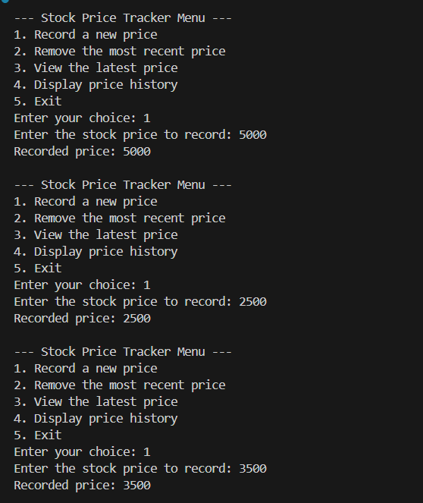
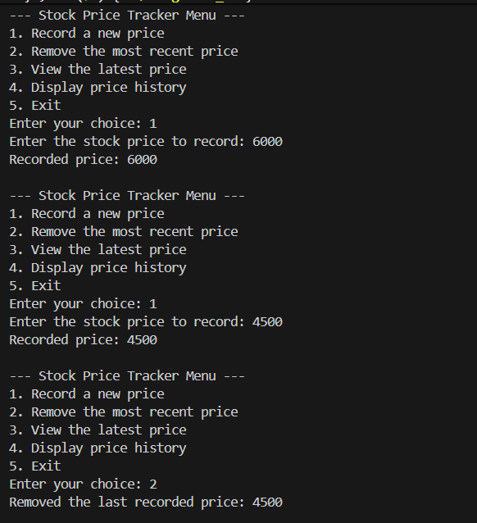
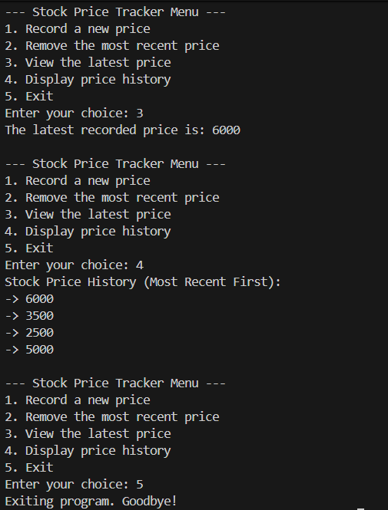

Program 2

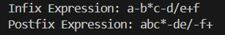

Program 3
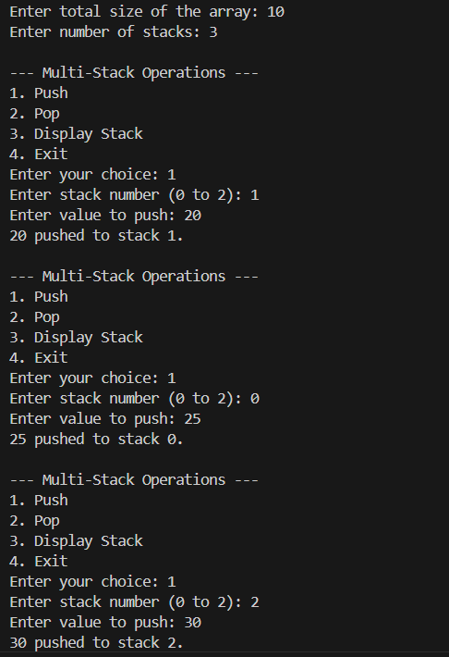
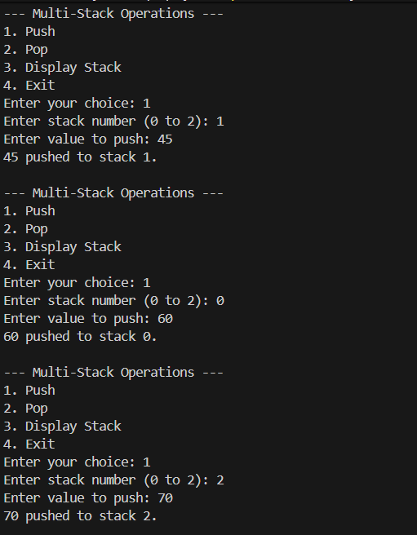
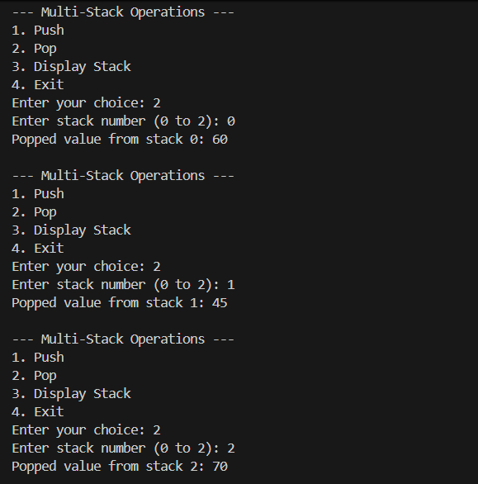
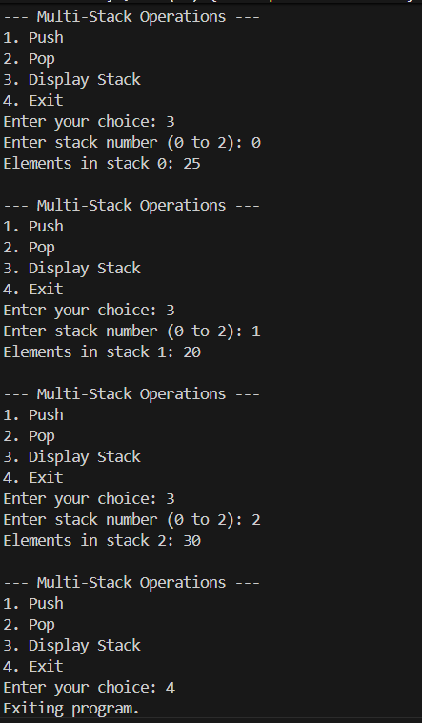

Program 4
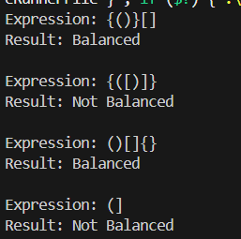
Program 5

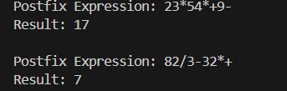

CONCLUSION:

This assignment provided a comprehensive practical study of stack data structures implemented through both linked lists and arrays, reinforcing their versatility in real-world problem solving. By designing a stock price tracker with a singly linked-list–based stack, we demonstrated dynamic memory allocation and operations like record, remove, and latest, which highlight the LIFO (Last-In-First-Out) principle in maintaining recent data history. Converting infix to postfix expressions showcased the algorithmic power of stacks in handling operator precedence and associativity, while evaluating postfix expressions emphasized efficient arithmetic computation directly from linear notation. Implementing multiple stacks using a single array strengthened the concept of space-optimized static memory allocation and highlighted challenges like stack overflow and underflow, demanding careful boundary management. The balanced parentheses checker illustrated how stacks naturally model nested structures, a concept vital in compilers and syntax validation.
Overall, this assignment bridged both theoretical and practical aspects of stacks—from algorithmic transformations in expressions to dynamic applications like history tracking and validation—providing a strong foundation for advancing into parsing algorithms, expression evaluation in programming languages, memory management, and advanced stack-based problem solving.

