Bansilal Ramnath Agarwal Charitable Trust’s

VISHWAKARMA INSTITUTE OF TECHNOLOGY – PUNE

DATA STRUCTURES

Division | SY CS-A
Batch | 3
GR Number (PRN) | 12413247
Roll No. | 72
Name | Atharva Dhamdhere

ASSIGNMENT 6

AIM

- Write a program to keep track of patients as they checked into a medical clinic, assigning patients to doctors on a first-come, first-served basis.
- Pizza parlour accepting maximum n orders. Orders are served on an FCFS basis. Order once placed can’t be cancelled. Write C++ program to simulate the system using circular QUEUE.
- Write a program that maintains a queue of passengers waiting to see a ticket agent. The program user should be able to insert a new passenger at the rear of the queue, Display the passenger at the front of the Queue, or remove the passenger at the front of the queue. The program will display the number of passengers left in the queue just before it terminates.
- Write a program to implement multiple queues i.e. two queues using array and perform following operations on it. A. Add Queue, B. Delete from Queue, C. Display Queue

- In a call center, customer calls are handled on a first-come, first-served basis. Implement a queue system using Linked list where:
- Each customer call is enqueued as it arrives.
- Customer service agents dequeue calls to assist customers.
- If there are no calls, the system waits.

OBJECTIVE:

The primary objective of this assignment is to develop a deep understanding and practical expertise in the fundamental concepts and applications of queue data structures, emphasizing both linked list and array-based implementations. Through various scenarios modeled on real-world systems, the assignment aims to strengthen skills in dynamic and static queue management and their operational behaviors.

- Master Queue Implementation Using Linked Lists:
  - Build a dynamic queue system to simulate real-time processes such as customer call handling, reinforcing enqueue and dequeue operations in first-come, first-served scenarios.
  - Demonstrate efficient memory management and pointer manipulation to maintain order and handle idle conditions when the queue is empty.

- Apply Circular Queue Concepts with Arrays:
  - Implement circular queue structures to manage fixed-size, continuous data flows like pizza orders, ensuring optimal usage of array space through wrap-around logic.
  - Handle operational constraints including overflow detection and non-cancellable order processing, illustrating practical aspects of bounded queues.

- Design Multiple Queues Within a Single Array Framework:
  - Develop and manage two independent queues simultaneously in a shared array environment, addressing partitioning, overflow, and underflow conditions to ensure robust boundary control.
  - Implement comprehensive queue operations such as insertion, deletion, and display for each queue, demonstrating multi-queue management within constrained memory.

- Simulate Real-World Queue-Based Systems:
  - Model scenarios such as patient check-ins and passenger ticketing to capture the essence of queues in service order management and process scheduling.
  - Enable user interaction for insertion, deletion, and state display, reinforcing the conceptual mechanics and practical utility of queues in everyday applications.

THEORY

Queue Implementation Using Linked Lists:
Queues are linear data structures that process elements in a First-In-First-Out (FIFO) order, which is critical for many real-time and service-oriented systems such as medical clinics or call centers. Implementing queues using linked lists offers dynamic memory allocation advantages, meaning the queue can expand or shrink as needed without fixed size limitations.
Each node in a linked list queue contains the actual data (such as patient ID, customer call details, or passenger information) and a pointer to the next node, maintaining the sequential order of arrival. The queue typically maintains two pointers: the front, which points to the first node to be served, and the rear, which points to the last inserted node. This structure supports:
- Enqueue operations, where new nodes are dynamically added at the rear, ensuring the newest element waits its turn.
- Dequeue operations, where nodes are removed from the front, representing the completion of service or processing.
Because linked lists avoid the need for contiguous memory allocation, they efficiently handle fluctuating workloads and varying queue sizes, which is especially crucial for unpredictable environments like call centers or clinics where the influx of data varies over time. Moreover, linked lists can be easily extended to implement priority queues or multi-level queues, enhancing their usability in complex scheduling algorithms.

Circular Queue Using Arrays:
A circular queue overcomes the limitations of a linear queue implemented with arrays, especially the problem of wasted space when elements are dequeued from the front. By conceptually connecting the end of the array back to the beginning, the circular queue enables efficient reuse of array slots, maximizing fixed capacity.
The circular queue requires careful pointer or index manipulation, using modulo arithmetic to wrap around when the end of the array is reached. This technique maintains the logical order while ensuring insertion and deletion operations remain O(1) in time complexity. Critical considerations include:
- Overflow detection, which happens when the queue is full, and no new elements can be enqueued without overwriting existing data.
- Underflow detection, which happens when attempting to dequeue from an empty queue.
This model is particularly suitable for systems like pizza order management where the maximum number of pending orders is limited, and fairness in processing (FCFS) must be preserved without canceling orders. The circular queue’s predictable memory footprint is ideal for embedded or real-time applications with strict memory constraints.

Multiple Queues Using Arrays:
Implementing multiple queues within a single array combines the benefits of array-based static allocation with the flexibility of managing multiple independent FIFO structures simultaneously. This strategy avoids multiple memory allocations by logically segmenting the array into dedicated sections, each representing a separate queue.
Essential mechanisms include:
- Maintaining individual front and rear indices for each queue to preserve independent operations.
- Implementing checks for overflow and underflow within each logical partition to ensure no queue corrupts another's data.
- Enabling enqueue, dequeue, and display functionalities on each queue, facilitating multitasking and parallel processing scenarios in constrained memories.
This concept is critical for operating systems, network routers, or multitasking applications where multiple processes or data streams require queued management concurrently.

Real-World Applications and Operational Significance:
The use cases simulated in this assignment exemplify the critical role of queues in everyday systems. Assigning patients to doctors on a first-come, first-served basis ensures fairness and order in healthcare delivery. Similarly, managing pizza orders and passenger queues models real-life coordination and resource allocation problems. Customer call handling in call centers further illustrates queues’ role in managing variable workloads while maintaining service efficiency.
These scenarios underscore the importance of queue characteristics like order preservation, dynamic size management, and efficient insertion/deletion. Handling empty queues gracefully (waiting for calls or passengers) and detecting overflow conditions (maximum order capacity) are crucial operational robustness features. Additionally, circular queues and multi-queue implementations highlight optimization techniques for memory utilization and system throughput.
Advanced Considerations:
Besides basic FIFO operations, knowledge gained here prepares one for exploring more sophisticated queue variants such as:
- Priority Queues, where elements are served based on priority rather than arrival time.
- Double-ended Queues (Deques), allowing insertion and removal at both ends.
- Concurrent Queues, essential in multi-threaded environments requiring thread-safe operations.

ALGORITHMS

Program 1

1. Initialize:
- Create an empty queue with front and rear pointers set to nullptr.
- Initialize nextPatientId = 1.

2. Check if queue is empty:
- Return true if front == nullptr, else false.

3. Check-in a new patient:
- Create a new node with patient name and patientId = nextPatientId++.
- Set node's next pointer to nullptr.
- If the queue is empty:
- Set front = rear = new node.
- Else:
- Set rear->next = new node.
- Set rear = new node.
- Display patient check-in confirmation.

4. Assign patient to doctor:
- If queue is empty:
- Print "No patients are waiting."
- Else:
- Remove node from front of queue.
- Update front = front->next.
- If front == nullptr, set rear = nullptr.
- Display assigned patient information.

5. View next patient:
- If queue is empty:
- Print "No patients are waiting."
- Else:
- Display patient at front of queue.

6. Display waiting list:
- If queue is empty:
- Print "Waiting list is empty."
- Else:
- Traverse from front to rear.
- Print patient name and ID in order.

7. User Menu:
- Show options: Check-in, Assign to Doctor, View Next Patient, Display Waiting List, Exit
- Take user input and call corresponding function.
- Repeat until user chooses Exit.
Program 2
1. Initialize:
- Input maximum capacity of orders (n).
- Create an array of Order structures of size n.
- Set front = 0, rear = -1, currentSize = 0, nextOrderId = 1.

2. Check if queue is full:
- Return true if currentSize == capacity.

3. Check if queue is empty:
- Return true if currentSize == 0.

4. Place a new order:
- If queue is full, print "Cannot accept new orders" and return.
- Increment rear = (rear + 1) % capacity.
- Set orders[rear].orderId = nextOrderId++.
- Set orders[rear].customerName = customerName.
- Increment currentSize.
- Print confirmation of order placement.

5. Serve an order:
- If queue is empty, print "No pending orders" and return.
- Serve orders[front].
- Increment front = (front + 1) % capacity.
- Decrement currentSize.
- Print confirmation of order served.

6. Display all pending orders:
- If queue is empty, print "Order queue is empty" and return.
- Traverse from front to rear (consider circular indexing) and print all orders.

7. User Menu:
- Show options: Place Order, Serve Order, Display Orders, Exit.
- Take user input and call corresponding function.
- Repeat until user chooses Exit.

Program 3

1. Initialize:
- Create an empty queue with front and rear pointers set to nullptr.
- Initialize nextTicketId (e.g., 101) and currentSize = 0.

2. Check if queue is empty:
- Return true if front == nullptr, else false.

3. Insert a new passenger:
- Create a new node with passenger name and ticketId = nextTicketId++.
- Set node's next pointer to nullptr.
- Increment currentSize.
- If queue is empty:
- Set front = rear = new node.
- Else:
- Set rear->next = new node.
- Set rear = new node.
- Display confirmation of passenger insertion.

4. Remove passenger from the front:
- If queue is empty:
- Print "Queue is empty, no passengers to remove."
- Else:
- Remove node at front of queue.
- Update front = front->next.
- If front == nullptr, set rear = nullptr.
- Decrement currentSize.
- Display confirmation of passenger removal.

5. Display passenger at the front:
- If queue is empty:
- Print "Queue is empty."
- Else:
- Display passenger's name and ticketId at front of queue.

6. Display current size of the queue:
- Return currentSize.

7. User Menu:
- Show options: Insert Passenger, Remove Passenger, Display Front, Exit.
- Take user input and call corresponding function.
- Repeat until user chooses Exit.

Program 4

1. Initialize:
- Input total array size n (must be ≥ 2).
- Create array arr[n].
- Set front1 = rear1 = -1 (Queue 1).
- Set front2 = rear2 = n (Queue 2).

2. Check if queues are full:
- Queues are full if rear1 + 1 == rear2.

3. Add element to a queue:
a. If queueNum == 1:
- If front1 == -1, set front1 = 0.
- Increment rear1.
- Set arr[rear1] = value.
b. If queueNum == 2:
- If front2 == n, set front2 = n-1.
- Decrement rear2.
- Set arr[rear2] = value.
- If queues are full, display error.

4. Delete element from a queue:
a. If queueNum == 1:
- If front1 == -1 or front1 > rear1, queue is empty.
- Else, delete arr[front1] and increment front1.
- If front1 > rear1, reset front1 = rear1 = -1.
b. If queueNum == 2:
- If front2 == n or front2 < rear2, queue is empty.
- Else, delete arr[front2] and decrement front2.
- If front2 < rear2, reset front2 = rear2 = n.

5. Display a queue:
a. If queueNum == 1:
- Traverse arr from front1 to rear1 and print elements.
b. If queueNum == 2:
- Traverse arr from front2 down to rear2 and print elements.

6. User Menu:
- Show options: Add, Delete, Display, Exit.
- Take user input and call corresponding function.
- Repeat until user chooses Exit.

Program 5

1. Initialize:

- Create an empty queue with front and rear pointers set to nullptr.

- Initialize nextCallId = 1.

2. Check if queue is empty:

- Return true if front == nullptr, else false.

3. Add a new incoming call (enqueue):

- Create a new node with callerName and callId = nextCallId++.

- Set node's next pointer to nullptr.

- If queue is empty:

- Set front = rear = new node.

- Else:

- Set rear->next = new node.

- Set rear = new node.

- Display confirmation that call has been added to the queue.

4. Agent takes the next call (dequeue):

- If queue is empty:

- Print "No calls to answer."

- Else:

- Remove node at front of queue.

- Update front = front->next.

- If front == nullptr, set rear = nullptr.

- Display confirmation of call being assisted.

5. Display next waiting call:

- If queue is empty:

- Print "No calls are waiting."

- Else:

- Display callerName and callId of front node.

6. User Menu:

- Show options: Add Call, Answer Call, Display Next Call, Exit.

- Take user input and call corresponding function.

- Repeat until user chooses Exit.

PROGRAMS

Program 1

#include <iostream>
#include <string>
#include <limits>

struct Patient {
std::string name;
int patientId;
};

struct Node {
Patient patient;
Node* next;
};

class ClinicQueue {
private:
Node *front, *rear;
int nextPatientId;

public:
ClinicQueue() {
front = rear = nullptr;
nextPatientId = 1;
}

~ClinicQueue() {
Node* temp = front;
while (temp != nullptr) {
front = front->next;
delete temp;
temp = front;
}
}

bool isEmpty() {
return front == nullptr;
}

void checkIn(const std::string& name) {
Node* temp = new Node;
temp->patient.name = name;
temp->patient.patientId = nextPatientId++;
temp->next = nullptr;

if (isEmpty()) {
front = rear = temp;
} else {
rear->next = temp;
rear = temp;
}

std::cout << "Patient '" << name << "' (ID: " << temp->patient.patientId << ") has checked in." << std::endl;
}

void assignToDoctor() {
if (isEmpty()) {
std::cout << "No patients are waiting." << std::endl;
return;
}

Node* temp = front;
front = front->next;

if (front == nullptr) {
rear = nullptr;
}

std::cout << "Assigning Patient '" << temp->patient.name << "' (ID: " << temp->patient.patientId << ") to a doctor." << std::endl;
delete temp;
}

void viewNextPatient() {
if (isEmpty()) {
std::cout << "No patients are waiting." << std::endl;
return;
}
std::cout << "Next patient to be seen is '" << front->patient.name << "' (ID: " << front->patient.patientId << ")." << std::endl;
}

void displayWaitingList() {
if (isEmpty()) {
std::cout << "The waiting list is empty." << std::endl;
return;
}

std::cout << "\n--- Current Waiting List ---" << std::endl;
Node* temp = front;
int position = 1;
while (temp != nullptr) {
std::cout << position++ << ". " << temp->patient.name << " (ID: " << temp->patient.patientId << ")" << std::endl;
temp = temp->next;
}
std::cout << "--------------------------" << std::endl;
}
};

void showMenu() {
std::cout << "\n--- Clinic Patient Management ---" << std::endl;
std::cout << "1. Check-in a new patient" << std::endl;
std::cout << "2. Assign patient to doctor" << std::endl;
std::cout << "3. View next patient" << std::endl;
std::cout << "4. Display waiting list" << std::endl;
std::cout << "5. Exit" << std::endl;
std::cout << "Enter your choice: ";
}

int main() {
ClinicQueue clinic;
int choice;
std::string name;

do {
showMenu();
std::cin >> choice;
std::cin.ignore(std::numeric_limits<std::streamsize>::max(), '\n');

switch (choice) {
case 1:
std::cout << "Enter patient's name: ";
std::getline(std::cin, name);
clinic.checkIn(name);
break;
case 2:
clinic.assignToDoctor();
break;
case 3:
clinic.viewNextPatient();
break;
case 4:
clinic.displayWaitingList();
break;
case 5:
std::cout << "Exiting the program." << std::endl;
break;
default:
std::cout << "Invalid choice. Please try again." << std::endl;
}
} while (choice != 5);

return 0;
}

Program 2

#include <iostream>
#include <string>
#include <limits>

struct Order {
int orderId;
std::string customerName;
};

class PizzaParlorQueue {
private:
Order* orders;
int front;
int rear;
int capacity;
int currentSize;
int nextOrderId;

public:
PizzaParlorQueue(int n) {
capacity = n;
orders = new Order[capacity];
front = 0;
rear = -1;
currentSize = 0;
nextOrderId = 1;
}

~PizzaParlorQueue() {
delete[] orders;
}

bool isFull() {
return currentSize == capacity;
}

bool isEmpty() {
return currentSize == 0;
}

void placeOrder(const std::string& customerName) {
if (isFull()) {
std::cout << "Sorry, we are at maximum capacity and cannot accept new orders." << std::endl;
return;
}
rear = (rear + 1) % capacity;
orders[rear].orderId = nextOrderId++;
orders[rear].customerName = customerName;
currentSize++;
std::cout << "Order #" << orders[rear].orderId << " for " << customerName << " has been placed." << std::endl;
}

void serveOrder() {
if (isEmpty()) {
std::cout << "There are no pending orders to serve." << std::endl;
return;
}
Order servedOrder = orders[front];
front = (front + 1) % capacity;
currentSize--;
std::cout << "Serving Order #" << servedOrder.orderId << " for customer " << servedOrder.customerName << "." << std::endl;
}

void displayOrders() {
if (isEmpty()) {
std::cout << "The order queue is empty." << std::endl;
return;
}
std::cout << "\n--- Pending Pizza Orders ---" << std::endl;
int count = 0;
int i = front;
while (count < currentSize) {
std::cout << (count + 1) << ". Order #" << orders[i].orderId << " - " << orders[i].customerName << std::endl;
i = (i + 1) % capacity;
count++;
}
std::cout << "--------------------------" << std::endl;
}
};

void showMenu() {
std::cout << "\n--- Pizza Parlor Menu ---" << std::endl;
std::cout << "1. Place a new order" << std::endl;
std::cout << "2. Serve an order" << std::endl;
std::cout << "3. Display all pending orders" << std::endl;
std::cout << "4. Exit" << std::endl;
std::cout << "Enter your choice: ";
}

int main() {
int capacity;
std::cout << "Enter the maximum number of orders the pizza parlor can handle: ";
std::cin >> capacity;
std::cin.ignore(std::numeric_limits<std::streamsize>::max(), '\n');

if (capacity <= 0) {
std::cout << "Capacity must be a positive number. Exiting." << std::endl;
return 1;
}

PizzaParlorQueue parlor(capacity);
int choice;
std::string name;

do {
showMenu();
std::cin >> choice;
std::cin.ignore(std::numeric_limits<std::streamsize>::max(), '\n');

switch (choice) {
case 1:
std::cout << "Enter customer name: ";
std::getline(std::cin, name);
parlor.placeOrder(name);
break;
case 2:
parlor.serveOrder();
break;
case 3:
parlor.displayOrders();
break;
case 4:
std::cout << "Closing the pizza parlor. Goodbye!" << std::endl;
break;
default:
std::cout << "Invalid choice. Please try again." << std::endl;
}
} while (choice != 4);

return 0;
}
Program 3

#include <iostream>
#include <string>
#include <limits>

struct Passenger {
std::string name;
int ticketId;
};

struct Node {
Passenger passenger;
Node* next;
};

class TicketQueue {
private:
Node *front, *rear;
int nextTicketId;
int currentSize;

public:
TicketQueue() {
front = rear = nullptr;
nextTicketId = 101;
currentSize = 0;
}

~TicketQueue() {
Node* temp = front;
while (temp != nullptr) {
front = front->next;
delete temp;
temp = front;
}
}

bool isEmpty() {
return front == nullptr;
}

int getSize() {
return currentSize;
}

void insertPassenger(const std::string& name) {
Node* temp = new Node;
temp->passenger.name = name;
temp->passenger.ticketId = nextTicketId++;
temp->next = nullptr;
currentSize++;

if (isEmpty()) {
front = rear = temp;
} else {
rear->next = temp;
rear = temp;
}

std::cout << "Passenger '" << name << "' (Ticket ID: " << temp->passenger.ticketId << ") has been added to the queue." << std::endl;
}

void removePassenger() {
if (isEmpty()) {
std::cout << "The queue is empty. No passengers to remove." << std::endl;
return;
}

Node* temp = front;
front = front->next;

if (front == nullptr) {
rear = nullptr;
}

currentSize--;
std::cout << "Passenger '" << temp->passenger.name << "' (Ticket ID: " << temp->passenger.ticketId << ") has been served and removed from the queue." << std::endl;
delete temp;
}

void displayFrontPassenger() {
if (isEmpty()) {
std::cout << "The queue is empty. No passengers are waiting." << std::endl;
return;
}
std::cout << "The passenger at the front of the queue is '" << front->passenger.name << "' (Ticket ID: " << front->passenger.ticketId << ")." << std::endl;
}
};

void showMenu() {
std::cout << "\n--- Ticket Agent Queue System ---" << std::endl;
std::cout << "1. Insert a new passenger" << std::endl;
std::cout << "2. Remove passenger from the front" << std::endl;
std::cout << "3. Display passenger at the front" << std::endl;
std::cout << "4. Exit" << std::endl;
std::cout << "Enter your choice: ";
}

int main() {
TicketQueue queue;
int choice;
std::string name;

do {
showMenu();
std::cin >> choice;
std::cin.ignore(std::numeric_limits<std::streamsize>::max(), '\n');

switch (choice) {
case 1:
std::cout << "Enter passenger's name: ";
std::getline(std::cin, name);
queue.insertPassenger(name);
break;
case 2:
queue.removePassenger();
break;
case 3:
queue.displayFrontPassenger();
break;
case 4:
std::cout << "\nProgram terminating." << std::endl;
std::cout << "Number of passengers left in the queue: " << queue.getSize() << std::endl;
break;
default:
std::cout << "Invalid choice. Please try again." << std::endl;
}
} while (choice != 4);

return 0;
}

Program 4
#include <iostream>

class MultiQueue {
private:
int* arr;
int size;
int front1, rear1;
int front2, rear2;

public:
MultiQueue(int n) {
size = n;
arr = new int[size];

front1 = -1;
rear1 = -1;

front2 = size;
rear2 = size;
}

~MultiQueue() {
delete[] arr;
}

void addQueue(int queueNum, int value) {
if (rear1 + 1 == rear2) {
std::cout << "Error: Queue is full. Cannot add element." << std::endl;
return;
}

if (queueNum == 1) {
if (front1 == -1) {
front1 = 0;
}
rear1++;
arr[rear1] = value;
std::cout << value << " added to Queue 1." << std::endl;
} else if (queueNum == 2) {
if (front2 == size) {
front2 = size - 1;
}
rear2--;
arr[rear2] = value;
std::cout << value << " added to Queue 2." << std::endl;
} else {
std::cout << "Invalid queue number." << std::endl;
}
}

void deleteFromQueue(int queueNum) {
if (queueNum == 1) {
if (front1 == -1 || front1 > rear1) {
std::cout << "Queue 1 is empty. Cannot delete." << std::endl;
return;
}
int deletedValue = arr[front1];
front1++;
std::cout << deletedValue << " deleted from Queue 1." << std::endl;

if (front1 > rear1) {
front1 = rear1 = -1;
}
} else if (queueNum == 2) {
if (front2 == size || front2 < rear2) {
std::cout << "Queue 2 is empty. Cannot delete." << std::endl;
return;
}
int deletedValue = arr[front2];
front2--;
std::cout << deletedValue << " deleted from Queue 2." << std::endl;

if (front2 < rear2) {
front2 = rear2 = size;
}
} else {
std::cout << "Invalid queue number." << std::endl;
}
}

void displayQueue(int queueNum) {
if (queueNum == 1) {
if (front1 == -1 || front1 > rear1) {
std::cout << "Queue 1 is empty." << std::endl;
return;
}
std::cout << "Elements in Queue 1: ";
for (int i = front1; i <= rear1; i++) {
std::cout << arr[i] << " ";
}
std::cout << std::endl;
} else if (queueNum == 2) {
if (front2 == size || front2 < rear2) {
std::cout << "Queue 2 is empty." << std::endl;
return;
}
std::cout << "Elements in Queue 2: ";
for (int i = front2; i >= rear2; i--) {
std::cout << arr[i] << " ";
}
std::cout << std::endl;
} else {
std::cout << "Invalid queue number." << std::endl;
}
}
};

void showMenu() {
std::cout << "\n--- Multi-Queue Operations ---" << std::endl;
std::cout << "1. Add to Queue" << std::endl;
std::cout << "2. Delete from Queue" << std::endl;
std::cout << "3. Display Queue" << std::endl;
std::cout << "4. Exit" << std::endl;
std::cout << "Enter your choice: ";
}

int main() {
int size;
std::cout << "Enter the total size of the array for the queues: ";
std::cin >> size;

if (size < 2) {
std::cout << "Size must be at least 2 to support two queues. Exiting." << std::endl;
return 1;
}

MultiQueue mq(size);
int choice, queueNum, value;

do {
showMenu();
std::cin >> choice;

if (choice >= 1 && choice <= 3) {
std::cout << "Enter queue number (1 or 2): ";
std::cin >> queueNum;
if (queueNum != 1 && queueNum != 2) {
std::cout << "Invalid queue number. Please try again." << std::endl;
continue;
}
}

switch (choice) {
case 1:
std::cout << "Enter value to add: ";
std::cin >> value;
mq.addQueue(queueNum, value);
break;
case 2:
mq.deleteFromQueue(queueNum);
break;
case 3:
mq.displayQueue(queueNum);
break;
case 4:
std::cout << "Exiting program." << std::endl;
break;
default:
std::cout << "Invalid choice. Please try again." << std::endl;
}
} while (choice != 4);

return 0;
}

Program 5
#include <iostream>
#include <string>
#include <limits>

struct Call {
std::string callerName;
int callId;
};

struct Node {
Call call;
Node* next;
};

class CallQueue {
private:
Node *front, *rear;
int nextCallId;

public:
CallQueue() {
front = rear = nullptr;
nextCallId = 1;
}

~CallQueue() {
Node* temp = front;
while (temp != nullptr) {
front = front->next;
delete temp;
temp = front;
}
}

bool isEmpty() {
return front == nullptr;
}

void enqueue(const std::string& name) {
Node* temp = new Node;
temp->call.callerName = name;
temp->call.callId = nextCallId++;
temp->next = nullptr;

if (isEmpty()) {
front = rear = temp;
} else {
rear->next = temp;
rear = temp;
}

std::cout << "Call received from '" << name << "' (Call ID: " << temp->call.callId << "). Added to the queue." << std::endl;
}

void dequeue() {
if (isEmpty()) {
std::cout << "The queue is empty. No calls to answer." << std::endl;
return;
}

Node* temp = front;
front = front->next;

if (front == nullptr) {
rear = nullptr;
}

std::cout << "Agent is now assisting '" << temp->call.callerName << "' (Call ID: " << temp->call.callId << ")." << std::endl;
delete temp;
}

void displayFront() {
if (isEmpty()) {
std::cout << "The queue is empty. No calls are waiting." << std::endl;
return;
}
std::cout << "Next call to be answered is from '" << front->call.callerName << "' (Call ID: " << front->call.callId << ")." << std::endl;
}
};

void showMenu() {
std::cout << "\n--- Call Center System ---" << std::endl;
std::cout << "1. Add a new incoming call" << std::endl;
std::cout << "2. Agent takes next call" << std::endl;
std::cout << "3. Display next waiting call" << std::endl;
std::cout << "4. Exit" << std::endl;
std::cout << "Enter your choice: ";
}

int main() {
CallQueue callQueue;
int choice;
std::string name;

do {
showMenu();
while (!(std::cin >> choice)) {
std::cout << "Invalid input. Please enter a number." << std::endl;
std::cin.clear();
std::cin.ignore(std::numeric_limits<std::streamsize>::max(), '\n');
showMenu();
}
std::cin.ignore(std::numeric_limits<std::streamsize>::max(), '\n');

switch (choice) {
case 1:
std::cout << "Enter caller's name: ";
std::getline(std::cin, name);
callQueue.enqueue(name);
break;
case 2:
callQueue.dequeue();
break;
case 3:
callQueue.displayFront();
break;
case 4:
std::cout << "Shutting down the call center system." << std::endl;
break;
default:
std::cout << "Invalid choice. Please try again." << std::endl;
}
} while (choice != 4);

return 0;
}

OUTPUT:

Program 1
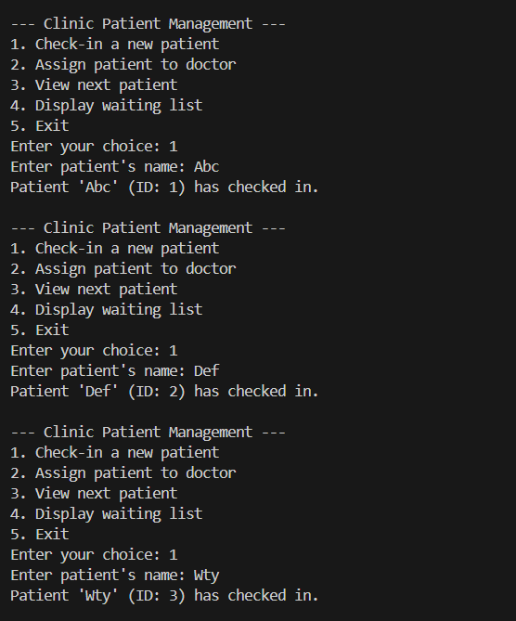
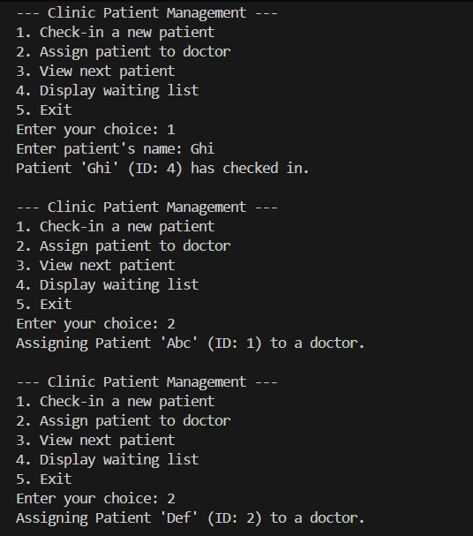
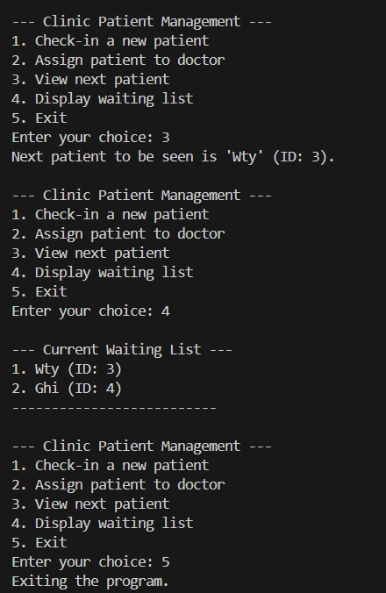

Program 2

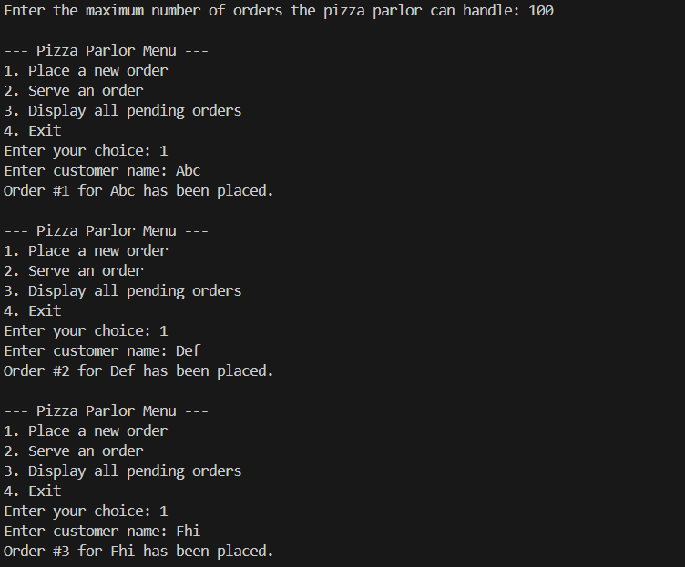
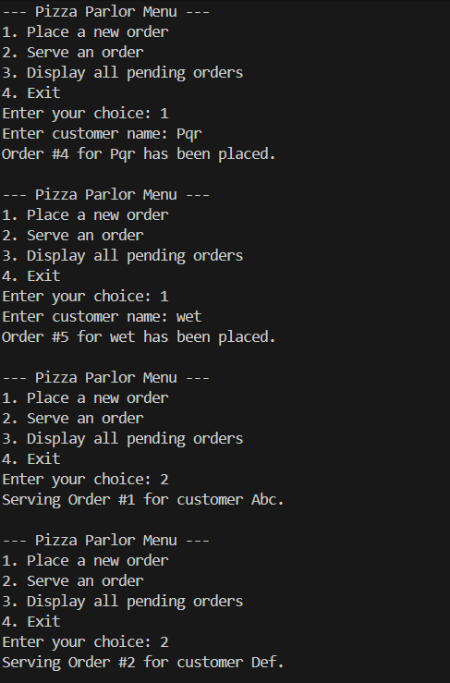
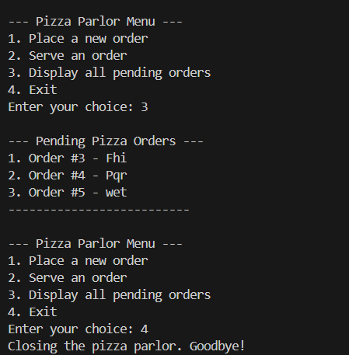

Program 3
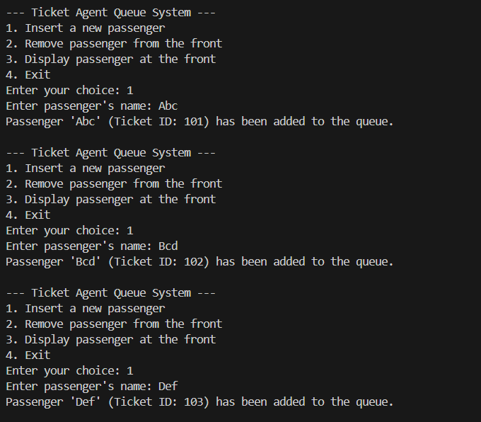
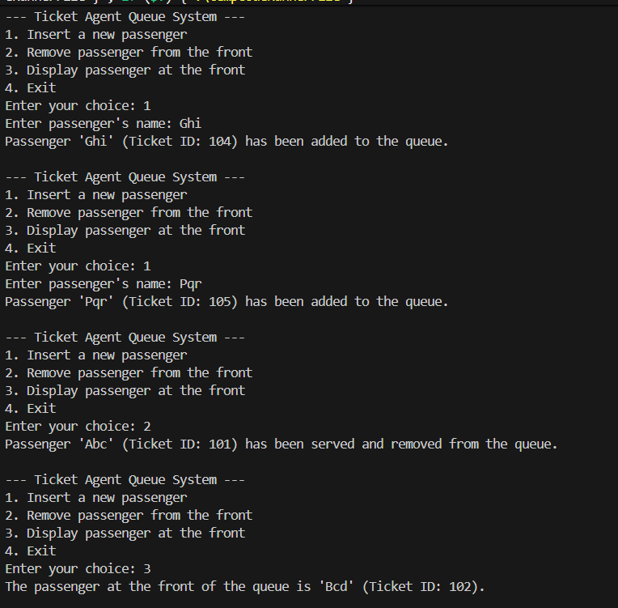
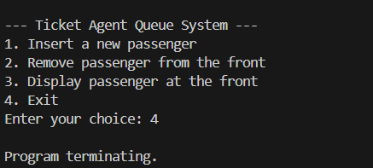

Program 4

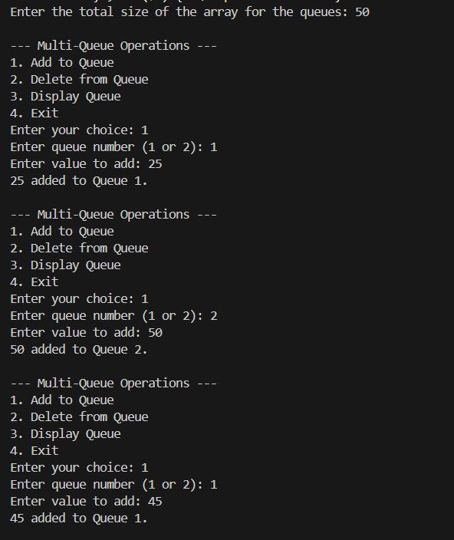
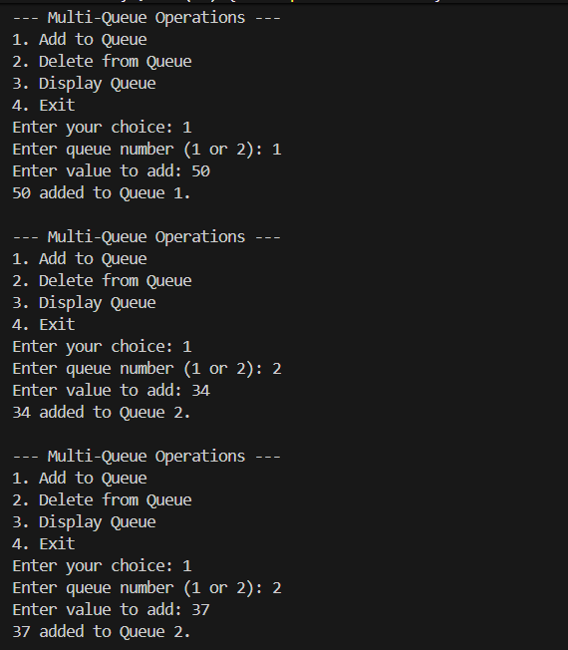
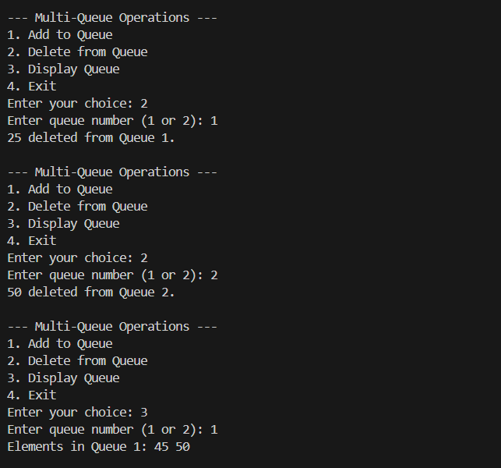

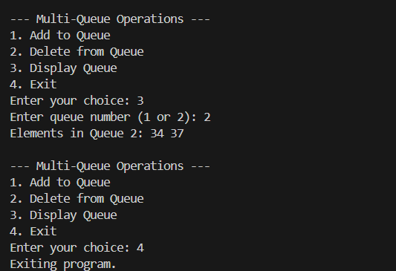

Program 5

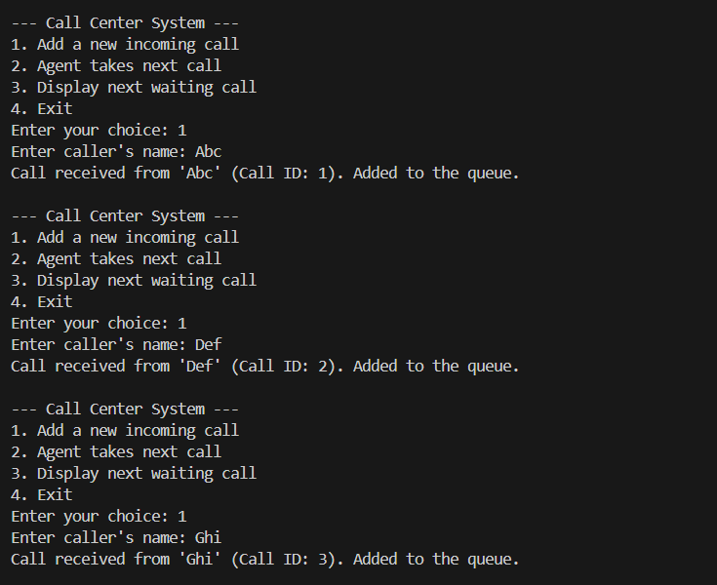
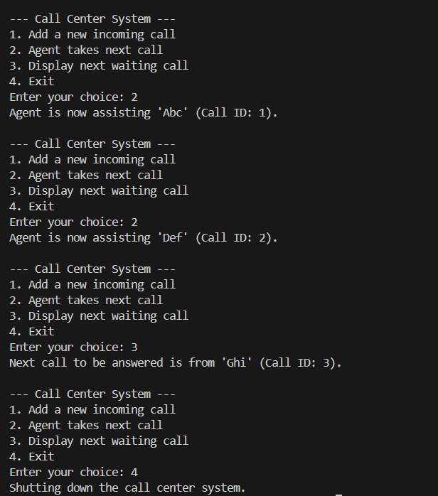

CONCLUSION:

This assignment provided an extensive practical exploration of queue data structures through both linked list and array-based implementations, highlighting their critical role in real-world systems requiring orderly and fair processing. By designing a patient check-in system using a linked-list-based queue, we demonstrated dynamic memory management and queue operations such as enqueue and dequeue, emphasizing the FIFO (First-In-First-Out) principle fundamental to service order management. Implementing a circular queue for pizza orders showcased efficient memory utilization through wrap-around logic and reinforced handling of boundary conditions like queue overflow and underflow in fixed-size buffers. The multiple queue implementation within a single array strengthened concepts of space optimization and index partitioning, illustrating challenges of concurrent queue management without data corruption. Real-world scenarios such as passenger ticket queues and customer call centers underscored how queues provide fairness and synchronization in service-oriented applications.
Overall, this assignment bridged theoretical concepts and practical applications of queues—from dynamic linked list implementations to memory-efficient static arrays—building a solid foundation for advanced studies in process scheduling, resource allocation, and real-time system design.

