Bansilal Ramnath Agarwal Charitable Trust’s

VISHWAKARMA INSTITUTE OF TECHNOLOGY – PUNE

DATA STRUCTURES

Division | SY CS-A
Batch | 3
GR Number (PRN) | 12413247
Roll No. | 72
Name | Atharva Dhamdhere

ASSIGNMENT 9

AIM

- Write a Program to accept a graph from a user and represent it with Adjacency Matrix and perform BFS and DFS traversals on it.

- Write a Program to implement Prim’s algorithm to find minimum spanning tree of a user defined graph. Use Adjacency List to represent a graph.
- Write a Program to implement Kruskal’s algorithm to find the minimum spanning tree of a user defined graph. Use Adjacency List to represent a graph.

OBJECTIVE:

The primary objective of this assignment is to gain a clear understanding of Binary Search Trees (BSTs) and their operational behaviour through practical implementation. By completing this exercise, the learner will strengthen their grasp of hierarchical data organization, recursive processing, and efficient searching techniques.
The specific goals include:
- Implementation of Binary Search Trees (BST):
Construct a BST where each node maintains the property that the left child contains values smaller than the parent node, and the right child contains values greater than the parent node.
- Insertion and Deletion Operations:
Perform insertion to add new elements while preserving the BST property, and execute deletion operations to remove specified nodes (handling all three cases — leaf node, node with one child, and node with two children).
- Displaying Tree Contents:
Print the BST elements in different traversal orders such as Inorder, Preorder, and Postorder, to visualize the structure and data arrangement within the tree.
- Traversal to Minimum and Maximum Values:
Develop logic to navigate to the minimum (leftmost node) and maximum (rightmost node) elements of the tree, demonstrating efficient search for boundary values within the BST.

THEORY

A Graph is a powerful non-linear data structure that models relationships between entities using a collection of vertices (nodes) and edges (connections). Graphs are essential in computer science and engineering for representing and solving real-world problems such as transportation systems, social media networks, computer routing, communication links, and dependency mapping.
Graphs can be directed or undirected, weighted or unweighted, and dense or sparse, depending on the nature of their connections and the presence of edge weights. The choice of representation and traversal algorithm greatly impacts the efficiency and performance of graph-based computations.
Graph Representation
To work with graphs programmatically, two widely used representations are employed:
- Adjacency Matrix:
  - This representation uses a two-dimensional array of size V × V, where V is the total number of vertices.
  - If an edge exists between vertex i and vertex j, then the matrix entry A[i][j] is set to 1 (or the edge’s weight in weighted graphs); otherwise, it remains 0.
  - Advantages: Quick edge existence check (O(1) time complexity).
  - Limitations: High memory usage (O(V²) space), making it inefficient for sparse graphs where many entries remain zero.
  - This representation is more suitable for dense graphs, where most vertices are connected.
- Adjacency List:
  - This structure uses an array of linked lists, where each index in the array corresponds to a vertex, and the list at each index stores its neighboring vertices and associated edge weights.
  - Advantages: Space-efficient (O(V + E) complexity), especially for sparse graphs, and faster for iterating through connected vertices.
  - Limitations: Edge existence checks are slower (O(V) in the worst case) compared to adjacency matrices.
  - It is particularly effective for algorithms requiring traversal or iteration over a vertex’s neighbors, such as BFS, DFS, Prim’s, and Kruskal’s algorithms.
Graph Traversal Techniques
Traversal refers to the process of systematically visiting every vertex in the graph. Two major traversal techniques are:
- Breadth-First Search (BFS):
  - BFS explores the graph in layers. It begins from a source node, visits all its immediate neighbors first, and then gradually moves outward to the next level of vertices.
  - Implemented using a Queue data structure, BFS ensures level-order traversal and is ideal for finding the shortest path in unweighted graphs.
  - BFS is widely used in network broadcasting, web crawling, GPS navigation, and peer-to-peer systems.
- Depth-First Search (DFS):
  - DFS explores as deep as possible along each branch before backtracking. It starts at a given node and recursively explores each unvisited neighbor until there are no more paths left.
  - Implemented using Recursion or an explicit Stack, it provides a depth-wise traversal of the graph.
  - DFS is used in topological sorting, detecting cycles, pathfinding, and solving puzzles or mazes.
Minimum Spanning Tree (MST)
A Minimum Spanning Tree (MST) connects all vertices in a connected, weighted, undirected graph using the smallest total edge weight and no cycles. MSTs are fundamental in network design, clustering, and optimization problems like minimizing the cost of wiring, road construction, or data transmission paths.
Two popular greedy algorithms used to compute MSTs are:
- Prim’s Algorithm:
  - Prim’s algorithm starts from an arbitrary vertex and grows the MST one edge at a time, always selecting the smallest-weight edge that connects a vertex inside the tree to one outside it.
  - In each iteration, it updates the shortest known distance of all unvisited vertices and adds the edge with the minimum weight.
  - While it can be optimized using a Priority Queue (Min-Heap) for faster edge selection, a simpler implementation can use a distance array and linear search.
  - It performs efficiently with Adjacency Lists, especially in dense graphs.
- Kruskal’s Algorithm:
  - Kruskal’s algorithm takes a global edge-based approach. It begins by sorting all edges in ascending order of weight and then adds them one by one to the MST, provided they do not create a cycle.
  - Cycle detection is handled using the Disjoint Set Union (DSU) or Union-Find data structure, employing Path Compression and Union by Rank for nearly constant-time operations.
  - Kruskal’s algorithm is highly effective for sparse graphs, where the number of edges is much less than the square of the vertices.

ALGORITHMS

Program 1

- Start
- Initialize the adjacency matrix adj[][] and the visited array visited[].
- Display Menu:
- Create Graph
- Display Adjacency Matrix
- BFS Traversal
- DFS Traversal
- Exit
- Read user choice
- If Create Graph:
- Input the number of vertices v and edges e.
- For each edge:
a. Input the vertices src and dest.
b. Set adj[src][dest] = 1 and adj[dest][src] = 1.
- If Display Adjacency Matrix:
- Print the vertex numbers as headers.
- For each vertex i, display its connections using adj[i][j].
- If BFS Traversal:
- Input the starting vertex start.
- Initialize a queue and mark all vertices as unvisited.
- Enqueue the starting vertex and mark it as visited.
- While the queue is not empty:
a. Dequeue a vertex v and display it.
b. For each vertex i from 1 to v:
If adj[v][i] == 1 and i is unvisited, enqueue i and mark it as visited.
- If DFS Traversal:
- Input the starting vertex start.
- Mark all vertices as unvisited.
- Call the recursive function DFS(start):
  - Mark the current vertex as visited and display it.
  - For each vertex i from 1 to v:
    - If adj[vertex][i] == 1 and i is unvisited, recursively call DFS(i).
- If Exit:
Terminate the program.
- Repeat steps 3–9 until the user selects Exit.
- Stop

Program 2

- Start
- Initialize:
- graph[] as adjacency list for all vertices
- mark[] = 0 for all vertices (to track visited nodes)
- lowCost[] = ∞ for all vertices
- parentNode[] = 0 for all vertices
- Input graph details:
a. Read total number of vertices nodes
b. Read total number of edges links
- For each edge, do:
a. Input u, v, and w (vertices and weight)
b. Add a new node for v in adjacency list of u
c. Add a new node for u in adjacency list of v
- Set starting vertex current = 1
- lowCost[current] = 0
- mark[current] = 1
- visitedCount = 1
- Repeat until all vertices are visited:
a. For each adjacent vertex of current:
- If unvisited and edge weight < stored lowCost, then update:
  - lowCost[adjacent] = weight
  - parentNode[adjacent] = current
b. Find the unvisited vertex with the minimum lowCost value
c. Mark it as visited (mark[vertex] = 1)
d. Set current = vertex
e. Increment visitedCount
- Compute total cost = sum of all lowCost values
- Display results:
Minimum Spanning Tree edges (parentNode[i] → i)
Total Minimum Cost
- Stop

Program 3

Start

Initialize arrays:
a. edges[] – to store all edges with source, destination, and weight
b. parent[] – to store parent nodes for each vertex (for disjoint sets)

Input number of vertices nodes and number of edges links

For each edge from 1 to links, do:
a. Input src, dest, and weight
b. Store these values in edges[]

Sort all edges in ascending order based on their weight

For each vertex i from 1 to nodes, set parent[i] = i

Initialize edgeCount = 0 and minCost = 0

Repeat until edgeCount < nodes - 1:
a. Select the next smallest edge (u, v) from sorted list
b. Find parent of u → setU
c. Find parent of v → setV
d. If setU is not equal to setV, then
i. Add this edge to the MST
ii. Add its weight to minCost
iii. Merge the sets using union(setU, setV)
iv. Increment edgeCount

Display all MST edges and the total minimum cost

Stop

PROGRAMS

Program 1

#include <iostream>
#include <queue>
using namespace std;

#define MAX 20

int adj[MAX][MAX];
bool visited[MAX];
int v, e;

void createGraph() {
int src, dest;
cout << "\nEnter graph details:\n";
cout << "Number of vertices: ";
cin >> v;
cout << "Number of edges: ";
cin >> e;

for (int i = 1; i <= v; i++)
for (int j = 1; j <= v; j++)
adj[i][j] = 0;

cout << "\nEnter edges (src dest):\n";
for (int i = 1; i <= e; i++) {
cout << "Edge " << i << ": ";
cin >> src >> dest;
adj[src][dest] = 1;
adj[dest][src] = 1;
}
}

void displayMatrix() {
cout << "\nAdjacency Matrix:\n ";
for (int i = 1; i <= v; i++)
cout << i << " ";
cout << endl;

for (int i = 1; i <= v; i++) {
cout << i << " ";
for (int j = 1; j <= v; j++)
cout << adj[i][j] << " ";
cout << endl;
}
}

void BFS(int start) {
queue<int> q;
for (int i = 1; i <= v; i++)
visited[i] = false;

visited[start] = true;
q.push(start);

cout << "\nBFS Traversal: ";
while (!q.empty()) {
int node = q.front();
q.pop();
cout << node << " ";

for (int i = 1; i <= v; i++) {
if (adj[node][i] && !visited[i]) {
visited[i] = true;
q.push(i);
}
}
}
cout << endl;
}

void DFSUtil(int node) {
visited[node] = true;
cout << node << " ";
for (int i = 1; i <= v; i++) {
if (adj[node][i] && !visited[i])
DFSUtil(i);
}
}

void DFS(int start) {
for (int i = 1; i <= v; i++)
visited[i] = false;

cout << "\nDFS Traversal: ";
DFSUtil(start);
cout << endl;
}

int main() {
int choice, start;
createGraph();

do {
cout << "\n=== Graph Traversal Menu ===\n";
cout << "1. Display Adjacency Matrix\n";
cout << "2. BFS Traversal\n";
cout << "3. DFS Traversal\n";
cout << "4. Exit\n";
cout << "Enter your choice: ";
cin >> choice;

switch (choice) {
case 1:
displayMatrix();
break;
case 2:
cout << "Enter starting vertex: ";
cin >> start;
BFS(start);
break;
case 3:
cout << "Enter starting vertex: ";
cin >> start;
DFS(start);
break;
case 4:
cout << "Exiting\n";
break;
default:
cout << "Invalid choice\n";
}
} while (choice != 4);

return 0;
}
Program 2
#include <iostream>
using namespace std;

struct EdgeNode {
int dest;
int cost;
EdgeNode* link;
};

EdgeNode* graph[20];
int mark[20], lowCost[20], parentNode[20];
int nodes, links;

void buildGraph() {
int i, u, v, w;

cout << "\nEnter total vertices: ";
cin >> nodes;
cout << "Enter total edges: ";
cin >> links;

for (i = 1; i <= nodes; i++) {
graph[i] = NULL;
mark[i] = 0;
parentNode[i] = 0;
lowCost[i] = 9999; // Large value
}

cout << "\nEnter edges as (Vertex1 Vertex2 Weight):\n";
for (i = 1; i <= links; i++) {
cout << "Edge " << i << ": ";
cin >> u >> v >> w;

EdgeNode* temp = new EdgeNode;
temp->dest = v;
temp->cost = w;
temp->link = graph[u];
graph[u] = temp;

temp = new EdgeNode;
temp->dest = u;
temp->cost = w;
temp->link = graph[v];
graph[v] = temp;
}
}

void showGraph() {
cout << "\nAdjacency List Representation:\n";
for (int i = 1; i <= nodes; i++) {
cout << "Vertex " << i << " -> ";
EdgeNode* temp = graph[i];
while (temp != NULL) {
cout << temp->dest << "(" << temp->cost << ") -> ";
temp = temp->link;
}
cout << "NULL\n";
}
}

void findMST_Prim() {
int current = 1, visitedCount = 1, totalWeight = 0;
EdgeNode* temp;

lowCost[current] = 0;
mark[current] = 1;
while (visitedCount < nodes) {
temp = graph[current];
while (temp != NULL) {
if (!mark[temp->dest] && lowCost[temp->dest] > temp->cost) {
lowCost[temp->dest] = temp->cost;
parentNode[temp->dest] = current;
}
temp = temp->link;
}
int nextVertex = -1, minEdge = 9999;
for (int i = 1; i <= nodes; i++) {
if (!mark[i] && lowCost[i] < minEdge) {
minEdge = lowCost[i];
nextVertex = i;
}
}
mark[nextVertex] = 1;
current = nextVertex;
visitedCount++;
}
for (int i = 1; i <= nodes; i++)
totalWeight += lowCost[i];
cout << "\nMinimum Spanning Tree (Prim’s Algorithm):\n";
for (int i = 2; i <= nodes; i++)
cout << parentNode[i] << " --> " << i << " (Weight: " << lowCost[i] << ")\n";
cout << "Total Minimum Cost: " << totalWeight << endl;
}
int main() {
int option;
buildGraph();
do {
cout << "\n--- MENU ---\n";
cout << "1. Display Graph (Adjacency List)\n";
cout << "2. Find MST using Prims Algorithm\n";
cout << "3. Exit\n";
cout << "Enter choice: ";
cin >> option;
switch (option) {
case 1:
showGraph();
break;
case 2:
findMST_Prim();
break;
case 3:
cout << "Exiting program\n";
break;
default:
cout << "Invalid choice\n";
}
} while (option != 3);
return 0;
}
Program 3

#include <iostream>
using namespace std;

struct Edge {
int src;
int dest;
int weight;
};

int parent[20], nodes, links;
Edge edges[50], mst[20];

int findParent(int i) {
while (parent[i] != i)
i = parent[i];
return i;
}

void unionSets(int i, int j) {
int a = findParent(i);
int b = findParent(j);
parent[a] = b;
}

void createGraph() {
cout << "\nEnter number of vertices: ";
cin >> nodes;
cout << "Enter number of edges: ";
cin >> links;

for (int i = 1; i <= links; i++) {
cout << "\nEnter details for Edge " << i << ":\n";
cout << "Source: ";
cin >> edges[i].src;
cout << "Destination: ";
cin >> edges[i].dest;
cout << "Weight: ";
cin >> edges[i].weight;
}
}

void sortEdges() {
for (int i = 1; i <= links; i++) {
for (int j = i + 1; j <= links; j++) {
if (edges[i].weight > edges[j].weight) {
Edge temp = edges[i];
edges[i] = edges[j];
edges[j] = temp;
}
}
}
}

void kruskalMST() {
int edgeCount = 0, minCost = 0, i = 1;

for (int k = 1; k <= nodes; k++)
parent[k] = k;

sortEdges();

while (edgeCount < nodes - 1 && i <= links) {
int u = edges[i].src;
int v = edges[i].dest;
int setU = findParent(u);
int setV = findParent(v);

if (setU != setV) {
mst[edgeCount++] = edges[i];
minCost += edges[i].weight;
unionSets(setU, setV);
}
i++;
}

cout << "\nEdges in the Minimum Spanning Tree:\n";
for (int k = 0; k < edgeCount; k++)
cout << mst[k].src << " --> " << mst[k].dest << " (Weight: " << mst[k].weight << ")\n";

cout << "Total Minimum Cost: " << minCost << endl;
}

void displayAdjList() {
cout << "\nAdjacency List Representation:\n";
for (int i = 1; i <= links; i++) {
cout << edges[i].src << " -> " << edges[i].dest << " (" << edges[i].weight << ")\n";
cout << edges[i].dest << " -> " << edges[i].src << " (" << edges[i].weight << ")\n";
}
}

int main() {
int choice;

createGraph();

do {
cout << "\n--- MENU ---\n";
cout << "1. Display Adjacency List\n";
cout << "2. Find MST using Kruskals Algorithm\n";
cout << "3. Exit\n";
cout << "Enter choice: ";
cin >> choice;

switch (choice) {
case 1:
displayAdjList();
break;
case 2:
kruskalMST();
break;
case 3:
cout << "Exiting\n";
break;
default:
cout << "Invalid choice\n";
}
} while (choice != 3);

return 0;
}

OUTPUT:

Program 1

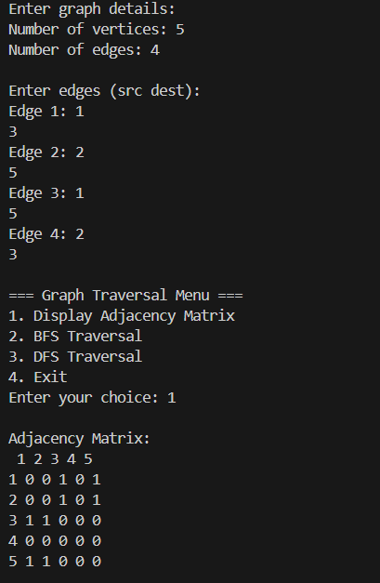
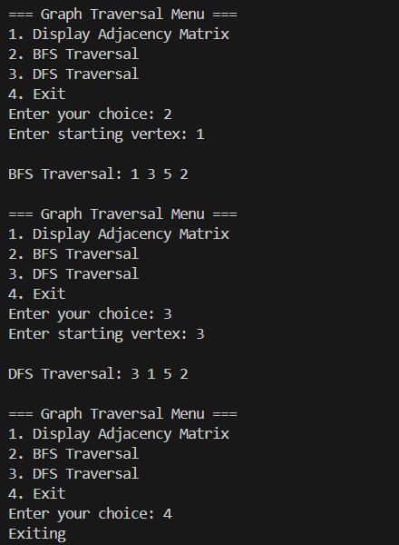

Program 2

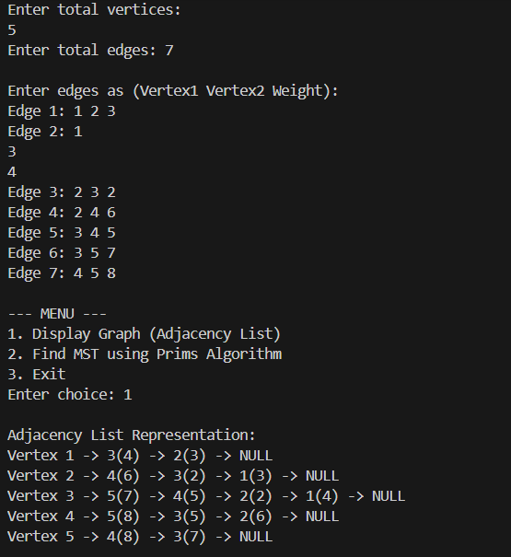
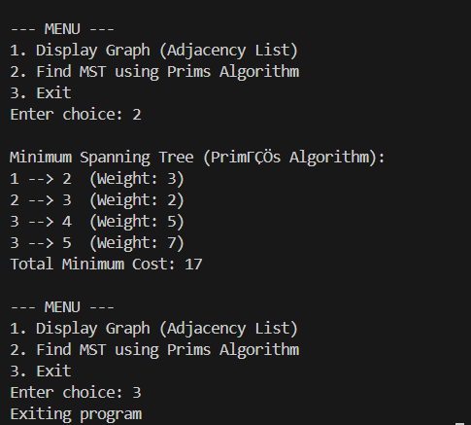

Program 3
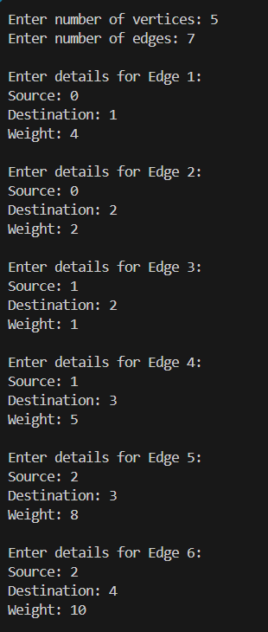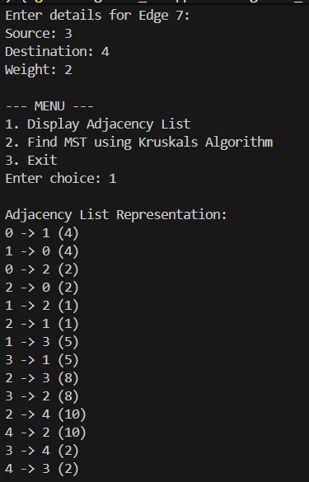
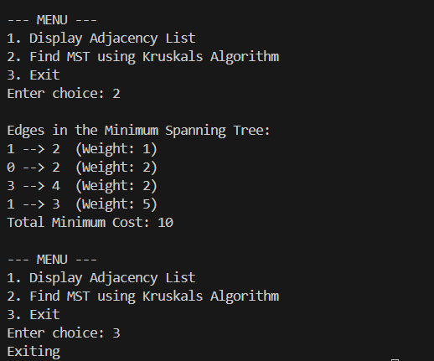

CONCLUSION:

This assignment offered valuable hands-on experience in applying and analyzing essential graph algorithms. By implementing the required programs, the foundational ideas of graph representation and the working of greedy strategies were effectively understood.
Graph Traversal:
Implementing Breadth-First Search (BFS) and Depth-First Search (DFS) using the Adjacency Matrix helped demonstrate how graphs can be explored. BFS efficiently traverses level by level using a queue, while DFS explores deeper paths through recursion or an explicit stack.
Minimum Spanning Tree (MST):
The comparison between Prim’s and Kruskal’s algorithms highlighted different approaches to constructing an MST. Prim’s algorithm incrementally expands the tree by connecting the nearest vertex outside the MST, whereas Kruskal’s algorithm considers all edges in ascending order of weight and includes only those that don’t form cycles, aided by the Disjoint Set Union (DSU) technique for cycle detection.
In summary, this assignment effectively met its goals by converting theoretical concepts—graph structures (Adjacency Matrix and List), traversal (BFS, DFS), and optimization techniques (Prim’s and Kruskal’s)—into practical, working C++ implementations. This not only strengthened understanding of non-linear data structures but also deepened insight into algorithmic problem-solving methods.

