Bansilal Ramnath Agarwal Charitable Trust’s

VISHWAKARMA INSTITUTE OF TECHNOLOGY – PUNE

DATA STRUCTURES

Division | SY CS-A
Batch | 3
GR Number (PRN) | 12413247
Roll No. | 72
Name | Atharva Dhamdhere

ASSIGNMENT 8

AIM

- Write a Program to create a Binary Tree and perform following Non recursive operations on it.
  - Inorder Traversal
  - Preorder Traversal
  - Display Number of Leaf Nodes
  - Mirror Image.

- Write a Program to create a Binary Tree and perform the following Recursive operations on it.
- Inorder Traversal
- Preorder Traversal
- Display Number of Leaf Nodes
- Mirror Imag

OBJECTIVE:

This assignment focuses on mastering the non-linear Binary Search Tree (BST) data structure by implementing its fundamental properties, traversal methods, and analytical algorithms in a structured and practical manner:

• BST Construction and Properties: Developing a BST through recursive node insertion, ensuring the core property (left child < parent < right child) is maintained at all times. This structure allows for efficient O(log n) searches for minimum and maximum values, highlighting the BST’s advantage over linear data structures in ordered data retrieval. Additionally, the recursive insertion process reinforced understanding of dynamic memory allocation and pointer management in tree-based structures.

• Tree Traversal Methods: Implementing breadth-first traversal using a queue to display nodes level by level, demonstrating the importance of different traversal strategies for various applications. This level-wise approach is particularly useful in scenarios such as hierarchical data representation, shortest-path computations, and systematic processing of tree nodes.

• Recursive Analysis and Manipulation: Appling recursive algorithms to evaluate the tree’s structure by counting total nodes and computing its height, providing insights into tree balance and depth. Furthermore, a mirror image of the tree was created through systematic swapping of left and right subtrees, which reinforced both the understanding of tree symmetry and practical manipulation of hierarchical data.

• Node Deletion Logic: Mastering the complex logic of node deletion by addressing all three cases: nodes with zero, one, or two children. For nodes with two children, the algorithm correctly identifies and replaces the node with its inorder successor, maintaining the BST property and ensuring structural integrity. This exercise highlighted the nuanced decision-making required in tree operations and the importance of recursive problem-solving techniques.

• Practical Applications and Insights: Throughout the assignment, emphasis is placed on the real-world relevance of BSTs, such as in database indexing, file systems, and efficient searching algorithms. Implementing these operations provided hands-on experience with recursion, dynamic memory management, and the interplay between algorithmic efficiency and data structure design.

Overall, this assignment bridged theoretical understanding with practical implementation, solidifying the learner’s grasp of BSTs as versatile and efficient data structures suitable for complex data management, hierarchical organization, and algorithmic problem-solving in computer science.

THEORY

A Binary Tree is a non-linear data structure that represents hierarchical relationships through a collection of nodes connected by edges. Each tree has a single root node, and every node can have at most a left and a right child. This structure is inherently recursive, as any node can be viewed as the root of its own subtree, making it suitable for problems that naturally involve hierarchical relationships, such as expression parsing, organizational structures, and decision-making models.
A Binary Search Tree (BST) is a specialized binary tree with a strict ordering property: for any node, all values in its left subtree are less than the node’s value, and all values in its right subtree are greater. This property prevents duplicate values and enables highly efficient search, insertion, and deletion operations, with an average time complexity of O(log n) in balanced trees. BSTs are widely used in applications requiring fast lookup, such as database indexing, associative containers, and priority-based scheduling.
Core Operations of a BST:
- Insertion: Starting from the root, the tree is traversed left for smaller values and right for larger values until a NULL position is found. The new node is then inserted, maintaining the BST property.
- Deletion: Node removal depends on the number of children:
  - Leaf node (0 children): Removed directly without affecting the rest of the tree.
  - Node with one child: The parent node is linked directly to the child, bypassing the node.
  - Node with two children: The node is replaced with its inorder successor (the smallest value in the right subtree), and the successor is recursively deleted. This ensures the BST property remains intact.
- Finding Minimum and Maximum: The minimum value is located by following the leftmost path from the root, while the maximum value is found by following the rightmost path.

Tree Traversals:
- Breadth-First Traversal (Level-Order): Visits nodes level by level, from top to bottom and left to right, typically implemented using a queue. This traversal is useful for applications like printing tree structure, shortest-path algorithms, and scheduling tasks.
- Depth-First Traversals: Include Inorder (Left-Root-Right), Preorder (Root-Left-Right), and Postorder (Left-Right-Root). Inorder traversal of a BST yields nodes in ascending order, which is particularly useful for sorting and range queries.
Recursive Analysis and Manipulation:
- Counting Nodes: The total number of nodes is computed recursively by summing 1 (for the current node) with the counts of its left and right subtrees.
- Computing Height: The height is determined recursively as 1 plus the maximum height of the left and right subtrees, helping evaluate tree balance and efficiency of operations.
- Mirror Image: A mirror image of the BST can be created by recursively swapping the left and right child pointers of each node, effectively inverting the tree’s structure.

ALGORITHMS

Program 1

- Start
- Initialize an empty Binary Tree (root = NULL).
- Create the Tree:
  - Input root node value.
  - If value is -1, tree remains empty.
  - Otherwise, create root node.
  - Initialize a queue and enqueue the root.
  - While the queue is not empty:
    - Dequeue the current node.
    - Input left child value:
      - If not -1, create node, attach as left child, enqueue it.
    - Input right child value:
      - If not -1, create node, attach as right child, enqueue it.
- Display Menu:
  - Inorder Traversal (Non-recursive)
  - Preorder Traversal (Non-recursive)
  - Display Number of Leaf Nodes
  - Create Mirror Image
  - Exit
- Repeat until user selects Exit:
  - If choice = 1 (Inorder Traversal):
    - Initialize a stack and set current = root.
    - While current is not NULL or stack is not empty:
      - Push all left children onto the stack.
      - Pop node from stack, print its value.
      - Move to its right child.
  - If choice = 2 (Preorder Traversal):
    - Initialize a stack and push root.
    - While stack is not empty:
      - Pop node, print its value.
      - Push right child (if exists), then left child (if exists).
  - If choice = 3 (Leaf Node Count):
    - Initialize a queue and enqueue root.
    - Set count = 0.
    - While queue is not empty:
      - Dequeue node.
      - If both left and right are NULL, increment count.
      - Enqueue left and right children (if exist).
    - Print count.
  - If choice = 4 (Mirror Image):
    - Initialize a queue and enqueue root.
    - While queue is not empty:
      - Dequeue node.
      - Swap its left and right children.
      - Enqueue left and right children (if exist).
    - Print “Tree has been mirrored.”
  - If choice = 5 (Exit):
    - Print “Exiting program.”
  - Else:
    - Print “Invalid choice.”
- End

Program 2

Start

Initialize an empty Binary Tree (root = NULL).

Create the Tree:

Input root value.

If value = -1, tree remains empty.

Else, create root node and enqueue it into a queue.

While the queue is not empty:

Dequeue a node (current).

Input left child value:

If not -1, create node, attach as left child, enqueue it.

Input right child value:

If not -1, create node, attach as right child, enqueue it.

Display Menu:

Inorder Traversal (Recursive)

Preorder Traversal (Recursive)

Display Number of Leaf Nodes

Create Mirror Image

Exit

Repeat until user selects Exit:

If choice = 1 (Inorder Traversal):

Call inorderRecursive(node) recursively:

If node is NULL, return.

Traverse left subtree.

Print current node data.

Traverse right subtree.

If choice = 2 (Preorder Traversal):

Call preorderRecursive(node) recursively:

If node is NULL, return.

Print current node data.

Traverse left subtree.

Traverse right subtree.

If choice = 3 (Leaf Node Count):

Call countLeafNodesRecursive(node) recursively:

If node is NULL, return 0.

If node has no left and right child, return 1.

Else, return sum of left and right subtree leaf counts.

Print total leaf nodes.

If choice = 4 (Mirror Image):

Call mirrorImageRecursive(node) recursively:

If node is NULL, return.

Swap left and right child pointers.

Apply mirror recursively to left and right subtrees.

Print “Tree has been mirrored.”

If choice = 5 (Exit):

Print “Exiting program.”

Else:

Print “Invalid choice.”

End

PROGRAMS

Program 1

#include <iostream>
#include <queue>
#include <stack>

using namespace std;

struct Node {
int data;
Node* left;
Node* right;

Node(int val) : data(val), left(nullptr), right(nullptr) {}
};

class BinaryTree {
private:
Node* root;

void destroyTree(Node* node) {
if (node) {
destroyTree(node->left);
destroyTree(node->right);
delete node;
}
}

public:
BinaryTree() : root(nullptr) {}

~BinaryTree() {
destroyTree(root);
}

void createTree() {
if (root != nullptr) {
cout << "Tree already exists. Cannot create a new one." << endl;
return;
}

int val;
cout << "Enter root value (-1 for no node): ";
cin >> val;

if (val == -1) {
return;
}

root = new Node(val);
queue<Node*> q;
q.push(root);

while (!q.empty()) {
Node* current = q.front();
q.pop();

cout << "Enter left child for " << current->data << " (-1 for no node): ";
cin >> val;
if (val != -1) {
current->left = new Node(val);
q.push(current->left);
}

cout << "Enter right child for " << current->data << " (-1 for no node): ";
cin >> val;
if (val != -1) {
current->right = new Node(val);
q.push(current->right);
}
}
}

void inorderTraversal() {
if (root == nullptr) {
cout << "Tree is empty." << endl;
return;
}

stack<Node*> s;
Node* current = root;

while (current != nullptr || !s.empty()) {
while (current != nullptr) {
s.push(current);
current = current->left;
}
current = s.top();
s.pop();
cout << current->data << " ";
current = current->right;
}
cout << endl;
}

void preorderTraversal() {
if (root == nullptr) {
cout << "Tree is empty." << endl;
return;
}

stack<Node*> s;
s.push(root);

while (!s.empty()) {
Node* current = s.top();
s.pop();
cout << current->data << " ";

if (current->right) {
s.push(current->right);
}
if (current->left) {
s.push(current->left);
}
}
cout << endl;
}

void displayLeafNodesCount() {
if (root == nullptr) {
cout << "Tree is empty. Number of leaf nodes: 0" << endl;
return;
}

queue<Node*> q;
q.push(root);
int count = 0;

while (!q.empty()) {
Node* current = q.front();
q.pop();

if (current->left == nullptr && current->right == nullptr) {
count++;
}

if (current->left) {
q.push(current->left);
}
if (current->right) {
q.push(current->right);
}
}
cout << "Total number of leaf nodes: " << count << endl;
}

void mirrorImage() {
if (root == nullptr) {
cout << "Tree is empty. Cannot mirror." << endl;
return;
}

queue<Node*> q;
q.push(root);

while (!q.empty()) {
Node* current = q.front();
q.pop();

// Swap the children
Node* temp = current->left;
current->left = current->right;
current->right = temp;

if (current->left) {
q.push(current->left);
}
if (current->right) {
q.push(current->right);
}
}
cout << "Tree has been mirrored." << endl;
}
};

void showMenu() {
cout << "\n--- Binary Tree Operations Menu ---\n";
cout << "1. Inorder Traversal (Non-recursive)\n";
cout << "2. Preorder Traversal (Non-recursive)\n";
cout << "3. Display Number of Leaf Nodes\n";
cout << "4. Create Mirror Image\n";
cout << "5. Exit\n";
cout << "Enter your choice: ";
}

int main() {
BinaryTree tree;
int choice;

cout << "--- Create the Binary Tree first ---\n";
tree.createTree();

do {
showMenu();
cin >> choice;

switch (choice) {
case 1:
cout << "Inorder Traversal: ";
tree.inorderTraversal();
break;
case 2:
cout << "Preorder Traversal: ";
tree.preorderTraversal();
break;
case 3:
tree.displayLeafNodesCount();
break;
case 4:
tree.mirrorImage();
break;
case 5:
cout << "Exiting program.\n";
break;
default:
cout << "Invalid choice.\n";
break;
}
} while (choice != 5);

return 0;
}

Program 2
#include <iostream>
#include <queue>
#include <stack>
#include <algorithm>

using namespace std;

struct Node {
int data;
Node* left;
Node* right;

Node(int val) : data(val), left(nullptr), right(nullptr) {}
};

class BinaryTree {
private:
Node* root;

void destroyTree(Node* node) {
if (node) {
destroyTree(node->left);
destroyTree(node->right);
delete node;
}
}

void inorderRecursive(Node* node) {
if (node == nullptr) {
return;
}
inorderRecursive(node->left);
cout << node->data << " ";
inorderRecursive(node->right);
}

void preorderRecursive(Node* node) {
if (node == nullptr) {
return;
}
cout << node->data << " ";
preorderRecursive(node->left);
preorderRecursive(node->right);
}

int countLeafNodesRecursive(Node* node) {
if (node == nullptr) {
return 0;
}
if (node->left == nullptr && node->right == nullptr) {
return 1;
}
return countLeafNodesRecursive(node->left) + countLeafNodesRecursive(node->right);
}

void mirrorImageRecursive(Node* node) {
if (node == nullptr) {
return;
}
mirrorImageRecursive(node->left);
mirrorImageRecursive(node->right);
swap(node->left, node->right);
}

public:
BinaryTree() : root(nullptr) {}

~BinaryTree() {
destroyTree(root);
}

void createTree() {
if (root != nullptr) {
cout << "Tree already exists. Cannot create a new one." << endl;
return;
}

int val;
cout << "Enter root value (-1 for no node): ";
cin >> val;

if (val == -1) {
return;
}

root = new Node(val);
queue<Node*> q;
q.push(root);

while (!q.empty()) {
Node* current = q.front();
q.pop();

cout << "Enter left child for " << current->data << " (-1 for no node): ";
cin >> val;
if (val != -1) {
current->left = new Node(val);
q.push(current->left);
}

cout << "Enter right child for " << current->data << " (-1 for no node): ";
cin >> val;
if (val != -1) {
current->right = new Node(val);
q.push(current->right);
}
}
}

void inorderTraversal() {
if (root == nullptr) {
cout << "Tree is empty." << endl;
return;
}
inorderRecursive(root);
cout << endl;
}

void preorderTraversal() {
if (root == nullptr) {
cout << "Tree is empty." << endl;
return;
}
preorderRecursive(root);
cout << endl;
}

void displayLeafNodesCount() {
int count = countLeafNodesRecursive(root);
if (root == nullptr) {
cout << "Tree is empty. Number of leaf nodes: 0" << endl;
} else {
cout << "Total number of leaf nodes: " << count << endl;
}
}

void mirrorImage() {
if (root == nullptr) {
cout << "Tree is empty. Cannot mirror." << endl;
return;
}
mirrorImageRecursive(root);
cout << "Tree has been mirrored." << endl;
}
};

void showMenu() {
cout << "\n--- Binary Tree Operations Menu ---\n";
cout << "1. Inorder Traversal (Recursive)\n";
cout << "2. Preorder Traversal (Recursive)\n";
cout << "3. Display Number of Leaf Nodes\n";
cout << "4. Create Mirror Image\n";
cout << "5. Exit\n";
cout << "Enter your choice: ";
}

int main() {
BinaryTree tree;
int choice;

cout << "--- Create the Binary Tree first ---\n";
tree.createTree();

do {
showMenu();
cin >> choice;

switch (choice) {
case 1:
cout << "Inorder Traversal: ";
tree.inorderTraversal();
break;
case 2:
cout << "Preorder Traversal: ";
tree.preorderTraversal();
break;
case 3:
tree.displayLeafNodesCount();
break;
case 4:
tree.mirrorImage();
break;
case 5:
cout << "Exiting program.\n";
break;
default:
cout << "Invalid choice.\n";
break;
}
} while (choice != 5);

return 0;
}

OUTPUT:

Program 1
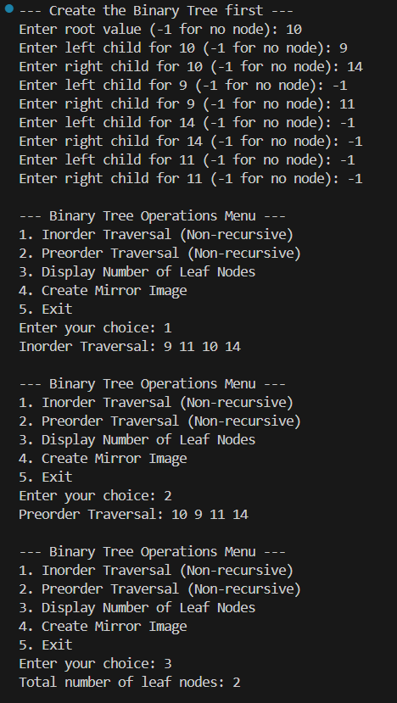
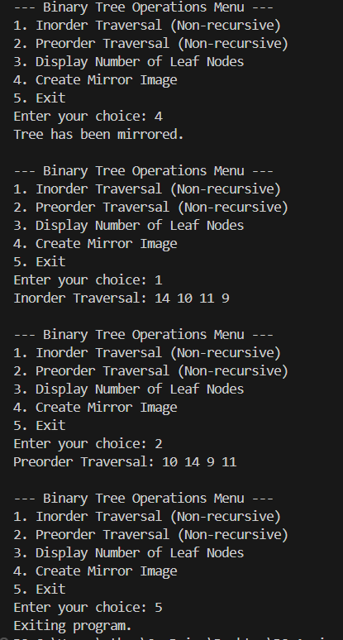

Program 2
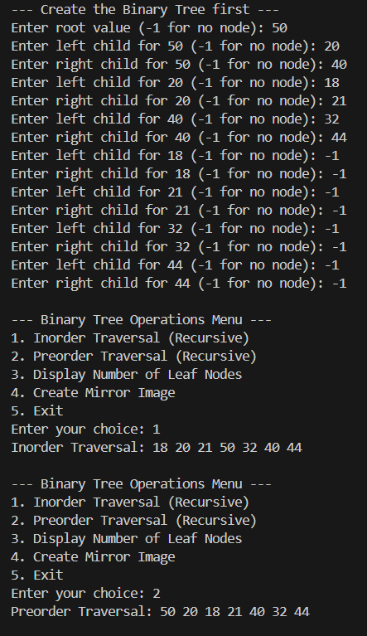
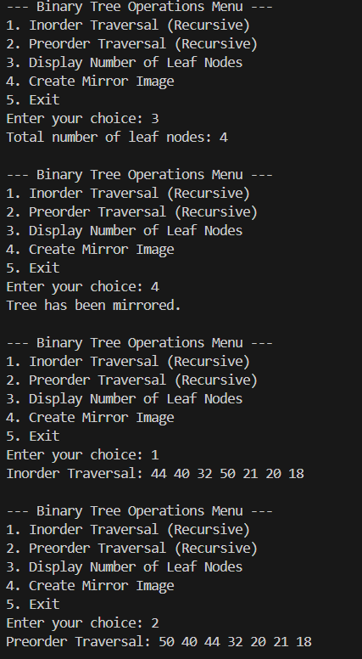
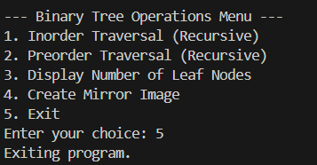

CONCLUSION:

This assignment effectively showcased a thorough understanding of binary tree algorithms by implementing them through two complementary approaches: recursion and iteration. The recursive method capitalized on the inherent hierarchical structure of trees, offering elegant and concise solutions for traversals, leaf counting, and mirroring. Conversely, the iterative method utilized explicit stacks and queues to manually manage program state, providing deeper insight into the operational logic behind these processes. By implementing identical functionalities using both paradigms, this work underscored the essential trade-offs between the simplicity and readability of recursion and the explicit control and efficiency of iteration when dealing with complex, non-linear data structures.

