Bansilal Ramnath Agarwal Charitable Trust’s

VISHWAKARMA INSTITUTE OF TECHNOLOGY – PUNE

DATA STRUCTURES

Division | SY CS-A
Batch | 3
GR Number (PRN) | 12413247
Roll No. | 72
Name | Atharva Dhamdhere

ASSIGNMENT 10

AIM

- Write a Program to implement Dijkstra’s algorithm to find shortest distance between two nodes of a user defined graph. Use Adjacency List to represent a graph.

- Write a Program to accept a graph from a user and represent it with Adjacency List and perform BFS and DFS traversals on it.

OBJECTIVE:

The objective of this assignment is to understand and implement fundamental graph algorithms using the Adjacency List representation to ensure efficient storage and traversal.
- To accept a user-defined graph and represent it using an Adjacency List for optimized memory usage.
- To perform Breadth-First Search (BFS) and Depth-First Search (DFS) traversals to explore the structure and connectivity of the graph.
- To implement Dijkstra’s algorithm for finding the shortest distance between two specified nodes in a weighted graph.
- To develop a clear understanding of graph traversal techniques and shortest path computation through practical implementation.
- To analyze the time and space efficiency of graph algorithms when applied to real-world problems such as navigation, routing, and network optimization.

THEORY

A graph is a fundamental non-linear data structure made up of a finite set of vertices (nodes) and a set of edges that define relationships or connections between them. Graphs are highly versatile and are used to model numerous real-world problems such as social networks, road maps, communication systems, transportation routes, and computer networks.
Graphs can be:
- Directed or Undirected: In directed graphs, edges have direction (e.g., one-way roads), while in undirected graphs, edges are bidirectional.
- Weighted or Unweighted: Weighted graphs assign a cost or distance to each edge; unweighted graphs treat all edges equally.

Graph Representation
Adjacency List:
The Adjacency List is an efficient way to represent a graph, especially when the number of edges is much less than the square of vertices (sparse graphs).
- Each vertex has a list of its neighboring vertices and corresponding edge weights (if any).
- It uses O(V + E) space, which is more memory-efficient than an adjacency matrix.
- It provides faster iteration over neighbors, which makes it ideal for traversal algorithms like BFS, DFS, and shortest path algorithms.

Graph Traversal Algorithms
1. Breadth-First Search (BFS):
BFS explores the graph level by level, starting from a given source vertex.
- It visits all immediate neighbors of the source first before moving to the next level of nodes.
- It is implemented using a Queue to keep track of vertices to be explored next.
- BFS is particularly useful for:
  - Finding the shortest path in an unweighted graph.
  - Checking connectivity or bipartiteness of a graph.
  - Exploring all reachable vertices from a given starting node.
2. Depth-First Search (DFS):
DFS explores as deeply as possible along each branch before backtracking.
- It can be implemented using recursion or an explicit Stack.
- DFS helps in:
  - Cycle detection in both directed and undirected graphs.
  - Topological sorting for directed acyclic graphs (DAGs).
  - Finding connected components in a graph.
- DFS gives a deep understanding of the graph’s structure by following paths exhaustively before moving to other branches.

Shortest Path Algorithm
3. Dijkstra’s Algorithm:
Dijkstra’s algorithm is a greedy algorithm designed to find the shortest path from a single source vertex to all other vertices in a weighted graph with non-negative edge weights.
- It maintains a distance array initialized with infinity for all vertices except the source (set to 0).
- At each step, it selects the vertex with the smallest known distance and updates the distances of its adjacent vertices.
- A priority queue (min-heap) or linear search can be used to find the vertex with the minimum tentative distance efficiently.
- It is widely used in:
  - Network routing algorithms (e.g., OSPF).
  - GPS navigation systems for finding the shortest route.
  - Resource allocation and transportation planning.

ALGORITHMS

Program 1

- Start
- Initialize Data Structures:
a. Create an adjacency list to store vertices and their corresponding edges with weights.
b. Initialize the visited[] array to 0 (false).
c. Initialize the distanceArr[] array to a large number (INF) for all vertices.
- Input Graph Details:
a. Read the number of vertices (V) and edges (E).
b. For each edge, input the two vertices and the edge weight.
c. Insert both directions of the edge into the adjacency list (since the graph is undirected).
- Input Source and Destination Vertices.
- Set Initial Conditions:
a. Set the source vertex’s distance to 0.
b. Mark all other vertices as unvisited.
- Repeat Until All Vertices Are Processed:
a. Select the unvisited vertex with the smallest distance value (using a function like findMinVertex()).
b. Mark this vertex as visited.
c. For each neighbor of this vertex:
If the neighbor is unvisited and the path through the current vertex offers a shorter distance, update the neighbor’s distance.
- Once All Vertices Are Visited:
a. The array distanceArr[] now contains the shortest distances from the source to every vertex.
- Display Results:
a. Print the shortest distance from the source vertex to all vertices.
b. Print the shortest path distance from the source to the destination vertex.
- Stop

Program 2

- Start
- Initialize Data Structures:
a. Create an array of linked lists adjList[] to store vertices and their adjacent nodes.
b. Create a visited[] array initialized to false for all vertices.
- Input Graph Details:
a. Read the number of vertices v and edges e.
b. For each edge, input two vertices src and dest.
c. Create a new node for dest and insert it into the adjacency list of src.
d. Create a new node for src and insert it into the adjacency list of dest (since the graph is undirected).
- Display Adjacency List:
For each vertex, traverse its linked list and print all connected vertices.
- Breadth-First Search (BFS):
a. Input the starting vertex start.
b. Initialize an empty queue and mark all vertices as unvisited.
c. Enqueue the starting vertex and mark it as visited.
d. While the queue is not empty:
i. Dequeue the front vertex current and display it.
ii. For every adjacent vertex of current, if it is unvisited:
- Mark it as visited.
- Enqueue it.
e. Continue until the queue becomes empty.
- Depth-First Search (DFS):
a. Input the starting vertex start.
b. Mark all vertices as unvisited.
c. Call the recursive function DFSUtil(vertex) that:
i. Prints the current vertex.
ii. Marks it as visited.
iii. For each adjacent unvisited vertex, recursively calls DFSUtil().
- Menu-driven Execution:
a. Display menu options:
- Display Adjacency List
- BFS Traversal
- DFS Traversal
- Exit
b. Perform the corresponding operation based on user choice until exit.
- Stop

PROGRAMS

Program 1

#include <iostream>
using namespace std;

#define MAX 20
#define INF 9999

struct Node {
int vertex;
int weight;
Node* next;
};

Node* adjList[MAX];
int visited[MAX], distanceArr[MAX];
int vertices, edges;

void createGraph() {
int i, src, dest, wt;
cout << "\nEnter number of vertices: ";
cin >> vertices;
cout << "Enter number of edges: ";
cin >> edges;

for (i = 1; i <= vertices; i++) {
adjList[i] = NULL;
visited[i] = 0;
distanceArr[i] = INF;
}

cout << "\nEnter edges (src dest weight):\n";
for (i = 1; i <= edges; i++) {
cout << "Edge " << i << ": ";
cin >> src >> dest >> wt;

Node* newNode = new Node;
newNode->vertex = dest;
newNode->weight = wt;
newNode->next = adjList[src];
adjList[src] = newNode;

newNode = new Node;
newNode->vertex = src;
newNode->weight = wt;
newNode->next = adjList[dest];
adjList[dest] = newNode;
}
}

void displayAdjList() {
cout << "\nAdjacency List Representation:\n";
for (int i = 1; i <= vertices; i++) {
cout << "Vertex " << i << ": ";
Node* temp = adjList[i];
while (temp != NULL) {
cout << temp->vertex << "(" << temp->weight << ") -> ";
temp = temp->next;
}
cout << "NULL\n";
}
}

int findMinVertex() {
int min = INF, index = -1;
for (int i = 1; i <= vertices; i++) {
if (!visited[i] && distanceArr[i] < min) {
min = distanceArr[i];
index = i;
}
}
return index;
}

void dijkstra(int start) {
distanceArr[start] = 0;

for (int i = 1; i <= vertices; i++) {
int u = findMinVertex();
if (u == -1) break;

visited[u] = 1;

Node* temp = adjList[u];
while (temp != NULL) {
int v = temp->vertex;
int w = temp->weight;

if (!visited[v] && distanceArr[u] + w < distanceArr[v])
distanceArr[v] = distanceArr[u] + w;

temp = temp->next;
}
}
}

int main() {
createGraph();
displayAdjList();

int start, end;
cout << "\nEnter source vertex: ";
cin >> start;
cout << "Enter destination vertex: ";
cin >> end;

dijkstra(start);

cout << "\nShortest distances from vertex " << start << ":\n";
for (int i = 1; i <= vertices; i++)
cout << "To " << i << " = " << distanceArr[i] << endl;

cout << "\nShortest distance from " << start << " to " << end << " = " << distanceArr[end] << endl;

return 0;
}

Program 2
#include <iostream>
#include <queue>
using namespace std;

struct Node {
int vertex;
Node* next;
};

Node* adjList[20];
bool visited[20];
int v, e;

void createGraph() {
cout << "\nEnter number of vertices: ";
cin >> v;
cout << "Enter number of edges: ";
cin >> e;

for (int i = 1; i <= v; i++)
adjList[i] = NULL;

cout << "\nEnter edges (src dest):\n";
for (int i = 1; i <= e; i++) {
int src, dest;
cout << "Edge " << i << ": ";
cin >> src >> dest;

Node* newNode = new Node{dest, adjList[src]};
adjList[src] = newNode;

newNode = new Node{src, adjList[dest]};
adjList[dest] = newNode;
}
}

void displayAdjList() {
cout << "\nAdjacency List Representation:\n";
for (int i = 1; i <= v; i++) {
cout << "Vertex " << i << ": ";
Node* temp = adjList[i];
while (temp != NULL) {
cout << temp->vertex << " -> ";
temp = temp->next;
}
cout << "NULL\n";
}
}

void BFS(int start) {
queue<int> q;
for (int i = 1; i <= v; i++)
visited[i] = false;

visited[start] = true;
q.push(start);

cout << "BFS Traversal: ";
while (!q.empty()) {
int current = q.front();
q.pop();
cout << current << " ";

Node* temp = adjList[current];
while (temp != NULL) {
if (!visited[temp->vertex]) {
visited[temp->vertex] = true;
q.push(temp->vertex);
}
temp = temp->next;
}
}
cout << endl;
}

void DFSUtil(int vertex) {
visited[vertex] = true;
cout << vertex << " ";

Node* temp = adjList[vertex];
while (temp != NULL) {
if (!visited[temp->vertex])
DFSUtil(temp->vertex);
temp = temp->next;
}
}

void DFS(int start) {
for (int i = 1; i <= v; i++)
visited[i] = false;

cout << "DFS Traversal: ";
DFSUtil(start);
cout << endl;
}

int main() {
int choice, start;

createGraph();

do {
cout << "\n=== Graph Traversal Menu ===\n";
cout << "1. Display Adjacency List\n";
cout << "2. BFS Traversal\n";
cout << "3. DFS Traversal\n";
cout << "4. Exit\n";
cout << "Enter your choice: ";
cin >> choice;

switch (choice) {
case 1:
displayAdjList();
break;

case 2:
cout << "Enter starting vertex: ";
cin >> start;
BFS(start);
break;

case 3:
cout << "Enter starting vertex: ";
cin >> start;
DFS(start);
break;

case 4:
cout << "Exiting\n";
break;

default:
cout << "Invalid choice\n";
}
} while (choice != 4);

return 0;
}

OUTPUT:

Program 1

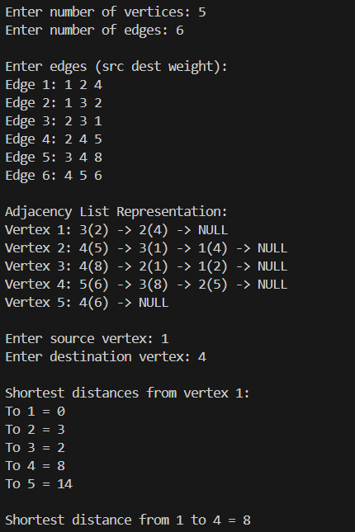

Program 2

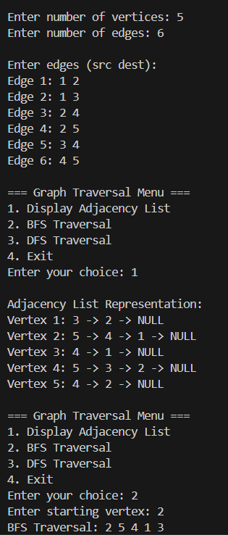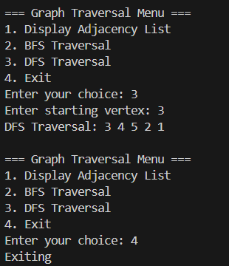

CONCLUSION:

The assignment effectively enhanced the understanding of graph traversal and shortest path algorithms using Adjacency List representation. By implementing both BFS/DFS and Dijkstra’s Algorithm, the concepts of graph exploration and optimization were practically demonstrated.
Graph Traversal (BFS and DFS):
Through BFS and DFS implementations, the distinction between level-wise and depth-wise exploration was clearly observed. BFS used a queue to systematically explore neighbouring nodes, making it ideal for finding the shortest path in unweighted graphs. DFS, using recursion or a stack, explored as deep as possible before backtracking, providing insights into path discovery and connectivity analysis.
Shortest Path Algorithm (Dijkstra’s):
The Dijkstra’s algorithm program focused on finding the minimum distance between two nodes in a weighted graph. Using a priority queue and the adjacency list for efficient edge access, it demonstrated how greedy selection ensures optimal shortest paths. The algorithm also reinforced the importance of edge relaxation and distance updates during traversal.
The assignment successfully integrated graph traversal and shortest path computation, offering a strong understanding of how adjacency lists improve efficiency in sparse graphs. It strengthened concepts of graph theory, queue-based and greedy algorithms, and their real-world applications such as routing, navigation systems, and network analysis.

