Bansilal Ramnath Agarwal Charitable Trust’s

VISHWAKARMA INSTITUTE OF TECHNOLOGY – PUNE

DATA STRUCTURES

Division | SY CS-A
Batch | 3
GR Number (PRN) | 12413247
Roll No. | 72
Name | Atharva Dhamdhere

ASSIGNMENT 11

AIM

- Implement a hash table with collision resolution using linear probing.

OBJECTIVE:

The objective of this assignment is to understand the concept of hashing and to implement a hash table data structure with efficient data storage and retrieval. This includes applying a hash function to map keys to indices and handling collisions using the linear probing technique. The goal is to observe how linear probing resolves conflicts when multiple keys hash to the same index, and to develop the ability to perform basic operations such as insertion, searching, and displaying data in the hash table.

THEORY

A Hash Table is a data structure that stores data in the form of key-value pairs and provides efficient operations for insertion, searching, and sometimes deletion. The main idea behind hashing is to convert a key into an array index using a mathematical formula called a hash function. This allows direct access to elements, making search operations very fast, typically O(1) on average.
1. Hashing
Hashing is a technique used to map large key values into a fixed range of indices in a hash table.
It converts a key into a hash index using the formula:
$$\text{hash}=h(key)$$
Where h(key) is the hash function.
Hashing is widely used in:
- Databases
- Symbol tables in compilers
- Caching
- Searching applications

2. Hash Function
A hash function determines the index where a key will be stored in the hash table.
A good hash function should:
- Be simple to compute
- Distribute keys uniformly
- Minimize collisions
The most commonly used hash function is:
$$h\left(key\right)=key \%\text{ table size}$$
This function works well when the table size is a prime number, as it reduces clustering.

3. Collision
A collision occurs when two different keys produce the same hash index.
Since multiple keys can map to the same location, a method is required to handle this.
Example:
If h(10) = 3 and h(24) = 3, both want to occupy index 3 → Collision occurs.
Collisions are common and unavoidable, so efficient collision handling is important.

4. Collision Resolution Techniques
Collision resolution deals with how to store and retrieve elements after a collision.
There are two major ways:
- Open Hashing (Separate Chaining) – using linked lists
- Closed Hashing (Open Addressing) – finding another empty position in the table
In this assignment, we use Open Addressing with Linear Probing.

5. Linear Probing (Open Addressing)
In linear probing, if the hash index of a key is already occupied, we check the next index sequentially:
$$index=(index+1)mod\text{ table size}$$
This continues until an empty slot is found.
Example
Hash Table Size = 7
Keys = 10, 21, 32
h(10) = 3
h(21) = 0
h(32) = 4
If inserting 18:
h(18) = 4 → index 4 is full (occupied by 32)
Check 5 → Empty
So store 18 at index 5

Advantages of Linear Probing
- Simple and easy to implement
- Uses only the existing array, no extra memory needed
Disadvantages
- Causes primary clustering (consecutive filled slots reduce performance)
- Search time increases when the table becomes full

6. Searching in Linear Probing
To search a key:
- Compute its hash index.
- Check that index.
- If not found, move forward one step at a time (linear probing) until:
  - The key is found, or
  - An empty slot is encountered (meaning the key is not in the table)

7. Load Factor
Load factor determines how full the hash table is:
$$\text{Load Factor}=\frac{\text{Number of elements inserted}}{\text{Table size}}$$
As the load factor increases, the number of collisions also increases.
To maintain efficiency, the load factor is usually kept below 0.7.

ALGORITHMS

Program 1

1. Start
2. Input table size and initialize all elements to -1
3. Define hash function: index = key % size
4. For insertion:
a. Compute index
b. If slot empty, insert
c. Else use linear probing to find next empty slot and insert
5. For searching:
a. Compute index
b. If key matches, return found
c. Else probe sequentially until key found or empty cell reached
6. Display the hash table
7. Stop

PROGRAMS

Program 1

#include <iostream>
using namespace std;

class HashTable {
private:
int size;
int* table;

public:
HashTable(int s);
int hashFunction(int key);
void insert(int key);
bool search(int key);
void display();
};

// Constructor
HashTable::HashTable(int s) {
size = s;
table = new int[size];
for (int i = 0; i < size; i++)
table[i] = -1;
}

// Hash Function
int HashTable::hashFunction(int key) {
return key % size;
}

// Insert Operation (Linear Probing)
void HashTable::insert(int key) {
int index = hashFunction(key);

while (table[index] != -1) {
index = (index + 1) % size;
}

table[index] = key;
cout << "Inserted " << key << " at index " << index << endl;
}

// Search Operation (Linear Probing)
bool HashTable::search(int key) {
int index = hashFunction(key);
int startIndex = index;

while (table[index] != -1) {
if (table[index] == key)
return true;

index = (index + 1) % size;

if (index == startIndex)
return false;
}
return false;
}

// Display Table
void HashTable::display() {
cout << "\nHash Table:\n";
for (int i = 0; i < size; i++) {
if (table[i] != -1)
cout << i << " --> " << table[i] << endl;
else
cout << i << " --> " << "Empty" << endl;
}
}

int main() {
int size, n, key;

cout << "Enter size of hash table: ";
cin >> size;

HashTable ht(size);

cout << "How many keys to insert? ";
cin >> n;

cout << "Enter keys:\n";
for (int i = 0; i < n; i++) {
cin >> key;
ht.insert(key);
}

ht.display();

cout << "\nEnter key to search: ";
cin >> key;

if (ht.search(key))
cout << key << " found in the hash table.\n";
else
cout << key << " not found in the hash table.\n";

return 0;
}

OUTPUT:

Program 1

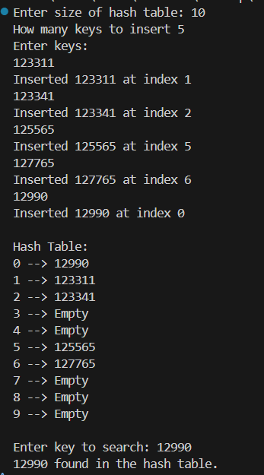

CONCLUSION:

In this assignment, a hash table was successfully implemented using the concept of hashing and collision resolution through linear probing. The hash function was used to map keys to specific indices, enabling fast and direct access to data. However, when multiple keys mapped to the same index, collisions occurred. These collisions were efficiently resolved by linear probing, which searches sequentially for the next available slot in the table. Through this implementation, we learned how hashing improves search and insertion efficiency, typically achieving constant time complexity $O(1)$in average cases. This assignment helped in understanding the internal working of hash tables and the importance of collision resolution techniques in ensuring efficient data storage and retrieval.

