Bansilal Ramnath Agarwal Charitable Trust’s

VISHWAKARMA INSTITUTE OF TECHNOLOGY – PUNE

DATA STRUCTURES

Division | SY CS-A
Batch | 3
GR Number (PRN) | 12413247
Roll No. | 72
Name | Atharva Dhamdhere

ASSIGNMENT 12

AIM

- Use Hashtable to Store and retrieve student records using roll numbers.

OBJECTIVE:

The objective of this assignment is to understand how a hash table can be used to store and retrieve student records efficiently using roll numbers as keys. This includes applying a suitable hash function, inserting student data into the table, searching records by roll number, and resolving collisions using an appropriate technique. The goal is to observe how hashing ensures fast access to student information and to develop the ability to perform basic operations such as insertion, search, and display in a hash table.

THEORY

A Hash Table is a data structure that stores data in the form of key-value pairs and provides efficient operations for insertion, searching, and sometimes deletion. The main idea behind hashing is to convert a key into an array index using a mathematical formula called a hash function. This allows direct access to elements, making search operations very fast, typically O(1) on average.
1. Hashing
Hashing is a technique used to map large key values into a fixed range of indices in a hash table.
It converts a key into a hash index using the formula:
$$\text{hash}=h(key)$$
Where h(key) is the hash function.
Hashing is widely used in:
- Databases
- Symbol tables in compilers
- Caching
- Searching applications

2. Hash Function
A hash function determines the index where a key will be stored in the hash table.
A good hash function should:
- Be simple to compute
- Distribute keys uniformly
- Minimize collisions
The most commonly used hash function is:
$$h\left(key\right)=key \%\text{ table size}$$
This function works well when the table size is a prime number, as it reduces clustering.

3. Collision
A collision occurs when two different keys produce the same hash index.
Since multiple keys can map to the same location, a method is required to handle this.
Example:
If h(10) = 3 and h(24) = 3, both want to occupy index 3 → Collision occurs.
Collisions are common and unavoidable, so efficient collision handling is important.

4. Collision Resolution Techniques
Collision resolution deals with how to store and retrieve elements after a collision.
There are two major ways:
- Open Hashing (Separate Chaining) – using linked lists
- Closed Hashing (Open Addressing) – finding another empty position in the table
In this assignment, we use Open Addressing with Linear Probing.

5. Linear Probing (Open Addressing)
In linear probing, if the hash index of a key is already occupied, we check the next index sequentially:
$$index=(index+1)mod\text{ table size}$$
This continues until an empty slot is found.
Example
Hash Table Size = 7
Keys = 10, 21, 32
h(10) = 3
h(21) = 0
h(32) = 4
If inserting 18:
h(18) = 4 → index 4 is full (occupied by 32)
Check 5 → Empty
So store 18 at index 5

Advantages of Linear Probing
- Simple and easy to implement
- Uses only the existing array, no extra memory needed
Disadvantages
- Causes primary clustering (consecutive filled slots reduce performance)
- Search time increases when the table becomes full

6. Searching in Linear Probing
To search a key:
- Compute its hash index.
- Check that index.
- If not found, move forward one step at a time (linear probing) until:
  - The key is found, or
  - An empty slot is encountered (meaning the key is not in the table)

7. Load Factor
Load factor determines how full the hash table is:
$$\text{Load Factor}=\frac{\text{Number of elements inserted}}{\text{Table size}}$$
As the load factor increases, the number of collisions also increases.
To maintain efficiency, the load factor is usually kept below 0.7.

ALGORITHMS

Program 1

- Start
- Input the hash table size
Initialize all student records as empty (rollNo = -1, name = "", marks = 0.0, isEmpty = true).
- Define hash function:
index = rollNo % size
- Insertion:
a. Compute index using the hash function.
b. If the slot is empty, insert the student record.
c. If the slot is not empty, perform linear probing:
  - Move to the next index (index + 1) % size
  - Continue probing until an empty slot is found.
  - Insert the student record there.
- Searching:
a. Compute index using the hash function.
b. If roll number matches, record is found.
c. Otherwise, use linear probing to check the next slots one by one.
d. Stop when the record is found or an empty slot is encountered.
- Display:
Print the entire hash table showing index, roll number, name, and marks.
Print "Empty" for unused slots.
- Stop

PROGRAMS

Program 1

#include <iostream>
#include <string>
using namespace std;

struct Student {
int rollNo;
string name;
float marks;
bool isEmpty;

Student() : rollNo(-1), name(""), marks(0.0), isEmpty(true) {}
};

class HashTable {
private:
int size;
Student* table;

public:
HashTable(int s);
int hashFunction(int rollNo);
void insert(int rollNo, string name, float marks);
bool search(int rollNo);
void display();
void displayStudent(int rollNo);
};

// Constructor
HashTable::HashTable(int s) {
size = s;
table = new Student[size];
}

// Hash Function
int HashTable::hashFunction(int rollNo) {
return rollNo % size;
}

// Insert Operation (Linear Probing)
void HashTable::insert(int rollNo, string name, float marks) {
int index = hashFunction(rollNo);
int startIndex = index;

while (!table[index].isEmpty) {
if (table[index].rollNo == rollNo) {
cout << "Roll number " << rollNo << " already exists!\n";
return;
}
index = (index + 1) % size;

if (index == startIndex) {
cout << "Hash table is full!\n";
return;
}
}

table[index].rollNo = rollNo;
table[index].name = name;
table[index].marks = marks;
table[index].isEmpty = false;
cout << "Inserted student (Roll No: " << rollNo << ") at index " << index << endl;
}

// Search Operation (Linear Probing)
bool HashTable::search(int rollNo) {
int index = hashFunction(rollNo);
int startIndex = index;

while (!table[index].isEmpty) {
if (table[index].rollNo == rollNo)
return true;

index = (index + 1) % size;

if (index == startIndex)
return false;
}
return false;
}

// Display Table
void HashTable::display() {
cout << "\n========== Hash Table (Student Records) ==========\n";
cout << "Index\tRoll No\tName\t\tMarks\n";
cout << "==================================================\n";
for (int i = 0; i < size; i++) {
if (!table[i].isEmpty)
cout << i << "\t" << table[i].rollNo << "\t" << table[i].name << "\t\t" << table[i].marks << endl;
else
cout << i << "\t" << "Empty" << endl;
}
cout << "==================================================\n";
}

// Display specific student details
void HashTable::displayStudent(int rollNo) {
int index = hashFunction(rollNo);
int startIndex = index;

while (!table[index].isEmpty) {
if (table[index].rollNo == rollNo) {
cout << "\n--- Student Details ---\n";
cout << "Roll No: " << table[index].rollNo << endl;
cout << "Name: " << table[index].name << endl;
cout << "Marks: " << table[index].marks << endl;
cout << "Index in Table: " << index << endl;
return;
}

index = (index + 1) % size;

if (index == startIndex)
break;
}
cout << "Student with roll number " << rollNo << " not found!\n";
}

int main() {
int size, n, rollNo;
string name;
float marks;

cout << "Enter size of hash table: ";
cin >> size;

HashTable ht(size);

cout << "How many student records to insert? ";
cin >> n;
cout << "\nEnter student details:\n";
for (int i = 0; i < n; i++) {
cout << "\nStudent " << (i + 1) << ":\n";
cout << "Roll No: ";
cin >> rollNo;
cout << "Name: ";
cin.ignore();
getline(cin, name);
cout << "Marks: ";
cin >> marks;
ht.insert(rollNo, name, marks);
}
ht.display();
cout << "\nEnter roll number to search: ";
cin >> rollNo;
if (ht.search(rollNo)) {
cout << "Student found!\n";
ht.displayStudent(rollNo);
} else {
cout << "Student with roll number " << rollNo << " not found in the hash table.\n";
}

return 0;
}

OUTPUT:

Program 1

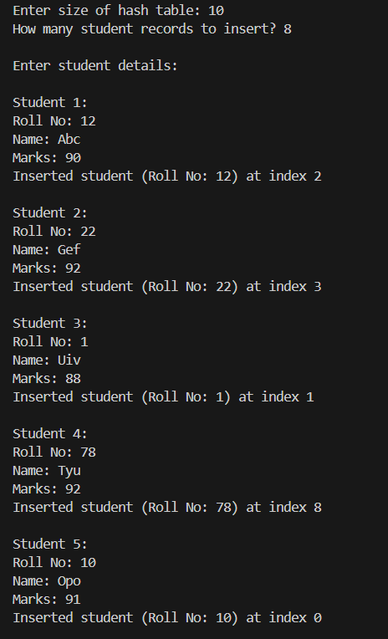
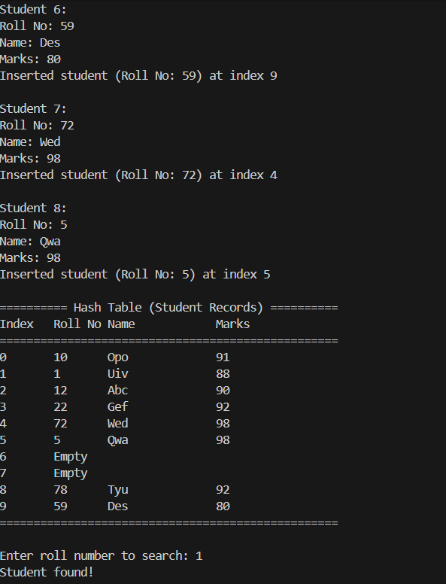

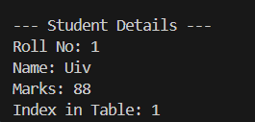

CONCLUSION:

The implementation of this assignment demonstrated how a hash table can efficiently store and retrieve student records using roll numbers as keys. The hash function enabled quick access by mapping keys to specific indices, while collisions were handled using linear probing. Linear probing ensured that when a position was occupied, the next available slot was found through sequential searching. This approach highlighted how hashing provides fast insertion and searching, generally achieving O(1) average time complexity. Overall, the assignment provided clear understanding of hashing, collision handling, and the practical working of hash tables.

