Game Design Document

Fill up the Following document

1. Write the title of your project.

Killer mode on

1. What is the goal of the game?

Kill every other player to get points.

To win the game you have to have the most number of points among all the players.

1. Write a brief story of your game?

It is the year 3000 and most of the world is destroyed and filled with pollution.

To survive you have to kill all the other players as they will try to kill you also

This is Survival of the Fittest!.

1. Which are the playing characters of this game?

* Playing characters are the ones which respond to the user based on the input from the user
* Cars, monkeys, dinos, wizards etc, are the playing characters in the game.

|  |  |  |
| --- | --- | --- |
| Number | Character Name | What can this character do? |
| 1 | My Player( decided by the player itself) | Shoot bullets, gather ammo. |
| 2 | Other Players( players playing the game from another computer) up to 10 | Shoot bullets, gather ammo. |

1. Which are the Non Playing Characters of this game?

* Non Playing characters are the ones which don't have an action or a behavior when the user interacts with the game.
* Hurdles, stones, bananas, coins, etc are non playing characters in the game.

|  |  |  |
| --- | --- | --- |
| Number | Character Name | What can this character do? |
| 1 | Virus | Toxic, can decrease your health and ammo |
| 2 | Ammo | Collect these to increase ammo |

Draw your imagination of this game. What does this game look like?

* Draw the game either on your computer or on paper,
* Add images of scenes of the game to show each of the playing and non-playing characters at least once.

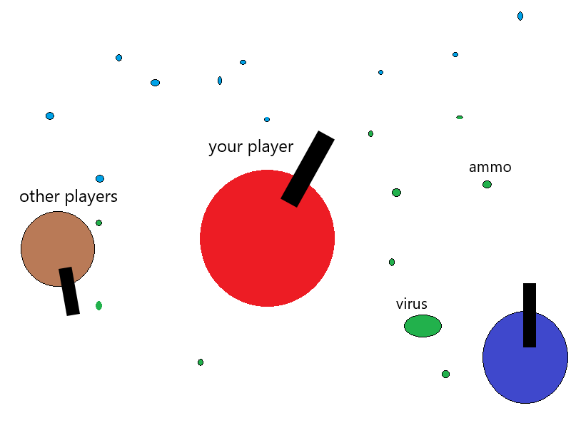

My game idea with the player and all the PCs and NPCs.

How do you plan to make your game engaging?

By making the game a multiplayer game, the people will enjoy competing with others. Thus, making the game more engaging. And also adding various rewards like trophies or badges when the player accomplishes some thing