# Kono Implementation in Lisp

#### Philip Glazman

# Bug Report

This program does not have any known bugs.

# Feature Report

All the features listed in the rubric are implemented as described with the exception of the computer being able to quit the round.

# Description of Data Structures

### Data Structures

* players
  + List containing player-one, player-one’s color, player-two, and player-two color.
* board
  + List of lists representing the board. Each list is a row. Each row contains n number of strings that represent a game piece.
* scores
  + List containing computer, computer’s color, human, human player’s color, and round number.
* listOfPieces
  + List of coordinates representing game pieces for computer.
* opponentCoordinates
  + List containing coordinates of closest opponent.

# Top-Level Calling of Functions

# Log

|  |  |  |
| --- | --- | --- |
| Description | Timestamp | Duration |
| Added board generation, user input for board size, user input for loading game from file. | 2/9/18 9:30pm | 3 hr |
| Added board logic so that board is generated recursively. | 2/12/18 12:08pm | 1.5 hr |
| Added display function for board to be displayed. | 2/12/18 12:45pm | .5 hr |
| Board rows and columns correctly numbered in display function. Home points correctly set up during board generation. | 2/12/18 3:43pm | 2 hr |
| Added menu for round logic. Players alternate during each round. Current player is properly displayed. Added color choice – human chooses color or computer randomly chooses color. Added random dice roll to determine who is first to play. | 2/12/18 10:09pm | 3 hr |
| Added serialization for loading existing game file. | 2/13/18 12:40pm | 2hr |
| Refactored user menu. Added user input for human player board movements. Added user input for selecting board pieces. Added input validation for selecting board pieces. Board updates on each player move. Players alternate. User is prompted with choose for piece movement based on direction. | 2/16/18 4:54pm | 5.5 hr |
| Added output for each player’s color. Board now updates after each human move. Debugged issues where game board did not correctly load from file. | 2/17/18 11:40pm | 2.5 hr |
| Added more input validation for board movements. Refactored functions for loading game. | 2/18/18 1:32pm | 2 hr |
| Added utility functions for checking the number of remaining pieces for each player and checking if pieces occupy the opponent side. Round is now completed when human or computer moves all their available pieces to opposite side. | 2/19/18 3:24pm | 5 hr |
| Points correctly calculated for when pieces reach home points. Player scores announced. Winning player is announced and awarded difference in points in round scores to tournament scores. Added tournament control, user can play another round or exit game. Winner is first player in next round. | 2/19/18 10:02pm | 5 hr |
| Computer can identify closest opponent and attempt to block it. Began basic computer strategy outline. | 2/20/18 1:07pm | 2.5 hr |
| Completed computer strategy for blocking opponent piece from east side. Computer can now identify a list of its friendly pieces. | 2/20/18 10:58pm | 2 hr |
| Added serialization to save game to file. Finished computer blocking strategy. Added computer attack strategy and functionality for selecting random piece to move forward. | 2/21/18 9:28pm | 4 hr |
| Computer blocking strategy now updates board after block decision. Refactored offensive strategy. Added retreat strategy. Computer can identify its super pieces. Added to serialization so that super pieces can be loaded. | 2/22/18 3:45pm | 2.5 hr |
| Computer strategy for capturing pieces using its own super pieces is completed. Added input validation for all human user input. Added input validation for selecting pieces. | 2/22/18 11:16pm | 4 hr |
| Added comments for serialization process. Added comments to score counting. Fixed bug in serialization where saving a game would not correctly save game board. | 2/23/18 10:24pm | 2 hr |
| Fixed issue where human player could not move their super pieces. Fixed issue where capture strategy only worked for first identified super piece. Fixed issue when computer would not recognize opponent’s super piece as opponent. Added additional comments for computer strategy. Added comments for all functions. | 2/24/18 9:44pm | 3.5 hr |
| Fixed issue where tournament scores would not correctly print if there was a tie. Fixed an issue when points would not be deduced for quitting game. Added round number to serialization. | 2/24/18 10:54pm | 1 hr |

# How to Run the Program

To run from command line:

*sbcl --non-interactive --load program.lsp*

## Starting a new game.

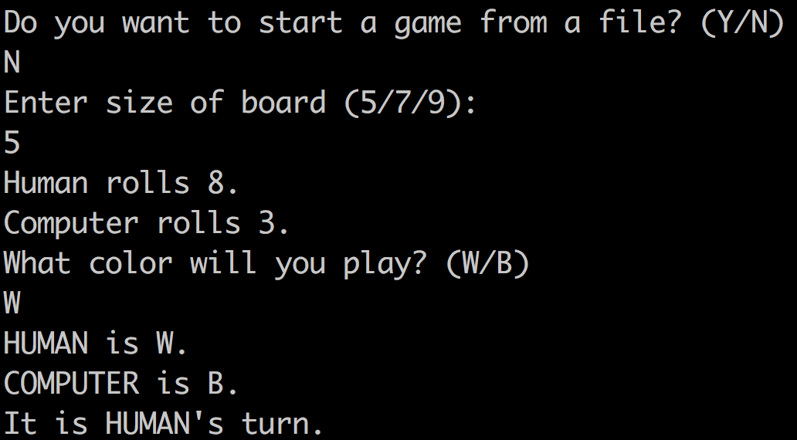

## Player Menu.

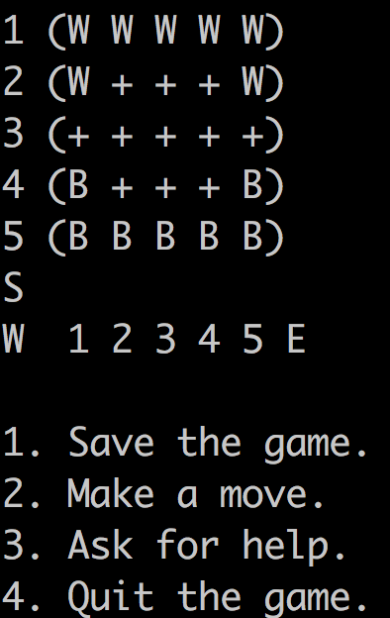

## Saving Game.

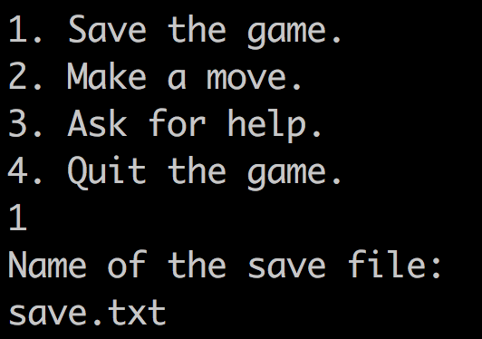

## Loading Game from File.

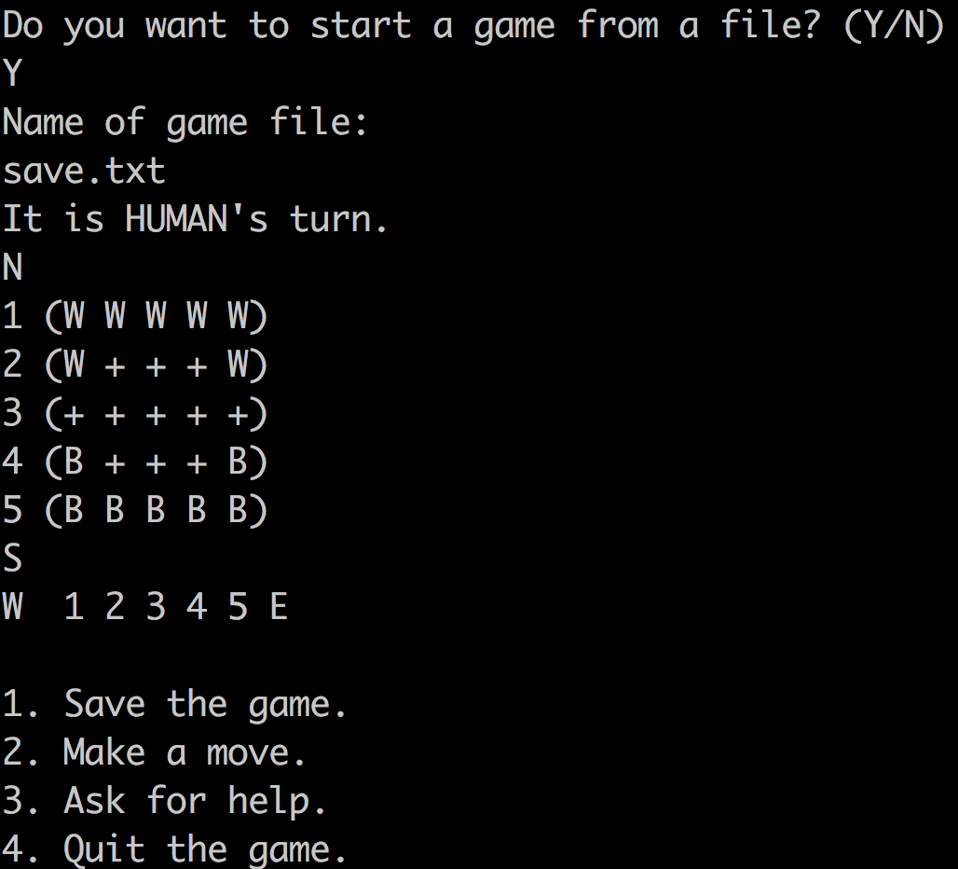

## Making a Move.

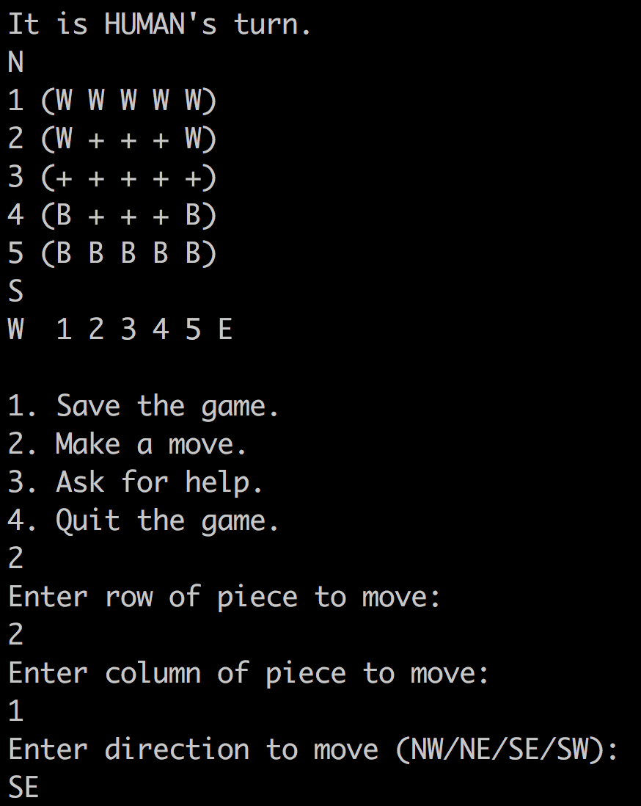

## Computer Making Move.

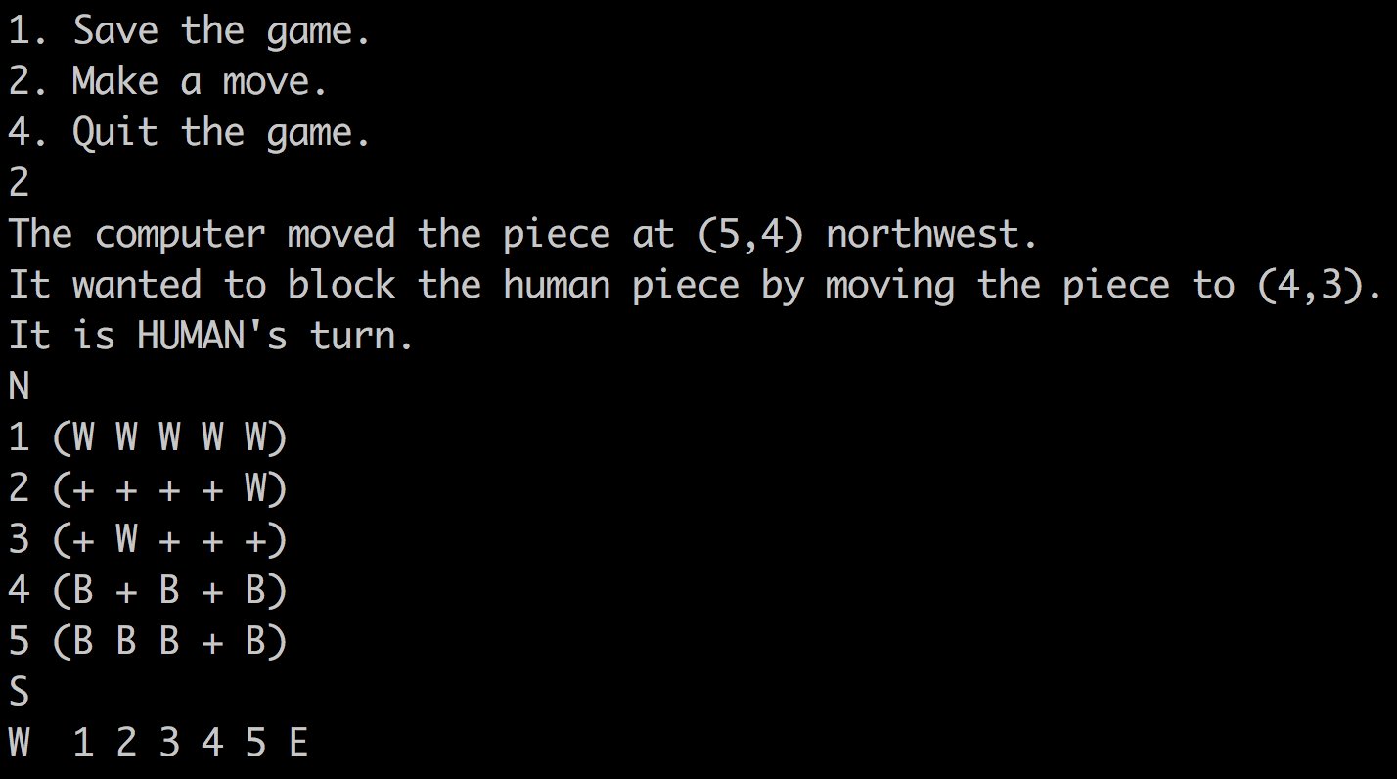

## Asking for Help.

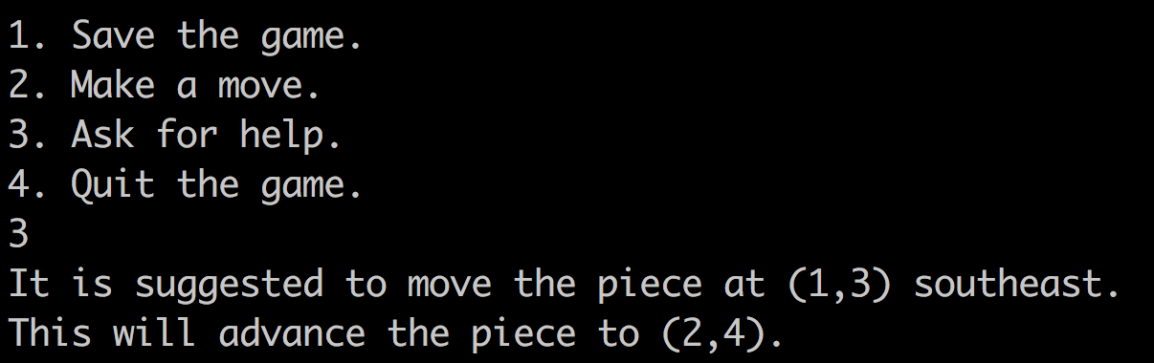

## Quiting Game.

