PROD/DR MCP Pipeline
Driving the failover drill by hand, one command at a time
Repository github.com/MangoTim/pipeline-dr · sites 192.168.147.105 (PROD) and 192.168.147.104 (DR) · artifact Red Hat linux-mcp-server, unmodified
1. What this guide is
One pipeline builds and scans one image, Ansible deploys that exact artifact to a PROD site and a DR site, and the MCP answers from whichever site is live. This guide walks through the manual version of that pipeline: the same stages as the Jenkins job, unbundled into one script per stage so you can stop between any two of them and explain what just happened.
It also answers a question the pipeline itself cannot answer: what are the MCP's tools actually for? Only some of them carry weight here, and this guide is explicit about which ones and why. The short answer is in section 6 — the MCP is not decoration in the middle of the pipeline. It is the component that decides whether the failover is allowed to happen.
THE PUNCHLINE the SAME artifact, deployed to two different machines, gives a different answer depending on which one is live — because the MCP inspects the host it is deployed on, over SSH.
2. The two sites
 | PROD | DR
Host | 192.168.147.105 | 192.168.147.104
Role | production + the control plane  (Jenkins, the scanners, the manual steps) | the standby
Deploy user | rhai (uid 1001) | dr (uid 1001)
MCP endpoint | http://192.168.147.105:8095/mcp | http://192.168.147.104:8095/mcp
Hostname the MCP reports | server-gateway.example.com | localhost.localdomain
Privilege model | rootless podman, no sudo, no become | rootless podman, no sudo, no become

Neither user is in the wheel group and no sudo password is used anywhere. Ansible drives each site as its own non-root account, and the MCP container runs as the matching uid so that it can read the mounted SSH key (mode 0600).
3. Before you start
The Aqua credential — the one thing you must set up
Step 04 is a hard gate on the Aqua console's verdict, and the console's password is deliberately not in the repository. Put it in the deploy user's home directory, on the host, once:
ssh rhai@192.168.147.105
mkdir -p ~/.mcp-demo && umask 077
cat > ~/.mcp-demo/aqua.env <<'EOF'
AQUA_USER=administrator
AQUA_PASSWORD=<the aqua console password>
EOF
Everything else is already in place
The one-time host setup — port 8095 open on both sites, python3.9 installed, linger enabled for both users, the pipeline SSH key authorised on the DR site — is documented in RUNBOOK.md. It is the same setup for the Jenkins run and for the manual run; the manual path simply does not need the Jenkins container.
4. Driving it
From the laptop, in the repository:
cd products/mcp-dr-pipeline
./manual/remote-run.sh list # what the steps are
./manual/remote-run.sh 00 # preflight — checks, changes nothing
./manual/remote-run.sh 03 # copies the repo to .105 and builds
./manual/remote-run.sh 03 --no-sync # re-run without copying
./manual/remote-run.sh all # every step, in order
The number is the NN in step-NN-*.sh. Each command copies the repository to the control plane and runs that ONE step there, as the rhai user, with rootless podman. If you prefer to work directly on the host:
ssh rhai@192.168.147.105
cd ~/mcp-dr-pipeline
./manual/step-03-build-image.sh
NOTE the steps run on the PROD host, NOT inside the Jenkins container. That is deliberate: the manual path is the pipeline unbundled, running on the machine it deploys to, so you can see every command as it executes.
5. The steps at a glance
Step | Script | What it does | Gate
00 | step-00-preflight.sh | check the tools, both sites, the key, the port, the credential | — (reports only)
01 | step-01-fetch-source.sh | download the upstream MCP source at the pinned commit | —
02 | step-02-resolve-version.sh | build the image tag for this run | —
03 | step-03-build-image.sh | build the upstream Containerfile, unmodified | —
04 | step-04-scan-aqua.sh | scan with the Aqua console | Image Is Compliant
05 | step-05-scan-trivy.sh | baseline Trivy scan: libraries (JSON) + OS packages | no CRITICAL OS CVE
06 | step-06-remediate.sh | upgrade the vulnerable Python packages, drop pip from the venv | fails if a CVE has no fix
07 | step-07-scan-trivy-final.sh | re-scan the image that will actually ship | no HIGH/CRITICAL library CVE
08 | step-08-export-artifact.sh | podman save | gzip, plus the sha256 | —
09 | step-09-deploy.sh | Ansible: copy the one tarball to both sites, start both | both units active
10 | step-10-verify-prod.sh | the MCP answers as PROD, and 8095 is held by the MCP process | hostname + listening port
11 | step-11-failover.sh | warm the standby, PROVE it can take the load, then cut over | the readiness probe
12 | step-12-failback.sh | stand DR down, bring PROD back | PROD answers again
13 | step-13-show-same-artifact.sh | prove both sites run the same bytes | image ID + layers

Steps 00 to 13 map one-to-one onto the Jenkins stages. The manual path adds the same gates in the same order — the only difference is that you can see each one run.
6. Every step, in detail
How the drill works, end to end
Four views of the same run. The activity diagram is the whole workflow as a flow: build and scan once, fork to the two sites, then the drill with its two gates. The pipeline picture carries the command behind every stage. The drill picture and the sequence diagram carry the drill itself — five moves, and production is never at risk until move four.
the workflow as an activity diagram — the two gates are the diamonds
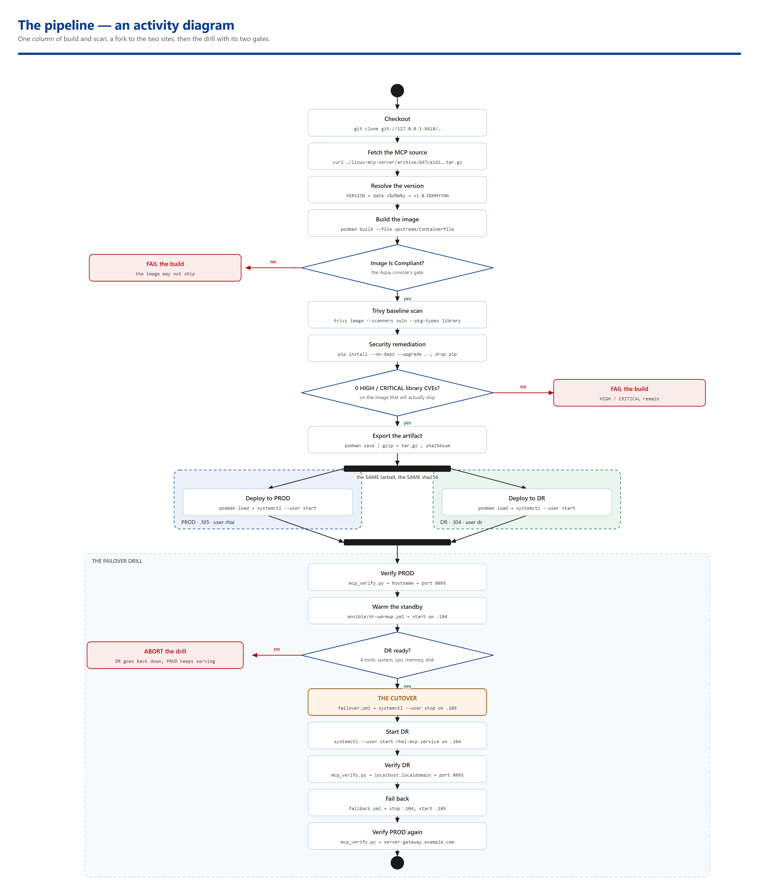
the pipeline, with the command behind every stage
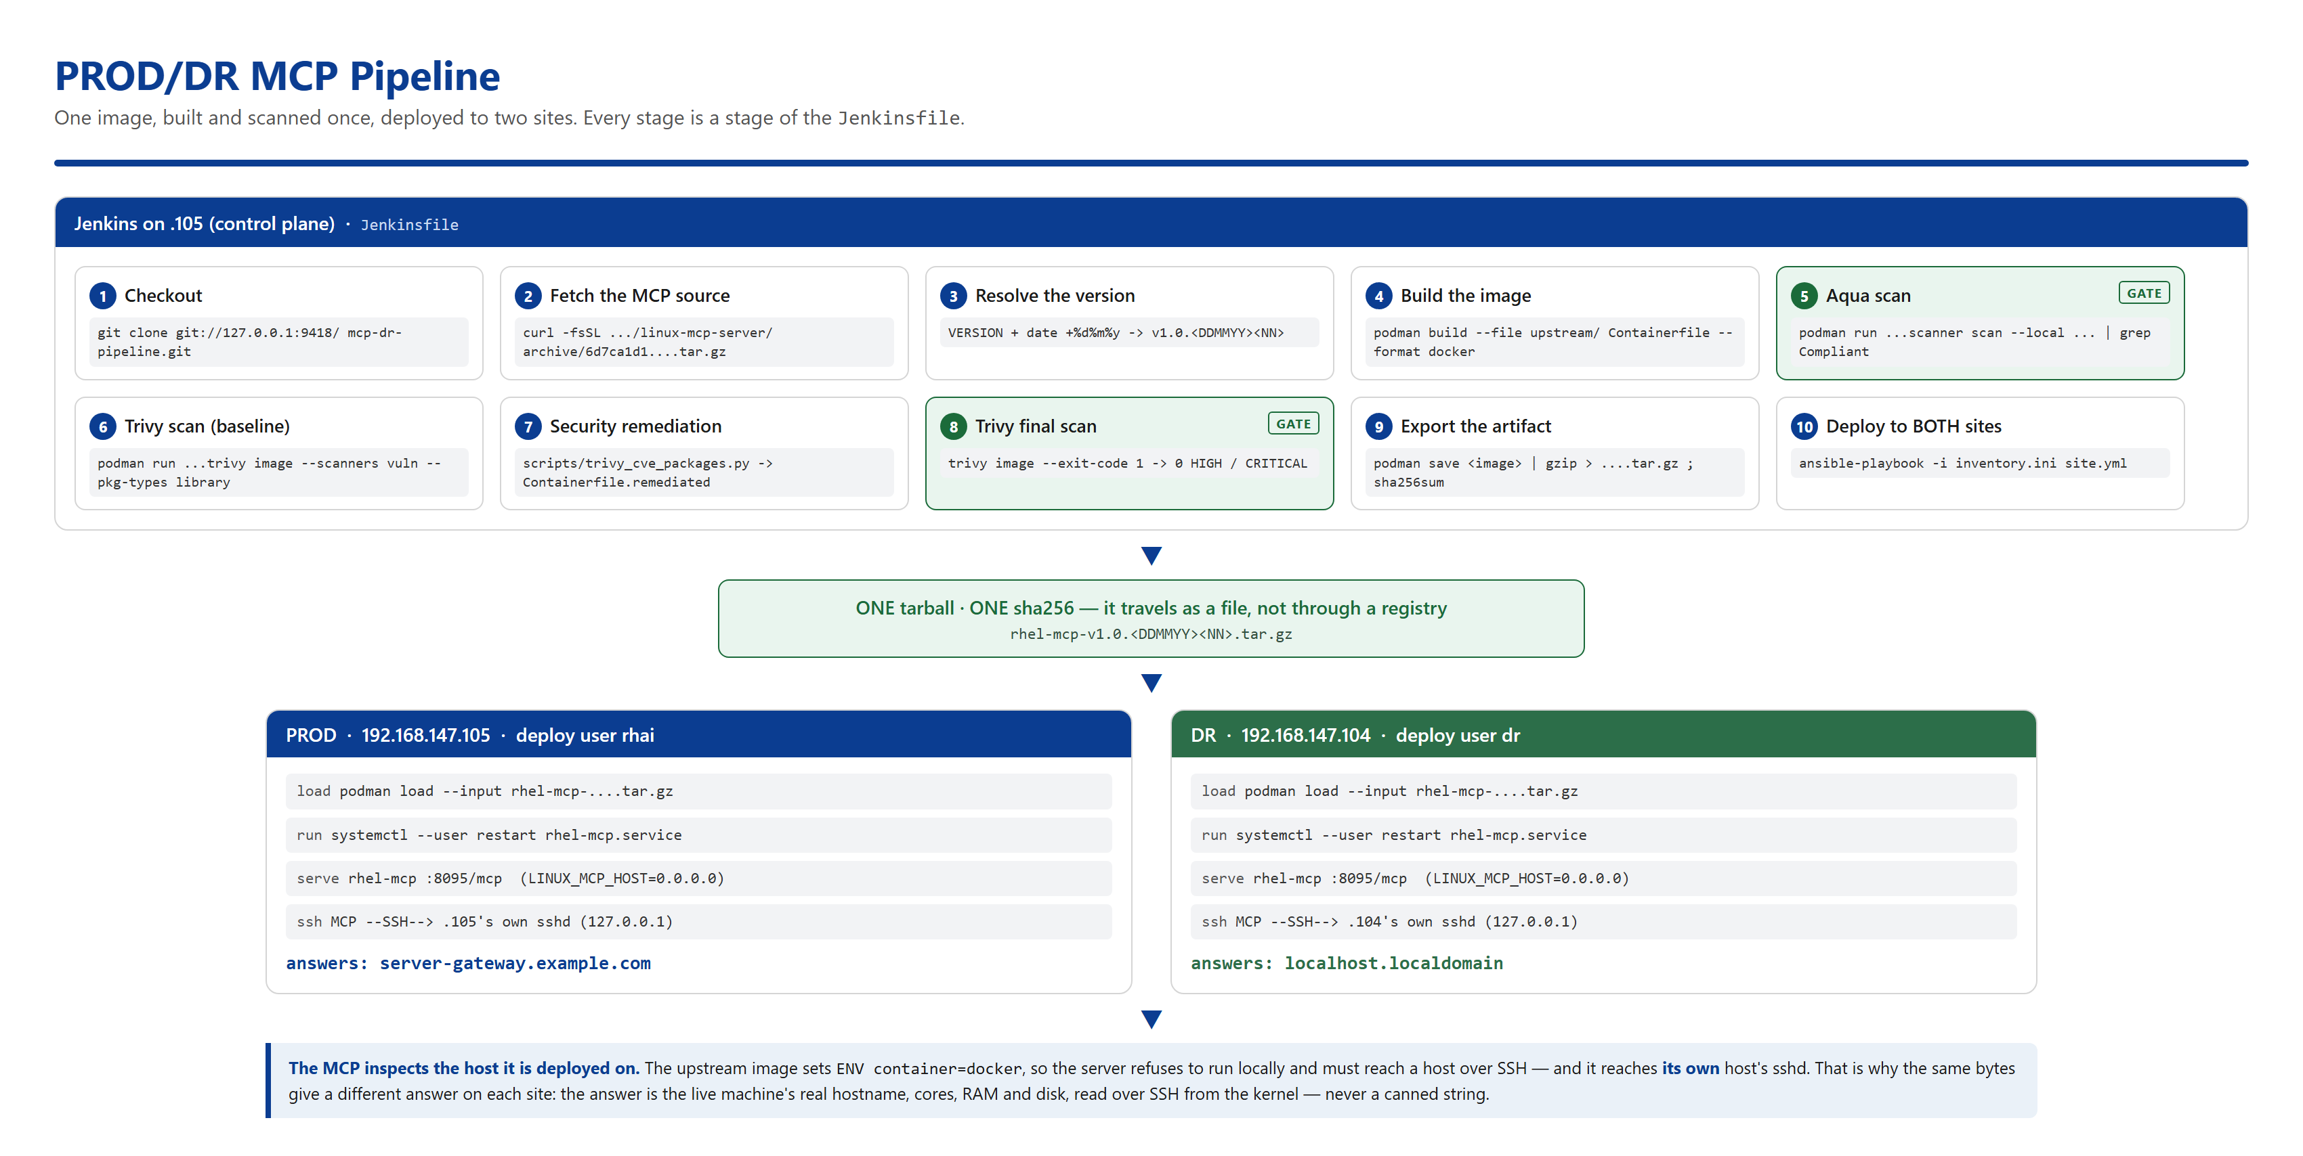
the pipeline, and where the two sites come from
BUILD ONCE, DEPLOY THE SAME BYTES TO BOTH SITES
.105 PROD (control plane) .104 DR
----------------------------------- -----------------------------------
Jenkins :8081
1 Checkout -> 2 Fetch MCP source -> 3 Version
|
v
4 podman build Red Hat's own Containerfile, unmodified
|
v
5 Aqua scan ---GATE---> 6 Trivy (baseline: what to fix)
|
v
7 Remediate upgrade the packages,
drop pip -> a DERIVED image
|
v
8 Trivy final ---GATE---> 9 Export
0 HIGH/CRITICAL rhel-mcp-...tar.gz
|
ONE tarball, ONE sha256 |
+------------------------------------------+
v
.105 PROD (rhai) .104 DR (dr)
+--------------------------+ +--------------------------+
| podman load | | podman load |
| systemd --user unit | | systemd --user unit |
| rhel-mcp :8095/mcp | | rhel-mcp :8095/mcp |
| | | | | |
| +-- SSH --> .105 | | +-- SSH --> .104 |
| sshd | | sshd |
+--------------------------+ +--------------------------+
same image, same bytes same image, same bytes
answers answers
server-gateway.example.com localhost.localdomain
The container talks to ITS OWN host's sshd. That is what makes the answer identify the site: the MCP inspects the machine it is deployed on, so the same image gives a different answer on each box.
The pipeline, with the command behind every step
# | What happens | The command / file that does it
1 | Checkout | git clone git://127.0.0.1:9418/mcp-dr-pipeline.git  (the bare origin inside the Jenkins container)
2 | Fetch the MCP source | curl -fsSL .../rhel-lightspeed/linux-mcp-server/archive/  6d7ca1d1....tar.gz -> upstream/
3 | Resolve the version | the VERSION file + TZ=Asia/Hong_Kong date +%d%m%y  -> v1.0.<DDMMYY><NN>
4 | Build the image | podman build --file upstream/Containerfile  --format docker --network host
5 | Aqua scan [GATE] | podman run ... registry.aquasec.com/scanner:2022.4.868  scan --local ...  then: grep "Image Is Compliant"
6 | Trivy baseline | podman run ... trivy image --scanners vuln  --pkg-types library --severity HIGH,CRITICAL  a work list, not a verdict
7 | Remediate | scripts/trivy_cve_packages.py -> cve-fixes.txt  -> writes Containerfile.remediated  -> podman build --file Containerfile.remediated
8 | Trivy final [GATE] | the same Trivy command with --exit-code 1,  against the image that will actually ship
9 | Export the artifact | podman save <image> | gzip > rhel-mcp-....tar.gz  sha256sum rhel-mcp-....tar.gz
10 | Deploy to BOTH sites | ansible-playbook -i inventory.ini site.yml  -> ansible/roles/mcp/tasks/main.yml  podman load + systemctl --user restart

Every one of those is a stage in the Jenkinsfile, and every one of them has a script of its own in manual/ (step-00 ... step-13) for the by-hand run.
the drill, move by move
THE FAILOVER DRILL (step 11 / the "Failover Drill" stage)
move PROD .105 DR .104
---- -------------------------------- -----------------------------------
1 * live, :8095 answering o stopped
2 * still serving -- warm it up --> start the unit
(production untouched) wait for :8095 to accept
3 * still serving -- readiness ---> get_system_information
the gate runs WHILE get_cpu_information
PROD is serving get_memory_information
get_disk_usage
-> 4 cores, 72% RAM free, 77% disk free
OK READY -> carry on
XX NOT READY -> abort: DR goes back
down, PROD keeps serving, the
step FAILS. The standby is never
promoted.
4 * still serving -- THE CUTOVER -> start the unit
stop the PROD unit :8095 now answers on .104
5 o stopped -- VERIFY ------> get_system_information
:8095 refused -> localhost.localdomain
get_listening_ports
-> 8095 held by linux-mcp-server
Move 5 is the proof, and it is two facts in one session: the hostname says WHICH site is live, and the socket table says the answer is real — the linux-mcp-server process really holds port 8095 on that host, so the hostname cannot have been a canned string.
THE FAILBACK IS THE MIRROR step 12 stops DR, starts PROD and verifies that .105 answers server-gateway.example.com again. The pipeline deliberately ENDS in that posture — PROD live, DR stopped — so the demo always starts from a known state.
The drill, with the command behind every move
Move | What happens | The command / file that does it
1 | Warm the standby | ansible-playbook -i inventory.ini dr-warmup.yml  -> ansible/dr-warmup.yml  -> systemctl --user start rhel-mcp.service on .104
2 | The readiness gate | podman run -i --rm --network host <image> - \  --url http://192.168.147.104:8095/mcp \  --target 192.168.147.104 \  --expect localhost.localdomain ...  with scripts/mcp_dr_probe.py on STDIN
3 | The cutover | ansible-playbook -i inventory.ini failover.yml  -> ansible/failover.yml  -> systemctl --user stop rhel-mcp.service on .105  -> systemctl --user start rhel-mcp.service on .104
4 | Verify | podman run -i --rm --network host <image> - \  --url http://192.168.147.104:8095/mcp \  --expect localhost.localdomain \  --call get_listening_ports \  --assert get_listening_ports=8095  with scripts/mcp_verify.py on STDIN
5 | Fail back | ansible-playbook -i inventory.ini failback.yml  -> ansible/failback.yml (the exact mirror)

the drill, with the command behind every move
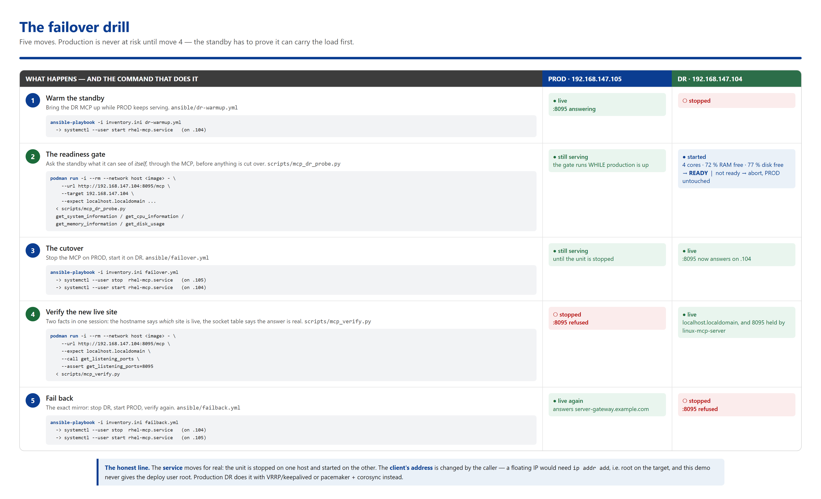
the same drill as a sequence diagram — who talks to whom
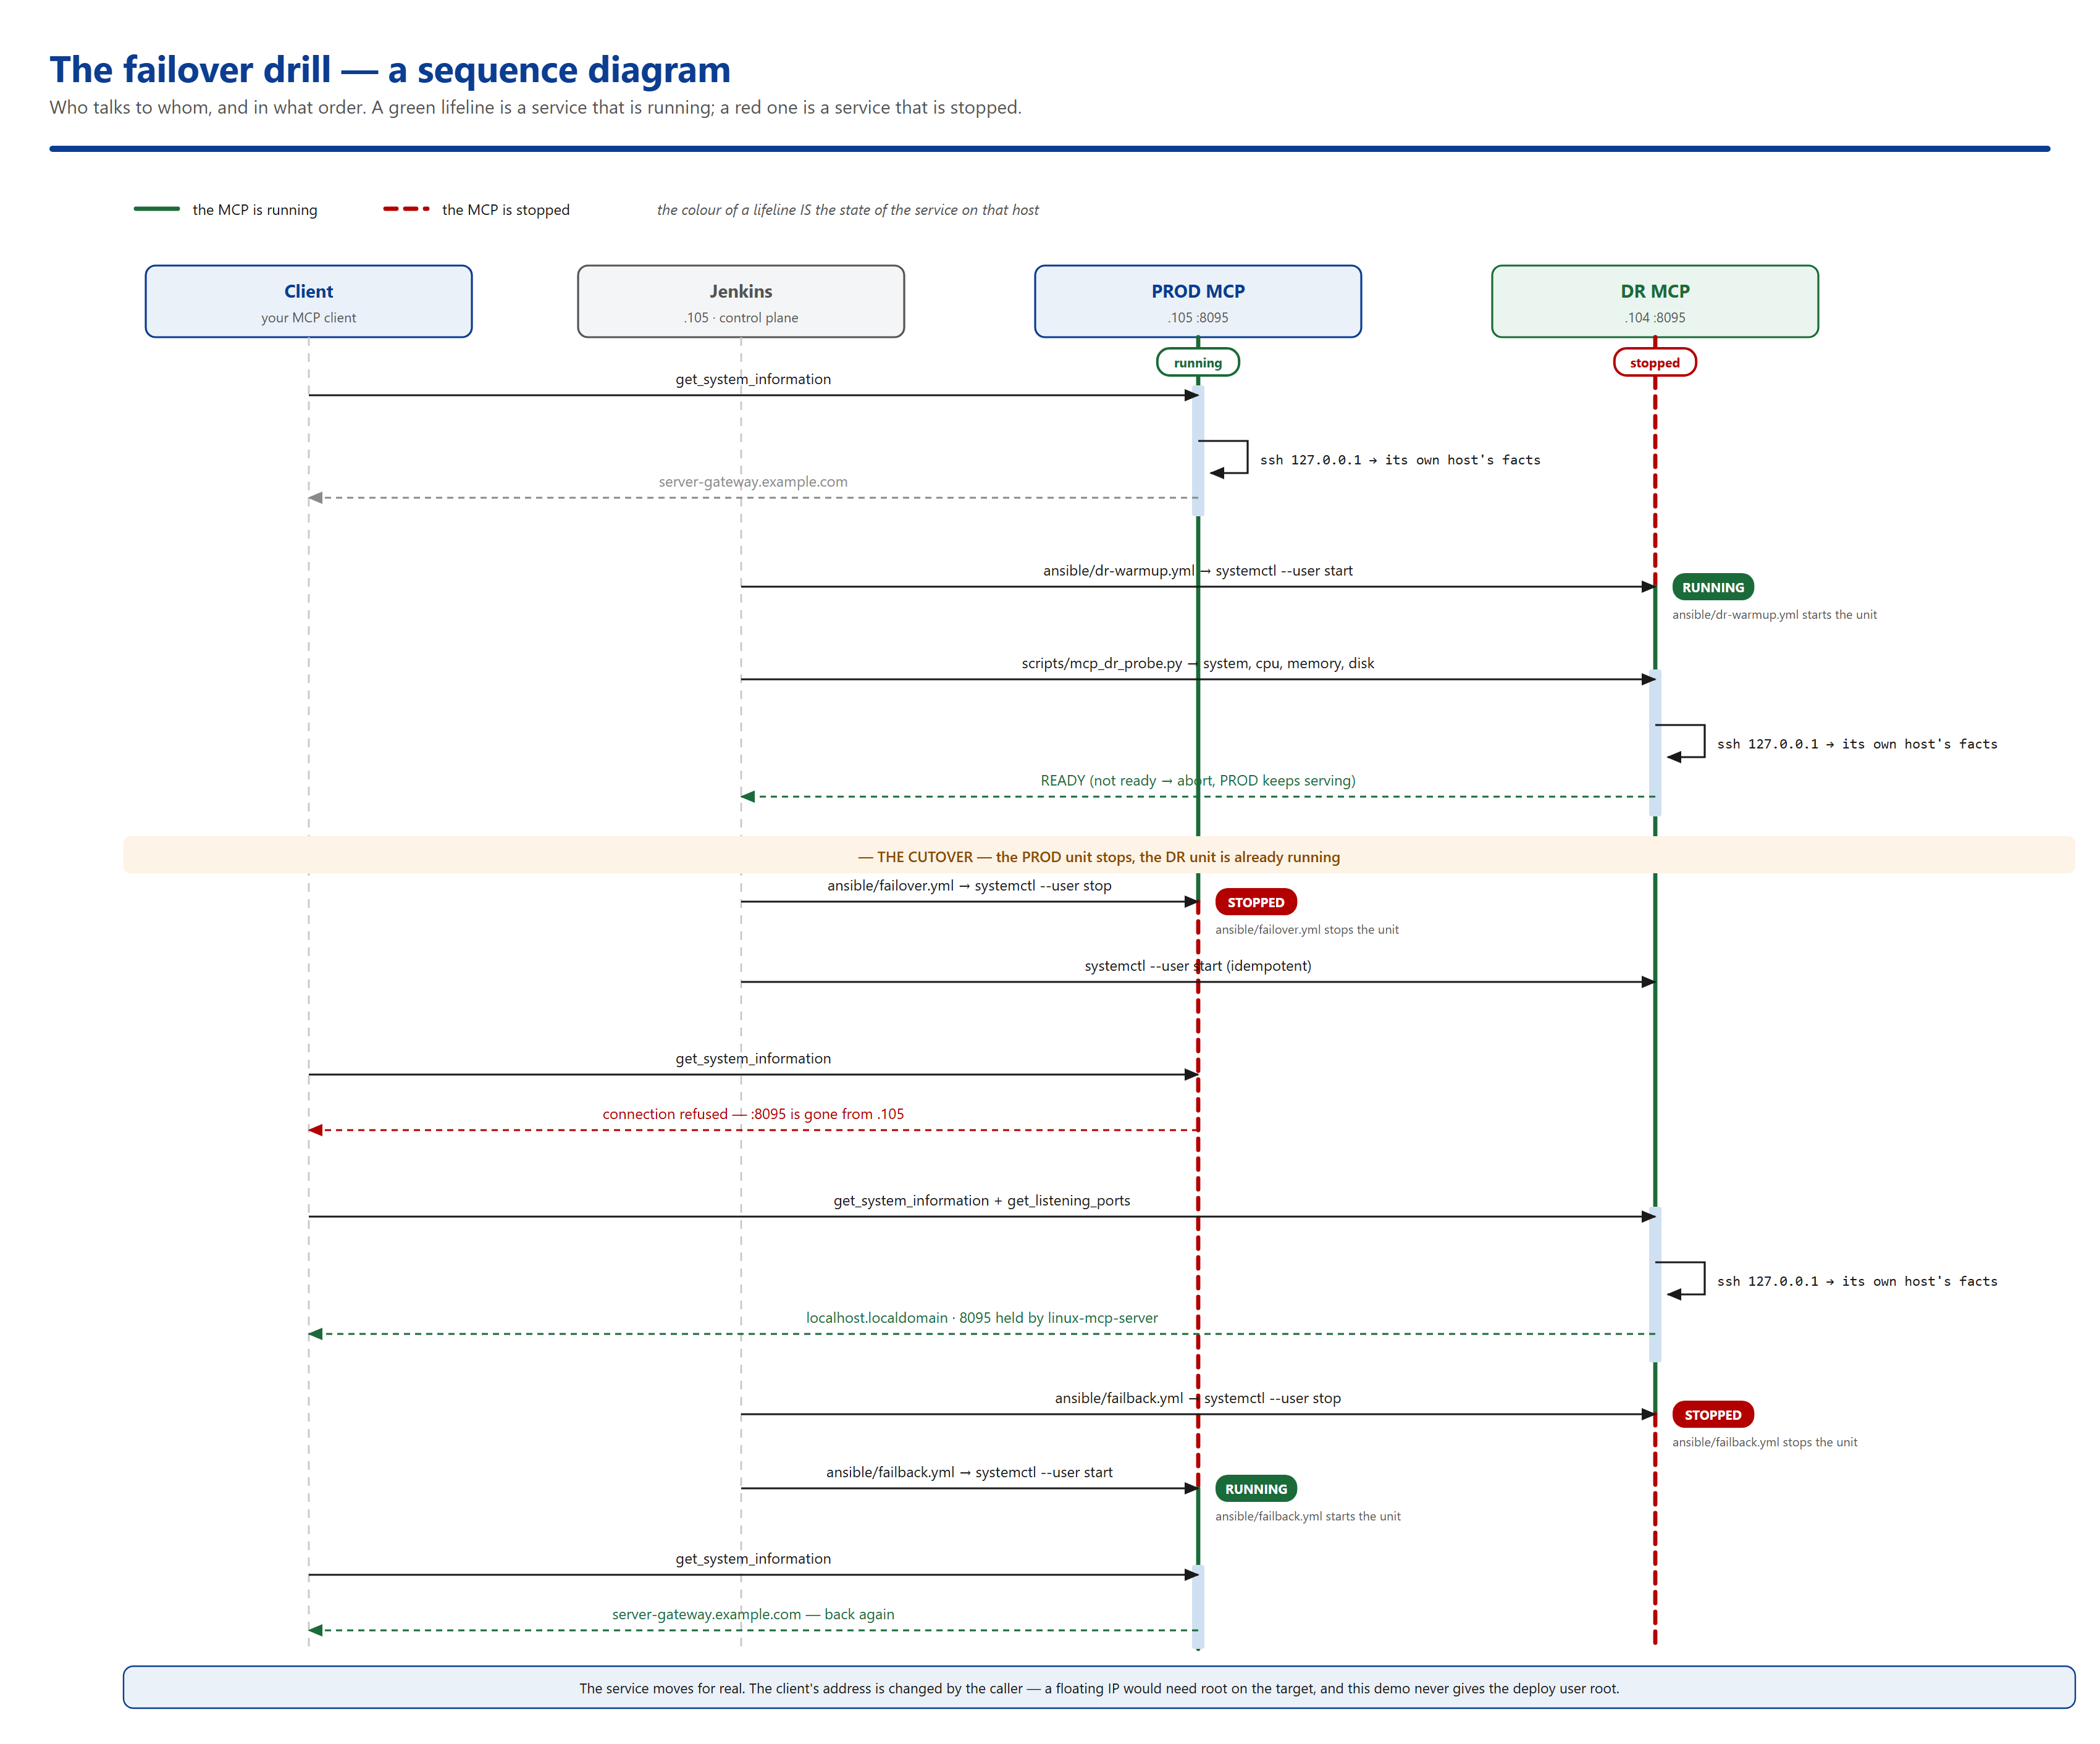
Two details worth noticing. First, the verify and probe clients run INSIDE the container: the script is piped in on STDIN rather than bind-mounted, because podman runs on the host and cannot see a path inside a container — so the client tests the exact image that was deployed, and needs no extra dependency on the controller, because the image already ships fastmcp. Second, the playbook is a thin wrapper: the real work is one systemd command on each side, and that is why the drill needs no root on either site.
Step 00 — preflight
script manual/step-00-preflight.sh
gate —
What it does
Checks everything the later steps depend on, before anything is built. It changes nothing.
- the tools: podman, curl, python3, gzip, sha256sum, tar, ssh, ansible-playbook
- the checkout is complete (Jenkinsfile, the scripts, the inventory)
- the pipeline SSH key is readable
- both sites answer over the pipeline key (ansible -m ping)
- port 8095 on both sites
- the Aqua credential file exists (it is never printed)
- the podman API socket the scanners need
Expected output
OK podman -> /usr/bin/podman
OK ansible-playbook -> /home/rhai/.local/bin/ansible-playbook
OK the checkout looks complete
OK /home/rhai/.ssh/id_rhai108_rsa
192.168.147.105 | SUCCESS => {"changed": false, "ping": "pong"}
192.168.147.104 | SUCCESS => {"changed": false, "ping": "pong"}
OK 192.168.147.105:8095 answers
OK /home/rhai/.mcp-demo/aqua.env (not printed)
OK /run/user/1001/podman/podman.sock
<<< [step 00] OK
GOTCHA rootless podman does not expose an engine socket by default, and the Aqua and Trivy scanners need one to reach the local image. Step 00 starts it on demand: podman system service --time=0 unix:///run/user/$(id -u)/podman/podman.sock — the unix:// prefix is required, and the directory has to exist first.
Step 01 — fetch the upstream source
script manual/step-01-fetch-source.sh
gate —
What it does
Downloads Red Hat's linux-mcp-server from GitHub and unpacks it into upstream/. The commit is pinned, so the build is reproducible. Nothing is vendored in this repository — there is no second copy of Red Hat's code to keep in sync, and the upstream source is never modified.
url : https://github.com/rhel-lightspeed/linux-mcp-server/archive/6d7ca1d1da8598c2e816fd69e98b8f7cf97da0d1.tar.gz
OK the upstream source is ready:
AGENTS.md Containerfile docs licenses pyproject.toml src tests
<<< [step 01] OK
Step 02 — resolve the version
script manual/step-02-resolve-version.sh
gate —
What it does
Builds the image tag from the VERSION file, the Hong Kong date and a run counter. In Jenkins the counter is BUILD_NUMBER; here it lives in the state file, so a manual run produces the same SHAPE of tag. The values are written to .manual-state.env, which every later step reads.
VERSION file : 1.0
Hong Kong date : 041126
run number : 01
image version : v1.0.04112612
pre-remediation : rhel-mcp:v1.0.04112612
post-remediation : rhel-mcp-remediated:v1.0.04112612
artifact : rhel-mcp-v1.0.04112612.tar.gz
<<< [step 02] OK
NOTE re-running step 02 gives a NEW tag (the counter increments) instead of overwriting the old one. Delete .manual-state.env to start from scratch.
Step 03 — build the image
script manual/step-03-build-image.sh
gate —
What it does
Builds the upstream Containerfile exactly as Red Hat shipped it. Two flags matter and both are load-bearing:
- --network host — this host's container egress is dropped in the firewalld FORWARD chain, so a bridged build hangs on the pip install. Host networking routes it through OUTPUT.
- --format docker — podman's default OCI format silently drops the HEALTHCHECK instruction; the docker format keeps it and is what the scanners expect.
Expected output
id=ec616084ab360b11f21b9d90a4ed825cd39d795770c43e67eceebf7253a946aa size=325000000 created=...
<<< [step 03] OK
TAKES A WHILE the upstream image installs a Python virtualenv from PyPI. Expect a few minutes. The two scanners take about a minute each, so the whole manual run is roughly 15 minutes.
Step 04 — the Aqua gate
script manual/step-04-scan-aqua.sh
gate Image Is Compliant
What it does
The Aqua console on this host decides whether the image may ship. The step continues only if the report says so.
--- Aqua scan summary ---
Image Is Compliant
<<< [step 04] OK
How the scanner is invoked
podman run --rm --network host \
-v /run/user/1001/podman/podman.sock:/var/run/docker.sock \
registry.aquasec.com/scanner:2022.4.868 \
scan --host https://192.168.147.105 --local localhost/rhel-mcp:v1.0.04112612 \
--no-verify --user "$AQUA_USER" --password "$AQUA_PASSWORD" --html
- --local <image> is the syntax this scanner version accepts; the plugin generates a form it rejects.
- --html sends the report to STDOUT, which is redirected to a file. Do NOT use --htmlfile <path> — that writes inside the scanner container and is lost when --rm deletes it.
- --no-verify is there because the console certificate is self-signed.
IF IT TIMES OUT 'TLS handshake timeout' means the aqua-web console container on the host has lost its outbound path. Fix it with: podman network reload
Step 05 — the baseline Trivy scan
script manual/step-05-scan-trivy.sh
gate no CRITICAL OS CVE
What it does
Two scans. The library scan runs as JSON, because step 06 parses it — it is the INPUT to the remediation, not a gate. The OS scan gates CRITICAL right here.
Expected output
Target: usr/local/lib/python3.11/site-packages/fastmcp (lang-pkgs)
authlib 1.7.2 HIGH -> 1.9.1
pyjwt 2.13.0 HIGH -> 2.14.0
certifi 2026.7.22 HIGH -> 2026.10.18
dnspython 2.8.0 HIGH -> 2.9.0
joserfc 1.7.4 HIGH -> 1.7.5
msgpack 1.1.1 CRITICAL NO FIX PUBLISHED
setuptools 65.5.0 HIGH NO FIX PUBLISHED
urllib3 2.2.2 HIGH NO FIX PUBLISHED
trivy (library) exit code: 1
...
trivy (OS packages) exit code: 0
<<< [step 05] OK
WHY THE LIBRARY SCAN IS NOT A GATE HERE because these findings are not a verdict, they are a work list. Step 06 fixes them and step 07 re-scans the image that actually ships. Gating twice would fail the run for no reason.
Step 06 — security remediation
script manual/step-06-remediate.sh
gate fails if a CVE has no fix
What it does
Turns the Trivy JSON into a concrete upgrade list and fixes the image. Two kinds of finding are handled differently:
- the MCP's OWN dependencies — authlib, pyjwt, certifi, dnspython, joserfc. Upgraded in place to the version Trivy names as the fix.
- the copies pip bundles in its own _vendor directory — urllib3, msgpack, setuptools. They are real files in the image, but the MCP never imports them and there is no upstream fix to install. pip has no business in a runtime virtualenv, so it is removed and the vendored copies go with it.
The result is a DERIVED image — FROM the upstream one — so every upstream layer, label, environment variable, user and entrypoint is preserved exactly. (podman commit would clobber the entrypoint.)
Expected output
--- packages to upgrade ---
authlib==1.9.1
certifi==2026.10.18
dnspython==2.9.0
joserfc==1.7.5
pyjwt==2.14.0
<<< [step 06] OK
GOTCHA upgrade with --no-deps. Without it pip reshuffles the tree, downgrades jaraco.context and wheel, and ADDS findings rather than removing them.
Step 07 — the final Trivy gate
script manual/step-07-scan-trivy-final.sh
gate no HIGH/CRITICAL library CVE
What it does
The hard gate, run against the remediated image — the one that will actually ship.
- no HIGH or CRITICAL library CVEs
- no CRITICAL OS CVEs
trivy (library) exit code: 0
trivy (OS packages) exit code: 0
<<< [step 07] OK
THE RESULT 19 HIGH/CRITICAL library findings down to 0, with the OS gate unchanged. The pipeline refuses to ship a known-vulnerable image, and if Trivy ever finds a HIGH/CRITICAL library CVE with no published fix, step 06 exits 3 and the run stops.
Step 08 — export the artifact
script manual/step-08-export-artifact.sh
gate —
What it does
podman save | gzip, plus the sha256. The artifact travels as a FILE, not through a registry — the DR site has to be able to receive a promoted image even when the PROD registry is down. That is the whole point of a DR site.
artifact : rhel-mcp-v1.0.04112612.tar.gz
size : 118.4M
sha256 : 9c1f... (also written to rhel-mcp-v1.0.04112612.tar.gz.sha256)
<<< [step 08] OK
Step 09 — deploy to both sites
script manual/step-09-deploy.sh
gate both units active
What it does
ansible-playbook site.yml copies that ONE tarball to .105 and .104. Each site loads it into its own rootless podman store and runs it as a systemd USER unit. No root, no sudo password, no shared filesystem.
Expected output
TASK [Load the artifact into the site's own podman store] ****
TASK [Install the MCP policy file] ****
TASK [Install the systemd user unit] ****
TASK [Start the MCP server] ****
TASK [Wait for the MCP endpoint] ****
192.168.147.105 : ok=8 changed=6 failed=0
192.168.147.104 : ok=8 changed=6 failed=0
<<< [step 09] OK
GOTCHA systemctl --user enable --now is a NO-OP on an already-active unit, so a redeploy would load the new image into the store and leave the container running the OLD one. The role therefore uses systemctl --user restart, and then removes the superseded images so each build does not leave 325 MB behind.
Step 10 — verify PROD
script manual/step-10-verify-prod.sh
gate hostname + listening port
What it does
Asks the PROD endpoint who it is — and proves the answer is real. Two MCP tools are called in ONE session:
get_system_information says which site is answering. get_listening_ports says port 8095 on that host is held by the linux-mcp-server process. Together they mean the hostname cannot have come from a canned string — the MCP really reached the host's kernel over SSH and read its socket table.
Expected output
[verify] tools exposed (19): get_cpu_information, get_disk_usage, ...
[verify] get_system_information(host=192.168.147.105) returned:
{"hostname":"server-gateway.example.com","os_name":"Red Hat Enterprise Linux 8.10 (Ootpa)", ...}
[verify] get_listening_ports(host=192.168.147.105) returned:
=== Listening Ports ===
Proto Local Address Status PID/Program
--------------------------------------------------------------------------------
TCP 0.0.0.0:8095 LISTEN users:(("linux-mcp-serve",pid=2150982,fd=8))
...
[verify] PASS: get_listening_ports reports '8095'
[verify] PASS: http://192.168.147.105:8095/mcp is serving server-gateway.example.com
<<< [step 10] OK
Step 11 — the failover drill
script manual/step-11-failover.sh
gate the readiness probe
What it does — three things, in this order
1. Warm the standby.
dr-warmup.yml starts the DR MCP and waits for the port. PRODUCTION KEEPS SERVING THROUGHOUT — the standby is checked before anything is taken away.
2. The readiness gate.
The MCP asks the DR site what it can see of ITSELF, and the answer is compared against the minimums in manual/env.sh (2 cores, 10 % memory free, 10 % disk free on the tightest real filesystem).
[probe] hostname : localhost.localdomain
[probe] CPU
[probe] logical cores : 4
[probe] memory
[probe] RAM total : 7.5 GiB
[probe] RAM available : 5.4 GiB (72.2 % free)
[probe] disk
[probe] / xfs 25.4 GiB total 5.9 GiB used 19.5 GiB free ( 76.8 % free)
[probe] (14 pseudo filesystems skipped — tmpfs, overlay, ... — only real ones are gated)
[probe] READY: localhost.localdomain has 4 cores, 72.2 % memory free, 76.8 % disk free (tightest: / (xfs))
IF THE GATE FAILS the drill is ABORTED. The standby goes back down, PROD keeps serving, and the step exits 1:
[probe] NOT READY for failover:
[probe] - only 4 logical cores, need at least 64
BLOCKED: the DR site is not fit to take over. Rolling back.
...
PROD is still serving — production was never at risk.
3. The cutover.
failover.yml stops the PROD MCP and promotes DR, then the endpoint is asked again.
[verify] PASS: get_listening_ports reports '8095'
[verify] PASS: http://192.168.147.104:8095/mcp is serving localhost.localdomain
the PROD endpoint is now down. Ask it anything — it will not answer:
http://192.168.147.105:8095/mcp -> HTTP 000
connection refused (expected)
<<< [step 11] OK
Step 12 — failback
script manual/step-12-failback.sh
gate PROD answers again
What it does
The exact inverse. failback.yml stops the DR MCP and starts PROD again, then the endpoint is asked again — and the listening-ports proof shows the MCP process is back on 8095 on the PROD host. The same artifact, the same socket, the original site.
[verify] PASS: get_listening_ports reports '8095'
[verify] PASS: http://192.168.147.105:8095/mcp is serving server-gateway.example.com
<<< [step 12] OK
Step 13 — the evidence
script manual/step-13-show-same-artifact.sh
gate image ID + layers
What it does
This is not a Jenkins stage — it is the proof that ties the demo together. Two different machines loaded the same tarball, so the image they run MUST be identical. It compares the image ID (the authoritative identity) and every layer digest (the content itself).
192.168.147.105 image id ec616084ab360b11f21b9d90a4ed825cd39d795770c43e67eceebf7253a946aa
192.168.147.104 image id ec616084ab360b11f21b9d90a4ed825cd39d795770c43e67eceebf7253a946aa
layers (identical content, in order):
1 sha256:50830ca4b47aab8a2525635f36c715ec73d0f48c37549bdcdd6a5fb0cf4c354a
2 sha256:5f70bf18a086007016e948b04aed3b82103a36bea41755b6cddfaf10ace3c6ef
...
manifest digest PROD sha256:3974f7bd233198a2760f4951d3fee133bbeeb5cf8cc7aa92565126c80fff196c
manifest digest DR sha256:bc8db3c2b1660dc11bfe0ea4624d8bdd2e61551334e322d25101655bb05c7bab
PASS: both sites run the SAME image (ec616084ab36)
and every one of its layers is byte-identical
WHY THE MANIFEST DIGESTS DIFFER and why that is fine. Each site's podman rebuilds the manifest when it loads the tarball, and the two hosts do not run the same podman build (.105 has 4.9.4-rhel, .104 has 4.9.4-dev). The manifest bytes — and therefore their hash — differ even though every layer is identical. The image ID and the layer hashes are the content identity, and those match.
7. The MCP: what each tool is for
The MCP is Red Hat's own linux-mcp-server, deployed unmodified at commit 6d7ca1d1. Two things about it matter here:
- its upstream Containerfile sets ENV container=docker, which makes the server REFUSE to execute locally and require a remote host over SSH. That is exactly what this demo needs: the container inspects its own host's sshd, so the answer identifies the site that is actually serving.
- over an HTTP transport the server evaluates EVERY tool call against an authorization policy, and a call that matches no rule is denied. There is no implicit 'allow' over HTTP — that behaviour only exists on the stdio transport. The role therefore installs a policy file with a single wildcard rule (action: ssh_default, all_users: true).
The five tools that carry weight
These are the tools the pipeline actually calls. Each one proves something the others cannot.
Tool | Used in | What it proves that nothing else could
get_system_information | steps 10, 11, 12 | WHICH SITE IS LIVE. Same image, different hostname — the MCP answers from whichever host it is deployed on. This is the demo's punchline.
get_listening_ports | steps 10, 11, 12 | THAT THE ANSWER IS REAL. Port 8095 on that host is held by the linux-mcp-server process, so the hostname cannot have come from a canned string.
get_cpu_information | step 11 (readiness) | IS THE STANDBY BIG ENOUGH? The core count of the DR box, measured by the same tool that will later report on it in production.
get_memory_information | step 11 (readiness) | IS THERE ROOM TO RUN? How much of the DR box's RAM is actually available, not what the spec sheet says.
get_disk_usage | step 11 (readiness) | IS THERE ROOM TO WRITE? Free space on the tightest real filesystem on the DR box.

The readiness gate in detail
This is the difference between a failover DEMONSTRATION and a failover GATE. A demonstration proves the switch happened. A gate proves the switch was safe.
The probe runs before any cutover, against the standby's own MCP, while production is still serving. It calls four tools in one session and checks the numbers:
Check | Minimum | Why
logical cores | 2 | the workload has to fit on the box you are failing over to
RAM available | 10 % free | a standby that is already swapping will not survive the load
tightest real filesystem | 10 % free | a full disk on the standby is an outage waiting to happen

Only real filesystems are gated. tmpfs, overlay and the other pseudo mounts are skipped, because a 3-byte devtmpfs would otherwise dominate the calculation. The tightest one wins — capacity is only as good as the worst filesystem.
The other fourteen tools
All nineteen tools are exposed and all nineteen work over the same SSH transport. The remaining fourteen are simply not needed to prove a failover, and using them for their own sake would make the pipeline longer without making it stronger:
Tool | What it would be for here
get_service_status | asserting that sshd is healthy on the site being promoted — the natural next gate if the drill ever needs to prove the transport itself, not just the destination
list_services | showing what else is running on the standby, and therefore what else a cutover would disturb
get_journal_logs / read_log_file / get_service_logs | the 'why was the standby not ready' investigation — the first thing you reach for after a readiness gate fails
get_network_interfaces / get_network_connections | confirming the standby is reachable on the network the traffic will actually use
list_processes / get_process_info | checking that nothing unexpected is already consuming the capacity the readiness gate just measured
get_hardware_information | recording the standby's hardware for the DR documentation — useful, but not a gate
list_block_devices / list_directories / list_files / read_file | read-only filesystem inspection. Genuinely useful tools, but they have no bearing on whether a failover is safe

THE POINT the pipeline calls five of nineteen tools, and each of the five carries a gate that can stop the run. The other fourteen are available and working, but a tool that is never called is not part of the pipeline — it is only part of the API surface.
8. The evidence a run leaves behind
Everything lands in manual-reports/ on the control plane. The Jenkins job archives the same kind of file — build #11 on 2026-11-04 archived 14 of them and passed every gate, ending with the transcript below.
File | What it is
aqua-report.html | the Aqua compliance report
aqua-scan.err | the scanner's own log
trivy-report.json / trivy-report.txt | the baseline library scan (machine + human readable)
trivy-os-report.txt | the baseline OS scan
pip-list.txt | what is really installed in the upstream image
cve-fixes.txt | the packages the remediation upgraded
trivy-final-report.txt | the final library gate
trivy-final-os-report.txt | the final OS gate
image-inspect.txt | the image ID and layers from both sites
failover-transcript.txt | the whole drill, in order

The transcript
This is the real transcript archived by Jenkins build #11, cut down to the lines that carry the argument. The numbers are live measurements, so they move a little from run to run.
===== PROD verification =====
[verify] PASS: get_listening_ports reports '8095'
[verify] PASS: http://192.168.147.105:8095/mcp is serving server-gateway.example.com
===== DR READINESS PROBE (before any cutover) =====
[probe] hostname : localhost.localdomain
[probe] CPU
[probe] logical cores : 4
[probe] memory
[probe] RAM available : 5.4 GiB (72.2 % free)
[probe] disk
[probe] / xfs 25.4 GiB total 5.9 GiB used 19.5 GiB free ( 76.8 % free)
[probe] (14 pseudo filesystems skipped - tmpfs, overlay, ... - only real ones are gated)
[probe] READY: localhost.localdomain has 4 cores, 72.2 % memory free, 76.8 % disk free (tightest: / (xfs))
===== FAILOVER: DR is now serving =====
[verify] PASS: get_listening_ports reports '8095'
[verify] PASS: http://192.168.147.104:8095/mcp is serving localhost.localdomain
===== FAILBACK: PROD is serving again =====
[verify] PASS: get_listening_ports reports '8095'
[verify] PASS: http://192.168.147.105:8095/mcp is serving server-gateway.example.com
The end state
The drill ends with the FAILBACK, so PROD is live and DR is stopped. That is the intended DR posture, not a failure: a standby that is left running when it is not needed is standby you cannot trust.
9. When it goes wrong
Symptom | Cause | Fix
the PROD endpoint refuses connections | firewalld is blocking port 8095 | firewall-cmd --permanent --add-port=8095/tcp && firewall-cmd --add-port=8095/tcp — never --reload, it flushes podman's CNI chains
the MCP container dies when you log out | a systemd user unit without linger | loginctl enable-linger <user>
the site still runs the previous image after a deploy | systemctl --user enable --now is a no-op on an active unit | use systemctl --user restart — the role does
Authorization denied: tool 'get_system_information' | the policy file is missing, so over HTTP every call is denied | check the unit mounts the policy and sets LINUX_MCP_POLICY_PATH
the Aqua scan times out with a TLS handshake error | the aqua-web console container lost its outbound path | podman network reload on the host
'API Service endpoint scheme "" is not supported' | podman system service needs the unix:// prefix, and the directory must exist | mkdir -p /run/user/$(id -u)/podman, then start the service with the unix:// prefix
the build hangs on the pip install | container egress is dropped in the firewalld FORWARD chain | build with --network host
the image lost its entrypoint after remediation | podman commit was used instead of a derived build | build the derived image with FROM <upstream>
'version 3.6 is not supported' from Ansible | the target interpreter is too old for ansible-core >= 2.15 | dnf install -y python39 on the target; the inventory already pins /usr/bin/python3.9
a podman --format '{{.Repository}}' fails with a template error | Ansible templated the Go template before podman saw it | wrap it in {% raw %}{{...}}{% endraw %}

10. Appendix — the interesting details
Why the MCP answers over SSH at all
The upstream Containerfile sets ENV container=docker. That makes the server refuse local execution and require a remote host over SSH. In this demo the container runs with --network host and inspects its own host's sshd — so the answer identifies the site that is actually serving. The image is unmodified; this is how Red Hat intends it to be used.
Why the artifact is a tarball and not a registry push
A DR site has to be able to receive a promoted image even when the PROD registry is down. That is the whole point of a DR site. The pipeline exports podman save | gzip and Ansible copies that ONE file to both sites, which load it into their own rootless podman stores. Both sites therefore run byte-identical content.
Why the key lives in ~/.mcp-keys and not ~/.ssh
The bind mount needs the :z SELinux relabel, and that relabel would otherwise change the context of the host's own authorized_keys and break host SSH logins. A dedicated directory keeps the blast radius to the key that is supposed to be relabelled.
Why --userns=keep-id:uid=1001,gid=1001
It makes the container's uid 1001 map to the host's uid 1001 — the deploy user — so the mounted private key (mode 0600, owned by that user) stays readable from inside the container.
Why there is no become, anywhere
Each site is driven as its own non-root user (rhai on PROD, dr on DR) with rootless podman. dr never needs to be in the wheel group and no sudo password is involved at any point. The role runs systemctl --user, which needs loginctl enable-linger to survive logout.
Why the client's address changes at the cutover
The service moves for real: the MCP unit is stopped on one host and started on the other, so the container really is running on the other site. The client's endpoint is changed by the caller — from http://192.168.147.105:8095/mcp to http://192.168.147.104:8095/mcp.
That is the one simulated part of the drill, and it is simulated on purpose. A client-facing address that survives a cutover needs a floating IP, and moving an address between hosts means 'ip addr add', which needs CAP_NET_ADMIN — root on the target. Giving the deploy user root would undo the property the rest of the role is built on. Production DR uses a routing protocol instead: VRRP with keepalived, or pacemaker and corosync with fencing, so the address follows the elected master and split brain is actively prevented.
THE LINE THE DEMO DRAWS the SERVICE moves for real; the ADDRESS is changed by the caller. Everything else is checkable — one tarball, two rootless stores, a unit genuinely stopped and started, and an MCP that reports the live site's own kernel state (hostname, cores, RAM, disk) rather than a canned string.
What is deliberately out of scope
- NetApp and shared storage — the demo has no shared filesystem on purpose; the artifact travels as a file.
- patching the upstream source — no file in linux-mcp-server is edited. The policy file, the systemd unit, the verify client and the probe all live in this repository. The IMAGE is hardened after the build; the SOURCE is untouched.
- the chatbot's MCP registry — the chatbot can already consume this MCP through the existing HTTP bridge.

