Strategic Price Cycles in Sydney’s Retail Petrol Market
Evidence from Station-Level Price Data, ACCC Market Reports, and FuelCheck Extension to 2026

ECOS3997 Final Report - Revised Research Portfolio Version
Student Name: Hoi Hio Wai
Student Number: 490061457
Word count: approximately 8,800 words, excluding references and appendix material
Revision note: This version preserves the original figures and ACCC extracted figures, adds a structured literature review, strengthens the methodology table and limitations, and includes a portfolio project page for external presentation.

The project is best positioned as an applied economics and market data analytics portfolio piece. Its value is not that it is a finished econometric paper, but that it demonstrates research design, market-structure reasoning, regulatory awareness and a pathway from descriptive analysis to a reproducible raw-data workflow. The next hard upgrade would be to download full NSW FuelCheck price-history microdata to 2025 or 2026 and implement automated cycle detection, brand-level leader-follower measurement and anomaly scoring in Python.
The literature review strengthens the project in three ways. Edgeworth-cycle and petrol-market studies provide the theoretical foundation for cyclical price restoration. Australian evidence on FuelWatch and price leadership shows how transparent fuel markets can support focal pricing and strategic monitoring. Digital-finance literature on tokenised real-world assets, AMMs and decentralised exchanges extends the project conceptually: transparency and digitisation do not automatically create efficient markets; market design, liquidity depth, arbitrage incentives and sophisticated participants determine whether transparent market infrastructure improves competition or creates new surveillance challenges.
The main methodological upgrade is to convert the original visual interpretation into a staged analytical framework. First, recurring trough-to-peak-to-trough cycles are identified. Second, asymmetry is assessed by comparing sharp restoration phases with slower discounting phases. Third, lead-lag logic is used to examine whether particular brands or stations repeatedly restore prices first and whether others follow within a short window. Fourth, anomaly detection flags failed restorations, false starts, unusual focal-price persistence and outlier stations. Finally, wholesale benchmarks and ACCC evidence are used to separate retail-level cycle behaviour from cost-driven changes in Mogas 95, terminal gate prices and exchange-rate conditions.
The empirical interpretation remains deliberately cautious. The report does not claim to prove explicit collusion or illegal price fixing. Instead, it treats repeated sharp price restorations, gradual discounting phases, retailer response delays and outlier station behaviour as indicators of strategic interdependence and coordination risk in an oligopolistic retail market. This distinction matters because pricing patterns can support market-surveillance hypotheses without satisfying the legal or evidentiary threshold for collusion.
This revised portfolio version examines strategic petrol price cycles in Sydney as a transparent-market pricing case. The project combines the original 2021 station-level and brand-level petrol-price evidence with ACCC petroleum market monitoring reports for 2023, 2024 and 2025, plus a partial 2026 stress-test extension. The central question is not merely whether Sydney has price cycles, but how those cycles can be interpreted through cyclicality, asymmetry, lead-lag behaviour, failed restorations, wholesale-cost shocks and market transparency.

Executive Summary

Table of Contents
Executive Summary
1. Introduction
2. Background and Theoretical Framework
2.1 Sydney’s retail petrol market
2.2 Price cycles and Edgeworth pricing
2.3 Bertrand competition, price commitment and collusion
3. Literature Review
3.1 Retail petrol price cycles and Edgeworth theory
3.2 Australian petrol markets, price leadership and tacit coordination risk
3.3 Price transparency, consumer search and monitoring capacity
3.4 Cycle detection, lead-lag behaviour and anomaly-based market surveillance
3.5 Digital market infrastructure, AMMs and tokenised market surveillance
4. Data and Methodology
4.1 Original data sources and ACCC extension
4.2 Cycle identification
4.3 Lead-lag and anomaly detection design
5. Evidence of Price Cycles in Sydney
5.1 Brand-average pricing patterns
5.2 Station-level pricing patterns
5.3 Hourly and continuing-cycle evidence
5.4 Rising trend in 2021 price cycles
5.5 ACCC update: 2023-2025 and partial 2026 framing
5.6 ACCC extracted figures: 2023-2026 cycle and shock evidence
6. Discussion
6.1 Edgeworth cycles and strategic interdependence
6.2 Lead-lag behaviour and strategic coordination
6.3 Anomaly detection and market surveillance
6.4 Transparency effects and digital market infrastructure
7. Limitations and Non-Claim Statement

Non-claim statement
This project does not claim to establish explicit collusion, unlawful price fixing or consumer harm. The evidence is interpreted as strategic interdependence, cyclical pricing behaviour and coordination risk in a transparent oligopolistic retail market. Pricing data can motivate surveillance questions, but they cannot by themselves prove illegal conduct. Any stronger legal conclusion would require additional evidence such as communications, internal documents, enforcement findings or a formal econometric identification strategy.
8. Conclusion
9. Portfolio Project Page
Current version is a polished descriptive and research-design portfolio report, not a completed econometric paper. The next build should implement a reproducible Python pipeline using FuelCheck microdata to produce automated cycle classification, brand-level leader-follower metrics, anomaly scores and GitHub-ready visual outputs.

Limitations and next build
Cycle identification; asymmetry assessment; lead-lag detection design; anomaly-detection categories; wholesale-cost interpretation using TGP, Mogas 95 and ACCC context; figure-based evidence chain; literature bridge to transparent digital-market infrastructure and market surveillance.

Methods and outputs
Original 2021 station-level and brand-level petrol price charts; partial 2022 continuation evidence; ACCC September quarter petroleum market reports for 2023, 2024 and 2025; ACCC May 2026 weekly fuel-price monitoring report; planned NSW FuelCheck monthly price-history extension.

Data and evidence sources
1. Do Sydney retail petrol prices display recurring asymmetric cycles consistent with Edgeworth-style pricing behaviour?
2. Which brands or stations appear to restore prices first, and how quickly do others follow?
3. Which observations should be flagged as failed restorations, false starts or outlier station behaviour?
4. How should transparent fuel-price data be interpreted as both a consumer tool and a strategic monitoring environment?

Research questions
Revised and extended an undergraduate economics research report into a portfolio project examining Sydney retail petrol price cycles from 2021 to partial 2026. The project combines Edgeworth price-cycle theory, station-level pricing evidence, ACCC petroleum market reports, lead-lag detection logic, anomaly-detection framing and market transparency discussion to analyse strategic pricing behaviour in a digitally transparent consumer market.

Project summary
Positioning: Applied economics | Market data analytics | ACCC monitoring | Price-cycle detection | Market surveillance
Project title: Strategic Price Cycles in Sydney’s Retail Petrol Market

9. Portfolio Project Page
10. References
Aquilina, M., Foley, S., Gambacorta, L., & Krekel, W. (2024). Decentralised dealers? Examining liquidity provision in decentralised exchanges. BIS Working Paper No. 1227.
Byrne, D. P., & de Roos, N. (2016). Learning to coordinate: A study in retail gasoline. Working paper, University of Melbourne and University of Sydney.
Holt, C., Igami, M., & Scheidegger, S. (2022). Detecting Edgeworth cycles. Working paper.
Koshiyama, A., Firoozye, N., & Treleaven, P. (2021). Market manipulation: A survey. Working paper.
Laschinger, R., Leonhard, H., Dorfleitner, G., & Schaefers, W. (2025). Liquidity mechanisms in decentralized finance: Design, fragmentation, and arbitrage in real-world asset markets. Working paper.
Singh, S. F., Michalopoulos, P., & Veneris, A. (2023). DEEPER: Enhancing liquidity in concentrated liquidity AMM DEX via sharing. IEEE conference paper.

1. Introduction
This report examines retail petrol price cycles in Sydney. Retail petrol markets are useful settings for studying strategic pricing because the product is relatively homogeneous, price changes are frequent, consumers can compare prices, and firms repeatedly observe one another’s pricing decisions. Sydney is especially suitable for this type of analysis because retail prices are monitored by the Australian Competition and Consumer Commission (ACCC) and because NSW FuelCheck provides a public digital infrastructure for fuel price reporting.
The central research question is whether Sydney’s retail petrol prices display cyclical pricing patterns consistent with Edgeworth-style price cycles, and how the original 2021 analysis can be strengthened using more recent ACCC market reports and a more reproducible empirical design. The original version of the report relied mainly on visual inspection of 2021 station-level and brand-average data. This revised version preserves the original figures but adds a clearer method for cycle identification, lead-lag detection and anomaly detection. It also incorporates ACCC evidence from the September quarter 2023, September quarter 2024 and September quarter 2025 reports.
The main finding is that Sydney’s petrol market continues to show repeated asymmetric cycles: prices rise sharply during restoration or relenting phases and then fall more gradually during discounting phases. The pattern is consistent with strategic interdependence among retailers in a transparent oligopolistic market. Recent ACCC reports confirm that price cycles remain a prominent feature of the five largest Australian cities and that Sydney’s cycles have become longer than the weekly patterns observed in Perth. In the year to September 2025, Sydney’s average cycle duration was around five and a half weeks, compared with around seven weeks in the year to September 2023.
The revised interpretation is deliberately cautious. The observed patterns may resemble coordination, but the evidence is insufficient to establish explicit collusion. It is more appropriate to describe the market as one in which firms make strategic pricing decisions under repeated interaction and high price transparency. This framing also allows the project to speak to broader market-surveillance questions: how can public price data be used to detect price leaders, follower delays, failed restorations and outlier stations?
The report proceeds as follows. Section 2 outlines the market background and theoretical framework. Section 3 reviews the literature on Edgeworth cycles, Australian petrol-market coordination, transparency, market surveillance and digital market infrastructure. Section 4 describes the data and methodology, including the ACCC extension and lead-lag/anomaly-detection design. Section 5 presents the evidence, Section 6 discusses the implications, Section 7 states limitations and non-claims, Section 8 concludes, and Section 9 presents a portfolio project page.

2. Background and Theoretical Framework

2.1 Sydney’s retail petrol market
Sydney’s retail petrol market contains a mix of vertically integrated oil majors, supermarket-affiliated retailers and independent operators. Major brands in the original data include Ampol, BP, Caltex, Caltex Woolworths, Coles Express and 7-Eleven. These firms sell a relatively homogeneous product, but they differ in network size, local market position, pricing systems and tolerance for short-term margin losses.
The ACCC monitors petrol markets in Australia and has repeatedly documented the presence of petrol price cycles in the five largest capital cities. The ACCC defines these cycles as sudden, sharp increases in petrol prices followed by a gradual decline. Importantly, ACCC reports state that these cycles occur only at the retail level; wholesale prices do not display the same cyclical movements. This matters because the analysis must separate strategic retail-price movement from cost-side changes in refined fuel prices.
Retail petrol prices are also affected by cost-side factors. The major external drivers are the international refined petrol benchmark, Singapore Mogas 95, and the AUD/USD exchange rate. The Terminal Gate Price (TGP) provides a domestic wholesale benchmark. The ACCC also uses gross indicative retail differences, calculated as retail prices minus indicative wholesale prices, as a broad indicator of retail costs and margins. These concepts are useful because a rising retail price does not automatically imply rising retail margin: it may reflect movements in Mogas 95, exchange rates, excise or wholesale costs.

2.2 Price cycles and Edgeworth pricing
Petrol price cycles are repeated movements in which retail prices rise sharply and then decline more gradually. They are asymmetric: the restoration or relenting phase is short and steep, while the discounting phase lasts longer. In Sydney, the original 2021 charts show several multi-week cycles, and more recent ACCC reports confirm that Sydney cycles remained long relative to Adelaide and Perth.
The Edgeworth cycle framework is especially relevant because petrol retailers repeatedly compete over a homogeneous product under capacity constraints and heterogeneous consumer search behaviour. Some consumers actively use fuel price apps and buy near troughs; others buy when they need petrol and are less responsive to price differences. This mixture of price-sensitive and less price-sensitive demand creates room for both undercutting and restoration behaviour.
A standard Edgeworth cycle has three broad phases. First, during the discounting phase, retailers gradually reduce prices to undercut competitors and gain market share. Second, during the attrition phase, prices approach low-margin levels and firms wait for a rival to restore price first. Third, during the relenting phase, one or more retailers raise prices sharply, and other retailers may follow if the signal is credible. The success of a cycle therefore depends on both price leadership and follower response.

2.3 Bertrand competition, price commitment and collusion
The Bertrand model provides a useful contrast. Under simple Bertrand competition with homogeneous products, simultaneous price-setting firms have strong incentives to undercut each other, leading prices toward marginal cost. This helps explain the discounting logic but does not explain why retail prices periodically jump upward in a coordinated-looking way. A static Bertrand model therefore cannot fully explain Sydney’s asymmetric price cycles.
Price commitment theory extends the analysis by recognising that firms do not continuously change prices in infinitesimal increments. Instead, petrol retailers set prices on a discrete grid and adjust prices at specific times. When prices become too low, each firm may prefer a rival to restore first while it continues to capture sales at the lower price. This produces mixed incentives and can generate failed restorations, false starts and delayed responses.
Collusion is another possible interpretation of coordinated-looking price movements, but this report does not claim to establish explicit collusion. The stronger and safer interpretation is strategic interdependence. Petrol retailers can observe one another’s prices and may respond to focal-price signals, but the station-level data also show deviations and disorderly movements. These deviations are important because they suggest that price cycles are not mechanically coordinated by all firms at all times.
This final literature strand positions the Sydney petrol project as a transparent-market surveillance case study. FuelCheck and on-chain market data are structurally different, but both raise a similar analytical question: how does greater real-time visibility affect strategic behaviour among market participants? In this project, the petrol market provides the concrete empirical setting, while digital-finance literature provides a forward-looking extension. Analysts still need to ask similar questions: who leads price changes, how quickly others respond, whether anomalies cluster around particular events, and whether transparency improves market quality or enables strategic monitoring.
AMM and decentralised-exchange research is useful here as a conceptual extension, not as a claim that petrol markets and tokenised financial markets are equivalent. AMMs can provide always-available liquidity, but in thin or fragmented markets deterministic pricing may expose liquidity pools to slippage, arbitrage extraction and manipulation risk. Studies of decentralised exchanges also show that liquidity provision may remain concentrated among sophisticated participants despite open access. The broader lesson is that market design, liquidity depth, arbitrage incentives and participant sophistication determine whether transparent market infrastructure improves competition or creates new vulnerabilities.
Recent digital-finance literature provides a controlled bridge for explaining the broader relevance of transparent-market pricing behaviour. Tokenised real-world asset markets promise improved accessibility, tradability and price discovery, but emerging evidence suggests that secondary-market liquidity remains difficult to sustain. In fragmented tokenised markets, different liquidity mechanisms perform distinct roles: automated market makers provide continuous execution, peer-to-peer marketplaces support more flexible price discovery, and centralised buybacks provide stable but less flexible exits. This literature is relevant because it shows that transparency and digitisation do not automatically produce efficient markets.

3.5 Digital market infrastructure, AMMs and tokenised market surveillance
Anomaly detection also gives the project a useful regulatory-surveillance angle. In market surveillance, unusual patterns are not automatically proof of misconduct. They are risk indicators that help identify where deeper investigation may be warranted. A failed restoration, repeated brand leadership or unusually fast follower response may therefore be treated as a surveillance signal rather than as conclusive evidence of collusion. This distinction is important because it allows the project to discuss coordination risk without overstepping the evidentiary boundary.
For the present project, this literature supports an explicitly staged methodology. First, identify repeated cyclical price movements. Second, assess asymmetry by comparing sharp restorations against gradual discounting. Third, examine lead-lag behaviour by identifying first movers and follower delays. Fourth, classify anomalies such as failed restorations, false starts, unusual focal-price persistence, outlier stations and atypical wholesale-retail divergences. This structure avoids pretending that the project has implemented a full algorithmic model while still making the descriptive analysis more disciplined and reproducible.
The methodological literature on cycle detection and market surveillance supports the revised project’s shift from description to structured analysis. Holt, Igami and Scheidegger show that the choice of detection method can materially affect competition-policy conclusions. Some methods identify cycles through price-change asymmetry, while others detect repeated periodicity or use algorithmic approaches such as spectral methods, splines or machine learning. The practical implication is that cycle evidence should be interpreted cautiously: the same market may look more or less cyclical depending on the operational rule used.

3.4 Cycle detection, lead-lag behaviour and anomaly-based market surveillance
This dual effect is central to the revised Sydney project. Market transparency can improve consumer welfare and regulatory visibility, but it may also support strategic monitoring among firms. A retailer considering a restoration can observe whether competitors follow, whether a restoration fails, and whether a rival deviates from a focal pricing pattern. The same information that helps consumers avoid high prices may therefore also help firms learn from each other’s pricing behaviour. This does not mean transparency is bad; it means transparency changes the strategic environment and should be analysed as market infrastructure rather than as a neutral information tool.
Price transparency is usually justified from the consumer side. FuelCheck, FuelWatch and fuel-price apps can reduce search costs, help motorists compare prices and encourage purchases near the trough of a cycle. However, the literature shows that transparency should not be evaluated only from the demand side. In the Perth FuelWatch setting studied by Byrne and de Roos, firms submitted tomorrow’s station-level prices to the government and those prices became publicly observable. That design helped consumers compare prices, but it also allowed firms to monitor competitors’ prices with unusual precision.

3.3 Price transparency, consumer search and monitoring capacity
This literature also helps refine the lead-lag component of the methodology. A price leader should not be defined merely as the first station or brand to raise prices. A meaningful leader is a station or retailer that raises prices and is followed by a broader market restoration within a defined period. This distinction allows the project to separate successful price leadership from failed restoration attempts. In portfolio terms, it turns a simple visual observation into a more credible market-behaviour indicator.
The key lesson is not that Sydney petrol cycles prove collusion. That would be an overclaim. Byrne and de Roos had an unusually rich long-run dataset and still acknowledged that explicit communication could not be ruled out. The safer interpretation for this Sydney project is that transparent petrol markets can generate strategic interdependence, price leadership and coordination risk. This supports examining whether particular retailers restore prices first, whether others follow within a short window, and whether failed restorations may reflect strategic experimentation rather than random noise.
Australian petrol markets are especially relevant because they combine repeated interaction, observable prices, major-brand concentration and regulator-monitored data. Byrne and de Roos provide a particularly important Australian case study using fifteen years of station-level daily data from Perth. They show that BP, as a market leader, used price leadership and repeated price experiments to help establish focal pricing rules, including Thursday price jumps and daily price cuts of approximately two cents per litre. Their study matters for this project because it demonstrates how focal pricing rules can emerge gradually in a transparent petrol market rather than appearing as a one-off pattern.

3.2 Australian petrol markets, price leadership and tacit coordination risk
Holt, Igami and Scheidegger extend this literature by focusing on how Edgeworth cycles should be detected. Their key distinction is between cyclicality and asymmetry. A series may show asymmetric price movements, such as large increases and smaller decreases, without necessarily displaying a genuine recurring cycle. Their approach therefore supports treating cycle identification as a staged process: first identify recurring trough-to-peak-to-trough movements, then assess whether those cycles are asymmetric, irregular, persistent and economically meaningful. This distinction is important for the present project because the original report relied mainly on visual interpretation, while the revised version uses a more structured detection logic.
Noel’s work on Edgeworth price cycles and focal prices provides the theoretical base for interpreting the Sydney patterns. In that framework, firms may compete prices down through repeated small cuts before one or more firms restore prices toward a focal level that rivals can observe and follow. The restoration phase is therefore not just a price increase; it is a strategic attempt to reset margins after discounting has compressed them. This logic directly supports the original report’s distinction between relenting phases and discounting phases, and it also explains why some cycles may fail when rivals do not follow the initial restoration.
Retail petrol price cycles are commonly studied in industrial organisation because they provide observable evidence of dynamic pricing in concentrated but competitive markets. A petrol price cycle is not simply any price increase followed by a decrease. The key issue is whether prices repeatedly move through a cyclical pattern in which firms undercut each other during a discounting phase and then restore prices sharply during a relenting phase. Edgeworth-cycle theory is useful because it explains how repeated interaction among retailers selling a relatively homogeneous product can produce sharp restorations and slower subsequent undercutting without requiring every firm to move simultaneously or symmetrically.

3.1 Retail petrol price cycles and Edgeworth theory

3. Literature Review

4. Data and Methodology

4.1 Original data sources and ACCC extension
The original analysis uses retail petrol pricing data for major Sydney retail sites during the 2021 calendar year and partial 2022 data. Prices are examined at both brand-average and station levels. The original figures are retained in this version to preserve the visual evidence from the undergraduate report.
The revised version extends the evidence using three ACCC market reports: the September quarter 2023 report, the September quarter 2024 report and the September quarter 2025 report. These reports provide updated observations on quarterly average prices, the number and duration of price cycles, Mogas 95 movements, gross indicative retail differences and the role of fuel-price apps and websites. The reports are used as authoritative market context rather than as a substitute for downloading the raw FuelCheck microdata.
The 2026 component should be treated as a partial extension. NSW FuelCheck historical data can be appended to the original station-level dataset using monthly price-history files, but the 2026 year is incomplete. For research integrity, 2026 should be framed as a stress-test or update sample rather than as a complete annual comparison. This avoids pretending that partial-year data have the same interpretation as a full-year sample.

4.2 Cycle identification
The original report identified cycles visually from brand-average and station-level charts. The revised version defines a more reproducible workflow. A cycle can be identified by locating a trough, a subsequent sharp price restoration to a local peak, and a gradual decline to the next trough. The main cycle metrics are duration, amplitude, days to peak, days from peak to next trough, restoration speed and discounting speed.
The ACCC’s method is useful here because it measures the duration of a price cycle by the number of days from the lowest point to the next lowest point. This definition can be applied to daily brand-average or city-average prices. The same logic can be applied to FuelCheck station-level data, although station-level data require more cleaning because individual stations may have missing observations, brand changes, local outliers or periods of unchanged prices.
The extended analysis should therefore report both city-level cycle measures and station-level heterogeneity. City-level averages show the broad market pattern, while station-level data reveal whether individual sites are early movers, late followers, non-participants or anomaly cases.

4.3 Lead-lag and anomaly detection design
Lead-lag detection is used to identify which retailer or station first raises prices during a restoration phase and how long other retailers take to follow. For each cycle, the first mover can be defined as the brand or station whose price first increases by a threshold amount from the trough within a short restoration window. Follower delay can then be measured as the number of days between the first mover’s restoration and each other retailer’s restoration.
This method turns the original “who followed whom” visual interpretation into a measurable market-behaviour indicator. It is directly linked to the economic theory: Edgeworth cycles require signals, response and partial coordination. A retailer that repeatedly restores prices before others may function as a price leader. A retailer that regularly follows with a delay may be a follower. A retailer that does not restore, or restores and quickly reverses, may indicate failed coordination or local competitive pressure.
Anomaly detection is used to flag observations that do not fit the expected Edgeworth-cycle pattern. Relevant anomalies include failed restorations, false starts, stations that remain at a focal price for unusually long periods, extreme outlier prices, unexpected price restorations and unusually fast discounting. These anomalies are not noise to be ignored. They are evidence about where strategic coordination breaks down, where local competition is stronger, or where data quality problems may exist.
The surveillance interpretation is useful for a portfolio version of the project. The same logic used to identify fuel-price leaders, follower delays and false starts can be translated into broader market-monitoring concepts, including leader-follower behaviour, strategic coordination and anomaly detection in transparent markets.
Table 1. Operational methodology framework for the revised portfolio project
Analytical task | Operational definition | Purpose in this project
Cycle detection | Identify recurring trough-to-peak-to-next-trough movements in daily or rolling-average petrol prices. | Separates genuine repeated cycles from isolated price movements.
Asymmetry assessment | Compare sharp relenting/restoration phases with slower discounting phases. | Tests whether observed cycles match the Edgeworth-cycle pattern.
Lead-lag detection | Identify first-mover brands or stations and measure follower delay within a defined response window. | Turns visual follower behaviour into a measurable strategic-interaction indicator.
Anomaly detection | Flag failed restorations, false starts, unusually persistent focal prices, outlier stations and unexpected reversals. | Creates a market-surveillance layer without claiming misconduct.
Cost-shock control | Compare retail prices with TGP, Mogas 95 and ACCC market context. | Avoids misclassifying wholesale-cost movements as strategic retail pricing.
2026 partial extension | Treat 2026 data as a shock-period stress test rather than a full-year sample. | Prevents overclaiming from incomplete and policy-affected data.

5. Evidence of Price Cycles in Sydney

5.1 Brand-average pricing patterns
Figure 1. Average retail petrol prices by brand
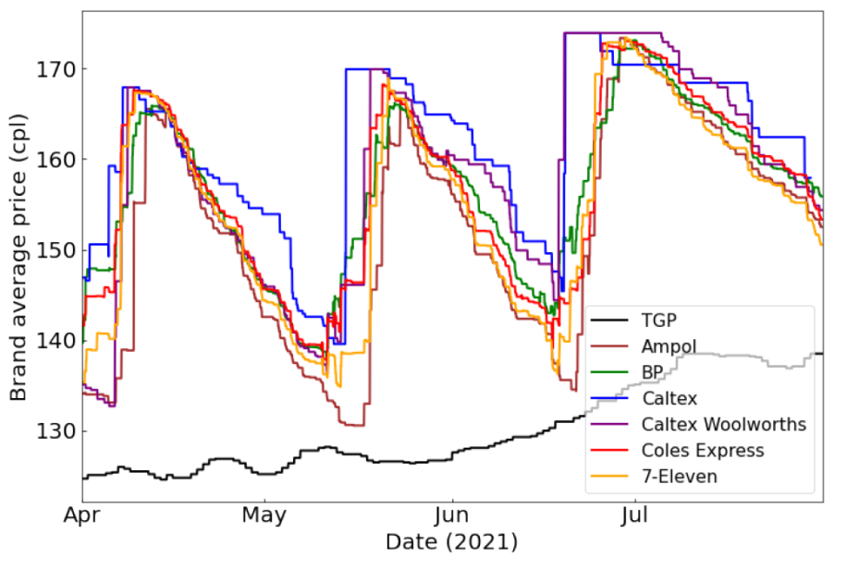
Figure 1 shows three clear asymmetric price cycles between April and July 2021. The brand-average prices rise sharply during restoration phases and then decline more gradually during discounting phases. This pattern is consistent with Edgeworth-style cyclical pricing. The amplitude of the cycles is substantial, and the rising TGP benchmark indicates that wholesale-cost pressure also contributed to higher cycle peaks.
The figure also shows rival-responsive behaviour. When one major retailer restores prices, other brands tend to follow within a short period. This is the empirical motivation for adding lead-lag detection to the revised methodology. Instead of saying only that “other firms followed”, the extended project can measure which brand moved first and how many days elapsed before other brands restored prices.

5.2 Station-level pricing patterns
Figure 2. Station-level prices by brand in March quarter 2021
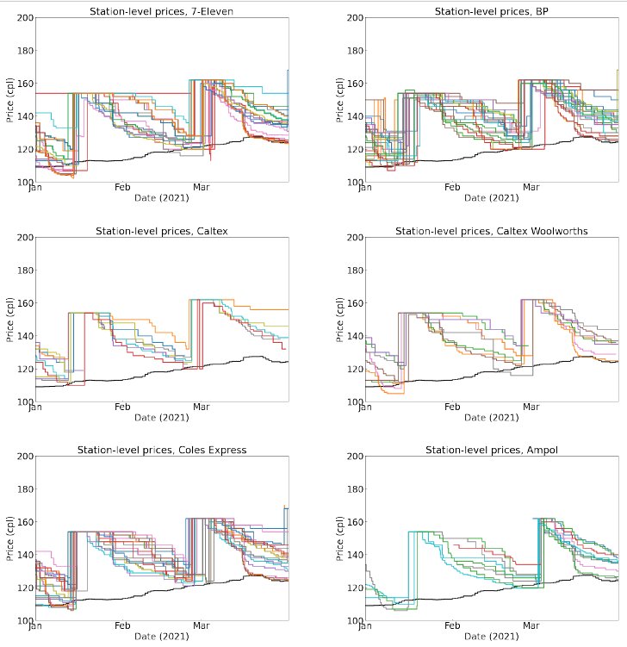
Figure 2 provides station-level evidence for the March quarter of 2021. Several major brands show the expected asymmetric pattern: rapid price increases followed by gradual discounting. However, the station-level charts also reveal deviations that are hidden in the brand-average series. Some stations remain at the same price for long periods, and some restorations appear to fail or reverse quickly.
These deviations are useful for anomaly detection. A failed cycle, a false start or a station that does not follow the broader cycle can be treated as an event requiring classification rather than as random visual clutter. This is where the project becomes more than a descriptive chart exercise.
Figure 3. Station-level prices by brand in June quarter 2021
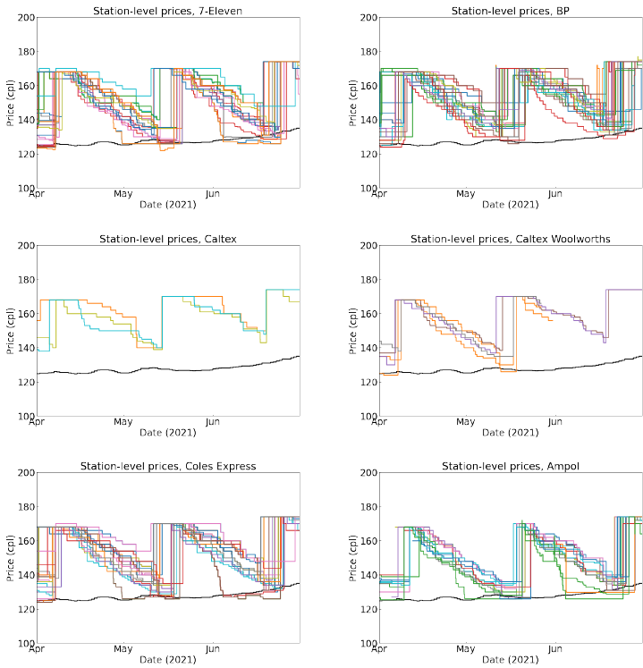
Figure 3 shows stronger cyclical behaviour across the June quarter. Most brands display clearer asymmetric cycles, although the number of Caltex observations declines as Ampol branding changes affect the dataset. Some stations also appear to fall below the TGP benchmark during the trough phase, which suggests low-margin or negative-margin periods if the benchmark is interpreted as a wholesale cost proxy.
The June quarter is useful because the cycle pattern is visually cleaner. It therefore provides a better basis for testing whether major retailers lead restorations and whether smaller or more localised retailers follow with longer delays.
Figure 4. Station-level prices by brand in September quarter 2021
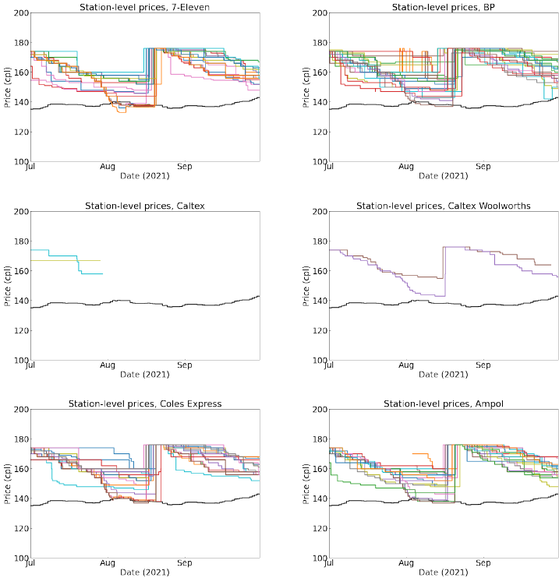
Figure 5. Station-level prices by brand in December quarter 2021
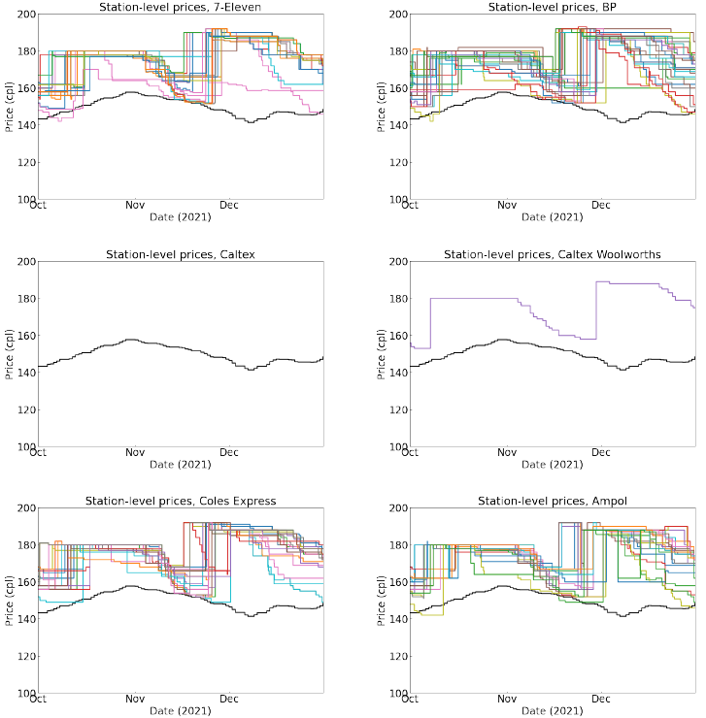
Figures 4 and 5 show more disorderly cycles in the September and December quarters. Compared with Figures 2 and 3, there are more persistent focal prices, delayed responses and variation across stations within the same brand. This is important because it shows that price cycles are not perfectly synchronised at all station levels.
The disorderly quarters are especially valuable for anomaly analysis. They contain exactly the type of behaviour that a market-surveillance design should flag: delayed cycle take-offs, focal prices that persist too long, restoration attempts that do not spread across brands, and stations that appear disconnected from the broader cycle.

5.3 Hourly and continuing-cycle evidence
Figure 6. Hourly data for 1 January 2021
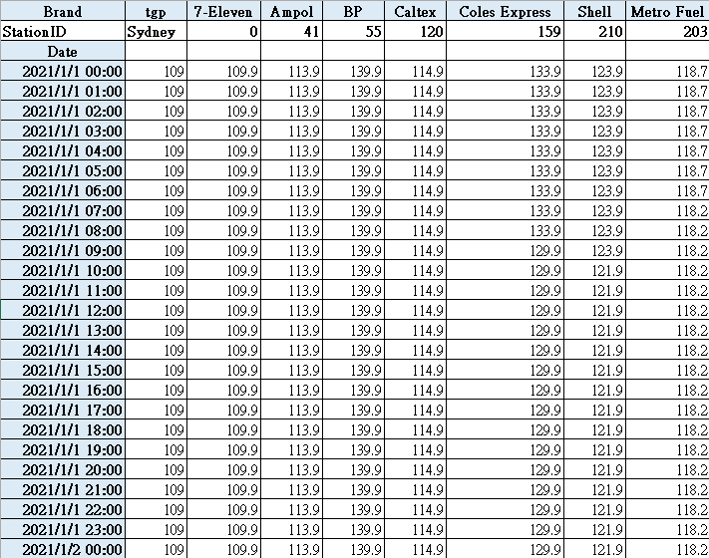
Figure 6 shows hourly price data for 1 January 2021. The table does not show a meaningful within-day cycle. Most stations either do not change prices or change prices only once within the day. This supports the use of daily rather than hourly data for cycle detection, while still recognising that price reporting infrastructure can support much higher-frequency monitoring if required.
Figure 7. Daily average retail petrol prices in Sydney, 21 March 2022 to 2 May 2022
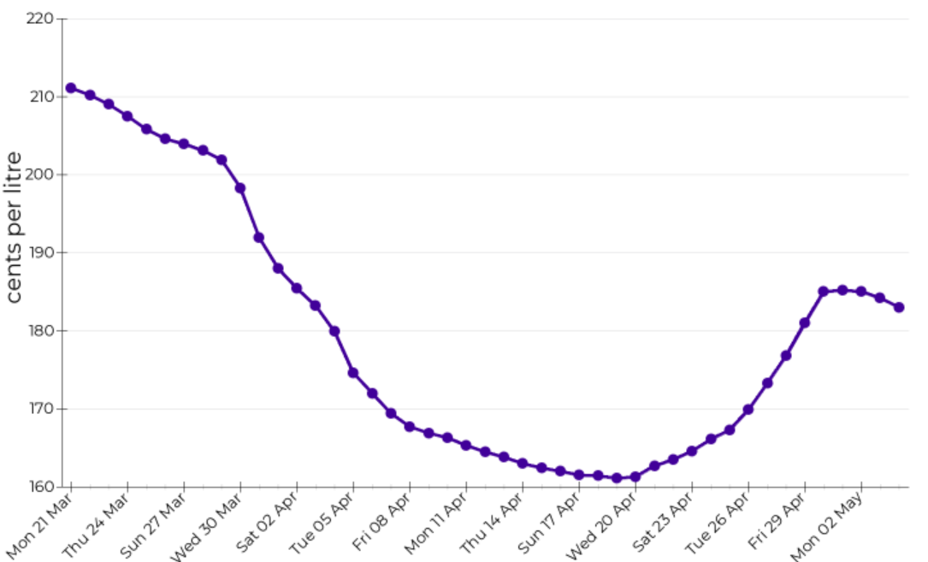
Figure 7 shows a daily average cycle from late March to early May 2022. The graph clearly displays a long discounting phase followed by a sharp price restoration. This reinforces the importance of using daily data rather than weekly averages, because weekly data may obscure the timing of the trough and the speed of restoration.
Figure 8. Information on five continuing cycles in Sydney
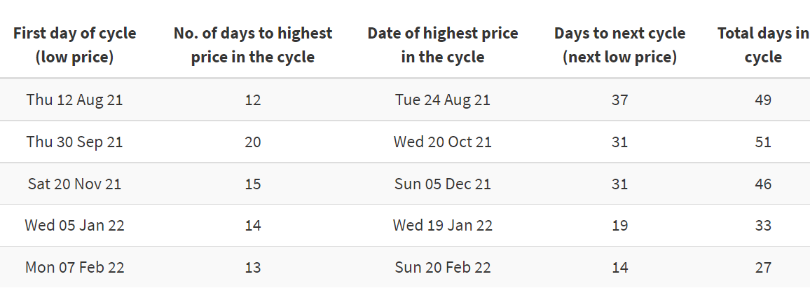
Figure 8 summarises five continuing cycles from August 2021 to February 2022. The cycles vary in total duration, from fewer than 30 days to around 50 days. The number of days to the highest price is generally shorter than the number of days from peak to the next trough, which is consistent with asymmetric Edgeworth cycles.

5.4 Rising trend in 2021 price cycles
A key feature of the 2021 data is the upward movement in both troughs and peaks. Sydney’s average retail petrol price increased across the year. The March quarter average was lower than the June, September and December quarter averages, and the TGP benchmark also increased. The correct interpretation is therefore not simply that retailers increased margins. Some of the upward movement reflected higher wholesale costs and broader global fuel-price pressure.
Because crude oil is the main raw material for refined petrol, increases in crude oil and Mogas 95 prices raise wholesale costs for retailers. When the TGP benchmark increases, retailers may need to restore to a higher focal price to maintain margins. This cost-side channel must be separated from the strategic cycle channel.
Figure 9. Theoretical Edgeworth cycle
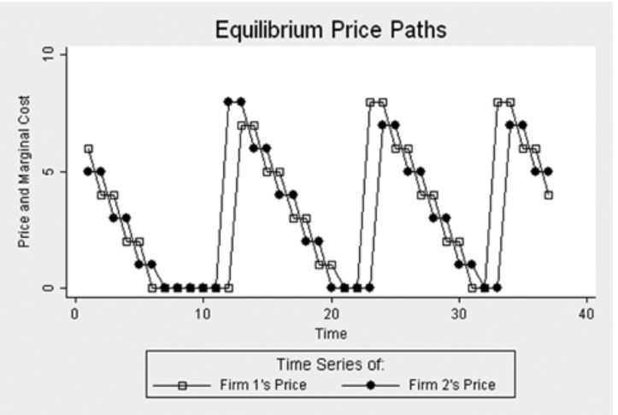

5.5 ACCC update: 2023-2025 and partial 2026 framing
The three recent ACCC reports materially strengthen the revised version of this project. They confirm that price cycles remain a live feature of the five largest Australian cities and provide updated quantitative benchmarks for Sydney. The reports also help separate cost-side petrol price movements from retail-cycle behaviour.
The September quarter 2023 ACCC report recorded average retail petrol prices across the five largest cities at 195.6 cpl, an increase of 12.7 cpl from the June quarter. The ACCC attributed the increase overwhelmingly to higher Mogas 95 prices and a lower AUD/USD exchange rate, with the combined Mogas 95 effect increasing by 12.8 cpl in Australian cents per litre terms. For the cycle analysis, the key point is that Sydney had three price cycles in the September quarter 2023, two more than the previous quarter, and the average duration of cycles in the year to September 2023 was around seven weeks in Sydney, Melbourne and Brisbane. The report also noted that Sydney’s quarterly average retail petrol price increased by 15.7 cpl and that Sydney’s gross indicative retail differences increased by 4.1 cpl from the previous quarter, partly reflecting three price-cycle peaks in the quarter.
The September quarter 2024 ACCC report shows a different market environment. Average retail petrol prices across the five largest cities declined to 182.8 cpl, down 13.7 cpl from the June quarter. This reflected lower Mogas 95 prices, lower gross indicative retail differences and lower other wholesale costs and margins. For Sydney, the key cycle benchmark is that the average duration of price cycles was around five and a half weeks in the September quarter 2024. This is shorter than the approximately seven-week average reported in the year to September 2023, but still much longer than the weekly cycles observed in Perth.
The September quarter 2025 ACCC report shows continued cyclical behaviour. Average retail petrol prices across the five largest cities increased to 178.8 cpl, up 3.1 cpl from the June quarter. The increase largely reflected higher international refined petrol prices and other wholesale costs and margins, while gross indicative retail differences across the five largest cities were unchanged at 16.4 cpl. In Sydney specifically, the September quarter 2025 average retail price was 179.4 cpl, up 1.9 cpl from the June quarter. The ACCC identified three price cycles in Sydney during the quarter, each around five weeks in duration, and reported an annual average cycle duration of around five and a half weeks in Sydney in the year to September 2025.
Taken together, the 2023-2025 reports support two important revisions to the original report. First, Sydney’s cycles remain asymmetric and persistent, but their duration varies over time. Second, large changes in average retail prices must be interpreted alongside Mogas 95, exchange rates, TGPs and gross indicative retail differences. In other words, the cycle mechanism and the cost-push mechanism operate together. A serious empirical version of the project must model or at least describe both.
Table 2. ACCC update incorporated into the revised report
ACCC report | 5-city average retail price | Sydney cycle evidence | Cost-side interpretation | Use in revised project
September quarter 2023 | 195.6 cpl, up 12.7 cpl from June quarter 2023 | Sydney had 3 price cycles in the quarter; year-to-September average duration around 7 weeks in Sydney, Melbourne and Brisbane | Increase largely due to Mogas 95 and lower AUD/USD; Sydney GIRD increased by 4.1 cpl | Shows high-price, long-cycle environment and supports need to separate cost effects from cycle effects
September quarter 2024 | 182.8 cpl, down 13.7 cpl from June quarter 2024 | Average duration around 5.5 weeks in Sydney and Brisbane; Perth weekly | Decline reflected lower Mogas 95, lower GIRD and lower other wholesale costs/margins | Shows cycles continued even when average prices fell; useful robustness period
September quarter 2025 | 178.8 cpl, up 3.1 cpl from June quarter 2025; Sydney 179.4 cpl | 3 Sydney cycles in the quarter, each around 5 weeks; annual Sydney duration around 5.5 weeks | Increase reflected higher refined petrol prices and other wholesale costs; GIRD unchanged at 16.4 cpl across five cities | Confirms ongoing Sydney cycles and provides latest ACCC benchmark before partial 2026 update
May 2026 weekly monitoring report | By 20 May 2026, 5-city average daily retail petrol prices were 185.2 cpl, down 72.0 cpl from 31 March after the temporary excise cut, but 14.3 cpl higher than 20 February. | Typical cycle movements in Sydney, Melbourne, Brisbane and Adelaide largely did not occur through March-April; some retailer increases at selected sites appeared cycle-related but not fully market-wide. | The 2026 evidence is dominated by Middle-East conflict, excise-policy shock, Mogas 95 and TGP movements; it is a stress-test period rather than a clean annual cycle sample. | Supports partial-2026 framing, showing why cycle detection must control for policy shocks and wholesale-cost pass-through.
For the partial 2026 extension, the practical next step is to append monthly FuelCheck price-history data and apply the same cycle-identification rules. The 2026 update should report preliminary trough-to-trough durations, brand-level restoration leaders, follower delays and anomaly counts. It should not be treated as a complete annual sample until the full 2026 data are available.

5.6 ACCC extracted figures: 2023-2026 cycle and shock evidence
The ACCC figures extracted below turn the update section from a pure literature-summary extension into visual benchmark evidence. The figures are not a substitute for raw FuelCheck microdata, but they are useful external validation: they confirm that the cycle pattern persisted beyond the original 2021 sample, while also showing that the level of prices moved with Mogas 95, exchange rates, wholesale prices and policy shocks.
The September quarter 2023 figure shows a high-price environment with substantial variation across the five largest cities. Sydney, Melbourne and Brisbane displayed longer cycles, while Perth continued to show short, sharp weekly movements. This supports the need to separate city-wide cycle structure from local retailer participation and from fuel-grade or city-specific market design.
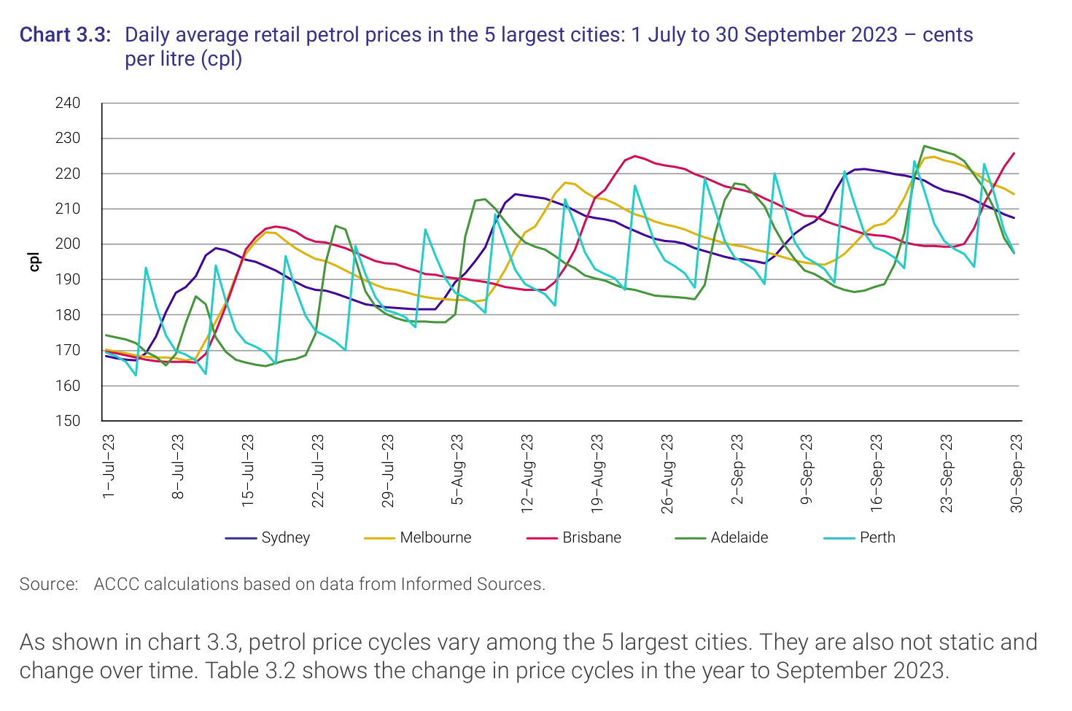
Figure 10. ACCC September quarter 2023 evidence: daily average retail petrol prices across the five largest cities. The figure anchors the 2023 high-price regime and shows that Sydney’s cycle behaviour should be interpreted alongside broader city-level price pressure. Source: ACCC (2023).
The 2024 figure shows that price cycles remained visible even when average retail petrol prices were falling in the quarter. This is important because it prevents a lazy interpretation that “prices fell, therefore strategic cycles disappeared.” They did not. The cycle mechanism continued, but it operated on a lower cost base as Mogas 95 and gross indicative retail differences declined.
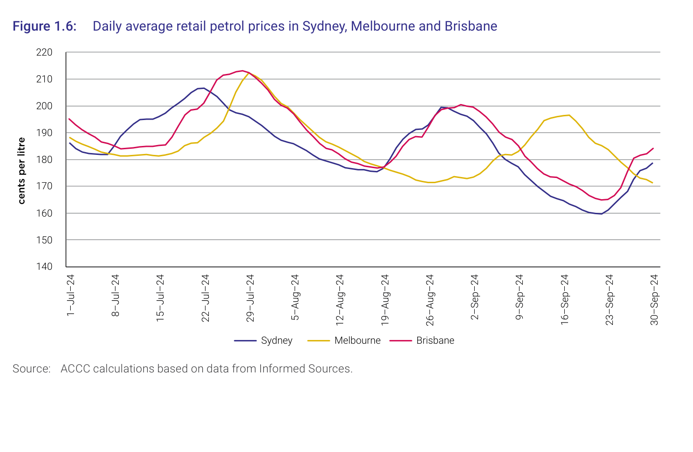
Figure 11. ACCC September quarter 2024 evidence: Sydney, Melbourne and Brisbane price cycles during a falling-price regime. The figure shows that cyclical retail pricing can persist even when quarterly average prices decline. Source: ACCC (2024).
The 2025 figure provides the cleanest portfolio-style benchmark because the ACCC explicitly reports three cycles in Sydney during the quarter, each around five weeks in duration. It also reports that Melbourne had three cycles ranging between five and six weeks and Brisbane had three cycles ranging from around five to nearly seven weeks. This supports the report’s lead-lag and cycle-duration extension because cycle length is measurable and comparable across cities.
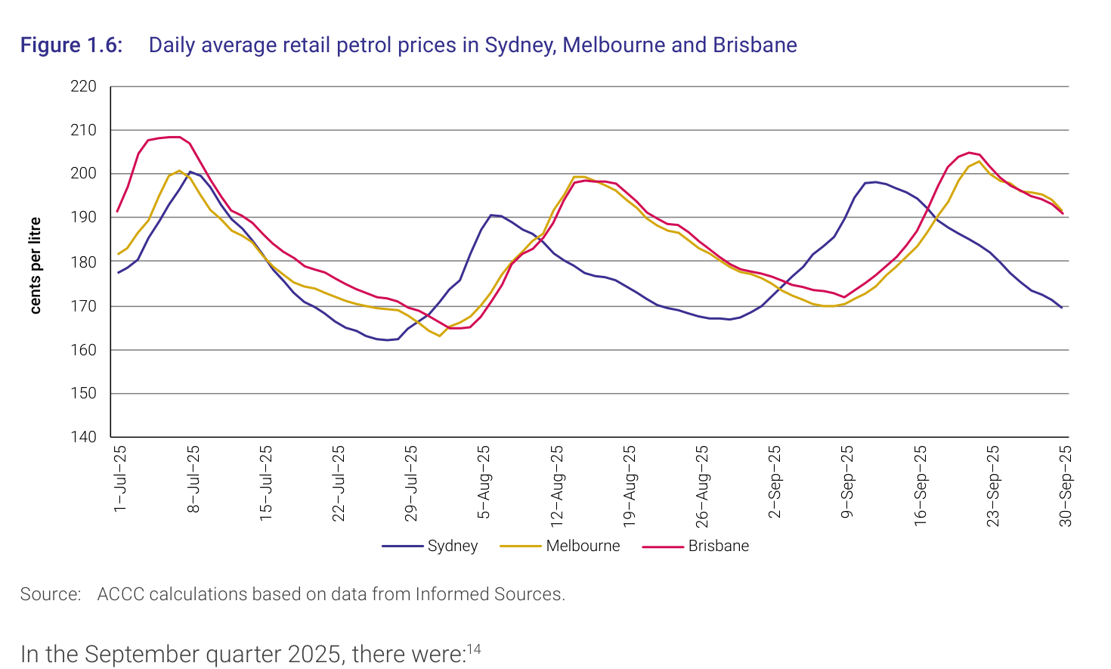
Figure 12. ACCC September quarter 2025 evidence: Sydney, Melbourne and Brisbane price cycles, with Sydney recording three cycles of roughly five weeks in the quarter. This is the cleanest benchmark for cycle persistence in the updated portfolio version. Source: ACCC (2025).
The May 2026 weekly monitoring figure should be treated differently from the quarterly figures. It reflects a disrupted policy and geopolitical environment rather than an ordinary cycle period. The ACCC increased its fuel reporting from quarterly to weekly in response to Middle-East conflict, and the temporary 32 cpl fuel-excise reduction from April 2026 materially affected retail and wholesale prices. For this reason, the 2026 extension should be framed as a partial stress-test sample rather than a clean full-year continuation.
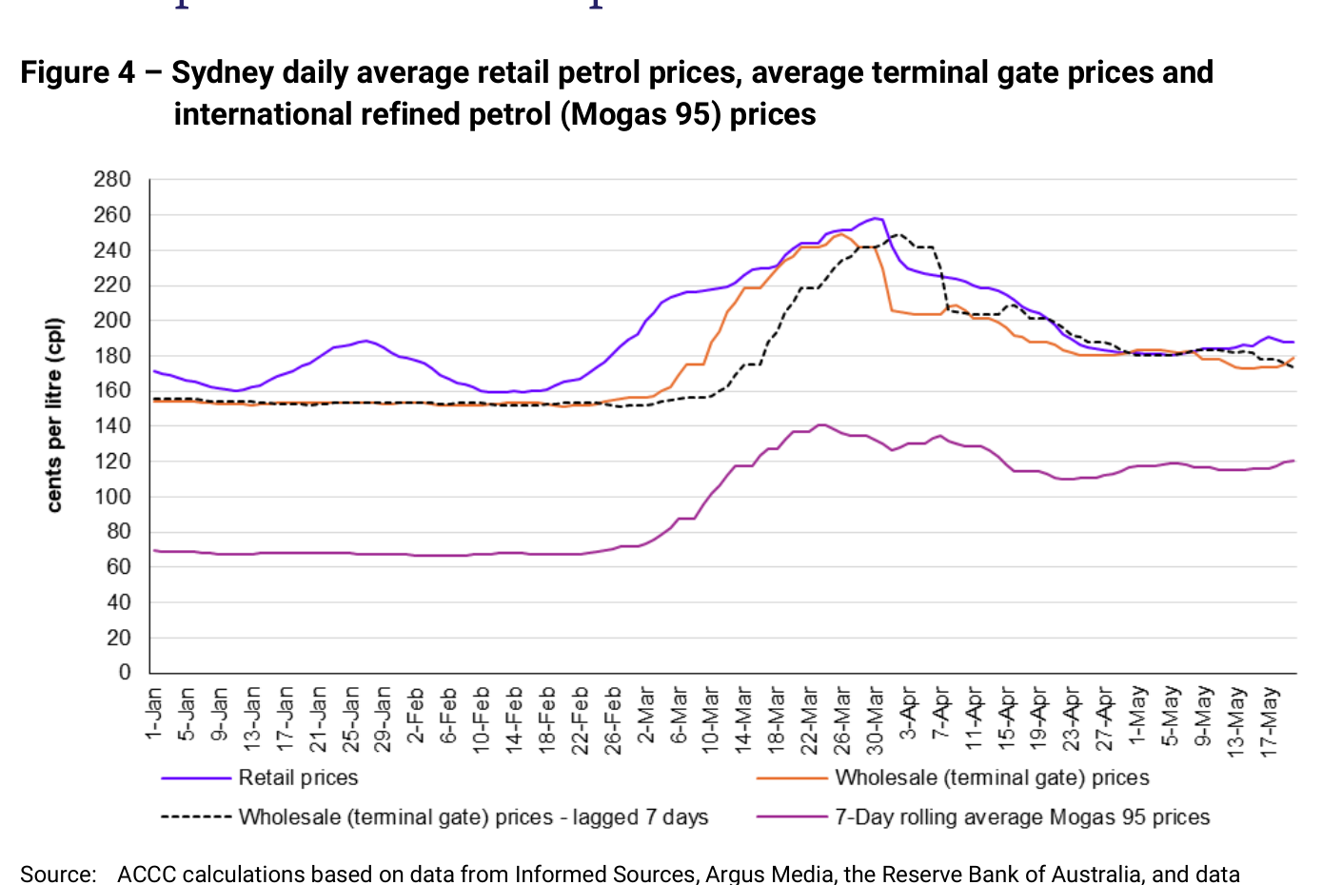
Figure 13. ACCC May 2026 weekly monitoring evidence: Sydney retail petrol prices, terminal gate prices and Mogas 95 during a disrupted policy and geopolitical environment. This figure should be treated as a partial stress-test sample, not as a normal full-year extension. Source: ACCC (2026).
The practical implication is clear: the revised empirical design should not simply extend the 2021 chart forward. It should tag 2023, 2024, 2025 and partial 2026 as different market regimes. A robust dataset should include variables for calendar period, wholesale benchmark movements, excise-policy changes, price-cycle phase, first-mover identity, follower delay and anomaly type. Otherwise the model will confuse cost shocks with strategic cycle behaviour - rookie error, academically expensive.

6. Discussion

6.1 Edgeworth cycles and strategic interdependence
The evidence supports the existence of price cycles in Sydney’s retail petrol market. Across the original figures, the recurring pattern is clear: prices rise quickly, fall slowly and repeat over multi-week intervals. The ACCC’s more recent reports confirm that this remains a current market feature rather than merely a 2021 anomaly.
The Edgeworth framework explains why retailers may undercut during discounting phases and then restore prices when the market becomes too low-margin. It also explains why cycles can fail or become disorderly. If firms do not interpret the restoration signal in the same way, if some retailers delay too long, or if local competitive pressure is strong, the cycle can break down or fragment at the station level.
The updated ACCC evidence also makes clear that retail-cycle interpretation cannot ignore wholesale-cost factors. The September 2023 quarter was dominated by Mogas 95 and exchange-rate pressure, while the September 2024 quarter saw retail prices decline with lower refined petrol prices and margins. The September 2025 quarter again involved higher refined petrol prices and other wholesale costs. Strategic cycles therefore sit on top of a moving cost base.

6.2 Lead-lag behaviour and strategic coordination
Lead-lag behaviour is the most important empirical upgrade to the original report. The original charts show that some firms appear to restore prices earlier than others, but the revised project should make this measurable. For each cycle, the analysis should identify the first mover, the second mover, the median follower delay and the proportion of stations that restore within a defined window.
This directly corresponds to strategic coordination in repeated markets. If the same brand repeatedly restores prices first and others follow within one or two days, that pattern suggests price leadership. If followership becomes slower or inconsistent, the cycle may be weaker. If a restoration attempt is not followed by enough competitors, the first mover may need to reverse its price, producing a failed cycle.
This is not the same as proving collusion. Lead-lag analysis can show strategic interdependence and coordinated-looking behaviour, but explicit collusion would require evidence beyond pricing data. The value of lead-lag detection is that it makes the behavioural structure of the cycle visible without overclaiming the legal interpretation.

6.3 Anomaly detection and market surveillance
Anomaly detection provides a second major upgrade. In the original version, failed cycles, false starts and outlier stations were mostly described qualitatively. In the revised version, they can be classified systematically. An anomaly can be defined as any price path that departs from the expected cycle pattern after accounting for the broader market phase.
Relevant anomaly categories include: failed restoration attempts, rapid reversals after a price increase, stations that remain at a focal price for unusually long periods, stations that fall materially below the wholesale benchmark, unusually large one-day increases, and stations that do not participate in a cycle followed by most nearby competitors. Each category has a different interpretation. Some may reflect strategic non-participation, some may reflect local competition, and some may reflect data-quality issues.
This gives the project a market-surveillance angle. In financial markets, surveillance teams look for unusual trading patterns, leader-follower behaviour, spoofing-like signals, failed coordination, outliers and abnormal responses to public information. A petrol-market dataset is obviously not a financial market dataset, but the analytical structure is transferable: identify the normal market pattern, define deviations, classify anomalies and interpret whether the deviations are benign, competitive or potentially concerning.
A related ACCC compliance report outside the petrol sector is useful only as a regulatory-monitoring analogy. In Telstra’s 2024-25 Structural Separation Undertaking compliance report, the ACCC classified non-compliance types, noted root causes such as system and data quality issues, human error and manual-process weakness, and assessed remediation steps. This is not petrol-market evidence, but it supports the broader analytical framing: surveillance work becomes more credible when anomalies are classified, explained and linked to remediation or monitoring controls rather than merely labelled as “odd”.

6.4 Transparency effects and digital market infrastructure
The role of market transparency is central. FuelCheck and fuel price apps help consumers search for lower prices and time purchases near troughs. The ACCC repeatedly encourages motorists to use fuel price apps and websites because there is often a range of prices available within a cycle. Transparency therefore has a direct consumer-welfare benefit.
However, transparency also has a strategic side. When prices are visible in near real time, retailers can also monitor competitors more easily. This may make it easier to observe whether a restoration signal has been followed, whether a rival is undercutting, and whether a price leader has successfully triggered a cycle. The same data infrastructure that helps consumers can also improve firms’ ability to observe one another.
This creates a broader policy trade-off. In digitally transparent markets, real-time disclosure can improve consumer information, regulatory visibility and market efficiency. But it may also facilitate strategic monitoring, arbitrage-like responses and faster coordination around visible price signals. The digital-finance literature on tokenised RWAs, AMMs and decentralised exchanges reinforces this point: transparency and open access do not automatically democratise market quality. Market design, liquidity depth, sophisticated participants and surveillance infrastructure determine whether transparency becomes a competitive force or a strategic advantage for better-equipped actors.

7. Limitations and Non-Claim Statement
This report has several limitations. First, the original analysis is descriptive and relies on visual identification of cycles rather than a fully implemented algorithm. The revised methodology defines how cycle detection should work, but a complete empirical extension would need to download, clean and process the full FuelCheck microdata.
Second, the report does not estimate a formal econometric model. Future research could use station-level panel models, event-study methods or hazard models to test whether particular brands systematically lead price restorations and whether local competition affects follower delay or discounting speed.
Third, ACCC reports provide reliable market context but are not a substitute for raw station-level analysis. The ACCC reports summarise city-level and quarterly dynamics, whereas the proposed lead-lag and anomaly analysis requires station-level daily data. The reports should therefore be used as benchmark evidence and external validation rather than as the only empirical source.
Fourth, the 2026 extension is incomplete by definition. Partial-year data may be affected by seasonal patterns, geopolitical shocks and incomplete cycle windows. The 2026 results should therefore be described as preliminary until the full-year FuelCheck dataset becomes available.
Raw-data implementation is therefore the main next-stage upgrade. A stronger version would download monthly FuelCheck price-history files, clean brand and station identifiers, construct daily station-level price panels, match available TGP or wholesale-cost benchmarks, and implement automated cycle detection, lead-lag scoring and anomaly flags in Python. This is deliberately presented as future work, not as a completed result in the current portfolio version.
Finally, the report cannot distinguish conclusively between tacit coordination, explicit collusion and parallel rational responses to market conditions. The evidence supports strategic interdependence, but it does not prove illegal conduct.

8. Conclusion
This revised report finds that Sydney’s retail petrol market displays clear evidence of asymmetric price cycles. The original 2021 data show sharp price restorations, gradual discounting, station-level heterogeneity and failed or disorderly cycle attempts. The ACCC September quarter reports for 2023, 2024 and 2025 confirm that Sydney price cycles remain a current and persistent market feature.
The key upgrade is methodological. The original report identified cycles visually; the revised version turns that logic into a more standard empirical framework based on cycle identification, lead-lag detection and anomaly detection. This makes the project more credible as a research portfolio piece because it shows how descriptive charts can be converted into measurable market-behaviour indicators.
The updated ACCC evidence also improves the interpretation of price movements. Sydney’s cycle behaviour must be understood alongside Mogas 95, exchange rates, TGPs and gross indicative retail differences. The retail cycle explains the shape and timing of price movements, while wholesale costs and international market factors help explain the level around which those cycles occur.
The broader lesson is that transparent market infrastructure has two sides. FuelCheck can help consumers compare prices and buy near the trough of a cycle, but the same information environment may also help retailers monitor competitors and coordinate-looking price restorations. This makes the project useful not only as an applied economics report, but also as a small market-surveillance case study for transparent digital markets.

10. References
ACCC. (2007). Petrol prices and Australian consumers: Report of the ACCC inquiry into the price of unleaded petrol. Australian Competition and Consumer Commission.
ACCC. (2018). Petrol price cycles in Australia. Australian Competition and Consumer Commission.
ACCC. (2021). Report on the Australian petroleum market: March quarter 2021. Australian Competition and Consumer Commission.
ACCC. (2021). Report on the Australian petroleum market: June quarter 2021. Australian Competition and Consumer Commission.
ACCC. (2021). Report on the Australian petroleum market: September quarter 2021. Australian Competition and Consumer Commission.
ACCC. (2021). Report on the Australian petroleum market: December quarter 2021. Australian Competition and Consumer Commission.
ACCC. (2023). Report on the Australian petroleum market: September quarter 2023. Australian Competition and Consumer Commission.
ACCC. (2024). Report on the Australian petroleum market: September quarter 2024. Australian Competition and Consumer Commission.
ACCC. (2025). Report on the Australian petroleum market: September quarter 2025. Australian Competition and Consumer Commission.
ACCC. (2026). Weekly fuel price monitoring report: Friday 22 May 2026. Australian Competition and Consumer Commission.
ACCC. (2025). Telstra’s Structural Separation Undertaking: Annual compliance report 2024-25. Australian Competition and Consumer Commission.
Bedford, J. (2020). Research paper into fuel price cycles within South Australia.
Data.NSW. (2026). FuelCheck price history data. NSW Government Open Data Portal.
de Roos, N., & Katayama, H. (2010). Retail petrol price cycles in Western Australia.
Fernando, J. (2021). Edgeworth price cycle. Investopedia.
Noel, M. D. (2007). Edgeworth price cycles, cost-based pricing, and sticky pricing in retail gasoline markets. The Review of Economics and Statistics, 89(2), 324-334.
Noel, M. D. (2008). Edgeworth price cycles and focal prices: Computational dynamic Markov equilibria. Journal of Economics & Management Strategy, 17(2), 345-377.

