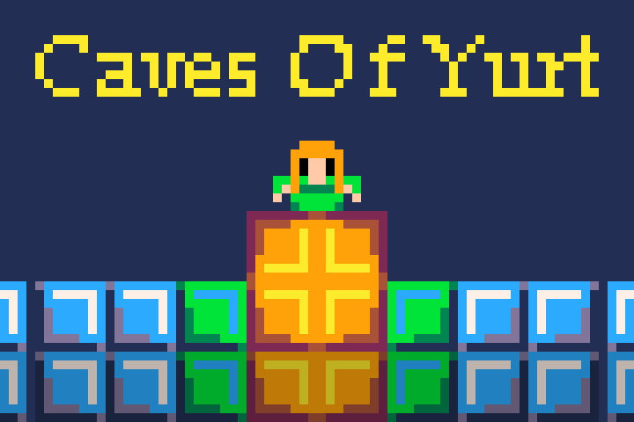

Game concept by Seán Óg

Target platform: PC-first, ports on Xbox, PlayStation, Nintendo

Target audience: Teens & up

Target rating: Everyone (ESRB), 3+ (PEGI)

Expected shipping date: November 27th, 2020

Story & Gameplay

Caves of Yurt is set in a fantasy world called Yearth which is inhabited by many strange monsters & magical entities. Humans and other humanoid species exist in this world alongside the monsters, but most live in tribes above-ground where the hostile monsters cannot cope due to light sensitivity. However, due to many years of harassment from the evil entities that exist above-ground many of these tribes started to venture into the caves despite the monsters that lurked inside, in hopes of finding the root of this evil or at the very least, a remedy.

A tribe called the De’lati were the first to strike gold. Two cave divers came back with glowing rocks and luminescent liquid which turned out to be the source of a powerful energy that came to be known as Yurtage. This powerful energy not only protected the tribespeople from the entities, but also provided infinite warmth and light.

Once word spread, every one of the tribes inhabiting Yearth started to cave dive, in hopes of finding sources of Yurtage and maybe some answers to the mysteries surrounding this strange planet. People even set up small dwellings within the Caves of Yurt, constantly learning more about how to deal with the monsters inside, but they are few and far between.

Player’s goal in story

The player’s goal in the story is to play as one of these cave divers. His/her objective is to get to through 5 randomized cave levels, fighting monsters, avoiding traps, and dealing with limited visibility all to beat a boss at the end and acquire a substantial amount of Yurtage, plus as much treasure as they can along the way. At the end of the 5 levels there will be a special cave / structure that contains more rocks of Yurtage than anyone could carry back to the surface in a lifetime, so the player’s objective is to grab just one glowing rock and then return *back* *through* the 5 levels with the treasure in hand and bring it back to their tribe.

Brief idea of flow of the game

The basic flow is going to be like most roguelike games; difficult, semi-randomized, and highly replay-able. The player will descend into the deepest depths of the Caves of Yurt and will acquire Yurtage, then climb all the way back out. If they succeed, they win the game.

The player will die a lot as they learn how to survive in the Caves, but every time they die and start again, the levels will have rearranged their layouts (by using randomized premade map chunks). This makes dying both something the player will want to avoid as their progress will be lost but also something that is kind of exciting, for they may have a better chance at survival if luck is on their side next time.

Players will be able to use various items they can acquire from shops to change up the way they play and allow for easier ways to deal with enemies. One of these items that will be vital to gameplay is ladders. The player will be able to use these to descend quicker and to allow an easier *ascent* once they have beaten the boss and acquired the Yurtage.

Depth Level 1

* Basic platforming, not many traps or enemies, player will get to the bottom of the map before finding somewhere to descend deeper into the caves.
* *Possible shop* (the player may come across a shop. However, the chance of this will be higher if the player collected a lot of gold, but it will still not be guaranteed)

Depth Level 2

* Moderate platforming, much more traps, some enemies.
* *Possible shop.*

Depth Level 3

* Platforming difficulty maxes out, not as many traps as level 2, lots of enemies.
* *Definite shop.*

Depth Level 4

* Lots of traps, lots of enemies, complete darkness (torch required)
* *No shop.*

Depth Level 5

* A few traps, a few enemies, one **boss** fight.
* If the player succeeds in defeating the boss, he/she will pick up a rock of Yurtage and will then attempt to return to the surface.
* The levels will retain the same layout as before, but enemies will have come back, and the player will have to use the powers of the Yurtage and ladders that they have previously placed to ascend to victory.

Character

The player controls a character of their choice, with a selection of male & female looking sprites with different skin colours and hair colours. This choice will make no difference to gameplay other than visually. There is no need for an in-depth story for each character as the background story tells us that everyone is doing this, it is the new way of life for the humanoids of Yearth.

Controls

Retro Layout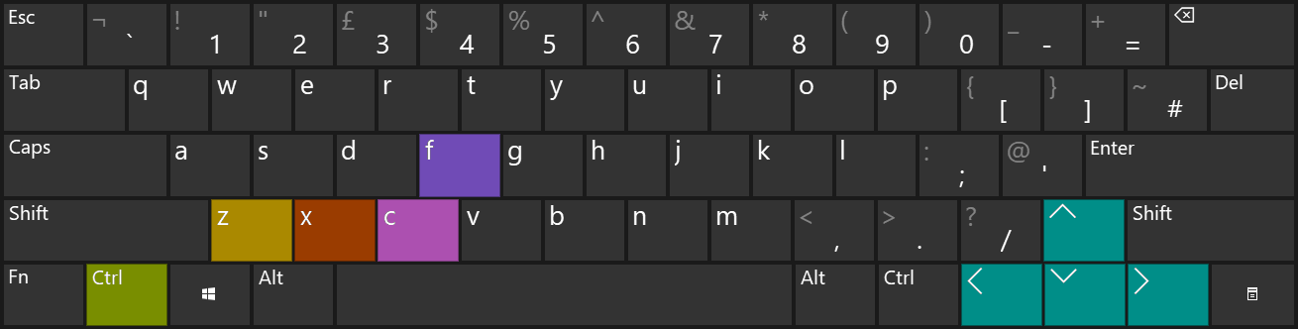

Modern Layout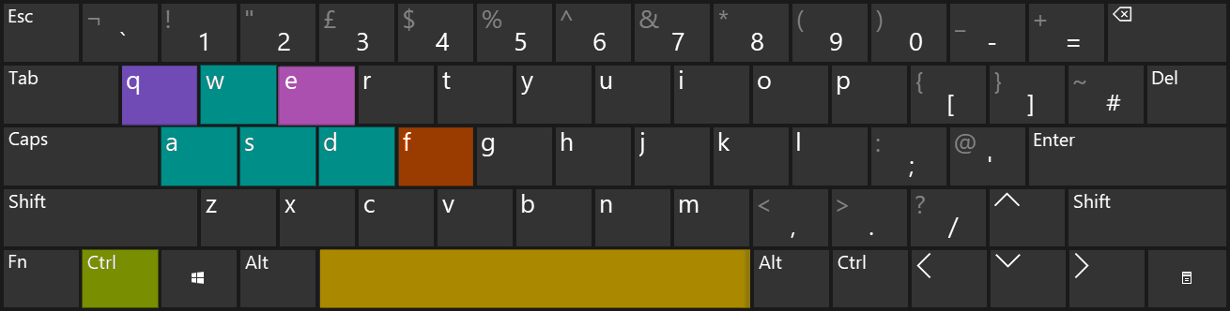

Key