**Manguluri Lalitha**

lalithamanguluri@gmail.com 8309729838 [linkedin.com/in/lalitha-manguluri-250195283](https://linkedin.com/in/lalitha-manguluri-250195283)

# EDUCATION

|  |  |
| --- | --- |
| **BE (Bachelor of Engineering)- ECE**  R.L.Jalappa Institute Of Technology  CGPA-8.0 | 2021 – 2025 Bengaluru |
| **Intermediate (PRE-University)- MPC**  Sri Chaitanya Junior College  Percentage- 96.2 | 2019 – 2021 Tirupathi |
| **10th (Secondary School Certificate)**  Chinmaya Hari Hara vidhyalaya  Percentage- 9.5% | 2018 – 2019 Ellayapalli |

# INTERNSHIPS

## Python Full Course for Beginners by Mosh

I has successfully completed the 1 month training program on Python Full Course for Beginners.Covering Python basics,data structures, file I/O, object-oriented programming, problem-solving, and debugging.The skills and knowledge gained will undoubtedly contribute to their my personal and professional development.

# SOFTWARE SKILLS

**Leadership | Self Motivated | Communication Skills | Quick Learner | Adoptable**

# COURSES

**Java | Python | HTML**

# LANGUAGES

English | Telugu

# PROJECTS

## Handwritten Digit Recognition Using Python

**Advancing workplace safety with IoT Enabled Industrial Marketing**

# DECLARATION

I hereby declare all the information and details shared in this resume are correct and inclusive. I take full liability

for the correctness of the information.

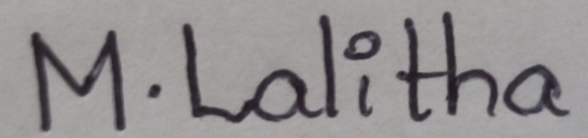

Manguluri Lalitha

12-07-2025