# **HƯỚNG DẪN CÀI ĐẶT MÔI TRƯỜNG**

1. Downloading and installing Node.js and Npm

* **[sudo] npm install npm -g**

1. Download & Install MongoDB

* <https://medium.com/@LondonAppBrewery/how-to-download-install-mongodb-on-windows-4ee4b3493514>

1. MongoDB Compass

* <https://www.mongodb.com/products/compass>

1. Download Postman

* <https://www.postman.com/downloads/>

# **THIẾT KẾ DATABASE**

## Mô hình quan hệ dữ liệu

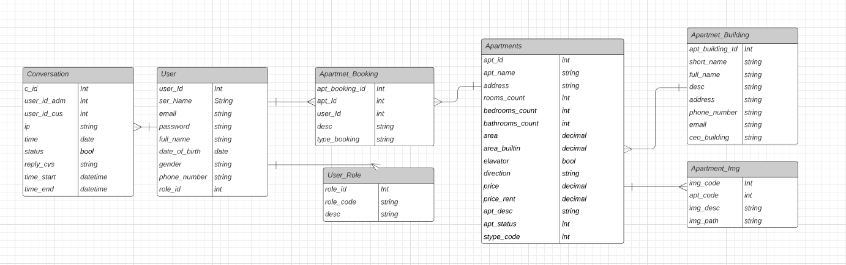

## Phân biệt dữ liệu

### Bảng Apartmet_Booking

* Column type_booking

|  |  |
| --- | --- |
| Value | Description |
| 01 | Apartmet Booking: Khách hàng đã fill đầy đủ thông tin để được nhân viên sale tư vấn. |
| 02 | Apartmet Favourties: Khách hàng muốn lưu lại thông tin favourties mà khách hàng muốn xem ngay lại ở lần sau. |

# REST APIS

## User Role URL

|  |  |  |  |  |  |
| --- | --- | --- | --- | --- | --- |
| Get | |  |  | | --- | --- | | All | <http://localhost:3000/api>/user_role | | By Id | [http://localhost:3000/api/user_role](http://localhost:3000/api/user_role%20) /{id} | |
| Post | {      "role_code": "01",      "desc": "Đây là admin, full quyền đấy nhá."  } |
| Put | [http://localhost:3000/api/user_role/{id}](http://localhost:3000/api/user_role/%7bid%7d)  {      "role_code": "01",      "desc": "Đây là admin, full quyền đấy nhá."  } |
| Detele | [http://localhost:3000/api/user_role/{id}](http://localhost:3000/api/user_role/%7bid%7d) |

## User

|  |  |  |  |  |  |
| --- | --- | --- | --- | --- | --- |
| Get | |  |  | | --- | --- | | All | <http://localhost:3000/api>/user | | By Id | [http://localhost:3000/api/user](http://localhost:3000/api/user_role%20)/{id} | |
| Post | {      "user_name": "Mạnh Đạt",          "email": "dattm201197@gmail.com",          "password": "chưa xử lý",          "full_name": "Trần Mạnh Đạt",          "date_of_birth": "2018-03-29T13:34:00.000",          "gender": "F",          "phone_number": "0988968286",          "user_role_id": "5f041fb7798e5833a4eaf232"  } |
| Put | [http://localhost:3000/api/user/{id}](http://localhost:3000/api/user/%7bid%7d)  {      "user_name": "Mạnh Đạt",          "email": "dattm201197@gmail.com",          "password": "chưa xử lý",          "full_name": "Trần Mạnh Đạt",          "date_of_birth": "2018-03-29T13:34:00.000",          "gender": "F",          "phone_number": "0988968286",          "user_role_id": "5f041fb7798e5833a4eaf232"  } |
| Detele | [http://localhost:3000/api/user/{id}](http://localhost:3000/api/user/%7bid%7d) |

## Apartment Building URL

|  |  |  |  |  |  |
| --- | --- | --- | --- | --- | --- |
| Get | |  |  | | --- | --- | | All | <http://localhost:3000/api/apartment_building> | | By Id | <http://localhost:3000/api/apartment_building>/{id} | |
| Post | {      "short_name": "Valentino1",      "full_name": "Manh Dat Company",      "desc": "JPG",      "address": "JAPAN",      "phone_number": "0988968286",      "email": "dattm201197@gmail.com",      "ceo_building": "Trần Mạnh Đạt",      "logo_img": "img_.pft"  } |
| Put | {      "short_name": "Valentino1",      "full_name": "Manh Dat Company",      "desc": "JPG",      "address": "JAPAN",      "phone_number": "0988968286",      "email": "dattm201197@gmail.com",      "ceo_building": "Trần Mạnh Đạt",      "logo_img": "img_.pft"  } |
| Detele | [http://localhost:3000/api/apartment_building/{id}](http://localhost:3000/api/apartment_building/%7bid%7d) |

## Apartment URL

|  |  |  |  |  |  |
| --- | --- | --- | --- | --- | --- |
| Get | |  |  | | --- | --- | | All | <http://localhost:3000/api/apartment> | | By Id | <http://localhost:3000/api/apartment>/{id} | |
| Post | {  "apt_name": "PH",  "address": "HN",  "rooms_count": 10,  "bedrooms_count": 20,  "bathrooms_count": 11,  "area": 123,  "area_builtin": 100,  "elavator": true,  "direction": "Đông",  "price": 39999,  "price_rent": 1222,  "apt_desc": "What",  "apt_status": 1,  "stype_code": 1,  "apartmet_building_id": "5efee2b94f25e23a18faa891",  "apartment_img": [{ "img_desc": "Angular", "img_path": "angular.png"},  { "img_desc": "JSON", "img_path": "json.png"},  { "img_desc": "Asp.Net", "img_path": "aspnet.png"}]  } |
| Put | {  "apt_name": "PH",  "address": "HN",  "rooms_count": 10,  "bedrooms_count": 20,  "bathrooms_count": 11,  "area": 123,  "area_builtin": 100,  "elavator": true,  "direction": "Đông",  "price": 39999,  "price_rent": 1222,  "apt_desc": "What",  "apt_status": 1,  "stype_code": 1,  "apartmet_building_id": "5efee2b94f25e23a18faa891",  "apartment_img": [{ "img_desc": "Angular", "img_path": "angular.png"},  { "img_desc": "JSON", "img_path": "json.png"},  { "img_desc": "Asp.Net", "img_path": "aspnet.png"}]  } |
| Detele | [<http://localhost:3000/api/apartment>/{id}](http://localhost:3000/api/apartment_building/%7bid%7d) |