**The screenshots here in this document are not displaying the latest theme/styling changes. But these screenshots demonstrate the functionality as a whole.**

**The home page:**

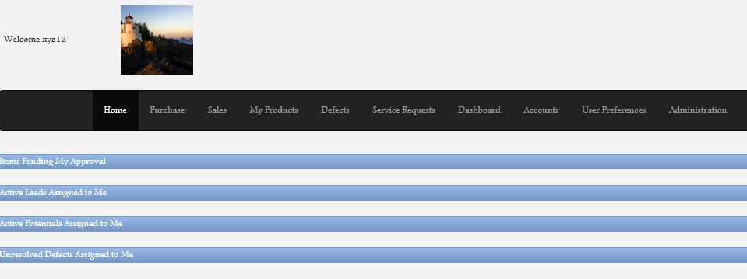

Once the user logs in, can see some useful links. All these are expendables -

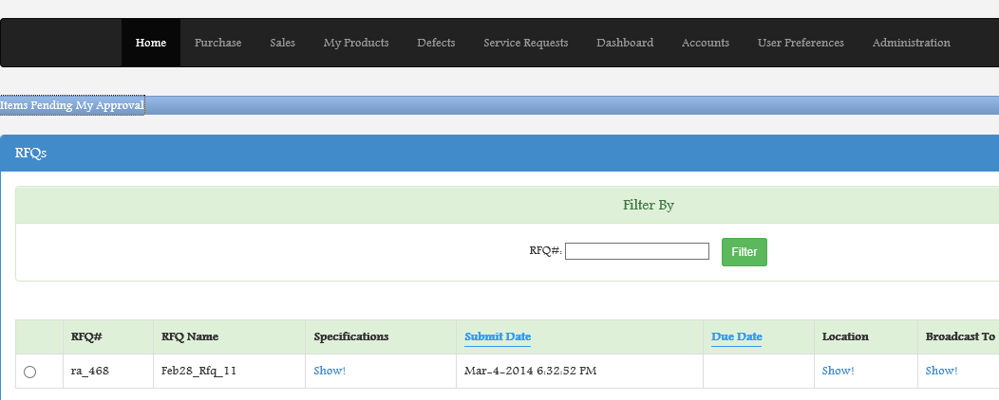

**The Purchase Screen**

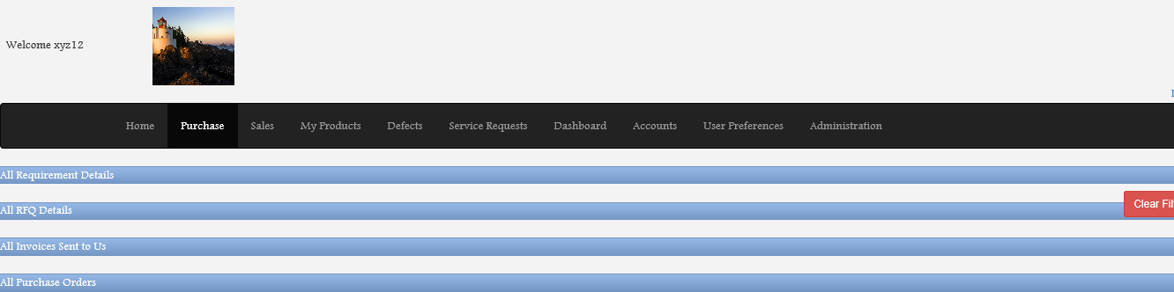

RFQ details floated by the organization -

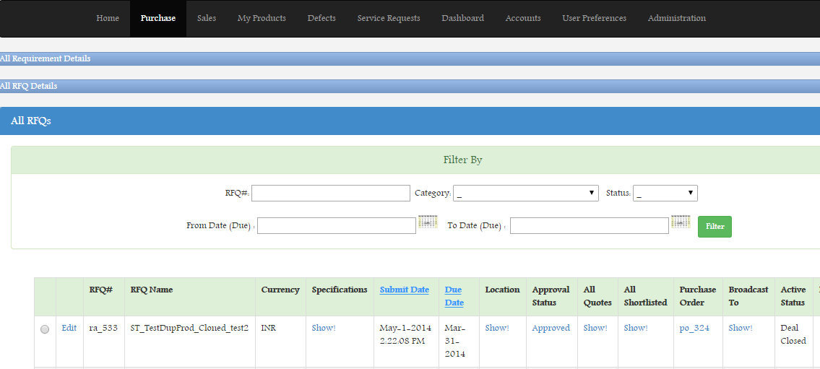

All invoices sent to the organization available in the purchase screen. Note the Payment details and defect details link. The client can track all payments related to a particular invoice from the same screen. Also, the client can view all defects related to a particular invoice from the same screen -

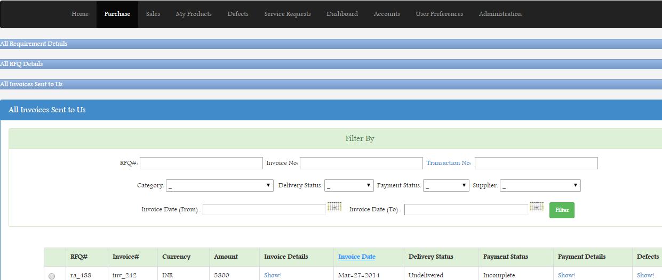

All purchase orders issued can be viewed from the same purchase screen -

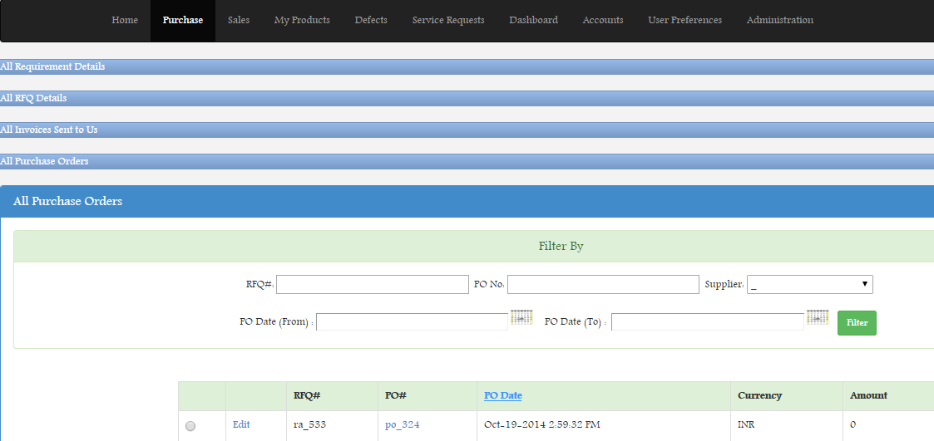

**The sales screen -**

Users can view and track lead, potentials, sales orders and invoices sent to clients all from this single screen.

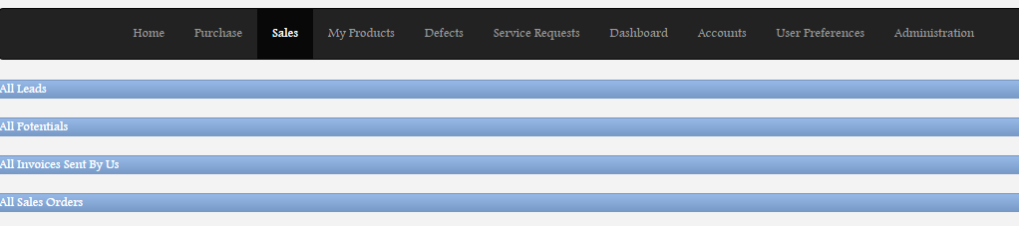

Like in the purchase screen, all these sections in the sales screen are also expandable.

**Important feature** to note here. All subsections like RFQ, Invoices, Leads, Potentials have **smart buttons** associated -

e.g., Using the **Document** button, user can keep all documents related to a lead in a single place. Using the **Notes** button, user can keep notes associated with a lead. Using the **Logs** button user can view/track who is making what changes - this allows organization wide **audit-facility.**

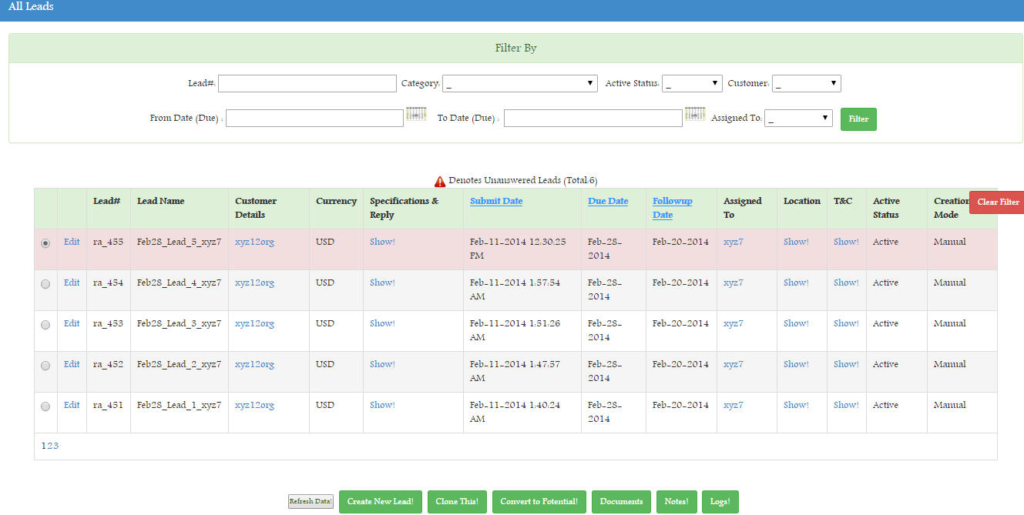

**Product catalogue -**

Users from the organization can maintain the product catalogues here. Also, all sales order related to a particular product can be tracked from here

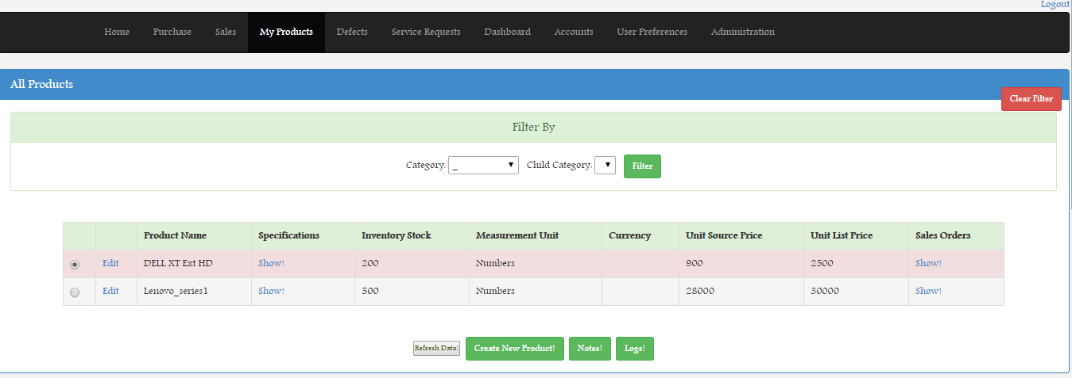

By clicking on the **Sales Order** link for any particular product the user can view all the transactions related to that product. These details are pulled from all transactions/invoices generated for the particular product. All **screens are always**  **in-sync.**

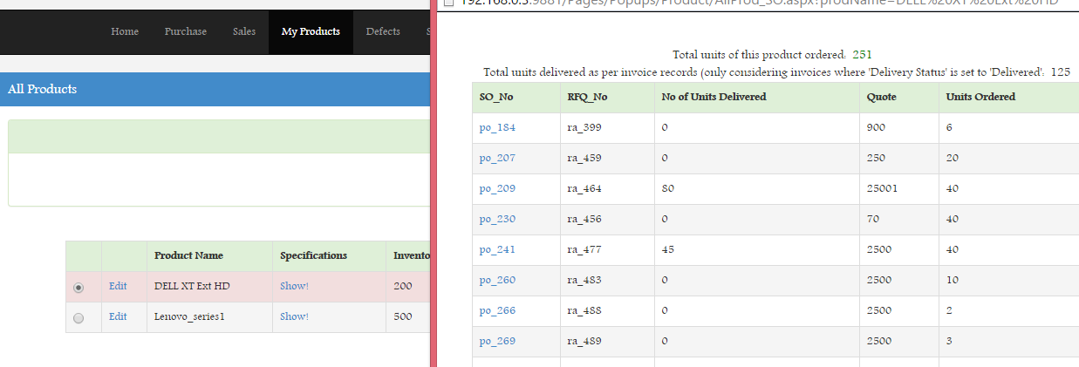

**Defect Home Page -**

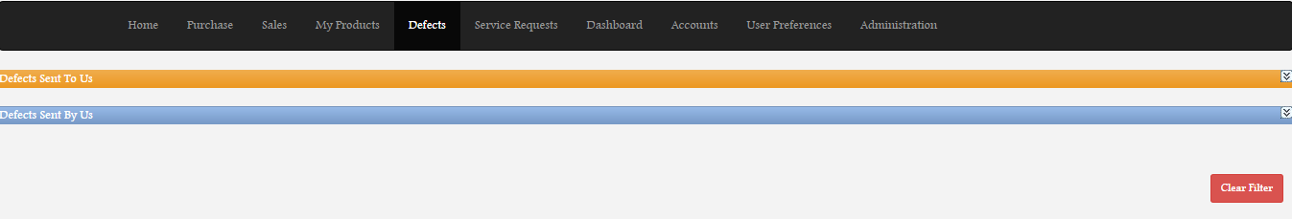

There are two sections in the defect home page - a. Defects sent to this organization, b. Defects Sent from this organization.

As shown in this screen shot, **all communication** between the parties related to a defect can be maintained from the defect home page.

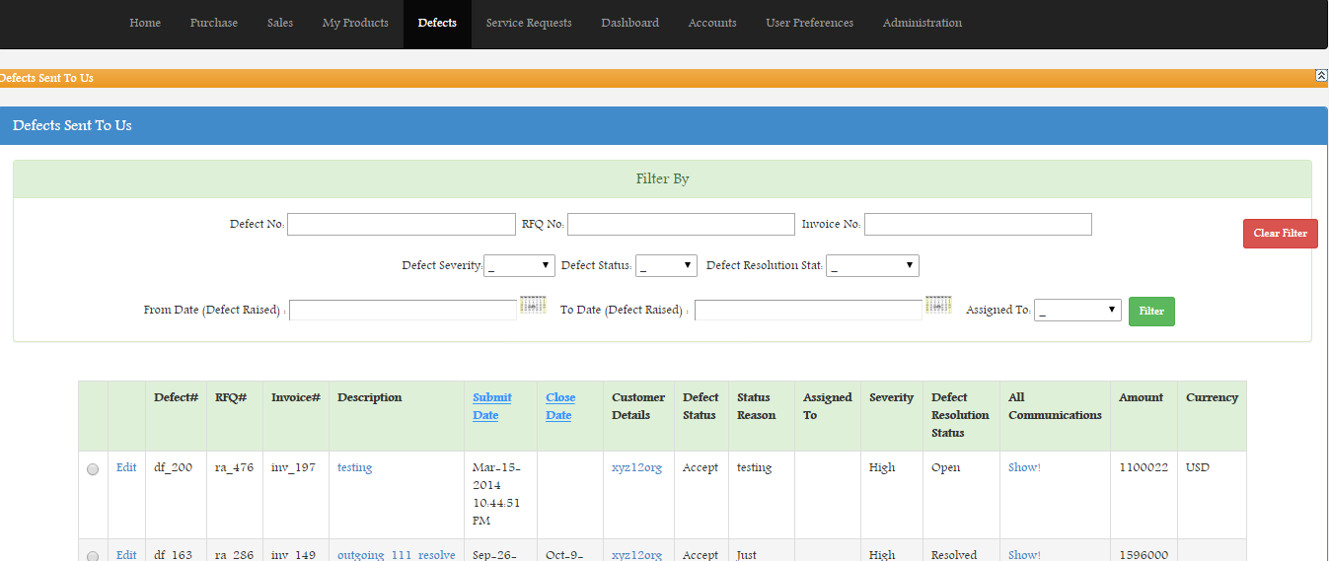

**Service Request Home Page -**

Like defect, there is a service request home page - 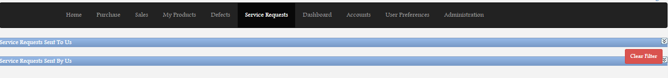

**Dashboard Page -**

There is a large number of pre-built dashboards already available for the users.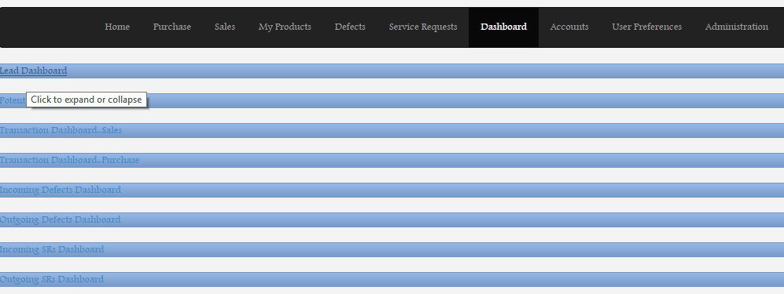

The dashboards have in-built report generation module which allows user to download the report -

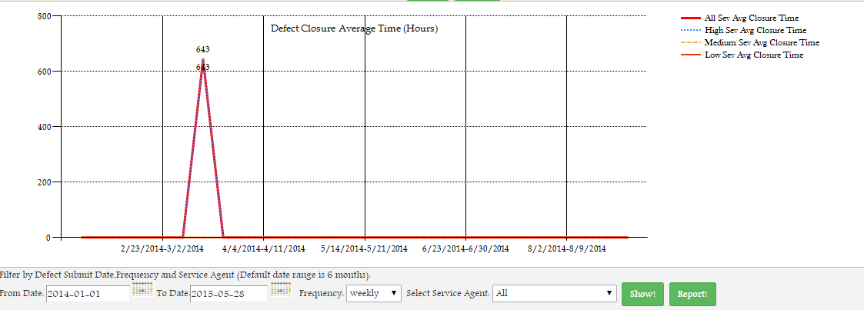

**Accounts Page -**

The accounts page is where all accounts (client/vendor) details are maintained. There are quick links available which allows user to view all transactions with a particular account, all defects related to a particular account from the same page.

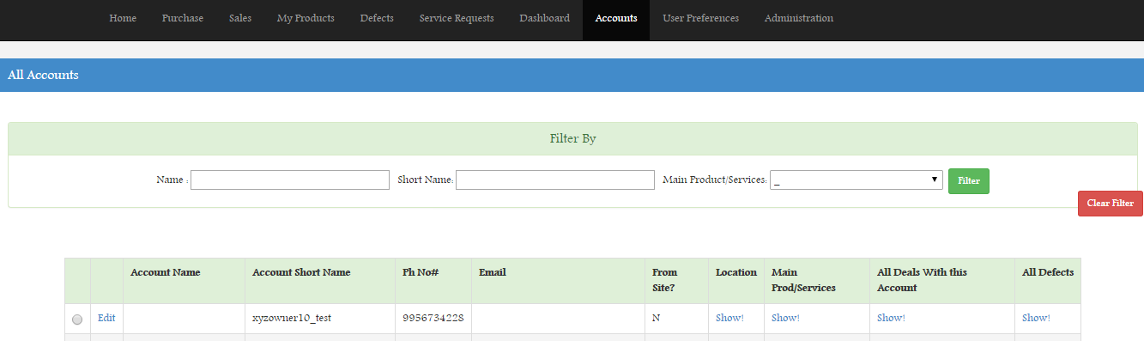

**Admin Page -**

This page is mainly restricted to administrators of each organization. Here the admin can control access to different sections of the portal, maintain and create workflows, define document formats (e.g. default format of the invoice for his/her organization) etc -

