**Software Requirements Specification**

**Doctoral Student Progress Tracker**

**Version 1.0**

**Instructors:** Anu Mary Chacko, Manjusha K, Joe Cheri Ross

**Course:** CS4096D Software Engineering Lab

**Date**: 18 - 02 - 2025

**Group-10**  
P. MAAKHISH SAI B221135CS  
N.B.S MANHAAS B220780CS  
N DEERAJ KUMAR B220432CS

Revisions

|  |  |  |  |
| --- | --- | --- | --- |
| Version | Primary Author(s) | Description of Version | Date Completed |
| Initial Draft - 1 | Maakhish Sai  NBS Manhaas  Deeraj | The first version of SRS is prepared. | 18-02-2025 |

### **Use Case Diagram:**

## 

## **Use Case Descriptions and Steps**

**Actors:**

1. **Ph.D. Students**
2. **Ph.D. Co-Ordinator**

### **1. Upload Student List (U0)**

**Description:** The **PhD Coordinator** uploads the list of PhD students into the system in excel format. This list is used to verify student enrollment before login.

**Steps:**

1. **PhD Coordinator selects** a file containing student details (e.g., CSV or Excel format) and uploads it to the system.

### **2. Verify Student Enrollment (U0A)**

**Description:** Before a student can log in, the system checks if their name exists in the uploaded student list.

**Steps:**

1. A **PhD Student** enters their credentials on the login page.
2. The system checks if their name exists in the uploaded student list.
3. If the student is found, they proceed to the login process.
4. If not found, an error message is displayed, and login is denied leading to another use – case meant to deal with this exception.

### **3. Login (U1)**

**Description:** A **PhD Student** logs into the **Doctoral Tracker System** after enrollment verification.

**Steps:**

1. The student logs in to the system using NITC Google Mail Address.

### **4. View Profile (U2)**

**Description:** A **PhD Student** views their personal details, DC members, and other profile-related information.

**Steps:**

1. Students after successful login can view their profile pages.
2. It is a generalized use case for U2A, U2B, U2C.

### **5. View DC Members (U2A)**

**Description:** A student can see the list of Doctoral Committee (DC) members assigned to them.

**Steps:**

1. Students can view the details of DC Members to the committee they belong to.

### **6. View Personal Details (U2B)**

**Description:** A student can see their personal details (name, email, registration date, etc.).

**Steps:**

1. Students can see their “**Personal Details"**.

### **7. Edit Personal Details (U2C)**

**Description:** A student can update their contact details and other editable fields.

**Steps:**

1. Students can update their personal details.
2. After updating they can save it.

### **8. Manage DC Meetings (U3)**

**Description:** Students and coordinators manage DC meetings, including scheduling and modifications.

**Steps:**

1. Student/coordinator accesses **"Manage DC Meetings"**.
2. Views scheduled meetings.
3. Can request a **new meeting** (U4) or **modify minutes** (U5A).

### **9. Request New DC Meeting (U4)**

**Description:** A student submits a request for a new DC meeting.

**Steps:**

1. Students click on **"Request New DC Meeting"**.
2. A computer-generated mail is sent to DC Committee Members.

### **10. Approve/Reject DC Minutes (U5)**

**Description:** The **PhD Coordinator** reviews and approves or rejects DC meeting minutes.

**Steps:**

1. Coordinator reviews meeting minutes.
2. Approves or rejects them.

### **11. Modify DC Minutes (U5A)**

**Description:** Allows **PhD Students** to modify DC meeting minutes before approval.

**Steps:**

1. Student modifies the DC Minutes.
2. The student then saves it and sends another request to PhD Co-Ordinator.

### **12. Announce Exam Date (U6)**

**Description:** The **PhD Coordinator** announces the exam date.

**Steps:**

1. Coordinator selects the date and confirms.
2. Students receive notifications.

### **13. Submit Exam Request (U7)**

**Description:** A student submits a request to appear for an exam.

**Steps:**

1. Student fills out required details.
2. Students submit the request.

### **14. View Exam Results (U8)**

**Description:** Students can check their exam results.

**Steps:**

1. Students can see their results posted by the PhD Co-Ordinator.

### **15. Request Re-exam (U9)**

**Description:** If a student fails the comprehensive exam for the first two attempts, they can request a re-exam.

**Steps:**

1. Students view the results.
2. Student submits a Re-Examination request to PhD Co-Ordinator.

### **16. Handle Third Re-exam Request (U9A)**

**Description:** If a student requests to attempt the comprehensive exam third time, then an error message is displayed to student.

**Steps:**

1. An Error Message is displayed to the student.

### **17. Track Publications (U10)**

**Description:** A student can track the status of their research publications.

**Steps:**

1. Students can see their papers and can see their status.

### **18. Upload Paper (U11)**

**Description:** A student uploads their research paper to the system.

**Steps:**

1. Student selects a file and uploads it.

### **19. Update Paper Status (U12)**

**Description:** The student updates the publication status (e.g., "Under Review", "Published").

**Steps:**

1. Student selects a paper and updates the status of it.

### **20. View Student Publications (U13)**

**Description:** The **PhD Coordinator** can see the list of all student publications.

**Steps:**

1. Coordinator can access all student's publications.
2. Coordinator can then select each student and can see each student’s publications.

### **21. Upload SWAYAM Courses List (U14)**

**Description:** The **PhD Coordinator** uploads a list of available SWAYAM courses as an excel sheet.

**Steps:**

1. Coordinator u**p**loads SWAYAM courses as a file.

### **22. View Available SWAYAM Courses (U15)**

**Description:** Students can view a list of available SWAYAM courses.

**Steps:**

1. Student accesses **"View Available SWAYAM Courses"**.

### **23. Submit SWAYAM Course Request (U16)**

**Description:** Students request registration for SWAYAM courses.

**Steps:**

1. Students select their courses that align their interest.
2. Students then request for approval from the PhD Coordinator.

### **24. Approve/Reject SWAYAM Requests (U17)**

**Description:** The **PhD Coordinator** approves or rejects SWAYAM course registrations.

**Steps:**

1. Coordinator accesses **"Approve/Reject SWAYAM Requests"**.
2. Reviews requests and decides.

### **Functional requirements**

1. **User Authentication and Authorization**

* **Student Login**
  + The system shall allow students to log in using their NITC Google Mail accounts.
* **Co-Ordinator Login**
  + The system shall allow Ph.D. Coordinators to log in using a secure username and password.
* **Enrollment Verification**
  + The system shall verify that a student exists in the pre-uploaded student list before granting access.

1. **Profile and DC Committee Management**

* **Profile Viewing:**
  + The system shall enable students to view their complete profile, including personal details and associated Doctoral Committee (DC) members.
* **Profile Editing:**
  + The system shall allow students to update editable fields (e.g., ORCID) while keeping other static information unchanged.
* **DC Committee Details:**
  + The system shall allow students to view and, where applicable, update contact details for their assigned DC members.

1. **Research Publication Tracking**

* **Publication Upload:**
  + The system shall allow students to upload research publications in supported formats (e.g., PDF).
* **Publication Status Update:**
  + The system shall allow students to update the status of each publication (e.g., Submitted, Under Review, Accepted, Published).
* **Publication History for Coordinators:**
  + The system shall provide Ph.D. Coordinators with access to a detailed history of all student publications.

1. **DC Meeting Workflow**

* **Meeting Request and Notification:**
  + The system shall enable students to request new DC meetings and automatically send email notifications to all DC members upon request.
* **Meeting Minutes Submission:**
  + The system shall allow students to submit DC meeting minutes for review.
* **Minutes Modification:**
  + The system shall allow students to modify and resubmit meeting minutes if initial submissions are rejected.
* **Minutes Approval:**
  + The system shall allow Ph.D. Coordinators to review, approve, or request further edits on submitted meeting minutes.

1. **Comprehensive Exam Management**

* **Exam Scheduling and Notification:**
  + The system shall display scheduled comprehensive and oral exam dates to students and notify them accordingly.
* **Result Viewing:**
  + The system shall allow students to view their exam results.
* **Re-Examination Requests:**
  + The system shall enable students to submit re-exam requests if eligible.
* **Third Attempt Restriction:**
  + The system shall display an error message and block further requests if a student attempts a third exam after two failures.

1. **SWAYAM Course Registration**

* **Course Listing:**
  + The system shall allow students to view a current list of available SWAYAM courses.
* **Registration Request:**
  + The system shall enable students to submit registration requests for courses aligned with their interests.
* **Approval Process:**
  + The system shall allow Ph.D. Coordinators to review and approve or reject SWAYAM course requests.

1. **Administrative Functions**

* **Data Upload:**
  + The system shall allow Ph.D. Coordinators to upload and update student lists and SWAYAM course details using supported file formats (e.g., CSV, Excel).
* **Automated Notifications:**
  + The system shall automatically send email notifications for critical events, including meeting requests, exam announcements, and course registration outcomes.

**Non-Functional Requirements**

1. **Performance and Efficiency**

* **Response Time:**
  + The system shall respond to 95% of user interactions within 2 seconds under normal load conditions.
* **Concurrent Users:**
  + The system shall support at least 1,000 concurrent users without significant performance degradation.
* **Optimized Data Access:**
  + All database queries shall be optimized with proper indexing to ensure quick data retrieval.

1. **Scalability**

* **Modular Architecture:**
  + The system shall adopt a microservices or modular architecture, allowing individual services to scale independently.
* **API-First Design:**
  + The system shall use an API-first approach to facilitate future integrations and expansion.

1. **Security**

* **Authentication Protocol:**
  + The system shall implement OAuth 2.0 for secure user authentication.
* **Data Encryption:**
  + Sensitive data shall be encrypted both in transit and at rest.
* **Access Control:**
  + The system shall enforce Role-Based Access Control (RBAC) to ensure that only authorized users can access restricted functions.
* **Credential Storage:**
  + All passwords and sensitive credentials shall be securely hashed before storage.

1. **Reliability and Availability**

* **Uptime:**
  + The system shall achieve 99.9% uptime, excluding scheduled maintenance periods.
* **Backup and Recovery:**
  + The system shall perform regular automated backups and include a recovery process to restore data within one hour in the event of a failure.
* **Error Logging:**
  + The system shall maintain detailed error logs and alert administrators in real time upon critical failures.

1. **Usability**

* **User Interface:**
  + The system shall provide an intuitive, consistent, and accessible user interface that meets modern usability standards.
* **User Testing:**
  + The system shall undergo regular usability testing, ensuring that at least 90% of target users can complete core tasks without assistance.
* **Documentation:**
  + The system shall include comprehensive user documentation and help resources accessible from within the application.

1. **Maintainability**

* **Coding Standards:**
  + The system’s codebase shall adhere to industry coding standards and best practices to facilitate long-term maintenance.
* **Automated Testing:**
  + The system shall include automated unit, integration, and system tests, integrated into the continuous integration pipeline.
* **Technical Documentation:**
  + The system’s architecture and code shall be well-documented to support future enhancements and maintenance efforts.

1. **Portability and Compatibility**

* **Cross-Browser Support:**
  + The system shall be compatible with the latest versions of major web browsers (e.g., Chrome, Firefox, Safari, Edge).
* **Responsive Design:**
  + The user interface shall be fully responsive and accessible on both desktop and mobile devices.

1. **Compliance**

* **Regulatory Adherence:**
  + The system shall comply with all relevant data protection regulations and industry standards to ensure legal and operational integrity.

**Class Diagram**

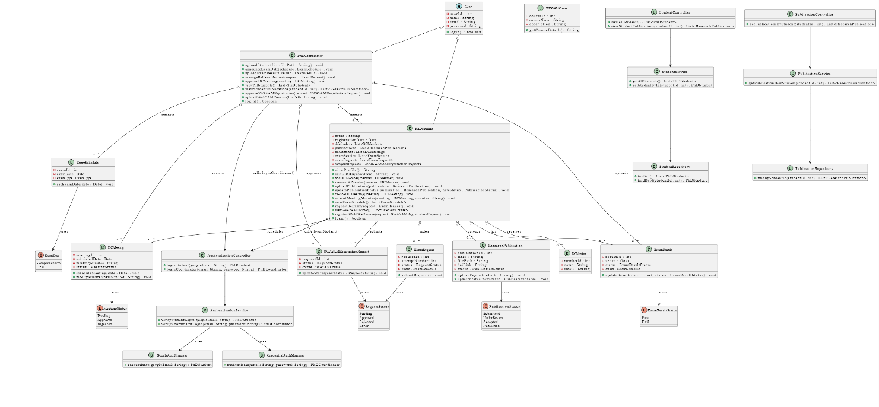

**Database Design**

