HIGH-LEVEL DESIGN

AI-Powered Retail
Operations Copilot
Punjab Sports Mart
HCLTech Future Ready AI Engineer Hackathon
Dr. B. R. Ambedkar NIT Jalandhar | 10 October 2026
A simple, evidence-grounded assistant for store operations

1. Purpose and Scope
This High-Level Design describes a small retail operations copilot for store employees and managers. It accepts a question or issue, checks safety, classifies the request, retrieves policy or business evidence when needed, recommends next steps, and routes cases that require human attention. The design uses one Python application with cooperating modules coordinated by a central orchestrator; it does not create a separate service for every agent.
Design area | Decision
Users | Cashiers, inventory associates, store managers, customer service associates, and regional managers.
Primary capabilities | Issue triage, policy lookup with citations, deterministic analysis of supplied CSV data, safe recommendations, and simulated escalation.
System boundary | Prototype uses local policy Markdown files and CSV snapshots. It does not connect to live POS, ERP, payments, CRM, inventory, or vendor systems.
AI approach | Triage, safety, workflow, and numeric analysis use deterministic Python logic. Language models are not required in the baseline design.
User experience | A lightweight Streamlit application presents the question, response, evidence, priority, and routing status.

2. Architectural Principles
- Keep one application and one runtime so the team can build and demonstrate it reliably.
- Use separate modules with clear inputs and outputs to show agents cooperating without deploying separate services.
- Run safety checks before normal processing and validate every response before display or export.
- Use policy files for operational rules and CSV calculations for business facts; do not let a model invent either.
- Route only to allowlisted data queries and simulated workflows. A person approves real-world actions.

3. High-Level Architecture
The orchestrator coordinates the request. A safety gate runs first. Safe requests go to triage, which provides category, priority, confidence, and rationale. The orchestrator then selects policy retrieval, CSV analysis, or both. A workflow agent applies escalation rules, the response composer explains supported next steps, and the validator checks the result before it is shown. Unsafe requests take the refusal and security-routing path.
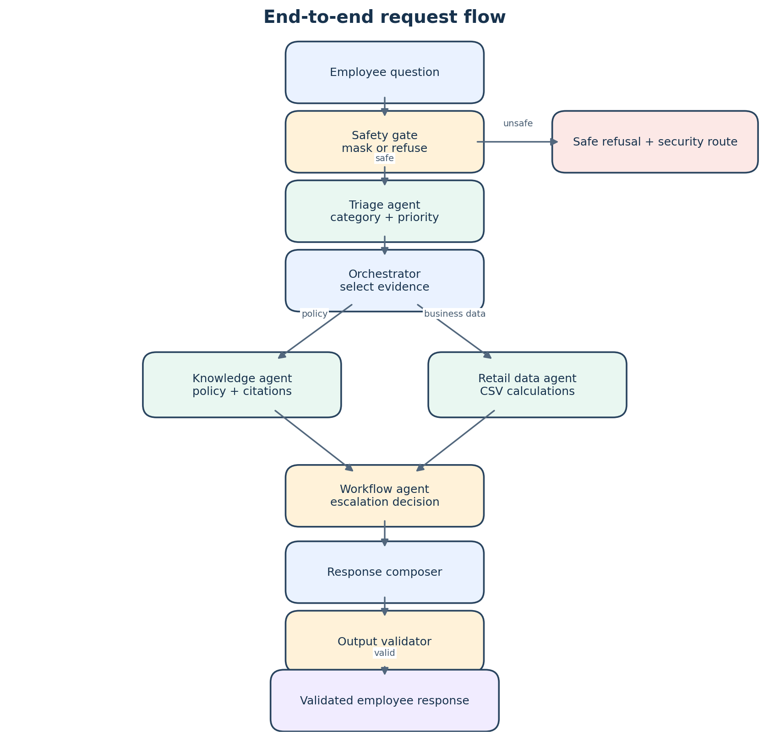
Figure 1. Request flow through the copilot.
Component | Purpose
Streamlit interface | Collects employee text and displays the validated answer and supporting details.
Central orchestrator | Coordinates modules and selects evidence paths based on triage and request intent.
Safety and triage modules | Protect sensitive information and assess the category, urgency, and confidence.
Knowledge and retail data agents | Return cited policy passages and deterministic facts from approved local files.
Workflow and response modules | Apply escalation rules, compose a grounded answer, and validate required fields.
Evaluation runner | Uses the same orchestrator for public cases and writes predictions and measured metrics.

4. Technology Stack by Layer
Layer | Technology | Role in this design
Presentation | Python, Streamlit | Simple local web UI for question entry and response display.
Application / orchestration | Python 3.11+; ordinary Python modules and functions | One process coordinates the agents and routes requests.
Safety and triage | Python standard library (regular expressions, keyword/rule matching) | PII pattern masking, restricted-request detection, category rules, priority overrides, and confidence heuristic.
Policy retrieval | Markdown files; scikit-learn TF-IDF vectorization and cosine similarity | Indexes policy sections in memory and retrieves relevant passages with source metadata.
Structured data analysis | pandas | Loads and filters supplied CSV files, performs joins, counts, and comparisons.
Workflow / validation | Python standard library; pandas for escalation matrix lookup | Applies deterministic routing, checks response fields and citation provenance, and prepares simulated ticket details.
Evaluation / outputs | Python; pandas; CSV files | Runs public test cases through the same pipeline and writes schema-aligned predictions and a metrics report.
Storage | Local Markdown, CSV, and output files; in-memory retrieval index | No database or external storage service is needed for the prototype.
Runtime / deployment | Local Python virtual environment; Streamlit local server | Runs on a developer or demo laptop. Dependencies are installed from a pinned requirements file.
External model/API | None in the baseline | Avoids API keys, network dependency, variable model output, and per-call cost in the demo.

The retrieval index is built when the application starts and retains each section’s filename and heading path. Triage confidence is a rule-based clarity score for routing, not a calibrated probability. If retrieval is weak or required records are missing, the copilot must say so and request review rather than fill gaps with guesses.

5. Agent Workflows
Each agent is a module or function in the same application. The orchestrator passes explicit results between them. The agents do not make external changes to store systems.
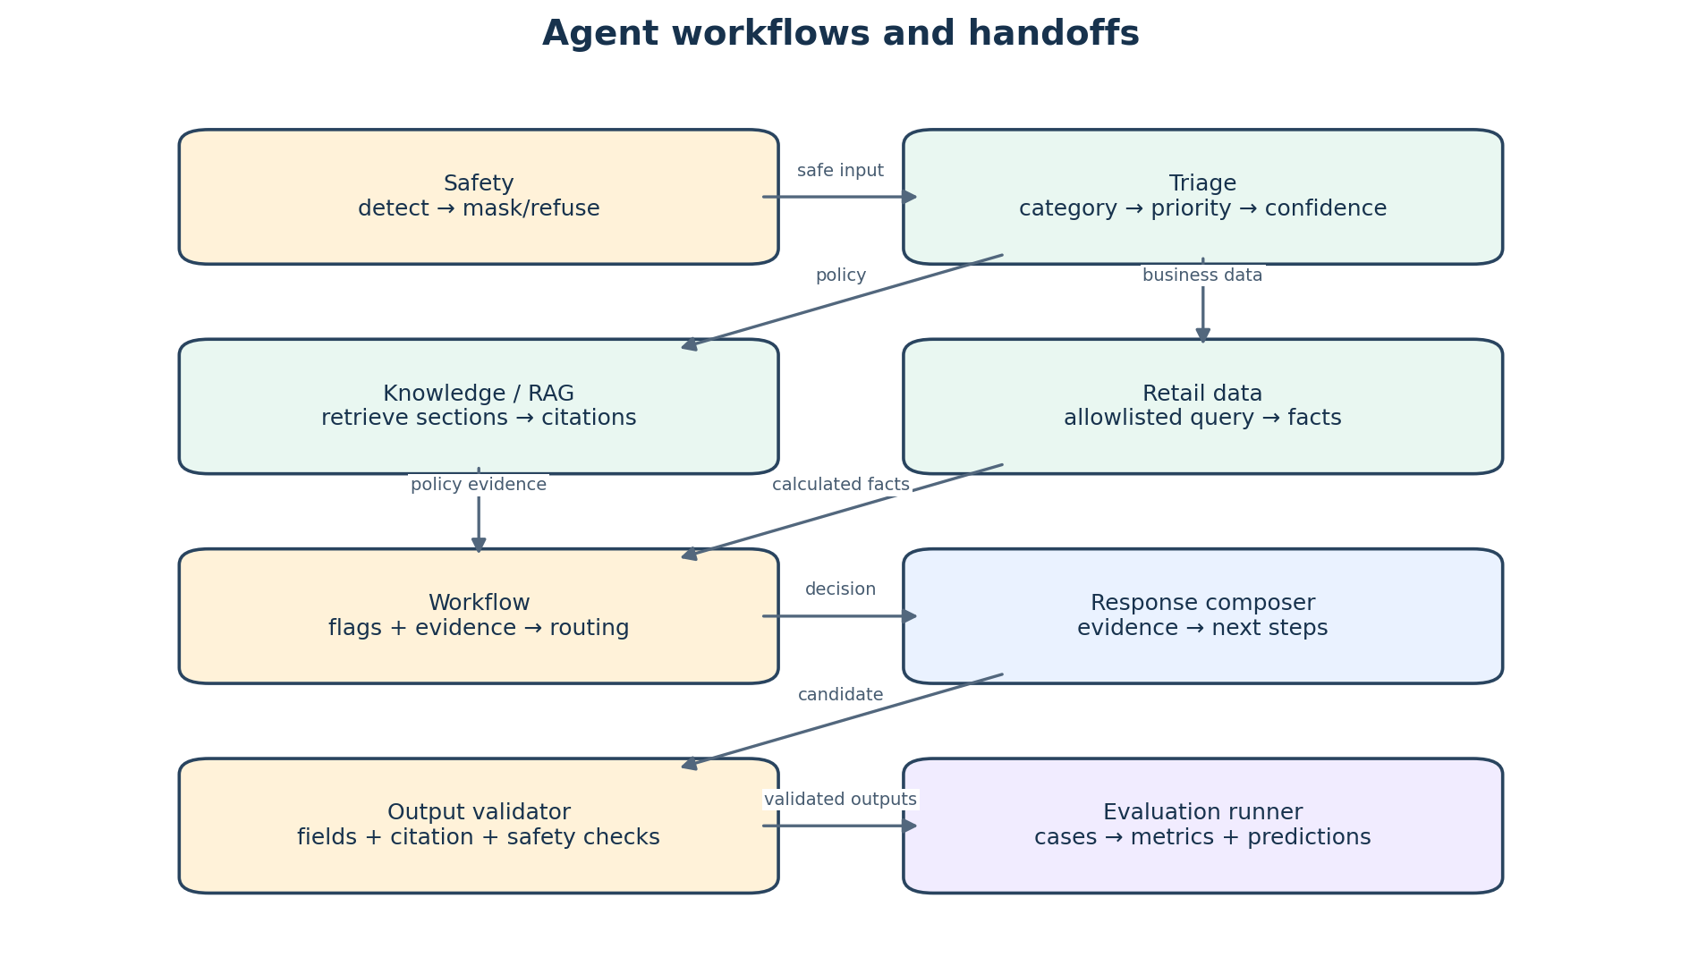
Figure 2. Individual agent steps and the information passed between them.
Agent / module | Individual workflow | Output passed onward
1. Safety agent | Receive raw question → identify requests for restricted data, prompt-injection attempts, or sensitive patterns → mask recognizable PII → either stop unsafe processing or pass safe text onward. | Safe text; masked flag; refusal flag; security escalation signal.
2. Triage agent | Receive safe text → match the exact permitted categories → inspect impact and scope → apply deterministic priority rules → estimate confidence from match strength and ambiguity → mark low-confidence cases for review. | Category; P1–P4 priority; confidence; short rationale; review signal.
3. Knowledge / RAG agent | Receive question and triage context → search indexed policy sections → select relevant passages → retain original filename and section heading → return only supported citations. | Policy passages; citations; retrieval status.
4. Retail data agent | Receive recognized intent and entities → choose an allowlisted query → read relevant CSV tables → filter/join/aggregate with pandas → report calculations and source filenames. | Computed facts; datasets used; missing-data notes.
5. Workflow / escalation agent | Receive triage, safety flags, and evidence → apply hard safety and approval rules → consult the escalation matrix → determine team, channel, and SLA where available → prepare a simulated ticket if needed. | Escalation status; destination/team; reason; simulated ticket details.
6. Response composer | Receive triage, policy passages, calculated facts, and workflow decision → summarize what is known → give practical next steps → distinguish confirmed facts from likely causes. | Candidate employee-facing response and response fields.
7. Output validator | Receive candidate response → verify allowed category/priority and required fields → check citations against indexed policy sections → check safety and escalation flags → return response or safe fallback. | Validated response or safe fallback with validation notes.
8. Evaluation runner | Read public cases → call the same orchestrator as the UI → compare outputs to expected labels and safety checks → write rows using the supplied prediction schema → calculate and report metrics. | predictions.csv and measured evaluation metrics.

5.1 Triage priority rules
Priority | Typical interpretation | Example handling
P1 | Immediate high-risk or broad-impact incident: safety hazard, security/payment exposure, or store-wide service failure. | Apply hard override and immediate human/security routing.
P2 | High-impact, repeated, or multi-customer issue without immediate danger. | Prioritize responsible manager or operations team review.
P3 | Localized routine store issue. | Provide standard troubleshooting and policy-backed steps.
P4 | General question or non-urgent guidance. | Answer with policy evidence when available.

Exact category labels and priority definitions come from the hackathon participant guide. Safety and policy rules override the rule-based classification. A low-confidence threshold such as 0.60 may trigger human review; it is a configurable heuristic until validated on labeled cases.

6. Evidence and Data Design

6.1 Policy evidence
- Read supplied Markdown policies and split them by heading section.
- Index section text with TF-IDF and retain filename and heading metadata.
- Retrieve a small number of relevant sections for a request.
- Attach citations from retrieved metadata, never from guessed filenames or generated headings.
- If no relevant section is found, state that limitation and route or ask for clarification.

6.2 Business data evidence
The retail data agent reads the supplied CSVs without modifying them. It validates file names and columns at startup and exposes fixed query functions rather than model-generated SQL or Python. Example analyses include comparing on-hand quantity with reorder point, comparing purchase-order and received quantities, reviewing vendor rates, grouping quality complaints, and filtering recent support cases. Answers name the files used and describe calculated results.
Request example | Likely data sources | Analysis
Why is a product repeatedly out of stock at a store? | product, inventory, receipts, vendor tables | Resolve SKU; compare stock and reorder point; check ordered versus received units; review vendor measures.
Which open high-priority cases arrived in the last day? | support cases; optionally store table | Filter by status, priority, and the defined time window; group by store or category.
Are product quality complaints increasing? | returns/quality; product and store tables | Count and group complaint records by reason, SKU, and store.

For time-bound test questions, the evaluation’s stated anchor timestamp is used instead of the laptop clock. If joins or required fields are unavailable, the answer reports that limitation and avoids asserting an unsupported root cause.

7. Safety, Escalation, and Human Oversight
- Check for restricted-data requests, payment/security concerns, injury, unsafe equipment, and prompt-injection attempts.
- Mask recognizable personal or payment-like data before downstream processing and avoid writing raw sensitive text to logs.
- Apply policy and approval requirements, then assess incident scope and impact.
- Use triage output for remaining classification; hard risk rules can raise priority but the model-less classifier cannot lower them.
- Escalate P1, low-confidence, restricted, conflicting-policy, and approval-required cases.
- Use the supplied escalation matrix for team, channel, and SLA when a matching route exists; otherwise route to a human manager and say routing data is missing.
- Present recommendations and simulated ticket information only. A human performs real refunds, inventory updates, and vendor communications.

8. Interface and Response
The employee sees a concise recommendation with enough context to act or escalate. The UI should display the category, priority, confidence, reason, next steps, citations, datasets used, escalation destination, and safety status. The output file must follow the actual evaluation prediction schema exactly; that schema, not an example response, controls column names, order, and value types.
Response information | Purpose
Category, priority, confidence, rationale | Explain how the issue was classified and how certain the rules are.
Answer and recommended next steps | Give actionable guidance grounded in policy or data.
Citations and data used | Show where policy statements and calculated facts came from.
Escalation and safety flags | Make review, refusal, and routing visible.
Notes | Disclose missing evidence or uncertainty.

9. Evaluation and Operational View
The batch evaluation runner and interactive UI use the same orchestrator, avoiding separate behavior in the demo and scoring path. Evaluation compares category and priority to the supplied labels, validates citation source provenance, checks data-backed responses against the CSV records, and verifies safe handling of restricted cases. Metrics are reported only after the runner calculates them; target values are not presented as achieved results before measurement.
- Category and priority accuracy on the supplied public cases.
- Citation presence and validity for policy questions.
- Safety pass rate for refusal and privacy cases.
- Data-use correctness for questions requiring CSV calculations.
- Prediction file validity against the supplied schema.

10. Deployment, Limits, and Assumptions
Topic | High-level design
Deployment | Run locally in one Python environment using Streamlit. No cloud service or network connection is required for core behavior.
Configuration | Keep data and policy paths in one documented application entry point or environment setting; use actual supplied directory names.
Security | Do not commit credentials or sensitive output. The baseline has no authentication; demo data should be the supplied dataset.
Reliability | Validate files at startup, use deterministic rules and calculations, and return a safe message when data or citations are missing.
Limitations | Static CSV snapshots; heuristic triage confidence; lightweight local retrieval; simulated escalation; no live transaction execution.
Future extensions | Calibrate confidence, add role-based access and audit logs, improve retrieval, and connect approved live systems with human authorization.

11. Summary
The proposed system is a single, understandable application: safety checks protect the request, triage determines its type and urgency, policy and data agents provide evidence, workflow applies human routing, and validation checks the answer. Python, Streamlit, pandas, and a small TF-IDF policy index provide a complete stack without separate services or a required external model. This keeps the prototype straightforward to explain and suitable for the supplied hackathon data and evaluation flow.

