Manuscript Number: TSG-02730-2025

Paper Title:
FedAvgIm: Federated Learning for Multi-Site Impedance Identification of Inverter-Based Resources

Journal: IEEE Transactions on Smart Grid
Response to editor and reviewers
Authors:
Quang Manh Hoang, Guilherme Vieira Hollweg, Akhtar Hussain, Wencong Su, Van-Hai Bui*

Dear Dr. Mahmud Fotuhi-Firuzabad
Editor in Chief
IEEE Transactions on Smart Grid

We are pleased to submit the revised manuscript entitled “FedAvgIm: Federated Learning for Multi-Site Impedance Identification of Inverter-Based Resources” for possible publication in IEEE Transactions on Smart Grid.
We would like to thank the editor and the reviewers for their careful and constructive comments. We have carefully considered all comments, and the manuscript has been thoroughly revised based on this feedback. In addition, the paper-related resources, including code, data, and simulation files, have also been provided, as detailed below.

Reviewers’ comments to the authors are presented in RED.
Authors’ responses to the reviewer’s comments are presented in BLACK.
Modifications to main manuscript are presented in BLUE.
Reviewer #1:

Comment: The authors have addressed my comments satisfactorily. I have no further questions.
Authors’ response:
We sincerely thank the reviewer for the positive assessment and for confirming that the previous comments have been satisfactorily addressed.

Reviewer #2:

Comment: The authors have adequately addressed my previous comments in the revised manuscript. The revised version clarifies the use of EMT measurement-based admittance data, removes the ambiguity regarding the trunk-head architecture, and presents the proposed method as a standard FedAvg-based framework. The additional studies on non-IID scenarios, measurement errors, and stability-assessment sensitivity further strengthen the technical validity of the work.
Overall, the manuscript has been significantly improved, and the main concerns raised in my previous review have been satisfactorily resolved. I have no further major comments.
Authors’ response:
We sincerely thank the reviewer for the careful evaluation and encouraging comments. We are glad that the revisions have clarified the EMT measurement-based admittance data, the FedAvg-based framework, and the additional studies on non-IID data, measurement errors, and stability-assessment sensitivity.

Reviewer #3:

Comment: Thanks to the authors for their revisions. My comments are addressed well.
Authors’ response and action:
We sincerely thank the reviewer for the positive feedback and for confirming that the previous comments have been addressed well.

Reviewer #4:

Authors’ response:
We thank the reviewer. We found no additional comments requiring a response.

Reviewer #5:

While the proposed federated learning framework demonstrates promising convergence and accuracy under idealized conditions, its practical viability is severely undermined by three fundamental gaps concerning data provenance, architectural generalization, and operational boundary conditions. These issues must be rigorously addressed before the manuscript can be considered for publication.
Authors’ response:
We sincerely thank the reviewer for the careful evaluation and constructive comments. We have carefully considered all the comments, and the manuscript has been revised accordingly. The detailed responses to the reviewer’s comments are provided below.
Comment #1:
1. Using simulation datasets weakens the evidence for real-world applicability. The authors are encouraged to provide additional validation using field measurements or at least hardware-in-the-loop (HIL) experiments.
Authors’ response (#1):
We agree with the reviewer that field or HIL measurements would further strengthen the evidence for real-world applicability. The present work focuses on EMT measurement-based admittance datasets, which allow controlled evaluation under different IBR parameters, measurement-noise levels, non-IID settings, and grid-strength conditions. To avoid overstating the scope of the validation, we have added a concise limitation statement noting that field/HIL validation will be pursued in future work.
Modifications in the manuscript (#1):
On page 14:
Fifth, the present validation is based on EMT measurement-based admittance datasets rather than field or HIL measurements. Future work will further evaluate FedAvgIm using HIL platforms or field-measured IBR data.
Comment #2:
2. if the global model is intended to cover broader heterogeneity, what specific metrics define the allowable boundary of parameter/structural mismatch?
Authors’ response (#2):
We thank the reviewer for this important comment. The main purpose of the global model in FedAvgIm is to improve admittance-identification performance under severe local data scarcity while preserving raw-data locality, since collecting dense admittance measurements at each local IBR site is time-consuming. We agree that, when learning across multiple IBR sites, heterogeneity in parameters and structures is unavoidable and may affect the effectiveness of a single global model.
To address this issue, we added the section “Efficiency evaluation under different non-IID levels,” where different degrees of parameter and structural heterogeneity are considered. In this study, the maximum mean discrepancy (MMD) metric is used to quantify the distributional mismatch among client datasets. In addition, worst-client MSE and per-client error dispersion are used as performance-based indicators to evaluate whether the global model remains effective for all clients or whether some clients become outliers. The results show that FedAvgIm remains beneficial under mild-to-moderate heterogeneity, but its advantage decreases under severe heterogeneity due to client drift. We have clarified this point in the limitation discussion.
Below is Section IV-E: Case 5: Efficiency evaluation under different non-IID levels.
Statistical heterogeneity, or non-IID data, is an important issue in federated learning frameworks, particularly for IBR admittance estimation, where IBRs may be provided by different vendors and may have different circuit structures. To investigate this issue, three cases (G1, G2, and G3) with different levels of non-IIDness are designed by varying the IBR topology and parameters. Specifically, G1 consists of nine IBRs with the same circuit structure but different parameters. G2 represents a mixed-topology case, in which IBR4 and IBR9 use L-filter inverters, while the remaining IBRs use LCL-filter inverters. G3 has the same topology configuration as G2 but introduces significantly larger parameter variations. The maximum mean discrepancy (MMD) metric is used to quantify the distributional discrepancy among the datasets and assess whether their distributions are similar [25]. In this study, G1 is used as the baseline case. A summary of the designed cases is shown in Table IV.
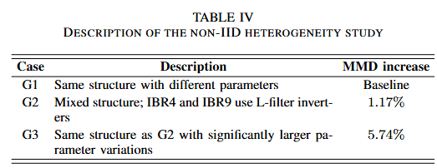
Fig. 15 evaluates the worst-client test MSE under different numbers of local epochs. For G1 and G2, increasing the number of local epochs reduces the worst-client MSE, indicating that additional local computation helps improve the performance of the most poorly performing client. This suggests that, under mild or moderate heterogeneity, increasing local training can enhance the fairness of FedAvgIm by allowing each client to better adapt to its local admittance characteristics before aggregation. However, this trend is not observed in G3. The worst-client MSE in G3 remains much higher than those in G1 and G2 for all local epoch settings, and increasing the local epoch does not lead to a consistent improvement. Since G3 has the largest parameter variations and the highest MMD increase, this result indicates that severe statistical heterogeneity can cause stronger client drift, where local models move toward different client-specific optima before aggregation. Consequently, the aggregated global model becomes less effective for the worst-performing client.
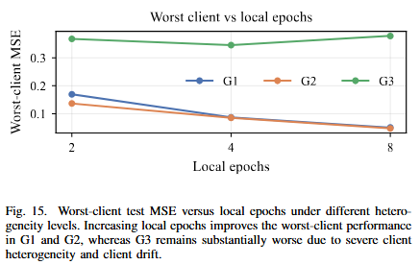
Fig. 16 compares the final test MSE of FedAvgIm and local-only training under the three heterogeneity cases. FedAvgIm consistently achieves a lower test MSE than local-only training, demonstrating the benefit of collaborative learning across IBR datasets. In G1 and G2, the improvement is substantial because the clients share relatively similar admittance characteristics, allowing the global model to learn common patterns across clients. In contrast, although FedAvgIm still outperforms local-only training in G3, the performance gap is reduced. This agrees with the MMD-based heterogeneity analysis, which shows that G3 has the largest distributional discrepancy among clients. Therefore, the results indicate that FedAvgIm is effective for improving generalization compared with isolated local training, but its advantage decreases when client heterogeneity becomes severe.
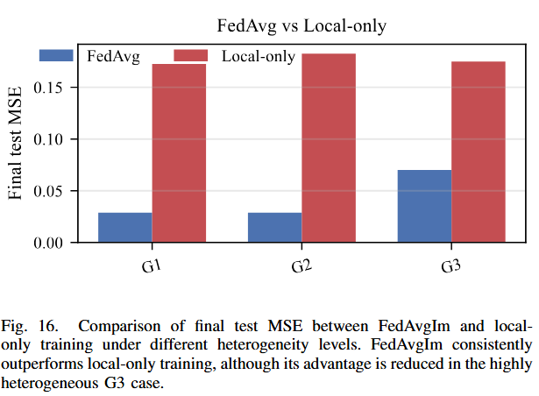
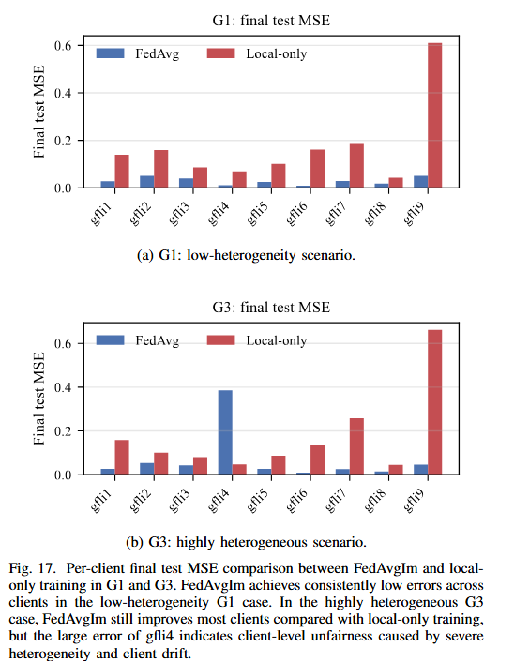
Fig. 17 compares the per-client final test MSE of FedAvgIm and local-only training in G1 and G3. In the low-heterogeneity G1 case, FedAvgIm achieves consistently low errors across nearly all clients and clearly outperforms local-only training. This demonstrates that, when IBRs share the same circuit structure and only differ in parameters, the global model learned by FedAvgIm can effectively capture common admittance characteristics across clients. By contrast, local-only training produces larger and more uneven errors, especially for gfli9, indicating that isolated training is more sensitive to limited local data and client-specific variations.
In the highly heterogeneous G3 case, FedAvgIm still pro- vides performance gains for most clients compared with local-only training, but its benefit becomes less uniform. In particular, gfli4 shows a much higher FedAvgIm test MSE than the other clients. This result suggests that strong topology and parameter heterogeneity can make some client distributions deviate significantly from the global distribution learned during aggregation. Consequently, the aggregated model may be biased toward the dominant client patterns and may not generalize well to outlier clients. This supports the observation from the worst-client analysis and the MMD-based heterogeneity study that severe non-IIDness can introduce client drift and reduce the fairness of FedAvgIm across clients.
It should be noted that a single surrogate model is unlikely to generalize across all types of inverter-based resources (IBRs), given their diverse control architectures and converter topologies. Instead, the proposed framework is intended to operate effectively across groups of IBRs with similar behavioral characteristics. To systematically address broader heterogeneity, future work should consider multi-model frameworks based on clustered federated learning or personalized federated learning [26].
Modifications in the manuscript (#2):
On page 14:
Third, a single global model may not generalize well across highly heterogeneous IBR fleets; clustered or personalized federated learning should be investigated for broader heterogeneity.
Comment #3:
3. Does grid strength affect the identification accuracy? In particular, how does the method perform under weak-grid conditions where IBR instability may occur?
Authors’ response (#3):
We thank the reviewer for this insightful comment. In general, the IBR admittance/impedance dataset can be obtained under a controlled measurement setup before the IBR is connected to a specific external grid. In such a case, the external grid strength does not directly affect the constructed admittance dataset. If the admittance is measured while the IBR is already connected to a grid, then grid strength may affect the quality of the measured data, depending on the perturbation design, signal-to-noise ratio, operating condition, and proximity to instability. This issue belongs mainly to the data-acquisition stage.
In the proposed identification framework, grid strength is not used as a direct input feature of the learning model. The model input is defined as the operating-point and frequency variables, i.e., ($V, P, Q, f$). Therefore, for a given training dataset, grid strength does not directly affect the input structure or prediction process of the admittance-identification model. Instead, the identified IBR admittance is combined with the grid impedance in the subsequent generalized Nyquist stability assessment. Thus, grid strength mainly affects the final stability-assessment stage rather than the admittance-identification model itself.
The manuscript already evaluates two grid-strength conditions in the stability-assessment case (Case 6: Application of the estimated admittance models to IBR–grid small-signal stability analysis), where the weaker-grid condition can lead to instability and the corresponding conclusion is validated by EMT time-domain simulation. However, we agree that under weak-grid or near-critical operating conditions, small admittance-estimation errors may change the stable/unstable decision because the generalized Nyquist eigenloci can be close to the critical point. To clarify this limitation, we have revised the limitation statement.
Modifications in the manuscript (#3):
On page 14:
Fourth, admittance-estimation errors can affect the final stable/unstable decision, especially under weak-grid or near-critical conditions where the generalized Nyquist eigenloci are close to the critical point, so formal error bounds and uncertainty quantification are important future directions.

