Manuscript Number: TSG-02730-2025

Paper Title:
FedAvgIm: Federated Learning for Multi-Site Impedance Identification of Inverter-Based Resources

Journal: IEEE Transactions on Smart Grid
Response to editor and reviewers
Authors:
Quang Manh Hoang, Guilherme Vieira Hollweg, Akhtar Hussain, Wencong Su, Van-Hai Bui*

Dear Dr. Mahmud Fotuhi-Firuzabad
Editor in Chief
IEEE Transactions on Smart Grid

With this cover letter, we will submit the revised manuscript entitled “FedAvgIm: Federated Learning for Multi-Site Impedance Identification of Inverter-Based Resources” for possible publication in IEEE Transactions on Smart Grid journal.
We would like to thank the editor and the reviewers for their careful and constructive comments. We have carefully considered all comments, and the manuscript has been thoroughly revised based on this feedback. In addition, the paper-related resources, including code, data, and simulation files, have also been provided, as detailed below.

Reviewer’s comments to the authors are presented in RED.
Authors’ responses to the reviewer’s comments are presented in BLACK.
Modifications to main manuscript are presented in BLUE.
Reviewer #1:

Comment #1:
1. Please clarify the privacy and threat model because federated learning alone does not guarantee privacy.
Authors’ response (#1):
We sincerely thank the reviewer for this important comment. We agree that federated learning alone does not provide formal privacy guarantees. Accordingly, we have revised the manuscript to avoid overclaiming data privacy and to clarify that the privacy benefit of FedAvgIm comes from data locality and reduced raw-data exposure, rather than from cryptographic protection or differential privacy.
We have also clarified the assumed threat model. The current work considers an honest-but-curious setting, where the cloud aggregator and participating clients are assumed to follow the FedAvg protocol but may inspect the exchanged model parameters. Under this setting, FedAvgIm keeps proprietary admittance measurements at local IBR sites and avoids centralized raw-data pooling. However, model updates may still leak information under stronger adversarial settings, such as model inversion, gradient leakage, membership inference, collusion, malicious clients, or poisoning attacks. These formal privacy and security protections are outside the scope of the current paper. We have therefore revised the manuscript to state this limitation and identify secure aggregation and differential privacy as future research directions.
Modifications on manuscript (#1):
To avoid overclaiming privacy guarantees, we revised several terms throughout the manuscript:
- “privacy-preserving” $→$ “privacy-aware” and “raw-data-locality-preserving”
- “data-privacy” $→$ “data locality” where appropriate
Page 6: It should be noted that federated learning does not inherently guarantee privacy. In the proposed FedAvgIm framework, the privacy benefit mainly arises from data locality: raw measurement data remain on local clients and are not directly shared with the central coordinator, while only model parameters are exchanged. In this work, an honest-but-curious threat model is considered, in which the cloud aggregator and clients are assumed to follow the FedAvg protocol but may inspect the exchanged model parameters. Under this setting, FedAvgIm improves data locality by keeping proprietary admittance measurements at local IBR sites and avoiding centralized raw-data pooling. However, it does not provide formal privacy guarantees against inference attacks, such as model inversion, gradient leakage, or membership inference, nor against malicious behaviors such as poisoning or collusion.
Page 13: Several limitations remain. First, federated learning does not inherently provide formal privacy guarantees; in this work, the privacy-related benefit is limited to reducing direct raw-data exposure. Formal privacy mechanisms, such as secure aggregation and differential privacy, should be integrated and investigated in future work.
Comment #2:
2. The results rely on analytically generated data so please validate performance under measurement noise and EMT scan uncertainty.
Authors’ response (#2):
We thank the reviewer for this important comment. We agree that validation under measurement noise and EMT scan uncertainty is important for demonstrating the practical relevance of the proposed framework. In the revised manuscript, we replaced the previously analytical-data-based evaluation with EMT measurement-based admittance datasets, which include measurement noise and scan-related numerical uncertainty.
In the revised setup, two small linearly independent voltage perturbations are injected at the PCC in the dq frame, each with an amplitude of 5% of the nominal voltage magnitude. The instantaneous three-phase PCC voltages and currents are measured, transformed into the dq frame, and then used to estimate the dq admittance through the frestimate function in MATLAB. Compared with the analytical dataset, this EMT measurement-based dataset better represents a black-box identification scenario, where the internal IBR parameters are unavailable and the admittance responses must be obtained from measured terminal signals.
We also added a new validation case under different measurement-noise levels. The data collection time for the nine IBR admittance datasets is approximately 7 hours for one scenario. For the full validation study, which includes four measurement-noise levels and two IBR structure settings, the total estimation time is approximately 42 hours on a laptop with a 13th Gen Intel(R) Core(TM) i5-13500HX CPU at 2.50 GHz and 16.0 GB RAM.
The new results show that, although the EMT measurement-based setting leads to slightly higher prediction errors than the analytical case, the main conclusion of the paper remains unchanged: FedAvgIm still achieves performance close to centralized training and consistently outperforms local-only learning under limited local data. We have revised all case studies accordingly.
Modifications on manuscript (#2):
On page 2: Specifically, EMT measurement-based admittance datasets are constructed for nine IBRs with different architectures, controller parameters, measurement-noise levels, and degrees of non-independent and identically distributed (non-IID) data. These EMT measurement-based datasets are used to represent the black-box identification scenario in which internal model parameters are unavailable.
On page 4:
A. Data Acquisition and Structure
As shown at the bottom of Fig. 3, admittance profiles can be obtained from EMT simulations, field devices using measurement-based methods [11], or analytical IBR mod- els [5]. In this paper, an EMT simulation-based measurement approach is adopted to validate the proposed machine- learning framework under different measurement-noise levels and frequency-scan uncertainty conditions. The accuracy of the measurement-based admittance data is evaluated in Fig. 2 by comparison with the analytical admittance model.
In this work, two small linearly independent voltage perturbations are injected at the PCC in the dq frame, each with an amplitude of 5% of the nominal voltage magnitude. A multitone frequency injection is used to reduce the measurement time. The instantaneous three-phase PCC voltages and currents are then measured and transformed into the dq frame. The dq admittance is estimated using the frestimate function in MATLAB. This procedure is applied to nine grid-following inverters, denoted as IBR1–IBR9, with different topologies, such as L- and LCL-filter inverters, and different parameter settings. The detailed configurations and EMT simulation files are provided in [23].
On page 5:
The total estimation time for the nine IBRs is approximately 7 hours on a laptop with a 13th Gen Intel(R) Core(TM) i5-13500HX CPU at 2.50 GHz and 16.0 GB RAM. For the full validation study, which requires admittance models under four different noise levels and two different IBR structures, the total estimation time is approximately 42 hours. These datasets are provided in [23]. In the federated-learning setting considered here, the datasets are stored locally at the corresponding IBR sites, and their use for decentralized training is discussed in the next subsection.
And on page 6-7:
Several evaluation cases are considered to assess the proposed framework under extremely data-scarce local IBR set- tings, noisy measurement environments, and non-IID scenarios:
- Case 1: Comparison with fully centralized training and local-only training across nine clients.
- Case 2: Impact of adding a new IBR client during training.
- Case 3: Comparison with transfer learning under strict data-locality constraints.
- Case 4: Evaluation under measurement-noise conditions.
- Case 5: Efficiency evaluation under different non-IID levels.
- Case 6: Application of the estimated admittance models to IBR–grid small-signal stability analysis.
Specifically, the datasets used in Cases 1–4 are obtained from nine IBRs with the same topology but different parameter settings. In Case 5, some IBRs are modified from LCL-filter to L-filter configurations to introduce stronger physical heterogeneity and evaluate the framework under more pronounced non-IID conditions.
On page 9:
D. Case 4: Evaluation under measurement-noise conditions
In this scenario, four levels of white measurement noise (0%, 1%, 2%, and 3%) are applied to the voltage and current measurements before the admittance profiles are estimated. The total time required for the data collection process is approximately 28 hours.
As shown in Tab. III and Fig. 14, the proposed framework maintains stable learning behavior under all tested measurement-noise levels. In the noise-free case, FedAvgIm achieves a test MSE of 0.0408 and a physical prediction accuracy of 89.52%. When the noise level increases to 1%, the accuracy remains nearly unchanged at 89.01%, indicating that the proposed framework is insensitive to mild measurement noise. As the noise level further increases to 2% and 3%, the physical prediction accuracy gradually decreases to 86.86% and 83.69%, respectively. This trend is expected because noise in the measured voltage and current signals affects the quality of the estimated admittance labels. Nevertheless, FedAvgIm still retains more than 83% physical prediction accuracy even under the highest tested noise level, demonstrating its robustness in noisy measurement environments.
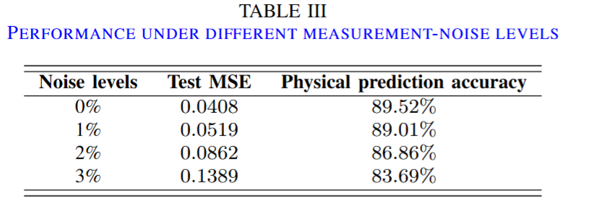
Fig. 14 further illustrates the convergence behavior of FedAvgIm under different measurement-noise levels using the physical prediction accuracy metric. The accuracy is computed after inverse-transforming the predicted admittance responses back to physical units and evaluating the normalized prediction error. Although higher noise levels lead to lower final accuracy, all learning curves converge smoothly within approximately 150 communication rounds. This indicates that measurement noise mainly affects the attainable prediction accuracy rather than destabilizing the federated training process. Overall, the results show that FedAvgIm provides stable and robust admittance identification performance under noisy measurement conditions.
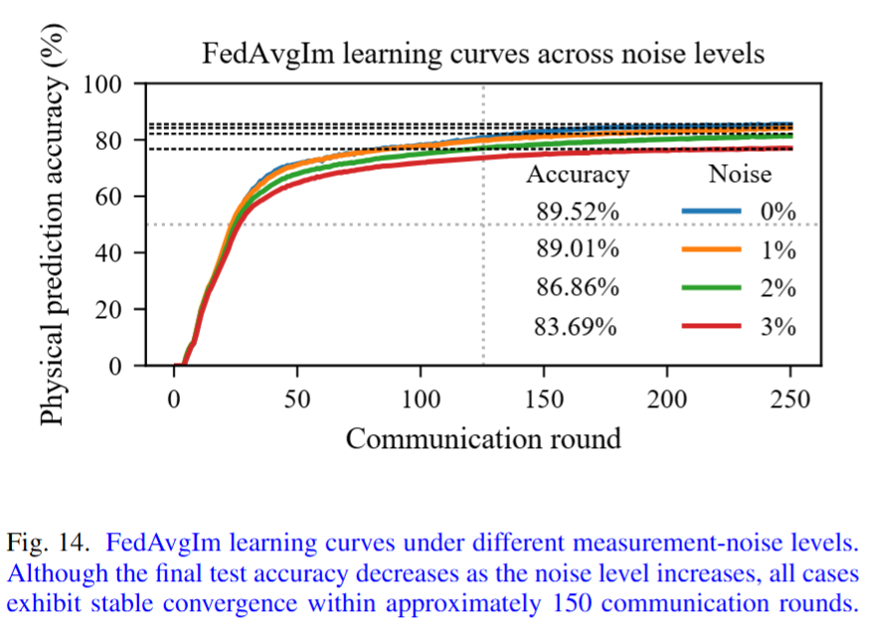
Comment #3:
3. Please quantify client heterogeneity and test FedAvgIm under more severe non IID distributions.
Authors’ response (#3):
We thank the reviewer for this valuable comment. We agree that client heterogeneity should be quantified and that the proposed FedAvgIm framework should be further evaluated under more severe non-IID conditions. In the revised manuscript, we added a new case study, Case 5: Evaluation under different non-IID levels, to explicitly quantify client heterogeneity and assess the performance of FedAvgIm under increasingly heterogeneous IBR datasets.
Specifically, we designed three non-IID scenarios, denoted as G1, G2, and G3, by varying both the IBR topology and parameter distributions. G1 is the baseline case, where all nine IBRs have the same circuit and control structure but different parameters. G2 introduces stronger physical heterogeneity by replacing IBR4 and IBR9 with L-filter inverters, while the remaining IBRs use LCL-filter inverters. G3 uses the same mixed-topology configuration as G2 but further increases the parameter variations to create a more severe non-IID setting.
To quantify the degree of client heterogeneity, we added the maximum mean discrepancy (MMD) metric, which measures the distributional discrepancy among client datasets. Using G1 as the baseline, the MMD increase is 1.17% for G2 and 5.74% for G3, confirming that G3 represents the most heterogeneous setting. These values are summarized in the newly added Table IV.
We also evaluated FedAvgIm under these three non-IID levels and compared it with local-only training. The revised results show that FedAvgIm consistently outperforms local-only training in all three cases, demonstrating the benefit of collaborative learning. However, the improvement becomes smaller under the highly heterogeneous G3 setting. In particular, the worst-client analysis shows that G3 has a much higher worst-client MSE, and increasing the number of local epochs does not consistently improve performance. This indicates stronger client drift, where local models move toward different client-specific optima before aggregation. The per-client results further show that the global model performs less uniformly in G3, especially for the outlier client gfli4.
Therefore, the revised manuscript now makes a more balanced conclusion: FedAvgIm is effective under mild and moderate non-IID settings and still improves most clients under severe non-IID conditions, but its advantage decreases when topology and parameter heterogeneity become too strong. We also added a limitation statement that a single global surrogate model may not generalize well across all IBR types, and that clustered federated learning or personalized federated learning should be investigated in future work.
These revisions are reflected in Case 5, Table IV, Fig. 15, Fig. 16, and Fig. 17 of the revised manuscript.
Modifications on manuscript (#3):
On page 7: We revised the evaluation section to include a new non-IID study:
Several evaluation cases are considered to assess the proposed framework under extremely data-scarce local IBR settings, noisy measurement environments, and non-IID scenarios:
...
Case 5: Efficiency evaluation under different non-IID levels.
We also clarified the dataset setting:
Specifically, the datasets used in Cases 1–4 are obtained from nine IBRs with the same topology but different parameter settings. In Case 5, some IBRs are modified from LCL-filter to L-filter configurations to introduce stronger physical heterogeneity and evaluate the framework under more pronounced non-IID conditions.
On page 10-11: We added the heterogeneity quantification and efficiency evaluation under different non-IID levels:
Statistical heterogeneity, or non-IID data, is an important issue in federated learning frameworks, particularly for IBR admittance estimation, where IBRs may be provided by different vendors and may have different circuit structures. To investigate this issue, three cases (G1, G2, and G3) with different levels of non-IIDness are designed by varying the IBR topology and parameters. Specifically, G1 consists of nine IBRs with the same circuit structure but different parameters. G2 represents a mixed-topology case, in which IBR4 and IBR9 use L-filter inverters, while the remaining IBRs use LCL-filter inverters. G3 has the same topology configuration as G2 but introduces significantly larger parameter variations. The maximum mean discrepancy (MMD) metric is used to quantify the distributional discrepancy among the datasets and assess whether their distributions are similar. In this study, G1 is used as the baseline case. A summary of the designed cases is shown in Table IV.
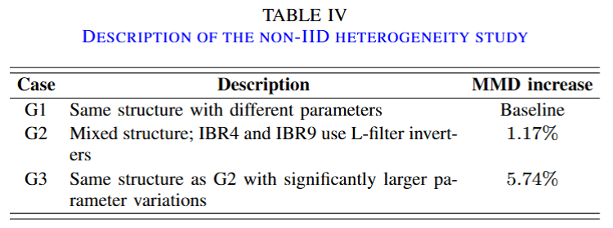
Fig. 15 evaluates the worst-client test MSE under different numbers of local epochs. For G1 and G2, increasing the number of local epochs reduces the worst-client MSE, indicating that additional local computation helps improve the performance of the most poorly performing client. This suggests that, under mild or moderate heterogeneity, increasing local training can enhance the fairness of FedAvg by allowing each client to better adapt to its local admittance characteristics before aggregation. However, this trend is not observed in G3. The worst-client MSE in G3 remains much higher than those in G1 and G2 for all local epoch settings, and increasing the local epoch does not lead to a consistent improvement. Since G3 has the largest parameter variations and the highest MMD increase, this result indicates that severe statistical heterogeneity can cause stronger client drift, where local models move toward different client-specific optima before aggregation. Consequently, the aggregated global model becomes less effective for the worst-performing client.
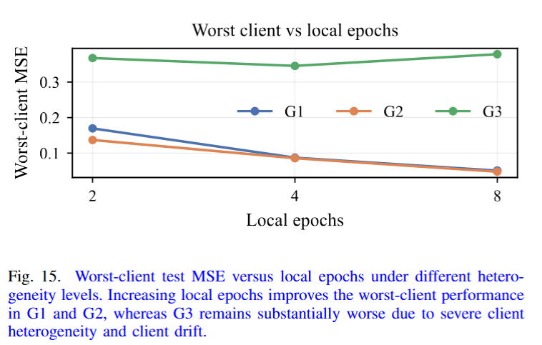
Fig. 16 compares the final test MSE of FedAvg and local- only training under the three heterogeneity cases. FedAvg consistently achieves a lower test MSE than local-only training, demonstrating the benefit of collaborative learning across IBR datasets. In G1 and G2, the improvement is substantial because the clients share relatively similar admittance characteristics, allowing the global model to learn common patterns across clients. In contrast, although FedAvg still outperforms local- only training in G3, the performance gap is reduced. This agrees with the MMD-based heterogeneity analysis, which shows that G3 has the largest distributional discrepancy among clients. Therefore, the results indicate that FedAvg is effective for improving generalization compared with isolated local training, but its advantage decreases when client heterogeneity becomes severe.
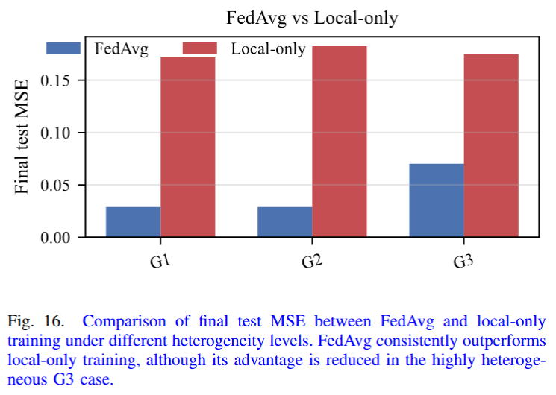
Fig. 17 compares the per-client final test MSE of FedAvg and local-only training in G1 and G3. In the low-heterogeneity G1 case, FedAvg achieves consistently low errors across nearly all clients and clearly outperforms local-only training. This demonstrates that, when IBRs share the same circuit structure and only differ in parameters, the global model learned by FedAvg can effectively capture common admittance characteristics across clients. By contrast, local-only training produces larger and more uneven errors, especially for gfli9, indicating that isolated training is more sensitive to limited local data and client-specific variations.

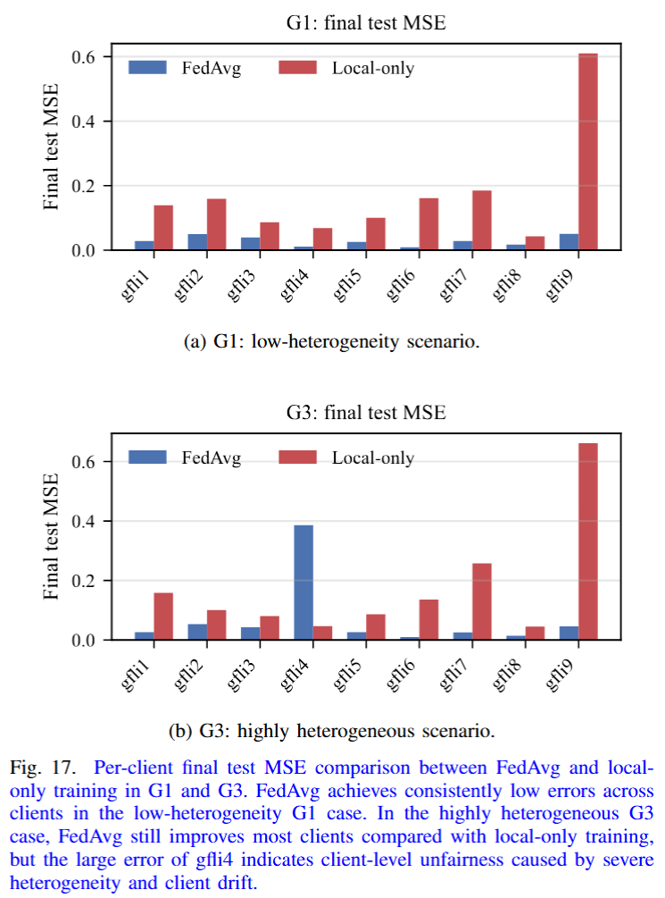
In the highly heterogeneous G3 case, FedAvg still provides performance gains for most clients compared with local-only training, but its benefit becomes less uniform. In particular, gfli4 shows a much higher FedAvg test MSE than the other clients. This result suggests that strong topology and parameter heterogeneity can make some client distributions deviate significantly from the global distribution learned during aggregation. Consequently, the aggregated model may be biased toward the dominant client patterns and may not generalize well to outlier clients. This supports the observation from the worst-client analysis and the MMD-based heterogeneity study that severe non-IIDness can introduce client drift and reduce the fairness of FedAvg across clients.
It should be noted that a single surrogate model is unlikely to generalize across all types of inverter-based resources (IBRs), given their diverse control architectures and converter topologies. Instead, the proposed framework is intended to operate effectively across groups of IBRs with similar behavioral characteristics. To systematically address broader heterogeneity, future work should consider multi-model frameworks based on clustered federated learning or personalized federated learning [25].
On pages 11 and 13:
We also added the limitations and future direction:
It should be noted that a single surrogate model is unlikely to generalize across all types of inverter-based resources (IBRs), given their diverse control architectures and converter topologies. Instead, the proposed framework is intended to operate effectively across groups of IBRs with similar behavioral characteristics. To systematically address broader heterogeneity, future work should consider multi-model frameworks based on clustered federated learning or personalized federated learning [25].
and
Finally, although this study focuses on grid-following inverters, future work will extend the framework to broader IBR heterogeneity, including grid-forming inverters, clustered federated learning, and personalized federated-learning strategies.
Comment #4:
4. Please report communication overhead including model size number of rounds and total uplink and downlink cost to support practicality claims.
Authors’ response (#4):
We thank the reviewer for this helpful comment. We agree that the communication overhead should be quantified to better support the practicality of the proposed FedAvgIm framework. In the revised manuscript, we added compact communication and computational overhead analysis after Table II.
Specifically, the FNN used in FedAvgIm has 824 trainable parameters. Assuming 32-bit floating-point transmission, the model size is approximately 3.30 kB. In each communication round, each selected client downloads the global model and uploads the locally updated model. Under the full-participation setting used in this work, with nine clients and 250 communication rounds, the total communication volume is approximately 7.42 MB uplink, 7.42 MB downlink, and 14.83 MB in total.
We also clarified the communication tradeoff. Compared with local-only learning, FedAvgIm introduces additional model-exchange communication, but it enables cross-site learning without raw-data pooling. Compared with centralized learning, FedAvgIm avoids transferring proprietary raw admittance datasets to a central server, at the cost of repeated lightweight model-parameter exchange.
Modifications on manuscript (#4):
On page 6: We added a new paragraph titled Communication and computational overhead:
The communication cost of FedAvgIm is determined by the size of the exchanged FNN parameters [24]. For the FNN in Table II, the number of trainable parameters is |w| = (4 × 32 + 32) + (32 × 16 + 16) + (16 × 8 + 8) = 824. Assuming 32-bit floating-point parameters, the model size is approximately 3.30 kB. In each communication round, each selected client downloads the global model and uploads the locally updated model. Therefore, under the full-participation setting used in this work with nine clients and 250 communication rounds, the total communication volume is approximately 7.42 MB uplink, 7.42 MB downlink, and 14.83 MB in total. Compared with local-only learning, FedAvgIm introduces additional model-exchange communication, but enables cross- site learning without raw-data pooling. Compared with centralized learning, FedAvgIm avoids transferring proprietary raw admittance datasets to a central server, at the cost of repeated lightweight model-parameter exchange.
Comment #5:
5. Please extend the stability validation to multiple operating points and report the stability decision consistency.
Authors’ response (#5):
We thank the reviewer for this helpful suggestion. We agree that validating the estimated admittance model at only one operating point is not sufficient to demonstrate its usefulness for stability assessment. In the revised manuscript, we have extended the stability validation to multiple operating points and explicitly reported the stability decision consistency between the admittance-based generalized Nyquist assessment and EMT time-domain simulations.
Specifically, in the revised Case 6, we evaluate the estimated dq-admittance model of IBR1 at five operating points, including different active and reactive power conditions: [1.0,0.0], [0.5,0.0], [0.8,0.0], [0.8,0.6], and [0.8,−0.6] p.u. These operating points are tested under two grid-impedance conditions, $Z_{g1} and Z_{g2}=1.3Z_{g1}$, representing the nominal and weaker-grid cases, respectively.
To quantify the consistency of the stability decisions, we compare the predicted stability results obtained from the estimated admittance models with the reference results obtained from EMT time-domain simulations. The revised Table VI reports 30 stability decisions, covering three admittance-error levels, five operating points, and two grid conditions. The 0% error case corresponds to the measurement-based admittance reference, while the 10% and 13% error cases represent approximate prediction-error levels obtained from FedAvgIm under different measurement-noise conditions.
The results show that the measurement-based admittance achieves 100% agreement with the EMT reference in the 0% error case. For the estimated admittance models, the 10% error case achieves 80% agreement, while the 13% error case achieves 90% agreement. Overall, 27 out of 30 stability decisions are consistent with the EMT reference results. These results demonstrate that the estimated admittance models can support stability screening across multiple operating points, while also showing that stability decisions may become sensitive when the generalized Nyquist eigenloci are close to the critical point (−1+j0).
We further added Nyquist plots and EMT time-domain validation to support this conclusion. In particular, Fig. 19 shows that under $Z_{g1}$, the Nyquist eigenloci do not encircle the critical point, indicating stable operation, whereas under the weaker grid $Z_{g2}$, the eigenlocus encircles the critical point, indicating instability. Fig. 20 confirms this result using EMT simulations, where the PCC voltage and current remain bounded under $Z_{g1}$ but exhibit growing oscillations under $Z_{g2}$. These additions strengthen the practical validation of FedAvgIm for impedance-based stability assessment.
Modifications on manuscript (#5):
On pages 11, 12, 13: In this case study, the estimated dq-admittance model of IBR1 obtained under the measurement-noise conditions in Case 4 is used for stability assessment. Five operating points, listed in Tab. V, are evaluated under two grid conditions, denoted by $Z_{g1}$ and $Z_{g2}= 1.3Z_{g1}$, and under different prediction-error levels. Since the estimated admittance is available at 20 discrete frequency points, the admittance samples are denoted by Y IBR(k), and the corresponding eigenvalues $λ_{1}(k)$ and $λ_{2}(k)$ are computed for k = 1, . . . , 20. These frequency-indexed eigenvalues are then used to form the Nyquist eigenloci for assessing the consistency between the predicted and actual stability conclusions.
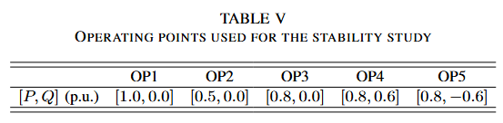
The stability prediction results are reported in Tab. VI, where 30 stability predictions are compared with the reference results obtained from EMT time-domain simulations. The 0% error level corresponds to the measurement-based admittance data used as the reference case. The 10% and 13% error levels represent the approximate admittance prediction errors obtained from the FedAvgIm framework under different measurement-noise conditions.
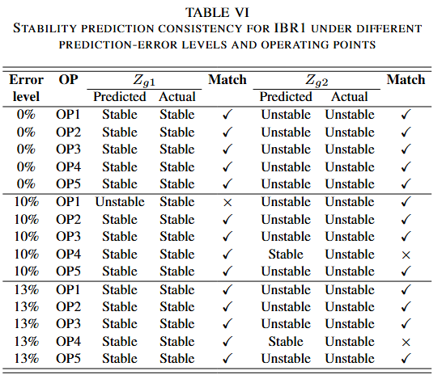
Under different operating points and grid conditions, the measurement-based admittance provides fully consistent stability predictions in the 0% error case, achieving 100% agreement with the EMT reference results. When admittance models with approximately 10% prediction error are used, two out of ten stability decisions are inconsistent with the EMT reference, resulting in an 80% agreement rate. When the prediction error increases to approximately 13%, only one out of ten stability decisions is inconsistent, corresponding to a 90% agreement rate. Overall, 27 out of the 30 stability predictions are consistent with the EMT reference results.
The non-monotonic relationship between admittance pre- diction error and stability-prediction accuracy is mainly due to the location of the generalized Nyquist eigenloci relative to the critical point (−1+j0). For some operating points and grid conditions, the eigenloci are very close to the critical point. As a result, small admittance-estimation errors can shift the eigenloci across the critical point and change the predicted stability conclusion. This behavior is illustrated in Fig. 18, where the 10% prediction-error case leads to an incorrect encirclement of the critical point, whereas the 13% prediction- error case remains consistent with the EMT reference. Therefore, the impact of admittance-estimation error on stability assessment is not strictly monotonic, but depends on how the error perturbs the eigenloci relative to the critical point.
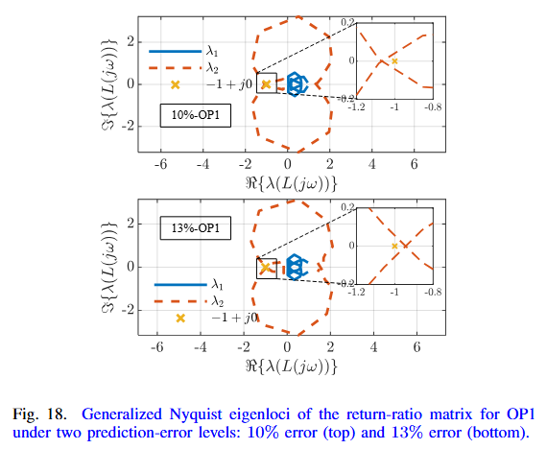
Fig. 19 shows the generalized Nyquist eigenloci derived from the estimated admittance of IBR1 at OP1 with a 13% prediction error. The two eigenvalues of the return-ratio matrix are evaluated under two grid-impedance scenarios: $Z_{g1}$ and $Z_{g2}$, where $Z_{g2} = 1.3Z_{g1}$ represents a weaker grid condition. Under $Z_{g1}$, the Nyquist eigenloci do not encircle the critical point (−1+j0), indicating stable operation. Under the weaker grid condition $Z_{g2}$, the Nyquist eigenlocus of $λ_{2}$ encircles the critical point, indicating instability.
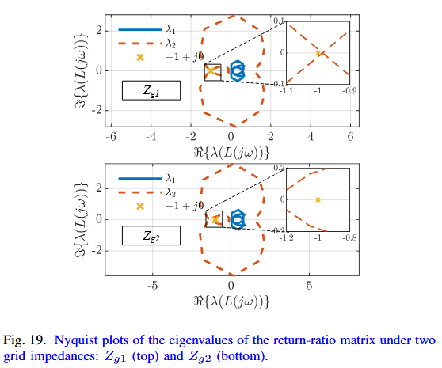
To validate this conclusion, two EMT time-domain simulations are performed separately in MATLAB/Simulink for the two grid-impedance scenarios using the same configuration as in Fig. 1. The PCC voltage and current responses are shown in Fig. 20. Under $Z_{g1}$, the PCC voltage and current responses remain bounded, confirming stable operation. In contrast, under the weaker-grid scenario \(Z_{g2}\), the PCC voltage exhibits rapidly growing oscillations, indicating instability. These EMT results are consistent with the generalized Nyquist assessment based on the estimated admittance model of IBR1.
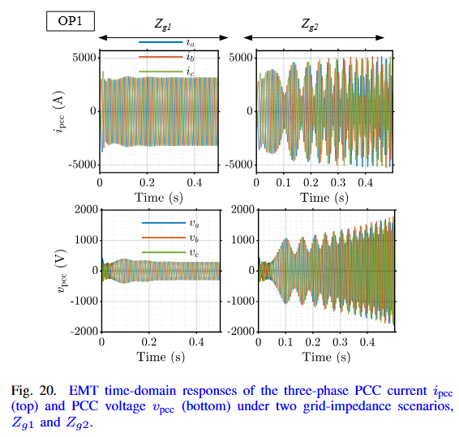
Comment #6:
6. The paper uses impedance identification while the model outputs admittance so please unify the terminology for consistency.
Authors’ response (#6):
We thank the reviewer for pointing out this terminology inconsistency. We agree that using “impedance identification” while the proposed model directly outputs admittance may cause confusion. In the revised manuscript, we have carefully revised the terminology to make the learning target and model output consistent.
Specifically, the proposed FedAvgIm model is now described as a dq-admittance identification/learning framework, because the neural network maps the input $(V,P,Q,f)$to the stacked real and imaginary parts of the dq-admittance matrix entries. Therefore, terms such as “impedance model output” and “impedance learning target” have been revised to “admittance model output” and “admittance learning target” where appropriate.
At the same time, we keep the term impedance/admittance in several background discussions because both representations are commonly used in the literature and are mathematically related. We also keep impedance-based stability analysis because this is the standard terminology for the generalized Nyquist stability framework, even though the return-ratio matrix in this work is constructed using the estimated IBR admittance and the grid admittance/impedance representation.
Thus, the revised manuscript now distinguishes three cases more clearly:
1. The learning target is dq-admittance.
2. The measurement/modeling background may refer to impedance/admittance because both forms are used in prior work.
3. The stability application is referred to as impedance-based stability analysis, consistent with standard terminology.
These revisions improve consistency while preserving the conventional terminology used in power-electronics stability analysis. The manuscript now explicitly states that dq-admittance is used as the learning target and that the corresponding impedance can be obtained if needed.
Modifications on manuscript (#6):
We changed the title of the manuscript: FedAvgIm: Federated Learning for Multi-Site Impedance/Admittance Identification of Inverter-Based Resources
On page 4: We clarified the following statement:
Although dq-admittance is used as the learning target in this work, the corresponding impedance can be obtained when needed.
On page 11: We clarified that the estimated model used in the stability study is the dq-admittance model of IBR1:
In this case study, the estimated dq-admittance model of IBR1 obtained under the measurement-noise conditions in Case 4 is used for stability assessment.

Reviewer #2:

The manuscript proposes a FedAvgIm to address data scarcity and privacy protection in the impedance identification of IBRs. While the application of decentralized learning to this domain is noted, the study relies on a fundamental methodological contradiction: utilizing analytical models to generate training data for a problem specifically motivated by the need for "black-box" identification. This logical disconnect, combined with the restrictive assumption that all participating IBRs share an identical small-signal structure, significantly limits the practical engineering value and generalization of the proposed framework. These core issues, along with concerns regarding model architecture and error sensitivity, must be addressed. The specific comments are as follows.
Authors’ response and action:
We would like to thank the reviewer for the insightful comments, which have significantly strengthened our manuscript. We have made our best effort to address all of the comments, and our responses are provided below.
Comment #1:
1. The primary motivation stated in the Introduction is to identify impedance for "black-box" inverters where internal parameters are unknown. However, in Section III-A, the authors state that the training datasets are generated using analytical models based on the component-connection method. If the analytical models are already available to generate the training data, there is no engineering need to train a Neural Network to "identify" the impedance. The authors should either justify this approach or, more preferably, validate the framework using measurement-based data to faithfully represent the "black-box" scenario described in the motivation.
Authors’ response (#1):
We sincerely thank the reviewer for this important comment. We agree that using analytically generated datasets is not fully aligned with the black-box motivation of the paper. In the revised manuscript, we have therefore replaced the previous analytical-model-based datasets with EMT measurement-based admittance datasets to more faithfully represent the black-box scenario where the internal IBR control structure and parameters are unavailable.
Specifically, the revised data-generation procedure no longer relies on using the component-connection analytical model as the training-data source. Instead, each IBR is treated as a black-box system in EMT simulation. Small voltage perturbations are injected at the PCC in the dq frame, and the terminal three-phase PCC voltages and currents are measured. These signals are then transformed into the dq frame, and the dq-admittance matrix is estimated from the measured responses using MATLAB frestimate. In this way, the training labels are obtained from input-output terminal behavior rather than from internal analytical parameters.
We retain the analytical admittance model only as a reference to evaluate the accuracy of the EMT measurement-based admittance data, as shown in Fig. 2. This comparison is used to verify that the measurement-based extraction procedure provides reasonable admittance profiles, not to generate the training data. The revised framework is therefore consistent with the intended black-box setting: the machine-learning model is trained from sparse EMT measurement-based admittance samples while the internal model parameters remain unavailable.
We also revised the performance evaluation accordingly. The revised manuscript now evaluates FedAvgIm using EMT measurement-based datasets for nine IBRs, including different controller/filter parameters, measurement-noise levels, and non-IID settings. Additional validation under measurement noise is also added to further reflect practical measurement uncertainty. The revised results show that, although the EMT measurement-based setting introduces scan-related uncertainty and slightly higher prediction errors compared with the previous analytical setting, the main conclusion remains unchanged: FedAvgIm achieves performance close to centralized training and consistently outperforms local-only learning under severe local data scarcity.
Modifications on manuscript (#1):
On page 2: Specifically, EMT measurement-based admittance datasets are constructed for nine IBRs with different architectures, controller parameters, measurement-noise levels, and degrees of non-independent and identically distributed (non-IID) data. These EMT measurement-based datasets are used to represent the black-box identification scenario in which internal model parameters are unavailable.
On page 4:
A. Data Acquisition and Structure
As shown at the bottom of Fig. 3, admittance profiles can be obtained from EMT simulations, field devices using measurement-based methods [11], or analytical IBR mod- els [5]. In this paper, an EMT simulation-based measurement approach is adopted to validate the proposed machine- learning framework under different measurement-noise levels and frequency-scan uncertainty conditions. The accuracy of the measurement-based admittance data is evaluated in Fig. 2 by comparison with the analytical admittance model.
In this work, two small linearly independent voltage perturbations are injected at the PCC in the dq frame, each with an amplitude of 5% of the nominal voltage magnitude. A multitone frequency injection is used to reduce the measurement time. The instantaneous three-phase PCC voltages and currents are then measured and transformed into the dq frame. The dq admittance is estimated using the frestimate function in MATLAB. This procedure is applied to nine grid-following inverters, denoted as IBR1–IBR9, with different topologies, such as L- and LCL-filter inverters, and different parameter settings. The detailed configurations and EMT simulation files are provided in [23].
On page 5:
The total estimation time for the nine IBRs is approximately 7 hours on a laptop with a 13th Gen Intel(R) Core(TM) i5-13500HX CPU at 2.50 GHz and 16.0 GB RAM. For the full validation study, which requires admittance models under four different noise levels and two different IBR structures, the total estimation time is approximately 42 hours. These datasets are provided in [23]. In the federated-learning setting considered here, the datasets are stored locally at the corresponding IBR sites, and their use for decentralized training is discussed in the next subsection.
And on page 6-7:
Several evaluation cases are considered to assess the proposed framework under extremely data-scarce local IBR set- tings, noisy measurement environments, and non-IID scenarios:
- Case 1: Comparison with fully centralized training and local-only training across nine clients.
- Case 2: Impact of adding a new IBR client during training.
- Case 3: Comparison with transfer learning under strict data-locality constraints.
- Case 4: Evaluation under measurement-noise conditions.
- Case 5: Efficiency evaluation under different non-IID levels.
- Case 6: Application of the estimated admittance models to IBR–grid small-signal stability analysis.
Specifically, the datasets used in Cases 1–4 are obtained from nine IBRs with the same topology but different parameter settings. In Case 5, some IBRs are modified from LCL-filter to L-filter configurations to introduce stronger physical heterogeneity and evaluate the framework under more pronounced non-IID conditions.
On page 9:
D. Case 4: Evaluation under measurement-noise conditions
In this scenario, four levels of white measurement noise (0%, 1%, 2%, and 3%) are applied to the voltage and current measurements before the admittance profiles are estimated. The total time required for the data collection process is approximately 28 hours.
As shown in Tab. III and Fig. 14, the proposed framework maintains stable learning behavior under all tested measurement-noise levels. In the noise-free case, FedAvgIm achieves a test MSE of 0.0408 and a physical prediction accuracy of 89.52%. When the noise level increases to 1%, the accuracy remains nearly unchanged at 89.01%, indicating that the proposed framework is insensitive to mild measurement noise. As the noise level further increases to 2% and 3%, the physical prediction accuracy gradually decreases to 86.86% and 83.69%, respectively. This trend is expected because noise in the measured voltage and current signals affects the quality of the estimated admittance labels. Nevertheless, FedAvgIm still retains more than 83% physical prediction accuracy even under the highest tested noise level, demonstrating its robustness in noisy measurement environments.

Fig. 14 further illustrates the convergence behavior of FedAvgIm under different measurement-noise levels using the physical prediction accuracy metric. The accuracy is computed after inverse-transforming the predicted admittance responses back to physical units and evaluating the normalized prediction error. Although higher noise levels lead to lower final accuracy, all learning curves converge smoothly within approximately 150 communication rounds. This indicates that measurement noise mainly affects the attainable prediction accuracy rather than destabilizing the federated training process. Overall, the results show that FedAvgIm provides stable and robust admittance identification performance under noisy measurement conditions.

Comment #2:
2. The manuscript assumes that the nine participating IBRs "share the same small-signal structure but differ in their parameters". In practical multi-site smart grids, IBRs are highly heterogeneous, involving different vendors, topologies and control strategies. The standard FedAvg algorithm often struggles with non-IID data arising from such structural heterogeneity. The authors need to discuss the applicability of FedAvgIm in a realistic environment with mixed IBR structures. A discussion on this limitation is necessary to align the contribution with practical grid conditions.
Authors’ response (#2):
We sincerely thank the reviewer for this insightful comment. We agree that practical multi-site smart grids may include IBRs from different vendors with different converter topologies, filter structures, and control settings. We also agree that standard FedAvg can suffer from client drift and reduced fairness under strong non-IID distributions caused by such structural heterogeneity.
To address this concern, we have revised the manuscript by adding a dedicated non-IID heterogeneity study in Case 5. In this new case study, we no longer restrict all clients to the same structure. Instead, we design three scenarios with increasing heterogeneity:
- G1: all nine IBRs have the same circuit and control structure but different parameters.
- G2: a mixed-topology setting, where IBR4 and IBR9 use L-filter inverters, while the remaining IBRs use LCL-filter inverters.
- G3: the same mixed-topology setting as G2, but with significantly larger parameter variations.
To quantify the degree of heterogeneity, we added the maximum mean discrepancy (MMD) metric. Using G1 as the baseline, the MMD increase is 1.17% for G2 and 5.74% for G3. These results are summarized in the newly added Table IV. The revised results show that FedAvgIm still outperforms local-only training in all three scenarios, indicating that collaborative learning remains useful even under mixed IBR structures. However, the benefit of FedAvgIm decreases as heterogeneity becomes more severe. In particular, in the highly heterogeneous G3 case, the worst-client MSE remains much higher than in G1 and G2, and increasing the number of local epochs does not consistently improve the worst-client performance. This behavior indicates stronger client drift, where local models move toward different client-specific optima before aggregation. The per-client results also show that FedAvgIm becomes less uniform in G3, especially for the outlier client gfli4.
We therefore revised the manuscript to make the applicability and limitation clearer. FedAvgIm is intended to work best for groups of IBRs with similar behavioral characteristics, even if their parameters and some filter structures differ. However, we do not claim that a single global FedAvg model can generalize across all possible IBR vendors, topologies, and control strategies. For broader heterogeneity, the revised manuscript now states that clustered federated learning or personalized federated learning should be considered in future work.
These revisions better align the contribution with realistic grid conditions and clarify the limitation of standard FedAvg under severe structural non-IID settings.
Modifications on manuscript (#2):
On page 7: We revised the evaluation section to include a new non-IID study:
Several evaluation cases are considered to assess the proposed framework under extremely data-scarce local IBR settings, noisy measurement environments, and non-IID scenarios:
...
Case 5: Efficiency evaluation under different non-IID levels.
We also clarified the dataset setting:
Specifically, the datasets used in Cases 1–4 are obtained from nine IBRs with the same topology but different parameter settings. In Case 5, some IBRs are modified from LCL-filter to L-filter configurations to introduce stronger physical heterogeneity and evaluate the framework under more pronounced non-IID conditions.
On page 10-11: We added the heterogeneity quantification and efficiency evaluation under different non-IID levels:
Statistical heterogeneity, or non-IID data, is an important issue in federated learning frameworks, particularly for IBR admittance estimation, where IBRs may be provided by different vendors and may have different circuit structures. To investigate this issue, three cases (G1, G2, and G3) with different levels of non-IIDness are designed by varying the IBR topology and parameters. Specifically, G1 consists of nine IBRs with the same circuit structure but different parameters. G2 represents a mixed-topology case, in which IBR4 and IBR9 use L-filter inverters, while the remaining IBRs use LCL-filter inverters. G3 has the same topology configuration as G2 but introduces significantly larger parameter variations. The maximum mean discrepancy (MMD) metric is used to quantify the distributional discrepancy among the datasets and assess whether their distributions are similar. In this study, G1 is used as the baseline case. A summary of the designed cases is shown in Table IV.

Fig. 15 evaluates the worst-client test MSE under different numbers of local epochs. For G1 and G2, increasing the number of local epochs reduces the worst-client MSE, indicating that additional local computation helps improve the performance of the most poorly performing client. This suggests that, under mild or moderate heterogeneity, increasing local training can enhance the fairness of FedAvg by allowing each client to better adapt to its local admittance characteristics before aggregation. However, this trend is not observed in G3. The worst-client MSE in G3 remains much higher than those in G1 and G2 for all local epoch settings, and increasing the local epoch does not lead to a consistent improvement. Since G3 has the largest parameter variations and the highest MMD increase, this result indicates that severe statistical heterogeneity can cause stronger client drift, where local models move toward different client-specific optima before aggregation. Consequently, the aggregated global model becomes less effective for the worst-performing client.

Fig. 16 compares the final test MSE of FedAvg and local- only training under the three heterogeneity cases. FedAvg consistently achieves a lower test MSE than local-only training, demonstrating the benefit of collaborative learning across IBR datasets. In G1 and G2, the improvement is substantial because the clients share relatively similar admittance characteristics, allowing the global model to learn common patterns across clients. In contrast, although FedAvg still outperforms local- only training in G3, the performance gap is reduced. This agrees with the MMD-based heterogeneity analysis, which shows that G3 has the largest distributional discrepancy among clients. Therefore, the results indicate that FedAvg is effective for improving generalization compared with isolated local training, but its advantage decreases when client heterogeneity becomes severe.

Fig. 17 compares the per-client final test MSE of FedAvg and local-only training in G1 and G3. In the low-heterogeneity G1 case, FedAvg achieves consistently low errors across nearly all clients and clearly outperforms local-only training. This demonstrates that, when IBRs share the same circuit structure and only differ in parameters, the global model learned by FedAvg can effectively capture common admittance characteristics across clients. By contrast, local-only training produces larger and more uneven errors, especially for gfli9, indicating that isolated training is more sensitive to limited local data and client-specific variations.


In the highly heterogeneous G3 case, FedAvg still provides performance gains for most clients compared with local-only training, but its benefit becomes less uniform. In particular, gfli4 shows a much higher FedAvg test MSE than the other clients. This result suggests that strong topology and parameter heterogeneity can make some client distributions deviate significantly from the global distribution learned during aggregation. Consequently, the aggregated model may be biased toward the dominant client patterns and may not generalize well to outlier clients. This supports the observation from the worst-client analysis and the MMD-based heterogeneity study that severe non-IIDness can introduce client drift and reduce the fairness of FedAvg across clients.
It should be noted that a single surrogate model is unlikely to generalize across all types of inverter-based resources (IBRs), given their diverse control architectures and converter topologies. Instead, the proposed framework is intended to operate effectively across groups of IBRs with similar behavioral characteristics. To systematically address broader heterogeneity, future work should consider multi-model frameworks based on clustered federated learning or personalized federated learning [25].
On pages 11 and 13:
We also added the limitations and future direction:
It should be noted that a single surrogate model is unlikely to generalize across all types of inverter-based resources (IBRs), given their diverse control architectures and converter topologies. Instead, the proposed framework is intended to operate effectively across groups of IBRs with similar behavioral characteristics. To systematically address broader heterogeneity, future work should consider multi-model frameworks based on clustered federated learning or personalized federated learning [25].
and
Finally, although this study focuses on grid-following inverters, future work will extend the framework to broader IBR heterogeneity, including grid-forming inverters, clustered federated learning, and personalized federated-learning strategies.
Comment #3:
3. In Section III-B, Equation (5) describes a "Trunk + Head" architecture inspired by personalized federated learning. However, the text immediately states that "both the trunk and head parameters are trained globally". This appears contradictory. If the entire network is aggregated globally, the distinction between trunk and head is redundant. The authors should clarify the purpose of this architectural split. If personalization was intended to address the heterogeneity mentioned above, it should be implemented and compared against the fully global approach.
Authors’ response (#3):
We thank the reviewer for pointing out this inconsistency. We agree that the previous “trunk + head” description was confusing because both parts were trained and aggregated globally. In that setting, the architectural split did not provide actual personalization and was therefore redundant.
To address this issue, we have revised Section III-B and removed the trunk–head formulation entirely. The revised manuscript now presents FedAvgIm as a standard FedAvg framework with a fully global feed-forward neural network, where all model parameters are updated locally and then aggregated by the cloud server using sample-size-weighted averaging. No personalized federated learning component is claimed or implemented in the revised framework.
Specifically, the revised model is described as a single FNN predictor $f(⋅;w),$ which maps the input $x=(V,P,Q,f)∈R^{4}$ to the dq-admittance label $y∈R^{8}$. The local objective, global objective, and server aggregation are now given by the standard FedAvg formulation. The revised Algorithm 1 also clearly states that each selected client initializes its local model from the global model, trains all parameters locally, sends the updated parameters to the server, and the server aggregates the full parameter set.
We also agree that personalization can be useful for severe structural heterogeneity among IBRs. However, since the current paper focuses on establishing and evaluating a standard FedAvg-based admittance-identification baseline, personalized FL is not implemented in this revision. Instead, we added a discussion in the non-IID study showing that standard FedAvgIm becomes less effective under severe heterogeneity, and we explicitly identify clustered federated learning and personalized federated learning as important future directions.
Therefore, the revised manuscript eliminates the contradiction and clearly distinguishes the current contribution from future personalized-FL extensions.
Modifications on manuscript (#3):
On page 6: We revised the mathematical formulation, algorithm’s title and steps to the standard FedAvg setting:
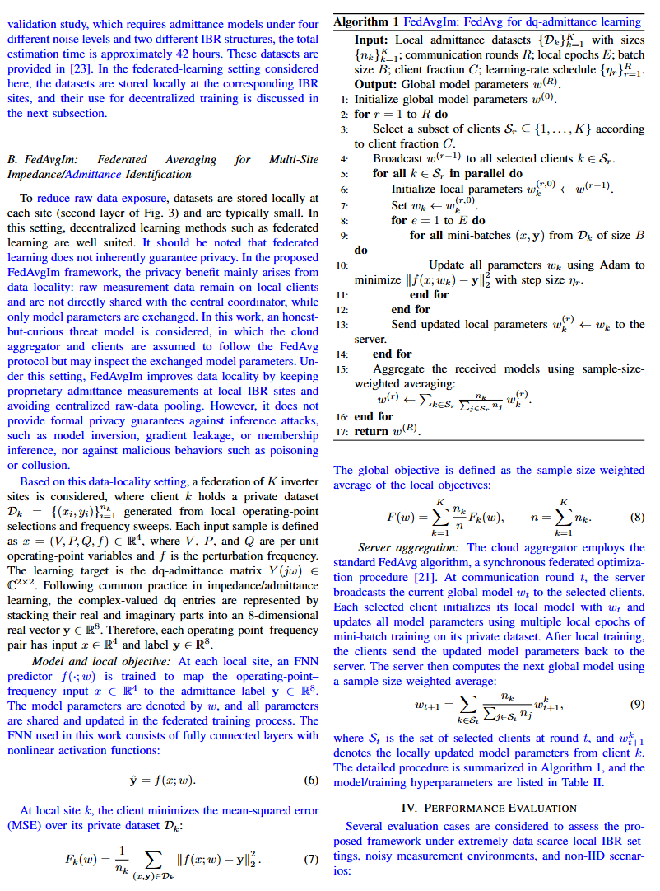
On page 11 and 13: We added personalized FL as future work rather than a claimed contribution:
To systematically address broader heterogeneity, future work should consider multi-model frameworks based on clustered federated learning or personalized federated learning.
and
…future work will extend the framework to broader IBR heterogeneity, including grid-forming invert- ers, clustered federated learning, and personalized federated- learning strategies.
Comment #4:
4. In Case 4, the estimated admittance is used for Nyquist stability analysis. Since neural networks inevitably produce prediction errors, the authors should provide a sensitivity analysis or error bounds. Specifically, how sensitive is the stability criterion to small prediction errors in the phase or magnitude of Ydq near the crossover frequency? A discussion on uncertainty quantification would significantly strengthen the reliability of the proposed stability assessment.
Authors’ response (#4):
We thank the reviewer for this important comment. We agree that admittance-prediction errors can affect the reliability of Nyquist-based stability assessment, especially when the generalized Nyquist eigenloci are close to the critical point $(-1+j0)$. In the revised manuscript, we have therefore expanded the stability validation in Case 6 to include a sensitivity-oriented analysis under different admittance-prediction error levels and multiple operating points.
Specifically, we evaluate the estimated dq-admittance model of IBR1 under three error levels: 0%, approximately 10%, and approximately 13%. The 0% case corresponds to the measurement-based admittance reference, while the 10% and 13% cases represent approximate admittance prediction errors obtained from FedAvgIm under different measurement-noise conditions. For each error level, we assess the stability decision consistency across five operating points and two grid-impedance conditions, $Z_{g1}$ and $Z_{g2}=1.3Z_{g1}$​. The revised Table VI reports 30 stability decisions and compares the admittance-based Nyquist prediction with EMT time-domain simulation results.
We further added Fig. 18 to illustrate this sensitivity. The figure shows that the relationship between admittance-prediction error and stability-decision accuracy is not strictly monotonic. A smaller overall prediction error does not always guarantee a more accurate stability decision, because the final stable/unstable conclusion depends on how the prediction error shifts the eigenloci relative to $(-1+j0)$. Therefore, small magnitude or phase errors near critical frequency regions may change the encirclement result if the stability margin is small.
We also clarified this limitation in the Conclusion. The revised manuscript now states that admittance-estimation errors can affect the final stable/unstable decision when the generalized Nyquist eigenloci are close to the critical point, and that uncertainty-aware stability assessment is needed for critical stability-margin cases. We now explicitly identify formal analytical error bounds or a rigorous uncertainty-quantification framework as an important future research direction.
Modifications on manuscript (#4):
On pages 11, 12, 13: In this case study, the estimated dq-admittance model of IBR1 obtained under the measurement-noise conditions in Case 4 is used for stability assessment. Five operating points, listed in Tab. V, are evaluated under two grid conditions, denoted by $Z_{g1}$ and $Z_{g2}= 1.3Z_{g1}$, and under different prediction-error levels. Since the estimated admittance is available at 20 discrete frequency points, the admittance samples are denoted by Y IBR(k), and the corresponding eigenvalues $λ_{1}(k)$ and $λ_{2}(k)$ are computed for k = 1, . . . , 20. These frequency-indexed eigenvalues are then used to form the Nyquist eigenloci for assessing the consistency between the predicted and actual stability conclusions.

The stability prediction results are reported in Tab. VI, where 30 stability predictions are compared with the reference results obtained from EMT time-domain simulations. The 0% error level corresponds to the measurement-based admittance data used as the reference case. The 10% and 13% error levels represent the approximate admittance prediction errors obtained from the FedAvgIm framework under different measurement-noise conditions.

Under different operating points and grid conditions, the measurement-based admittance provides fully consistent stability predictions in the 0% error case, achieving 100% agreement with the EMT reference results. When admittance models with approximately 10% prediction error are used, two out of ten stability decisions are inconsistent with the EMT reference, resulting in an 80% agreement rate. When the prediction error increases to approximately 13%, only one out of ten stability decisions is inconsistent, corresponding to a 90% agreement rate. Overall, 27 out of the 30 stability predictions are consistent with the EMT reference results.
The non-monotonic relationship between admittance pre- diction error and stability-prediction accuracy is mainly due to the location of the generalized Nyquist eigenloci relative to the critical point (−1+j0). For some operating points and grid conditions, the eigenloci are very close to the critical point. As a result, small admittance-estimation errors can shift the eigenloci across the critical point and change the predicted stability conclusion. This behavior is illustrated in Fig. 18, where the 10% prediction-error case leads to an incorrect encirclement of the critical point, whereas the 13% prediction- error case remains consistent with the EMT reference. Therefore, the impact of admittance-estimation error on stability assessment is not strictly monotonic, but depends on how the error perturbs the eigenloci relative to the critical point.

Fig. 19 shows the generalized Nyquist eigenloci derived from the estimated admittance of IBR1 at OP1 with a 13% prediction error. The two eigenvalues of the return-ratio matrix are evaluated under two grid-impedance scenarios: $Z_{g1}$ and $Z_{g2}$, where $Z_{g2} = 1.3Z_{g1}$ represents a weaker grid condition. Under $Z_{g1}$, the Nyquist eigenloci do not encircle the critical point (−1+j0), indicating stable operation. Under the weaker grid condition $Z_{g2}$, the Nyquist eigenlocus of $λ_{2}$ encircles the critical point, indicating instability.

To validate this conclusion, two EMT time-domain simulations are performed separately in MATLAB/Simulink for the two grid-impedance scenarios using the same configuration as in Fig. 1. The PCC voltage and current responses are shown in Fig. 20. Under $Z_{g1}$, the PCC voltage and current responses remain bounded, confirming stable operation. In contrast, under the weaker-grid scenario \(Z_{g2}\), the PCC voltage exhibits rapidly growing oscillations, indicating instability. These EMT results are consistent with the generalized Nyquist assessment based on the estimated admittance model of IBR1.

On page 13: Third, the stability study shows that admittance-estimation errors can affect the final stable/unstable decision when the generalized Nyquist eigenloci are close to the critical point. Therefore, a formal analytical error bound or rigorous uncertainty quantification is an important future research direction.
Comment #5:
5. The paper mentions using a full frequency set for testing but subsampling for training. Given that impedance responses typically exhibit wide variations over logarithmic frequency scales, the distribution of the sampled frequencies in the training set is critical. The authors should clarify the sampling strategy for the frequency input f. Using linearly spaced samples for training might bias the model towards high frequencies and neglect critical low-frequency dynamics.
Authors’ response (#5):
We thank the reviewer for this important comment. We agree that the frequency-sampling strategy is critical for admittance learning, because IBR admittance responses can vary significantly over logarithmic frequency scales, especially in the low-frequency range that is important for small-signal stability assessment.
In the revised manuscript, we clarified that the training frequencies are not generated from a uniformly linear grid. Instead, for each IBR, we first construct a full frequency grid $f_{test}$ using a domain-aware distribution, such as logarithmic spacing, piecewise-dense spacing, or randomized log-scale sampling. The training frequency set is then obtained by fixed-index subsampling of this predefined full grid:
$$f_{train}​=f_{test}​\left(1:2:N_{f}​\right).$$
Therefore, the fixed-stride subsampling is performed in the index domain of the designed frequency grid, not in a newly generated linearly spaced frequency domain. As a result, the sparse training set preserves the intended distribution of the original full grid. For example, when the full grid is logarithmically spaced or denser in the low-frequency region, the corresponding training grid also retains low-frequency coverage.
In our data-generation scripts, different IBR cases use different frequency distributions to avoid relying on a single artificial frequency pattern. Some cases use logarithmic grids over the full range, some use piecewise grids with denser low- or mid-frequency coverage, and some use randomized log-scale frequency samples. The full frequency vector, selected training indices, and train/test split rule are stored in the dataset metadata. In addition, the data-generation code and datasets, including the exact frequency-sampling procedure, have been released in the public repository to ensure reproducibility.
We have revised Section III-A to clarify this sampling strategy and to avoid the misunderstanding that the training samples are linearly spaced over frequency. This clarification also supports the stability-validation study, where the estimated admittance samples are evaluated through generalized Nyquist analysis.
Modifications on manuscript (#5):
On page 5: We added clarification that the full frequency grid is not necessarily linearly spaced:
For each remaining operating point, the measurement procedure is performed using the predefined voltage magnitude V and the corresponding steady-state current setpoints derived from (P, Q). The dq-admittance matrix $Y\left(jω\right)∈ C^{2×2}$is then estimated from EMT Simulink simulations over a prescribed frequency set $f_{test}$, whose distribution may be logarithmic, piecewise-dense, or randomized depending on the IBR scenario. The training frequency set is obtained by fixed-stride subsampling of this predefined frequency grid. In the implementation, the subsampling is applied to the frequency-grid index, e.g., $f_{train}= \left\{f_{test},i\right| i=1, 3, 5, . . . , N_{f}\}$, rather than to a newly generated uniformly linear frequency grid. Therefore, when ftest is logarithmic or denser in the low-frequency region, ftrain preserves the corresponding low-frequency coverage. The released datasets and data-generation scripts in [23] include the exact frequency vectors, selected training indices, and train/test split metadata for reproducibility.

Reviewer #3:

Thank the authors for their hard work. Overall, I find this work valuable. My comments and questions are as follows:
Authors’ response and action:
We would like to thank the reviewer for the recognition and helpful comments, which have significantly improved our manuscript. We have made our best effort to address all of the reviewer’s comments, and our responses are provided below.
Comment #1:
1. A sudden step change of grid impedance with 50% increase and the following instability seems unrealistic. Please find a way to justify it or use a more realistic scenario.
Authors’ response (#1):
We thank the reviewer for this helpful comment. We agree that a sudden 50% step increase in grid impedance may appear too severe and may not represent a typical real-time operating event. In the revised manuscript, we have therefore modified the stability-validation scenario to use a more moderate grid-strength variation.
Specifically, the original weak-grid case has been revised from a 50% impedance increase to a 30% increase, i.e., $Z_{g2}=1.3Z_{g1}$. This revised setting is intended to represent a weaker-grid operating condition rather than a literal sudden physical step change in the grid impedance. Such a change can be interpreted as a different grid-strength scenario caused by changes in network configuration, line switching, equivalent grid impedance seen from the PCC, or reduced short-circuit strength.
We have also revised the discussion to avoid implying that the instability is caused by an abrupt impedance step event. Instead, the revised Case 6 uses two separate EMT simulations under two grid-impedance scenarios, $Z_{g1}$ and $Z_{g2}$, and compares the stability conclusions obtained from generalized Nyquist analysis with EMT time-domain responses. The results show that under $Z_{g1}$, the Nyquist eigenloci do not encircle the critical point (−1+j0), and the EMT responses remain bounded. Under the weaker-grid condition $Z_{g2}=1.3Z_{g1}$, the Nyquist eigenlocus encircles the critical point, and the EMT simulation shows growing oscillations. Therefore, the revised validation focuses on whether the estimated admittance model can correctly distinguish stable and unstable operating conditions under different grid strengths, rather than on modeling an instantaneous grid-impedance jump.
This revision makes the stability-validation scenario more realistic and better aligned with the purpose of impedance-based small-signal stability assessment.
Modifications on manuscript (#1):
On page 11: We revised the grid-strength scenario from a 50% increase to a more moderate weak-grid case:
Five operating points, listed in Tab. V, are evaluated under two grid conditions, denoted by $Z_{g1}$ ​ and $Z_{g2}=1.3Z_{g1}$ and under different prediction-error levels.
On page 12: We revised the Nyquist validation to compare two grid-impedance scenarios:
Fig. 19 shows the generalized Nyquist eigenloci derived from the estimated admittance of IBR1 at OP1 with a 13% prediction error. The two eigenvalues of the return-ratio matrix are evaluated under two grid-impedance scenarios: $Z_{g1}$ ​ and $Z_{g2}$, where $Z_{g2} =1.3Z_{g1}$ ​ represents a weaker grid condition.
On page 12-13: We revised the EMT validation to use two separate grid-strength scenarios rather than emphasizing a sudden impedance step:
To validate this conclusion, two EMT time-domain simulations are performed separately in MATLAB/Simulink for the two grid-impedance scenarios using the same configuration as in Fig. 1. The PCC voltage and current responses are shown in Fig. 20. Under $Z_{g1}$, the PCC voltage and current responses remain bounded, confirming stable operation. In contrast, under the weaker-grid scenario \(Z_{g2}\), the PCC voltage exhibits rapidly growing oscillations, indicating instability.
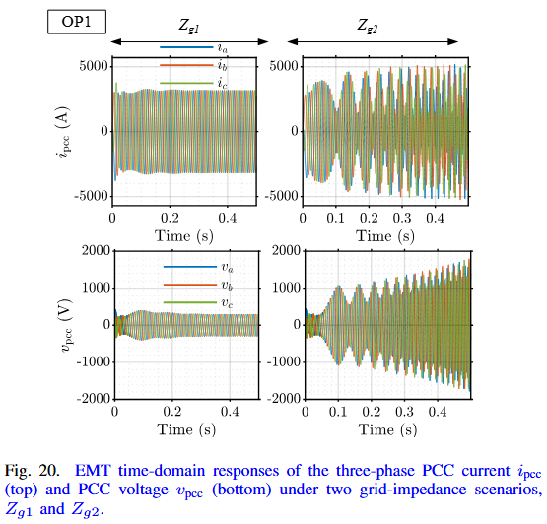
Comment #2:
2. Please clarify the benefits of the proposed approach compared to the parametric impedance model.
Authors’ response (#2):
We thank the reviewer for this helpful comment. We agree that the distinction between the proposed data-driven FedAvgIm framework and parametric impedance/admittance modeling should be clarified.
Parametric impedance/admittance models are highly useful when the IBR topology, controller structure, and internal parameters are known. In that case, analytical or component-connection-based modeling can provide interpretable models and can directly reveal the influence of physical and control parameters. However, this assumption is often difficult to satisfy in practical multi-vendor IBR systems, where converter control structures, controller gains, PLL settings, delays, and filter parameters may be proprietary or unavailable.
The proposed FedAvgIm framework targets a different scenario: black-box or limited-access IBRs, where only terminal voltage/current responses can be measured and the internal model parameters are not available. In this setting, FedAvgIm does not replace parametric modeling when such models are available. Instead, it provides a complementary approach for learning dq-admittance behavior from sparse measurement-based data collected at local IBR sites.
Compared with parametric impedance/admittance modeling, the main benefits of FedAvgIm are threefold. First, it does not require access to proprietary internal IBR parameters or controller details, because the model is trained from terminal measurement-based admittance data. Second, it reduces repeated frequency-scan effort by learning a mapping from operating point and frequency $(V,P,Q,f)$ to the dq-admittance entries, allowing admittance responses to be estimated over denser operating conditions after training. Third, it enables multi-site collaboration under raw-data-locality constraints: each IBR site keeps its local admittance measurements private, while only model parameters are exchanged through FedAvg.
In the revised manuscript, we clarified this relationship. We now use the analytical admittance model only as a reference to evaluate the accuracy of the EMT measurement-based admittance extraction, not as the main training-data source. The actual FedAvgIm validation is performed using EMT measurement-based datasets, which better represent the black-box scenario. Therefore, the proposed approach should be viewed as a measurement-based, data-driven, and federated complement to parametric modeling, especially useful when parametric IBR models are unavailable or cannot be shared.
Modifications on manuscript (#2):
On page 2: We clarified that analytical or parametric admittance modeling requires internal IBR information, which may not be available in practice:
Analytical approaches remain most suitable when the IBR architecture and parameters are available. In practice, this assumption often does not hold due to limited standardization and strong commercial incentives, vendors typically treat control algorithms and parameters as proprietary and may only provide black-box input-output models without internal details.
On page 3: We clarified the role of analytical admittance modeling and its limitation:
Nevertheless, analytical modeling requires detailed information about the IBR hardware and software. In practice, such information is often difficult to obtain because limited standardization and proprietary considerations lead vendors to treat controller designs and parameters as commercial secrets.
Comment #3:
3. Please state if there is any methodological novelty beyond FedAvg.
Authors’ response (#3):
We thank the reviewer for this important comment. We agree that the methodological scope of the paper should be stated more clearly. The revised manuscript does not claim to introduce a new federated optimization algorithm beyond the standard FedAvg method. Instead, the contribution lies in the problem formulation, adaptation, and validation of FedAvg for multi-site dq-admittance identification of IBRs under severe local data scarcity and raw-data-locality constraints.
Specifically, the novelty of this work is not a modification of the FedAvg aggregation rule, but the development and evaluation of a FedAvg-based framework tailored to the IBR admittance-identification problem. The framework formulates each IBR site as a federated client with its own sparse operating-point/frequency admittance dataset, defines the learning task as a mapping from $(V,P,Q,f)$ to the stacked real and imaginary parts of the dq-admittance matrix, and evaluates whether cross-site federated learning can reduce overfitting compared with local-only learning without centralizing raw admittance data.
In the revised manuscript, we clarified this point by presenting FedAvgIm as a standard FedAvg implementation for dq-admittance learning, with sample-size-weighted aggregation of all model parameters. We also added practical validation aspects that go beyond simply applying FedAvg to a generic dataset: EMT measurement-based admittance data generation, evaluation under measurement noise, non-IID IBR heterogeneity analysis using MMD, comparison with centralized/local-only/raw-data-locality-preserving transfer-learning baselines, and application to generalized Nyquist stability assessment with EMT time-domain validation.
Therefore, we have revised the manuscript to make the contribution more precise: FedAvgIm is not proposed as a new FL optimizer, but as a domain-specific federated-learning framework and validation study for data-scarce, multi-site IBR dq-admittance identification.
Modifications on manuscript (#3):
On page 2:
This paper proposes FedAvgIm, a decentralized federated-learning framework based on the FedAvg algorithm, for multi-site IBR admittance identification under strict data-locality requirements, extremely limited local datasets, unbalanced data across sites, and the presence of multiple IBRs within a system.
Comment #4:
4. What are the limitations to scale up the method with many IBRs?
Authors’ response (#4):
We thank the reviewer for this important comment. We agree that the scalability of FedAvgIm should be discussed more clearly, especially for future deployment in systems with many IBRs.
In the revised manuscript, we clarify that the current study evaluates FedAvgIm using nine IBR clients and is intended as a proof-of-concept for multi-site dq-admittance identification under severe local data scarcity. Scaling the method to a much larger number of IBRs may introduce several practical limitations.
First, the communication cost increases with the number of participating clients and communication rounds, because each selected client uploads local model parameters and downloads the updated global model in each round. Although the FNN used in this work is relatively small, large-scale deployment would still require careful design of client selection, communication frequency, and model compression.
Second, client heterogeneity becomes more challenging as more IBRs are included. In practical systems, IBRs may differ in vendor, topology, control strategy, filter structure, and operating range. The revised non-IID study shows that FedAvgIm remains beneficial compared with local-only training, but its performance advantage decreases under severe heterogeneity. Therefore, a single global FedAvg model may not scale well to all IBR types.
Third, client availability and data imbalance may become more significant in large systems. Different IBR sites may have different amounts of measured admittance data, different frequency/operating-point coverage, and different communication availability. These issues may affect aggregation fairness and the representativeness of the global model.
Fourth, the measurement cost remains a practical bottleneck. Although FedAvgIm reduces the need for dense local measurements by enabling cross-site learning, each new IBR site still needs enough local measurement-based admittance samples to participate meaningfully in training or adaptation.
We added this discussion to better clarify the practical scope of the proposed framework. The current FedAvgIm approach is most suitable for groups of IBRs with similar behavioral characteristics and compatible input-output admittance behavior. For larger-scale and more heterogeneous deployments, future work should investigate scalable client selection, communication-efficient training, clustered federated learning, personalized federated learning, and uncertainty-aware model validation.
Modifications on manuscript (#4):
On page 10-11: We added a discussion showing that severe heterogeneity reduces the benefit of standard FedAvg:
In the highly heterogeneous G3 case, FedAvg still provides performance gains for most clients compared with local-only training, but its benefit becomes less uniform. In particular, gfli4 shows a much higher FedAvg test MSE than the other clients. This result suggests that strong topology and parameter heterogeneity can make some client distributions deviate significantly from the global distribution learned during aggregation.
…
It should be noted that a single surrogate model is unlikely to generalize across all types of inverter-based resources (IBRs), given their diverse control architectures and converter topologies. Instead, the proposed framework is intended to operate effectively across groups of IBRs with similar behavioral characteristics. To systematically address broader heterogeneity, future work should consider multi-model frameworks based on clustered federated learning or personalized federated learning.
Comment #5:
5. Please include a comparison of communication complexity and cost, as well as a comparison of the required computational power.
Authors’ response (#5):
We thank the reviewer for this helpful suggestion. We agree that communication and computational overhead should be discussed to better support the practicality of the proposed framework. In the revised manuscript, we added a compact communication and computational overhead discussion after Table II.
For communication cost, we quantified the model size, number of communication rounds, and total uplink/downlink traffic. The FNN used in FedAvgIm contains 824 trainable parameters, corresponding to approximately 3.30 kB using 32-bit floating-point parameters. Since each selected client downloads the global model and uploads the locally updated model in each communication round, the full-participation setting with nine clients and 250 rounds leads to approximately 7.42 MB uplink, 7.42 MB downlink, and 14.83 MB total communication volume.
We also clarified the comparison with local-only and centralized learning. Local-only learning has no communication overhead but cannot leverage cross-site information. Centralized learning does not require repeated model exchange, but it requires raw admittance datasets to be transferred and pooled at a central server, which conflicts with the data-locality motivation of this work. FedAvgIm introduces repeated but lightweight model-parameter exchange, while keeping raw admittance data local and enabling collaborative learning.
For computational power, we clarified that the FNN is lightweight and the local datasets are small. With 250 communication rounds, 8 local epochs per round, and batch size 64, the largest client with 390 samples performs approximately 14,000 local mini-batch updates, while the smallest client with 40 samples performs approximately 2,000 updates. The server-side computation is limited to sample-size-weighted averaging of the received model parameters. Therefore, the main computational burden of the overall study comes from EMT-based admittance data generation rather than from training the lightweight FNN.
Modifications on manuscript (#5):
On page 6-7: We added a new paragraph titled Communication and computational overhead:
The communication cost of FedAvgIm is determined by the size of the exchanged FNN parameters [24]. For the FNN in Table II, the number of trainable parameters is |w| = (4 × 32 + 32) + (32 × 16 + 16) + (16 × 8 + 8) = 824. Assuming 32-bit floating-point parameters, the model size is approximately 3.30 kB. In each communication round, each selected client downloads the global model and uploads the locally updated model. Therefore, under the full-participation setting used in this work with nine clients and 250 communication rounds, the total communication volume is approximately 7.42 MB uplink, 7.42 MB downlink, and 14.83 MB in total. Compared with local-only learning, FedAvgIm introduces additional model-exchange communication, but enables cross- site learning without raw-data pooling. Compared with centralized learning, FedAvgIm avoids transferring proprietary raw admittance datasets to a central server, at the cost of repeated lightweight model-parameter exchange.
The computational cost is also modest because the model contains only 824 trainable parameters and each client has a small local dataset. With 250 communication rounds, 8 local epochs per round, and batch size 64, the largest client with 390 samples performs approximately 14,000 local mini-batch updates, while the smallest client with 40 samples performs approximately 2,000 updates. The server-side computation is limited to sample-size-weighted averaging of the received model parameters. Therefore, the main computational burden of the overall study comes from EMT-based admittance data generation rather than from training the lightweight FNN.
Comment #6:
6. Is the dataset realistic and noisy, or clean simulation results? Please state that in the manuscript.
Authors’ response (#6):
We thank the reviewer for this important comment. We agree that the nature of the dataset should be clearly stated. In the revised manuscript, we clarified that the dataset is EMT simulation-based measurement data, not purely clean analytical data. The admittance labels are obtained by applying a measurement-based frequency-scan procedure to EMT Simulink models: small dq-frame voltage perturbations are injected at the PCC, the three-phase PCC voltage/current responses are measured and transformed into the dq frame, and the dq admittance is estimated using MATLAB frestimate.
Therefore, the dataset is more realistic than clean analytical transfer-function data because it includes scan-related numerical uncertainty from EMT simulation, finite-duration signal processing, dq transformation, and frequency-response estimation. In addition, we added a dedicated measurement-noise study in Case 4, where white measurement noise levels of 0%, 1%, 2%, and 3% are applied to the measured voltage and current signals before admittance estimation.
The revised results show that FedAvgIm maintains stable learning behavior under all tested noise levels. As reported in Table III, the physical prediction accuracy decreases gradually from 89.52% at 0% noise to 83.69% at 3% noise, while all learning curves still converge smoothly within approximately 150 communication rounds. This confirms that the proposed framework was not evaluated only on clean simulation data, but also under noisy measurement conditions.
We have revised the manuscript to explicitly state the dataset source, the measurement-based EMT data-generation process, and the added noise conditions.
Modifications on manuscript (#6):
On page 2: We clarified that the datasets are EMT measurement-based rather than analytical clean data:
Specifically, EMT measurement-based admittance datasets are constructed for nine IBRs with different architectures, controller parameters, measurement-noise levels, and degrees of non-independent and identically distributed (non-IID) data. These EMT measurement-based datasets are used to represent the black-box identification scenario in which internal model parameters are unavailable.
On page 4: We added the measurement procedure:
In this work, two small linearly independent voltage perturbations are injected at the PCC in the dq frame, each with an amplitude of 5% of the nominal voltage magnitude. A multitone frequency injection is used to reduce the measurement time. The instantaneous three-phase PCC voltages and currents are then measured and transformed into the dq frame. The dq admittance is estimated using the frestimate function in MATLAB.
On page 9-10: We added a dedicated noisy-measurement validation: In this scenario, four levels of white measurement noise (0%, 1%, 2%, and 3%) are applied to the voltage and current measurements before the admittance profiles are estimated. The total time required for the data collection process is approximately 28 hours.
As shown in Tab. III and Fig. 14, the proposed framework maintains stable learning behavior under all tested measurement-noise levels. In the noise-free case, FedAvgIm achieves a test MSE of 0.0408 and a physical prediction accuracy of 89.52%. When the noise level increases to 1%, the accuracy remains nearly unchanged at 89.01%, indicating that the proposed framework is insensitive to mild measurement noise. As the noise level further increases to 2% and 3%, the physical prediction accuracy gradually decreases to 86.86% and 83.69%, respectively. This trend is expected because noise in the measured voltage and current signals affects the quality of the estimated admittance labels. Nevertheless, FedAvgIm still retains more than 83% physical prediction accuracy even under the highest tested noise level, demonstrating its robustness in noisy measurement environments.

Fig. 14 further illustrates the convergence behavior of FedAvgIm under different measurement-noise levels using the physical prediction accuracy metric. The accuracy is computed after inverse-transforming the predicted admittance responses back to physical units and evaluating the normalized prediction error. Although higher noise levels lead to lower final accuracy, all learning curves converge smoothly within approximately 150 communication rounds. This indicates that measurement noise mainly affects the attainable prediction accuracy rather than destabilizing the federated training process. Overall, the results show that FedAvgIm provides stable and robust admittance identification performance under noisy measurement conditions.


Reviewer #4:

The manuscript provides a novel and well-structured approach to federated learning in impedance identification, with convincing theoretical development and experimental validation.
Authors’ response and action:
We would like to thank the reviewer for the recognition and helpful comments, which have significantly improved our manuscript. We have made our best effort to address all of the reviewer’s comments, and our responses are provided below.
Comment #1:
1. In Case 3, the local transfer learning model is pretrained only on IBR4 (100 samples), whereas the federated transfer learning model leverages data from IBR2–IBR9 (1670 samples in total). Since the pretraining data scale differs substantially between the two settings, it is unclear whether the reported performance improvement stems from the federated mechanism itself or from the larger and more diverse pretraining dataset. It would strengthen the manuscript if the authors could clarify this point or provide an additional controlled experiment where the total pretraining data size is comparable across methods.
Authors’ response (#1):
We thank the reviewer for this important and fair comment. We agree that the pretraining data scale in the original Case 3 comparison is not identical between local transfer learning and federated transfer learning. Therefore, the improvement observed in the FL-TL setting should not be interpreted as being caused solely by the FedAvg aggregation mechanism itself.
In the revised manuscript, we clarify that the purpose of Case 3 is to compare two practical raw-data-locality-preserving transfer-learning settings rather than to isolate the effect of the optimizer under equal pretraining data size. In the local transfer-learning setting, only one source IBR dataset is available for pretraining, and the pretrained model is then fine-tuned on the target IBR. In contrast, FL-TL enables multiple source IBRs, IBR2–IBR9, to collaboratively pretrain a shared initialization without pooling their raw admittance data. Thus, the benefit of FL-TL comes from the combination of multi-source data diversity and federated raw-data-locality-preserving training, rather than from FedAvg alone.
We have revised the discussion of Case 3 to make this interpretation explicit. The revised text now states that FL-TL is advantageous because it allows the target IBR to start from a model pretrained on distributed multi-site admittance behavior, while still avoiding centralized raw-data pooling. At the same time, we avoid claiming that the observed improvement is solely due to the federated optimization mechanism. We also acknowledge that a fully controlled experiment with matched pretraining data size would be useful to isolate the effect of data scale from the effect of federated training, and we identify this as a future extension.
This clarification makes the comparison more precise: Case 3 demonstrates the practical value of federated multi-source pretraining under data-locality constraints, while not claiming a data-size-controlled superiority of FedAvg over local transfer learning.
Modifications on manuscript (#1):
On page 9: We clarified the purpose of the comparison between local TL and FL-TL:
Transfer learning is a common approach for impedance/admittance identification, where a model pretrained on one IBR is reused as an initialization for a different target IBR. This subsection compares local transfer learning with federated-learning-based transfer learning under data-locality constraints and limited labeled data at the target IBR.
…
It should be noted that the local TL and FL-TL settings differ in the amount and diversity of pretraining data. Therefore, this comparison is intended to evaluate a practical data-locality-preserving transfer-learning scenario rather than to isolate the effect of the FedAvg optimizer under equal pretraining data size. In local TL, the target model reuses a model pretrained from a single source IBR, whereas FL-TL allows multiple source IBRs to collaboratively pretrain a shared initialization without centralizing their raw admittance datasets. Thus, the improvement of FL-TL reflects the benefit of federated multi-source pretraining under raw-data-locality constraints, rather than the effect of FedAvg alone.
On page 9-10: We also stated the limitation of this case study:
The overfitting gap, defined as the difference between the final test and training MSE, is shown in Fig. 13 for five random seeds. Although the absolute values vary across seeds, FL-TL consistently exhibits a smaller overfitting gap than local transfer learning, indicating more stable and robust generalization across runs. It should be noted, however, that this comparison reflects a practical multi-source federated pretraining setting rather than a controlled experiment with matched pretraining data size. A data-size-controlled comparison would be useful to further separate the contribution of pretraining data diversity from that of federated optimization and will be considered in future work.
2. In Case 4, the stability analysis is conducted under a single operating condition. Could the author clarify whether prediction errors might lead to a potential misinterpretation of stability?
Authors’ response (#2):
We thank the reviewer for this important comment. We agree that stability validation under only one operating condition is not sufficient, and that admittance-prediction errors may lead to incorrect stability decisions, especially when the generalized Nyquist eigenloci are close to the critical point (−1+j0).
In the revised manuscript, the stability validation has been expanded and is now presented in Case 6. Instead of using a single operating condition, we evaluate the estimated dq-admittance model of IBR1 under five operating points and two grid-impedance conditions, $Z_{g1}$ and $Z_{g2}$. We also report the stability decision consistency under three admittance-error levels: 0%, approximately 10%, and approximately 13%. The 0% case corresponds to the measurement-based admittance reference, while the 10% and 13% cases represent approximate prediction-error levels obtained from FedAvgIm under different measurement-noise conditions.
The revised results confirm that prediction errors can indeed lead to potential misinterpretation of stability in some cases. As reported in Table VI, the measurement-based admittance achieves 100% agreement with the EMT reference in the 0% error case. However, with approximately 10% admittance-prediction error, two out of ten stability decisions are inconsistent with EMT simulations, resulting in an 80% agreement rate. With approximately 13% prediction error, one out of ten decisions is inconsistent, corresponding to a 90% agreement rate. Overall, 27 out of 30 stability predictions are consistent with the EMT reference results.
We also added a discussion explaining why the relationship between admittance-prediction error and stability-decision accuracy is not strictly monotonic. The stability decision depends not only on the overall admittance prediction error, but also on how this error shifts the Nyquist eigenloci relative to the critical point. Therefore, even a relatively small magnitude or phase error may change the predicted stable/unstable conclusion if the eigenloci are very close to (−1+j0).
Modifications on manuscript (#2):
On pages 11, 12, 13: In this case study, the estimated dq-admittance model of IBR1 obtained under the measurement-noise conditions in Case 4 is used for stability assessment. Five operating points, listed in Tab. V, are evaluated under two grid conditions, denoted by $Z_{g1}$ and $Z_{g2}= 1.3Z_{g1}$, and under different prediction-error levels. Since the estimated admittance is available at 20 discrete frequency points, the admittance samples are denoted by Y IBR(k), and the corresponding eigenvalues $λ_{1}(k)$ and $λ_{2}(k)$ are computed for k = 1, . . . , 20. These frequency-indexed eigenvalues are then used to form the Nyquist eigenloci for assessing the consistency between the predicted and actual stability conclusions.

The stability prediction results are reported in Tab. VI, where 30 stability predictions are compared with the reference results obtained from EMT time-domain simulations. The 0% error level corresponds to the measurement-based admittance data used as the reference case. The 10% and 13% error levels represent the approximate admittance prediction errors obtained from the FedAvgIm framework under different measurement-noise conditions.

Under different operating points and grid conditions, the measurement-based admittance provides fully consistent stability predictions in the 0% error case, achieving 100% agreement with the EMT reference results. When admittance models with approximately 10% prediction error are used, two out of ten stability decisions are inconsistent with the EMT reference, resulting in an 80% agreement rate. When the prediction error increases to approximately 13%, only one out of ten stability decisions is inconsistent, corresponding to a 90% agreement rate. Overall, 27 out of the 30 stability predictions are consistent with the EMT reference results.
The non-monotonic relationship between admittance pre- diction error and stability-prediction accuracy is mainly due to the location of the generalized Nyquist eigenloci relative to the critical point (−1+j0). For some operating points and grid conditions, the eigenloci are very close to the critical point. As a result, small admittance-estimation errors can shift the eigenloci across the critical point and change the predicted stability conclusion. This behavior is illustrated in Fig. 18, where the 10% prediction-error case leads to an incorrect encirclement of the critical point, whereas the 13% prediction- error case remains consistent with the EMT reference. Therefore, the impact of admittance-estimation error on stability assessment is not strictly monotonic, but depends on how the error perturbs the eigenloci relative to the critical point.


3. The manuscript notes that the framework is potentially applicable to grid-forming inverters, however, could the proposed FedAvgIm framework be extended to mixed GFL–GFM systems?
Authors’ response (#3):
We thank the reviewer for this important comment. We agree that the applicability of FedAvgIm to mixed grid-following and grid-forming inverter systems should be clarified.
The proposed FedAvgIm framework is formulated at the input-output admittance level, rather than relying on a specific internal controller model. Therefore, in principle, it can be extended to any IBR whose terminal small-signal behavior can be represented or measured as a dq-domain admittance matrix. This includes both grid-following and grid-forming inverters, provided that their admittance responses are obtained from measurement-based perturbation tests or EMT simulations.
However, we acknowledge that a mixed GFL–GFM system introduces stronger heterogeneity than the cases considered in the current manuscript. GFL and GFM inverters may have different control objectives, synchronization mechanisms, voltage/current source behavior, and small-signal characteristics. As a result, a single global FedAvg model trained across both GFL and GFM clients may not generalize well if their admittance distributions are significantly different. This is consistent with our revised non-IID study, where stronger structural heterogeneity reduces the benefit of standard FedAvg and introduces client-level performance imbalance.
Therefore, the current paper does not claim full validation for mixed GFL–GFM systems. Instead, the revised manuscript clarifies that the present study focuses on grid-following inverters, while extension to mixed GFL–GFM systems is an important future direction. For such systems, the framework would likely require additional mechanisms, such as adding inverter type or control-mode indicators to the input features, using clustered federated learning to group behaviorally similar IBRs, or applying personalized federated learning so that each GFL/GFM client can retain client-specific model components.
We have revised the manuscript to make this limitation clearer. In particular, we state that a single surrogate model is unlikely to generalize across all IBR types and that future work will extend the framework to broader IBR heterogeneity,
Modifications on manuscript (#3):
On page 11: We added a limitation discussion on broad IBR heterogeneity:
It should be noted that a single surrogate model is unlikely to generalize across all types of inverter-based resources (IBRs), given their diverse control architectures and converter topologies. Instead, the proposed framework is intended to operate effectively across groups of IBRs with similar behavioral characteristics. To systematically address broader heterogeneity, future work should consider multi-model frameworks based on clustered federated learning or personalized federated learning.
On page 13: We clarified that the present work focuses on grid-following inverters and that GFM or mixed GFL–GFM systems are left for future work:
Finally, although this study focuses on grid-following inverters, future work will extend the framework to broader IBR heterogeneity, including grid-forming inverters, clustered federated learning, and personalized federated-learning strategies.

Reviewer #5:

Comment #1:
1. Are the dq admittance data estimated using the proposed method accurate enough for direct application in small-signal stability analysis? The article provides only one example. If numerical errors in the admittance lead to incorrect estimation results in practical applications, what would be the consequences? Can the confidence level of the stability prediction results be quantified?
Authors’ response (#1):
We thank the reviewer for this important comment. We agree that the reliability of the estimated dq-admittance model for small-signal stability analysis should be examined more carefully, because prediction errors may lead to incorrect stability decisions when the generalized Nyquist eigenloci are close to the critical point (−1+j0).
In the revised manuscript, we have expanded the stability validation from a single example to a multi-condition consistency study in Case 6. Specifically, the estimated dq-admittance model of IBR1 is evaluated under five operating points and two grid-impedance conditions, $Z_{g1}$ and $Z_{g2}$. We also consider three admittance-error levels: 0%, approximately 10%, and approximately 13%. The stability decisions obtained from the generalized Nyquist criterion are compared with EMT time-domain simulation results.
The revised results show that the measurement-based admittance reference achieves 100% consistency with EMT simulations in the 0% error case. When the estimated admittance models with approximately 10% and 13% prediction errors are used, the stability decision consistency rates are 80% and 90%, respectively. Overall, 27 out of 30 stability decisions are consistent with the EMT reference results. Therefore, within the tested scenarios, the estimated admittance models are sufficiently accurate for stability screening, but not guaranteed to be error-free for all stability-margin conditions.
We also added a discussion on the consequences of incorrect stability interpretation. A false stable prediction may be risky because it can fail to detect an unstable IBR–grid interaction, potentially leading to poorly damped or growing oscillations in practice. A false unstable prediction is more conservative, but may lead to unnecessary operating restrictions or overly conservative grid-strength requirements. Therefore, for operating points where the Nyquist eigenloci are close to the critical point, additional validation or uncertainty-aware stability assessment is necessary.
Regarding confidence quantification, the revised manuscript reports an empirical stability decision consistency rate as a practical confidence indicator. However, we do not claim a formal probabilistic confidence bound in the current work. A rigorous uncertainty-quantification framework, for example using confidence intervals on admittance prediction, Monte Carlo perturbation of $Y_{dq}$, or robust Nyquist-margin analysis, is identified as an important future research direction.
Modifications on manuscript (#1):
On page 12: We quantified the stability decision consistency:
Under different operating points and grid conditions, the measurement-based admittance provides fully consistent stability predictions in the 0% error case, achieving 100% agreement with the EMT reference results. When admittance models with approximately 10% prediction error are used, two out of ten stability decisions are inconsistent with the EMT reference, resulting in an 80% agreement rate. When the prediction error increases to approximately 13%, only one out of ten stability decisions is inconsistent, corresponding to a 90% agreement rate. Overall, 27 out of the 30 stability predictions are consistent with the EMT reference results.
On page 12: We added a sensitivity discussion explaining why prediction errors can cause misclassification:
For some operating points and grid conditions, the eigenloci are very close to the critical point. As a result, small admittance-estimation errors can shift the eigenloci across the critical point and change the predicted stability conclusion.
On page 13: We added this limitation:
Third, the stability study shows that admittance- estimation errors can affect the final stable/unstable decision when the generalized Nyquist eigenloci are close to the critical point. Therefore, a formal analytical error bound or rigorous uncertainty quantification is an important future research direction.
2. Additionally, at the end of the first chapter, a logical overview of the remaining chapters should be provided in accordance with standard writing conventions.
Authors’ response (#2):
We thank the reviewer for this helpful suggestion. We agree that the end of the Introduction should provide a clear roadmap of the remaining sections to improve the logical flow of the manuscript.
In the revised manuscript, we added a paragraph at the end of Section I to summarize the organization of the paper. The revised overview now clearly indicates that Section II introduces the background and problem statement, Section III presents the proposed FedAvgIm framework, Section IV reports the performance evaluation through six case studies, and Section V concludes the paper. This revision improves readability and follows standard manuscript-writing conventions.
Modifications on manuscript (#2):
On page 2: We added the following roadmap paragraph:
The remainder of this paper is organized as follows. Section II provides an overview of admittance modeling methods and discusses the limitations of existing methods. Section III describes the proposed FedAvgIm framework, from data collection and organization to the proposed algorithm. Section IV presents the performance evaluation through six different case studies. Finally, Section V concludes the paper.
REFERENCES
[3] ManhqhUMich12/FedAvgIm-Federated-Learning-for-Multi-Site-Impedance-Identification-of-Inverter-Based-Resources: Appendix for the submitted paper.

