P. Manikanta
2403A51L52

AI Assisted Coding Assignment 9.2

Task 1: Function Summary Generation
Prompt: "Write a short, clear summary describing the purpose of each function in the script. Do not explain code implementation details."
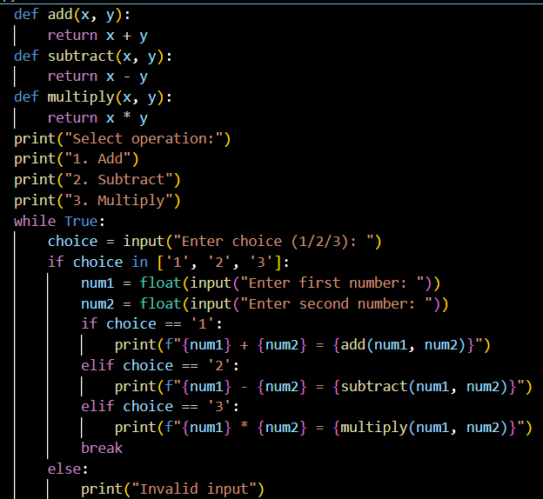
Output:
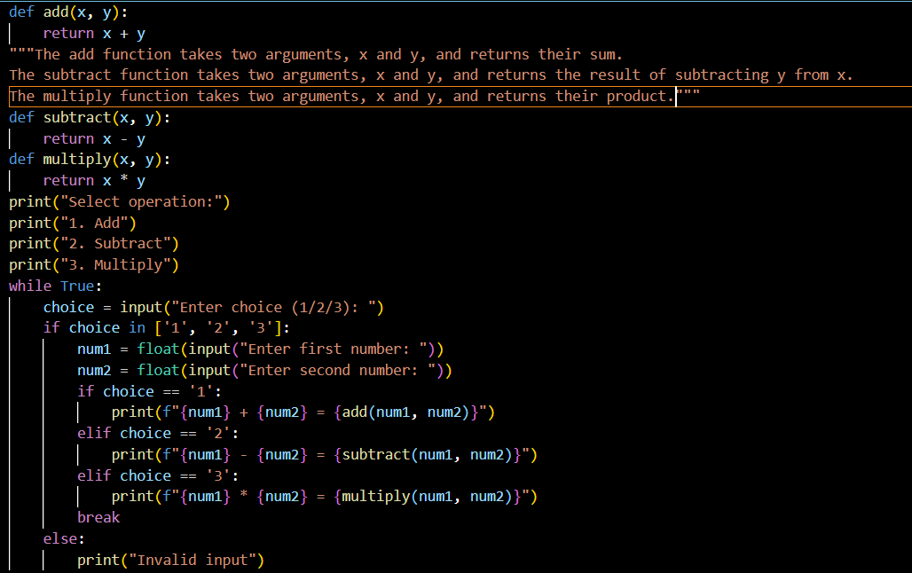

Explanation:
This prompt tells the AI to write only the main purpose of each function. Since it says not to explain the code steps, the AI gives short and clear summaries. It helps readers quickly understand what each function does.

Task 2: Logical Explanation for Conditions and Loops
Prompt Used: "Explain only the decision-making logic and loop behavior in the program. Skip basic syntax explanations within the code.”
Code:
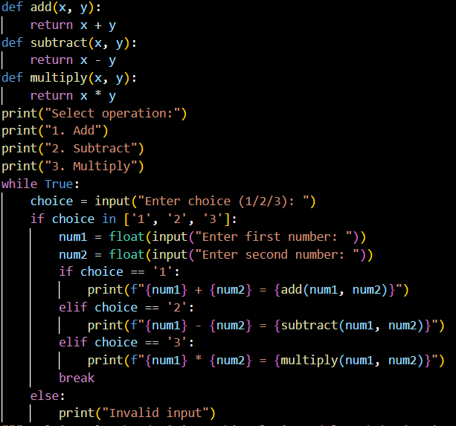
Output:

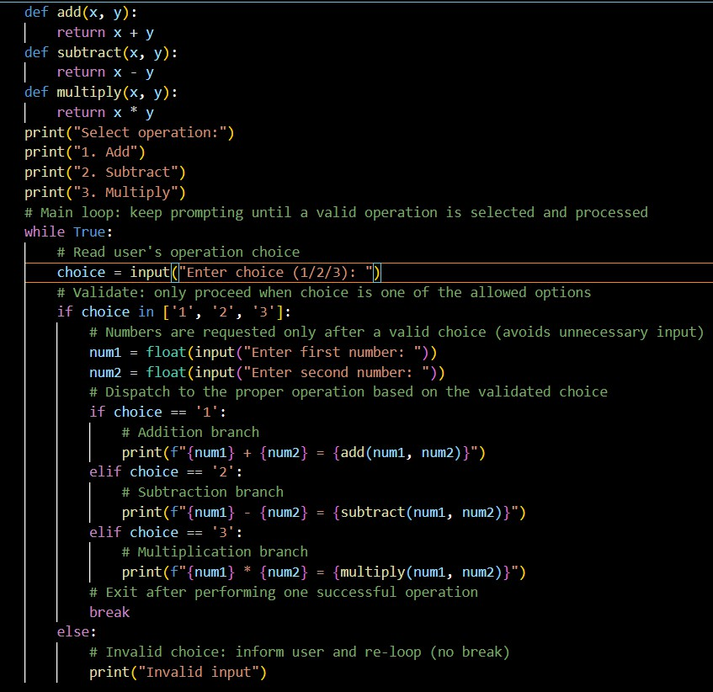
Explanation:
This prompt asks the AI to explain only the logic behind decisions and loops. So the AI describes why a condition is checked and what a loop is doing, instead of explaining Python syntax. This makes the program logic easier to understand.

Task 3: File-Level Overview
Prompt Used: "Write a brief overview summarizing the purpose and functionality of the entire Python file.within the code"
Code:

Output:
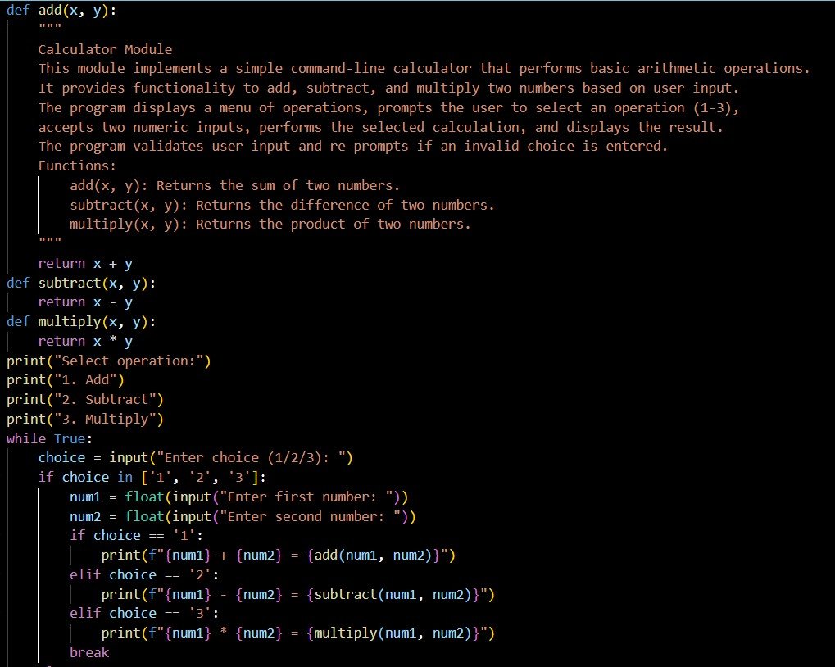

Explanation:
This prompt tells the AI to describe the whole file in general. The AI summarizes the overall purpose of the program and what it does. This helps someone understand the file before reading the code.

Task 4: Refining Existing Documentation
Prompt: "Rewrite the existing comments to improve clarity and consistency without changing technical meaning."
Code:

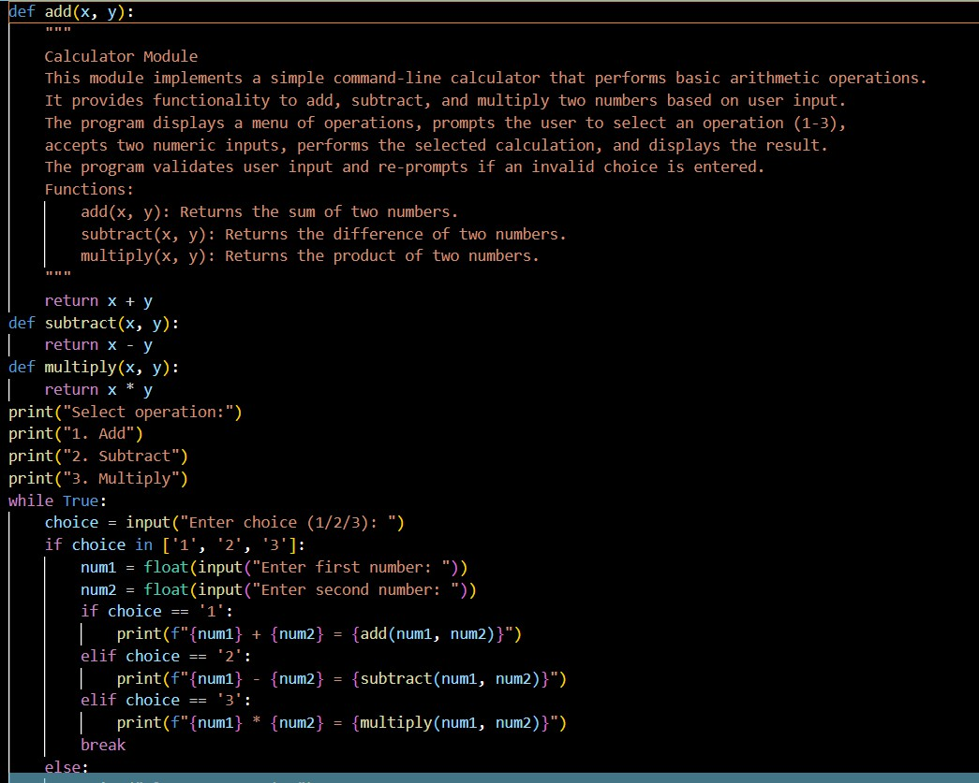
Output:

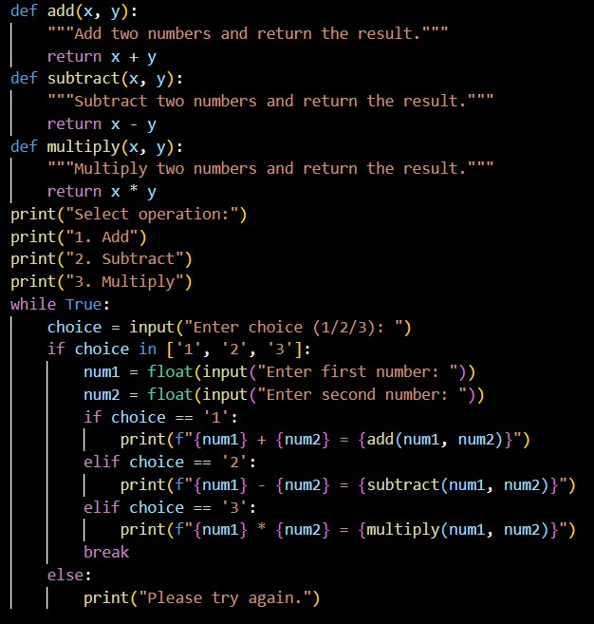
Explanation:
This prompt asks the AI to improve old comments without changing their meaning. The AI rewrites them in a
clearer and more professional way. It works like editing, not changing the code logic.

Task 5: Prompt Detail Impact Study
Code:

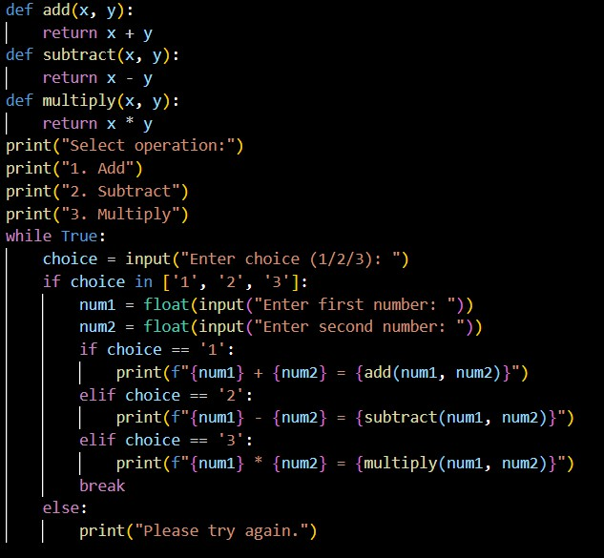
Prompt 1 : "Document this function." Prompt 1 Output:
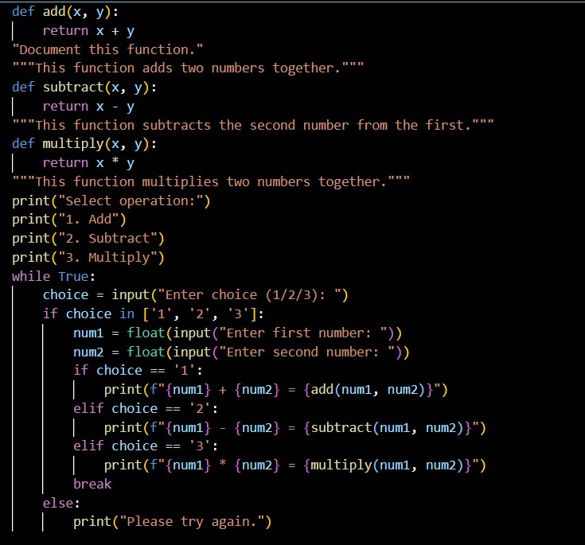

Prompt 2:” Write a clear and concise docstring for this function. Explain the function's purpose, describe each parameter with its meaning, and specify what the function returns. Do not describe internal calculations within the code.”
Prompt 2 Output:
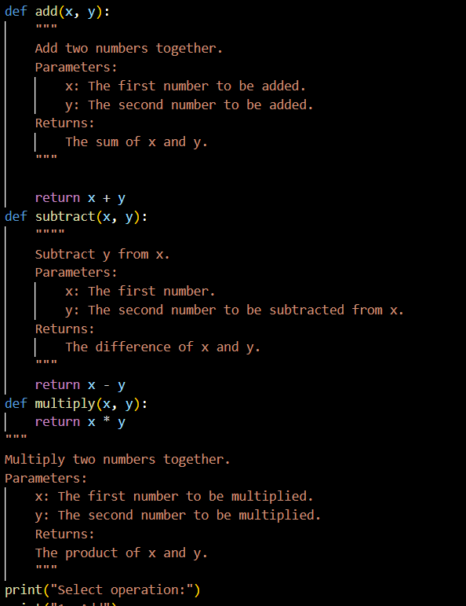

Output:

Criteria Brief Prompt Output Detailed Prompt Output Observation

Completeness Only mentions basic
Includes purpose, parameters, and Detailed prompt gives fuller

purpose
return value
documentation

Clarity Very short Clear and easy to understand Detailed prompt improves
clarity

Accuracy Correct but minimal Correct and informative Both accurate, but detailed is
more helpful

Readability Less informative for
new users
Easy for any developer to understand
Detailed prompt improves readability

Professional Quality
Too simple for real projects
Matches professional documentation standards
Prompt detail directly improves quality

Explanation:
Here I used two prompts: one short and one detailed. The short prompt gave only a basic description.
The detailed prompt gave full information about purpose, parameters, and return value. This shows that better prompts produce better documentation.

