  

To Supply Leftover Food to Poor

# Project Overview

The goal of the To Supply Leftover Food to Poor project is to effectively arrange for food collection, volunteer management, and transportation to many drop-off locations. The solution will streamline data management and provide real-time tracking through the use of the Salesforce platform. This project's long-term objectives are to enhance operational performance, user experience, and data quality in order to lessen food waste and support underserved communities.

# 2.Objectives

## Business Goals:

## • Develop a practical strategy for handling further food gifts.

• To increase the effectiveness of food distribution, streamline coordination between delivery, volunteers, and collection locations.   
• Offer real-time tracking and reporting to support impact analysis and decision-making.

**Particular Results:**

• Custom objects and connections were made to handle locations, volunteers, drop-off locations, and job assignments.   
• A real-time reporting system provides data on the distribution of food.   
• Dashboards that display information on food distribution, volunteer activity, and location-specific needs.

# 3.Salesforce Key Features and Concepts Utilized

This project makes use of a number of Salesforce functionalities, including:   
  
• New Objects: To keep track of details like the location, drop-off location, task, volunteer, and execution details, new objects were created.   
• Triggers: A unique Apex trigger named DropOffTrigger was used to automatically establish distance values.   
• Lighting App with Custom Tabs: The Food Connect Lightning App was created with custom tabs to provide easy navigation across all items.   
• Sharing Rules: Sharing rules were set up based on distance in order to restrict user access depending on proximity.

# 4.Detailed Steps to Solution Design

The design and development process consisted of the following steps:

* + **Data Models:** Developed data models for Venue, Drop-Off Point, Task, Volunteer, and Execution Details, including necessary fields and associations (Lookup and MasterDetail).
  + **User Interface Design**: Created custom tabs for simple navigation in

***FoodConnect*** Lightning App.

* + **Business Logic**: Developed the ***DropOffTrigger*** to automatically assign distances to the Distance Calculation field, enabling easy rule assignment.

## Screenshots:

**Screenshot of the UI**

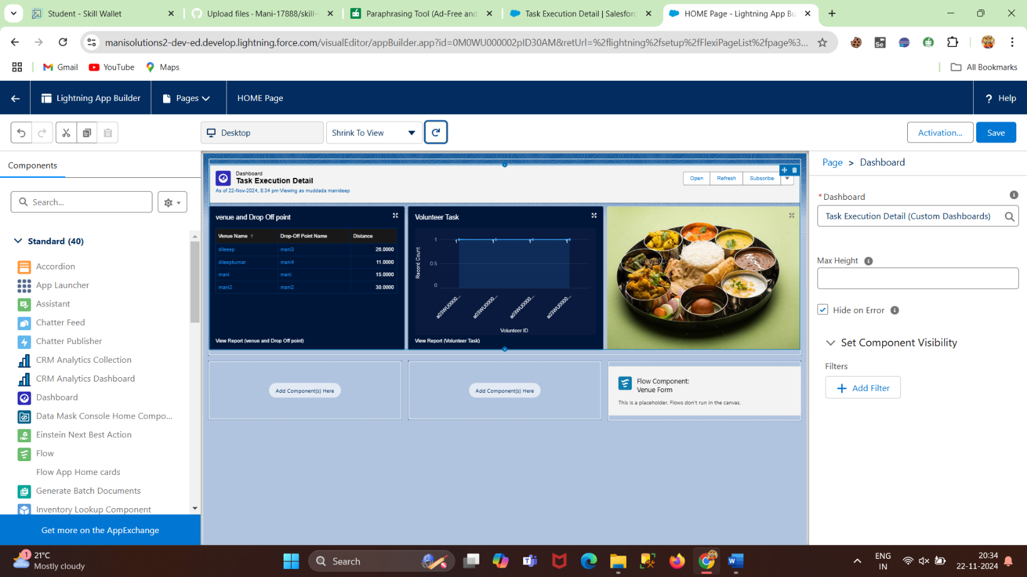

## Mani Add Screenshot of the Flow.

## 

# 

# 5.Testing and Validation

The testing strategy included:

* + **Unit Testing:** Unit tested Apex Classes and Triggers, including ***DropOffTrigger***

and custom field changes.

* + **User Interface Testing:** Validated each user interface component for ease of use and accurate data flow across bespoke tabs and the ***FoodConnect*** App.

# 6.Testing and Validation

The testing strategy included:

* + **Unit Testing:** Unit tested Apex Classes and Triggers, including ***DropOffTrigger***

and custom field changes.

* + **User Interface Testing:** Validated each user interface component for ease of use and accurate data flow across bespoke tabs and the ***FoodConnect*** App.

 

# 7.Key Scenarios Addressed by Salesforce in the Implementation Project

## Scenario 1: Coordinating Food Collection and Distribution

* + - Establish drop-off points and coordinate distances with specified sharing groups.

## Scenario 2: Volunteer Tracking and Assignment

* + - Ensured effective food collection and delivery by monitoring volunteer availability and tasks.

## Scenario 3: Feedback and Reporting

* + - Volunteers can provide feedback on deliveries, gather ratings, and track capacity for future improvements.

# 8.Conclusion

Through the use of Salesforce, the project successfully created a streamlined system for coordinating volunteers, organizing food donations, and scheduling delivery to designated locations. This platform significantly lowers food waste while achieving the goal of supplying food to disadvantaged areas, making it a scalable and useful solution to food security.