Adaptive Software Engineering

Name: K.ManiTeja
Roll no: 2420030139
Section - 1

Experiment-7: Kubernetes
Step 1: Install Minikube
Download and install the latest Minikube release according to the operating system. After installation, open Command Prompt as Administrator to verify the setup.
Step 2: Start the Minikube Cluster
Start Minikube using Docker as the container driver:
minikube start --driver=docker
Once the cluster starts, check its current status:
minikube status





Step 3: Install kubectl
Install kubectl, the command-line tool used to communicate with the Kubernetes cluster. On Windows, use the kubectl installation instructions and run the provided installation command from Command Prompt.
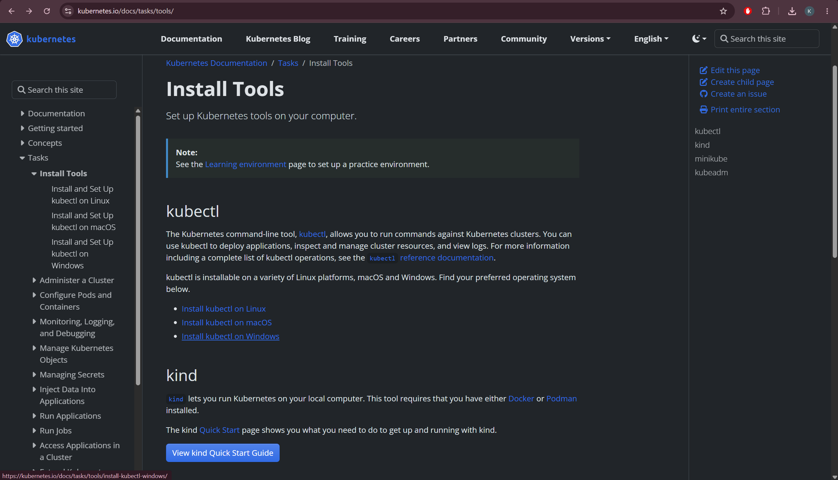
Step 4: Verify kubectl Installation
After installation, verify that kubectl is available:
kubectl version --client

Step 5: Verify the Kubernetes Nodes
Check the nodes available in the Minikube cluster:
kubectl get nodes
The Minikube node should be displayed with its current status.


Step 6: Create a Kubernetes Pod
Create a YAML file named pod.yaml containing the required Pod configuration. Apply the configuration to the Minikube cluster using:
kubectl apply -f pod.yaml
This creates the Pod described in the YAML file.



Step 7: Check the Pod
Verify that the Pod has been created and check its current status:
kubectl get pods
Step 8: Describe the Pod
Display detailed information about the nginx Pod, including its configuration and status:
kubectl describe pod nginx


Step 9: Access the Application
Forward the Pod's port to the local machine so that the application can be accessed through a web browser:
kubectl port-forward pod/nginx 8080:80


Open the displayed local address in a browser, such as http://localhost:8080, to access the nginx application.
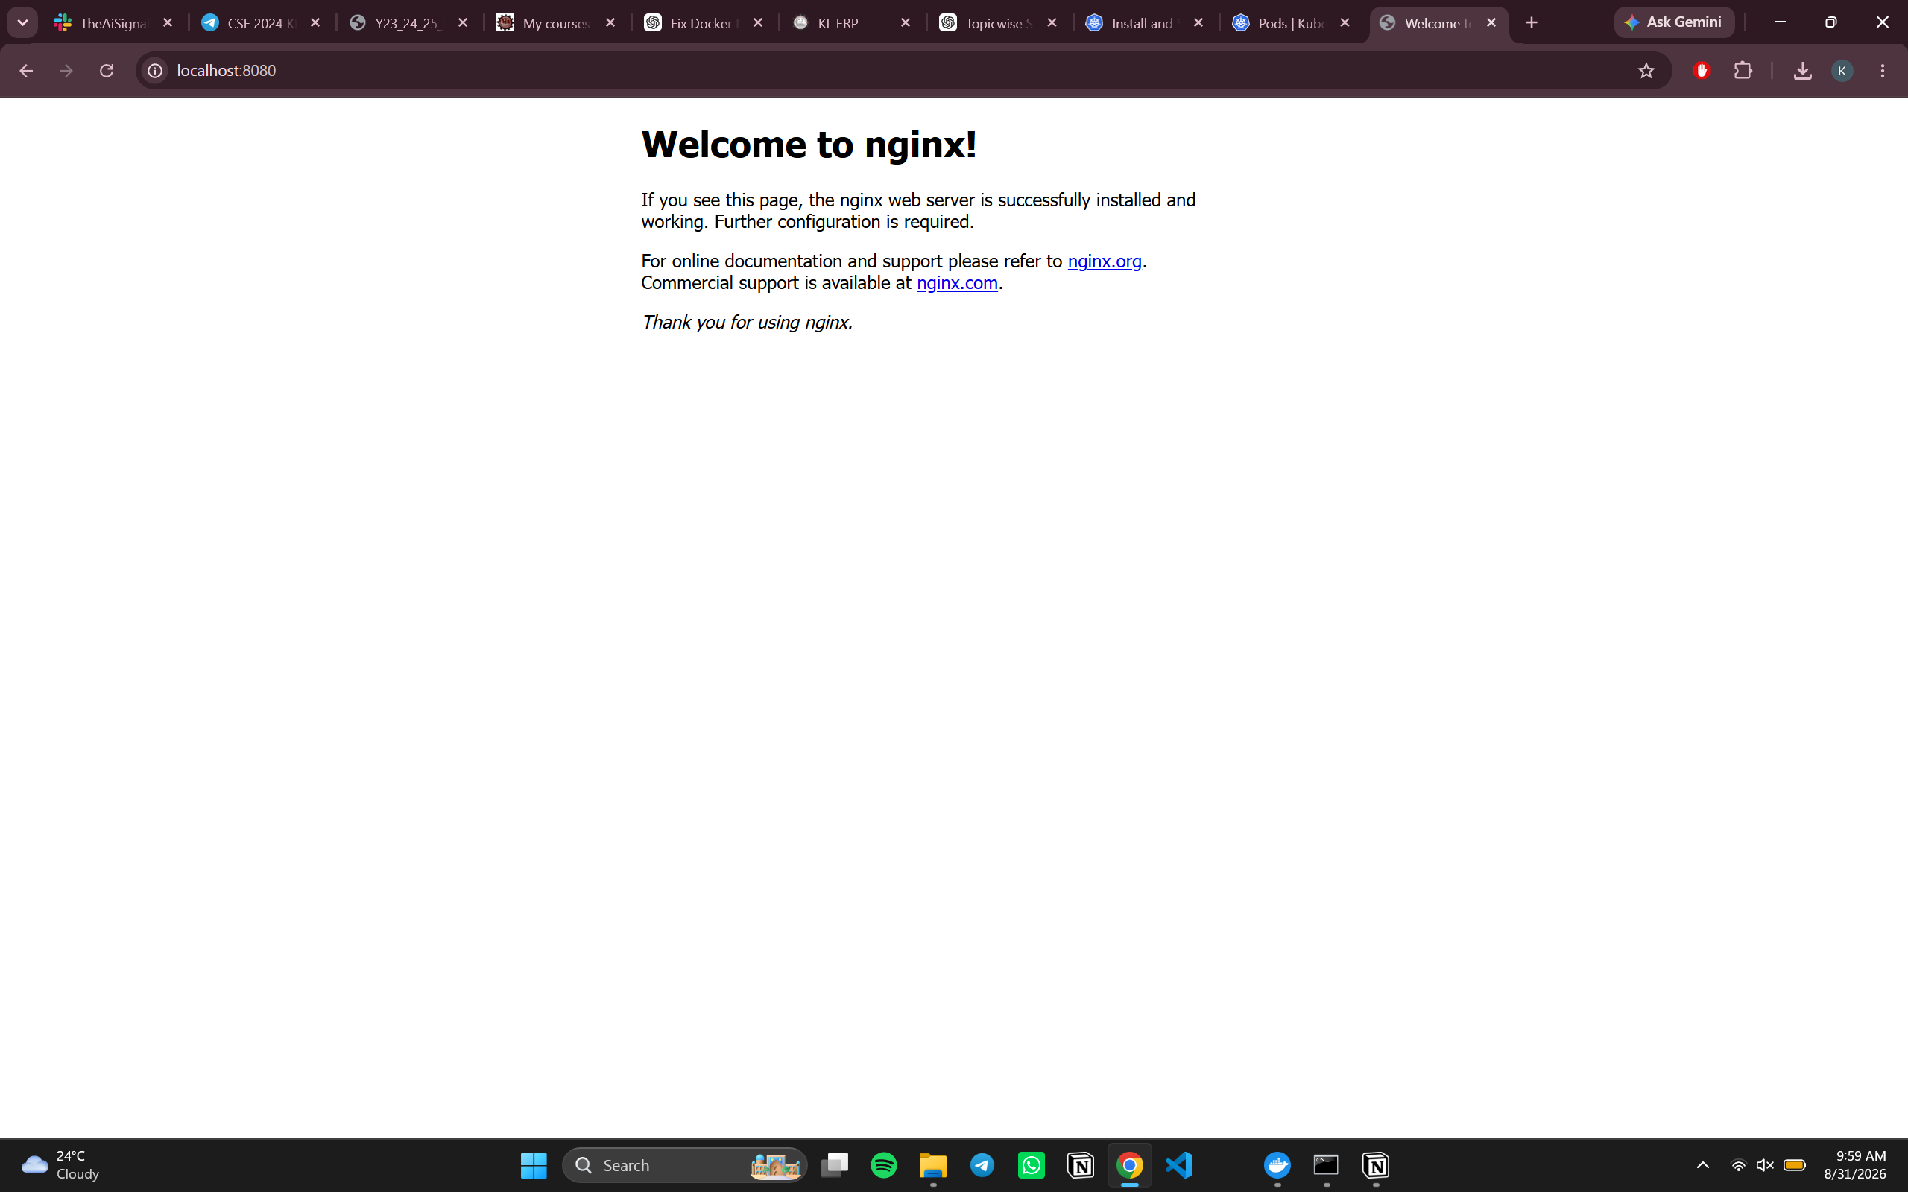
Basic Kubernetes Workflow
Install Minikube
↓
Start Minikube Cluster
↓
Install & Verify kubectl
↓
Check Kubernetes Nodes
↓
Create Pod using YAML
↓
Apply Pod Configuration
↓
Check / Describe Pod
↓
Access Application on localhost

