**A CRM Application to Handle the Clients and their property Related Requirements**

**By   
Manikanta Chodisetti  
manikanta_chodisetti@srmap.edu.in**

**Project Abstract**

Our World Properties integrates Salesforce to streamline customer interactions. Website engagement triggers automated record creation in Salesforce, capturing customer details and preferences. Salesforce categorizes users as approved or non-approved, offering tailored property selections to approved users. This enhances user experience and efficiency, providing personalized recommendations and broader listings. Seamless integration optimizes operations, improving customer engagement and facilitating growth in the real estate market.

|  |  |  |
| --- | --- | --- |
|  | **INDEX Page** |  |
| **Topics**  Introduction | - - - - - - - - - - - - - - - - - - - - - - - - | **Page no**  01 |
| Task 1 | - - - - - - - - - - - - - - - - - - - - - - - - | 01 |
| Task 2 | - - - - - - - - - - - - - - - - - - - - - - - - | 01 |
| Task 3 | - - - - - - - - - - - - - - - - - - - - - - - - | 02 |
| Task 4 | - - - - - - - - - - - - - - - - - - - - - - - - | 04 |
| Task 5 | - - - - - - - - - - - - - - - - - - - - - - - - | 05 |
| Task 6 | - - - - - - - - - - - - - - - - - - - - - - - - | 06 |
| Task 7 | - - - - - - - - - - - - - - - - - - - - - - - - | 01 |
| Task 8 | - - - - - - - - - - - - - - - - - - - - - - - - | 01 |
| Task 9 | - - - - - - - - - - - - - - - - - - - - - - - - | 02 |
| Task 10 | - - - - - - - - - - - - - - - - - - - - - - - - | 04 |
| Task 12 | - - - - - - - - - - - - - - - - - - - - - - - - | 05 |

# INTRODUCTION

Our World Properties has integrated Salesforce to enhance customer interactions and streamline its real estate operations. Through this integration, website engagement is seamlessly connected to Salesforce, where customer details and preferences are automatically captured. Salesforce then intelligently categorizes users into approved and non-approved segments, offering approved users personalized property recommendations while providing broader listings for others. This strategic use of Salesforce not only improves operational efficiency but also delivers a more personalized and engaging experience for customers, helping Dreams World Properties stay competitive and drive growth in the real estate market.

# Task 1

# Milestone 1 :- Create a Jotform and integrate it with the org to create a

# record of customers automatically.

# Client wants a form for the customers to get the details directly into the salesforce so that the admins can create a user in the org.

# 

# Published link: <https://form.jotform.com/242790855703059>

# Task 2

# Create Objects from Spreadsheet.

# Customer and Property Tables are created by using sample data.

# For Customer

# 

# For Property

# 

# Task 3

# Integrate JotForm with Salesforce Platform

# In this Milestone we are going to integrate JotForm with Salesforce. 1. On JotForm, we are integrated with salesforce org.

2. Select an Action - Create a record.

Select a Salesforce Object : - Customer

# 

# 3. Saving the Integration

# 

# Task 4

# Create Roles

# Create “Sales Executive” Role which reports to “Sales Representative”

# 

## Similarly Create a Role Name “Sales Manager” below Sales Executive which reports to Sales Executive, Also Add a Role below Sales Manager labeled as “Customer” which reports to Sales Manager.

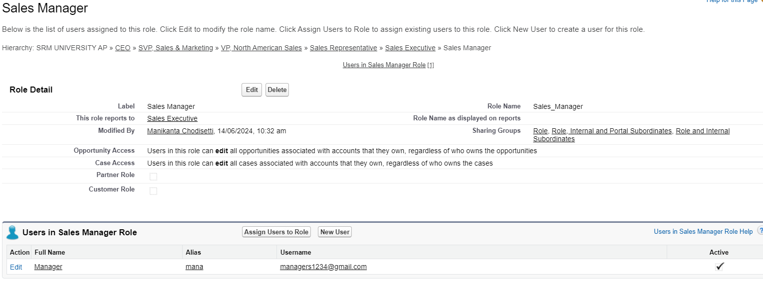

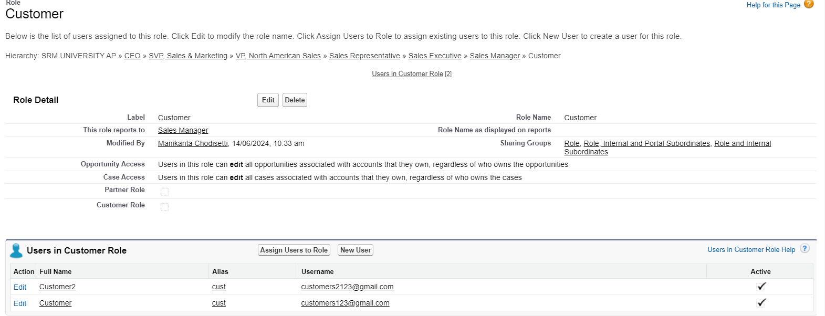

# Task 5

**Create a Property Details App**

From Setup>> Go to App Manager and click on New Lightning App and Name it as “Property Details” and add “Customer” and “Property” Object and Save it.

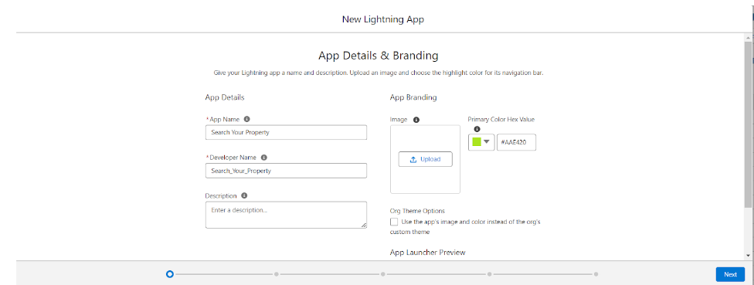

# Task 6

**Create Profiles**

1. Customer:
2. From Setup? Go to Profiles and Clone Salesforce Platform User and Name it “Customer”.

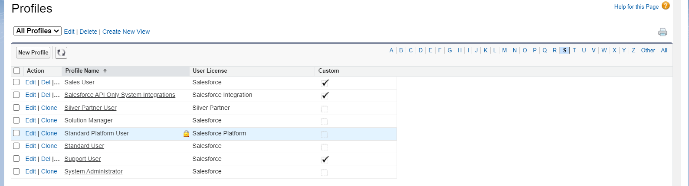

1. Uncheck all the Custom Objects and Check only Property Details From Custom App Settings.

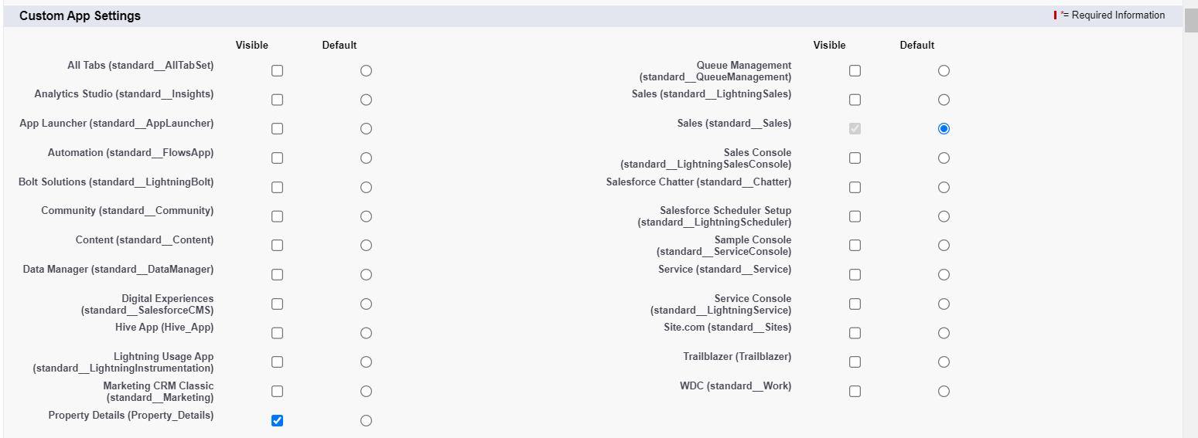

1. Also Remove all the Standard Object Permissions. Uncheck all the Custom Object Permissions and check read and view all in “Property”.

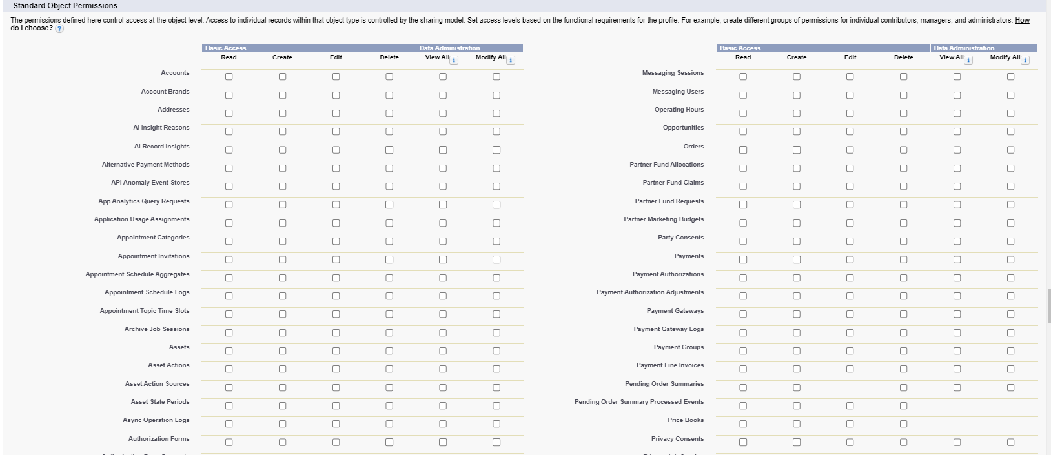

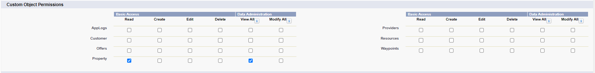

1. Property:
2. From Setup  >> Go to Profiles and Clone Salesforce Platform User and Name it “Manager”.

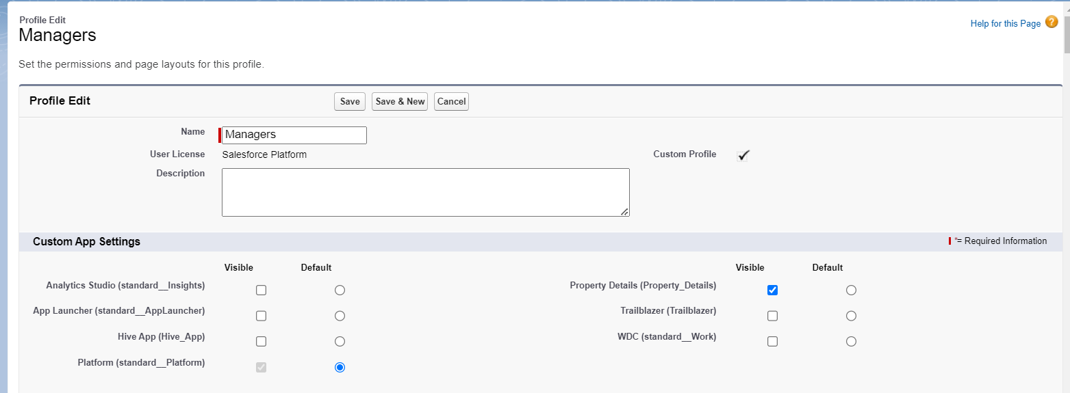

1. Uncheck all the Custom Objects and Check only Property Details From Custom App Settings.
2. Also Remove all the Standard Object Permissions. Uncheck all the Custom Object Permissions and check only “modify all” from “Property” and “Customer”.

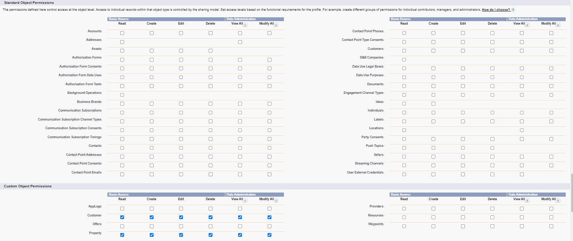

# Task 7

**Create a Check Box field on user**

Create Field on the User as per the business requirement.

1. Setup >> Object Manager >>  Search for User >>  Fields and Relationships
2. Create new Field Named as “Verified” as Data type “Check Box”

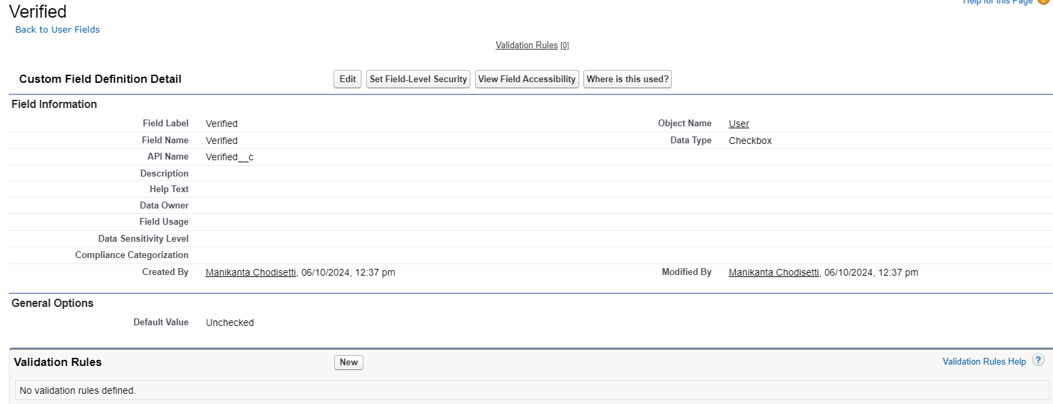

# Task 8

**Create Users**

Create three different users with three different Roles and profiles as we have mentioned above.

1. User-1 Executive

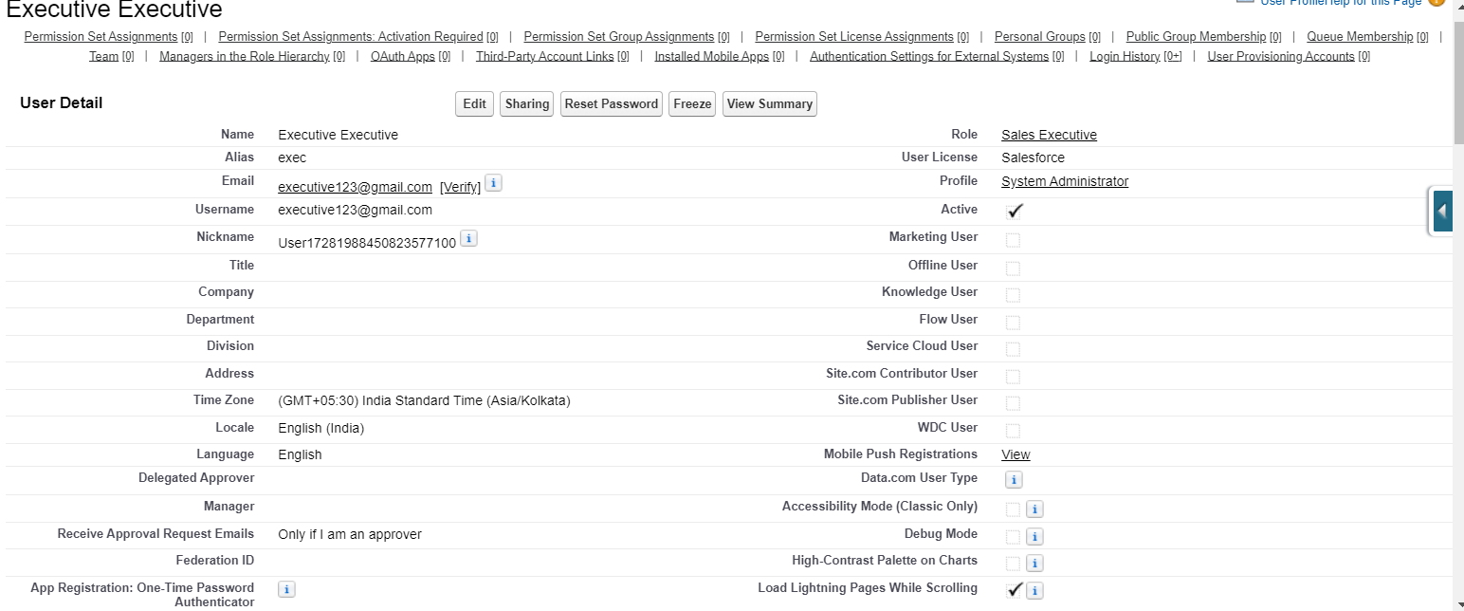

1. User-2 Manager

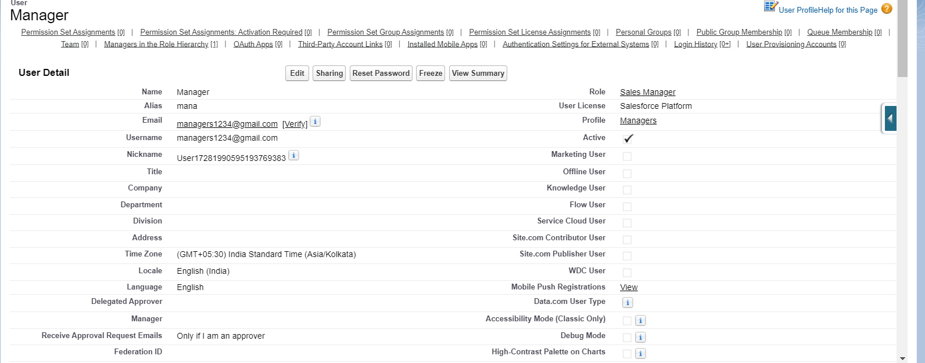

1. User-3 Customer

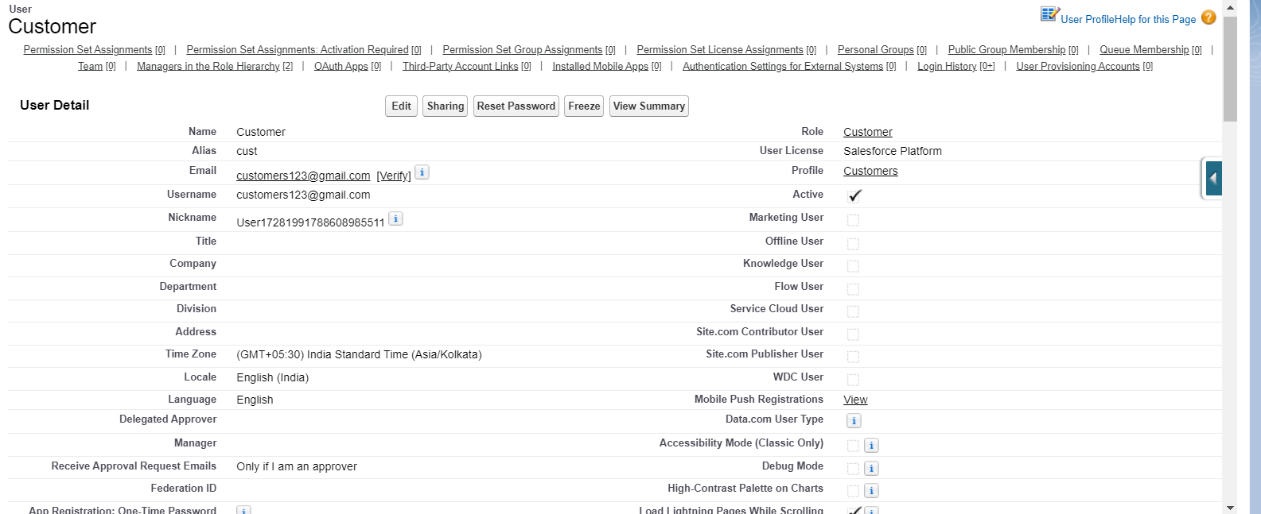

1. User-4 Customer2

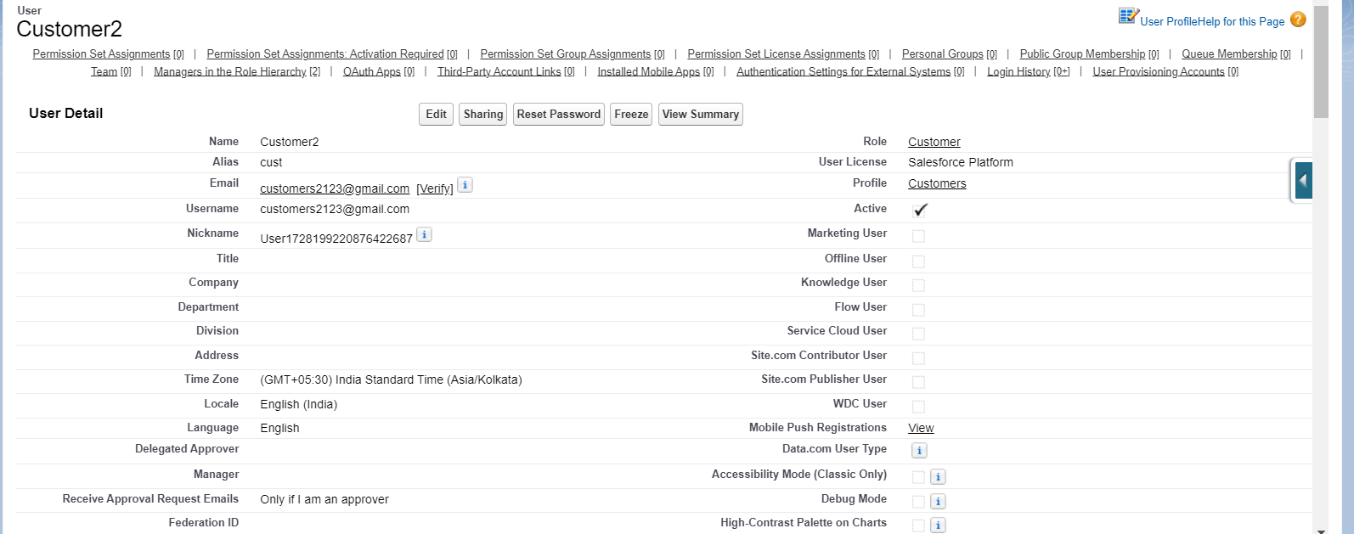

# Task 9

**Create an Approval Process for Property Object**

An Approval process to approve or reject the records as according

1. From Setup  >> Process Automation >> Approval Process .
2. Process Name - Property Approval.

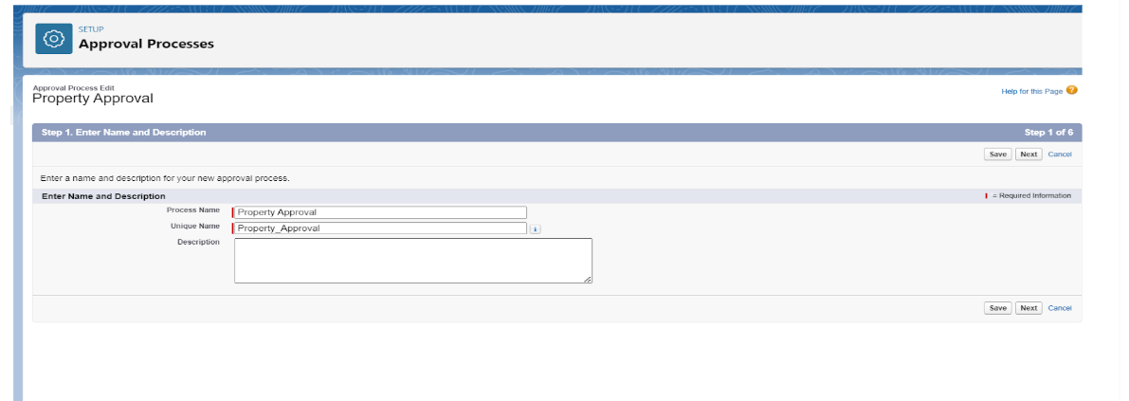

1. Give 2 criteria – Location is not equal to blank, Verified Equals false.

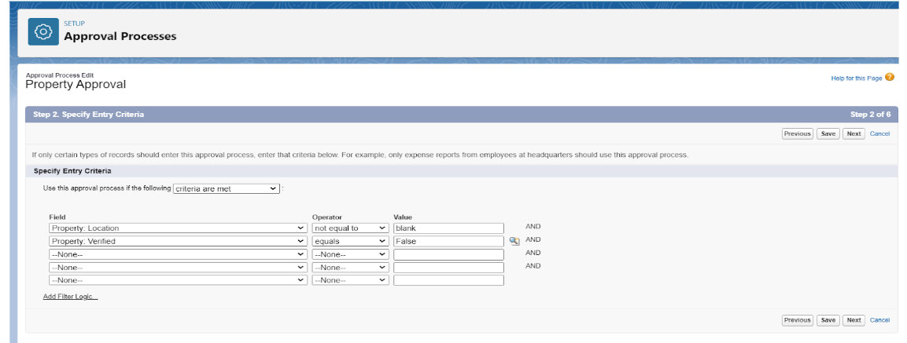

1. Click next and “Next Automated Approver Determined By”  Select Manager.
2. From Record Editability Properties >> Click on Administrators OR the currently assigned approver can edit records during the approval process.
3. From Step 5. Select Fields to Display on Approval Page Layout select Property, Owner, Location, Type.

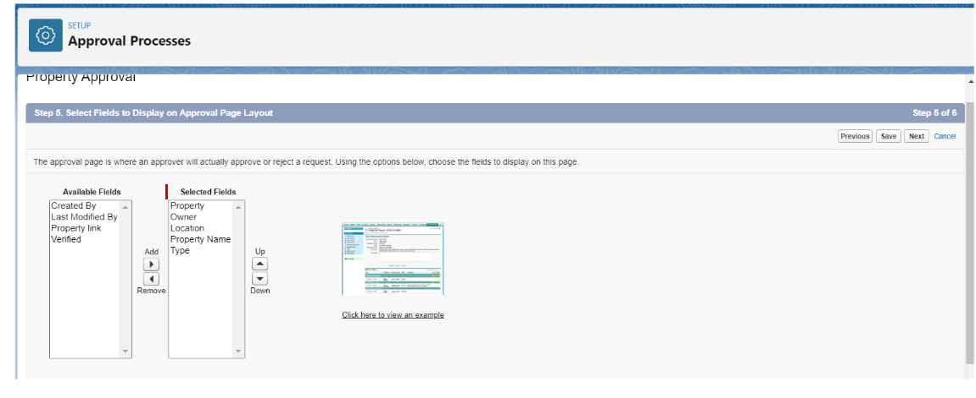

1. Click Next and Select the initial Submiters >>
2. Owner >>  Property Owner
3. Roles >>  Sales Manager
4. Save and Add an approval step name “Executive Approval ”.
5. Specify the Criteria >>  All record should enter .
6. click next and select the Approver as “ Sales Executive “ and “Save”.

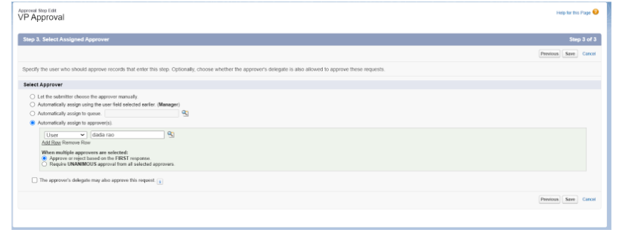

1. Add One field Update  as “Verified Property”.
2. Add One field Update  as “UnVerified Property”

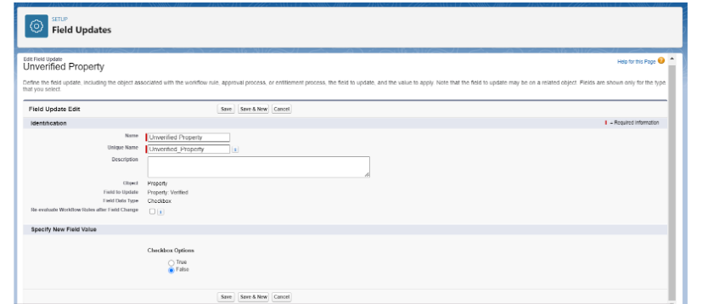

1. Activate the Approval Process.

# Task 10

**Create a Record trigger flow to submit the Approval Process Automatically.**

A flow that can submit the records directly for approval.

1. Search for Flows >> Click On New and Select “Record Trigger Flow”.
2. In Property. Select “Trigger the flow when” >> “A record is created”
3. Set Entry Conditions >> “None”.

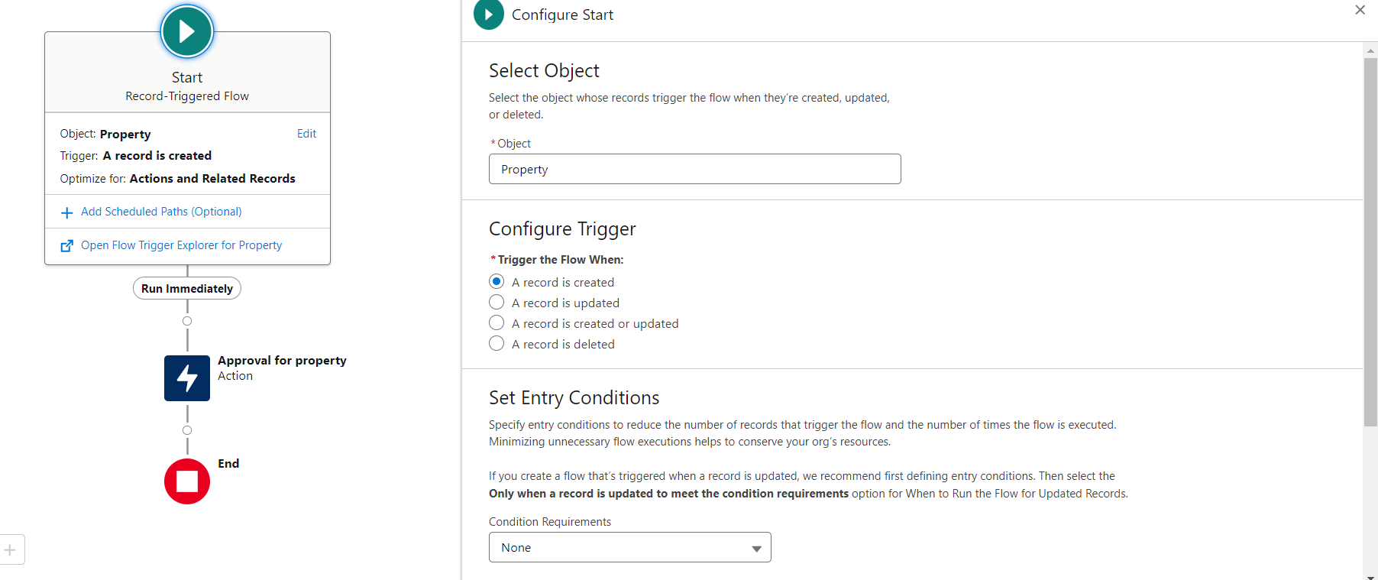

1. Add a “Action” >> “Submit for Approval”
2. Give Label >> Approval for property
3. Record Id >> {!$Record.Id} and Done.

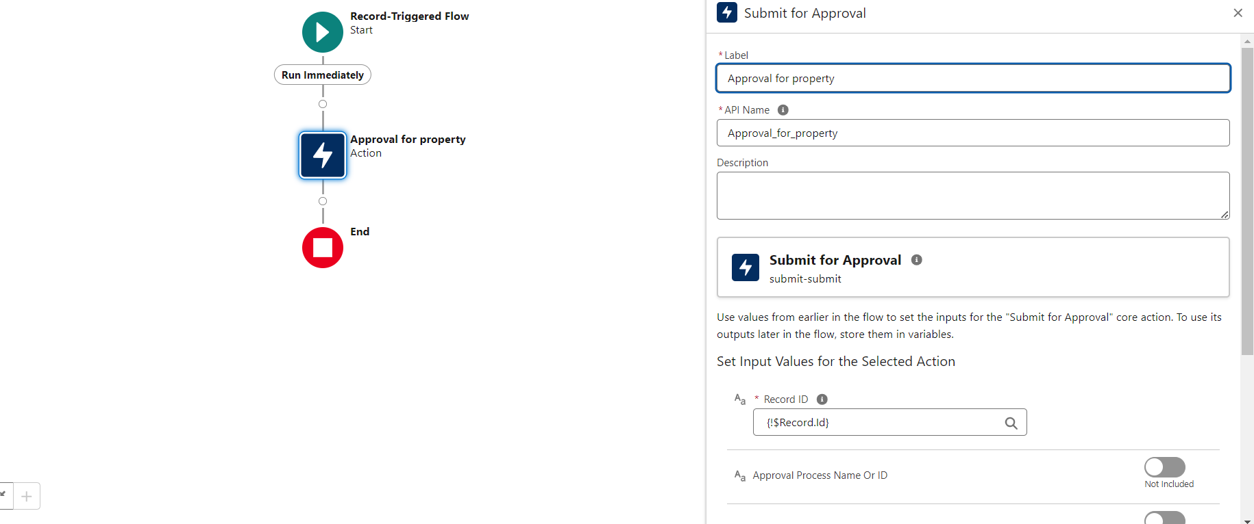

1. Save the Flow and Give label as “Property Approval” and “Activate”.

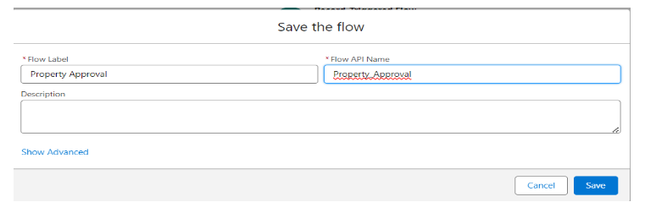

# Task 11

**Create an App Page**

Create an App Page on the Property details Object named as “Search Your Property”.

1. From Setup >> Go to Lightning App Builder >> Click on New >> Select App Page and Click on Next.
2. Give Label as “Search your Property” click “Next”.
3. Click “header and Left Sidebar”  and Click on “Done”.

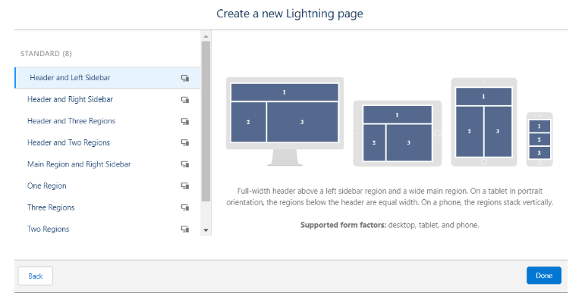

1. Click on “Save ” and then click on “Activate”.
2. From Page Setting select page activation as “Activate for all Users”.

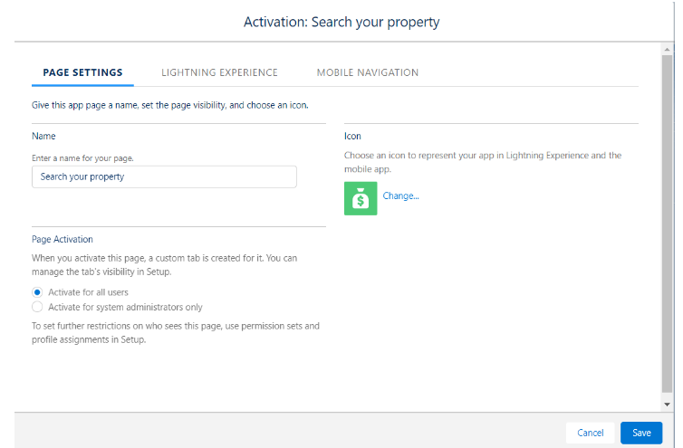

1. From Lightning Experience Click on “Property Details” and click on Add Page“.

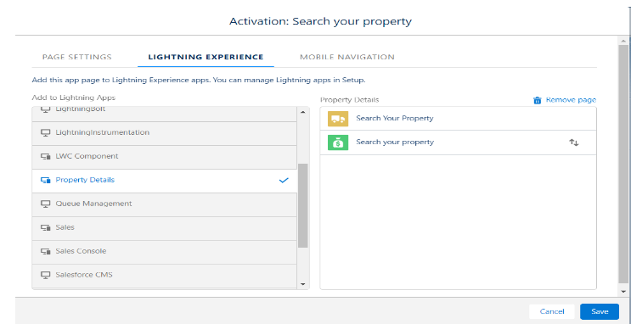

1. Then Click on “Save”.

# Task 12

**Create a LWC Component**

Create an LWC Component for the customers so that only verified customers can access the verified properties and non-Verified customers can access non verified properties, and deploy it on “Search your Property Page”.

1. Create an Apex Class and make it aura enabled and name it “PropertHandler_LWC”.

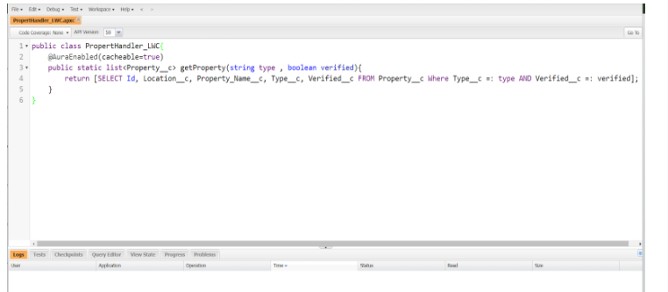

1. Create a Lightning Web Component in your VsCode, and (ctrl+shift +P) and click on authorize an org. Enter your login id and password to authorize your org.
2. Now (ctrl+shift +P)  and Create a lightning Web Component and Name it Anything you want to.
3. In Html File: -

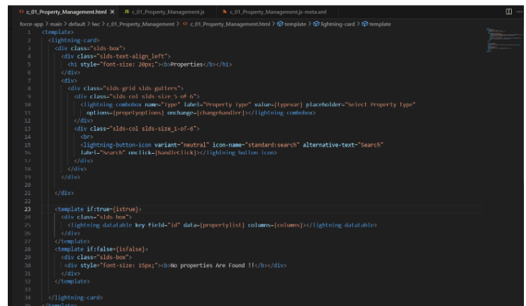

1. 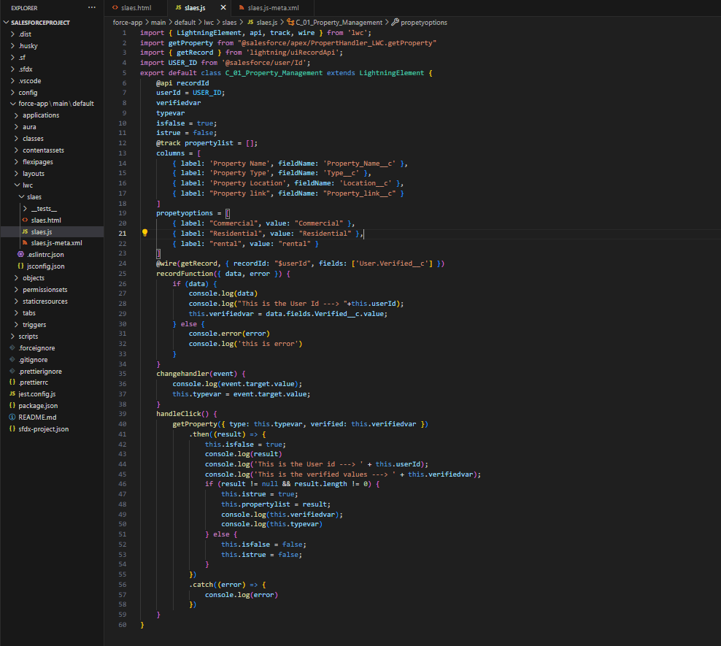In Js File:-
2. In meta File:-

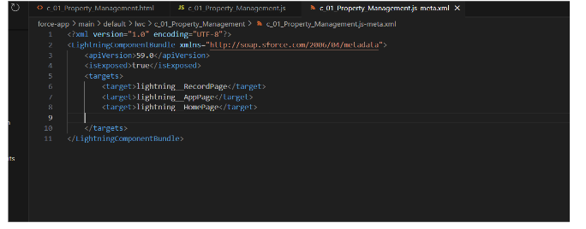

1. After Saving all the three Codes, Right Click and deploy this component to the org.

# 

# Task 13

# Drag the component to your App Page.

# Adding the Component to your Page

# From Setup >> Go to App Launcher >> Search for Property Details.

1. On this Page click on gear icon and click on Edit Page.

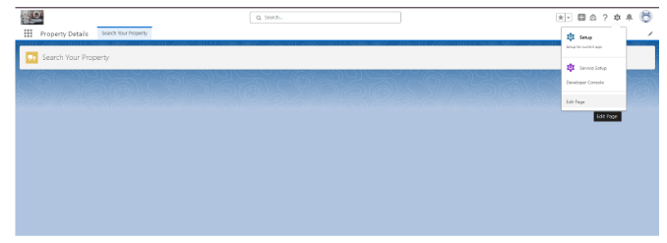

1. Drag the Component to your App Page and Save the Page.

# 

# Task 14

# Give Access of Apex Classes to Profiles

# The Apex Class has a Security, Enable the security for the profiles that needs to access this class.

1. From Setup >> Search for Apex Classes >> Click on “Security” behind “PropertyHandler__LWC”.

# From Profiles Add “Manager” and “Customer” and “Save”.

# 

# Conclusion:

# The integration of Salesforce into Our World Properties' operations has significantly improved both customer engagement and internal efficiency. By automating the capture of customer information and tailoring property selections based on user approval status, the company provides a more personalized and seamless experience. This not only enhances customer satisfaction but also positions Our World Properties for sustainable growth in the competitive real estate market. As the business continues to evolve, leveraging Salesforce's powerful tools will enable the company to stay ahead of industry trends and better meet customer needs.

# Future Works:

# Looking ahead, Our World Properties can expand the capabilities of its Salesforce integration by incorporating advanced analytics and AI-driven insights. This would allow the company to predict customer preferences more accurately and offer even more personalized property recommendations. Integrating additional customer engagement channels, such as social media and mobile apps, into Salesforce could further enhance data collection and interaction tracking. Additionally, optimizing workflow automation within Salesforce, such as contract management and lead nurturing, can improve operational efficiency. Continuous improvement in these areas will enable Our World Properties to stay competitive, scale effectively, and provide a superior customer experience in the evolving real estate landscape.

# Thank You