# **Week 3**

## **Task 1**

Output:

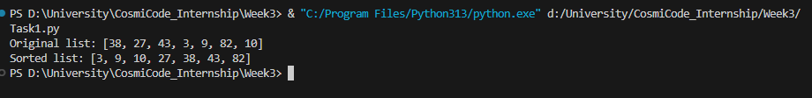

## **Task 2**

Output:

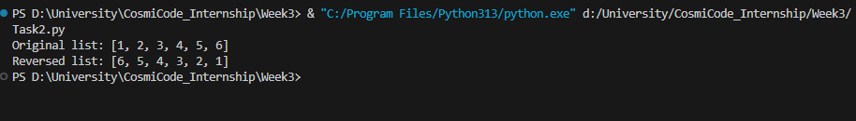

## **Task 3**

Output:

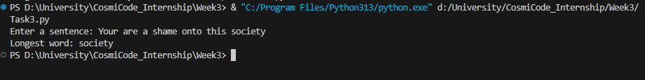

## **Task 4**

Output:

## **Task 5**

Output:

