# **Week 6**

## **Task 1**

Output:

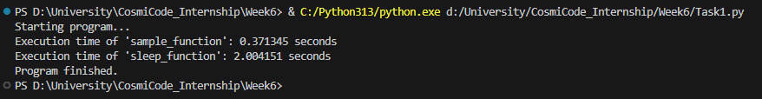

## **Task 2**

Output:

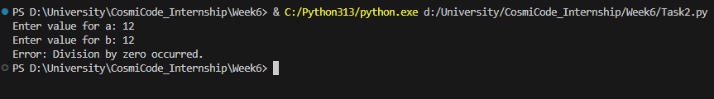

## **Task 3**

Output:



## **Task 4**

Output:

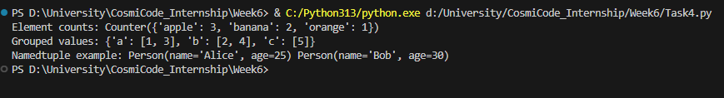

## **Task 5**

Output:

## **Task 6**

Output:



## **Task 7**

Output:

