MY SPRING BOOT ASSIGNMENT

Q1.create a restful API Spring Boot for student.

Ans.

Application.java

package com.ttn.springboot;
import org.springframework.boot.SpringApplication;
import org.springframework.boot.autoconfigure.SpringBootApplication;
@SpringBootApplication
public class Application {
public static void main(String[] args) {
SpringApplication.run(Application.class, args);
}
}
StudentController.java

package com.ttn.springboot.controller;
import com.ttn.springboot.entity.Student;
import com.ttn.springboot.service.StudentDetails;
import org.springframework.beans.factory.annotation.Autowired;
import org.springframework.web.bind.annotation.GetMapping;
import org.springframework.web.bind.annotation.RestController;
import java.awt.*;
import java.util.List;
@RestController
public class StudentController {
@Autowired
StudentDetails studentDetails;
@GetMapping("/Students")
public List<Student> getStudents() {
return studentDetails.getStudents();
}
}

StudentDetails.java
package com.ttn.springboot.service;
import com.ttn.springboot.entity.Student;
import org.springframework.stereotype.Service;
import java.util.Arrays;
import java.util.List;
@Service
public class StudentDetails {
public List<Student> getStudents(){
return Arrays.asList(new Student(1,"manidhar","JVM"),
new Student(2,"smriti babbar","android"),
new Student(3,"shivam","ios"),
new Student(4,"sanjeev","DEVOPS"));
}
}
Student.java
package com.ttn.springboot.entity;
public class Student {
private Integer id;
private String Name;
private String Competency;
public Student(Integer id, String name, String competency) {
this.id = id;
Name = name;
Competency = competency;
}
public Integer getId() {
return id;
}
public void setId(Integer id) {
this.id = id;
}
public String getName() {
return Name;
}
public void setName(String name) {
Name = name;
}
public String getCompetency() {
return Competency;
}
public void setCompetency(String competency) {
Competency = competency;
}
}
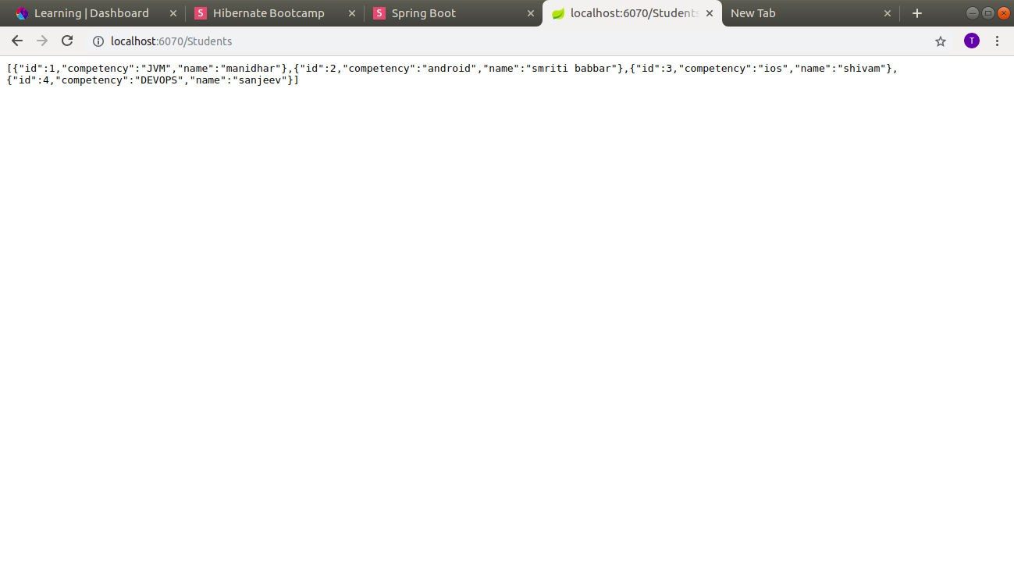
Q2.Run spring boot application with all three ways.
A.1.Through main class
2.through bootRun
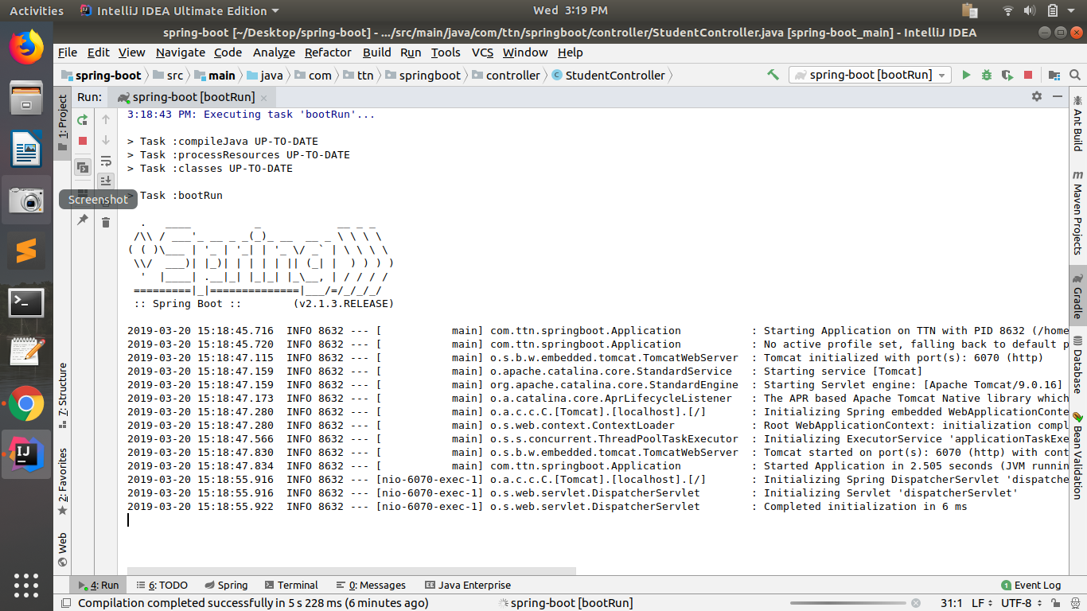
3.Through bootJar
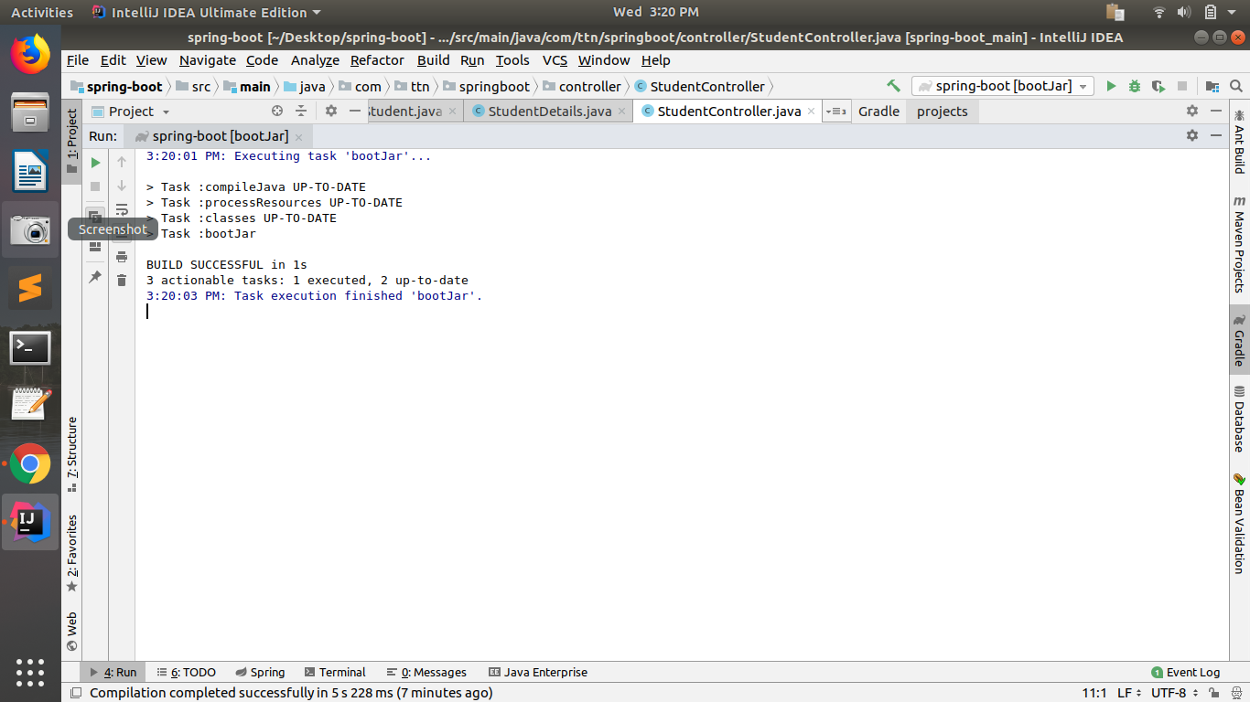
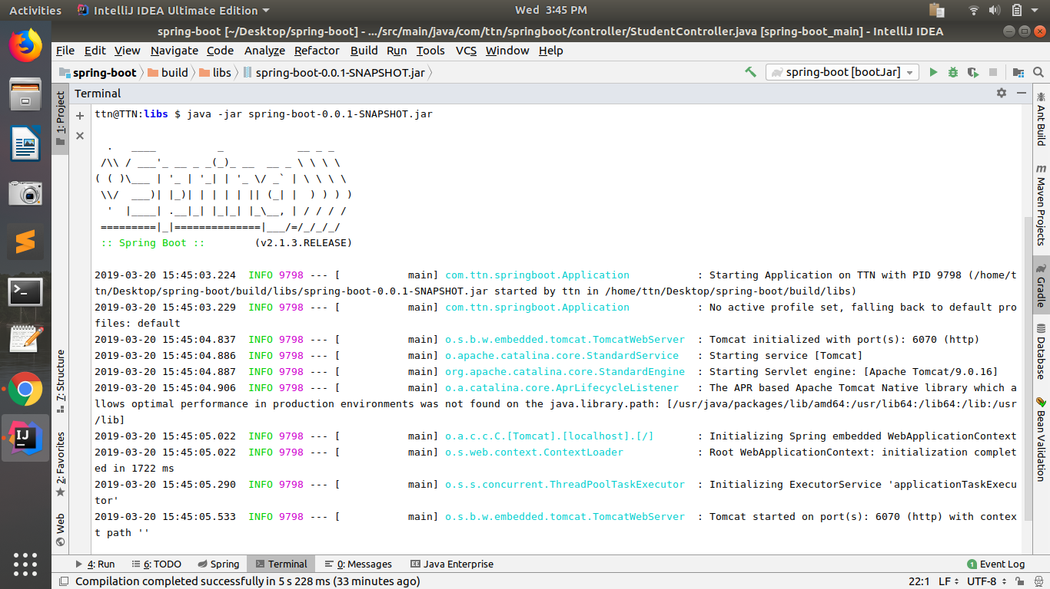
Q3.Create bean user containing two field username and password with spring context file.
A.
Application.java
package com.ttn.springboot;
import com.ttn.springboot.entity.User;
import org.aspectj.lang.annotation.Before;
import org.springframework.boot.SpringApplication;
import org.springframework.boot.autoconfigure.SpringBootApplication;
import org.springframework.context.annotation.Bean;
@SpringBootApplication
public class Application {
@Bean
User user(){
return new User("Manidhar","Mani023");
}
public static void main(String[] args) {
SpringApplication.run(Application.class, args);
}
}

UserController.java
package com.ttn.springboot.controller;
import com.ttn.springboot.entity.User;
import org.springframework.beans.factory.annotation.Autowired;
import org.springframework.stereotype.Controller;
import org.springframework.web.bind.annotation.GetMapping;
import org.springframework.web.bind.annotation.ResponseBody;
@Controller
public class UserController {
@Autowired
User user;
@GetMapping("/user")
@ResponseBody
public String getUser(){
return "Username is :"+user.getUsername() +"\n" +"Password is :"+user.getPassword();
}
}
User.java
package com.ttn.springboot.entity;
public class User {
private String Username;
private String Password;
public User(){
}
public User(String username, String password) {
Username = username;
Password = password;
}
public String getUsername() {
return Username;
}
public void setUsername(String username) {
Username = username;
}
public String getPassword() {
return Password;
}
public void setPassword(String password) {
Password = password;
}
}
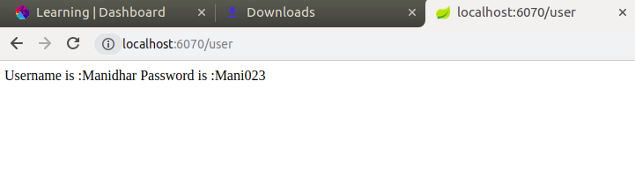
Q4.Create a Bean Database with two fields port and name and Access its values using application.properties
Answer.
Application.java
package com.ttn.springboot;
import com.ttn.springboot.entity.Database;
import com.ttn.springboot.entity.User;
import org.springframework.boot.SpringApplication;
import org.springframework.boot.autoconfigure.SpringBootApplication;
import org.springframework.context.annotation.Bean;
@SpringBootApplication
public class Application {
@Bean
User user() {
return new User("Manidhar", "Mani023");
}
@Bean
Database database() {
return new Database();
}
public static void main(String[] args) {
SpringApplication.run(Application.class, args);
}
}

DatabaseController.java
package com.ttn.springboot.controller;
import com.ttn.springboot.entity.Database;
import org.springframework.beans.factory.annotation.Autowired;
import org.springframework.web.bind.annotation.GetMapping;
import org.springframework.web.bind.annotation.RestController;
@RestController
public class DatabaseController {
@Autowired
Database database;
@GetMapping("/database")
public String getDatabase() {
return database.toString();
}
}
Database.java
package com.ttn.springboot.entity;
import org.springframework.beans.factory.annotation.Value;
public class Database {
@Value("${server.port}")
Integer Port;
@Value("${server.name}")
String Name;
public Database(Integer port) {
Port = port;
}
public Database() {
}
public Integer getPort() {
return Port;
}
public void setPort(Integer port) {
Port = port;
}
public String getName() {
return Name;
}
public void setName(String name) {
Name = name;
}
@Override
public String toString() {
return "Database{" +
"Port=" + Port +
", Name='" + Name + '\'' +
'}';
}
}

Application.properties

server.port=6070
server.name=human
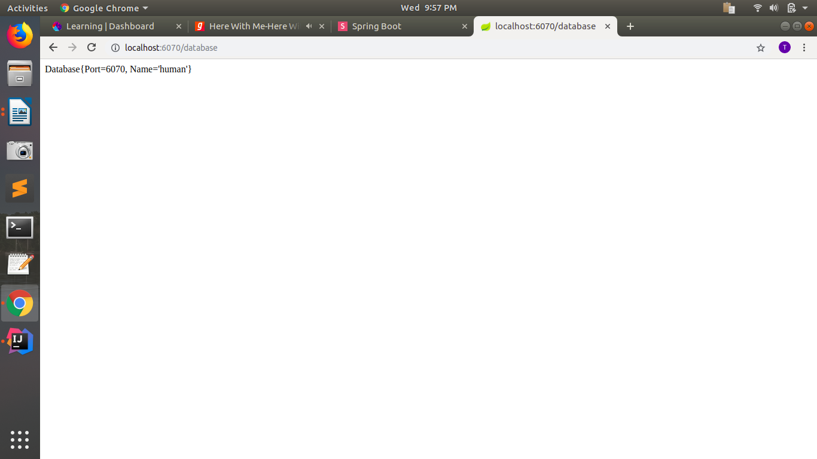
Q5.Configure environment specfic values form Database Bean
Answer.
application-prod.properties
server.port=6070
server.name=human
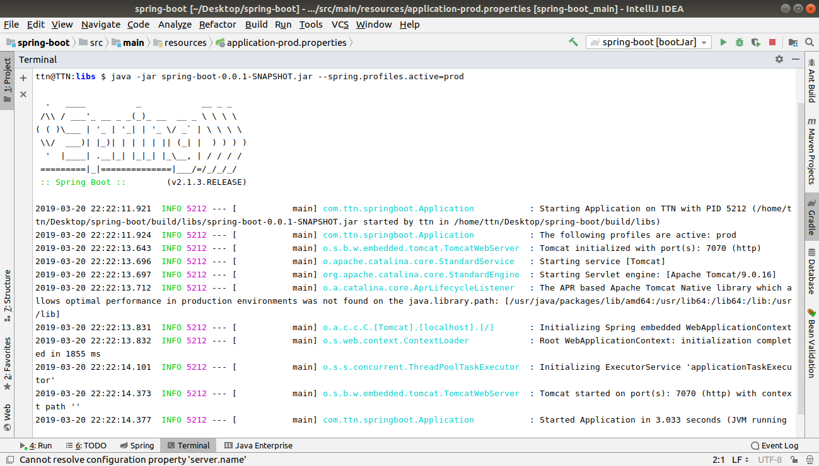
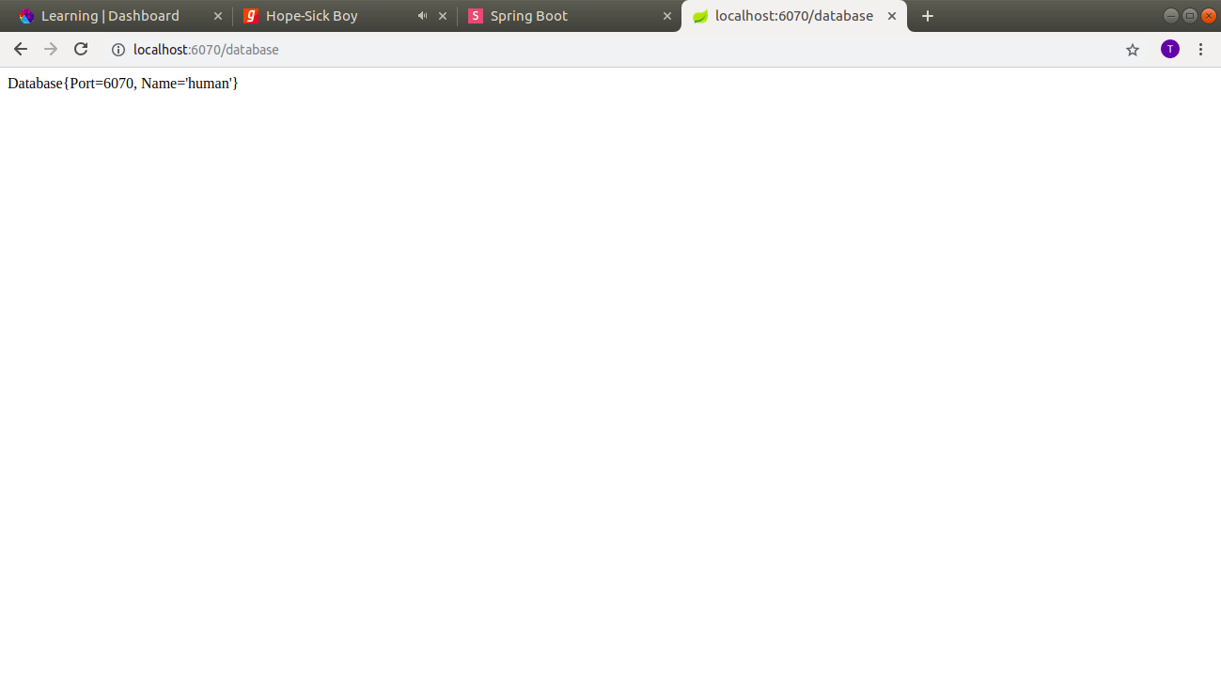
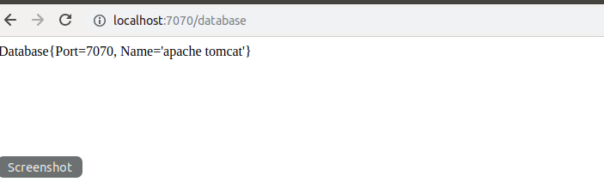

Question 6 :Apply Logging whereever you feel is necessity (1 Mark)
Answer 6 :
StudentController.java
package com.ttn.springboot.controller;
import com.ttn.springboot.entity.Student;
import com.ttn.springboot.service.StudentDetails;
import org.slf4j.Logger;
import org.slf4j.LoggerFactory;
import org.springframework.beans.factory.annotation.Autowired;
import org.springframework.web.bind.annotation.GetMapping;
import org.springframework.web.bind.annotation.RestController;
import java.awt.*;
import java.util.List;
//import java.util.logging.Logger;
@RestController
public class StudentController {
@Autowired
StudentDetails studentDetails;
Logger logger=(Logger) LoggerFactory.getLogger(StudentController.class);
@GetMapping("/Students")
public List<Student> getStudents() {
logger.info("ENTER THE STUENTS");
return studentDetails.getStudents();
}
}
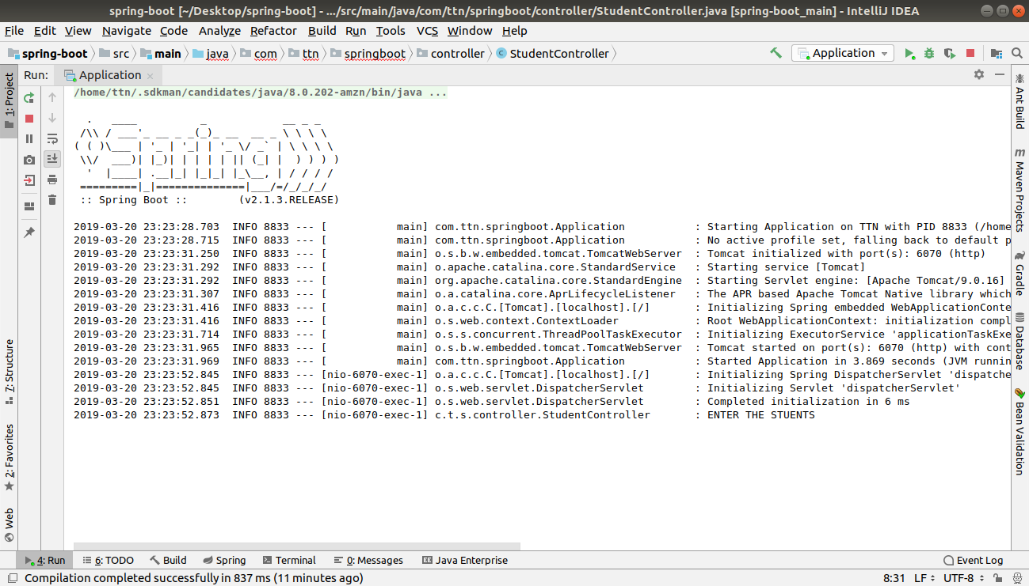

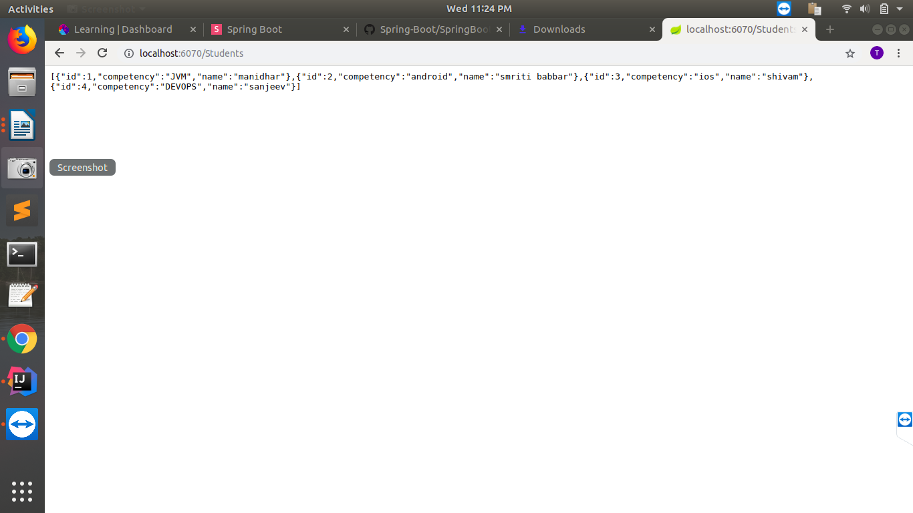
Question 7 : Bootstrap Data for Student Domain
Answer.
package com.ttn.springboot.event;
import com.ttn.springboot.entity.Student;
import org.springframework.boot.context.event.ApplicationStartedEvent;
import org.springframework.context.event.EventListener;
import org.springframework.stereotype.Component;
@Component
public class Bootstrap {
@EventListener(Student.class)
public void init(){
System.out.println("Your Application is up FOR STUDENT and running");
}
}
StudentController.java
package com.ttn.springboot.controller;
import com.ttn.springboot.entity.Student;
import com.ttn.springboot.event.Bootstrap;
import com.ttn.springboot.service.StudentDetails;
import org.slf4j.Logger;
import org.slf4j.LoggerFactory;
import org.springframework.beans.factory.annotation.Autowired;
import org.springframework.web.bind.annotation.GetMapping;
import org.springframework.web.bind.annotation.RestController;
import java.awt.*;
import java.util.List;
//import java.util.logging.Logger;
@RestController
public class StudentController {
@Autowired
StudentDetails studentDetails;
@Autowired
Bootstrap bootstrap;
Logger logger=(Logger) LoggerFactory.getLogger(StudentController.class);
@GetMapping("/Students")
public List<Student> getStudents() {
bootstrap.init();
logger.info("ENTER THE STUDENTS");
return studentDetails.getStudents();
}
}

