My hibernate assignment

Q1.Create a class Author with instance variables firstName, lastName and age.
A.
Author.java

package com.ttn.hibernate.QuestionOne;
import javax.persistence.Entity;
import javax.persistence.GeneratedValue;
import javax.persistence.GenerationType;
import javax.persistence.Id;
@Entity
public class Author {
@Id
@GeneratedValue(strategy = GenerationType.IDENTITY)
private String firstName;
private String lastName;
private Integer age;
public String getFirstName() {
return firstName;
}
public void setFirstName(String firstName) {
this.firstName = firstName;
}
public String getLastName() {
return lastName;
}
public void setLastName(String lastName) {
this.lastName = lastName;
}
public Integer getAge() {
return age;
}
public void setAge(Integer age) {
this.age = age;
}
@Override
public String toString() {
return "Author{" +
"firstName='" + firstName + '\'' +
", lastName='" + lastName + '\'' +
", age=" + age +
'}';
}
}

HIBERNATE.CFG.XML
<?xml version="1.0" encoding="UTF-8"?>
<!DOCTYPE hibernate-configuration PUBLIC "-//Hibernate/Hibernate Configuration DTD 3.0//EN"
"http://hibernate.sourceforge.net/hibernate-configuration-3.0.dtd">
<hibernate-configuration>
<session-factory>
<!--Database connection settings -->
<property name="hibernate.connection.driver_class">com.mysql.jdbc.Driver</property>
<property name="hibernate.connection.url">jdbc:mysql://localhost:3306/hibernateDB</property>
<property name="hibernate.connection.username">mani</property>
<property name="hibernate.connection.password">mani</property>
<!--JDBC connection pool-->
<property name="connection.pool_size">10</property>
<!-- SQL Dialect-->
<property name="hibernate.dialect">org.hibernate.dialect.MySQLDialect</property>
<!--echo all executed SQL-->
<property name="show_sql">true</property>
<!--drop or re-create database schema at startup-->
<property name="hbm2ddl.auto">create</property>
<!--Annotated entity class-->
<mapping class="com.ttn.hibernate.Author"/>
</session-factory>
</hibernate-configuration>
Application.java

package com.ttn.hibernate.QuestionOne;
import com.ttn.hibernate.Author;
import org.hibernate.Session;
import org.hibernate.SessionFactory;
import org.hibernate.cfg.Configuration;
public class Application {
public static void main(String[] args) {
com.ttn.hibernate.Author author=new Author();
author.setFirstName("MANIDHAR");
author.setLastName("TAMARALA");
author.setAge(29);
SessionFactory sessionFactory = new Configuration().configure().buildSessionFactory();
Session session=sessionFactory.openSession();
session.beginTransaction();
session.save(author);
session.getTransaction().commit();
session.close();
}
}

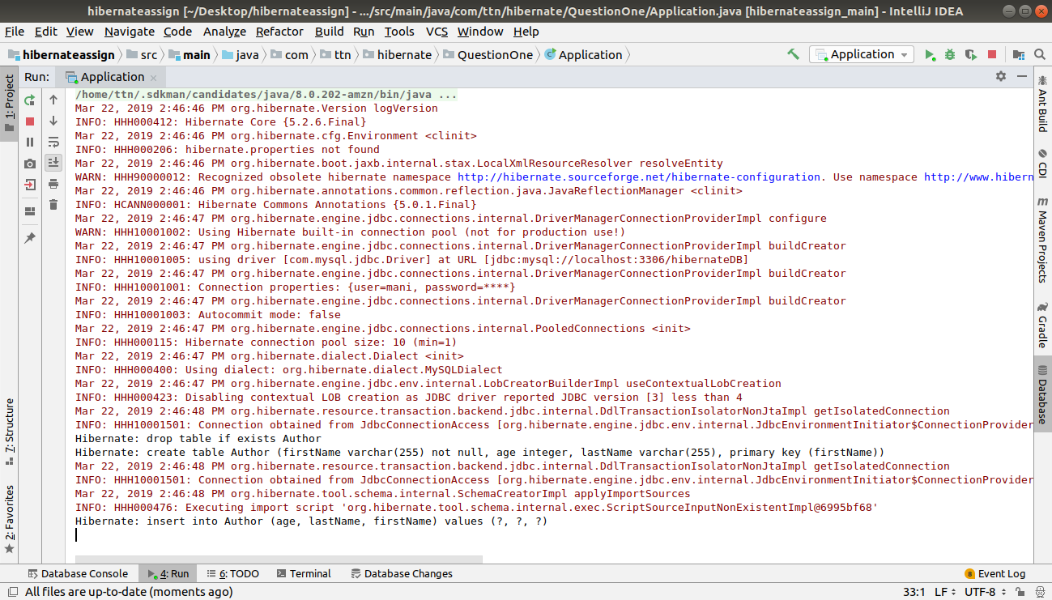
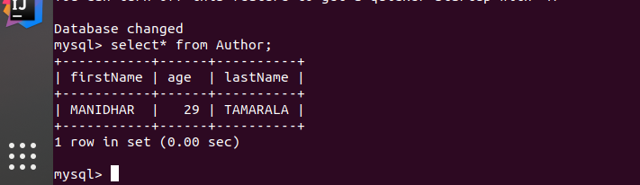

Q2.Perform CRUD operation for Author class.
A.
Application.java
package com.ttn.hibernate.QuestionOneandTwo;
public class Application {
public static void main(String[] args) {
//create
/* Author author=new Author();
author.setFirstName("MANIDHAR");
author.setLastName("TAMARALA");
author.setAge(29);
SessionFactory sessionFactory = new Configuration().configure().buildSessionFactory();
Session session=sessionFactory.openSession();
session.beginTransaction();
session.save(author);
session.getTransaction().commit();
session.close();*/
// read
/*SessionFactory sessionFactory=new Configuration().configure().buildSessionFactory();
Session session=sessionFactory.openSession();
session.beginTransaction();
Author author=session.get(Author.class,"MANIDHAR");
session.getTransaction().commit();
session.close();
System.out.println(author);
*/
//update
/* SessionFactory sessionFactory=new Configuration().configure().buildSessionFactory();
Session session=sessionFactory.openSession();
session.beginTransaction();
Author author=session.get(Author.class,"MANIDHAR");
author.setLastName("LOVA TAMARALA");
session.update(author);
session.getTransaction().commit();
session.close();
System.out.println(author);
*/
//delete
/* SessionFactory sessionFactory=new Configuration().configure().buildSessionFactory();
Session session=sessionFactory.openSession();
session.beginTransaction();
Author author=session.get(Author.class,"MANIDHAR");
session.delete(author);
session.getTransaction().commit();
session.close();
System.out.println(author);*/
}
}

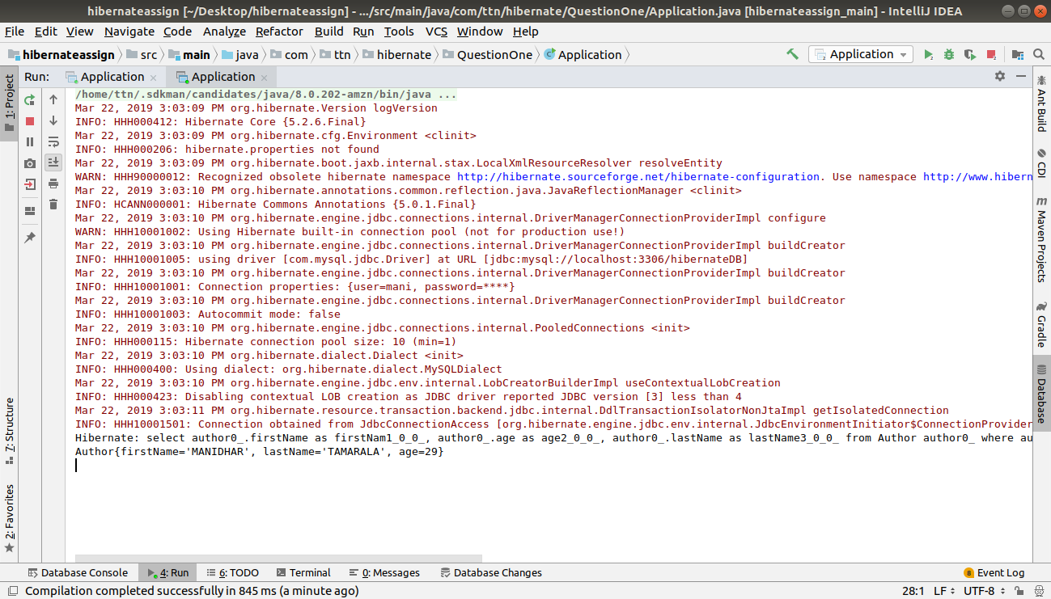
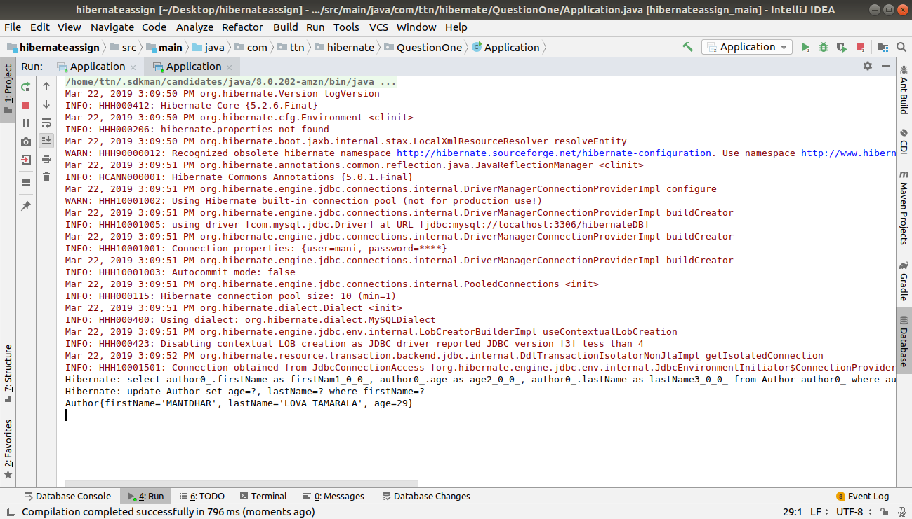
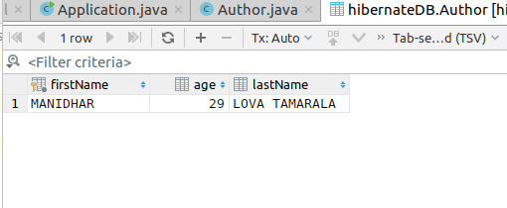

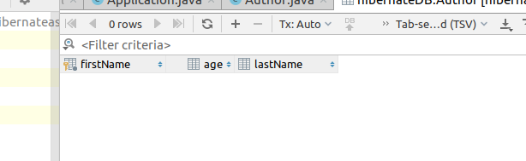

Q3.Use hbm2ddl create to introduce Date of Birth for Author.
A.

AuthorThree.java
package com.ttn.hibernate.QuestionThree;
import javax.persistence.Entity;
import javax.persistence.Id;
import java.sql.Date;
@Entity
public class AuthorThree {
@Id
private String firstName;
private String lastName;
private Integer age;
private Date date;
public AuthorThree() {
}
public AuthorThree(String firstName, String lastName, Integer age, Date date) {
this.firstName = firstName;
this.lastName = lastName;
this.age = age;
this.date = date;
}
public Date getDate() {
return date;
}
public void setDate(Date date) {
this.date = date;
}
public String getFirstName() {
return firstName;
}
public void setFirstName(String firstName) {
this.firstName = firstName;
}
public String getLastName() {
return lastName;
}
public void setLastName(String lastName) {
this.lastName = lastName;
}
public Integer getAge() {
return age;
}
public void setAge(Integer age) {
this.age = age;
}
@Override
public String toString() {
return "AuthorThree{" +
"firstName='" + firstName + '\'' +
", lastName='" + lastName + '\'' +
", age=" + age +
", date=" + date +
'}';
}
}
Applicationthree.java
package com.ttn.hibernate.QuestionThree;
import org.hibernate.Session;
import org.hibernate.SessionFactory;
import org.hibernate.cfg.Configuration;
import java.sql.Date;
public class ApplicationThree {
public static void main(String[] args) {
AuthorThree author=new AuthorThree();
author.setFirstName("MANIDHAR");
author.setLastName("TAMARALA");
author.setAge(29);
author.setDate(new Date(19950908));
SessionFactory sessionFactory = new Configuration().configure().buildSessionFactory();
Session session=sessionFactory.openSession();
session.beginTransaction();
session.save(author);
session.getTransaction().commit();
session.close();
}
}
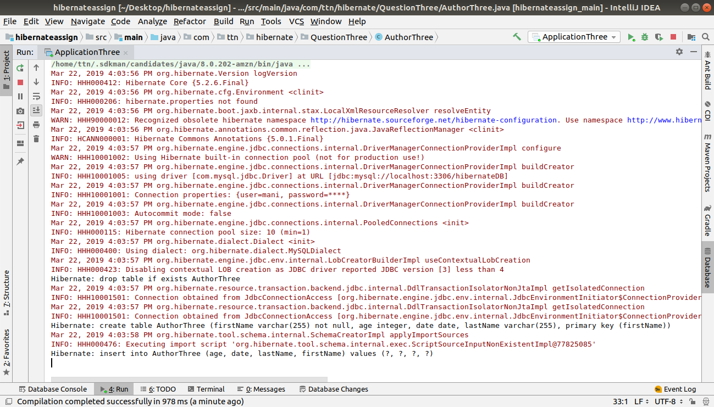
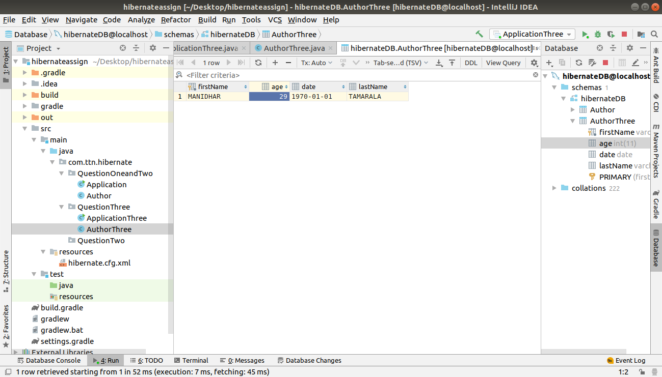

Q4.Use hbm2dll update to insert at least 4 records for Author.
A.

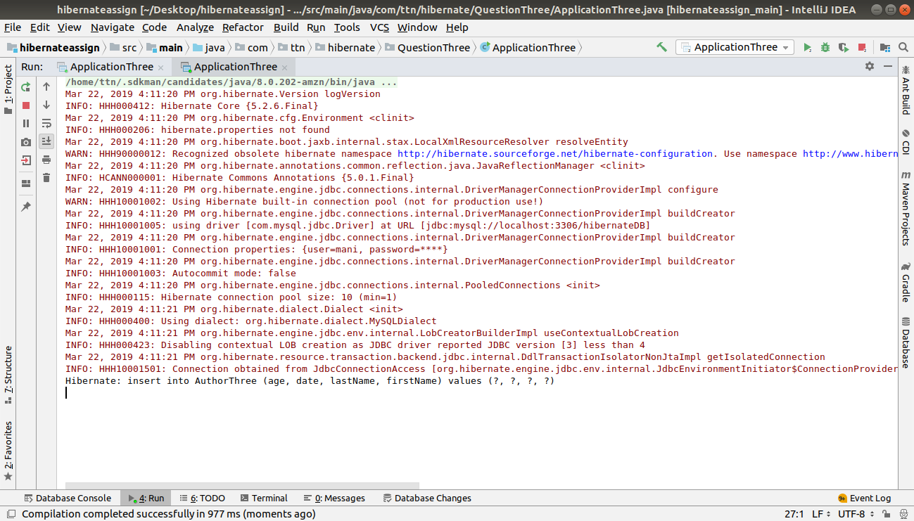
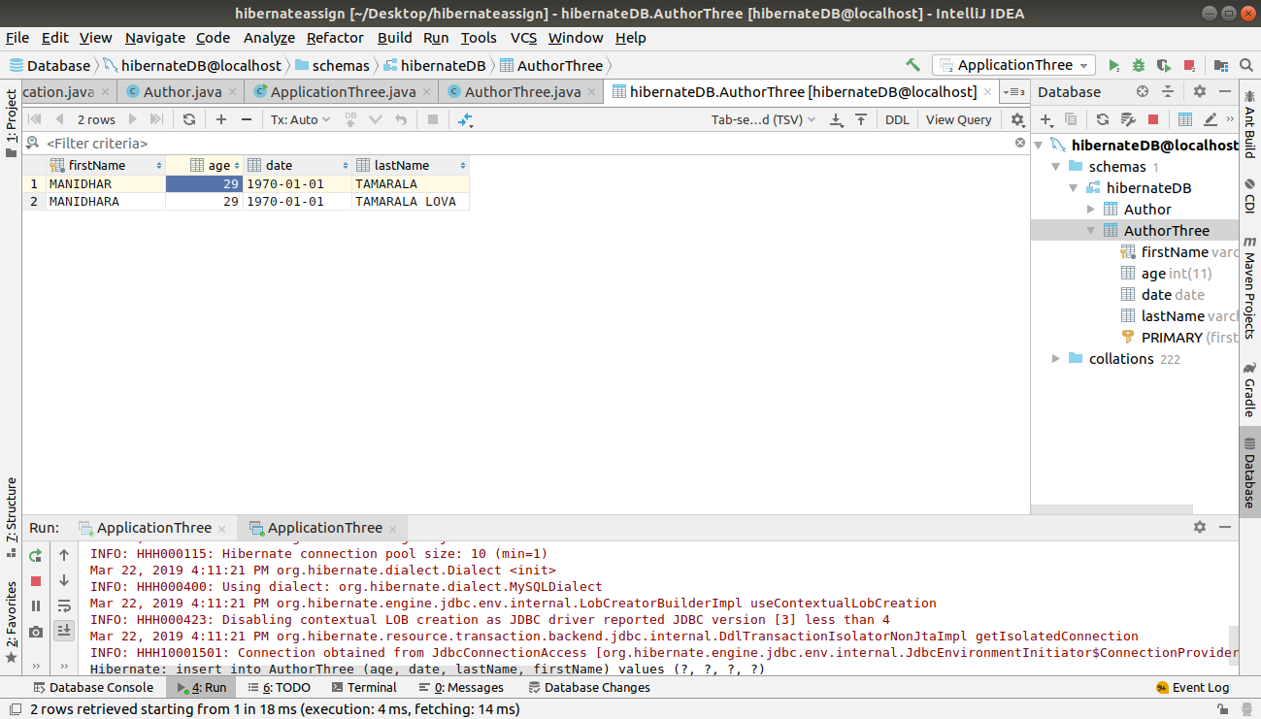

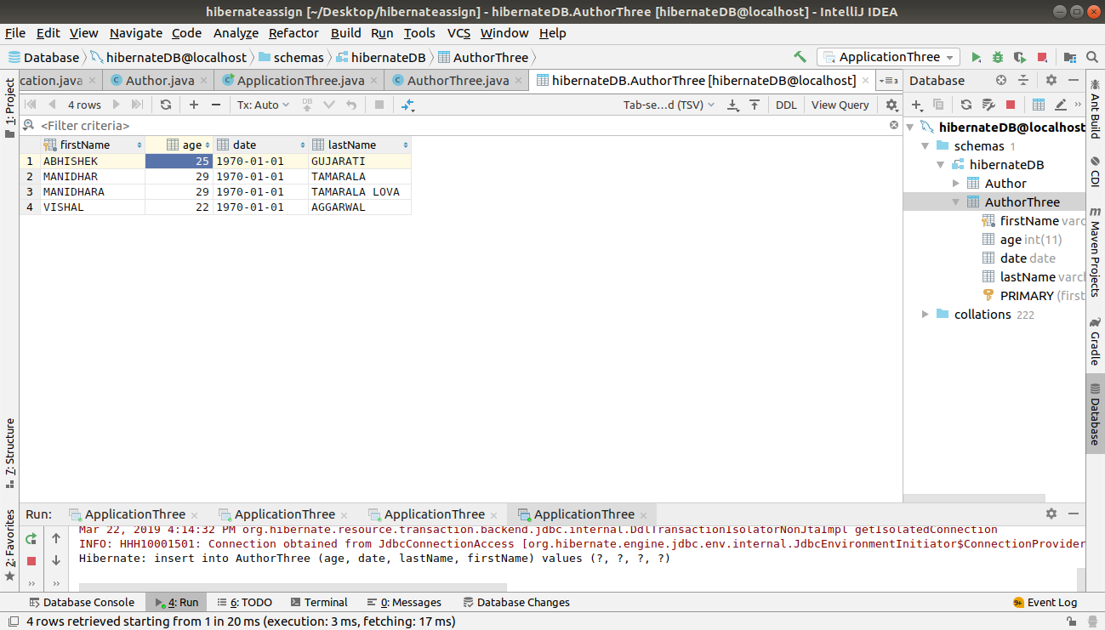
Q5.Perform hbm2dll create-drop by closing session factory.
A.

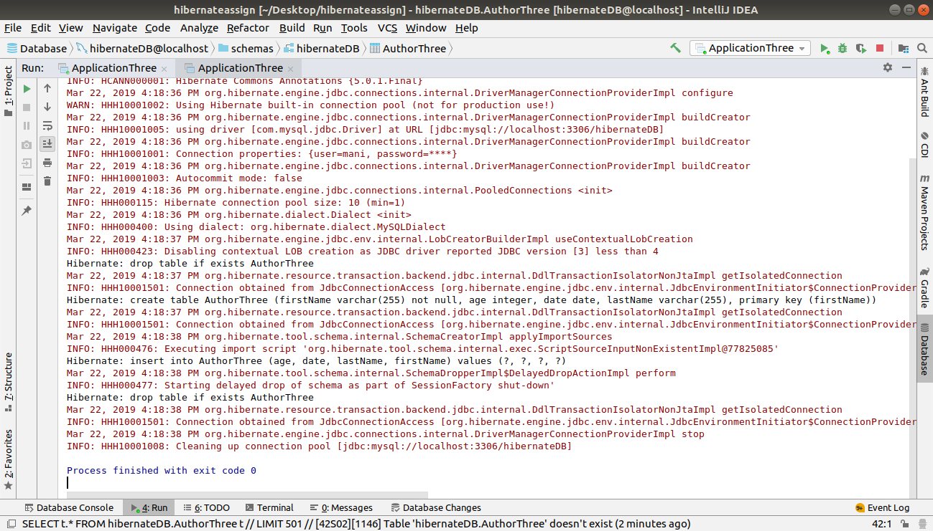

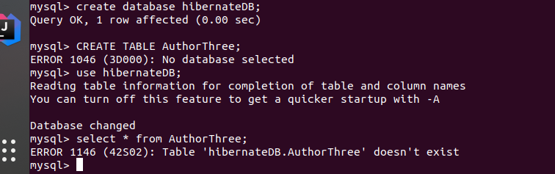

Q6.Rename all the fields using column annotation.
A.

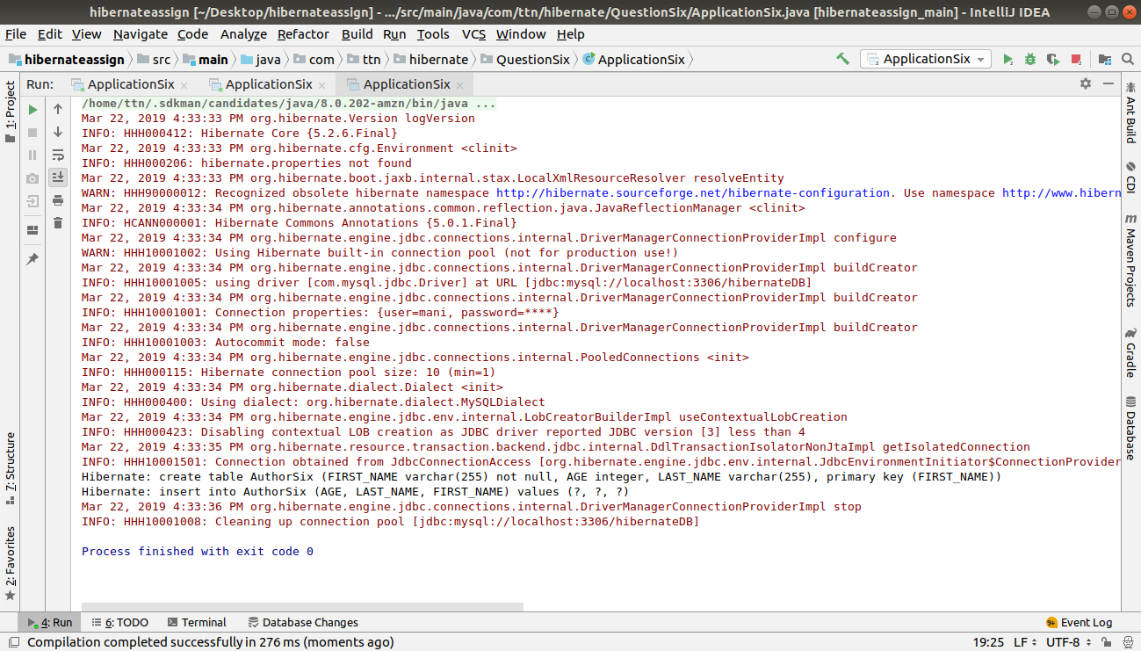

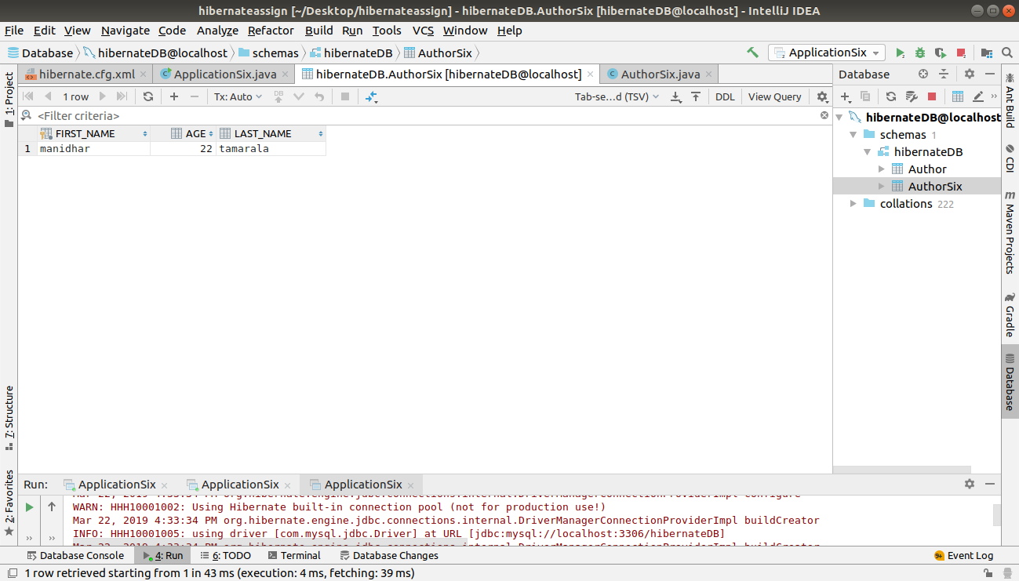

Q7.Mark lastName as @Transient.
A.
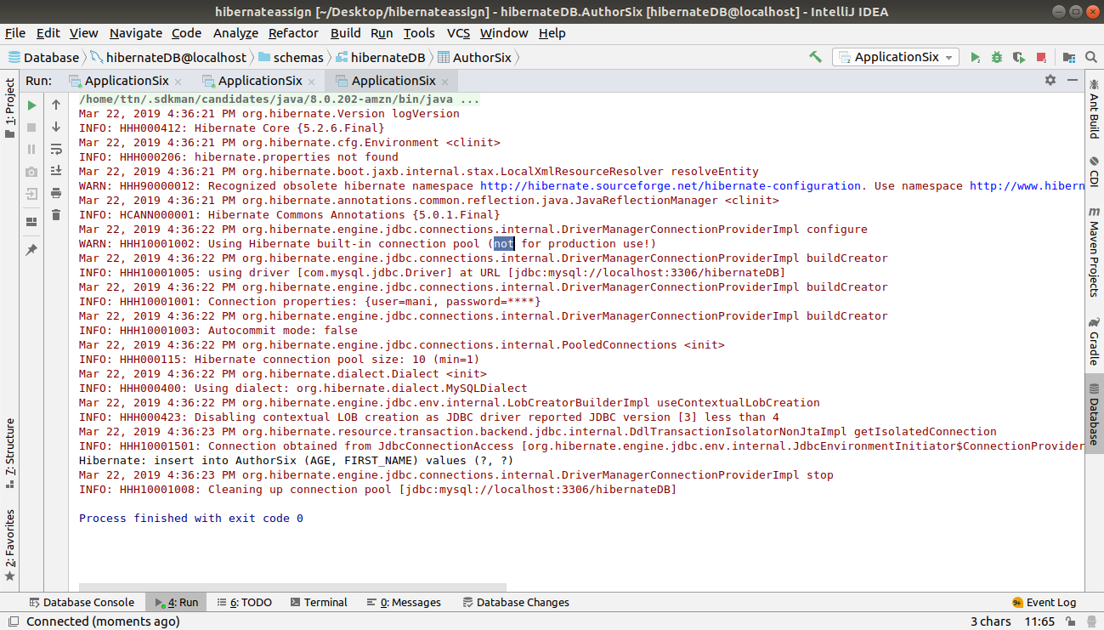

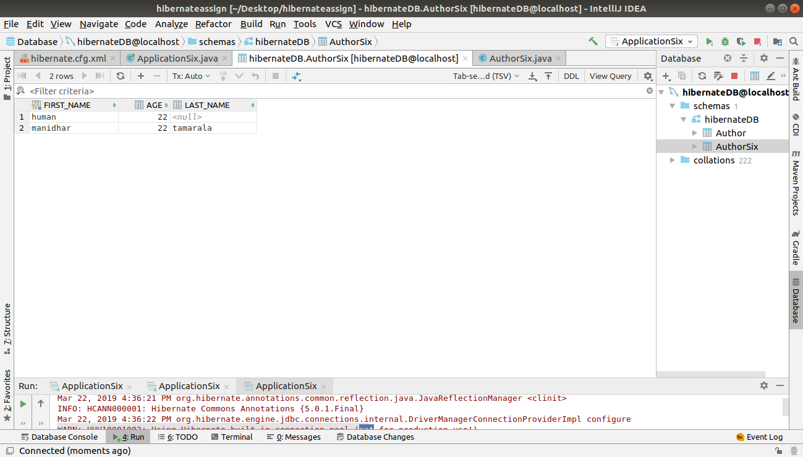
Q8.Use @Temporal for date of birth of Author.
A.
APPLICATION.JAVA
package com.ttn.hibernate.QuestionThree;
import org.hibernate.Session;
import org.hibernate.SessionFactory;
import org.hibernate.cfg.Configuration;
import java.util.Date;
public class ApplicationThree {
public static void main(String[] args) {
AuthorThree author=new AuthorThree();
author.setFirstName("manidhar");
author.setLastName("tamarala");
author.setAge(22);
author.setDate(new Date());
SessionFactory sessionFactory = new Configuration().configure().buildSessionFactory();
Session session=sessionFactory.openSession();
session.beginTransaction();
session.save(author);
session.getTransaction().commit();
session.close();
sessionFactory.close();
}
}

AUTHORTHREE.JAVA
package com.ttn.hibernate.QuestionThree;
import javax.persistence.Entity;
import javax.persistence.Id;
import javax.persistence.Temporal;
import javax.persistence.TemporalType;
import java.util.Date;
@Entity
public class AuthorThree {
@Id
private String firstName;
private String lastName;
private Integer age;
@Temporal(TemporalType.DATE)
Date date;
public AuthorThree() {
}
public AuthorThree(String firstName, String lastName, Integer age, Date date) {
this.firstName = firstName;
this.lastName = lastName;
this.age = age;
this.date = date;
}
public Date getDate() {
return date;
}
public void setDate(Date date) {
this.date = date;
}
public String getFirstName() {
return firstName;
}
public void setFirstName(String firstName) {
this.firstName = firstName;
}
public String getLastName() {
return lastName;
}
public void setLastName(String lastName) {
this.lastName = lastName;
}
public Integer getAge() {
return age;
}
public void setAge(Integer age) {
this.age = age;
}
@Override
public String toString() {
return "AuthorThree{" +
"firstName='" + firstName + '\'' +
", lastName='" + lastName + '\'' +
", age=" + age +
", date=" + date +
'}';
}
}
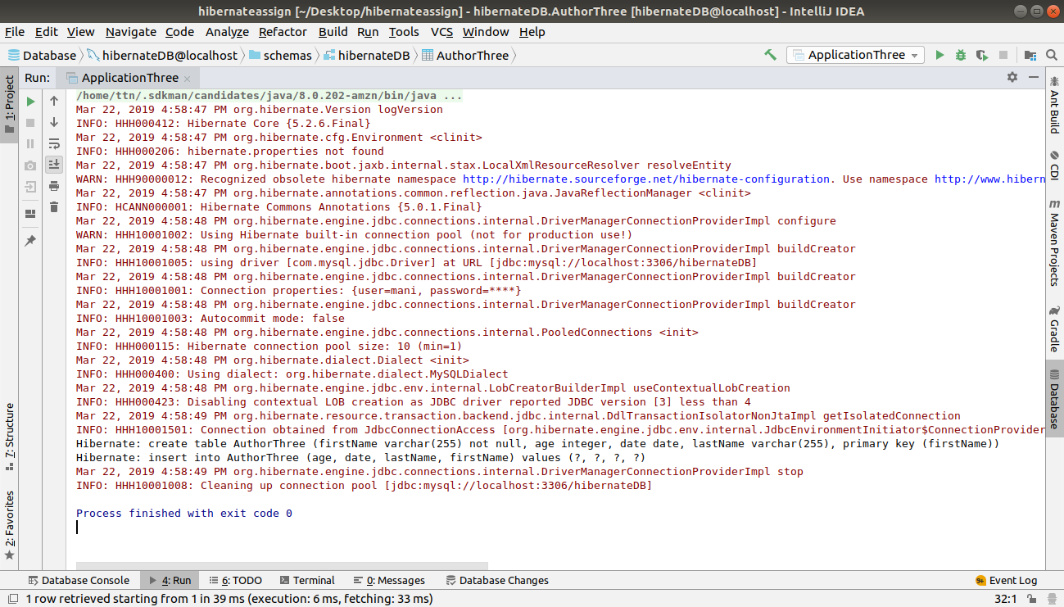

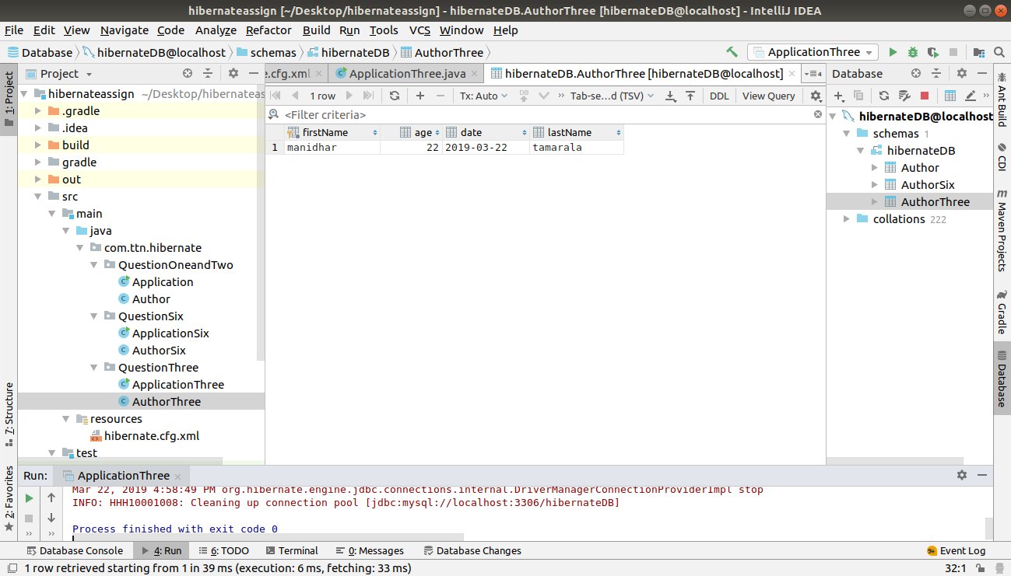

Q9.Generate Id for Author Using IDENTITY and TABLE starategy.
A.
ApplicationNine.java
package com.ttn.hibernate.QuestionNine;
import com.ttn.hibernate.QuestionThree.AuthorThree;
import org.hibernate.Session;
import org.hibernate.SessionFactory;
import org.hibernate.cfg.Configuration;
public class ApplicationNine {
public static void main(String[] args) {
AuthorNine author=new AuthorNine();
author.setName("manidhar");
author.setAge(22);
SessionFactory sessionFactory = new Configuration().configure().buildSessionFactory();
Session session=sessionFactory.openSession();
session.beginTransaction();
session.save(author);
session.getTransaction().commit();
session.close();
sessionFactory.close();
}
}

AuthorNINE.JAVA
package com.ttn.hibernate.QuestionNine;
import javax.persistence.Entity;
import javax.persistence.GeneratedValue;
import javax.persistence.GenerationType;
import javax.persistence.Id;
@Entity
public class AuthorNine {
@Id
@GeneratedValue(strategy = GenerationType.IDENTITY)
private Integer id;
private String name;
private Integer age;
public Integer getId() {
return id;
}
public void setId(Integer id) {
this.id = id;
}
public String getName() {
return name;
}
public void setName(String name) {
this.name = name;
}
public Integer getAge() {
return age;
}
public void setAge(Integer age) {
this.age = age;
}
@Override
public String toString() {
return "AuthorNine{" +
"id=" + id +
", name='" + name + '\'' +
", age=" + age +
'}';
}
}

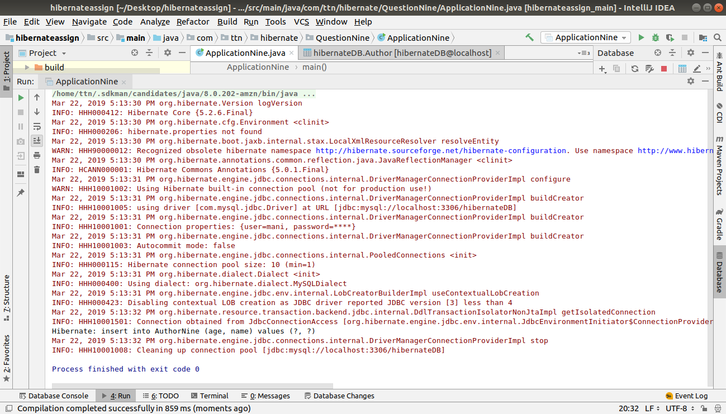
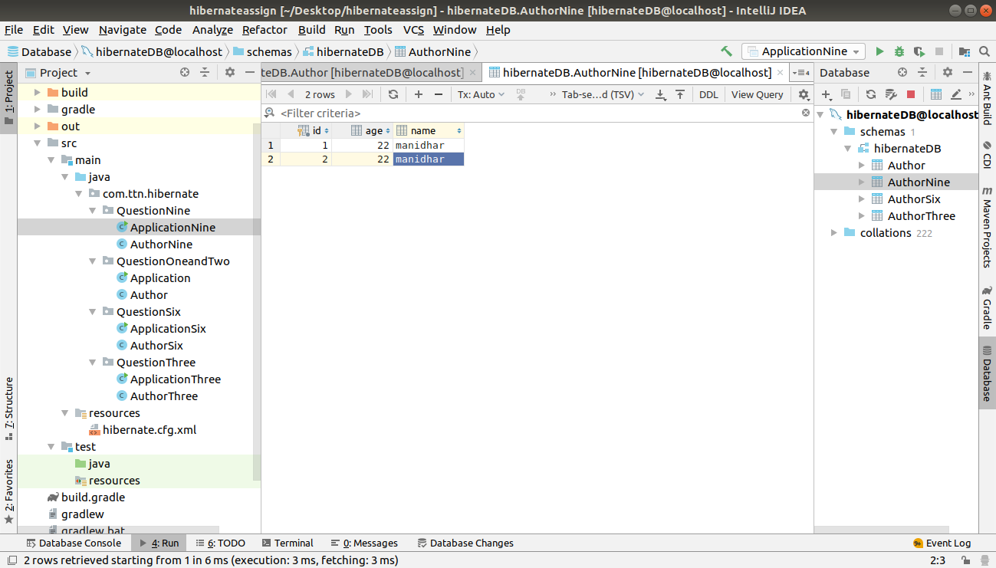

AuthorNINE.JAVA
package com.ttn.hibernate.QuestionNine;
import javax.persistence.Entity;
import javax.persistence.GeneratedValue;
import javax.persistence.GenerationType;
import javax.persistence.Id;
@Entity
public class AuthorNine {
@Id
@GeneratedValue(strategy = GenerationType.TABLE)
private Integer id;
private String name;
private Integer age;
public Integer getId() {
return id;
}
public void setId(Integer id) {
this.id = id;
}
public String getName() {
return name;
}
public void setName(String name) {
this.name = name;
}
public Integer getAge() {
return age;
}
public void setAge(Integer age) {
this.age = age;
}
@Override
public String toString() {
return "AuthorNine{" +
"id=" + id +
", name='" + name + '\'' +
", age=" + age +
'}';
}
}

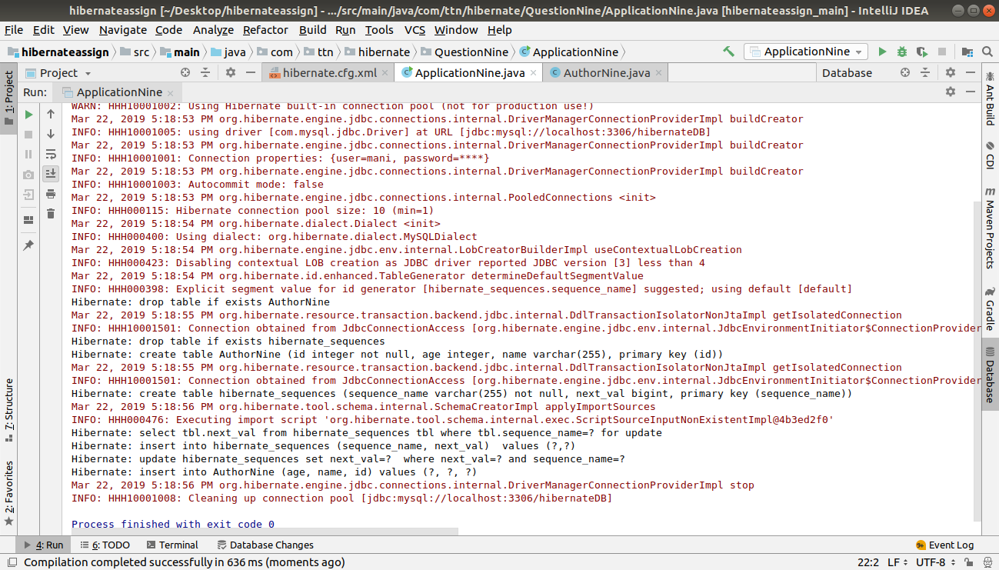
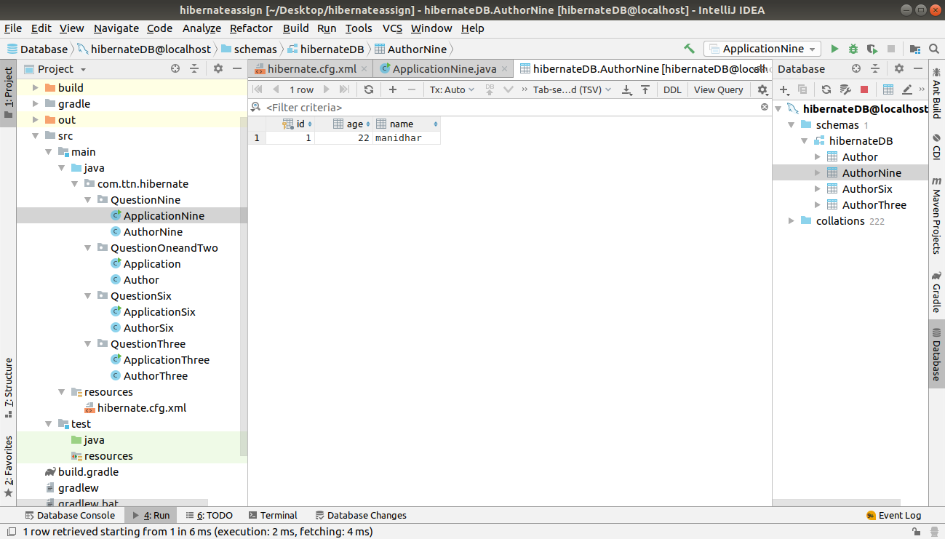

Q10.Create a class Address for Author with instance variables streetNumber, location, State.
Q11.Create instance variable of Address class inside Author class and save it as embedded object.

A.
APPLICATIONTen.java
package com.ttn.hibernate.QuestionTen;
import org.hibernate.Session;
import org.hibernate.SessionFactory;
import org.hibernate.cfg.Configuration;
public class ApplicationTen {
public static void main(String[] args) {
AuthorTen authorTen=new AuthorTen();
authorTen.setName("manidhar");
authorTen.setAge(32);
Address address=new Address();
address.setStreetNumber(137);
address.setLocation("Greater noida");
address.setState("uttar pradesh");
authorTen.setAddress(address);
SessionFactory sessionFactory=new Configuration().configure().buildSessionFactory();
Session session=sessionFactory.openSession();
session.beginTransaction();
session.save(authorTen);
session.getTransaction().commit();
session.close();
}
}
AuthorTEN.JAVA
package com.ttn.hibernate.QuestionTen;
import javax.persistence.*;
@Entity
public class AuthorTen {
@Id
@GeneratedValue(strategy = GenerationType.IDENTITY)
Integer id;
String name;
Integer age;
@Embedded
Address address;
public Integer getId() {
return id;
}
public void setId(Integer id) {
this.id = id;
}
public String getName() {
return name;
}
public void setName(String name) {
this.name = name;
}
public Integer getAge() {
return age;
}
public void setAge(Integer age) {
this.age = age;
}
public Address getAddress() {
return address;
}
public void setAddress(Address address) {
this.address = address;
}
@Override
public String toString() {
return "AuthorTen{" +
"id=" + id +
", name='" + name + '\'' +
", age=" + age +
", address=" + address +
'}';
}
}
Address.java
package com.ttn.hibernate.QuestionTen;
import javax.persistence.Embeddable;
@Embeddable
public class Address {
private Integer StreetNumber;
private String Location;
private String State;
public Integer getStreetNumber() {
return StreetNumber;
}
public void setStreetNumber(Integer streetNumber) {
StreetNumber = streetNumber;
}
public String getLocation() {
return Location;
}
public void setLocation(String location) {
Location = location;
}
public String getState() {
return State;
}
public void setState(String state) {
State = state;
}
}

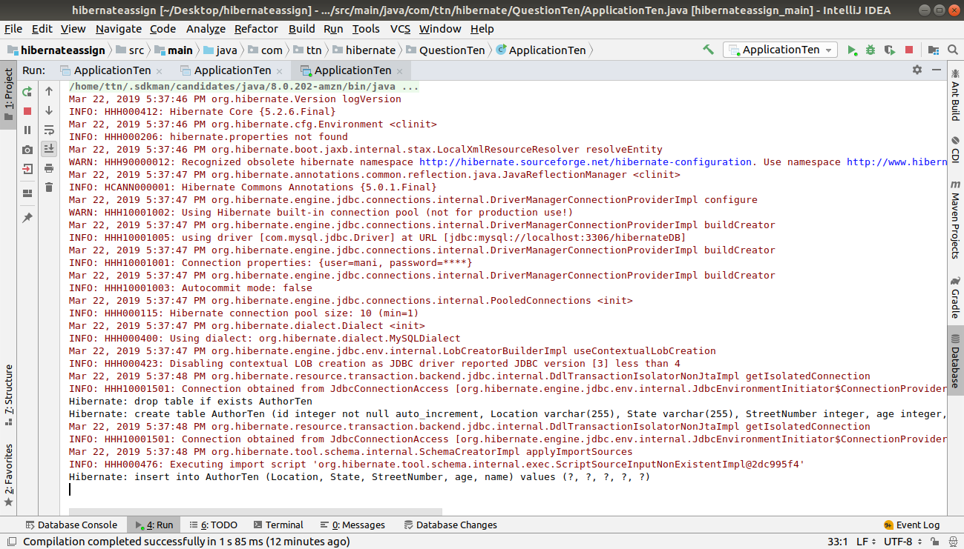

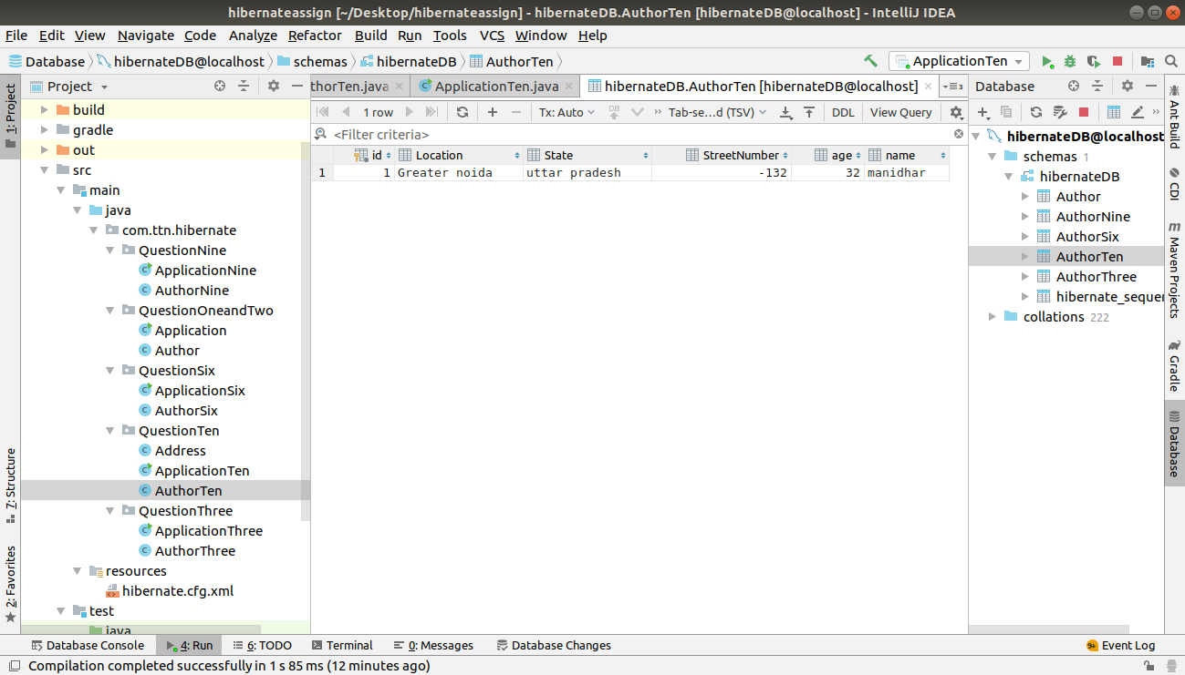

Q12.Introduce a List of subjects for author.
Q13. Persist 3 subjects for each author.
A.
ApplicationTwelve.java
package com.ttn.hibernate.QuestionTwelveandThirteen;
import org.hibernate.Session;
import org.hibernate.SessionFactory;
import org.hibernate.cfg.Configuration;
public class ApplicationTwelve {
public static void main(String[] args) {
AuthorTwelve authorTwelve=new AuthorTwelve();
authorTwelve.setName("manidhar");
authorTwelve.setAge(32);
authorTwelve.getSubjects().add("English");
authorTwelve.getSubjects().add("Maths");
authorTwelve.getSubjects().add("Science");
authorTwelve.getSubjects().add("Computer");
authorTwelve.getSubjects().add("Social");
SessionFactory sessionFactory=new Configuration().configure().buildSessionFactory();
Session session=sessionFactory.openSession();
session.beginTransaction();
session.save(authorTwelve);
session.getTransaction().commit();
session.close();
sessionFactory.close();
}
}

AuthorTwelve.java
package com.ttn.hibernate.QuestionTwelveandThirteen;
import javax.persistence.*;
import java.util.HashSet;
import java.util.Set;
@Entity
public class AuthorTwelve {
@Id
@GeneratedValue(strategy = GenerationType.IDENTITY)
Integer id;
String name;
Integer age;
@ElementCollection
Set<String> subjects = new HashSet<String>();
public Integer getId() {
return id;
}
public void setId(Integer id) {
this.id = id;
}
public String getName() {
return name;
}
public void setName(String name) {
this.name = name;
}
public Integer getAge() {
return age;
}
public void setAge(Integer age) {
this.age = age;
}
public Set<String> getSubjects() {
return subjects;
}
public void setSubjects(Set<String> subjects) {
this.subjects = subjects;
}
@Override
public String toString() {
return "AuthorTwelve{" +
"id=" + id +
", name='" + name + '\'' +
", age=" + age +
", subjects=" + subjects +
'}';
}
}

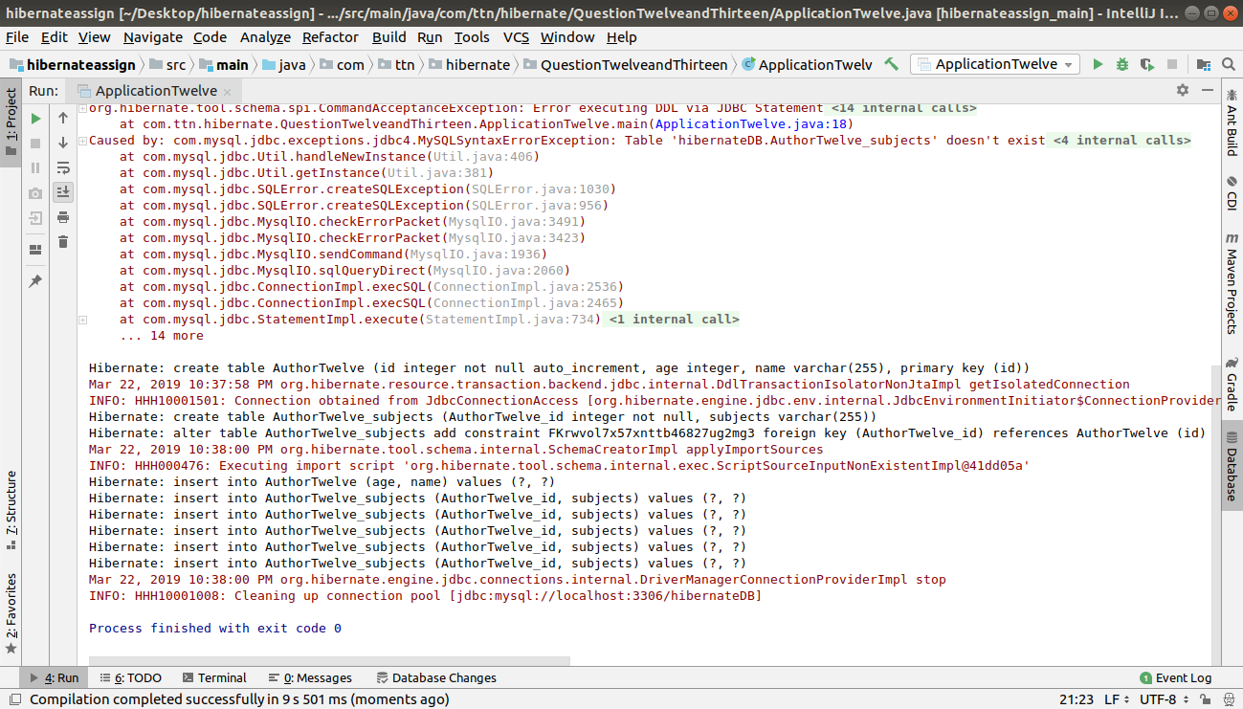

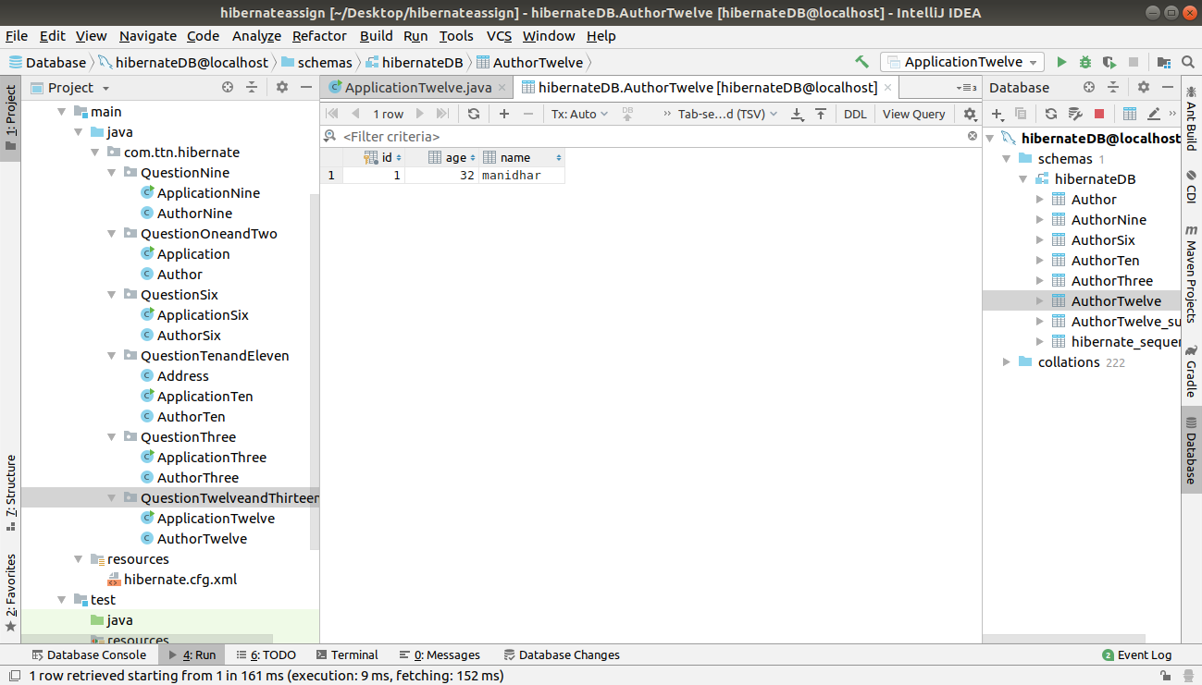
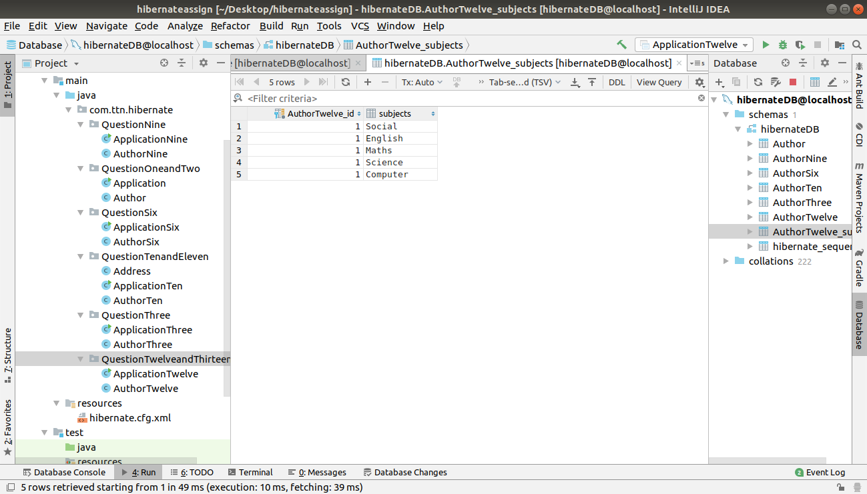

Q14. Create an Entity book with an instance variable bookName.
Q15. Implement One to One mapping between Author and Book.
A.
Book.java
package com.ttn.hibernate.QuestionFourteenandFifteen;
import javax.persistence.Entity;
import javax.persistence.GeneratedValue;
import javax.persistence.GenerationType;
import javax.persistence.Id;
@Entity
public class Book {
@Id
@GeneratedValue(strategy = GenerationType.AUTO)
private int bookId;
private String bookName;
public int getBookId() {
return bookId;
}
public void setBookId(int bookId) {
this.bookId = bookId;
}
public String getBookName() {
return bookName;
}
public void setBookName(String bookName) {
this.bookName = bookName;
}
@Override
public String toString() {
return "Book{" +
"bookId='" + bookId + '\'' +
", bookName='" + bookName + '\'' +
'}';
}
}
AuthorFifteen.java
package com.ttn.hibernate.QuestionFourteenandFifteen;
import com.ttn.hibernate.QuestionTenandEleven.Address;
import javax.persistence.*;
import java.util.Date;
import java.util.List;
import java.util.Set;
@Entity
public class AuthorFifteen {
@Id
@GeneratedValue(strategy = GenerationType.AUTO)
private int id;
@Column(name = "author_firstName")
private String firstName;
@Column(name = "author_lastName")
private String lastName;
@Column(name = "author_age")
private int age;
@Column(name = "author_dob")
@Temporal(TemporalType.DATE)
@Transient
private Date dob;
@Embedded
private Address address;
@ElementCollection
private Set<String> subjects;
@OneToOne
@JoinColumn(name = "join_book_column")
private Book book;
public Book getBook() {
return book;
}
public void setBook(Book book) {
this.book = book;
}
public Set<String> getSubjects() {
return subjects;
}
public void setSubjects(Set<String> subjects) {
this.subjects = subjects;
}
public Address getAddress() {
return address;
}
public void setAddress(Address address) {
this.address = address;
}
public Date getDob() {
return dob;
}
public void setDob(Date dob) {
this.dob = dob;
}
public int getId() {
return id;
}
public void setId(int id) {
this.id = id;
}
public String getFirstName() {
return firstName;
}
public void setFirstName(String firstName) {
this.firstName = firstName;
}
public String getLastName() {
return lastName;
}
public void setLastName(String lastName) {
this.lastName = lastName;
}
public int getAge() {
return age;
}
public void setAge(int age) {
this.age = age;
}
@Override
public String toString() {
return "Author{" +
"id=" + id +
", firstName='" + firstName + '\'' +
", lastName='" + lastName + '\'' +
", age=" + age +
", dob=" + dob +
", address=" + address +
", subjects=" + subjects +
", book=" + book +
'}';
}
}
ApplicationFourteen.java
package com.ttn.hibernate.QuestionFourteenandFifteen;
import com.ttn.hibernate.QuestionTenandEleven.Address;
import org.hibernate.Session;
import org.hibernate.SessionFactory;
import org.hibernate.cfg.Configuration;
import java.util.Date;
import java.util.HashSet;
import java.util.Set;
public class ApplicationFourteen {
public static void main(String[] args) {
AuthorFifteen author=new AuthorFifteen();
author.setFirstName("Manidhar");
author.setLastName("Tamarala");
author.setAge(21);
author.setDob(new Date());
Address address=new Address();
address.setStreetNumber(2/104);
address.setLocation("Omega1");
address.setState("Uttar Pradesh");
author.setAddress(address);
Set<String> subjects=new HashSet<>();
subjects.add("Maths");
subjects.add("physics");
subjects.add("Chemistry");
author.setSubjects(subjects);
Book book=new Book();
book.setBookName("DAA");
author.setBook(book);
SessionFactory sessionFactory=new Configuration().configure().buildSessionFactory();
Session session=sessionFactory.openSession();
session.beginTransaction();
session.save(author);
session.save(book);
session.getTransaction().commit();
session.close();
sessionFactory.close();
}
}
hibernate.cfg.xml
<!--QUESTION14 AND 15-->
<mapping class="com.ttn.hibernate.QuestionFourteenandFifteen.AuthorFifteen"/>
<mapping class="com.ttn.hibernate.QuestionFourteenandFifteen.Book"/>

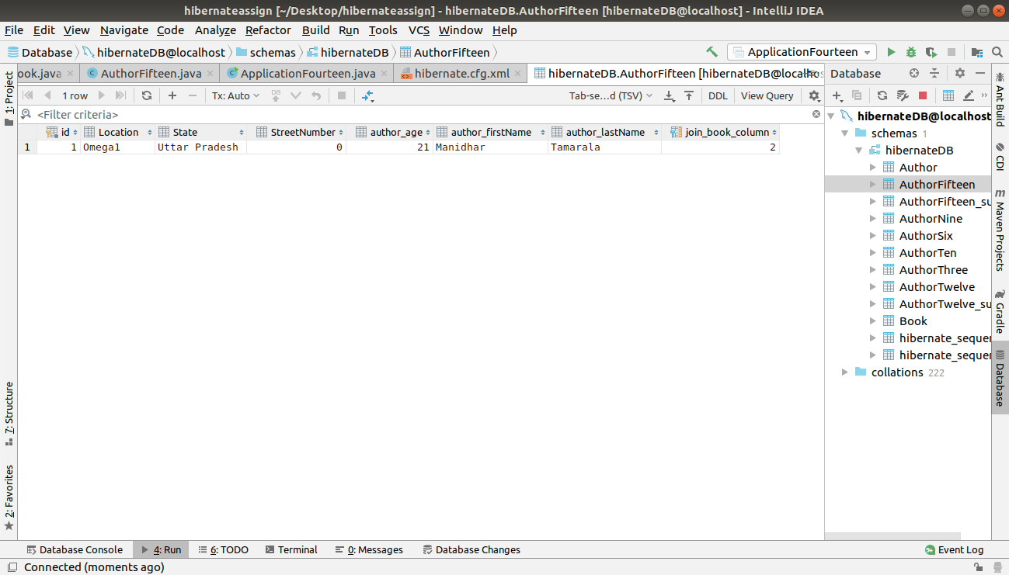
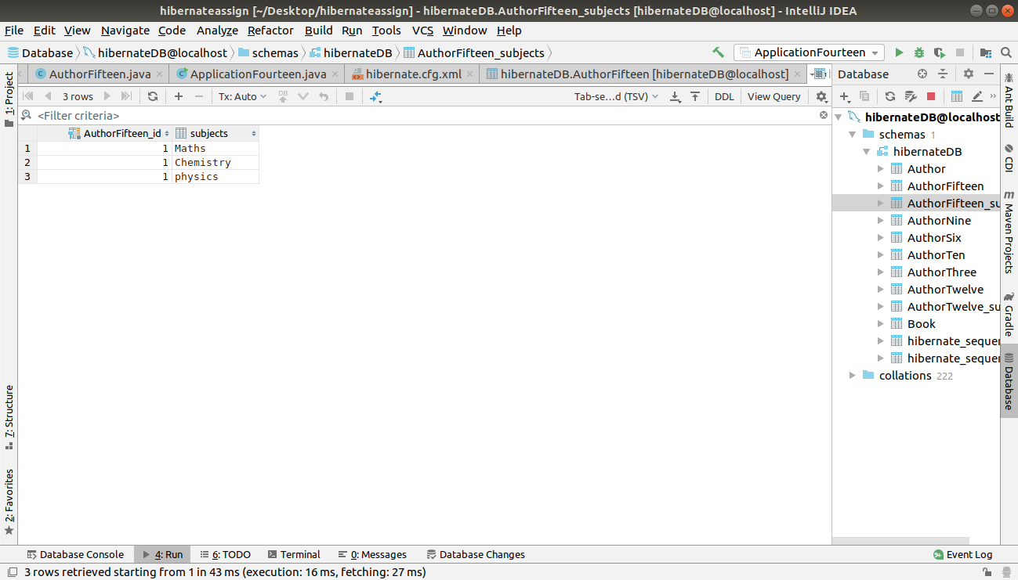

Q16. Implement One to Many Mapping between Author and Book(Unidirectional, BiDirectional and without additional table ) and implement cascade save.
A.
OneToMany(Unidirectional)
APPLICATIONSIXTEEN.JAVA
package com.ttn.hibernate.QuestionSixteen;
import com.ttn.hibernate.QuestionTenandEleven.Address;
import org.hibernate.Session;
import org.hibernate.SessionFactory;
import org.hibernate.cfg.Configuration;
import java.util.Date;
import java.util.HashSet;
import java.util.Set;
public class ApplicationSixteen {
public static void main(String[] args) {
AuthorSixteen author = new AuthorSixteen();
author.setFirstName("ayya");
author.setLastName("avuna");
author.setAge(21);
author.setDob(new Date());
Address address = new Address();
address.setStreetNumber(5/137);
address.setLocation("Alpha 1");
address.setState("Uttar Pradesh");
author.setAddress(address);
Set<String> subjects = new HashSet<>();
subjects.add("Maths");
subjects.add("physics");
subjects.add("Chemistry");
author.setSubjects(subjects);
BookSixteen bookSixteen = new BookSixteen();
bookSixteen.setBookName("DAA");
BookSixteen bookSixteen1 = new BookSixteen();
bookSixteen1.setBookName("Computer Networks");
BookSixteen bookSixteen2 = new BookSixteen();
bookSixteen2.setBookName("TAFN");
author.getBookSixteenListForAuthor().add(bookSixteen);
author.getBookSixteenListForAuthor().add(bookSixteen1);
author.getBookSixteenListForAuthor().add(bookSixteen2);
SessionFactory sessionFactory = new Configuration().configure().buildSessionFactory();
Session session = sessionFactory.openSession();
session.beginTransaction();
session.save(author);
session.save(bookSixteen);
session.save(bookSixteen1);
session.save(bookSixteen2);
session.getTransaction().commit();
session.close();
sessionFactory.close();
}
}
AuthorSIXTEEN.JAVA
package com.ttn.hibernate.QuestionSixteen;
import com.ttn.hibernate.QuestionTenandEleven.Address;
import javax.persistence.*;
import java.util.Collection;
import java.util.Date;
import java.util.HashSet;
import java.util.Set;
@Entity
public class AuthorSixteen {
@Id
@GeneratedValue(strategy = GenerationType.AUTO)
private int id;
@Column(name = "author_firstName")
private String firstName;
@Column(name = "author_lastName")
private String lastName;
@Column(name = "author_age")
private int age;
@Column(name = "author_dob")
@Temporal(TemporalType.DATE)
@Transient
private Date dob;
@Embedded
private Address address;
@ElementCollection
private Set<String> subjects;
@OneToMany
@JoinTable(joinColumns = @JoinColumn(name = "id"), inverseJoinColumns = @JoinColumn(name = "bookId"))
Collection<BookSixteen> bookSixteenListForAuthor = new HashSet<>();
public Collection<BookSixteen> getBookSixteenListForAuthor() {
return bookSixteenListForAuthor;
}
public void setBookSixteenListForAuthor(Collection<BookSixteen> bookSixteenListForAuthor) {
this.bookSixteenListForAuthor = bookSixteenListForAuthor;
}
public Set<String> getSubjects() {
return subjects;
}
public void setSubjects(Set<String> subjects) {
this.subjects = subjects;
}
public Address getAddress() {
return address;
}
public void setAddress(Address address) {
this.address = address;
}
public Date getDob() {
return dob;
}
public void setDob(Date dob) {
this.dob = dob;
}
public int getId() {
return id;
}
public void setId(int id) {
this.id = id;
}
public String getFirstName() {
return firstName;
}
public void setFirstName(String firstName) {
this.firstName = firstName;
}
public String getLastName() {
return lastName;
}
public void setLastName(String lastName) {
this.lastName = lastName;
}
public int getAge() {
return age;
}
public void setAge(int age) {
this.age = age;
}
@Override
public String toString() {
return "Author{" +
"id=" + id +
", firstName='" + firstName + '\'' +
", lastName='" + lastName + '\'' +
", age=" + age +
", dob=" + dob +
", address=" + address +
", subjects=" + subjects +
", bookSixteenListForAuthor=" + bookSixteenListForAuthor +
'}';
}
}
BookSIXTEEN.JAVA
package com.ttn.hibernate.QuestionSixteen;
import javax.persistence.Entity;
import javax.persistence.GeneratedValue;
import javax.persistence.GenerationType;
import javax.persistence.Id;
@Entity
public class BookSixteen {
@Id
@GeneratedValue(strategy = GenerationType.AUTO)
private int bookId;
private String bookName;
public int getBookId() {
return bookId;
}
public void setBookId(int bookId) {
this.bookId = bookId;
}
public String getBookName() {
return bookName;
}
public void setBookName(String bookName) {
this.bookName = bookName;
}
@Override
public String toString() {
return "BookSixteen{" +
"bookId='" + bookId + '\'' +
", bookName='" + bookName + '\'' +
'}';
}
}

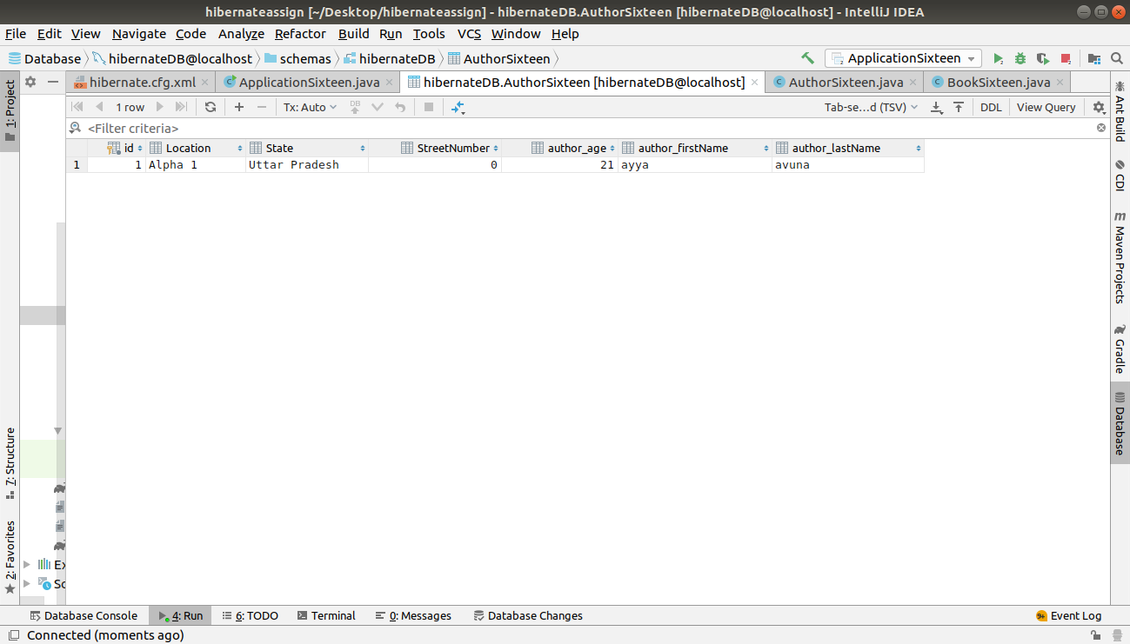
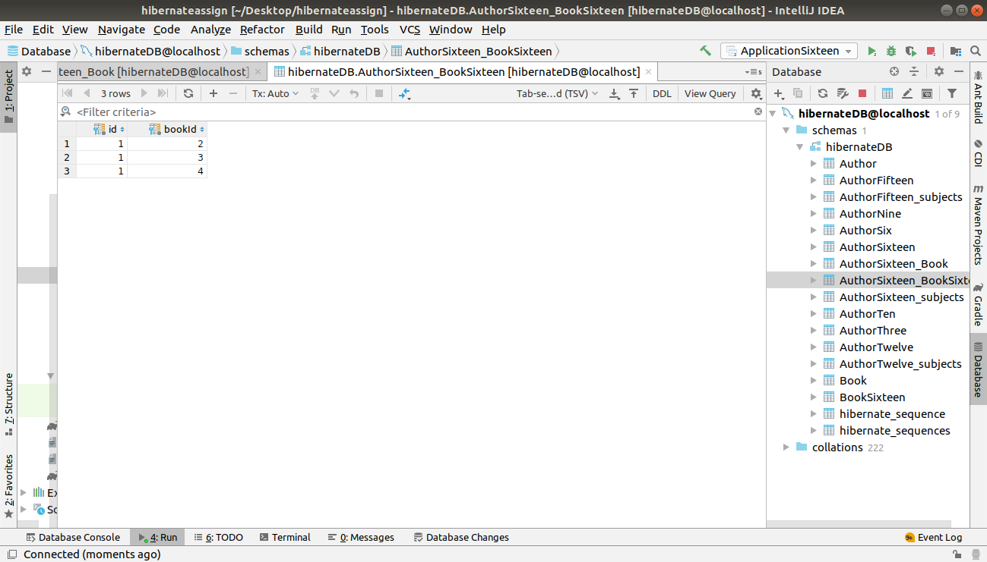

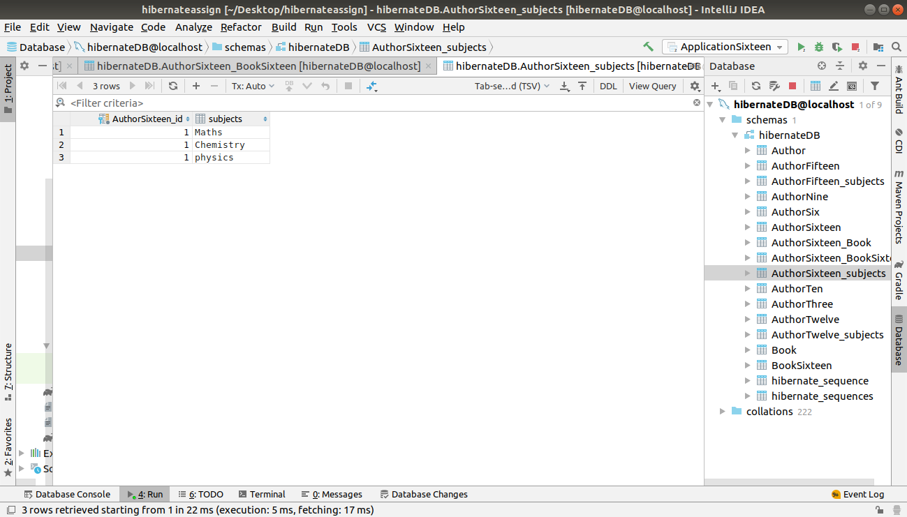

OneToMany(Bidirectional)
BOOKSIXTEENA.java
package com.ttn.hibernate.QuestionSixteenA;
import javax.persistence.*;
@Entity
public class BookSixteenA {
@Id
@GeneratedValue(strategy = GenerationType.IDENTITY)
private int id;
private String bookName;
@ManyToOne
AuthorSixteenA author;
public AuthorSixteenA getAuthor() {
return author;
}
public void setAuthor(AuthorSixteenA author) {
this.author = author;
}
public String getBookName() {
return bookName;
}
public void setBookName(String bookName) {
this.bookName = bookName;
}
}
AuthorSixteenA.java
package com.ttn.hibernate.QuestionSixteenA;
import javax.persistence.*;
import java.util.Date;
import java.util.HashSet;
import java.util.Set;
@Entity
public class AuthorSixteenA {
@Id
@GeneratedValue(strategy = GenerationType.IDENTITY)
@Column(name = "Id")
int id;
@Column(name = "First_Name")
private String fname;
@Column(name = "Last_Name")
private String lname;
@Column(name = "Age")
private int age;
@Temporal(TemporalType.DATE)
@Column(name = "Date_of_Birth")
private Date dob;
@OneToMany(cascade = CascadeType.PERSIST)
@JoinTable(joinColumns = @JoinColumn(name="Author_Id")
,inverseJoinColumns = @JoinColumn(name = "Book_Id"))
Set<BookSixteenA> books = new HashSet<>();
public Set<BookSixteenA> getBooks() {
return books;
}
public void setBooks(Set<BookSixteenA> books) {
this.books = books;
}
public String getFname() {
return fname;
}
public void setFname(String fname) {
this.fname = fname;
}
public String getLname() {
return lname;
}
public void setLname(String lname) {
this.lname = lname;
}
public int getAge() {
return age;
}
public void setAge(int age) {
this.age = age;
}
public Date getDob() {
return dob;
}
public void setDob(Date dob) {
this.dob = dob;
}
}
ApplicationsiteenA.java
package com.ttn.hibernate.QuestionSixteenA;
import org.hibernate.Session;
import org.hibernate.SessionFactory;
import org.hibernate.cfg.Configuration;
import java.util.Date;
public class ApplicationSixteenA {
public static void main(String[] args) {
AuthorSixteenA author = new AuthorSixteenA();
author.setFname("Anjali");
author.setLname("Sharma");
author.setAge(35);
author.setDob(new Date());
BookSixteenA book1 = new BookSixteenA();
book1.setBookName("Data Structure");
book1.setAuthor(author);
BookSixteenA book2 = new BookSixteenA();
book2.setBookName("Data Warehouse");
book2.setAuthor(author);
author.getBooks().add(book1);
author.getBooks().add(book2);
SessionFactory sessionFactory = new Configuration().configure().buildSessionFactory();
Session session = sessionFactory.openSession();
session.beginTransaction();
session.persist(author);
session.persist(book1);
session.persist(book2);
session.getTransaction().commit();
session.close();
}
}
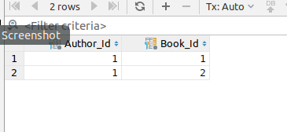

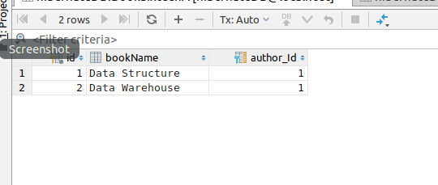

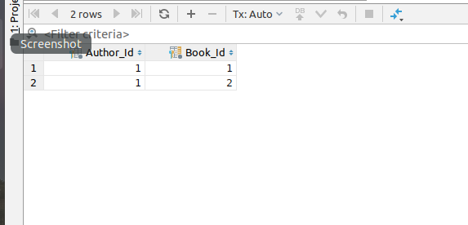

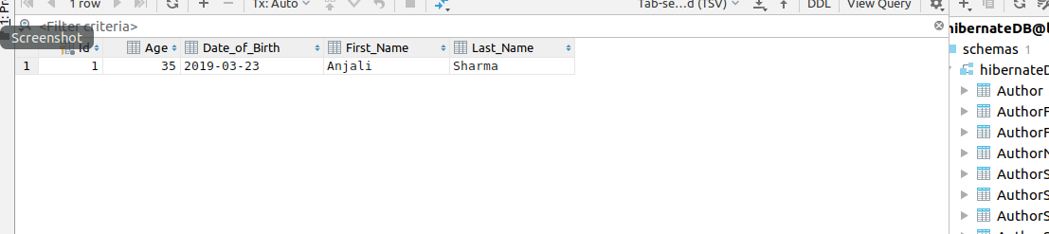
one to many without additional tables
BooksixteenB.java
package com.ttn.hibernate.QuestionSixteenB;
import javax.persistence.*;
@Entity
public class BookSixteenB {
@Id
@GeneratedValue(strategy = GenerationType.IDENTITY )
private int id;
private String bookName;
@ManyToOne
AuthorSixteenB author;
public AuthorSixteenB getAuthor() {
return author;
}
public void setAuthor(AuthorSixteenB author) {
this.author = author;
}
public String getBookName() {
return bookName;
}
public void setBookName(String bookName) {
this.bookName = bookName;
}
}
ApplicationSixteenB.java
package com.ttn.hibernate.QuestionSixteenB;
import org.hibernate.Session;
import org.hibernate.SessionFactory;
import org.hibernate.cfg.Configuration;
import java.util.Date;
public class ApplicationSixteenB {
public static void main(String[] args) {
AuthorSixteenB author = new AuthorSixteenB();
author.setFname("Anjali");
author.setLname("Sharma");
author.setAge(35);
author.setDob(new Date());
BookSixteenB book1 = new BookSixteenB();
book1.setBookName("Data Structure");
book1.setAuthor(author);
BookSixteenB book2 = new BookSixteenB();
book2.setBookName("Data Warehouse");
book2.setAuthor(author);
author.getBooks().add(book1);
author.getBooks().add(book2);
SessionFactory sessionFactory=new Configuration().configure().buildSessionFactory();
Session session=sessionFactory.openSession();
session.beginTransaction();
session.persist(author);
session.persist(book1);
session.persist(book2);
session.getTransaction().commit();
session.close();
}
}
AUTHORSIXTEENB.java
package com.ttn.hibernate.QuestionSixteenB;
import javax.persistence.*;
import java.util.Date;
import java.util.HashSet;
import java.util.Set;
@Entity
public class AuthorSixteenB {
@Id
@GeneratedValue(strategy = GenerationType.IDENTITY)
@Column(name = "Id")
int id;
@Column(name = "First_Name")
private String fname;
@Column(name = "Last_Name")
private String lname;
@Column(name = "Age")
private int age;
@Temporal(TemporalType.DATE)
@Column(name = "Date_of_Birth")
private Date dob;
@OneToMany(cascade = CascadeType.PERSIST, mappedBy = "author")
Set<BookSixteenB> books = new HashSet<>();
public Set<BookSixteenB> getBooks() {
return books;
}
public void setBooks(Set<BookSixteenB> books) {
this.books = books;
}
public String getFname() {
return fname;
}
public void setFname(String fname) {
this.fname = fname;
}
public String getLname() {
return lname;
}
public void setLname(String lname) {
this.lname = lname;
}
public int getAge() {
return age;
}
public void setAge(int age) {
this.age = age;
}
public Date getDob() {
return dob;
}
public void setDob(Date dob) {
this.dob = dob;
}
}
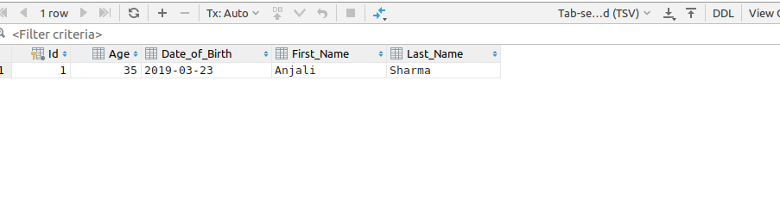
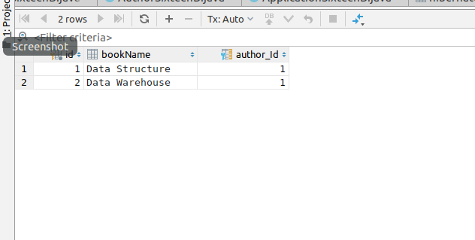

Q17. Implement Many to Many Mapping between Author and Book.
A.
ApplicationSEventeen.java
package com.ttn.hibernate.QuestionSeventeen;
import org.hibernate.Session;
import org.hibernate.SessionFactory;
import org.hibernate.cfg.Configuration;
import java.util.Date;
public class ApplicationSeventeen {
public static void main(String[] args) {
AuthorSeventeen author1 = new AuthorSeventeen();
author1.setFname("Manidhar");
author1.setLname("tamarala");
author1.setAge(34);
author1.setDob(new Date());
AuthorSeventeen author2 = new AuthorSeventeen();
author2.setFname("girish");
author2.setLname("Verma");
author2.setAge(45);
author2.setDob(new Date());
BookSeventeen book1 = new BookSeventeen();
book1.setBookName("Computer Organization");
BookSeventeen book2 = new BookSeventeen();
book2.setBookName("Java Programming");
author1.getBooks().add(book1);
author1.getBooks().add(book2);
book1.getAuthors().add(author1);
book2.getAuthors().add(author1);
author2.getBooks().add(book1);
author2.getBooks().add(book2);
book1.getAuthors().add(author2);
book2.getAuthors().add(author2);
SessionFactory sessionFactory=new Configuration().configure().buildSessionFactory();
Session session=sessionFactory.openSession();
session.beginTransaction();
session.persist(author1);
session.persist(author2);
session.getTransaction().commit();
session.close();
}
}
AuthorSEVENTEEN.JAVA
package com.ttn.hibernate.QuestionSeventeen;
import javax.persistence.*;
import java.util.*;
@Entity
public class AuthorSeventeen {
@Id
@GeneratedValue(strategy = GenerationType.IDENTITY)
@Column(name = "Id")
int id;
@Column(name = "First_Name")
private String fname;
@Column(name = "Last_Name")
private String lname;
@Column(name = "Age")
private int age;
@Temporal(TemporalType.DATE)
@Column(name = "Date_of_Birth")
private Date dob;
@ManyToMany(cascade = CascadeType.PERSIST)
List<BookSeventeen> books = new ArrayList<>();
public String getFname() {
return fname;
}
public void setFname(String fname) {
this.fname = fname;
}
public String getLname() {
return lname;
}
public void setLname(String lname) {
this.lname = lname;
}
public int getAge() {
return age;
}
public void setAge(int age) {
this.age = age;
}
public Date getDob() {
return dob;
}
public void setDob(Date dob) {
this.dob = dob;
}
public List<BookSeventeen> getBooks() {
return books;
}
public void setBooks(List<BookSeventeen> books) {
this.books = books;
}
}
BookSEVENTEEN.JAVA
package com.ttn.hibernate.QuestionSeventeen;
import javax.persistence.*;
import java.util.ArrayList;
import java.util.List;
@Entity
public class BookSeventeen {
@Id
@GeneratedValue(strategy = GenerationType.IDENTITY )
private int id;
private String bookName;
@ManyToMany
List<AuthorSeventeen> authors = new ArrayList<>();
public String getBookName() {
return bookName;
}
public void setBookName(String bookName) {
this.bookName = bookName;
}
public List<AuthorSeventeen> getAuthors() {
return authors;
}
public void setAuthors(List<AuthorSeventeen> authors) {
this.authors = authors;
}
}


