Question 1 : Implement AbstractController in StudentController. create a mapping index.html for it and render index.jsp view from it which displays messages "Hello from index.gsp"
Answer 1 :
StudentController.java
package com.ttn.jaffa;
import org.springframework.web.servlet.ModelAndView;
import org.springframework.web.servlet.mvc.AbstractController;
import javax.servlet.http.HttpServletRequest;
import javax.servlet.http.HttpServletResponse;
public class Studentcontroller extends AbstractController {
@Override
protected ModelAndView handleRequestInternal(HttpServletRequest request, HttpServletResponse response) throws Exception {
System.out.println("started mvc");
ModelAndView modelAndView=new ModelAndView("index");
return modelAndView;
}
}
spring-dispatcher-servlet.xml
<?xml version="1.0" encoding="UTF-8"?>
<beans xmlns="http://www.springframework.org/schema/beans"
xmlns:mvc="http://www.springframework.org/schema/mvc"
xmlns:xsi="http://www.w3.org/2001/XMLSchema-instance"
xmlns:context="http://www.springframework.org/schema/context"
xsi:schemaLocation="http://www.springframework.org/schema/beans
http://www.springframework.org/schema/beans/spring-beans.xsd
http://www.springframework.org/schema/mvc
http://www.springframework.org/schema/mvc/spring-mvc.xsd
http://www.springframework.org/schema/context
http://www.springframework.org/schema/context/spring-context.xsd">
<bean class="org.springframework.web.servlet.handler.BeanNameUrlHandlerMapping"/>
<bean name="/index" class="com.ttn.jaffa.Studentcontroller"/>
<bean class="org.springframework.web.servlet.mvc.support.ControllerClassNameHandlerMapping"/>
<bean id="viewResolver" class="org.springframework.web.servlet.view.InternalResourceViewResolver">
<property name="prefix">
<value>/WEB-INF/</value>
</property>
<property name="suffix">
<value>.jsp</value>
</property>
</bean>

<context:component-scan base-package="com.ttn.jaffa"/>
<mvc:annotation-driven/>
</beans>

Web.xml
<?xml version="1.0" encoding="UTF-8"?>
<web-app version="2.5"
xmlns="http://java.sun.com/xml/ns/j2ee"
xmlns:xsi="http://www.w3.org/2001/XMLSchema-instance"
xsi:schemaLocation="http://java.sun.com/xml/ns/j2ee
http://java.sun.com/xml/ns/j2ee/web-app_2_5.xsd">
<servlet>
<servlet-name>dispatcherServlet</servlet-name>
<servlet-class>
org.springframework.web.servlet.DispatcherServlet
</servlet-class>
<init-param>
<param-name>contextConfigLocation</param-name>
<param-value>/WEB-INF/spring-dispatcher-servlet.xml</param-value>
</init-param>
</servlet>
<servlet-mapping>
<servlet-name>dispatcherServlet</servlet-name>
<url-pattern>/</url-pattern>
</servlet-mapping>
</web-app>

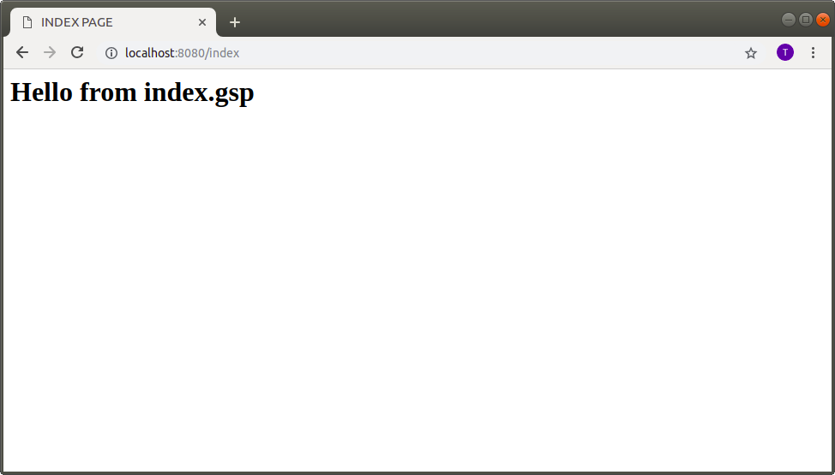

Question 2 :Now remove AbstractController and useMultiActionController for StudentController which contains 2 actions one action renders a jsp view and another action uses HttpServletResponse to show the output on the Web browser.
Answer 2 :
spring-dispatcher-servlet.xml

<!--Question2-->
<bean class="org.springframework.web.servlet.mvc.support.ControllerClassNameHandlerMapping"/>
<bean name="student" class="com.ttn.jaffa.StudentController"/>
<bean id="viewResolver"
class="org.springframework.web.servlet.view.InternalResourceViewResolver">
<property name="prefix">
<value>/WEB-INF/</value>
</property>
<property name="suffix">
<value>.jsp</value>
</property>
</bean>
STUDENTCONTROLLER.JAVA
// Question2
public class StudentController extends MultiActionController {
public ModelAndView dummy(HttpServletRequest httpServletRequest,
HttpServletResponse httpServletResponse) throws Exception {
ModelAndView modelAndView = new ModelAndView("Student");
return modelAndView;
}
public void dummy1(HttpServletRequest httpServletRequest,
HttpServletResponse httpServletResponse) throws Exception {
httpServletResponse.setContentType("text/html");
httpServletResponse.getWriter().println("<b>HELLO World</b>");
}
}
Student.jsp
<%@ page contentType="text/html;charset=UTF-8" language="java" %>
<html>
<head>
<title>FIRST MVC</title>
</head>
<body>
<h1>HI BUDDY HOW R U??</h1>
</body>
</html>
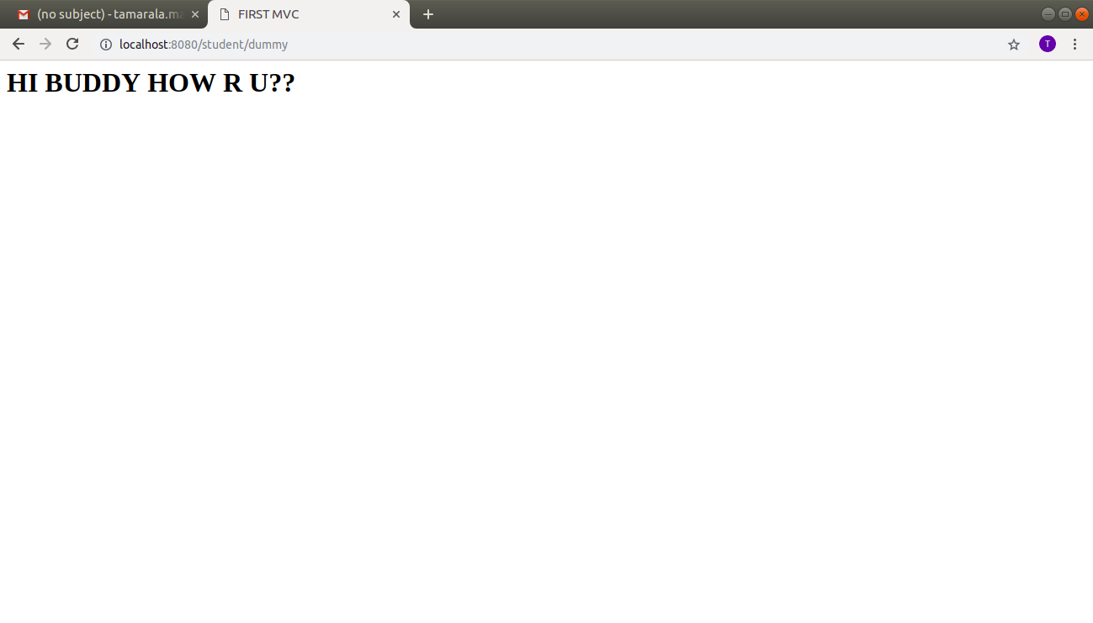
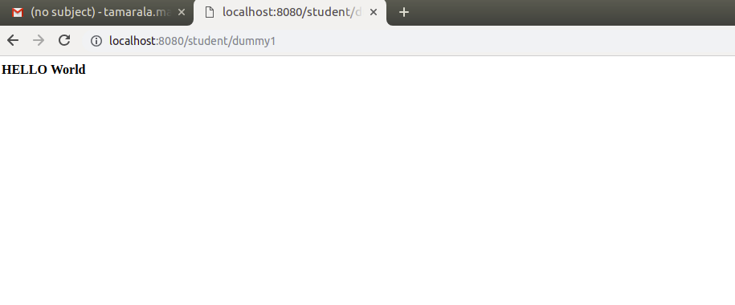

Question 3 :Use annotation in StudentController to define a default action index which renders a jsp page.
Answer 3 :
StudentController.java
package com.ttn.jaffa.Question3;
import org.springframework.stereotype.Controller;
import org.springframework.web.bind.annotation.RequestMapping;
import org.springframework.web.bind.annotation.ResponseBody;
import org.springframework.web.servlet.ModelAndView;
import org.springframework.web.servlet.mvc.multiaction.MultiActionController;
import javax.servlet.http.HttpServletRequest;
import javax.servlet.http.HttpServletResponse;
// Question3
@Controller
public class StudentController {
@RequestMapping("/")
public ModelAndView renderPage(){
ModelAndView modelAndView=new ModelAndView("display");
return modelAndView;
}
}

spring-dispatcher-servlet.xml
<?xml version="1.0" encoding="UTF-8"?>
<beans xmlns="http://www.springframework.org/schema/beans"
xmlns:mvc="http://www.springframework.org/schema/mvc"
xmlns:xsi="http://www.w3.org/2001/XMLSchema-instance"
xmlns:context="http://www.springframework.org/schema/context"
xsi:schemaLocation="http://www.springframework.org/schema/beans
http://www.springframework.org/schema/beans/spring-beans.xsd
http://www.springframework.org/schema/mvc
http://www.springframework.org/schema/mvc/spring-mvc.xsd
http://www.springframework.org/schema/context
http://www.springframework.org/schema/context/spring-context.xsd">
<bean id="viewResolver"
class="org.springframework.web.servlet.view.InternalResourceViewResolver">
<property name="prefix">
<value>/WEB-INF/</value>
</property>
<property name="suffix">
<value>.jsp</value>
</property>
</bean>
<context:component-scan base-package="com.ttn.jaffa.Question3"/>
<mvc:annotation-driven/>
</beans>
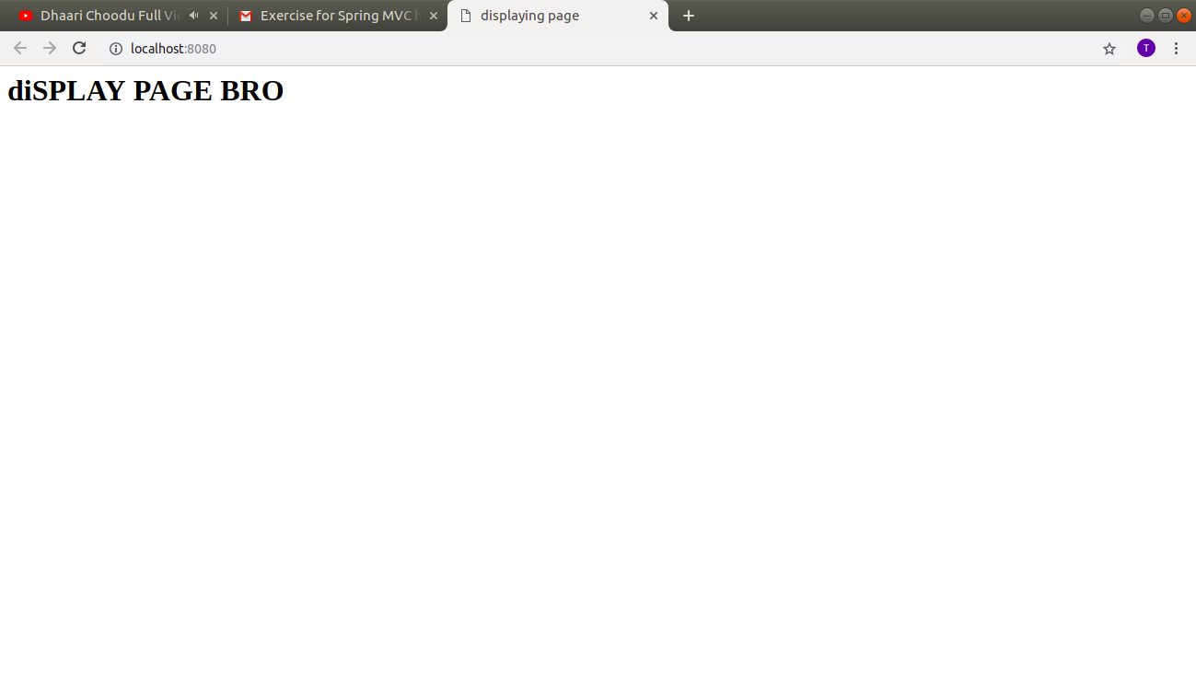
Question 4 :Create one more annotation based action hello inside the StudentController which and use @ResponseBody annotation from it to display Hello world.
Answer 4 :
StudentController.java
package com.ttn.jaffa.Question4;
import org.springframework.stereotype.Controller;
import org.springframework.web.bind.annotation.RequestMapping;
import org.springframework.web.bind.annotation.ResponseBody;
import org.springframework.web.servlet.ModelAndView;
import org.springframework.web.servlet.mvc.multiaction.MultiActionController;
import javax.servlet.http.HttpServletRequest;
import javax.servlet.http.HttpServletResponse;
// Question 4
@Controller
public class StudentController {
@RequestMapping("/")
ModelAndView index() {
ModelAndView modelAndView = new ModelAndView("index");
return modelAndView;
}

@RequestMapping("/hello")
@ResponseBody
String hello() {
return "Hello World!!!";
}
}
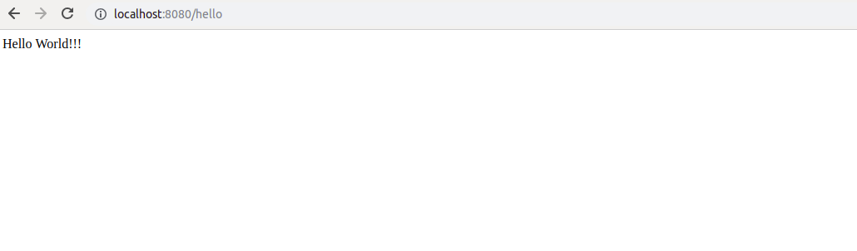
Question 5 :Create one more action which sends Model HelloWorld to the jsp file.
Answer 5 :
StudentController.java
package com.ttn.jaffa.Question5;
import org.springframework.stereotype.Controller;
import org.springframework.web.bind.annotation.RequestMapping;
import org.springframework.web.bind.annotation.ResponseBody;
import org.springframework.web.servlet.ModelAndView;
@Controller
public class StudentController {
/*Question 5*/
@RequestMapping("/send")
public ModelAndView printHelloWorld(){
ModelAndView modelAndView=new ModelAndView("index");
modelAndView.addObject("helloworld","Hello World");
return modelAndView;
}
@RequestMapping("/send1")
public ModelAndView printHelloWorld1(){
ModelAndView modelAndView=new ModelAndView("index");
modelAndView.addObject("human","Hello World human");
return modelAndView;
}
}

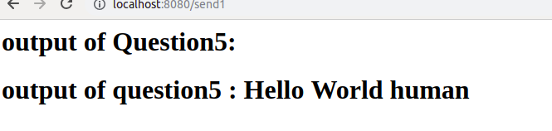

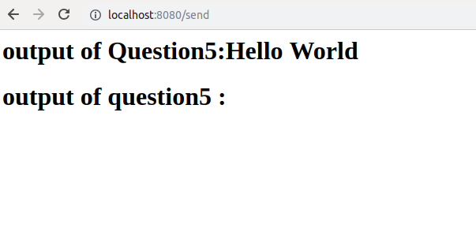
Question 6 :Use @PathVariable annotation to access firstname and lastname in an action inside StudentController place both the parameters in different arguments and access them.
Answer 6 :
StudentController.java
// Question 6
package com.ttn.jaffa.Question6;
import org.springframework.stereotype.Controller;
import org.springframework.web.bind.annotation.*;
import org.springframework.web.servlet.ModelAndView;
@Controller
@RequestMapping("/student")
public class StudentController {
@RequestMapping("/usernameAndPassword/{username}/{password}")
@ResponseBody
String returnVariables(@PathVariable("username") String uname, @PathVariable("password") String pword) {
return "Username: "+uname+" Password: "+pword;
}
}
spring-dispatcher-servlet.xml

<?xml version="1.0" encoding="UTF-8"?>
<beans xmlns="http://www.springframework.org/schema/beans"
xmlns:mvc="http://www.springframework.org/schema/mvc"
xmlns:xsi="http://www.w3.org/2001/XMLSchema-instance"
xmlns:context="http://www.springframework.org/schema/context"
xsi:schemaLocation="http://www.springframework.org/schema/beans
http://www.springframework.org/schema/beans/spring-beans.xsd
http://www.springframework.org/schema/mvc
http://www.springframework.org/schema/mvc/spring-mvc.xsd
http://www.springframework.org/schema/context
http://www.springframework.org/schema/context/spring-context.xsd">
<mvc:annotation-driven/>
<bean id="viewResolver"
class="org.springframework.web.servlet.view.InternalResourceViewResolver">
<property name="prefix">
<value>/WEB-INF/</value>
</property>
<property name="suffix">
<value>.jsp</value>
</property>
</bean>
<context:component-scan base-package="com.ttn.jaffa.Question6"/>
</beans>

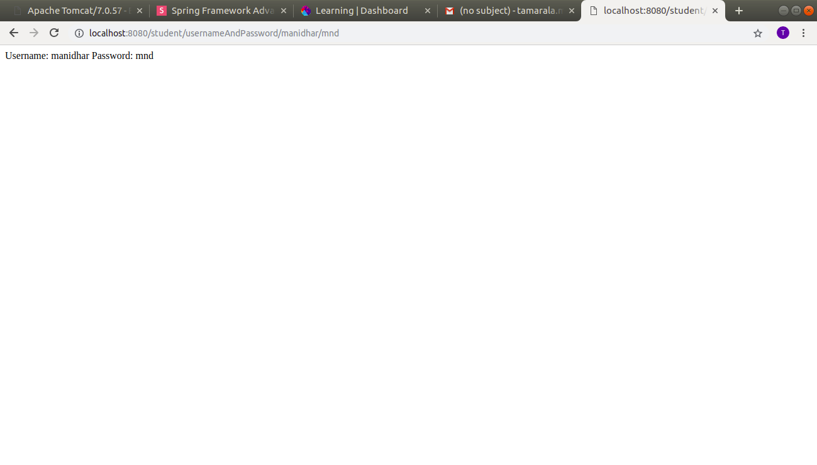

Question 7 :Now place both the arguments inside a Map and access the Map instead.(Hint : check the slide for @PathVariable action returnCountryAndState shows how to do it with map)

Answer 7 :
StudentController.java
package com.ttn.jaffa.Question7;
import org.springframework.stereotype.Controller;
import org.springframework.web.bind.annotation.PathVariable;
import org.springframework.web.bind.annotation.RequestMapping;
import org.springframework.web.bind.annotation.ResponseBody;
import java.util.Map;
// Question 7
@Controller
@RequestMapping("/student")
public class StudentController {
@RequestMapping("/firstnameAndLastname/{firstname}/{lastname}")
@ResponseBody
String returnNames(@PathVariable Map<String, String> requestMap) {
return "Firstname: " + requestMap.get("firstname") + " Lastname: " + requestMap.get("lastname");
}
}

spring-dispatcher-servlet.xml
<?xml version="1.0" encoding="UTF-8"?>
<beans xmlns="http://www.springframework.org/schema/beans"
xmlns:mvc="http://www.springframework.org/schema/mvc"
xmlns:xsi="http://www.w3.org/2001/XMLSchema-instance"
xmlns:context="http://www.springframework.org/schema/context"
xsi:schemaLocation="http://www.springframework.org/schema/beans
http://www.springframework.org/schema/beans/spring-beans.xsd
http://www.springframework.org/schema/mvc
http://www.springframework.org/schema/mvc/spring-mvc.xsd
http://www.springframework.org/schema/context
http://www.springframework.org/schema/context/spring-context.xsd">
<mvc:annotation-driven/>
<context:component-scan base-package="com.ttn.jaffa.Question7"/>

<bean id="viewResolver"
class="org.springframework.web.servlet.view.InternalResourceViewResolver">
<property name="prefix">
<value>/WEB-INF/</value>
</property>
<property name="suffix">
<value>.jsp</value>
</property>
</bean>
</beans>

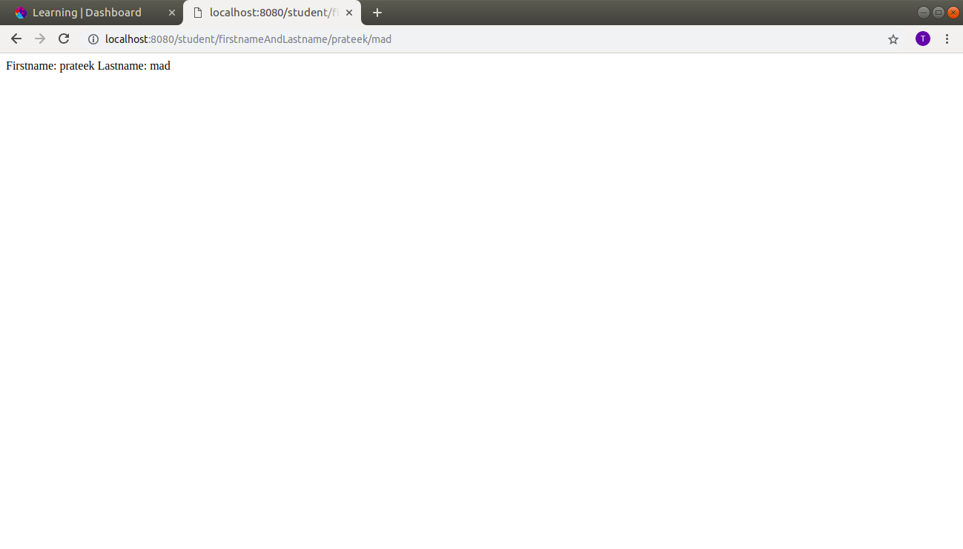

Question 8 :Use @RequestParam annotation to access the firstname and lastname in formData action of StudentController.
Answer 8 :
home.jsp
<%@ page contentType="text/html;charset=UTF-8" language="java" %>
<html>
<head>
<title></title>
</head>
<body>
<form method="post" action="/student/submitForm.html">
<label>Firstname</label>
<input name="firstname" type="text">
<br>
<br>
<label>Lastname</label>
<input name="lastname" type="text">
<br>
<br>
<input type="submit">
</form>
</body>
</html>

StudentController.java
// Question 8
package com.ttn.jaffa.Question8;
import org.springframework.stereotype.Controller;
import org.springframework.web.bind.annotation.RequestMapping;
import org.springframework.web.bind.annotation.RequestMethod;
import org.springframework.web.bind.annotation.RequestParam;
import org.springframework.web.bind.annotation.ResponseBody;
import org.springframework.web.servlet.ModelAndView;
@Controller
@RequestMapping("/student")
public class StudentController {
@RequestMapping(value = "/index.html", method = RequestMethod.GET)
ModelAndView index() {
ModelAndView modelAndView = new ModelAndView("home");
return modelAndView;
}
@RequestMapping(value = "/submitForm.html", method = RequestMethod.POST)
@ResponseBody
String submitForm(@RequestParam("firstname") String username,
@RequestParam("lastname") String password) {
return "Firstname: " + username + " Lastname: " + password;
}
}

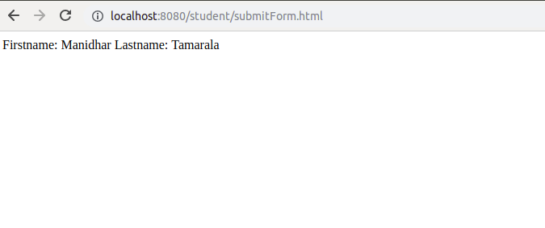
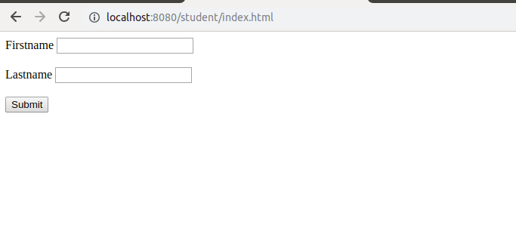

Q9. Create a StudentCO and bind firstname and lastname with instance variable of StudentCO.
Solution:
StudentCO.java
package com.ttn.jaffa.Question9;
public class StudentCO {
private String firstname;
private String lastname;
public String getFirstname() {
return firstname;
}
public void setFirstname(String firstname) {
this.firstname = firstname;
}
public String getLastname() {
return lastname;
}
public void setLastname(String lastname) {
this.lastname = lastname;
}
}
StudentController.java
// Question 9
package com.ttn.jaffa.Question9;
import com.ttn.jaffa.Question9.StudentCO;
import org.springframework.stereotype.Controller;
import org.springframework.web.bind.annotation.*;
import org.springframework.web.servlet.ModelAndView;
@Controller
@RequestMapping("/student")
public class StudentController {
@RequestMapping(value = "/index.html", method = RequestMethod.GET)
ModelAndView index() {
ModelAndView modelAndView = new ModelAndView("form");
return modelAndView;
}
@RequestMapping(value = "/submitForm.html", method = RequestMethod.POST)
@ResponseBody
String submitForm(StudentCO studentCO) {
return "Firstname: " + studentCO.getFirstname() + " <br>Lastname: " + studentCO.getLastname();
}
}

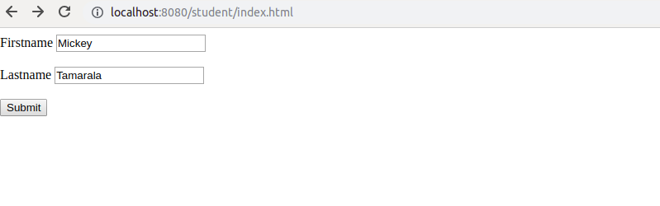
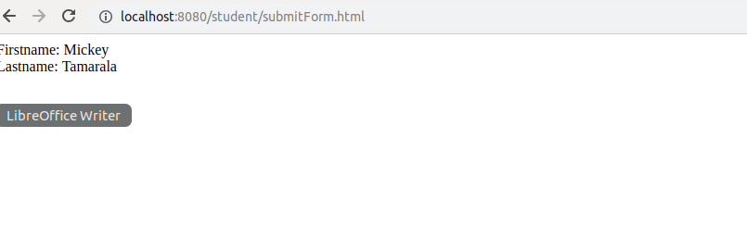

Q10. Use @ModelAttribute annotation to add Heading "Spring MVC Demo" in every model.
Solution:
StudentCO.java
package com.ttn.jaffa.Question10;
public class StudentCO {
private String firstname;
private String lastname;
public String getFirstname() {
return firstname;
}
public void setFirstname(String firstname) {
this.firstname = firstname;
}
public String getLastname() {
return lastname;
}
public void setLastname(String lastname) {
this.lastname = lastname;
}
}

StudentController.java
package com.ttn.jaffa.Question10;
import org.springframework.stereotype.Controller;
import org.springframework.ui.Model;
import org.springframework.web.bind.annotation.*;
import org.springframework.web.servlet.ModelAndView;
@Controller
@RequestMapping("/student")
public class StudentController {
@ModelAttribute
void addingObject(Model model){
model.addAttribute("heading","Spring MVC Demo");
}
@RequestMapping(value = "/index.html", method = RequestMethod.GET)
ModelAndView index() {
ModelAndView modelAndView = new ModelAndView("index1");
return modelAndView;
}
@RequestMapping(value = "/submitForm.html", method = RequestMethod.POST)
@ResponseBody
ModelAndView submitForm(@ModelAttribute("studentCO") StudentCO studentCO) {
ModelAndView modelAndView = new ModelAndView("submittedData");
return modelAndView;
}
}

index1.jsp
<%@ page contentType="text/html;charset=UTF-8" language="java" %>
<html>
<head>
<title></title>
</head>
<body>
<center>
<form method="post" action="/student/submitForm.html">
<label>Firstname</label>
<input name="firstname" type="text">
<br>
<br>
<label>Lastname</label>
<input name="lastname" type="text">
<br>
<br>
<input type="submit">
<br><br><hr>
${heading}
</form>
</center>
</body>
</html>

submittedData.jsp
<%@ page contentType="text/html;charset=UTF-8" language="java" %>
<html>
<head>
<title></title>
</head>
<body>
<center>
<h1>Firstname: ${studentCO.firstname} <br><br> Lastname: ${studentCO.lastname}</h1>
<br><br><hr>
${heading}
</center>
</body>
</html>

