MY SPRING DATA JPA ASSIGNMENT

Q1.Create a Person entity with instance variables Firstname, Lastname, salary, age and Id.
Q2.Implement CrudRepository for it.

A.
PERSISTENCECONTEXT.JAVA
package com.ttn.springjpa.config;
import org.springframework.context.annotation.Bean;
import org.springframework.context.annotation.Configuration;
import org.springframework.data.jpa.repository.config.EnableJpaRepositories;
import org.springframework.jdbc.datasource.DriverManagerDataSource;
import org.springframework.orm.jpa.JpaTransactionManager;
import org.springframework.orm.jpa.LocalContainerEntityManagerFactoryBean;
import org.springframework.orm.jpa.vendor.HibernateJpaVendorAdapter;
import javax.persistence.EntityManagerFactory;
import javax.sql.DataSource;
import java.util.Properties;
@Configuration
@EnableJpaRepositories("com.ttn.springjpa.repository")
public class PersistenceContext {
@Bean
DataSource dataSource() {
DriverManagerDataSource driverManagerDataSource = new DriverManagerDataSource();
driverManagerDataSource.setDriverClassName("com.mysql.jdbc.Driver");
driverManagerDataSource.setUrl("jdbc:mysql://localhost:3306/springjpaassign");
driverManagerDataSource.setUsername("mani");
driverManagerDataSource.setPassword("mani");
return driverManagerDataSource;
}
@Bean
LocalContainerEntityManagerFactoryBean entityManagerFactory(DataSource dataSource) {
LocalContainerEntityManagerFactoryBean entityManagerFactoryBean =
new LocalContainerEntityManagerFactoryBean();
entityManagerFactoryBean.setDataSource(dataSource);
entityManagerFactoryBean.setJpaVendorAdapter(new HibernateJpaVendorAdapter());
entityManagerFactoryBean.setPackagesToScan("com.ttn.springjpa.entity");
Properties jpaProperties = new Properties();
jpaProperties.setProperty("hibernate.dialect", "org.hibernate.dialect.MySQLDialect");
jpaProperties.setProperty("hibernate.show_sql", "true");
jpaProperties.setProperty("hibernate.hbm2ddl.auto", "create");
entityManagerFactoryBean.setJpaProperties(jpaProperties);
return entityManagerFactoryBean;
}
@Bean
JpaTransactionManager transactionManager(EntityManagerFactory entityManagerFactory) {
JpaTransactionManager transactionManager = new JpaTransactionManager();
transactionManager.setEntityManagerFactory(entityManagerFactory);
return transactionManager;
}
}
BUILD.GRADLE
plugins {
id 'java'
}
group 'com.ttn.springjpa'
version '1.0-SNAPSHOT'
sourceCompatibility = 1.8
repositories {
mavenCentral()
}
dependencies {
testCompile group: 'junit', name: 'junit', version: '4.12'
compile 'org.hibernate:hibernate-entitymanager:4.1.7.Final'
compile 'mysql:mysql-connector-java:5.1.13'
compile 'org.springframework.data:spring-data-jpa:1.11.4.RELEASE'
}
PERSON.JAVA
package com.ttn.springjpa.entity;
import javax.persistence.Entity;
import javax.persistence.GeneratedValue;
import javax.persistence.GenerationType;
import javax.persistence.Id;
@Entity
public class Person {
@Id
@GeneratedValue(strategy = GenerationType.AUTO)
private Integer Id;
private String Firstname;
private String Lastname;
private Integer Salary;
private Integer Age;
public Integer getId() {
return Id;
}
public void setId(Integer id) {
Id = id;
}
public String getFirstname() {
return Firstname;
}
public void setFirstname(String firstname) {
Firstname = firstname;
}
public String getLastname() {
return Lastname;
}
public void setLastname(String lastname) {
Lastname = lastname;
}
public Integer getSalary() {
return Salary;
}
public void setSalary(Integer salary) {
Salary = salary;
}
public Integer getAge() {
return Age;
}
public void setAge(Integer age) {
Age = age;
}
@Override
public String toString() {
return "Person{" +
"Id=" + Id +
", Firstname='" + Firstname + '\'' +
", Lastname='" + Lastname + '\'' +
", Salary=" + Salary +
", Age=" + Age +
'}';
}
}
PERSONREPOSITORY.JAVA

package com.ttn.springjpa.repository;
import com.ttn.springjpa.entity.Person;
import org.springframework.data.repository.CrudRepository;
public interface PersonRepository extends CrudRepository<Person,Integer> {
}
PERSONSERVICE.JAVA
package com.ttn.springjpa.service;
import com.ttn.springjpa.entity.Person;
import com.ttn.springjpa.repository.PersonRepository;
import org.springframework.beans.factory.annotation.Autowired;
import org.springframework.stereotype.Service;
@Service
public class PersonService {
@Autowired
PersonRepository personRepository;
Person person = new Person();
Person person1 = new Person();
Person person2 = new Person();
Person person3 = new Person();
Person person4 =new Person();
public void saveperson() {
person.setAge(24);
person.setId(3246);
person.setFirstname("manidhar");
person.setLastname("tamarala");
person.setSalary(13382);
personRepository.save(person);
person1.setAge(23);
person1.setId(3247);
person1.setFirstname("smriti");
person1.setLastname("babbar");
person1.setSalary(13782);
personRepository.save(person1);
person2.setAge(19);
person2.setId(3248);
person2.setFirstname("shivam");
person2.setLastname("saxena");
person2.setSalary(14000);
personRepository.save(person2);
person3.setAge(26);
person3.setId(3249);
person3.setFirstname("sanjeev");
person3.setLastname("kumar");
person3.setSalary(13922);
personRepository.save(person3);
person4.setAge(24);
person4.setId(3250);
person4.setFirstname("reshma");
person4.setLastname("mohan");
person4.setSalary(15000);
personRepository.save(person4);
}
}
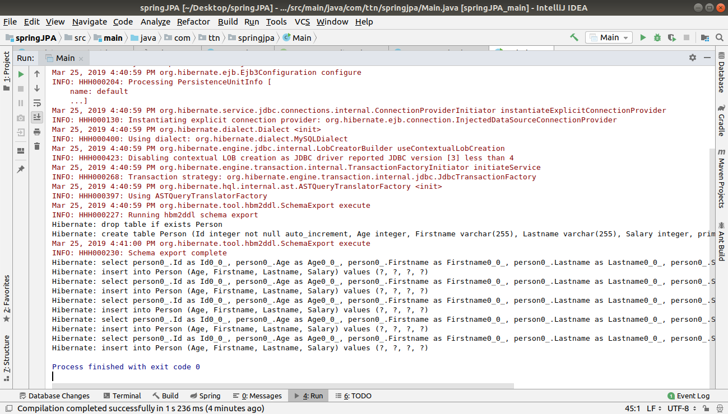

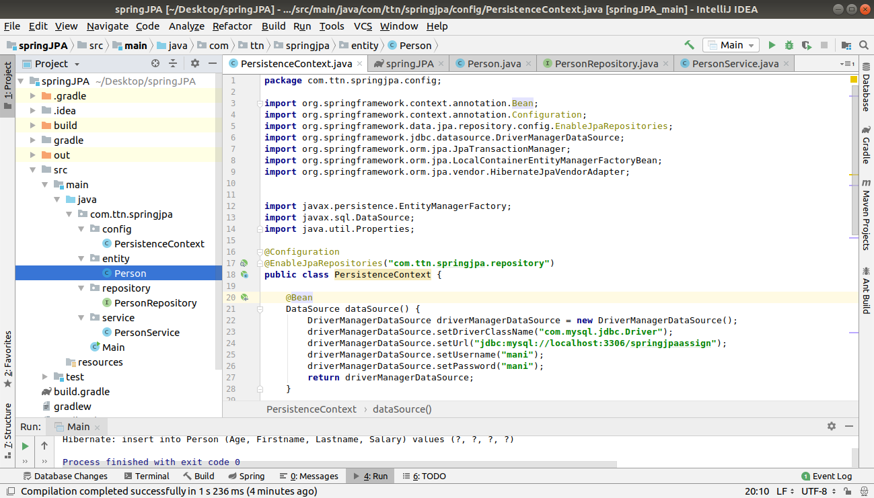
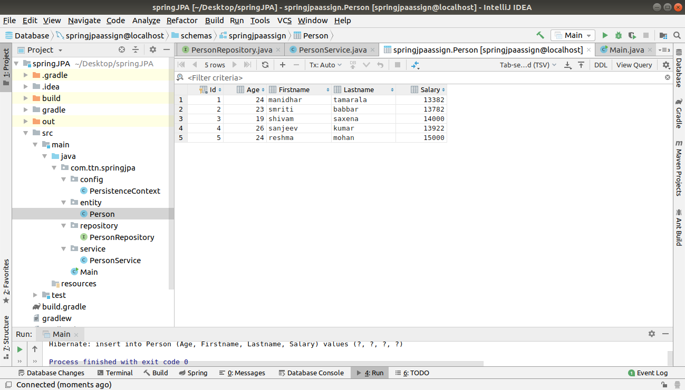

Q3.Perform all the methods inside CrudRepository for Person Class.
A.

Findone :

public Person findOne(){
return personRepository.findOne(3);
}

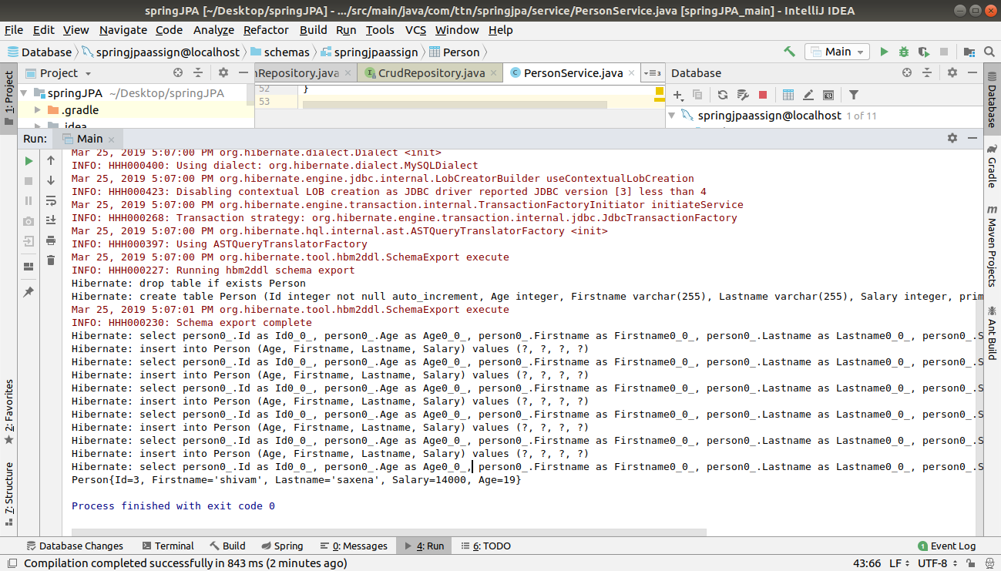
exists:
public boolean exists(){
return personRepository.exists(5);
}

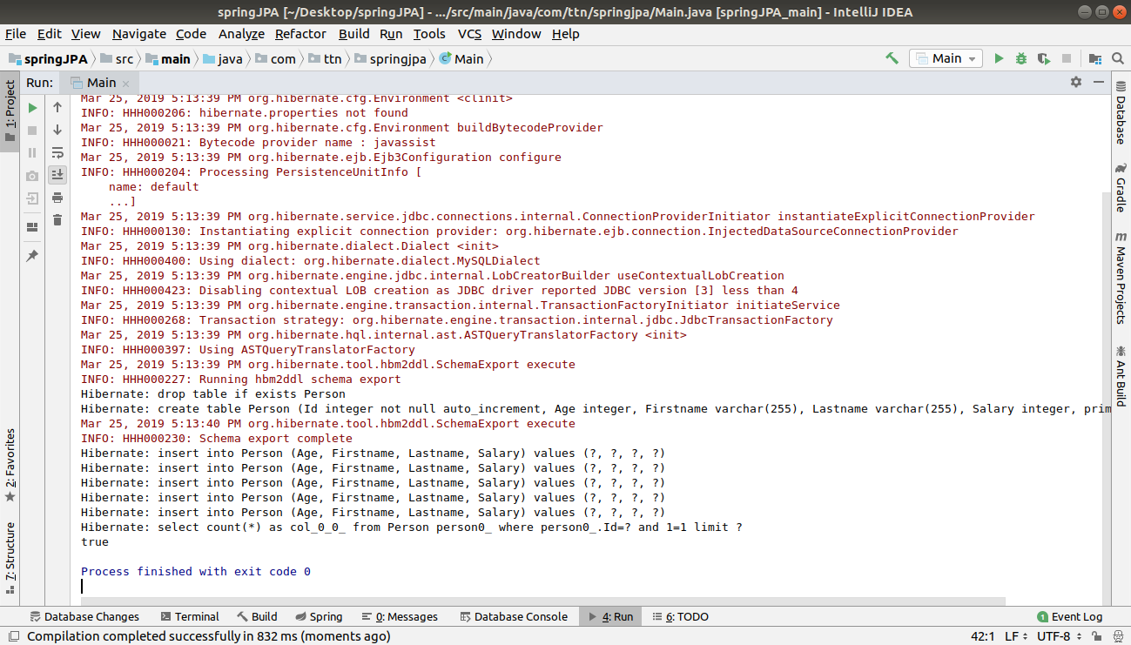

findall:
public Iterable<Person> findAll() {
return personRepository.findAll();
}

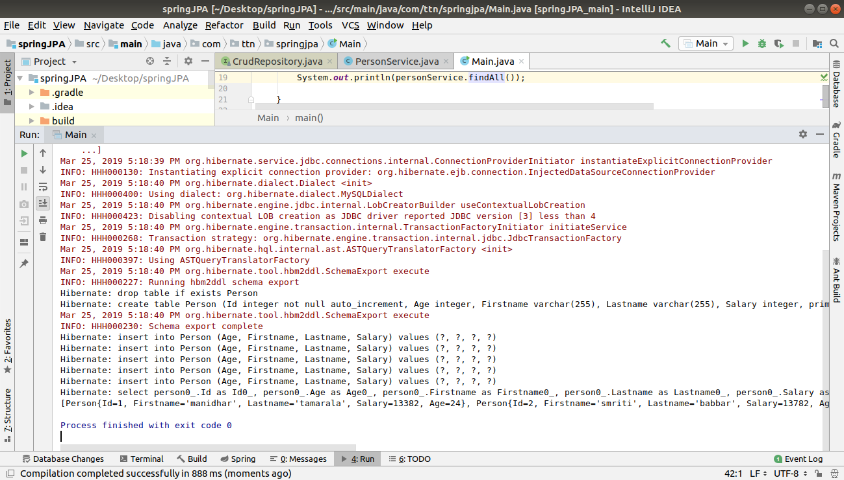
Iterable<T> findAll(Iterable<ID> ids) method:

count method:

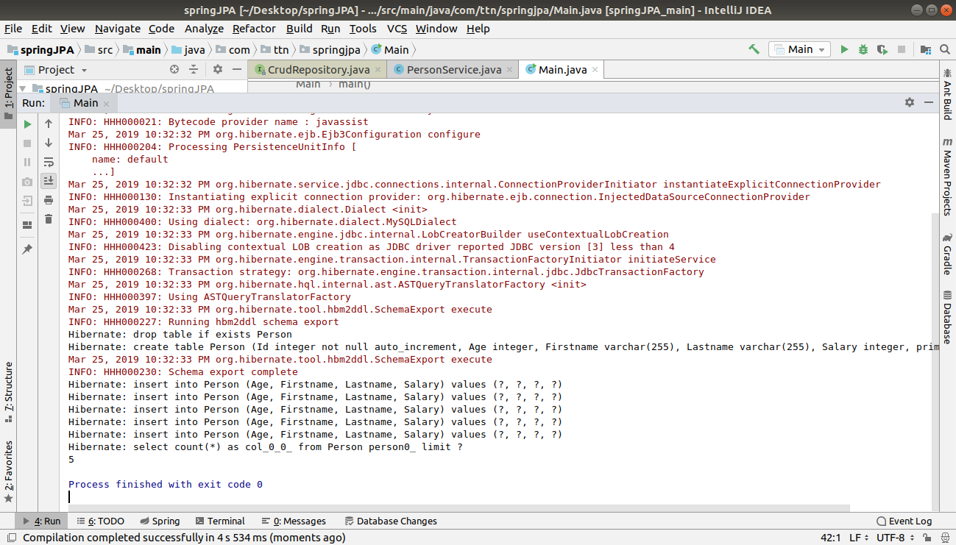

Q4.
For class Person find person declare methods in repository to find person by firstname, lastname and Id
Q5.
Use the methods declared above to fetch the person.
A.
PersonSERVICE.JAVA
public List<Person> findPersonByFirstName(String name){
return personRepository.findByFirstName(name);
}
public List<Person> findPersonByLastName(String name){
return personRepository.findByLastName(name);
}
public List<Person> findPersonById(int id){
return personRepository.findById(id);
}
Main.JAVA
System.out.println(personService.findPersonByFirstName("manidhar"));
System.out.println("\n");
System.out.println(personService.findPersonByLastName("babbar"));
System.out.println("\n");
System.out.println(personService.findPersonById(3));
PERSONRepository.java

// Q4
List<Person> findByFirstName(String name);
List<Person> findByLastName(String name);
List<Person> findById(Integer id);

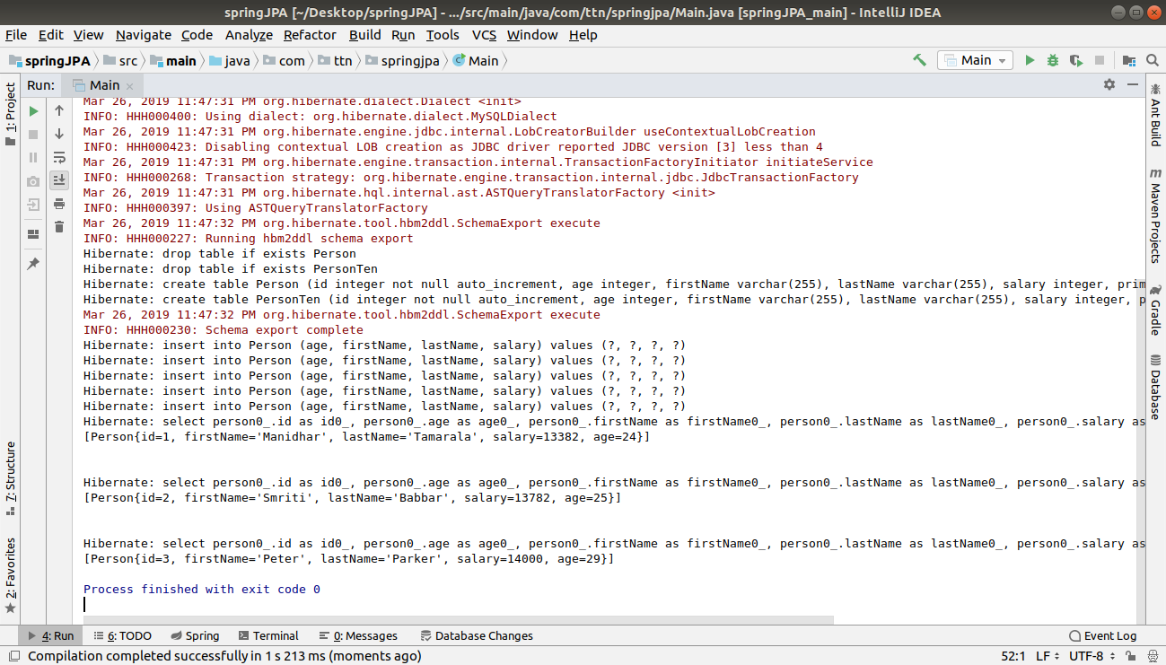

Q6.Use @Query to fetch firstname of the Person whose age is 25.
A.
personservice.java
package com.ttn.springjpa.service;
import com.ttn.springjpa.entity.Person;
import com.ttn.springjpa.repository.PersonRepository;
import org.springframework.beans.factory.annotation.Autowired;
import org.springframework.stereotype.Service;
import java.util.List;
@Service
public class PersonService {
@Autowired
PersonRepository personRepository;
Person person = new Person();
Person person1 = new Person();
Person person2 = new Person();
Person person3 = new Person();
Person person4 = new Person();
public void savePerson() {
person.setAge(24);
person.setFirstName("Manidhar");
person.setLastName("Tamarala");
person.setSalary(13382);
personRepository.save(person);
person1.setAge(25);
person1.setFirstName("Smriti");
person1.setLastName("Babbar");
person1.setSalary(13782);
personRepository.save(person1);
person2.setAge(19);
person2.setFirstName("Peter");
person2.setLastName("Parker");
person2.setSalary(14000);
personRepository.save(person2);
person3.setAge(25);
person3.setFirstName("Peter");
person3.setLastName("Roxy");
person3.setSalary(13922);
personRepository.save(person3);
person4.setAge(24);
person4.setFirstName("Reshma");
person4.setLastName("Mohan");
person4.setSalary(15000);
personRepository.save(person4);
}
//q3. find one method
public Person findOne() {
return personRepository.findOne(3);
}
// q3. exists method
public boolean exists() {
return personRepository.exists(5);
}
// q3 findall method
public Iterable<Person> findAll() {
return personRepository.findAll();
}
//Q3 Iterable<T> findAll(Iterable<ID> ids) METHOD
//
// public void findAll(){
// return personRepository.findAll(Iterable<Person> ids);
// }
// q3 long count() METHOD
public long count() {
return personRepository.count();
}
// q3. void delete(ID id) method
public void delete(int id) {
System.out.println("Deleting record of id "+id+"......");
personRepository.delete(id);
System.out.println("Deleted record of id "+id+"......");
}
//List<Person> firstnames=new ArrayList<Person>();
/*
public List<Person> findPersonByFirstname(int age) {
return personRepository.findPersonByFirstname(age);
}*/
public List<String> findPersonByFirstName(Integer age){
return personRepository.findPersonByFirstname(age);
}
}
personRepository.java

package com.ttn.springjpa.repository;
import com.ttn.springjpa.entity.Person;
import org.springframework.data.jpa.repository.Query;
import org.springframework.data.repository.CrudRepository;
import org.springframework.data.repository.query.Param;
import java.util.List;
public interface PersonRepository extends CrudRepository<Person, Integer> {
// Q4
// List<Person> findPersonByFirstName(String name);
List<Person> findPersonByLastName(String name);
Person findPersonById(Integer id);
@Query("SELECT firstName from Person where age=:age")
List<String> findPersonByFirstname(@Param("age") Integer age);
}
person.java
package com.ttn.springjpa.entity;
import javax.persistence.Entity;
import javax.persistence.GeneratedValue;
import javax.persistence.GenerationType;
import javax.persistence.Id;
@Entity
public class Person {
@Id
@GeneratedValue(strategy = GenerationType.AUTO)
private Integer id;
private String firstName;
private String lastName;
private Integer salary;
private Integer age;
public Integer getId() {
return id;
}
public void setId(Integer id) {
this.id = id;
}
public String getFirstName() {
return firstName;
}
public void setFirstName(String firstName) {
this.firstName = firstName;
}
public String getLastName() {
return lastName;
}
public void setLastName(String lastName) {
this.lastName = lastName;
}
public Integer getSalary() {
return salary;
}
public void setSalary(Integer salary) {
this.salary = salary;
}
public Integer getAge() {
return age;
}
public void setAge(Integer age) {
this.age = age;
}
@Override
public String toString() {
return "Person{" +
"id=" + id +
", firstName='" + firstName + '\'' +
", lastName='" + lastName + '\'' +
", salary=" + salary +
", age=" + age +
'}';
}
}
Main.java
package com.ttn.springjpa;
import com.ttn.springjpa.entity.Person;
import com.ttn.springjpa.service.PersonService;
import org.springframework.context.ConfigurableApplicationContext;
import org.springframework.context.annotation.AnnotationConfigApplicationContext;
import java.util.Iterator;
import java.util.List;
public class Main {
public static void main(String[] args) {
ConfigurableApplicationContext ctx = new AnnotationConfigApplicationContext("com.ttn.springjpa.config", "com.ttn.springjpa.service");
PersonService personService = ctx.getBean(PersonService.class);
// Q3
//personService.savePerson();
// System.out.println(personService.findOne());
// System.out.println(personService.exists());
// System.out.println(personService.findAll());
// System.out.println(personService.count());
//personService.delete(1);
List<String> list=personService.findPersonByFirstName(25);
Iterator<String> iterator=list.iterator();
while (iterator.hasNext()){
System.out.println(iterator.next());
}
}
}
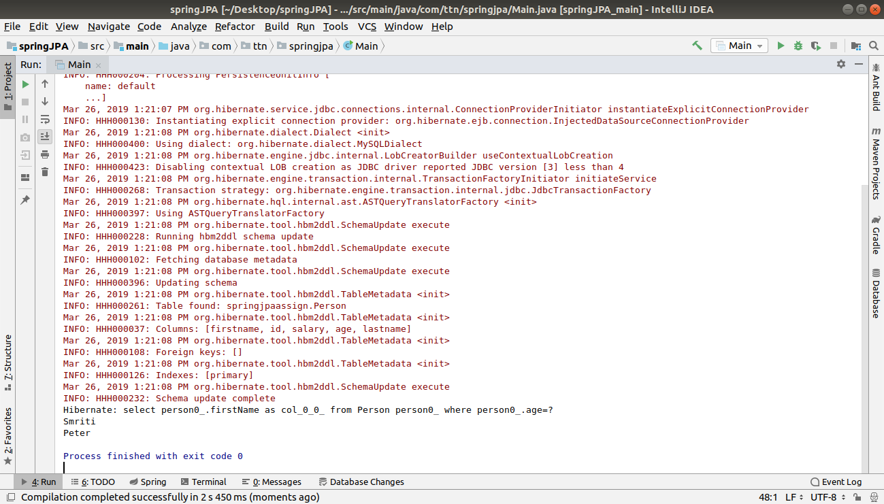

Q7.
Use @Query to fetch firstname and lastname of the Person whose age is 25.
A.

PersonService.java

public void findPersonByFirstNameAndLastName(Integer age) {
List<Object[]> list=personRepository.findPersonByFirstNameAndLastName(age);
Iterator<Object[]> iterator=list.iterator();
while (iterator.hasNext()){
Object[] objects=iterator.next();
System.out.println(objects[0] + " " +objects[1]);
}
}
Main.java

personService.findPersonByFirstNameAndLastName(25);

PersonRepository.java

@Query("SELECT firstName ,lastName from Person where age=:age")
List<Object[]> findPersonByFirstNameAndLastName(@Param("age") Integer age);

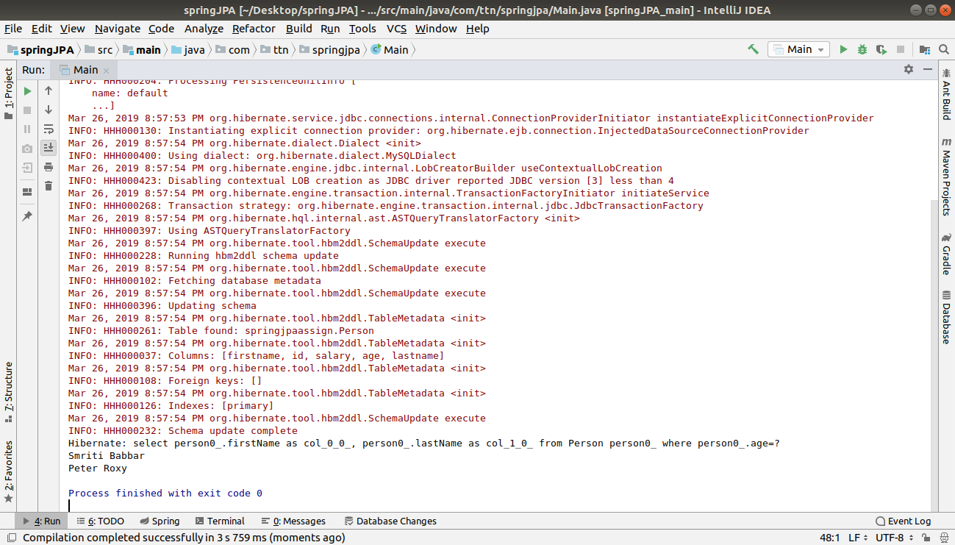
Q8.Get complete information of the Employee whose age is 25 using @Query.

A.
PersonService.java

public void allDataByAge(Integer age)
{
List<Person> data =personRepository.allDataByAge(age);
Iterator<Person> iterator=data.iterator();
while (iterator.hasNext()){
Person objects=iterator.next();
System.out.println(objects);
}
}

PersonRepository.java

@Query("SELECT e FROM Person e where age=:age")
List<Person> allDataByAge(@Param("age") Integer age);
Main.java
personService.allDataByAge(25);

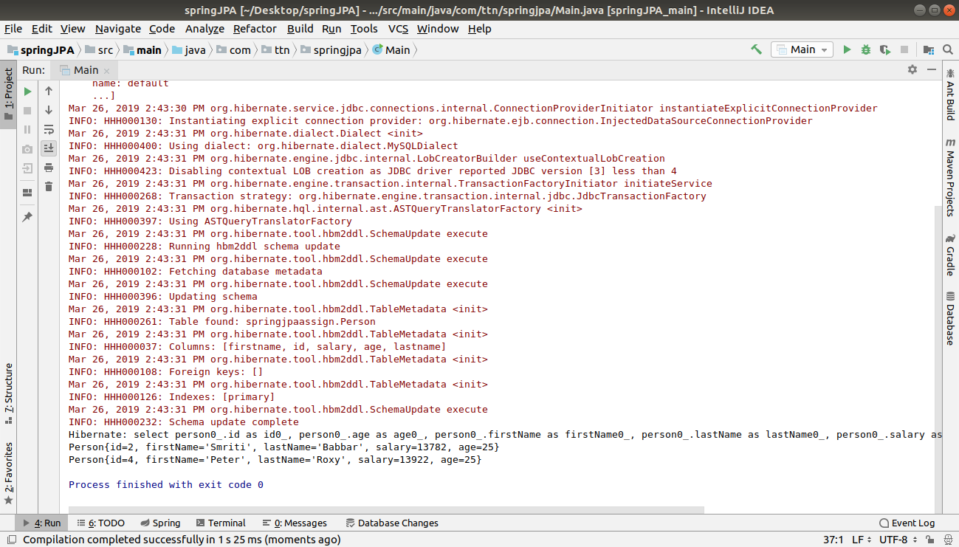
Q9.Count Person where name is "Peter" using @Query.

A.

PersonService.java
public Integer countByFirstName(String firstName) {
return personRepository.countByFirstName(firstName);
PersonRepository.java

//Question 9
@Query("select count(e) from Person e where firstName=:firstName")
Integer countByFirstName(@Param("firstName") String firstName);
Main.java
System.out.println(personService.countByFirstName("Peter"));
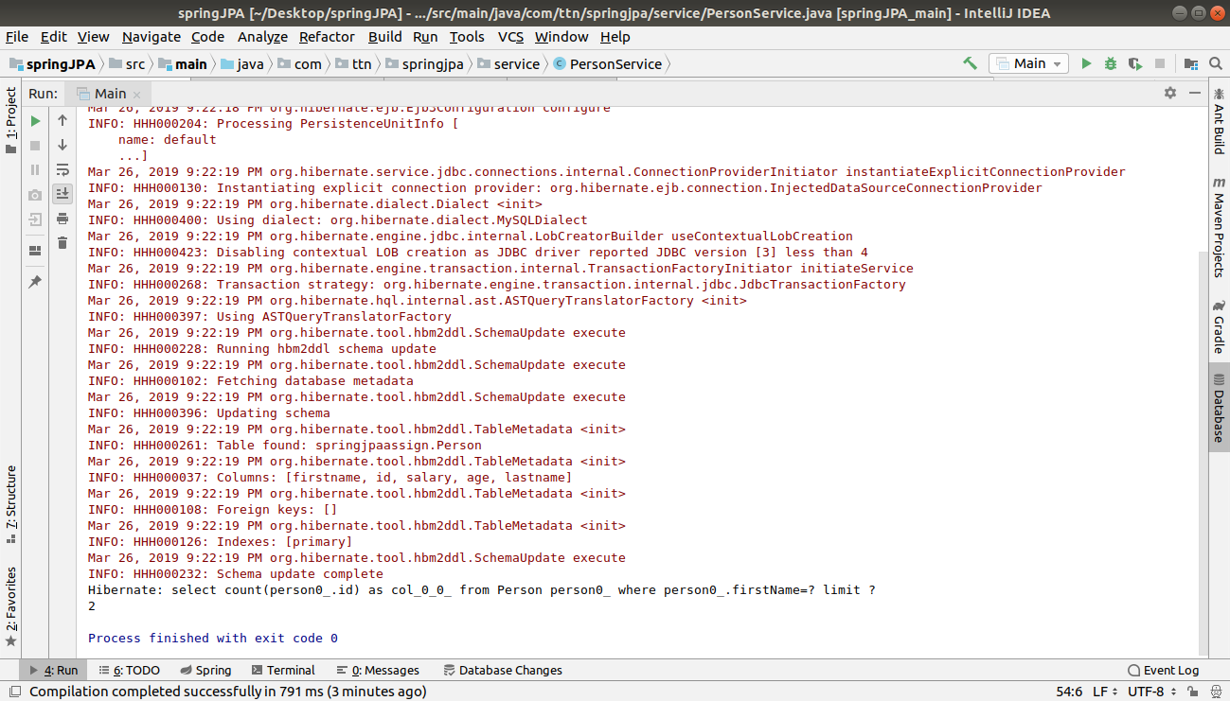
Q10.
Implement following methods for Person repository:
  - count
  - distinct
  - or
  - and
  - between
  - LessThan
  - GreaterThan
  - Like
  - Not
  - In
  - IgnoreCase

A.
Count method:
MainTEN.JAVA
package com.ttn.springjpa;
import com.ttn.springjpa.service.PersonService;
import com.ttn.springjpa.service.PersonTenService;
import org.springframework.context.ConfigurableApplicationContext;
import org.springframework.context.annotation.AnnotationConfigApplicationContext;
public class MainTen {
public static void main(String[] args) {
ConfigurableApplicationContext ctx = new AnnotationConfigApplicationContext("com.ttn.springjpa.config", "com.ttn.springjpa.service");
PersonTenService personTenService = ctx.getBean(PersonTenService.class);
personTenService.savePerson();
Integer count1 = personTenService.countByMethodOfPersonRepository("Peter");
System.out.println("Number of People From Peter Name is : " + count1);
}
}

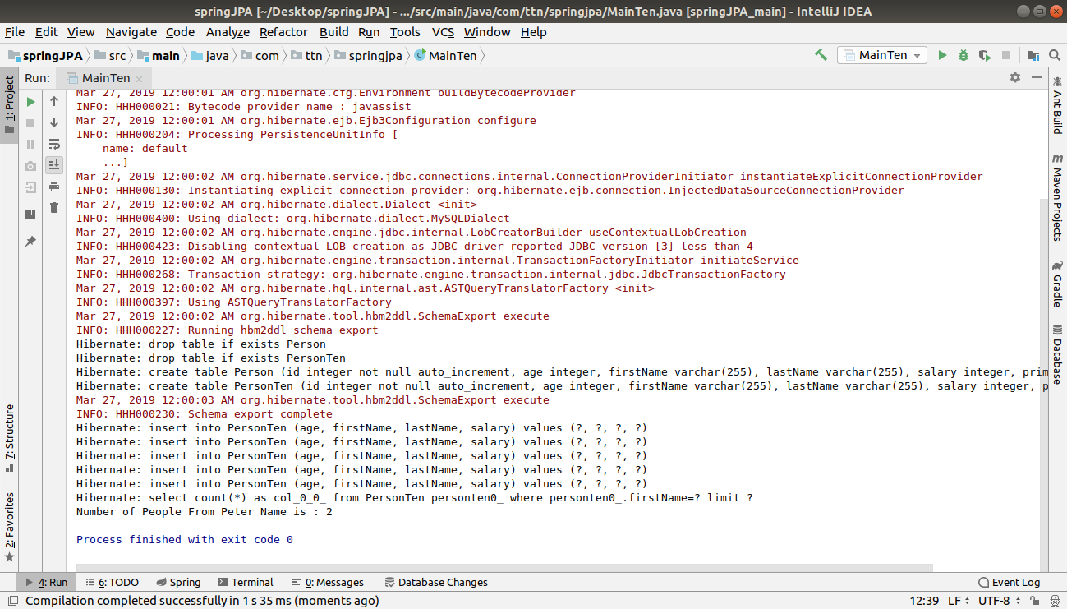
Distinct method:

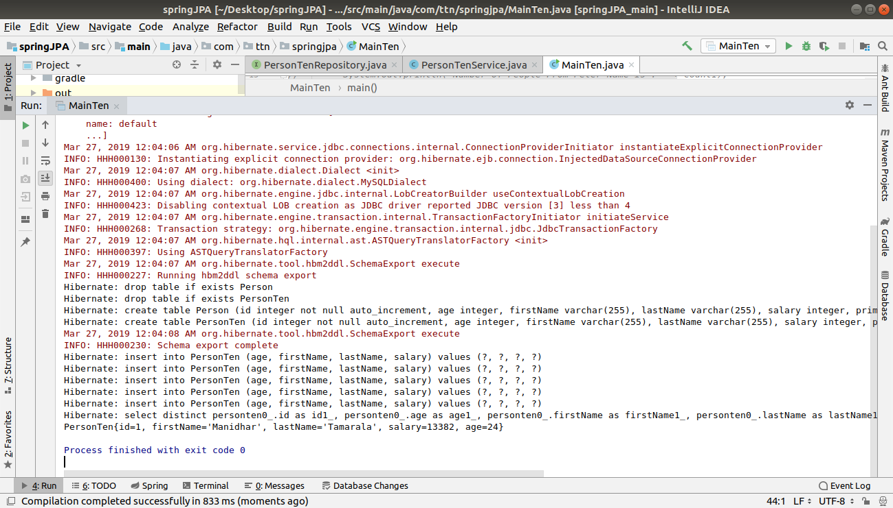

3.
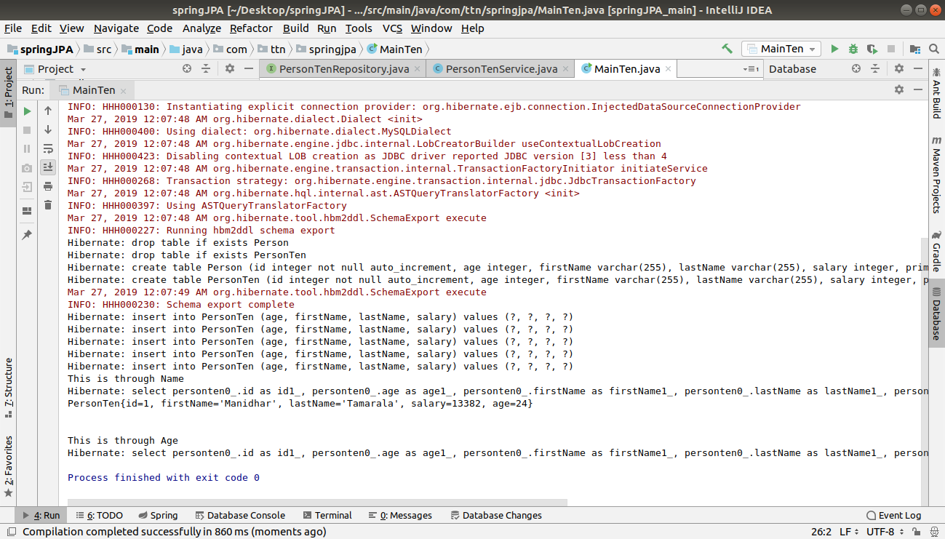
4.

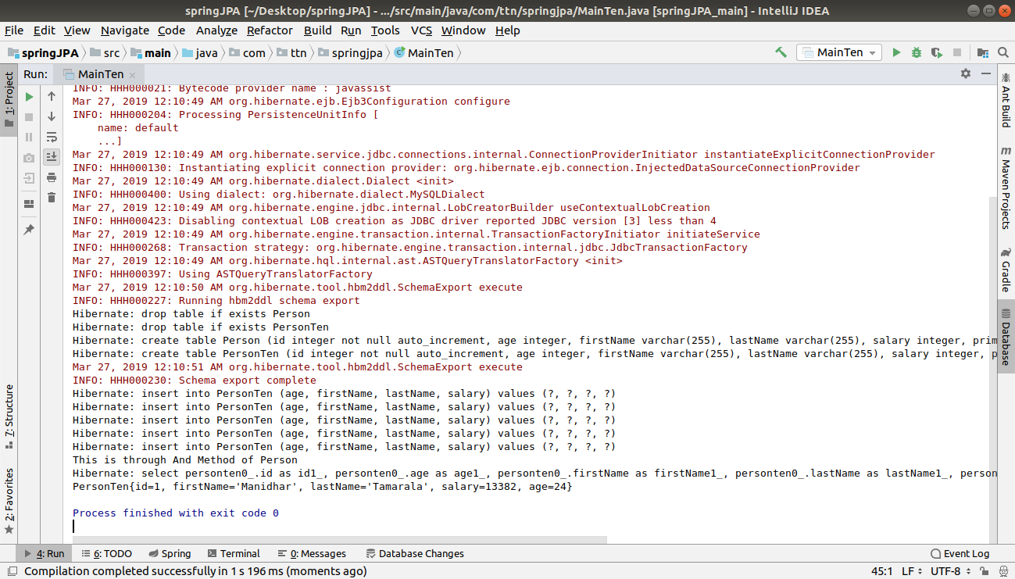

5.
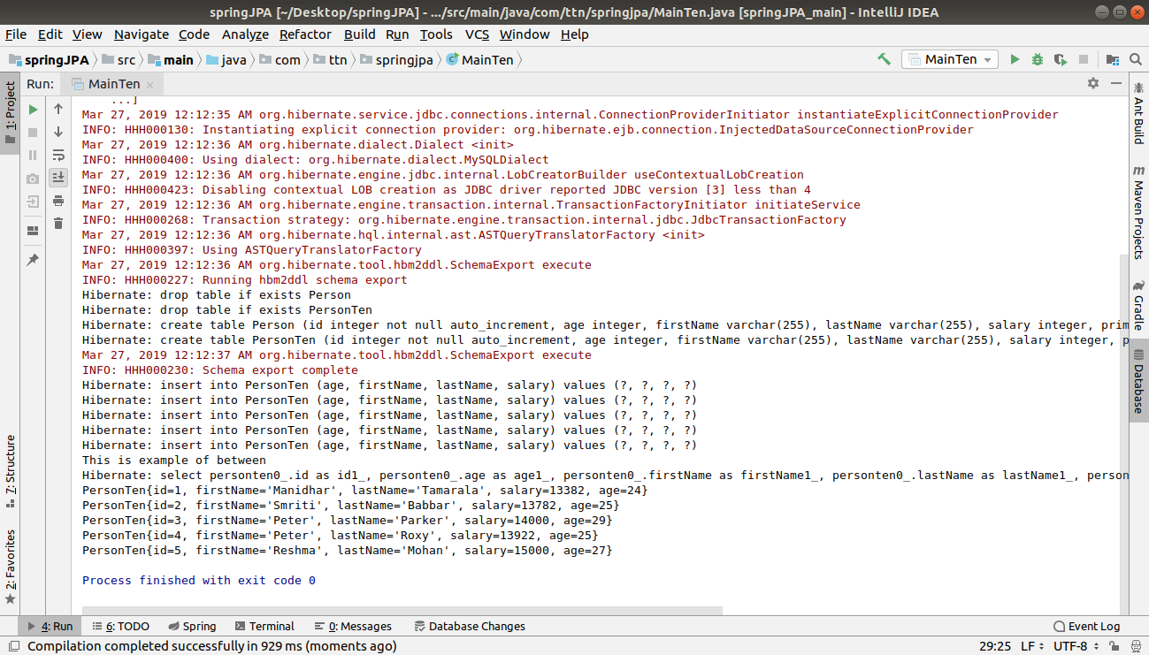

6.
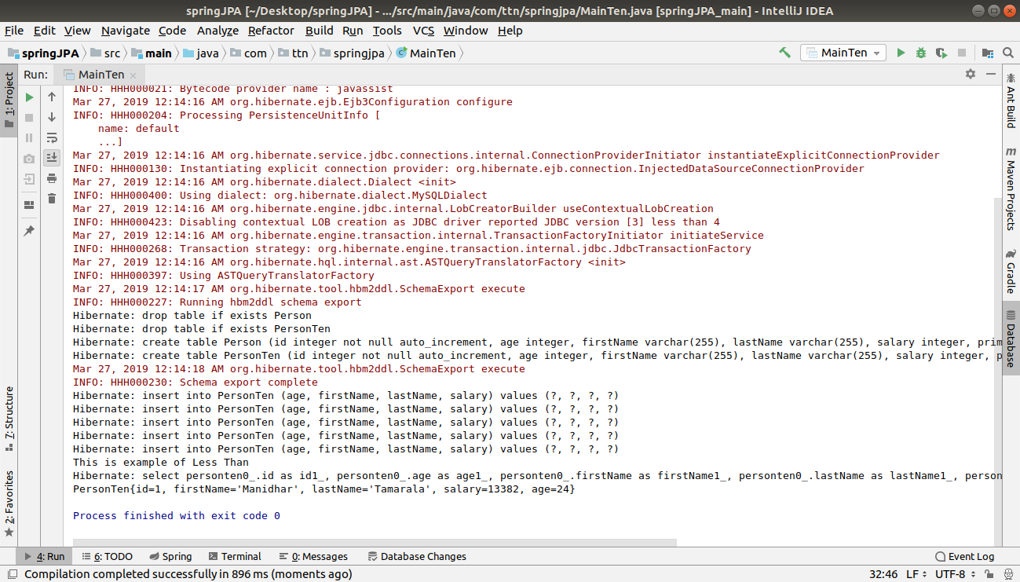

7.
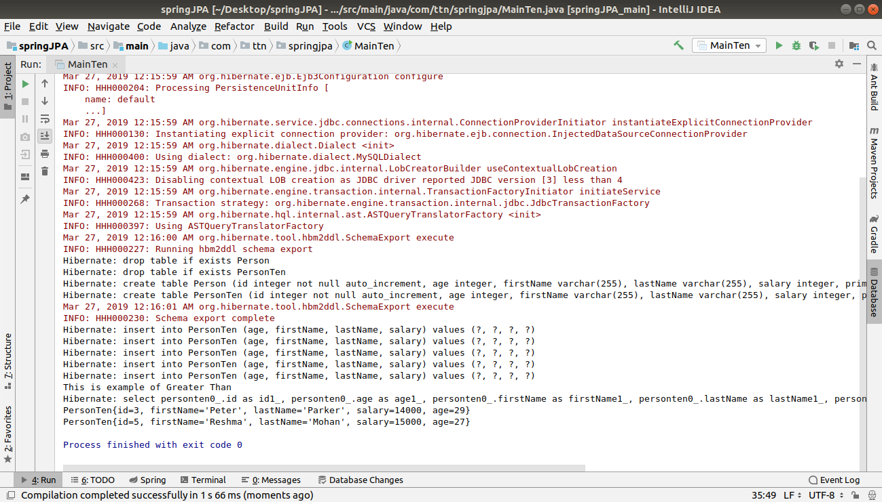

8.
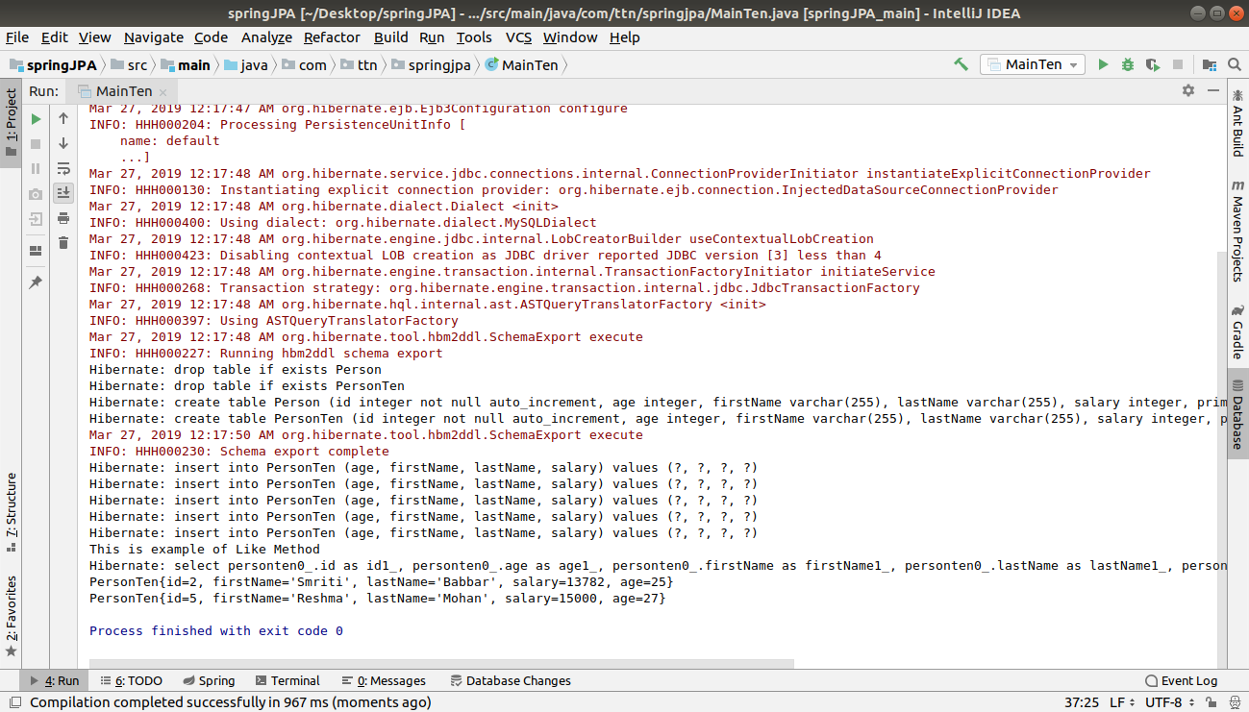
9.
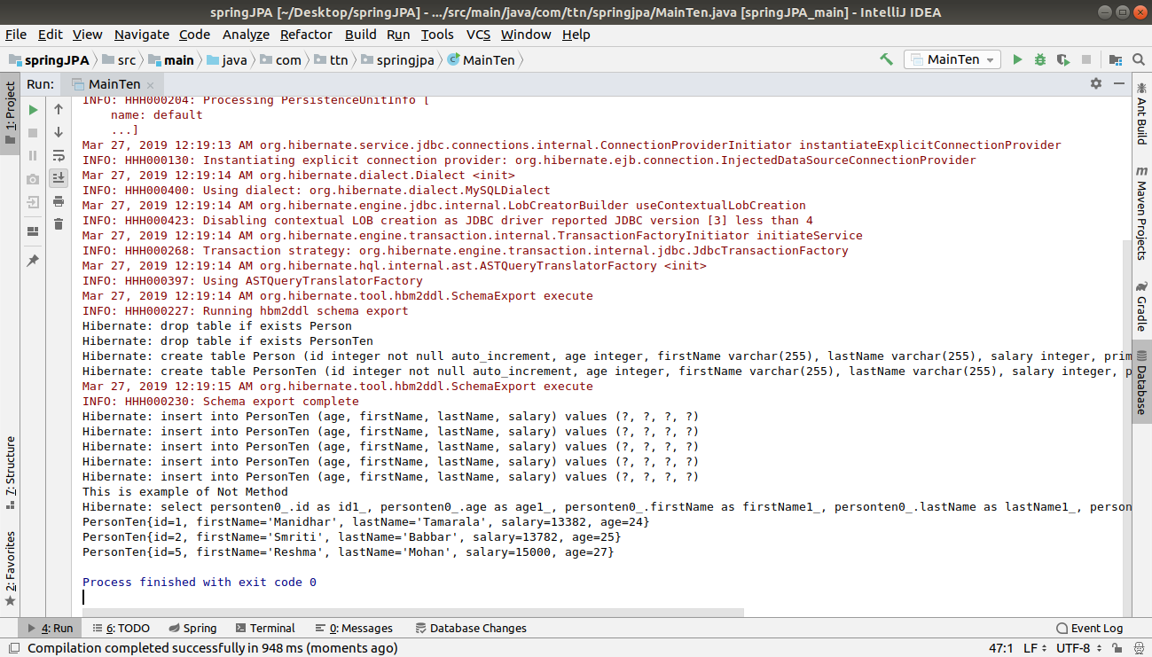

10.

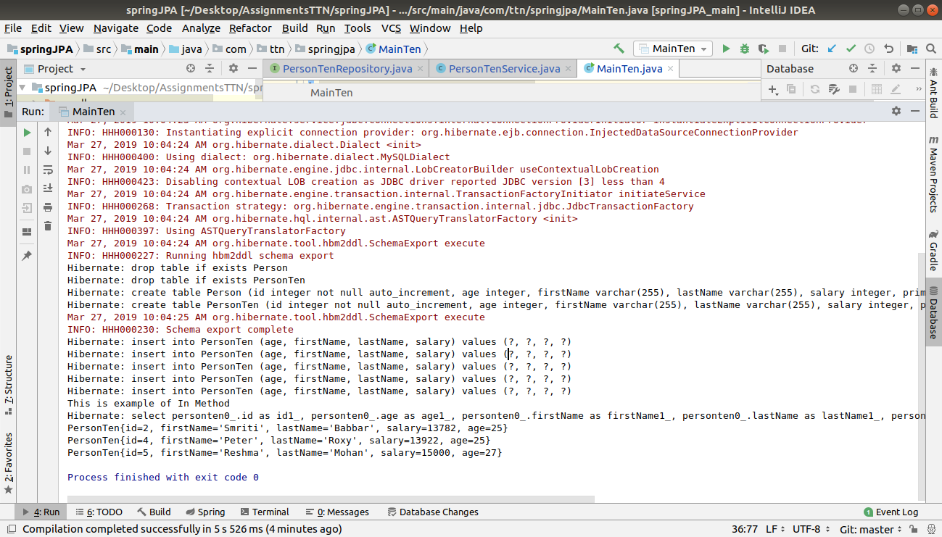
11.
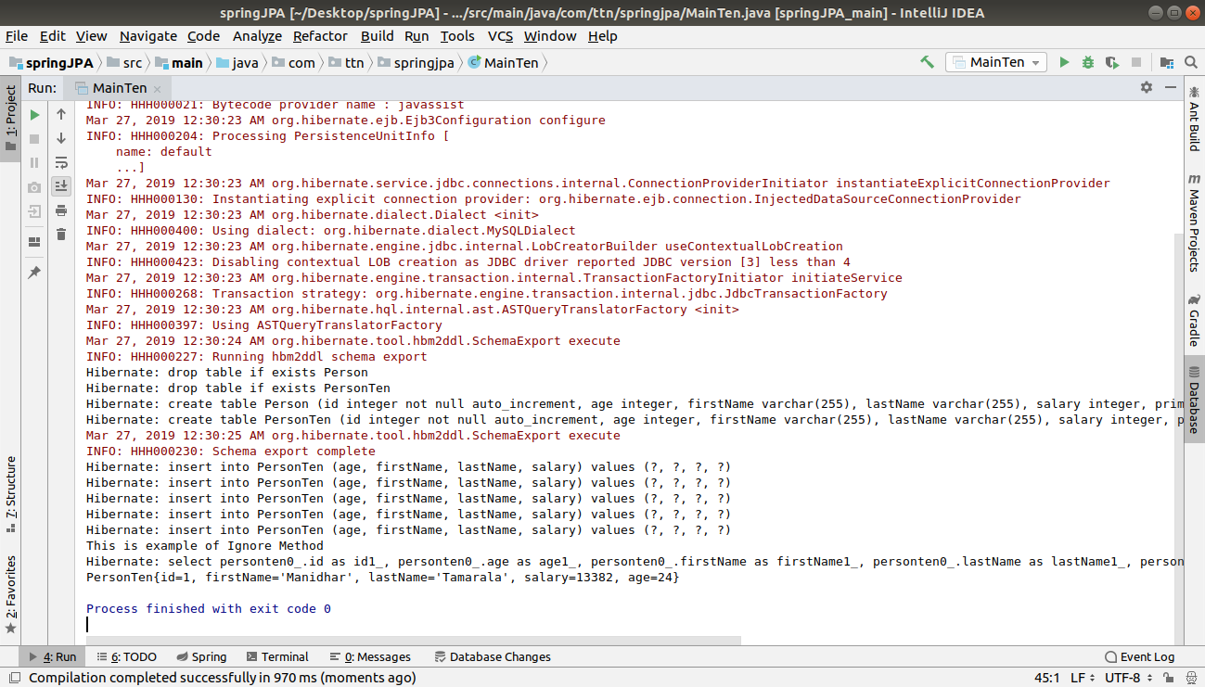
Q11.
Get the persons greater than age 25 and sort them in descending order according to id by method query.
A.
Main.java
System.out.println("This function print person greater than 25 and order by id in Descending order");
jpaServices.findByAgeGreaterThanAndOrderByIdDesc(25);

PersonRepository.java
// Question 11
List<Person> findByAgeGreaterThanOrderByIdDesc(Integer age);
PersonService.java
public void findByAgeGreaterThanAndOrderByIdDesc(Integer age){
List<Person> list=personRepository.findByAgeGreaterThanOrderByIdDesc(age);
Iterator<Person> iterator=list.iterator();
while (iterator.hasNext()){
System.out.println(iterator.next());
}
}

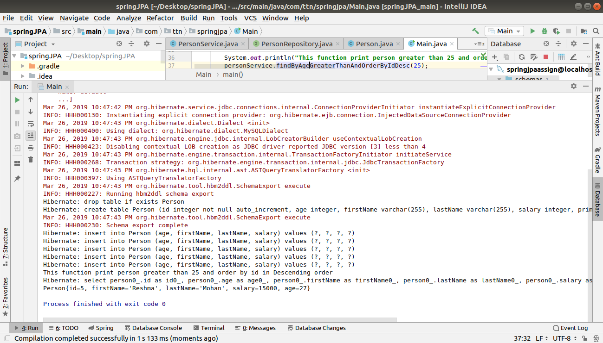

Q12.Do the question above using the Sort class.
A.
PERSONSERVICE.JAVA
package com.ttn.springjpa.service;
import com.ttn.springjpa.entity.Person;
import com.ttn.springjpa.repository.PersonRepository;
import org.springframework.beans.factory.annotation.Autowired;
import org.springframework.data.domain.Sort;
import org.springframework.stereotype.Service;
import java.util.Iterator;
import java.util.List;
@Service
public class PersonService {
@Autowired
PersonRepository personRepository;
Person person = new Person();
Person person1 = new Person();
Person person2 = new Person();
Person person3 = new Person();
Person person4 = new Person();
public void savePerson() {
person.setAge(24);
person.setFirstName("Manidhar");
person.setLastName("Tamarala");
person.setSalary(13382);
personRepository.save(person);
person1.setAge(25);
person1.setFirstName("Smriti");
person1.setLastName("Babbar");
person1.setSalary(13782);
personRepository.save(person1);
person2.setAge(29);
person2.setFirstName("Peter");
person2.setLastName("Parker");
person2.setSalary(14000);
personRepository.save(person2);
person3.setAge(25);
person3.setFirstName("Peter");
person3.setLastName("Roxy");
person3.setSalary(13922);
personRepository.save(person3);
person4.setAge(27);
person4.setFirstName("Reshma");
person4.setLastName("Mohan");
person4.setSalary(15000);
personRepository.save(person4);
}
//q3. find one method
public Person findOne() {
return personRepository.findOne(3);
}
// q3. exists method
public boolean exists() {
return personRepository.exists(5);
}
// q3 findall method
public Iterable<Person> findAll() {
return personRepository.findAll();
}
//Q3 Iterable<T> findAll(Iterable<ID> ids) METHOD
//
// public void findAll(){
// return personRepository.findAll(Iterable<Person> ids);
// }
// q3 long count() METHOD
public long count() {
return personRepository.count();
}
// q3. void delete(ID id) method
public void delete(int id) {
System.out.println("Deleting record of id " + id + "......");
personRepository.delete(id);
System.out.println("Deleted record of id " + id + "......");
}
//List<Person> firstnames=new ArrayList<Person>();
/*
public List<Person> findPersonByFirstname(int age) {
return personRepository.findPersonByFirstname(age);
}*/
public List<String> findPersonByFirstName(Integer age) {
return personRepository.findPersonByFirstname(age);
}
public void findPersonByFirstNameAndLastName(Integer age) {
List<Object[]> list = personRepository.findPersonByFirstNameAndLastName(age);
Iterator<Object[]> iterator = list.iterator();
while (iterator.hasNext()) {
Object[] objects = iterator.next();
System.out.println(objects[0] + " " + objects[1]);
}
}
public void allDataByAge(Integer age) {
List<Person> data = personRepository.allDataByAge(age);
Iterator<Person> iterator = data.iterator();
while (iterator.hasNext()) {
Person objects = iterator.next();
System.out.println(objects);
}
}
public Integer countByFirstName(String firstName) {
return personRepository.countByFirstName(firstName);
}
public void findByAgeGreaterThanAndOrderByIdDesc(Integer age){
List<Person> list=personRepository.findByAgeGreaterThanOrderByIdDesc(age);
Iterator<Person> iterator=list.iterator();
while (iterator.hasNext()){
System.out.println(iterator.next());
}
}
/*Question 12*/
public void findAll(Integer age, Sort sort){
List<Person> list=personRepository.findAll(age,sort);
Iterator<Person> iterator=list.iterator();
while (iterator.hasNext()){
System.out.println(iterator.next());
}
}
}
PersonRepository.java
/*Queston 12*/
@Query("select e from Person e where age>:age")
List<Person> findAll(@Param("age")Integer age , Sort sort);
Main.java
/*Question 12*/
System.out.println("This is through Sort Class");
personService.findAll(25, new Sort(Sort.Direction.DESC, "id"));

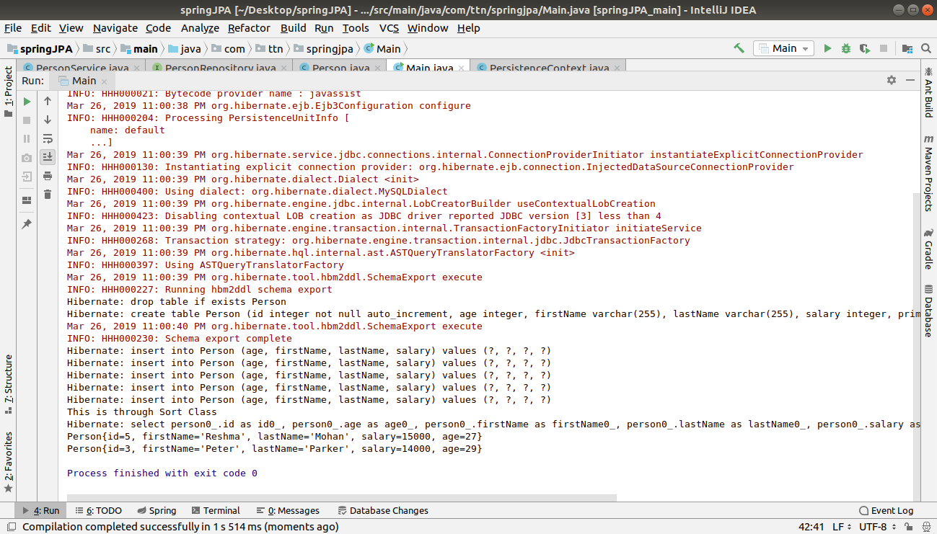
Q13.Apply Pagination on Person entities.
A.
Main.java
/*Question 13*/
System.out.println("This is of Pageable type");
personService.findAll(new PageRequest(2,3));
PersonSERVICE.JAVA
//Question 13
public void findAll(Pageable pageable){
Page<Person> page=personRepository.findAll(pageable);
System.out.println(page.getContent());
}
PERSONREPOSITORY.JAVA
Page<Person> findAll(Pageable pageable);



