My spring thymeleaf assignment

Q1.Create an external JS file and use it to show an alert on click of a button.

A.
BUILD.GRADLE
buildscript {
repositories {
mavenCentral()
}
dependencies {
classpath("org.springframework.boot:spring-boot-gradle-plugin:2.0.5.RELEASE")
}
}
plugins {
id 'org.springframework.boot' version '2.1.3.RELEASE'
id 'java'
}
apply plugin: 'io.spring.dependency-management'
group = 'com.ttn.springthymeleaf'
version = '0.0.1-SNAPSHOT'
sourceCompatibility = '1.8'
repositories {
mavenCentral()
}
dependencies {
implementation 'org.springframework.boot:spring-boot-starter-thymeleaf'
implementation 'org.springframework.boot:spring-boot-starter-web'
testImplementation 'org.springframework.boot:spring-boot-starter-test'
}
hello.html
<!DOCTYPE html>
<html xmlns:th="http://www.thymeleaf.org">
<head>
<meta charset="UTF-8">
<script th:src="@{'/javascripts/firstQ.js'}"></script>
<title>first Question</title>
</head>
<body>
<p>MY FIRST QUESTION</p>
<form>
<input type="button" value="click me" onclick="message()">
</form>
</body>
</html>

springthymeleafapplication.java

package com.ttn.springthymeleaf.springthymeleafA;
import org.springframework.boot.SpringApplication;
import org.springframework.boot.autoconfigure.SpringBootApplication;
@SpringBootApplication
public class SpringthymeleafAApplication {
public static void main(String[] args) {
SpringApplication.run(SpringthymeleafAApplication.class, args);
}
}
FirstQ.js

console.log("First Question is Running");
function message() {
alert("Welcome buddy !!!")
}
fIRSTCONTROLLER.JAVA
package com.ttn.springthymeleaf.springthymeleafA.controller;
import org.springframework.stereotype.Controller;
import org.springframework.web.bind.annotation.GetMapping;
import org.springframework.web.bind.annotation.RequestMapping;
@RequestMapping("/")
@Controller
public class FirstController {
@GetMapping("first")
public String sayhello(){
return "hello";
}
}
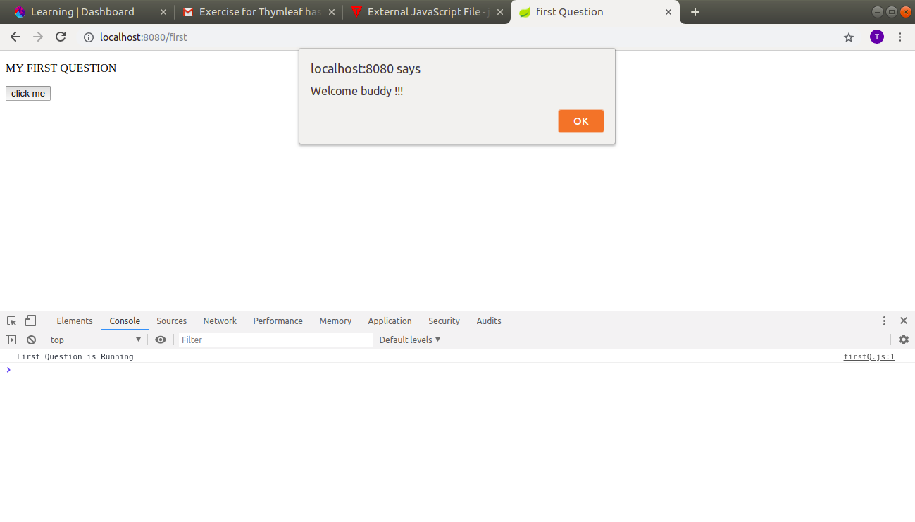

Q2.
Create an external CSS file and use it to modify hello world page background color to grey.
A.

HELLOWORLD.HTML

<!DOCTYPE html>
<html xmlns:th="http://www.thymeleaf.org">
<head>
<meta charset="UTF-8">
<link th:href="@{'/stylesheets/style2.css'}" rel="stylesheet"/>

<title>second Question</title>
</head>
<body>
<p>MY SECOND QUESTION</p>
</body>
</html>
STYLE2.CSS
body{
background-color: grey;
}
Firstcontroller.JAVA
@GetMapping("second")
public String helloWorld(){
return "helloworld";
}
}

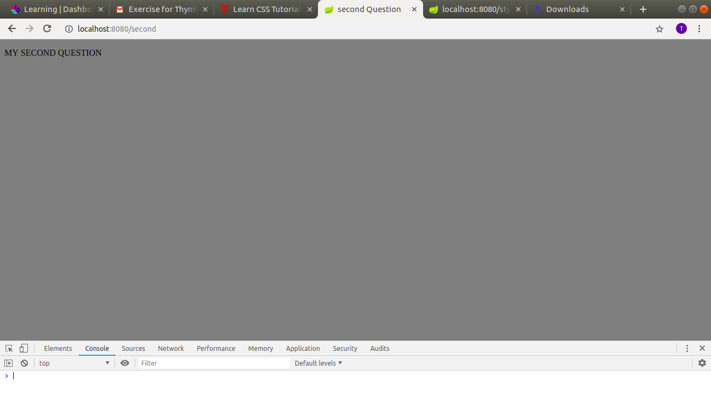
Q3.
Create an Employee registration form and bind it's requested values on the controller.
A.

Registration.html
<!DOCTYPE html>
<html xmlns:th="http://www.thymeleaf.org">
<head>
<meta charset="UTF-8">
<link th:href="@{'/stylesheets/style2.css'}" rel="stylesheet"/>
<title>third Question</title>
</head>
<body>
<p>MY THIRD QUESTION</p>
<form method="post">
<p>Username<input type="text" name="name"></p>
<p>Password<input type="password" name="password"></p>
<p>Competency<input type="text" name="competency"></p>
<p>Salary<input type="number" name="salary"></p>
<p>Mentor<input type="text" name="mentor"></p>
<br>
<button type="submit">Submit</button>
</form>
</body>
</html>

showemployee.html

<!DOCTYPE html><!DOCTYPE html>
<html lang="en" xmlns:th="http://www.w3.org/1999/xhtml">
<head>
<meta charset="UTF-8">
<title>third question</title>
</head>
<body>
<h5 th:text="${name}"></h5>
<h5 th:text="${password}"></h5>
<h5 th:text="${competency}"></h5>
<h5 th:text="${salary}"></h5>
<h5 th:text="${mentor}"></h5>
</body>
</html>

EmployeeController

package com.ttn.springthymeleaf.springthymeleafA.controller;
import org.springframework.stereotype.Controller;
import org.springframework.ui.Model;
import org.springframework.web.bind.annotation.RequestMapping;
import org.springframework.web.bind.annotation.RequestMethod;
import javax.servlet.http.HttpServletRequest;
@Controller
public class Employeecontroller {
/*Question 3*/
@RequestMapping(value = "/employee",method = RequestMethod.POST)
public String showRegisteredData(HttpServletRequest request, Model model){
String name=request.getParameter("name");
String password=request.getParameter("password");
String competency=request.getParameter("competency");
int salary=Integer.parseInt(request.getParameter("salary"));
String mentor=request.getParameter("mentor");
model.addAttribute("name",name);
model.addAttribute("password",password);
model.addAttribute("competency",competency);
model.addAttribute("salary",salary);
model.addAttribute("mentor",mentor);
return "showemployee";
}
@RequestMapping(value = "/employee",method = RequestMethod.GET)
public String sayHElloForm(){
return "registration";
}
}

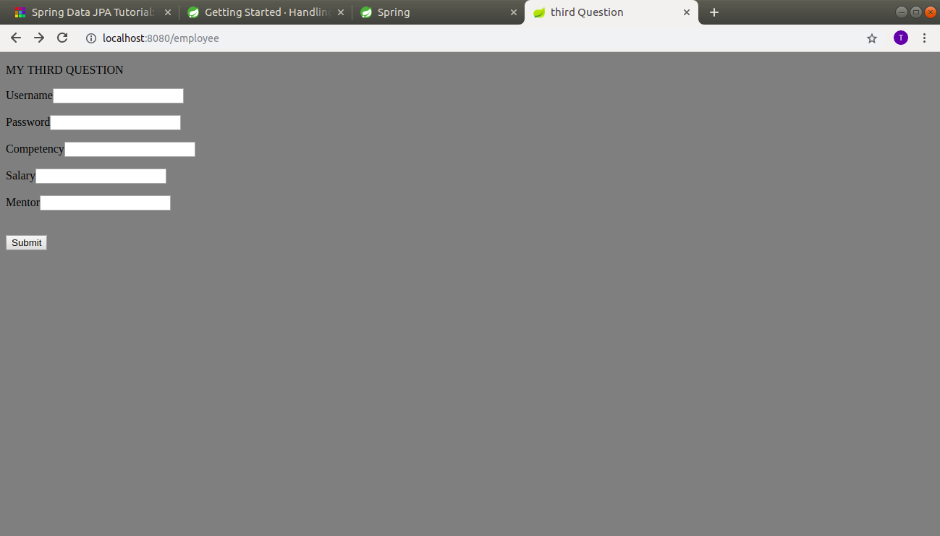

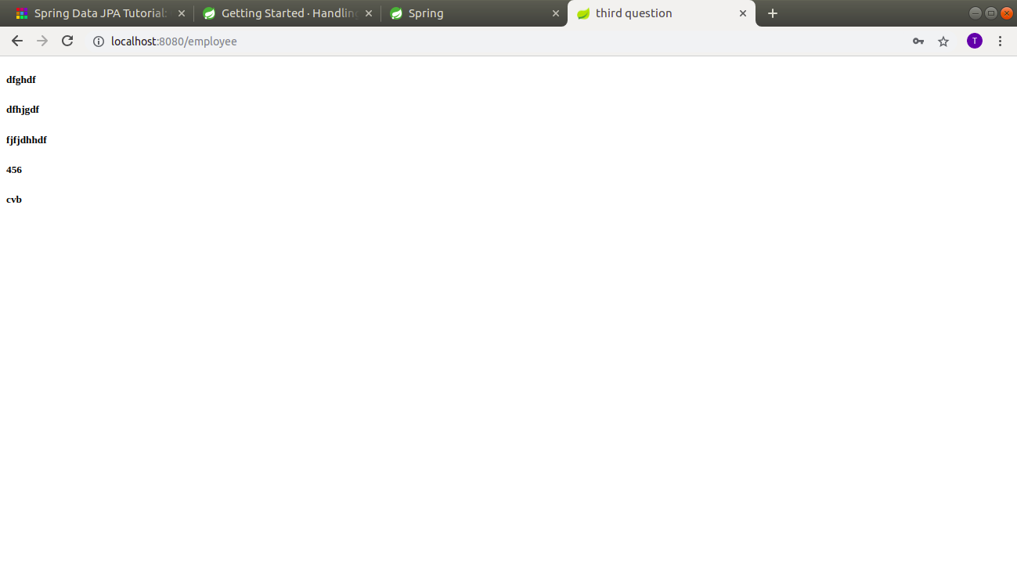

Q4.

Create a dynamic HTML page and render an Employee table with emp object return from the controller

A.
Emplyeecontroller.java
/*Question 4*/
@RequestMapping(value = "/employeefourth",method = RequestMethod.GET)
public String showEmployee(Model model){
List<EmployeeFour> employeeList= Arrays.asList(new EmployeeFour("manidhar","mani","JVM",12334,"PRATISH"),
new EmployeeFour("Vineet","Chaudary","ANDROID",45522,"richa"));
model.addAttribute("employeefour",employeeList);
return "showemployeefourth";
}

showemployeefourth.java
<!DOCTYPE html>
<html lang="en" xmlns:th="http://www.w3.org/1999/xhtml">
<head>
<meta charset="UTF-8">
<title>Fourth Question</title>
</head>
<body>
<table border="1px solid black ">
<tr>
<th>Name</th>
<th>Password</th>
<th>Competency</th>
<th>Salary</th>
<th>Mentor</th>
</tr>
<tr th:each="empl :${employeefour}">
<td th:text="${empl.name}"></td>
<td th:text="${empl.password}"></td>
<td th:text="${empl.competency}"></td>
<td th:text="${empl.salary}"></td>
<td th:text="${empl.mentor}"></td>
</tr>
</table>
</body>
</html>

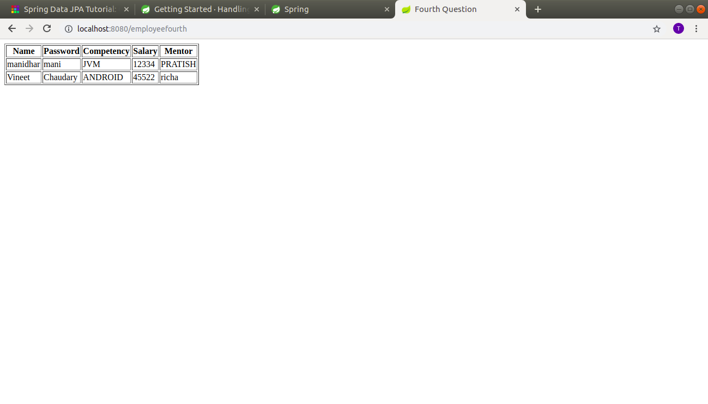
Q5.
Show different custom greeting message based on the type of user. For example, if the user is of type admin=true then show "Hello Admin" message on Page else show "Hello User" basis on isAdmin attribute value passed in model data.
A.
Employeecontroller.java

//Queston 5
@RequestMapping(value = "/checkAdmin" ,method = RequestMethod.POST)
public String isAdmin(HttpServletRequest request,Model model){
String value=request.getParameter("admin");
model.addAttribute("isAdmin",value);
return "checkadmin";
}
@RequestMapping(value = "/checkAdmin",method = RequestMethod.GET)
public String passAdminValue(){
return "formtocheckadmin";
}
formtocheckadmin.html
<!DOCTYPE html>
<html lang="en" xmlns:th="http://www.thymleaf.org">
<head>
<meta charset="UTF-8">
<title>Title</title>
</head>
<body>
<form method="post">
<input type="text" name="admin"><br/>
<input type="submit" value="submit">
</form>
</body>
</html>
checkadmin.html
<!DOCTYPE html>
<html lang="en" xmlns:th="http://www.thymleaf.org">
<head>
<meta charset="UTF-8">
<title>Title</title>
</head>
<body th:with="var=${isAdmin}">
<div th:if="${var=='admin'}">
Hello Admin
</div>
<div th:if="${var!='admin'}">
Hello User
</div>
</body>
</html>
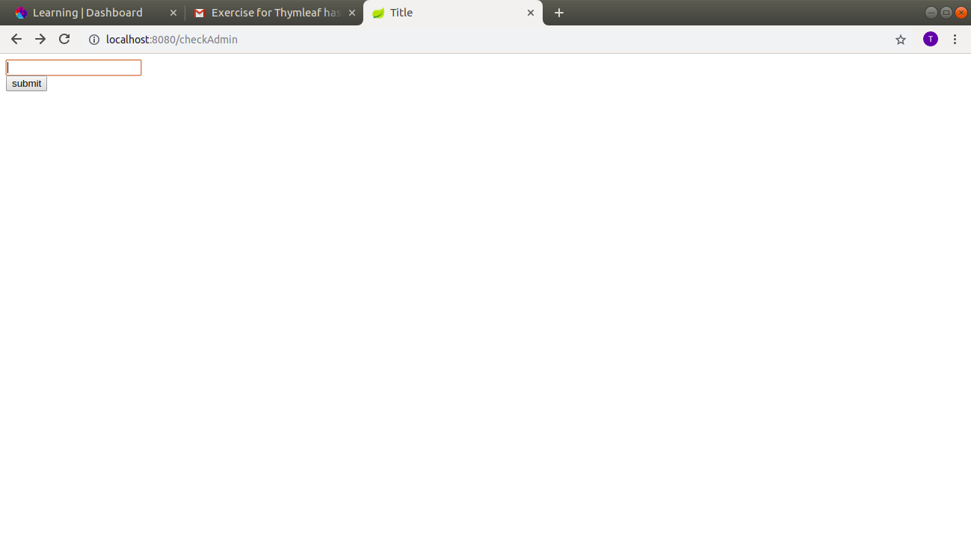
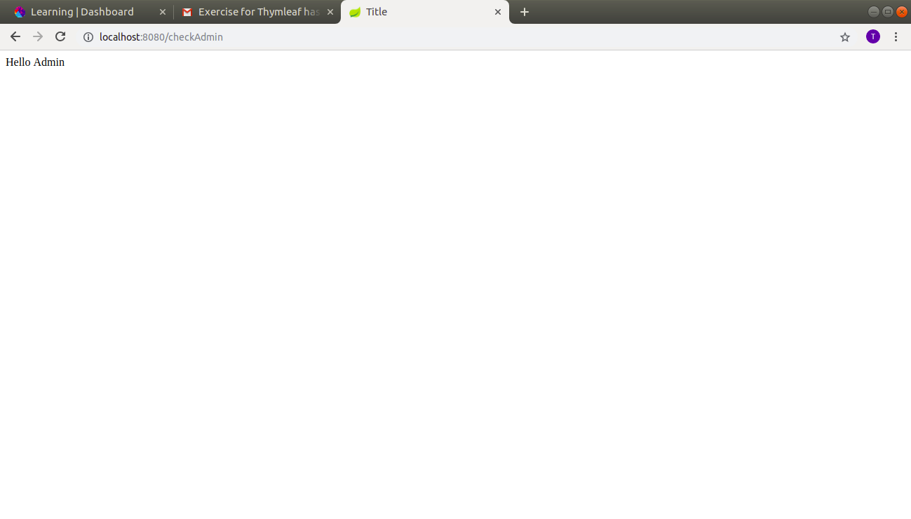

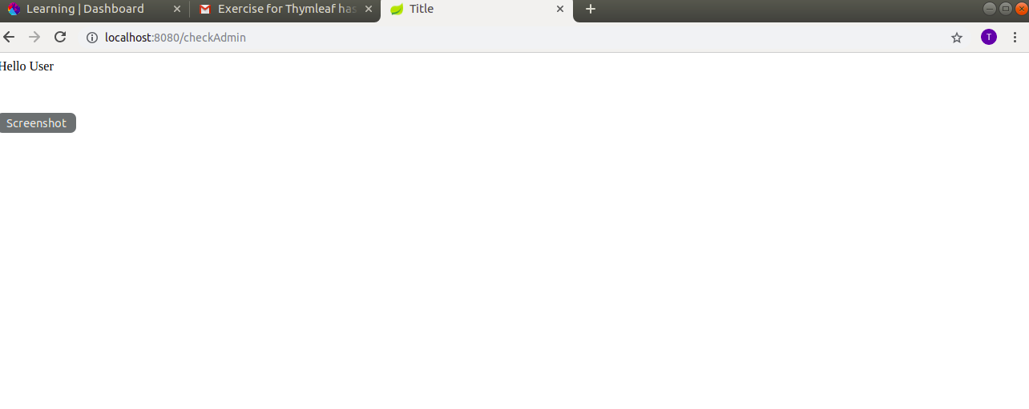

Q6.Create and split common header and footer in the above-created listing page.

A.
Firstcontroller.java

//QUESTION 6
@RequestMapping(value = "/headerandfooter" ,method = RequestMethod.GET)
public String headerAndFooter(){
return "footer";
}
headerandfooter.html
<!DOCTYPE html>
<html lang="en" xmlns:th="http://www.thymleaf.org">
<head>
<title>Header and footer</title>
</head>
<body>
<div th:fragment="header" class="header">
This is header
</div>
<div th:fragment="footer" class="footer">
copyright TO THE NEW: 2019
</div>
</body>
</html>
footer.html
<!DOCTYPE html>
<html lang="en" xmlns:th="http://www.thymleaf.org">
<body>
<div th:replace="headerandfooter :: header"></div>
<div th:replace="headerandfooter :: footer"></div>
</body>
</html>
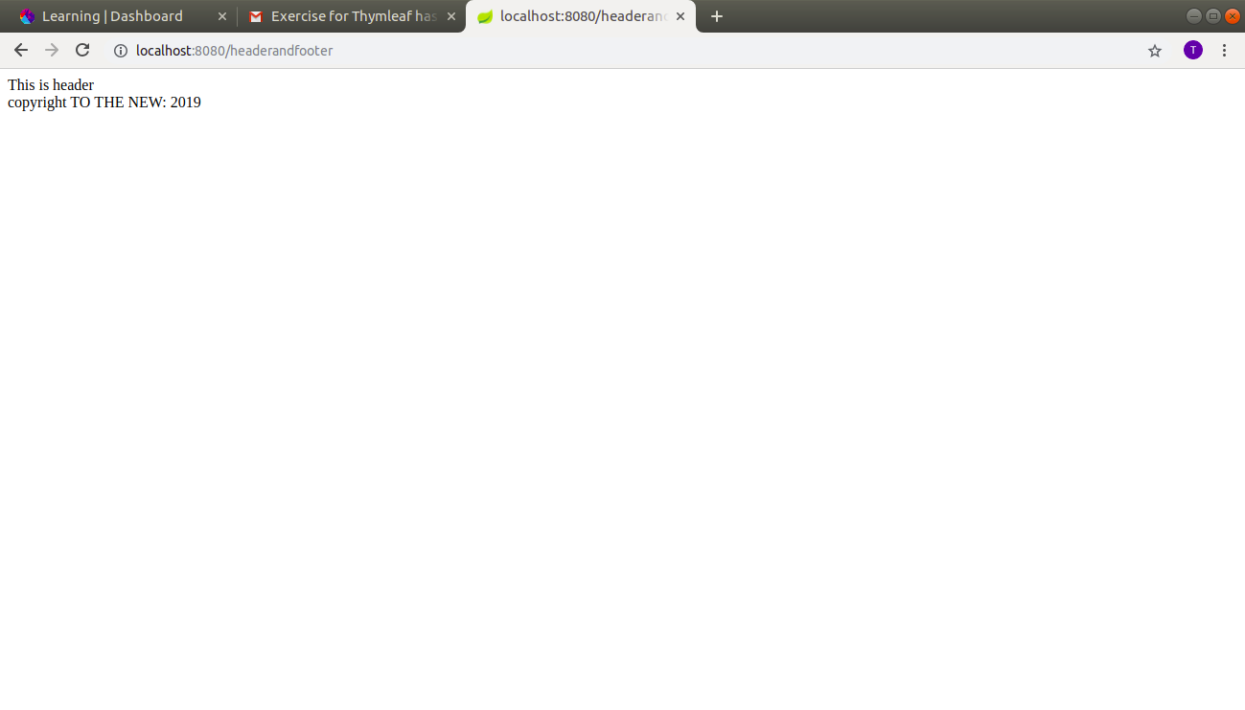

Q7.
Make a web page to show server time using ajax call.
A.
showtime.js
$(document).ready(function () {
var time = $.ajax({
url: "/getTime",
method: "GET"
});
time.done(function (data) {
$('#time').append(data)
});
time.fail(function (jqXHR, textStatus) {
console.log("Error in fetching time");
})
});
Firstcontroller.JAVA
//question 7
@RequestMapping(value = "/showtime")
public String showTime(){
return "ajaxtime";
}
@RequestMapping(value = "/getTime" ,method = RequestMethod.GET )
@ResponseBody
public String getTime(){
return new Date().toLocaleString();
}

AJAXTIME.HTML
<!DOCTYPE html>
<html lang="en" xmlns:th="http://www.thymleaf.org">
<head>
<meta charset="UTF-8">
<title>AJax</title>
<script
src="https://code.jquery.com/jquery-3.3.1.min.js"
integrity="sha256-FgpCb/KJQlLNfOu91ta32o/NMZxltwRo8QtmkMRdAu8="
crossorigin="anonymous"></script>
<script th:src="@{'/js/showtime.js'}"></script>
</head>
<body>
<p id="time"></p>
</body>
</html>
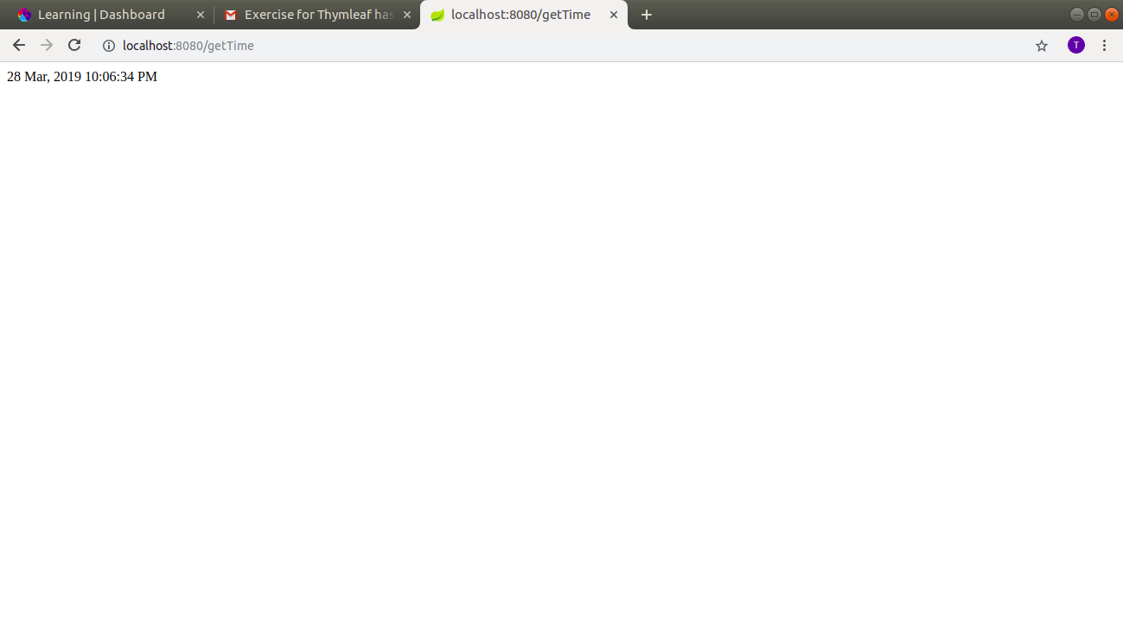
Q8.
Create a user listing table show alternate row color using a conditional tag.
A.

firstcontroller.java
/*Question 8*/
@RequestMapping(value = "/condition" ,method = RequestMethod.GET)
public String conditionalTag(){
return "conditionalEight";
}

conditionalEight.html

!DOCTYPE html>
<html lang="en" xmlns:th="http://www.w3.org/1999/xhtml">
<head>
<meta charset="UTF-8">
<title>Conditional Tag</title>
</head>
<body th:with="var=${({1,2,3,4,5,6,7,8,9,10})}">
<table>
<tr th:each="prod, iterStat : ${var}" class="row" th:classappend="${iterStat.odd}? 'odd':'even'">
<td th:text="${prod}">.</td>
</tr>
</table>
<link rel="stylesheet" th:href="@{/stylesheets/style1.css}">
</body>
</html>

style1.css
tr.row.odd{
background-color: yellow;
}

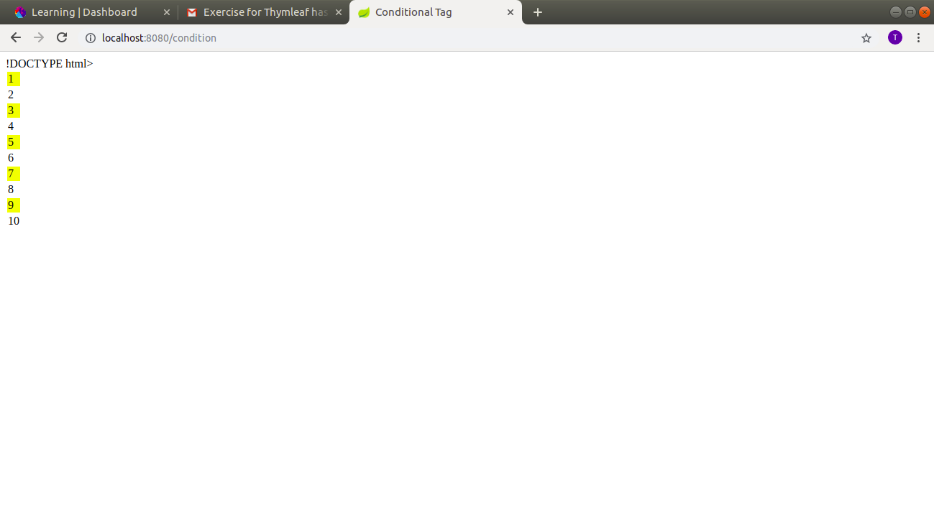

Q9.
Create an ENUM with values USER, ADMIN, SUPER_ADMIN and iterate it to show a custom message to users basis on the ENUM value
A.
Firstcontroller.java

// Question 9
@RequestMapping(value = "/showEnums", method = RequestMethod.GET)
public String showEnums() {
return "getEnum";
}
getEnum.html

<!DOCTYPE html>
<html lang="en" xmlns:th="http://www.w3.org/1999/xhtml">
<head>
<meta charset="UTF-8">
<title>Enum</title>
</head>
<body>
<label>Users</label>
<select>
<option th:value="None">Select One</option>
<option th:each="users:${T(com.ttn.springthymeleaf.springthymeleafA.enums.Users).values()}"
th:value="${users.getValue()}" th:text="${users.getValue()}"></option>
</select>
</body>
</html>
Users.java
package com.ttn.springthymeleaf.springthymeleafA.enums;
public enum Users {
User("This is user"),
Admin("This is admin"),
Super_Admin("This is super admin");
String value;
Users(String users){
value=users;
}
public String getValue(){
return value;
}
}
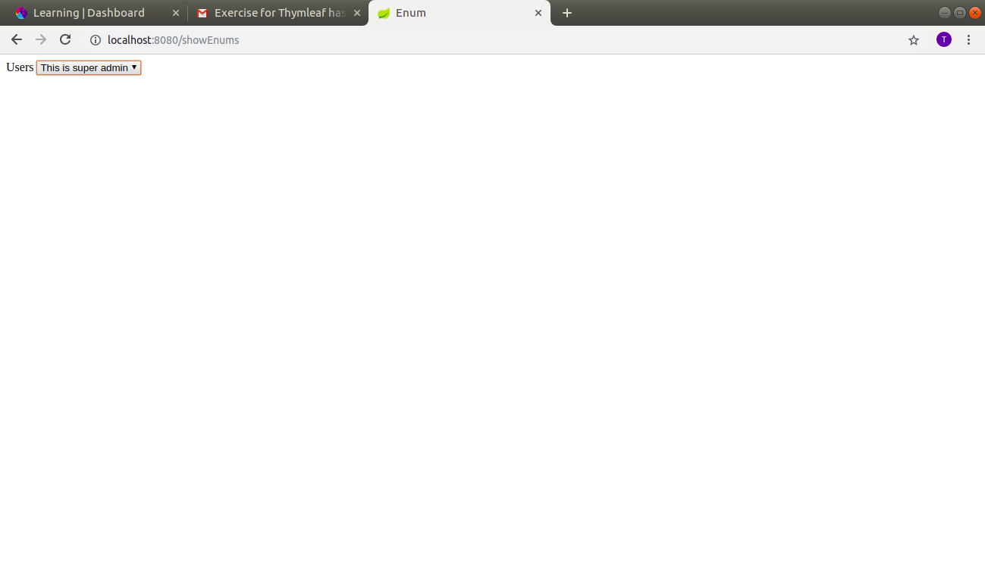
Q10.
Add loader in registration form submission which renders load till server return success form submission response.
A.
FIRSTCONTROLLER.JAVA
//Question 10
@RequestMapping(value = "/showLoader")
public String showLoader(){
return "registrationTen";
}
@PostMapping("/registrationSubmit")
@ResponseBody
public String registerEmployee(@ModelAttribute EmployeeTen employeeTen)
{
try {
Thread.sleep(2000);
} catch (InterruptedException e) {
e.printStackTrace();
}
return "Registered: "+employeeTen.getName()+"\n" +employeeTen.getAge();
}
Employeeten.JAVA

package com.ttn.springthymeleaf.springthymeleafA.QuestionTen;
public class EmployeeTen {
private String name;
private Integer age;
public EmployeeTen(String name, Integer age) {
this.name = name;
this.age = age;
}
public String getName() {
return name;
}
public void setName(String name) {
this.name = name;
}
public Integer getAge() {
return age;
}
public void setAge(Integer age) {
this.age = age;
}
}
SHOWLOADER.JS
function showImage(formData)
{
var res= $.ajax({
method: "POST",
url: "/registrationSubmit",
data: formData,
success: function (data) {
console.log(data)
$("#LoadingImage").hide();
$("#response").append("Response "+data);
console.log("Successful Registration");
},
error: function (xhr, status) {
$("#LoadingImage").hide();
alert('Unknown error ' + status);
}
});
}
REGISTRATIONTEN.JAVA
<!DOCTYPE html>
<html lang="en" xmlns:th="http://www.thymeleaf.org">
<head>
<meta charset="UTF-8">
<script
src="https://code.jquery.com/jquery-3.3.1.min.js"
integrity="sha256-FgpCb/KJQlLNfOu91ta32o/NMZxltwRo8QtmkMRdAu8="
crossorigin="anonymous"></script>
<title>Employee Registration Form</title>
<script th:src="@{/javascripts/showLoader.js}"></script>
<script type="text/javascript">
$(function(){
$("#LoadingImage").hide();
$("#employeeRegistrationForm").on('submit',function(){
var data=$("#employeeRegistrationForm").serialize();
showImage(data);
return false;
})
$(document).ajaxStart(function () {
$("#LoadingImage").show();
})
})
</script>
</head>
<body>
<form id="employeeRegistrationForm" method="post">
Name :<input type="text" id="name" name="name">
Age :<input type="text" id="age" name="age">
<input type="submit" value="Submit">
</form>
<p id="response"></p>
<div id="LoadingImage">
<img src="images/loader.gif"/>
</div>
</body>
</html>
