Table of Contents
Introduction 2
Block Diagram 3
Interface Specifications 4
State machine 5
Sequence Diagram 6
Threat model 7

Introduction
The Universal Asynchronous Receiver/Transmitter (UART) is a widely used serial communication protocol that enables data exchange between two hardware devices. It operates in full-duplex mode, meaning transmission and reception can occur simultaneously.
A typical UART interface requires three connections:
- Tx (Transmit) – sends data from the transmitting device.
- Rx (Receive) – receives data at the receiving device.
- GND (Ground) – provides a common electrical reference.
The transmission rate is defined by the baud rate, which specifies the number of signal changes (symbols) per second. The unit of baud rate is baud. In UART, each symbol typically represents one bit, so the baud rate and bit rate are often equal.
Unlike synchronous protocols such as I²C or SPI, UART is asynchronous — it does not use a clock line. Instead, both devices agree on a baud rate beforehand, and data frames are structured with start bits, data bits, optional parity bits, and stop bits to ensure proper synchronization and error detection.

Block Diagram
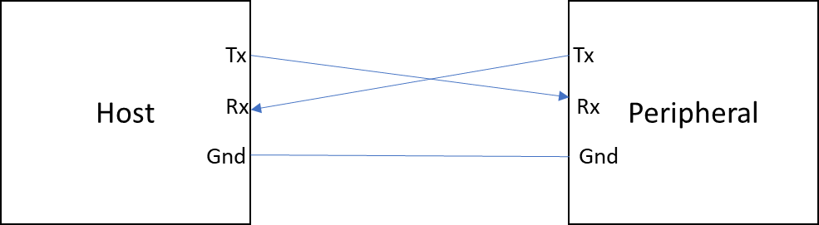
Figure 1: Basic UART wiring for full-duplex communication

The above diagram illustrates the basic UART interface connection between two devices — a Host (e.g., microcontroller or PC) and a Peripheral (e.g., sensor, module, or another MCU).
- Tx (Transmit) of the Host is connected to Rx (Receive) of the Peripheral.
  - This line carries data transmitted from the Host to the Peripheral.
- Rx (Receive) of the Host is connected to Tx (Transmit) of the Peripheral.
  - This line carries data transmitted from the Peripheral back to the Host.
- GND (Ground) of both devices is connected together.
  - This ensures a common electrical reference for reliable signal integrity.
The cross-connection of Tx and Rx enables full-duplex communication, allowing both devices to transmit and receive simultaneously.
UART communication is asynchronous, meaning no clock signal is shared between devices. Both ends must be configured with the same baud rate, data bits, parity, and stop bits to ensure proper synchronization.

Interface Specifications
Specifications of STM32 for CAN protocol is as follows:
The STM32F407G Discovery board provides multiple USART (USART1, USART2, USART3 and USART6) and UART (UART4 and UART5) peripherals. For this implementation, the USART peripheral configured in asynchronous mode is used to achieve UART communication, ensuring compatibility with standard serial interfaces while retaining flexibility for synchronous operation if required. The USART1 and USART6 interfaces are able to communicate at speeds of up to 10.5 Mbit/s. The other available interfaces communicate at up to 5.25 Mbit/s.
- In this we will use USART2. PA2: USART2_TX and PA3: USART2_RX
- Setting clock: set APB1 to 42MHz.
- Set baud rate:
- The UART stack provides two primary functions:
  - uint8_t uart_transmit(uint16_t *tx_buffer, uint8_t length);
  - uint8_t uart_receive(uint16_t *rx_buffer, uint8_t length);
  - These functions enable buffered transmission and reception of data. The return value indicates the status of the operation (success, error, or busy). Internally, the implementation is using polling.

State machine
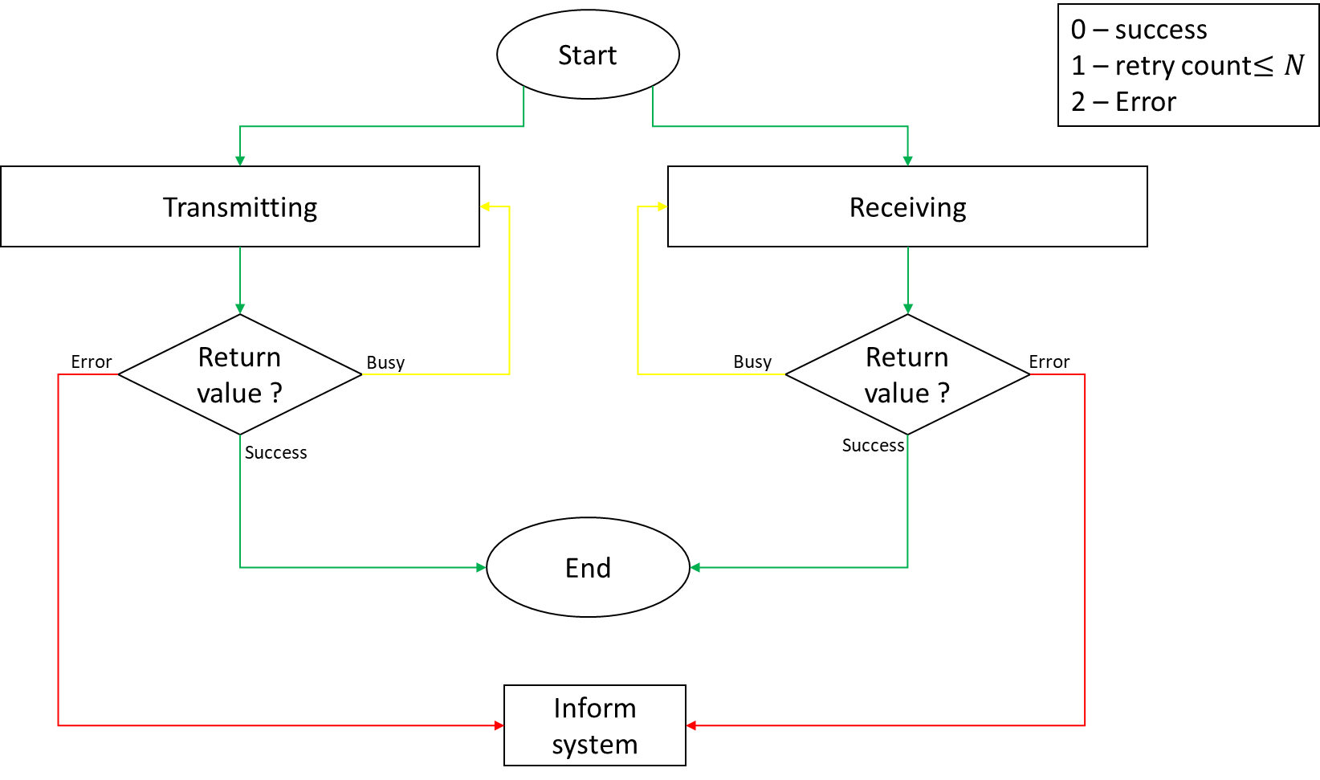
Figure 2: state machine for project

Sequence Diagram

Threat model

