|  |  |
| --- | --- |
| **Ex.No. :** 07  **Date :** 18-04-24 | **ACCESSING STUDENT MARKLIST DATABASE USING SERVLET** |

**AIM :**

To Implement Concept of Accessing Student Marklist Database using Servlet.

**PROGRAM :**

**HTML CODE :**

<!DOCTYPE html>

<html lang="en">

<head>

<meta charset="UTF-8">

<meta name="viewport" content="width=device-width, initial-scale=1.0">

<title>Document</title>

<style>

*{

padding: 0px;

margin: 0px;

}

.header{

border-top: 6px solid rgb(20, 21, 21);

border-bottom: 4px solid rgb(10, 214, 241);

font-family: "Gill sans",sans-serif;

font-size: 25px;

}

#logo,img{

margin-left: 100px;

}

#head,h2{

margin-top: -6%;

}

.fmbody{

margin-top: 1%;

width: 30%;

height: 250px;

background-color: rgb(12, 163, 171);

box-shadow: 10px 10px 15px 0px rgba(0, 0, 0, 0.5);

}

.fmbody {

display: flex;

flex-direction: column;

align-items: center;

}

.input-container {

display: flex;

gap: 20px;

}

label{

font-size: 25px;

padding-top: 10px;

color: white;

}

input

{

background-color: rgb(221, 237, 237);

height: 50px;

}

input:hover{

border-radius: 8px;

}

input:active{

color: rgb(236, 239, 244);

background-color: rgb(6, 212, 20);

}

#sub{

width: 20%;

}

</style>

</head>

<body>

<form action="exp5" method="post">

<div class="header">

<img src="annalogo.png" alt="" width="6%" height="10%" id="logo">

<center><p id="head"><b>Anna University, Chennai</b><br>Office of the Controller of Examinations<br>Pre-Examination Monitoring Systems</p></center>

</div>

<center>

<div class="fmbody">

<h1>STUDENT LOGIN</h1><br>

<label for="">Register Number</label>

<input type="text" name="rollno"><br>

<label for="">Date-of-Birth</label>

<input type="date" name="dob"><br>

<input type="submit" value="Login" id="sub">

</div>

</center>

</form>

</body>

</html>

**JAVA CODE :**

import jakarta.servlet.ServletException;

import jakarta.servlet.http.HttpServlet;

import jakarta.servlet.http.HttpServletRequest;

import jakarta.servlet.http.HttpServletResponse;

import java.io.IOException;

import java.io.PrintWriter;

import java.sql.*;

public class exp5 extends HttpServlet {

public void doPost(HttpServletRequest request, HttpServletResponse response) throws ServletException, IOException {

response.setContentType("text/html");

PrintWriter out = response.getWriter();

String rollno = request.getParameter("rollno");

try {

Class.forName("com.mysql.cj.jdbc.Driver");

Connection conn = DriverManager.getConnection("jdbc:mysql://localhost/mysql1", "root", "");

PreparedStatement stmt = conn.prepareStatement("SELECT * FROM studentdetails WHERE REGISTER_NUMBER=?");

stmt.setString(1, rollno);

ResultSet rs = stmt.executeQuery();

if (rs.next()) {

out.println("<style>");

out.println("table { font-size: 30px; border-collapse: collapse; background-color: rgb(119, 201, 189); box-shadow: 10px 10px 15px 0px rgba(0, 0, 0, 0.5); }");

out.println("th { background-color: rgb(9, 86, 59); color: white; }");

out.println("body { background-color: rgb(181, 229, 248); }");

out.println("#false { font-size:60px; }");

out.println("</style>");

out.println("<center>");

out.println("<table border=\"1\" width=\"1000px\">");

out.println("<tr><td colspan=\"5\">REGISTER NUMBER: " + rs.getString("REGISTER_NUMBER") + "<br>Name: " + rs.getString("Name") + "<br>BRANCH: B.E COMPUTER SCIENCE AND ENGINEERING</td></tr>");

out.println("<tr><th>Semester</th><th>Subject Code</th><th>Subject</th><th>Grade</th><th>Result</th></tr>");

String semester = rs.getString("SEMESTER");

out.println("<tr><td>" + semester + "</td><td>CCS375</td><td>WEB TECHNOLOGIES</td><td>" + rs.getString("CCS375_WEB_TECHNOLOGIES") + "</td><td>" + rs.getString("RESULT") + "</td></tr>");

out.println("<tr><td>" + semester + "</td><td>CCS358</td><td>PPL</td><td>" + rs.getString("CCS358_PPL") + "</td><td>" + rs.getString("RESULT") + "</td></tr>");

out.println("<tr><td>" + semester + "</td><td>CS3691</td><td>ESIOT</td><td>" + rs.getString("CS3691_ESIOT") + "</td><td>" + rs.getString("RESULT") + "</td></tr>");

out.println("<tr><td>" + semester + "</td><td>CCS341</td><td>DW</td><td>" + rs.getString("CCS341_DW") + "</td><td>" + rs.getString("RESULT") + "</td></tr>");

out.println("<tr><td>" + semester + "</td><td>CCS364</td><td>SC</td><td>" + rs.getString("CCS364_SC") + "</td><td>" + rs.getString("RESULT") + "</td></tr>");

out.println("<tr><td>" + semester + "</td><td>CCS356</td><td>OOSE</td><td>" + rs.getString("CCS356_OOSE") + "</td><td>" + rs.getString("RESULT") + "</td></tr>");

out.println("</table>");

out.println("</center>");

} else {

out.println("<center>");

out.println("<marquee id=\"false\" scrollamount=\"20\" style=\"font-size:40px\">NO RECORDS FOUND FOR REGISTER NUMBER " + rollno + "</marquee>");

out.println("</center>");

}

} catch (SQLException | ClassNotFoundException e) {

} }}

**WEB.XML CODE:**

<web-app>

<servlet>

<servlet-name>exp5</servlet-name>

<servlet-class> exp5</servlet-class>

</servlet>

<servlet-mapping>

<servlet-name> exp5</servlet-name>

<url-pattern>/ exp5 </url-pattern>

</servlet-mapping>

</web-app>

**OUTPUT :**

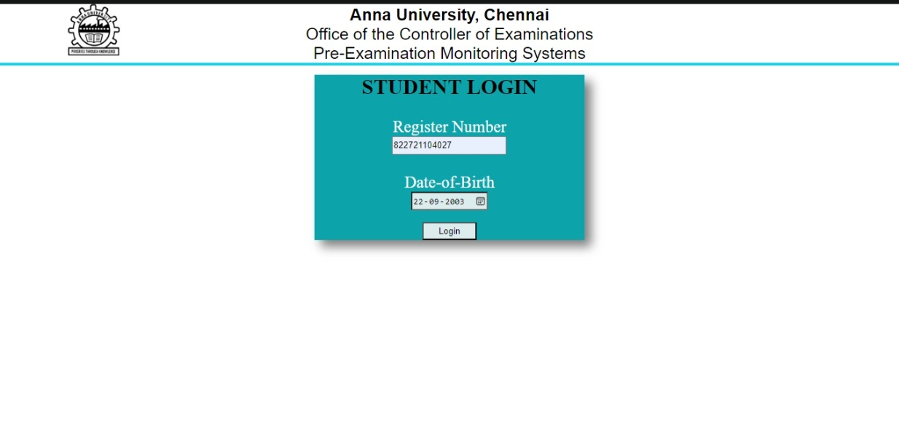

**INSERTED DATA IN DATABASE :**

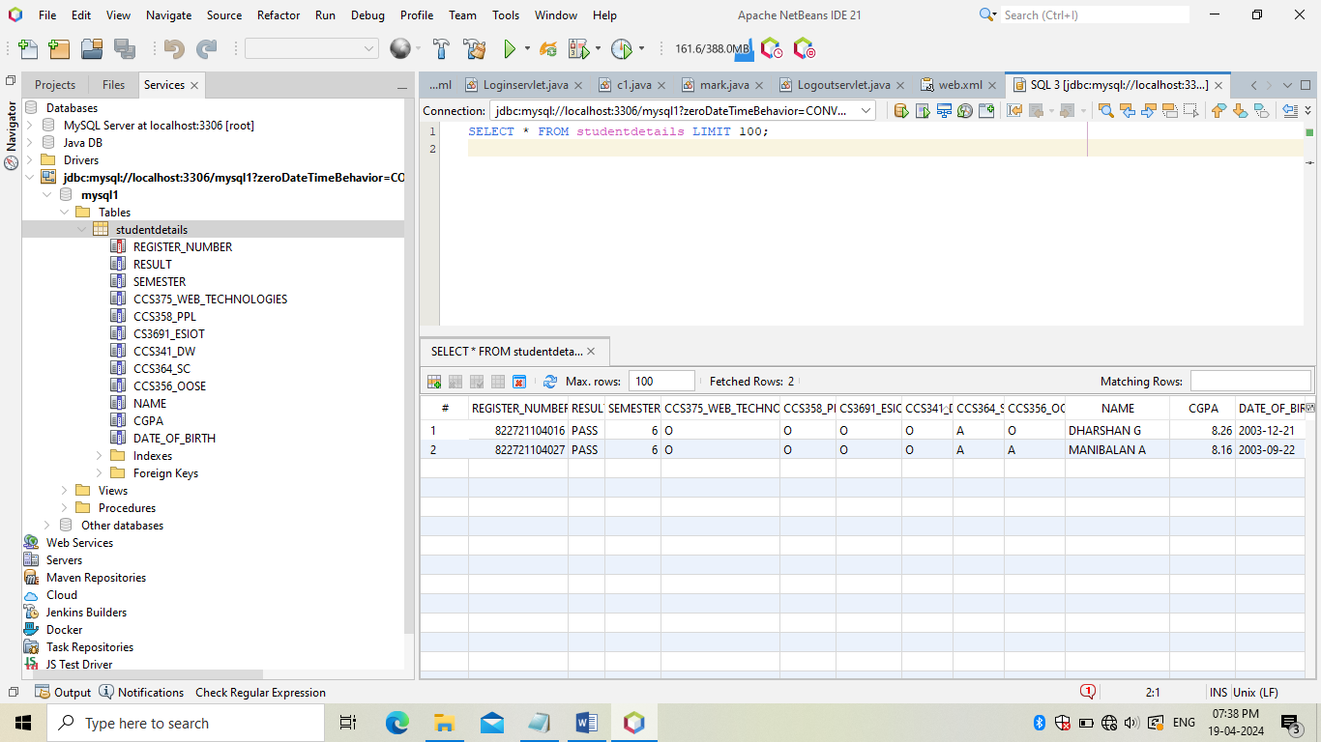

**SERVER RESPONSE :**

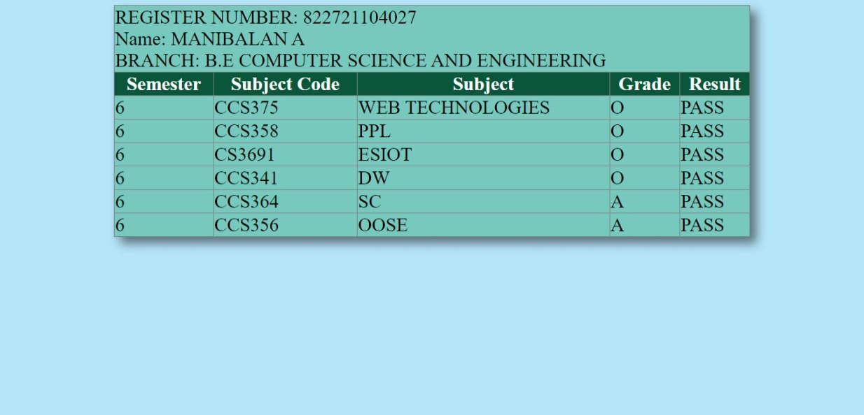

**RESULT :**

Thus, the Implementation of Concept of Accessing Student Marklist Database using Servlet is Executed and Verified Successfully.