|  |  |
| --- | --- |
| **Ex.No. :** 05  **Date :** 18-04-24 | **SESSION TRACKING USING SERVLETS** |

**AIM :**

To Implement Concept of Session Tracking using Servlets.

**PROGRAM :**

**HTML CODE :**

<!DOCTYPE html>

<html lang="en">

<head>

<meta charset="UTF-8">

<meta name="viewport" content="width=device-width, initial-scale=1.0">

<title>Document</title>

<style>

*{ margin: 0px; padding: 0px; }

.header{

border-top: 6px solid rgb(20, 21, 21); border-bottom: 4px solid rgb(10, 214, 241);

font-family: "Gill sans",sans-serif; font-size: 25px; }

#logo,img{ margin-left: 100px; }

#head,h2{ margin-top: -6%; }

.fmbody{ margin-top: 1%; width: 30%; height: 250px;

background-color: rgb(12, 163, 171);

box-shadow: 10px 10px rgba(0, 0, 0, 0.5); }

.fmbody { display: flex; flex-direction: column;align-items: center; }

.input-container { display: flex; gap: 20px; }

label{ font-size: 25px; padding-top: 10px; color: white; }

input { background-color: rgb(221, 237, 237); height: 50px; }

input:hover{ border-radius: 8px; }

input:active{ color: rgb(236, 239, 244); background-color: rgb(6, 212, 20); }

#sub{ width: 20%; }

</style>

</head>

<body>

<form action="Loginservlet" method="post">

<div class="header">

<img src="annalogo.png" alt="" width="6%" height="10%" id="logo">

<center><p id="head"><b>Anna University, Chennai</b><br>Office of the Controller of Examinations<br>Pre-Examination Monitoring Systems</p></center>

</div>

<center>

<div class="fmbody">

<h1>STUDENT LOGIN</h1><br>

<label for="">Register Number</label>

<input type="text" name="rollno"><br>

<input type="submit" value="Login" id="sub">

</div>

</center>

</body>

</html>

**JAVA CODE 1 :**

import jakarta.servlet.RequestDispatcher;

import jakarta.servlet.ServletException;

import jakarta.servlet.http.HttpServlet;

import jakarta.servlet.http.HttpServletRequest;

import jakarta.servlet.http.HttpServletResponse;

import jakarta.servlet.http.HttpSession;

import java.io.IOException;

import java.io.PrintWriter;

public class Loginservlet extends HttpServlet {

protected void doPost(HttpServletRequest request,

HttpServletResponse response)

throws ServletException, IOException {

response.setContentType("text/html");

PrintWriter out = response.getWriter();

String userName = request.getParameter("rollno").trim();

if (userName == null || userName.equals("")) {

out.print("Please enter rollno <br><br>");

RequestDispatcher requestDispatcher

= request.getRequestDispatcher("index.html");

requestDispatcher.include(request, response);

} else {

HttpSession session = request.getSession();

String id = session.getId();

if (session.isNew()) {

session.setAttribute("rollno", userName);

out.println("<style>");

out.println("");

out.println("");

out.println("body { background-color: rgb(181, 229, 248); }");

out.println("#false { font-size:60px; }"

+ " #a1{\n"

+ " border: 2px solid black;\n"

+ " text-decoration: none;\n"

+ " background-color: red;\n"

+ " color: white;\n"

+ " box-shadow: 3px 3px;\n"

+ " padding: 5px 5px 5px 5px;\n"

+ ";margin-left:400px; } p{\n"

+ "font-size: 40px ;text-shadow: 1px 8px rgb(51, 226, 188);\n"

+ " }");

out.println("</style>");

out.println("<a href=\"javascript:history.back()\">"

+ "back </a>");

out.println("<p> WELCOME </p><br>" + userName);

out.println("<a id=\"a1\" href=\"Logoutservlet\">"

+ "Log Out </a>");

out.println("<p>Click the button to view Mark.</p><br>");

out.println("<a id=\"a1\" href=\"mark\">"

+ "View Mark</a><br>");

out.print("<p>MY SESSION ID:</P>" + session.getId());

} else {

session.setAttribute("reg NO", userName);

session.setAttribute("session id", id);

response.sendRedirect(request.getContextPath() + "/c1");

}

}

out.close();

}

}

**JAVA CODE 2 :**

import jakarta.servlet.RequestDispatcher;

import jakarta.servlet.ServletException;

import jakarta.servlet.http.HttpServlet;

import jakarta.servlet.http.HttpServletRequest;

import jakarta.servlet.http.HttpServletResponse;

import jakarta.servlet.http.HttpSession;

import java.io.IOException;

import java.io.PrintWriter;

import javax.lang.model.SourceVersion;

public class c1 extends HttpServlet {

protected void doGet(HttpServletRequest request,

HttpServletResponse response)

throws ServletException, IOException {

response.setContentType("text/html");

PrintWriter out = response.getWriter();

HttpSession session = request.getSession();

String rollno = (String) session.getAttribute("userName");

out.println("<style>");

out.println("");

out.println("");

out.println("body { background-color: rgb(181, 229, 248); }");

out.println("#false { font-size:60px; }"

+ " #a1{\n"

+ " border: 2px solid black;\n"

+ " text-decoration: none;\n"

+ " background-color: red;\n"

+ " color: white;\n"

+ " box-shadow: 3px 3px;\n"

+ " padding: 5px 5px 5px 5px; float:right;\n"

+ " margin-left:400px; } p{\n"

+ " font-size: 40px ;text-shadow: 1px 8px rgb(51, 226, 188);\n"

+ " }");

out.println("</style>");

String id = (String) session.getAttribute("rollno");

out.println("<a href=\"javascript:history.back()\">"

+ "back </a>");

out.println("<p> <marquee>welcome BACK this Session</marquee></p><br>");

out.println("<a id=\"a1\" href=\"Logoutservlet\">"

+ "Log Out </a>");

out.println("<p>Click the button to view Mark.</p><br>");

out.println("<a id=\"a1\" href=\"mark\">"

+ "View Mark</a><br>");

out.print("<p>MY SESSION ID:</P>" + session.getId());

out.close();

}

}

**JAVA CODE 3 :**

import jakarta.servlet.ServletException;

import jakarta.servlet.http.HttpServlet;

import jakarta.servlet.http.HttpServletRequest;

import jakarta.servlet.http.HttpServletResponse;

import jakarta.servlet.http.HttpSession;

import java.io.IOException;

import java.io.PrintWriter;

import java.sql.Connection;

import java.sql.DriverManager;

import java.sql.PreparedStatement;

import java.sql.ResultSet;

import java.sql.SQLException;

public class mark extends HttpServlet {

@Override

public void doGet(HttpServletRequest request, HttpServletResponse response) throws ServletException, IOException {

response.setContentType("text/html");

PrintWriter out = response.getWriter();

String rollno = request.getParameter("rollno");

try {

HttpSession session = request.getSession(false);

String userName = (String) session.getAttribute("rollno");

out.println("Roll NO: " + userName + "");

out.println("<a id=\"a1\" href=\"Logoutservlet\">"

+ "Log Out </a>");

out.println("<a href=\"javascript:history.back()\">"

+ "back </a>");

Class.forName("com.mysql.cj.jdbc.Driver");

Connection conn = DriverManager.getConnection("jdbc:mysql://localhost/mysql1", "root", "");

PreparedStatement stmt = conn.prepareStatement("SELECT * FROM studentdetails WHERE REGISTER_NUMBER=?");

stmt.setString(1, userName);

ResultSet rs = stmt.executeQuery();

if (rs.next()) {

out.println("<style>");

out.println("table { font-size: 30px; border-collapse: collapse; background-color: rgb(119, 201, 189); box-shadow: 10px 10px 15px 0px rgba(0, 0, 0, 0.5); }");

out.println("th { background-color: rgb(9, 86, 59); color: white; }");

out.println("body { background-color: rgb(181, 229, 248); }");

out.println("""

#false { font-size:60px; } #a1{

border: 2px solid black;

text-decoration: none;

background-color: red;

color: white;

box-shadow: 3px 3px;

padding: 5px 5px 5px 5px;

float:right; }""");

out.println("</style>");

out.println("<center>");

out.println("<table border=\"1\" width=\"1000px\">");

out.println("<tr><td colspan=\"5\">REGISTER NUMBER: " + rs.getString("REGISTER_NUMBER") + "<br>Name: " + rs.getString("Name") + "<br>BRANCH: B.E COMPUTER SCIENCE AND ENGINEERING</td></tr>");

out.println("<tr><th>Semester</th><th>Subject Code</th><th>Subject</th><th>Grade</th><th>Result</th></tr>");

String semester = rs.getString("SEMESTER");

out.println("<tr><td>" + semester + "</td><td>CCS375</td><td>WEB TECHNOLOGIES</td><td>" + rs.getString("CCS375_WEB_TECHNOLOGIES") + "</td><td>" + rs.getString("RESULT") + "</td></tr>");

out.println("<tr><td>" + semester + "</td><td>CCS358</td><td>PPL</td><td>" + rs.getString("CCS358_PPL") + "</td><td>" + rs.getString("RESULT") + "</td></tr>");

out.println("<tr><td>" + semester + "</td><td>CS3691</td><td>ESIOT</td><td>" + rs.getString("CS3691_ESIOT") + "</td><td>" + rs.getString("RESULT") + "</td></tr>");

out.println("<tr><td>" + semester + "</td><td>CCS341</td><td>DW</td><td>" + rs.getString("CCS341_DW") + "</td><td>" + rs.getString("RESULT") + "</td></tr>");

out.println("<tr><td>" + semester + "</td><td>CCS364</td><td>SC</td><td>" + rs.getString("CCS364_SC") + "</td><td>" + rs.getString("RESULT") + "</td></tr>");

out.println("<tr><td>" + semester + "</td><td>CCS356</td><td>OOSE</td><td>" + rs.getString("CCS356_OOSE") + "</td><td>" + rs.getString("RESULT") + "</td></tr>");

out.println("</table>");

out.println("</center>");

} else {

out.println("<center>");

out.println("<p style=\"font-size:40px\"c>NO RECORDS FOUND FOR REGISTER NUMBER " + rollno + "</p>");

out.println("</center>");

}

out.print("MY SESSION ID:" + session.getId());

} catch (SQLException | ClassNotFoundException e) {

}

}

}

**JAVA CODE 4:**

import jakarta.servlet.ServletException;

import jakarta.servlet.http.HttpServlet;

import jakarta.servlet.http.HttpServletRequest;

import jakarta.servlet.http.HttpServletResponse;

import jakarta.servlet.http.HttpSession;

import java.io.IOException;

public class Logoutservlet extends HttpServlet {

@Override

protected void doGet(HttpServletRequest request, HttpServletResponse response)

throws ServletException, IOException {

HttpSession session = request.getSession(false);

if (session != null) {

session.invalidate();

}

response.sendRedirect("index.html");

}

}

**WEB.XML CODE:**

<?xml version="1.0" encoding="UTF-8"?>

<!--?xml version="1.0" encoding="UTF-8"?-->

<web-app id="WebApp_ID" version="2.4" xmlns="http://java.sun.com/xml/ns/j2ee" xmlns:xsi="http://www.w3.org/2001/XMLSchema-instance" xsi:schemalocation="http://java.sun.com/xml/ns/j2ee http://java.sun.com/xml/ns/j2ee/web-app_2_4.xsd">

<servlet>

<servlet-name>Loginservlet</servlet-name>

<servlet-class>Loginservlet</servlet-class>

</servlet>

<servlet>

<servlet-name>Logoutservlet</servlet-name>

<servlet-class>Logoutservlet</servlet-class>

</servlet>

<servlet>

<servlet-name>c1</servlet-name>

<servlet-class>c1</servlet-class>

</servlet>

<servlet-mapping>

<servlet-name>c1</servlet-name>

<url-pattern>/c1</url-pattern>

</servlet-mapping>

<servlet-mapping>

<servlet-name>Loginservlet</servlet-name>

<url-pattern>/Loginservlet</url-pattern>

</servlet-mapping>

<servlet>

<servlet-name>mark</servlet-name>

<servlet-class>

mark

</servlet-class>

</servlet>

<servlet-mapping>

<servlet-name>mark</servlet-name>

<url-pattern>/mark</url-pattern>

</servlet-mapping>

<servlet-mapping>

<servlet-name>Logoutservlet</servlet-name>

<url-pattern>/Logoutservlet</url-pattern>

</servlet-mapping>

<welcome-file-list>

<welcome-file>index.html</welcome-file>

</welcome-file-list>

</web-app>

**OUTPUT :**

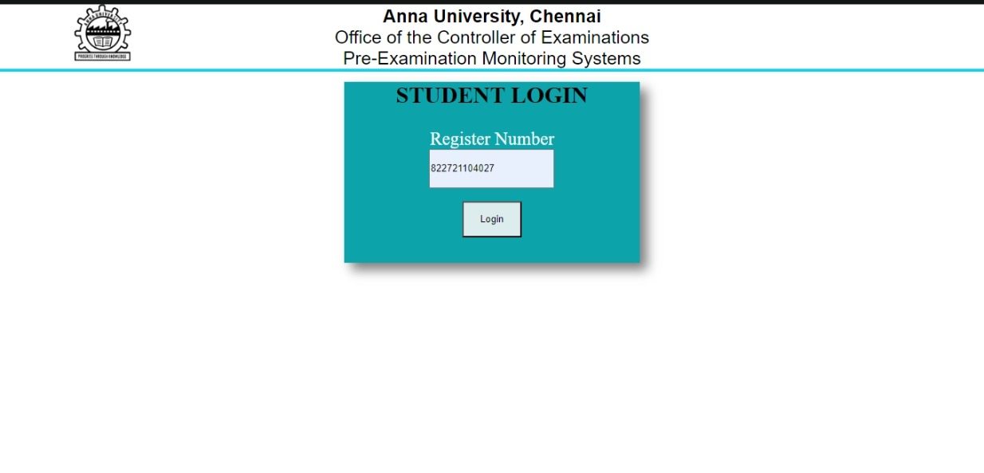

**SERVER RESPONSE :**

**FIRST – TIME LOGIN :**

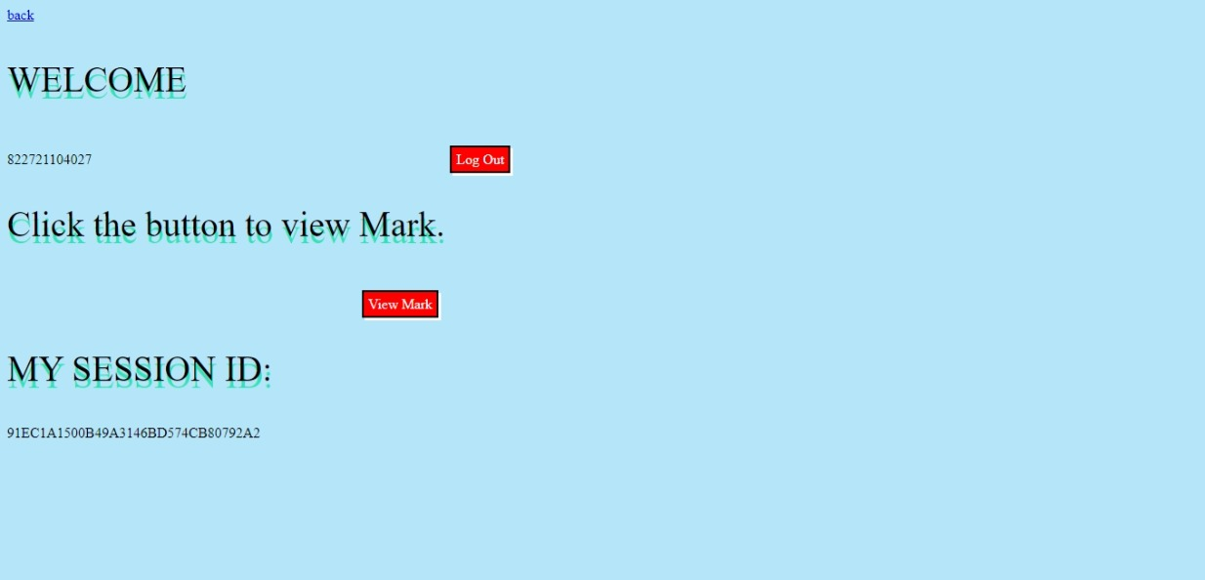

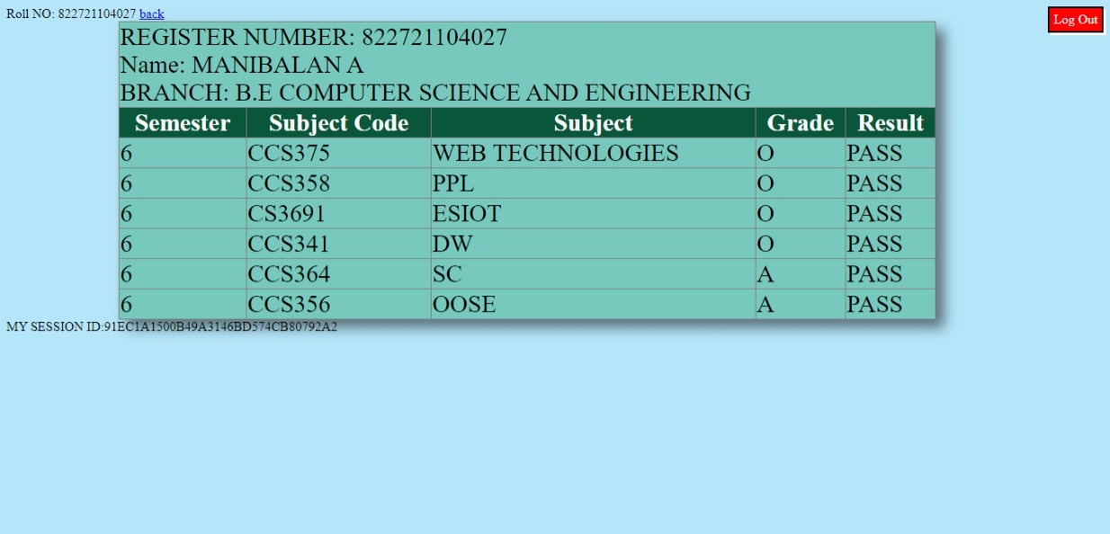

**RE --LOGIN :**

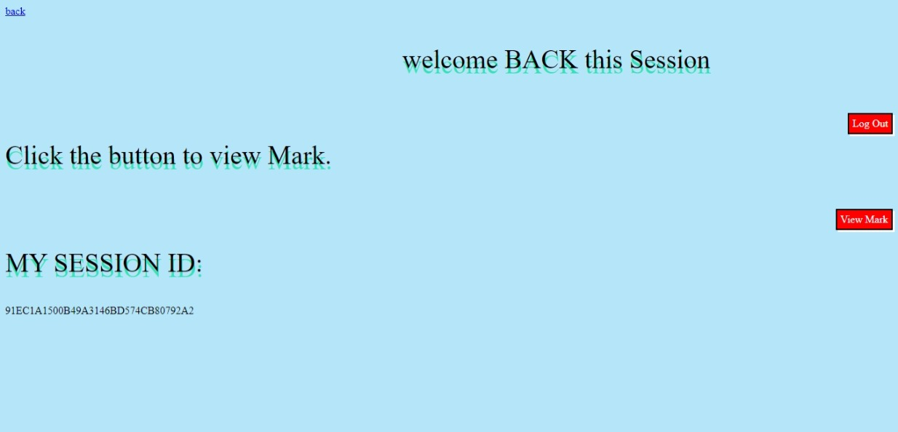

**RESULT :**

Thus the above program for Concept of Session Tracking using Servlets was Executed and verified Successfully.