|  |  |
| --- | --- |
| **Ex.No. :** 07  **Date :** 18-04-24 | **ACCESSING STUDENT MARKLIST DATABASE USING SERVLET** |

**AIM :**

To Implement Concept of Accessing Student Marklist Database using Servlet.

**PROGRAM :**

**HTML CODE :**

<html >

<head>

<meta charset="UTF-8">

<meta name="viewport" content="width=device-width, initial-scale=1.0">

<title>Document</title>

<style>

.bor{ border: 2px double blue; width: 700px;

height: 100%; margin-left: 25%;

background-repeat: repeat; }

form{ border: 2px dotted red;width: 300px; height: 60%;

margin-left: 25%;

background-image: linear-gradient(to right,rgb(210, 243, 21),rgb(108, 108, 153)); }

#sub{ border-radius: 3%;

background-image: linear-gradient(to top,rgb(233, 10, 103),rgb(5, 237, 245));}

</style>

</head>

<body>

<div class="bor">

<h1 style="text-align:center;color:rgb(168, 54, 54);">COMPUTER SCIENCE AND ENGINEERING</h1>

<form action="http://localhost/php/details.php" method="POST">

<h2 style="text-align: center;" >Student Lab Details</h2>

<label for="reg" >REGISTER NUMBER</LA>

<input type="text" id="reg" name="reg">

<br> <label for="date" >DATE</label> <br>

<input type="text" id="date" name="date"> <br>

<label for="sub"></label>

<input type="submit" id="sub" value="Details">

</form> </div>

</body>

</html>

**PHP CODE :**

<html>

<body>

<?php

$name1 = $_POST["reg"];$name2 = $_POST["date"];

$x = simplexml_load_file("studentlab.xml");?>

<h1 style="text-decoration:underline;">STUDENT DETAILS</h1>

<style>

tr{background-color:aliceblue;color:Blue;}

BODY{background-color:pink;}

</style>

<table border="2" style=" width:1000px;border-collapse: collapse; background-color:aliceblue;color:red;margin-left:10%;">

<tr style=" width:1000px;border-collapse: collapse; background-color:aliceblue;color:red ;text-align:center;">

<td style="width:120px;"><b>NAME</b> </td>

<td style="width:150px;"><b>REGISTER NUMBER</b></td>

<td style="width:60px;"><b>YEAR</b> </td>

<td style="width:120px;"> <b>DEPARTMENT</b></td>

<td style="width:120px;"> <b>DATE</b></td>

<td style="width:120px;"> <b>SYSTEM NUMBER</b></td>

<td style="width:120px;"><b>INCOMING TIME</b></td>

<td style="width:120px;"><b>OUTGOING TIME</b></td>

</tr>

</table>

<?php

foreach($x->children() as $a){

if($a->Reg_no==$name1 && $a->date==$name2){

?>

<div id="a">

<table border="2" style=" width:1000px;border-collapse: collapse;margin-left:10%;">

<tr style="text-align:center;" >

<td style="width:120px;"><?php echo "$a->name"; ?> </td>

<td style="width:150px;"><?php echo "$a->Reg_no"; ?> </td>

<td style="width:60px;"><?php echo "$a->year"; ?> </td>

<td style="width:120px;"><?php echo "$a->dept"; ?> </td>

<td style="width:120px;"><?php echo "$a->date"; ?> </td>

<td style="width:120px;"><?php echo "$a->pcno"; ?> </td>

<td style="width:120px;"><?php echo "$a->incoming_time"; ?></td>

<td style="width:120px;"><?php echo "$a->outgoing_time"; ?></td>

</tr>

</table>

<?php }}?>

</div>

</body>

</html>

**STUDENTLAB.XML CODE:**

<details>

<records>

<name>Manibalan A</name>

<Reg_no>822721104027</Reg_no>

<year>III</year>

<dept>CSE</dept>

<date>01-02-2024</date>

<pcno>15/270</pcno>

<incoming_time>1.30pm</incoming_time>

<outgoing_time>4.50pm</outgoing_time>

</records>

<records>

<name>Manibalan R</name>

<Reg_no>822721104028</Reg_no>

<year>III</year>

<dept>CSE</dept>

<date>01-02-2024</date>

<pcno>16/270</pcno>

<incoming_time>1.30pm</incoming_time>

<outgoing_time>4.50pm</outgoing_time>

</records>

<records>

<name>Manikandan</name>

<Reg_no>822721104029</Reg_no>

<year>III</year>

<dept>CSE</dept>

<date>01-02-2024</date>

<pcno>17/270</pcno>

<incoming_time>1.40pm</incoming_time>

<outgoing_time>4.30pm</outgoing_time>

</records>

<records>

<name>Manibalan A</name>

<Reg_no>822721104027</Reg_no>

<year>III</year>

<dept>CSE</dept>

<date>01-02-2024</date>

<pcno>31/270</pcno>

<incoming_time>9.50am</incoming_time>

<outgoing_time>12.00pm</outgoing_time>

</records>

</details>

**OUTPUT :**

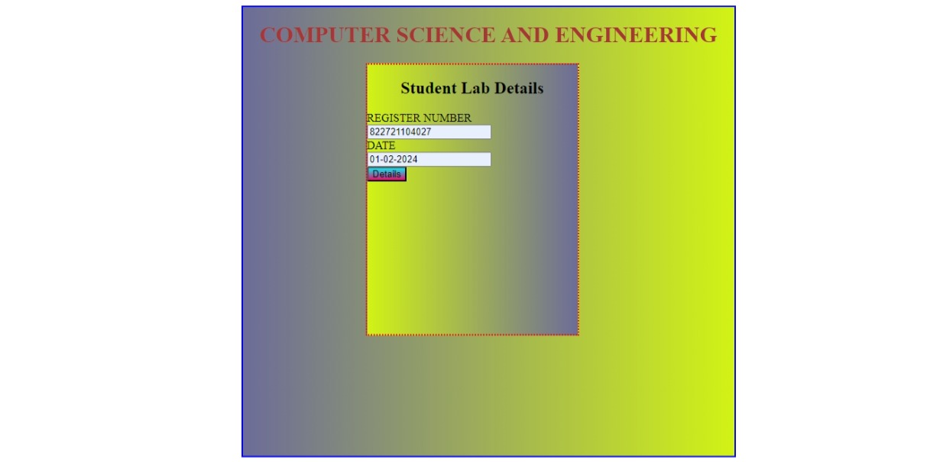

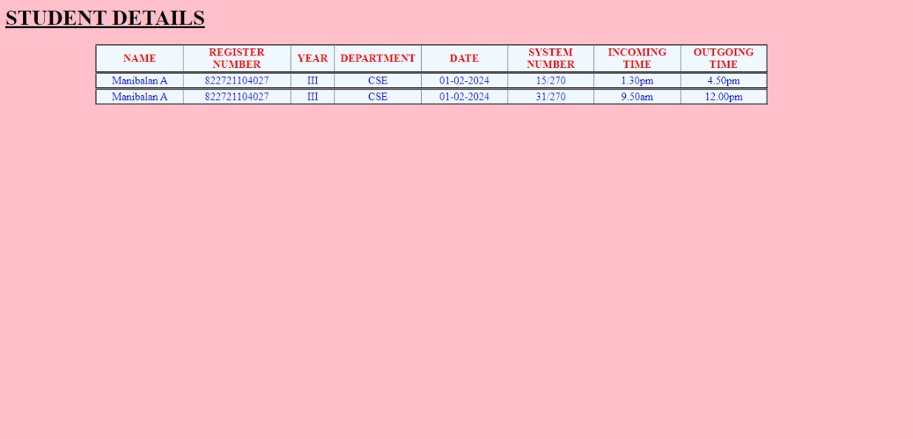

**RESULT :**

Thus, the Implementation of Concept of Accessing Student Marklist Database using Servlet is Executed and Verified Successfully.